Creating a Windows Mobile Line of Business (LOB) Application (Part 11 of 13): Targeting Multiple Devices (Level 300)

Webcast Date: 2006-03-15

Today’s documentation is slightly different from previous weeks. In the webcast you have seen how it is possible to target multiple devices, yet keep as much of the source code in a single tree. Since the entire RoadAssistance application has changed dramatically from the final solution of last week, it would be way too much work for you to repeat all the steps I went through. Rather than having you type a lot, I like to explain the general approach I took to target multiple devices and let you simply study the end result of today’s webcast. If you have questions about this approach, don’t hesitate to contact me via email: maarten.struys@pts.nl.

Dealing with different Form Factors

When you are creating a line of business application, especially a commercial one as an ISV, you might not know in advance on what devices your application will be running. Over the series up until now you have already seen how we can support Pocket PC’s with different screen orientation and Pocket PC’s with different screen resolutions. The story becomes a little more complex if you also want to target Smart Phones, because they have a much smaller screen, not touch screen capabilities, limited data entry capabilities and so on. For a Smart Phone it would make sense to redesign the user interface. At the same time you want to re-use as much code as possible. In a true multi-tier application, that would be easy to achieve, since you only replace the UI, keeping the rest of the code as is. As you have seen though, RoadAssistance is not a true multi-tier application. Of course the database is separated from the application as well as data access functionality and some functionality to deal with the MapPoint Web Service and the State & Notification Broker. At the same time, the UI code still contains some functionality as well. In today’s sample code, you will find a cool use of a new C# 2.0 language feature (as a matter of facts, it exists in Visual Basic.NET as well). From now on, RoadAssistance is heavily making use of partial classes. Using partial classes we have a way to divide a class over multiple source files. This allows for user interface code to be completely separated from functionality, with both still available inside the same class. On a memory strained device this would make sense, since we don’t have to instantiate new (business) objects, most likely resulting in less garbage collection actions and thus better performance. To explain the process of splitting up a UI related class into partial classes, take a look at this sample code, taken from RoadAssistance’s MainForm.cs file.

/// <summary>
/// MainForm_Load event handler.
/// After all initialization is done, wait for the SplashScreenThread to terminate and
/// immediately show the main form afterwards.
/// </summary>
/// <param name="sender">Originator of the event</param>
/// <param name="e">An EventArgs that contains the event data.</param>
private void MainForm_Load(object sender, EventArgs e)
{
// We have to wait until the user has entered a valid password,
// otherwise we should not attempt to access the Assignments table.
passWordEntered.WaitOne();

// verify if we have a valid password, otherwise it does not make sense
// to try and fill the dataset.
if (DbAccess.PassWord != null)
{
if (AssignmentsDataSetUtil.DesignerUtil.IsRunTime())
{
this.assignmentsTableAdapter.Connection.ConnectionString += ("Password = " + DbAccess.PassWord + ";");
this.assignmentsTableAdapter.FillByActiveAssignments(this.assignmentsDataSet.Assignments);
SelectOldestAssignment();
}
}

// Setup screen correctly for resolution and orientation.
Graphics g = CreateGraphics();
if (g.DpiX == 96) // Low resolution
{
pictureBox1.Image = Properties.Resources.MainFormImagePPCLowRes;
highResScreen = false;
}
else
{
pictureBox1.Image = Properties.Resources.MainFormImagePPCHiRes;
highResScreen = true;
}
g.Dispose();

// Initialize the State & Notification Broker SystemState variables we are interested in.
snapi = SnapiHelper.Instance();
menuItemSynchronize.Enabled = snapi.DeviceCradled();
snapi.NewCradleState += new SnapiHelper.CradleStateEventHandler(snapi_NewCradleState);

// Check if we are cradled, in that case we allow synchronization to the back-office
menuItemSynchronize.Enabled = SystemState.CradlePresent;

// Define the SMS messages that needs to be intercepted by the RoadAssistance
sms = new MessageInterceptor(InterceptionAction.NotifyAndDelete);
sms.MessageCondition = new MessageCondition(MessageProperty.Body,
MessagePropertyComparisonType.StartsWith,
"RoadAssist");
sms.MessageReceived += new MessageInterceptorEventHandler(sms_MessageReceived);

// We are done initializing, so inform the splash screen that it can
// close by setting an event.
appInitialized.Set();
Thread.CurrentThread.Priority = ThreadPriority.AboveNormal;

// Wait until the splash screen is really closed and start working.
splashScreenThread.Join();

// If no valid password has been entered, we assume the application needs to be terminated.
if (DbAccess.PassWord == null)
{
this.Close();
}
else
{
ReInitializeForm(device.GetType(this.ClientSize));
this.Enabled = true;
this.Visible = true;
}

Thread.CurrentThread.Priority = ThreadPriority.Normal;

currentTicks = DateTime.Now.Ticks;
}

If you take a look at the above source code, the only thing that really has to do with the user interface itself is the part where the screen is setup correctly for resolution and orientation. All other functionality is mainly application initialization code. What if we could change the above listed MainForm_Load event handler into something like this:

/// <summary>
/// MainForm_Load event handler.
/// Setup the correct screen for the current resolution and display orientation
/// and call a method to handle the load event.
/// </summary>
/// <param name="sender">Originator of the event</param>
/// <param name="e">An EventArgs that contains the event data.</param>
private void MainForm_Load(object sender, EventArgs e)
{
// Setup screen correctly for resolution and orientation.
Graphics g = CreateGraphics();
if (g.DpiX == 96) // Low resolution
{
pictureBox1.Image = Properties.Resources.MainFormImagePPCLowRes;
highResScreen = false;
}
else
{
pictureBox1.Image = Properties.Resources.MainFormImagePPCHiRes;
highResScreen = true;
}
g.Dispose();

ActOnLoadEvent();
}

In the above code sample we have some code specifically for a Pocket PC (Phone Edition) device to setup the screen correctly, and we call another method of the MainForm class that deals with further initialization. That other method, ActOnLoadEvent, will look like this:

/// <summary>
/// ActOnLoadEvent
/// This method is invoked on the MainForm_Load event handler.
/// Wait on the SplashScreen thread for user validation.
/// Fill the assignments datagrid with active assignments.
/// Setup State & Notification variables.
/// Prepare the application to intercept SMS messages.
/// </summary>
private void ActOnLoadEvent()
{
// We have to wait until the user has entered a valid password,
// otherwise we should not attempt to access the Assignments table.
passWordEntered.WaitOne();

// verify if we have a valid password, otherwise it does not make sense
// to try and fill the dataset.
if (DbAccess.PassWord != null)
{
if (AssignmentsDataSetUtil.DesignerUtil.IsRunTime())
{
this.assignmentsTableAdapter.Connection.ConnectionString += ("Password = " + DbAccess.PassWord + ";");
this.assignmentsTableAdapter.FillByActiveAssignments(this.assignmentsDataSet.Assignments);
SelectOldestAssignment();
}
}

// Initialize the State & Notification Broker SystemState variables we are interested in.
snapi = SnapiHelper.Instance();
menuItemSynchronize.Enabled = snapi.DeviceCradled();
snapi.NewCradleState += new SnapiHelper.CradleStateEventHandler(snapi_NewCradleState);

// Define the SMS messages that needs to be intercepted by the RoadAssistance
sms = new MessageInterceptor(InterceptionAction.NotifyAndDelete);
sms.MessageCondition = new MessageCondition(MessageProperty.Body,
MessagePropertyComparisonType.StartsWith,
"RoadAssist");
sms.MessageReceived += new MessageInterceptorEventHandler(sms_MessageReceived);

// We are done initializing, so inform the splash screen that it can
// close by setting an event.
appInitialized.Set();
Thread.CurrentThread.Priority = ThreadPriority.AboveNormal;

// Wait until the splash screen is really closed and start working.
splashScreenThread.Join();

// If no valid password has been entered, we assume the application needs to be terminated.
if (DbAccess.PassWord == null)
{
this.Close();
}
else
{
ReInitializeForm(device.GetType(this.ClientSize));
this.Enabled = true;
this.Visible = true;
}

Thread.CurrentThread.Priority = ThreadPriority.Normal;

currentTicks = DateTime.Now.Ticks;
}

This method is now independent of any Pocket PC related UI functionality and could be used immediately if we were about to target a Smart Phone as well. However, we still need to solve the problem of maintaining one single code base for shared functionality. Instead of putting shared functionality in a separate assembly, we will make use of partial types.

Juval Lowy describes partial types as follows in this excellent MSDN article: http://msdn.microsoft.com/msdnmag/issues/06/00/C20/default.aspx.

C# 2.0 allows you to split the definition and implementation of a class or a struct across multiple files. You can put one part of a class in one file and another part of the class in a different file by using the new partial keyword. For example, you can put the following code in the file MyClass1.cs:

public partial class MyClass
{
public void Method1() {...}
}

In the file MyClass2.cs, you can insert this code:

public partial class MyClass
{
public int Number;
public void Method2() {...}
}

In fact, you can have as many parts as you like in any given class. Partial type support is available for classes, structures, and interfaces, but you cannot have a partial enum definition.
Windows® Forms uses partial classes to store the visual designer output of the InitializeComponent method as well as the member controls. Partial types also enable two or more developers to work on the same type while both have their files checked out from source control without interfering with each other.

C# 2.0 supports partial types as follows: when the compiler builds the assembly, it combines from the various files the parts of a type and compiles them into a single type in Microsoft intermediate language (MSIL). The generated MSIL has no recollection which part came from which file.

Using partial types, we can now have separate files containing parts of the MainForm Class. If you take a look at today’s RoadAssistance solution, you will see different projects for RoadAssistance (the original project we have been working on for 11 weeks now) and for RoadAssistanceSP (a brand new version, containing the RoadAssistance application for Smart Phone), Let’s begin looking at the RoadAssistance project. If you look in solution explorer you will see a familiar file MainForm.cs, immediately followed by a new file MainForm.Methods.cs.

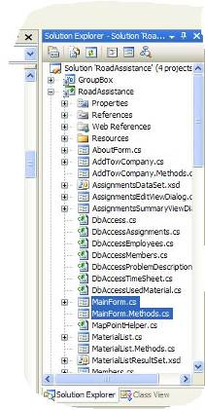

MainForm.cs contains all Pocket PC specific functionality for the MainForm class, like all event handlers and UI code that specifically deals with Pcoket PC devices. MainForm.Methods.cs on the other hand contains device independent methods that are part of the MainForm class. If you take a look at the beginning of the file MainForm.Methods.cs you will see that it implements part of the MainForm class, and specifies it as being partial:

namespace RoadAssistance
{
partial class MainForm
{

The C# compiler takes care of combining both MainForm.cs, MainForm.Designer.cs and MainForm.Methods.cs with one single class MainForm as the end result.

Now suppose we want to make use of exactly the same functionality in a RoadAssistance version for Smart Phones. To do so, we create a new project, called RoadAssistanceSP. In that project, we need to create new forms, because a Smart Phone has a completely different screen size as a Pocket PC. In creating the user interface, we carefully make sure to give all controls the same names that they had in the Pocket PC version of the user interface. What you end up with two different projects, containing different versions of the RoadAssistance application, but using the same names for forms, classes and controls. We also implement the same event handlers in the Smart Phone edition of RoadAssistance. For instance, take a look at the MainForm:

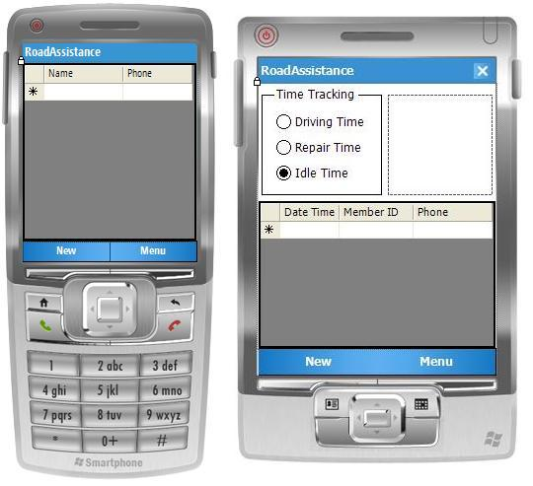

As you see, the Smart Phone version of the MainForm only has a datagrid visible. The GroupBox and the radio buttons are not visible. Instead of using radio buttons for time tracking, on the Smart Phone time tracking is done by different menu entries (although they still have the same names as the radio buttons on the Pocket PC edition of the MainForm).

If you take a look at the Load Event handler of the Smart Phone version of RoadAssistance, you will see that it is slightly different from the one that we showed earlier of the Pocket PC version:

/// <summary>
/// MainForm_Load event handler.
/// </summary>
/// <param name="sender">Originator of the event</param>
/// <param name="e">An EventArgs that contains the event data.</param>
private void MainForm_Load(object sender, EventArgs e)
{
ActOnLoadEvent();
radioButtonIdleTime.Checked = true;
radioButtonIdleTime.Enabled = false;
menuItemCloseAssignment.Enabled = (assignmentsDataSet.Assignments.Count != 0);
}

Instead of setting up a proper image to display on the MainForm, we now set some menu items enabled and checked, but we are also calling the method ActOnLoadEvent. There is only one more thing to do. We need to get access in the RoadAssistanceSP project to the file MainForm.Methods.cs. Instead of copying that file to the new project, we are creating a link to the original file, assuring that only one singe source file MainForm.Methods.cs exists, thus allowing easy maintenance.

In order to create a link to an existing file, you can do the following inside Visual Studio 2005. In Solution Explorer, right click on the RoadAssistanceSP project and select Add – Existing Item:

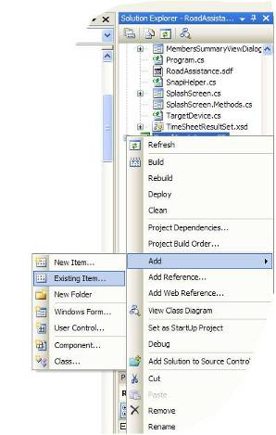

In the Add Existing Item dialog, navigate to the RoadAssistance source files, select the file MainForm.Methods.cs, but instead of clicking the open button make sure to click on the arrow at the right hand side of the open button and select “Add As Link”:

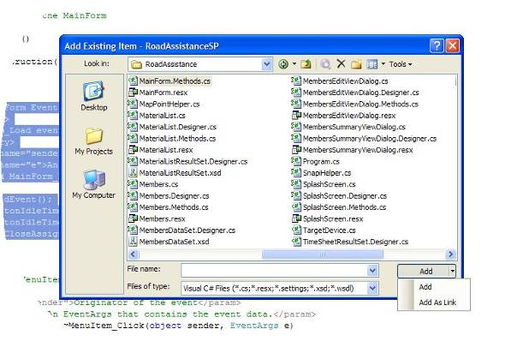
Doing so will create a link to the original source file MainForm.Methods.cs in the project RoadAssistanceSP, where it can be used, modified and so on, but only one physical copy of the file will exist (stored in the RoadAssistance project folder). In Solution Explorer this is indicated by a little arrow in the lower left side of the icon. As you can see, there are links to all DbAccess files as well. What we now have as an end result are two separate projects, RoadAssistance and RoadAssistanceSP. They both have specific code for user interface purposes and they share code containing common functionality.

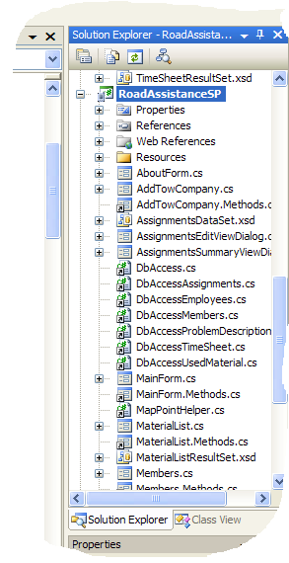

Distinguish between Pocket PC’s and Smart Phones

Even though we have common functionality separated in different partial classes, it can sometimes happen that we need to do something specific for either a Smart Phone or a Pocket PC. In those situations we will make use of conditional compilation. For example, take a look at another method that can be found in MainForm.Methods.cs:

/// <summary>
/// When a new SMS message is received that contains a new assignment,
/// we are storing the new assignment in the Assignment table of the SQL Mobile database.
/// Of course we have no clue what the user is currently doing, so to keep the application
/// responsive to the user, the assignment is stored in a separate thread.
/// When we are running on a PocketPC device we will inform the user about the new assignment
/// by means of a notification bubble. Since notification bubbles are not available on
/// SmartPhones, we use conditional compilation to use a notification bubble on PocketPC only.
/// </summary>
/// <param name="sender">Originator of the event</param>
/// <param name="e">An MessageInterceptorEventArgs that contains the event data.</param>
void sms_MessageReceived(object sender, MessageInterceptorEventArgs e)
{
ThreadPool.QueueUserWorkItem(StoreNewAssignment, e);
#if PocketPC
assignmentNotification.Icon = Properties.Resources.AssignmentNotificationIcon;
assignmentNotification.Visible = true;
#else
MessageBox.Show("New Assignment received");
#endif
}

This method is called when a new SMS message containing an assignment is received. On a Pocket PC we want to give an indication to the user, using a notification bubble. This control is not available on Smart Phones. Therefore, we use conditional compilation to either show a notification bubble or a Message Box. The compilation constant PocketPC is automatically set when compiling for PocketPC. Smartphone is automatically set when compiling for a SmartPhone.

You are now done with today’s sample code. Take a look at today’s final solution. You now have two different RoadAssistance applications with the same functionality. One of them runs on Pocket PC’s, the other one on Smart Phones. Both applications share as much code as possible. You can try both using the corresponding emulator in Visual Studio 2005.

