Creating a Windows Mobile Line of Business (LOB) Application (Part 7 of 13): Adding functionality (Level 300)

Webcast Date: 2006-02-15

The steps as written down in this document are not tested thoroughly. Even though all information is hopefully here, you might run into some unexpected problems. If so, don’t hesitate to contact me via email: maarten.struys@pts.nl.

Today’s sample code is the end result of all the steps that are described in this document. You can take last week’s sample code and follow all steps in this document to get to this end result yourself. Today’s completed samples, including fully documented source code can be found in the solution in the folder 20060215.
Note: To make sure that the described demos are working properly you must use last week’s sample code as initial project.

Demo1 – Authenticating the user

In today’s first demonstration you will check if a user is authorized to use the RoadAssistance application. To do so, you will make use of the RoadAssistance database. A user is authorized when these criteria are met:

- The username is found in the Employees table.
- The password is a valid password to access the RoadAssistance database.

The number of login attempts is restricted to three.

User Authentication is performed on the SplashScreen, while the application is performing some necessary initialization in the background. Since database access is needed to authenticate the user, you will start by creating a number of classes that allow easy access to the RoadAssistance database. Database access is separated from the UI, allowing you to use alternative connections, change database connection details etc. without the need to modify UI code.

In figure 1 you can see the classes that you will use to access the RoadAssistance database. The base class (DbAccess) maintains the connection string and is responsible for proper error handling. Derived from DbAccess are a number of other classes, working on individual tables of the RoadAssistance database.

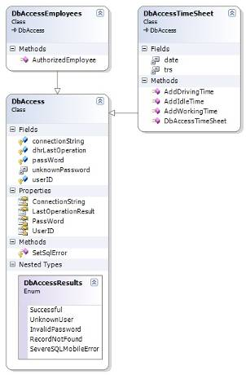
Figure 1 - Accessing the RoadAssistance database.

Adding the DbAccess Class to the RoadAssistance project

- Add a new Class to the RoadAssistance project and name it DbAccess.cs. An empty class is created and displayed in the Visual Studio Editor.
- Add the following using directives to just created class:

using System.Data;
using System.Data.SqlServerCe;

- Create the following static and instance variables:

protected static string connectionString;
protected static string passWord;
protected static int userID = 0;
protected DbAccessResults dhrLastOperation;

private const int unknownPassword = 25028;

As you can see, you just added three static variables, one holding the connection string to a SQL Mobile database, one to store the database password and one to store the ID of the current user using the RoadAssistance application. To keep track of errors, an instance variable is available that holds a copy of the last error. When errors occur in a database operation, it is important to read the value of dhrLastOperation immediately, after any other database operation it will likely be overwritten again.

The next thing to do is create an enum holding friendly error codes for errors that might occur when working with the RoadAssistance database.

- Immediately under the instance variables, add the following code to define the DbAccessResults enum:

public enum DbAccessResults
{
Successful = 0,
UnknownUser,
InvalidPassword,
RecordNotFound,
SevereSQLMobileError
}

The next thing you will do is create a number of properties to set and retrieve UserId, the password, the connection string and the last operation result.

- Immediately under the enum you have just added, add the following properties:

internal static int UserID
{
get
{
return userID;
}
set
{
userID = value;
}
}

internal static string PassWord
{
get
{
return passWord;
}
set
{
passWord = value;
connectionString = "Data Source ="
+ (System.IO.Path.GetDirectoryName(System.Reflection.Assembly.GetExecutingAssembly().GetName().CodeBase) + "\\RoadAssistance.sdf;")
+ "Password =" + passWord + ";";
}
}

public DbAccessResults LastOperationResult
{
get
{
return dhrLastOperation;
}
}

internal static string ConnectionString
{
get
{
return connectionString;
}
}

The PassWord property needs some extra explanation. When you set a new password, this property is also used to create the complete connection string to connect to the database. It is perfectly legal to do several actions in the set method of a property. Setting the connection string in the password property reduces the number of calls you have to make when creating the initial database connection. As you can see, the connection string is assembled using reflection. In this way it is possible to get the path where the database is located, without having to hard code that path. The only assumption is that the RoadAssistance database (RoadAssistance.sdf) is stored in the same folder as the executable for the RoadAssistance application.

Finally you need to create a protected method to set error results, that can be used by derived classes to inform users of the DbAccess class hierarchy about the result of a database operation.

- Immediately under the properties you have just added, add the following method:

protected void SetSqlError(int sqlNativeError)
{
if (sqlNativeError == unknownPassword)
{
dhrLastOperation = DbAccessResults.InvalidPassword;
}
else
{
dhrLastOperation = DbAccessResults.SevereSQLMobileError;
}
}

To make sure that you have not made any errors in the DbAccess class, rebuild the solution using the Build menu or F6. Suppose you didn’t get compilation errors, you are now done with the DbAccess class so you can close it. The next thing to do is derive a class from DbAccess to verify if a valid user is trying to logon to the RoadAssistance application.

Adding the DbAccessEmployees Class to the RoadAssistance project

- Add a new Class to the RoadAssistance project and name it DbAccessEmployees.cs. An empty class is created and displayed in the Visual Studio Editor.
- Add the following using directives to just created class:

using System.Data;
using System.Data.SqlServerCe;

- Modify the class such that it derives from the DbAccess class, by changing the first line of the class definition into:
class DbAccessEmployees : DbAccess

The DbAccessEmployees class contains only one method. This method is used to connect to the RoadAssistance database and to retrieve a record from the Employees table with a matching user name. Prior to calling this method, the password and the connection string to the RoadAssistance database must have been set.

- Add the following code to the DbAccessEmployees class:

public bool AuthorizedEmployee(string name)
{
bool success = false;

try
{
// Open the SQL database and lookup the user name
string query = "SELECT ID, Name FROM Employees WHERE Name = '" + name + "'";

using (SqlCeConnection connect = new SqlCeConnection(connectionString))
{
connect.Open();
SqlCeCommand cmd = new SqlCeCommand(query, connect);

using (SqlCeDataReader reader = cmd.ExecuteReader())
{
if (reader.Read())
{
// if we can read a record it means we have a valid user - password combination.
userID = reader.GetInt32(0);
success = true;
}
else
{
dhrLastOperation = DbAccessResults.RecordNotFound;
}
}
}
}
catch (SqlCeException exc)
{
SetSqlError(exc.NativeError);
}
return success;
}

As you can see in the code you have just added, you will work directly on the Employees table of the RoadAssistance database. The first thing to do is create a query to select the ID and the user name from the Employees table. If a record is found you have a valid user, if no record is found or if a database error occurs, the error code is saved. Note that you are making use of the C# using statement, which automatically disposes the SqlCeConnection and the SqlCeDataReader when they go out of scope.

To make sure that you have not made any errors in the DbAccessEmployees class, rebuild the solution using the Build menu or F6. Suppose you didn’t get compilation errors, you are now done with the DbAccessEmployees class so you can close it. The next thing to do is add functionality to validate a user name / password combination when the RoadAssistance application is started.

You will add user validation to the SplashScreen.cs file. In this way, validation of the user will occur in parallel with the rest of the RoadAssistance application initializing. A user is valid when

- The username is found in the Employees table
- A valid password is entered to connect to the RoadAssistance database

A user has three attempts to provide a valid user name / password combination.

- Open the file SplashScreen.cs in the source code editor of Visual Studio 2005.
- Add the following instance variables to SplashScreen.cs:

private AutoResetEvent passWordEntered;
private int logonAttempts = 0;
private const int nrLogonAttemptsAllowed = 3;

Because the RoadAssistance application will initialize in parallel and tries to connect to the RoadAssistance database during initialization, it can only do so when a valid password user name combination has been entered. Since the RoadAssistance application has not yet any means to know when this has happened, you will add some additional synchronization code to inform the RoadAssistance application when it is safe to start initializing. This synchronization will be done using an AutoResetEvent.

- In the file SplashScreen.cs, find the Constructor and add an additional parameter to it like this:

public SplashScreen(AutoResetEvent appInitialized, AutoResetEvent passWordEntered, int minimumDisplayTime)

- You also have to store the additional AutoResetEvent in SplashScreen by adding the following code in the constructur:

this.passWordEntered = passWordEntered;

- In the file SplashScreen.cs, find the btnDone_Click event handler and replace all code of the event handler by the following code:

ShowSplashScreen(true);

// Store the entered password so we can use it to connect to the database
DbAccess.PassWord = tbPassWord.Text;
DbAccessEmployees dbaEmployees = new DbAccessEmployees();

logonAttempts++;

// Check if we have an authorized employee to use the application
if (dbaEmployees.AuthorizedEmployee(tbUserName.Text))
{
// start a timer to display the splash screen image for at least the specified amount of time.
displayTimer = new System.Windows.Forms.Timer();
displayTimer.Interval = minDisplayTime * 1000;
displayTimer.Tick += new EventHandler(displayTimer_Tick);
displayTimer.Enabled = true;

// Tell the MainForm that a connection to the database can now be made.
this.passWordEntered.Set();
}
else
{
switch (dbaEmployees.LastOperationResult)
{
case DbAccess.DbAccessResults.UnknownUser:
case DbAccess.DbAccessResults.InvalidPassword:
if (logonAttempts < nrLogonAttemptsAllowed)
{
MessageBox.Show("Invalid username and/or password", "Login failed!");
ShowSplashScreen(false);
}
else
{
MessageBox.Show("Number of retries exceeded, the application will shut down");
this.DialogResult = DialogResult.Cancel;
this.Close();
}
break;
case DbAccess.DbAccessResults.SevereSQLMobileError:
MessageBox.Show("Unspecified SQL Server Mobile Error, closing down the application",
"Severe Error",
MessageBoxButtons.OK,
MessageBoxIcon.Exclamation,
MessageBoxDefaultButton.Button1);
this.DialogResult = DialogResult.Cancel;
this.Close();
break;
default:
break;
}
}

As you can see, the first thing that is done in the btnDone_Click event handler is storing the entered password in a static member of the class DbAccess and creating a new instance of the class DbAccessEmployees. After increasing the number of login attemts, you will call the method AuthorizedEmployee. When this method returns true, a valid user is found for the application. In that case, application initialization will continue on a separate thread, while the splashscreen is displayed for at least a minimum amount of time. Note: an event is set to inform the RoadAssistance application that a valid database password is found, meaning the application can now safely connect to the database using this password. If no valid user is found, the error code is retrieved and depending on the error code, another attempt will be allowed or the RoadAssistance application will be terminated. In case of application termination, you need to add some extra functionality to force the RoadAssistance application to continue running (since it is waiting on the passWordEntered event to be set. Therefore you need to add some additional code to the SplashScreen_Closing event handler. In case the application is cancelled (either by the user or by an invalid user name / password combination after three attempts), you will set the PassWord and UserId to initial values and force the RoadAssistance application to continue running.

- In the file SplashScreen.cs, find the SplashScreen_Closing event handler and add the following code at the beginning of the event handler:

if (this.DialogResult == DialogResult.Cancel)
{
DbAccess.UserID = 0;
DbAccess.PassWord = null;
// Even though no valid password has been entered we still have to set the event, to prevent against deadlock.
passWordEntered.Set();
}

- In the file SplashScreen.cs, find the btnCancel_Click event handler and replace its code by the following code:

this.DialogResult = DialogResult.Cancel;
this.Close();

Setting the DialogResult explicitly to DialogResult.Cancel assures that the proper action is performed in the SplashScreen_Closing event handler when the user decides to cancel starting the RoadAssistance application.

To explicitly distinguish between showing the splash screen picture or the user login screen on the SplashScreen form, you will finally add an additional private method to the file SplashScreen.cs.

- Add the following method to the file SplashScreen.cs:

private void ShowSplashScreen(bool asSplashScreen)
{
if (asSplashScreen)
{
// disable and hide all controls and the sip, but show the picture box
pictureBox.Visible = true;
ShowControls(false);
}
else
{
// hide the picture box, enable and show all controls and the sip
pictureBox.Visible = false;
tbPassWord.Text = "";
tbUserName.Text = "";
ShowControls(true);
tbUserName.Focus();
}
}

This method is responsible for either showing the pictureBox (hiding all other controls) or showing all controls to allow entering of a user name and password when the pictureBox is hidden.

Since you added an additional AutoResetEvent and changed the signature of the SplashScreen constructor, you also need to make a few modifications to the MainForm.

- Open the file MainForm.cs in the source code editor of Visual Studio 2005.
- Add the following instance variables to MainForm.cs:

private AutoResetEvent passWordEntered;

- In the file MainForm.cs, find the Constructor and add an the following statement to it to instantiate the newly added AutoResetEvent:

passWordEntered = new AutoResetEvent(false);

- In the file MainForm.cs, find the MainForm_Load event handler and add the following code at the beginning of the event handler:

// We have to wait until the user has entered a valid password,
// otherwise we should not attempt to access the Assignments table.
passWordEntered.WaitOne();

// verify if we have a valid password, otherwise it does not make sense to try and fill the dataset.
if (DbAccess.PassWord != null)
{
if (AssignmentsDataSetUtil.DesignerUtil.IsRunTime())
{
this.assignmentsTableAdapter.Connection.ConnectionString += ("Password = " + DbAccess.PassWord + ";");
this.assignmentsTableAdapter.Fill (this.assignmentsDataSet.Assignments);
}
}

- Remove the code immediately under the just added code to fill the assignmentsTableAdapter (identical to the highlighted code in the code snippet above), since we already have added that code to be executed only when a valid user name / password combination has been entered.

This code is responsible for pausing the RoadAssistance application until a valid user name / password combination has been entered on the splash screen. After that, the assignments datagrid is filled with assignments records from the Assignments table of the RoadAssistance database.

- In the same MainForm_Load event handler, now replace the code immediately under the statement splashScreenThread.Join() with the following code:

// If no valid password has been entered, we assume the application needs to be terminated.
if (DbAccess.PassWord == null)
{
this.Close();
}
else
{
ReInitializeForm(device.GetType(this.ClientSize));
this.Enabled = true;
this.Visible = true;
}

Thread.CurrentThread.Priority = ThreadPriority.Normal;

This code checks if a valid password is available in DbAccess. If not, the RoadAssistance application is not properly initialized, either because the user clicked the cancel key on the splash screen or because user validation failed or because a database error occurred. In all those cases, the application will shut down, otherwise it will continue running by showing the MainForm.

- The last thing to do for now is to change add an additional parameter when calling the SplashScreen constructor. To do so, find the SplashScreenThread method inside MainForm.cs and replace the first statement in the method by the following statement:

SplashScreen splashScreen = new SplashScreen(appInitialized, passWordEntered, 10);

With that you are done with all the validation code. To make sure that you have not made any errors, rebuild the solution using the Build menu or F6. When you want to test user validation, make sure to change the active configuration to Release to allow you to actually enter user name / password combinations on the splash screen.

Suppose you didn’t get compilation errors, you are now down with the DbAccessEmployees class so you can close it. The next thing to do is add functionality to validate a user name / password combination when the RoadAssistance application is started.

Demo2 – Automatically maintaining a time sheet

Making the difference in a successful line of business application often means automating things to limit the amount of data the user has to enter. In the RoadAssistance application, this means for instance completely automating time sheet maintenance. In the beginning of the series you already added a number of radio buttons on the main form of the application to distinguish between working time, driving time and idle time. Now it is time to add functionality to those buttons. The idea is to have one TimeSheet record per day, containing the total amount of working time, driving time and idle time. Apart from that, working time should be stored for each individual assignment worked on as well.

Generating a SqlCeResultSet for the TimeSheet table of the RoadAssistance Database

To allow easy interfacing in a type safe manner to the TimeSheet table, you will use a SqlCeResultSet. The first thing to do is generate a SqlCeResultSet class for the TimeSheet table, using Visual Studio 2005.

- Connect to the local RoadAssistance database in your project using the Server Explorer inside Visual Studio 2005. Note: You have to provide password information to connect to the database. The password used for the local database throughout the Webcast Series is “!RoadA001”.

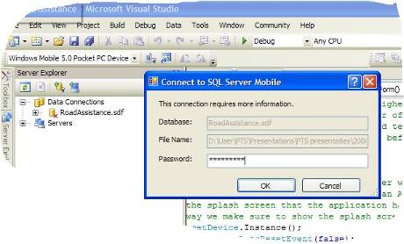
Figure 2 - Connecting to the local RoadAssistance database

- Add a New Data Source to the RoadAssistance project (using the Data menu of Visual Studio 2005). This will display the Data Source Configuration Wizard.

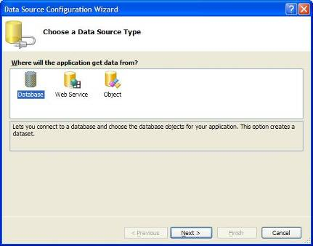
Figure 3 - Data Source Configuration Wizard

- Click Next on the Data Source Configuration Wizard (make sure Database is selected).
- Select the RoadAssistance database to connect to.
- Check the upper radio button on the dialog (see figure 4) to exclude sensitive data from the connection string. You will programmatically add sensitive data to the connection string later on.

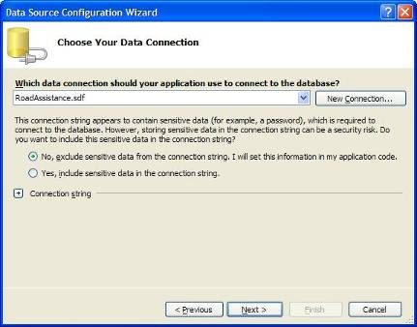
Figure 4 - Chosing a data connection

- Check the upper radio button on the dialog (see figure 4) to exclude sensitive data from the connection string. You will programmatically add sensitive data to the connection string later on.
- In the following screen of the Wizard (see figure 5) select the TimeSheet table and change the name of the dataset to TimeSheetResultSet. Then click Finish to add the dataset to the solution. Note: Even though you will in the end create a SqlCeResultSet, you begin by creating a strongly typed DataSet.

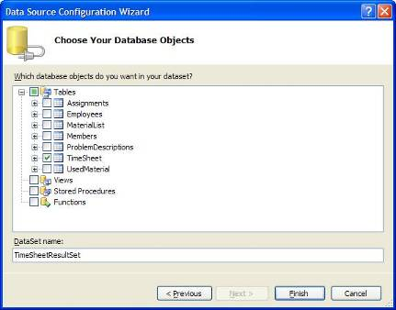
Figure 5 - Selecting which tables should be added to the dataset
Since you want to immediately work on the TimeSheet table of the RoadAssistance database itself, you need to change the generated DataSet into a SqlCeResultSet. SqlCeResultSets can be auto-generated by Visual Studio as well,
To generate a SqlCeResultSet for the TimeSheet you need to perform some additional steps.

- In Solution Explorer, select the file TimeSheetResultSet.xsd.
- In the Properties Window locate the Custom Tool property and change its value from MSDataSetGenerator to MSResultSetGenerator.

This time, a strongly typed SqlCeResultSet is generated instead of a strongly typed DataSet.

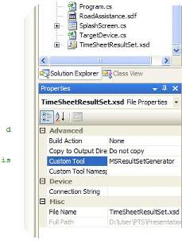
Figure 6 - Generating a SqlCeResultSet

Adding the DbAccessTimeSheet Class to the RoadAssistance project

To easily insert and update records in the TimeSheet table, the first thing to do is create yet another class to maintain the TimeSheet table. This class will again be derived from DbAccess so we have a proper connection string available and the ability to pass error information to callers of methods in the new class.

- Add a new Class to the RoadAssistance project and name it DbAccessTimeSheet.cs. An empty class is created and displayed in the Visual Studio Editor.
- Add the following using directives to just created class:

using System.Data;
using System.Data.SqlServerCe;

- Modify the class such that it derives from the DbAccess class, by changing the first line of the class definition into:

class DbAccessTimeSheet : DbAccess

The DbAccessTimeSheet class contains a number of methods to update idle time, working time and driving time information. These methods are used to connect to the RoadAssistance database and to either retrieve an existing record from the TimeSheet table with a matching date or create a new record in the table when no matching record exists.

- Add the following instance variables to the DbAccessTimeSheet class:

private string date;
private TimeSheetResultSetResultSets.TimeSheetResultSet trs;

Now you will add a constructor to the DbAccessTimeSheet class. In the constructor you will instantiate a TimeSheetResultSet object. You have to provide a connection string to this object to allow it to connect to the database. Since you already have a ConnectString available in the base class of DbAccessTimeSheet, you can simply pass that string.

- Add the following constructor code to the DbAccessTimeSheet class:

public DbAccessTimeSheet()
{

System.Data.SqlServerCe.ResultSetOptions resultSetOptions = System.Data.SqlServerCe.ResultSetOptions.Scrollable;
resultSetOptions = (resultSetOptions | System.Data.SqlServerCe.ResultSetOptions.Sensitive);
resultSetOptions = (resultSetOptions | System.Data.SqlServerCe.ResultSetOptions.Updatable);

trs = new RoadAssistance. TimeSheetResultSetResultSets.TimeSheetResultSet(ConnectionString, resultSetOptions);
date = DateTime.Now.ToShortDateString();
}

Finally you will add methods to maintain idle time, working time and driving time. All methods are identical from a functional point of view. They look up a record in the TimeSheet table with the current date. If it is found, time information is updated. If no record exists for the current date it will be created.

- Add the following methods to the DbAccessTimeSheet class:

public void AddIdleTime(long idleTicks)
{
bool addNewRecord = true;
int idleTime = (int)(idleTicks / 10000000);
if (trs.ReadLast()) {
string recordDate = trs.Date.ToShortDateString();

if (recordDate.CompareTo(date) == 0)
{
trs.IdleTime += idleTime;
trs.Update();
addNewRecord = false;
}
}

if (addNewRecord)
{
trs.AddTimeSheetRecord(DbAccess.UserID,
DateTime.Now,
0,
0,
idleTime);
}
}

public void AddWorkingTime(long workingTicks)
{
bool addNewRecord = true;
int workingTime = (int)(workingTicks / 10000000);

if (trs.ReadLast())
{
string recordDate = trs.Date.ToShortDateString();

if (recordDate.CompareTo(date) == 0)
{
trs.WorkingTime += workingTime;
trs.Update();
addNewRecord = false;
}
}

if (addNewRecord)
{
trs.AddTimeSheetRecord(DbAccess.UserID,
DateTime.Now,
workingTime,
0,
0);
}
}

public void AddDrivingTime(long drivingTicks)
{
bool addNewRecord = true;
int drivingTime = (int)(drivingTicks / 10000000);

if (trs.ReadLast())
{
string recordDate = trs.Date.ToShortDateString();

if (recordDate.CompareTo(date) == 0)
{
trs.DrivingTime += drivingTime;
trs.Update();
addNewRecord = false;
}
}

if (addNewRecord)
{
trs.AddTimeSheetRecord(DbAccess.UserID,
DateTime.Now,
0,
drivingTime,
0);
}
}

To make sure that you have not made any errors in the DbAccessTimeSheet class, rebuild the solution using the Build menu or F6. Suppose you didn’t get compilation errors, you are now done with the DbAccessTimeSheet class so you can close it. The next thing to do is add functionality to the MainForm to keep track of time sheet information.

Adding functionality to automatically maintain time information for the user

Keeping track of time information simply means taking action whenever the checked state of one of the radio buttons changes, thus reacting on a number of events.

- Open the file MainForm.cs in the source code editor of Visual Studio 2005.
- Add the following instance variable to MainForm.cs:

private long currentTicks;

This variable simply saves the time when a radio button event occurred.

- In the file MainForm.cs, find the MainForm_Load event handler and add an the following statement to it to set the initial time:

currentTicks = DateTime.Now.Ticks;

The next thing to do is create one single event handler that will be invoked when any of the 3 radio buttons have a state change from checked to unchecked v.v.

- Open the MainForm in designer mode, select the radioButtonIdleTime by single clicking on it.
- Add a CheckChanged event handler with the following name: TimeTrackingChecked_Changed.
- Add the same event handler to the other two radio buttons as well.

Now you will add functionality to the just created event handler. Each time a button is unchecked, you need to update the current record of the TimeSheet table, because it means that the user will start another activity.

- In the file MainForm.cs, find the TimeTrackingChecked_Changed event handler and add the following code to it:

if (sender.Equals(this.radioButtonDrivingTime))
{
if (radioButtonDrivingTime.Checked)
{
currentTicks = DateTime.Now.Ticks;
}
else
{
DbAccessTimeSheet dbaTimeSheet = new DbAccessTimeSheet();
dbaTimeSheet.AddDrivingTime(DateTime.Now.Ticks - currentTicks);
}
}
else if (sender.Equals(this.radioButtonIdleTime))
{
if (radioButtonIdleTime.Checked)
{
currentTicks = DateTime.Now.Ticks;
}
else
{
DbAccessTimeSheet dbaTimeSheet = new DbAccessTimeSheet();
dbaTimeSheet.AddIdleTime(DateTime.Now.Ticks - currentTicks);
}
}
else if (sender.Equals(this.radioButtonRepairTime))
{
if (radioButtonRepairTime.Checked)
{
assignmentsDataGrid.Enabled = false;
currentTicks = DateTime.Now.Ticks;
}
else
{
long workingTime = DateTime.Now.Ticks - currentTicks;
DbAccessTimeSheet dbaTimeSheet = new DbAccessTimeSheet();
dbaTimeSheet.AddWorkingTime(workingTime);

DataRowView currentRowView = (DataRowView)assignmentsBindingSource.Current;
AssignmentsDataSet.AssignmentsRow currentRow = (AssignmentsDataSet.AssignmentsRow)currentRowView.Row;
currentRow.WorkingTime += (int)(workingTime / 10000000);
assignmentsTableAdapter.Update(assignmentsDataSet);
assignmentsDataGrid.Enabled = true;
}
}

As you can see in the just entered code, first you will check which radio button caused activation of the event handler. The next thing to do is finding out if the radio button is currently checked or unchecked. When a radio button is checked you simply save the time of checking. When it is unchecked you update the TimeSheet record using functionality inside the DbAccessTimeSheet class. If the button causing the event is the radioButtonRepairTime, some extra functionality is needed to store repair time to the currently selected assignment as well. Since you already have a DataSet available for the Assignment table, you can simply use that to update WorkingTime in the Assignments table.

Rebuild the solution using the Build menu or F6. Suppose you didn’t get compilation errors, you can now test the new functionality by starting the RoadAssistance application, changing the radio buttons several times and verify that time information is stored in the TimeSheet table (either by using Query Analyzer on the device / emulator or by synchronizing the database with a back-end server.

NOTE: Some additional functionality is needed to make sure that the user can’t select the radioButtonRepairTime when no assignment is selected. This additional code is available in the final RoadAssistance solution for this week, but it is not part of the webcast demo’s. Therefore it is recommended, after ran the entire demo, to take a look at the final RoadAssistance solution that you downloaded as well.

Demo3 – Show active assignments only
The RoadAssistance user is only interested in active assignments, since those are assignments that he / she needs to work on. In order to limit the amount of information presented to the user, it makes sense to only display the active assignments in the assignments datagrid on the MainForm.

Adding an additional fill method to the AssignmentsDataSet

It is possible to extend strongly typed datasets, so they contain additional functionality, e.g. to filter database table data before adding that data to a dataset. This is exactly what you are going to implement for the AssignmentsDataSet.

- Open the dataset designer in Visual Studio for the AssignmentsDataSet by right clicking on the AssignmentsDataSet.xsd file and selecting View Designer from the popup menu.
- Add a new query by right clicking the AssignmentsTableAdapter class in the dataset designer and selecting Add Query in the popup menu (as shown in figure 7)

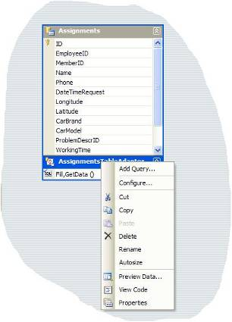
Figure 7 - Adding a new query

- In the TableAdapter Query Configuration Wizard accept all default settings until you reach the screen shown in figure 8.

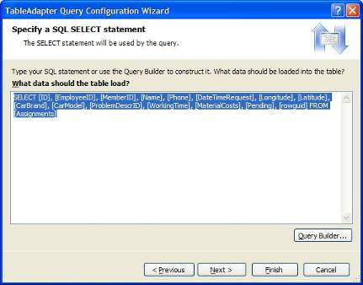
Figure 8 - TableAdapter Query Configuration Wizard

- Click the Query Builder button to show the Query Builder (see figure 9).
- In the Query Builder window locate the Pending column and add a filter to it. The filter should simply contain = 1, meaning that only records will be selected with Pending = 1.

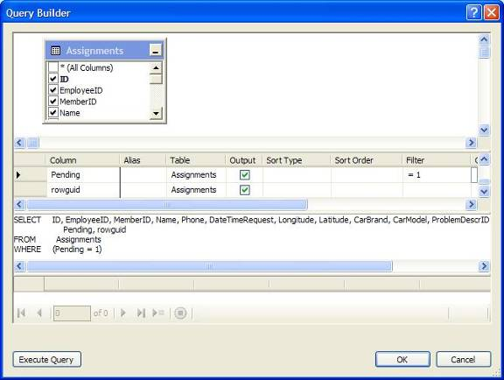
Figure 9 - Adding a filter in the Query Builder

- Click OK after you have added the Filter.
- The TableAdapter Query Configuration Wizard continues. Click Next on the screen where you see the just created query.
- Make sure to only check the “Fill a DataTable” check box in the next screen (see figure 10).
- Change the method name to “FillByActiveAssignments”.
- Click the Finish button to add the newly created method to the AssignmentsDataSet.

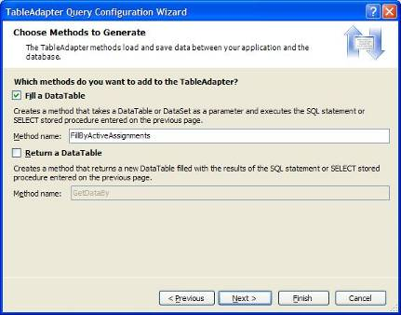
Figure 10 - Give the newly created method a meaningful name

Using the newly created fill method in the application

- In the source file MainForm.cs, search for the following string: this.assignmentsTableAdapter.Fill (which is located in the MainForm_Load event handler) and replace it by the following method call:

this.assignmentsTableAdapter.FillByActiveAssignments

The parameter passed to the method should remain unchanged.

Rebuild the solution using the Build menu or F6. Suppose you didn’t get compilation errors, you can now test the new functionality by starting the RoadAssistance application. This time, only active assignments should be visible in the assignments datagrid.

Demo4 – Changing an assignment from ‘active’ to ‘done’

One important piece of functionality for the user is to change an assignment from active to done. To do so, you will make use of tap and hold functionality in combination with a context menu.

- Open the MainForm in designer mode and drag a Context Menu from the Toolbox to the designer surface.
- Add the following menu entries to the context menu:
Close Assignment
Cancel Close Assignment
- Add a click event handler to the Close Assignment menu entry.
- Add the following code to the click event handler for the close assignment menu entry:

DataRowView currentRowView = (DataRowView)assignmentsBindingSource.Current;
AssignmentsDataSet.AssignmentsRow currentRow = (AssignmentsDataSet.AssignmentsRow)currentRowView.Row;
currentRow.Pending = false;
assignmentsTableAdapter.Update(currentRow);
this.assignmentsTableAdapter.FillByActiveAssignements(this.assignmentsDataSet.Assignments);

This code takes the currently selected assignment, changes its Pending state to false and writes the changed record to the database. Finally, the dataset is refreshed to make sure that only active assignments are displayed in the datagrid on the main form.

The last thing to do is hooking up the context menu to the datagrid.

- Open the MainForm in designer mode and select the assignments datagrid.
- Change the ContextMenu property of the datagrid, so that it holds the name of the just created context menu.

This will automatically add tap and hold functionality.

Rebuild the solution using the Build menu or F6. Suppose you didn’t get compilation errors, you can now test the new functionality by starting the RoadAssistance application. This time, tap and hold an active assignment on the datagrid and verify that the context menu shows. Select the Close Assignment menu entry and the assignment should be removed from the datagrid. It will still be available in the database for archiving purposes, but the user has no need to work on it anymore.

Demo5 – Adding new assignments on the device

In last week’s webcast you already created functionality to add a new assignment on the device. However, when create a new assignment and when you try to add a certain amount of working time to that assignment by selecting the radioButtonRepairTime, you can get a SQL Server Mobile exception (ConcurrencyException) when the assignments record is updated.

When a new assignments record was created, it was immediately stored in the RoadAssistance database. Since the ID number of the assignment is auto-generated in the database, the ID number of the assignment record in the database differs from the ID number of the assignment record in the dataset, the reason being that there is no synchronize back from the RoadAssistance database to the dataset. This can cause a concurrency problem when updating the original row in the dataset, because the record in the database has a different ID, so the original record in the dataset can not be found when updating it to the database. To prevent against such errors (for new records only, since they affect the autogenerated ID), you therefore need to explicitly fill the dataset again from the database after inserting a new record. More background information on this particular error can be found in the following article:

http://msdn.microsoft.com/msdnmag/issues/03/04/DataConcurrency/default.aspx

- In the file MainForm.cs, find the newMenuItemMenuItem_Click event handler and add an replace its code by the following code:

This code not only refills the dataset from the database after inserting a new record. It also initializes some fields of an assignment record to limit the amount of data the user has to enter when creating a new assignment record.

DataRowView newRowView = (DataRowView)assignmentsBindingSource.AddNew();
AssignmentsDataSet.AssignmentsRow newRow = (AssignmentsDataSet.AssignmentsRow)newRowView.Row;
newRow.rowguid = System.Guid.NewGuid();
newRow.Pending = true;
newRow.MaterialCosts = 0;
newRow.WorkingTime = 0;

RoadAssistance.AssignmentsEditViewDialog assignmentsEditViewDialog = RoadAssistance.AssignmentsEditViewDialog.Instance(this.assignmentsBindingSource);
assignmentsEditViewDialog.ShowDialog();

if (assignmentsDataSet.HasChanges())
{
assignmentsTableAdapter.Update(assignmentsDataSet);
assignmentsTableAdapter.FillByActiveAssignments(this.assignmentsDataSet.Assignments);
}

You are now done with today’s exercise. Rebuild the solution using the Build menu or F6. Deploy it to the device or the emulator. Experiment with the newly added code and don’t hesitate to extend it yourself.

NOTE: The final download of the RoadAssistance application contains a number of additional changes that are not described in this document.

