Creating a Windows Mobile Line of Business (LOB) Application (Part 6 of 13): The User Interface (Level 300)

Webcast Date: 2006-02-08

The steps as written down in this document are not tested thoroughly. Even though all information is hopefully here, you might run into some unexpected problems. If so, don’t hesitate to contact me via email: maarten.struys@pts.nl.

Today’s sample code is the end result of all the steps that are described in this document. You can take last week’s solution as a starting point and follow all steps in this document to get to this end result yourself. Today’s completed samples, including fully documented source code can be found in the solution in the folder 20060208.

Demo1 – Creating a splash screen

Today’s first demonstration adds a splash screen to the RoadAssistance application. This splash screen is used to authorize the user and to allow the application to fully initialize in the background. To be able to execute functionality on the splash screen and initialize the application at the same time, the splash screen runs on a separate thread.

Adding the SplashScreenForm to the RoadAssistance project

- Add a new Windows Form to the RoadAssistance project and name it SplashScreen.cs. The form designer will open and you can add UI controls to the form. If you want to know more about the form designer or adding files to projects, you can take a look at this article on MSDN: http://msdn.microsoft.com/library/en-us/dnppcgen/html/ui_data_designers_netcf2.asp
- Create a user interface according to figure 1. Note: Don’t forget to drag an InputPanel control to the design surface as well. Drop the Input Panel next to the already shown mainMenu1 control.

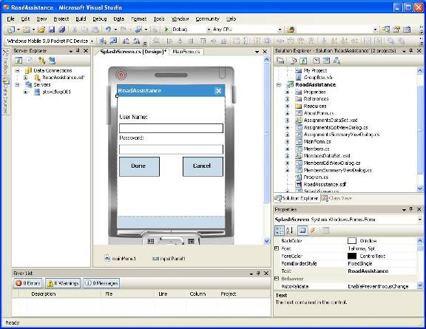
Figure 1 - SplashScreen inside Visual Studio 2005

The following controls should be added to the SplashScreen Form. Note, all values can be set using the Properties window. All properties that are not mentioned should keep their default value.

- Label with Text Property set to User Name:
Location = 3, 38 – Size = 100, 20
- Label with Text Property set to Password:
Location = 3, 85 – Size = 100, 20
- Textbox with Name set to tbUserName – Text Property blank
Location = 3, 61 – Size = 234, 21 – Anchor to Right, Top, Left
- Textbox with Name set to tbPassword – Text Property blank
Location = 3, 108 – Size = 234, 21 – Anchor to Right, Top, Left
PasswordChar = *
- Button with Name set to btnDone – Text set to Done
Location = 3, 135 – Size = 91, 44 – Anchor to Right, Top, Left
- Button with Name set to btnCancel – Text set to Cancel
Location = 146, 135 – Size = 91, 44 – Anchor to Right, Top, Left

- Add Click event handlers for both buttons and a Text_Changed event handler for the tbPassword textbox. You can leave the added event handlers empty for the time being.
- Add a Load event handler and a Closing event handler to the SplashScreen form.

The user interface part of the SplashScreen is now finished. In the next section you will add functionality to the SplashScreen.

Adding functionality to the SplashScreenForm

The SplashScreen has two different functions. It is used to get and verify user credentials and it is used to display a picture while the RoadAssistance application is initializing. Providing full verification of user credentials will be part of another Webcast in this series, for now we provide limited verification. During application initialization we want to display an image in a PictureBox, at the same time showing some text over the image. Displaying label controls on top of the PictureBox is not sufficient, since the background of label controls can not be transparent. Therefore, we will create our own PictureBox control, derived from PictureBox and we will display text on top of the displayed image by manually handling Paint events. The first thing to do is create a new class called MyPictureBox. This class is derived from PictureBox. MyPictureBox overrides the OnPaint method, to display additional information on top of the PictureBox. The text that is displayed is nicely centered on the screen. MyPictureBox can be used for both Low Res and High Res devices.

- Open the source file SplashScreen.cs
- Locate the cursor on the first empty line inside the SplashScreen class
- Add the following code:

private class MyPictureBox : PictureBox
{
protected override void OnPaint(PaintEventArgs e)
{
Graphics graphics = e.Graphics;
base.OnPaint(e);

Font textFont = new Font(FontFamily.GenericSansSerif, 16, FontStyle.Bold | FontStyle.Italic);
string title = "RoadAssistance";
string status = "Initializing";

Rectangle clientRect = this.ClientRectangle;

SizeF raSize = graphics.MeasureString(title, textFont);
SizeF stSize = graphics.MeasureString(status, textFont);

// adjust slightly because the measured string is clipped by a few pixels.
raSize.Width += 10;
stSize.Width += 10;

StringFormat sf = new StringFormat();
sf.Alignment = StringAlignment.Center;
sf.LineAlignment = StringAlignment.Center;

int xPosStart = clientRect.Width / 2 - ((int)raSize.Width / 2);
int yPosStart = clientRect.Height / 3;

graphics.DrawString(title,
textFont,
new SolidBrush(Color.Red),
new RectangleF(xPosStart, yPosStart, raSize.Width, raSize.Height),
sf);

xPosStart = clientRect.Width / 2 - ((int)stSize.Width / 2);
yPosStart = (clientRect.Height * 2) / 3;

graphics.DrawString(status,
textFont,
new SolidBrush(Color.Blue),
new RectangleF(xPosStart, yPosStart, stSize.Width, stSize.Height),
sf);

textFont.Dispose();

}
}

- Immediately under the class you just added to SplashScreen.cs, add the following instance variables:

private MyPictureBox pictureBox = new MyPictureBox();
private TargetDevice device;
private AutoResetEvent mainAppInitialized;
private System.Windows.Forms.Timer displayTimer;
private int minDisplayTime;

The first variable holds an instance of our newly created MyPictureBox. Device is used, just like in other forms, to get informed about changes in Display Orientation. Since the SplashScreen runs as a separate thread and it should continue running until the RoadAssistance application is initialized, the application will set an event when it is done initializing. Inside SplashScreen we keep a local copy of this AutoResetEvent called mainAppInitialized. You don’t know how long the RoadAssistance application needs for initialization, yet it is nice to display the SplashScreen for at least a minimum amount of time. Therefore, you will also use a Timer to show the SplashScreen for that amount of time. The SplashScreen will be closed and its thread will be terminated when both the displayTimer has elapsed and the event mainAppInitialized is set.

- Locate the constructor of SplashScreen and change it to accept two parameters as shown:

public SplashScreen(AutoResetEvent appInitialized, int minimumDisplayTime)

- Put the cursor on an empty line immediately under the call to InitializeComponent.
- Add the following code to the constructor:

device = new TargetDevice();

pictureBox.Visible = false;
pictureBox.Dock = DockStyle.Fill;
this.Controls.Add(pictureBox);
mainAppInitialized = appInitialized;
minDisplayTime = minimumDisplayTime;

In the constructor you will add the our pictureBox to the SplashScreen form and save copies of the appInitializedEvent event and the minimumDisplayTime (in seconds).

Note: SplashScreen creates its own instance of TargetDevice. The reason for this is that SplashScreen runs on a different thread, resulting in not executing the OnDisplayChanged event handler for SplashScreen when we are using the singleton instance, because it was created on another thread. This is comparable with the need to use Control.Invoke to update UI Controls on the thread that created them. The difference is that no exception is thrown, the application remains stable but the desired action, invoking the event handler on a different screen orientation does not work. It is perfectly safe to create another instance of TargetDevice, especially since it will only be used for a short amount of time, after which it will be GC'd. For all the other forms it makes sense to only use one instance. Better performance, less GC's, easier memory management.

Since you are using multithreading functionality (in this case the AutoResetEvent) you should add a using directive to use threading functionality without having to enter fully qualified names.

- Create an alias for the System.Threading namespace by adding the following statement immediately under the other using statements at the beginning of the SplashScreen.cs file:

using System.Threading;

- Locate the SplashScreen_Load event handler, put the cursor in it and add the following code:

ReInitializeForm(device.GetType(this.ClientSize));

device.OnDisplayModeChanged += new TargetDevice.DisplayModeChanged(device_OnDisplayModeChanged);

inputPanel1.Enabled = true;
#if DEBUG
tbUserName.Text = "Maarten Struys";
tbPassword.Text = "!RoadA001";
btnDone.Focus();
#else
tbUserName.Focus();
#endif

During the Load event handler, the SplashScreen is properly initialized, showing the controls according to the current display orientation and display resolution. To stay informed about display orientation changes, you must also subscribe to the DisplayModeChanged event of TargetDevice. You can see that the user name and the password are auto-initialized in Debug mode. This saves time typing passwords and user names during testing of the application. If you are using another user name / password combination make sure to change it accordingly in code. In normal operation, the user is prompted for a user name / password combination. To be able to enter information, the input panel is automatically displayed. Note: If you are copying and pasting the preceding code, an event handler device_OnDisplayModeChanged is not automatically created for you by Visual Studio, so it is best to really type in the preceding code yourself.

- Locate the btnDone_Click event handler, put the cursor in it and add the following code:

inputPanel1.Enabled = false;
ShowControls(false);
pictureBox.Visible = true;
this.Update();

displayTimer = new System.Windows.Forms.Timer();
displayTimer.Interval = minDisplayTime * 1000;
displayTimer.Tick += new EventHandler(displayTimer_Tick);
displayTimer.Enabled = true;

When the user has entered a user name / password combination, he / she clicks on the Done button that activates the btnDone_Click event handler. The first thing to do is to hide the input panel, to hide the controls and to show a nice image that will be shown during the remainder of the initialization of RoadAssistance. The next thing to do is create and start a timer. When the timer expires, the displayTimer_Tick event handler will be called. Note: The btnDone_Click event handler in the final version of RoadAssistance will also call functionality to validate the user name / password combination. That code will be added in a later episode of the Webcast series. For the time being, user name and password are not validated. Note: If you are copying and pasting the preceding code, an event handler displayTimer_Tick is not automatically created for you by Visual Studio, so it is best to really type in the preceding code yourself.

- Locate the btnCancel_Click event handler, put the cursor in it and add the following code:

this.Close();

This code simply closes the SplashScreen when the user wants to cancel providing logon credentials.

- Locate the tbPassWord_TextChanged event handler, put the cursor in it and add the following code:

btnDone.Enabled = ((tbPassword.Text.Length > 0) &&
(tbUserName.Text.Length > 0));

The code in this event handler simply enables the Done button when both user name and password contain at least one character, otherwise the Done button will be disabled.

- Locate the SplashScreen_Closing event handler, put the cursor in it and add the following code:

device.OnDisplayModeChanged -= new TargetDevice.DisplayModeChanged(device_OnDisplayModeChanged);
device.Dispose();
inputPanel1.Enabled = false;
Update();

The code in this event handler is used to unsubscribe from the DisplayModeChanged event handler. You will also make sure to hide the input panel so it will not obscure part of the main screen when the SplashScreen is closed. The extra Update is used to force hiding of the input panel immediately.

- Locate the displayTimer_Tick event handler, put the cursor in it and replace the original code by the following:

displayTimer.Enabled = false;
displayTimer.Tick -= new EventHandler(displayTimer_Tick);
displayTimer.Dispose();

// We have been waiting for the minimum amount of time. Now let's see if the application is initialized so we can continue to run.
mainAppInitialized.WaitOne();
this.Close();

When the timer expires, this event handler is called. Inside it you will make sure that the timer will not run again by simply disabling it, unsubscribing to its event handler and dispose it. One of the criteria to terminate the splash screen is now met. The next one is to wait until the RoadAssistance application has initialized. If so, the event mainAppInitialized is set. In the displayTimer_Tick event handler we block execution of the thread running the SplashScreen form until that event is set. At that time we can simply close the SplashScreen form.

- Locate the device_OnDisplayModeChanged event handler, put the cursor in it and replace the original code by the following:

ReInitializeForm(e.DeviceType);

- Now put the cursor at an empty line inside the SplashScreen class and add the following method to select the right image to display, depending on the screen orientation of the device:

private void ReInitializeForm(TargetDevice.DeviceType deviceType)
{
this.SuspendLayout();
switch (deviceType)
{
case TargetDevice.DeviceType.PocketPC240X240:
pictureBox.Image = Properties.Resources.SplashScreenImage240X320;
break;
case TargetDevice.DeviceType.PocketPC240X320:
pictureBox.Image = Properties.Resources.SplashScreenImage240X320;
break;
case TargetDevice.DeviceType.PocketPC320X240:
pictureBox.Image = Properties.Resources.SplashScreenImage320X240;
break;
case TargetDevice.DeviceType.PocketPC480X480:
pictureBox.Image = Properties.Resources.SplashScreenImage480X640;
break;
case TargetDevice.DeviceType.PocketPC480X640:
pictureBox.Image = Properties.Resources.SplashScreenImage480X640;
break;
case TargetDevice.DeviceType.PocketPC640X480:
pictureBox.Image = Properties.Resources.SplashScreenImage640X480;
break;
}
this.ResumeLayout();
}

- Finally add the following method to the SplashScreen class to display or hide the UI controls of the form.

private void ShowControls(bool visible)
{
label1.Visible = visible;
label2.Visible = visible;
tbPassword.Visible = visible;
tbUserName.Visible = visible;
btnDone.Visible = visible;
btnCancel.Visible = visible;
ControlBox = visible;
}

To make sure that you have not made any errors in the SplashScreen class, rebuild the solution using the Build menu or F6. Suppose you didn’t get compilation errors, you are now down with the SplashScreen class so you can close it. The next thing to do is make use of this class. For that you now need to open the MainForm.cs file, where you will add code to display the SplashScreen.

Activating the SplashScreen during application initialization

The SplashScreen is displayed when the RoadAssistance application is started. Since application initialization is performed in parallel with executing code on the SplashScreen, the SplashScreen form will run on its own, separate thread. This is not absolutely necessary, but it gives us a chance to introduce some basic multithreading concepts in the RoadAssistance application. If you want to have detailed information about multithreading, please take a look at the following whitepaper: http://msdn.microsoft.com/library/en-us/dnnetcomp/html/multithreaded_netcf_apps.asp. There is also a self-paced hands-on-lab available on MSDN which you can use to experiment with multithreaded application development yourself: http://msdn.microsoft.com/library/en-us/dnnetcomp/html/med204_msdn_dev_multithread_apps_netcf2.asp

In order to run the SplashScreen in a separate thread, you will first create a number of instance variables in the MainForm class.

- Open the MainForm.cs file.
- Create an alias for the System.Threading namespace by adding the following statement immediately under the other using statements at the beginning of the MainForm.cs file:

using System.Threading;

- Put the cursor on an empty line, immediately under the entry point of the MainForm class.
- Add the following instance variables:

private Thread splashScreenThread;
private AutoResetEvent appInitialized;

- Find the constructor of the MainForm class and replace its code by the following:

appInitialized = new AutoResetEvent(false);
splashScreenThread = new Thread(SplashScreenThread);
splashScreenThread.Priority = ThreadPriority.AboveNormal;
splashScreenThread.Start();

InitializeComponent();
this.Enabled = false;

#if DEBUG
this.MinimizeBox = false;
#else
this.MinimizeBox = true;
#endif

First you instantiate a new AutoResetEvent called appInitialized, which you will use to inform the SplashScreen, running on a separate thread, that the RoadAssistance application has finished initialization. Then the thread is created (the actual thread will execute the function SplashScreenThread), its priority is modified to make sure the SplashScreenThread starts running immediately and the thread is started. You also need to make sure to disable the MainForm, to prevent it to display its title on the device. The next thing to do is create the method SplashScreenThread.

- Add the following private method to the MainForm class:

private void SplashScreenThread()
{
SplashScreen splashScreen = new SplashScreen(appInitialized, 10);
splashScreen.ShowDialog();
}

This method will run in a separate thread, the thread you created in the MainForm constructor. The thread instantiates the SplashScreen and displays it as a modal dialog. When the SplashScreen dialog is closed, the thread will automatically be terminated. The SplashScreen thread needs to stay active until RoadAssistance has been initialized completely. Immediately before the MainForm is displayed on the device, a Load event is raised.

The last thing you will do is add some functionality to the MainForm_Load event handler, to wait for the SplashScreenThread to terminate. First you need to create a Load event handler.

- Open the MainForm screen in designer mode.
- Go to the properties, select the form events and double click on the Load event. A MainForm_Load event is now added to MainForm.cs, and the cursor is located in the event handler in the MainForm.cs file.
- Put the cursor inside the MainForm_Load event handler, and add the following code at the end of the MainForm_Load event handler:

appInitialized.Set();
Thread.CurrentThread.Priority = ThreadPriority.AboveNormal;

splashScreenThread.Join();
this.Enabled = true;
this.Visible = true;
Thread.CurrentThread.Priority = ThreadPriority.Normal;

First you will set the appInitialized AutoResetEvent to inform the SplashScreen that the RoadAssistance application is fully initialized. Then we increase the priority of the main thread temporary to make sure that no other applications that are running on the device will run in between (temporarily showing their UI). The Join method waits until the SplashScreenThread has terminated. Then you enable the MainForm and make it visibile. Finally you set the priority of the main thread back to normal and the RoadAssistance application is ready to run. Note: Later on you will add additional RoadAssistance initialization code to the MainForm constructor and the MainForm_Load event handler.

To make sure that you have not made any errors in the MainForm, rebuild the solution using the Build menu or F6. Suppose you didn’t get compilation errors, you can now run the RoadAssistance application and you should see a splash screen during initialization of the application.
Adding Assignments to the MainForm

Since RoadAssistance is under development while the Webcast series is running, sometimes there are some small changes in the user interface or in code, compared to previous webcast episodes. In the original version, the idea was to use the MainForm simply to fill out timesheet information, and have all other functionality in separate forms. This is not the best way to efficiently make use of the screen. It would be better to have the pending assignment immediately available to the user. Therefore you need to make a slide modification to the menu that is displayed on MainForm. Instead of having an Assignments menu entry as you had until now (see figure 2), assignment information will be displayed on the MainForm itself.

- Display the MainForm in designer mode and delete the Appointment menu entry. Note: The remainder of the menu will now be displayed on the left hand side. This is normal behavior.

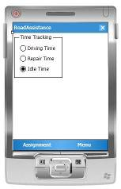
Figure 2 - Original MainForm of RoadAssistance

- Open the MainForm.cs file in the editor, find the menuItemAssignment_Click event handler and remove it from the file.

Using Visual Studio 2005, we you will now add a datagrid containing all assignments to the MainForm. To do so you can select the Add New Data Source entry in the Data menu of Visual Studio 2005. This will activate the Data Source Configuration Wizard. To make sure that we have a connection to the RoadAssistance database, first setup the connection to the database, using Server Explorer inside Visual Studio 2005.

- Inside the Server Explorer window, click on the Connect to Database icon, and click Browse in the Add Connection dialog.
- Now browse to the local copy of the RoadAssistance database (RoadAssistance.sdf) on your development machine. This database file is stored under the project you are currently working in.

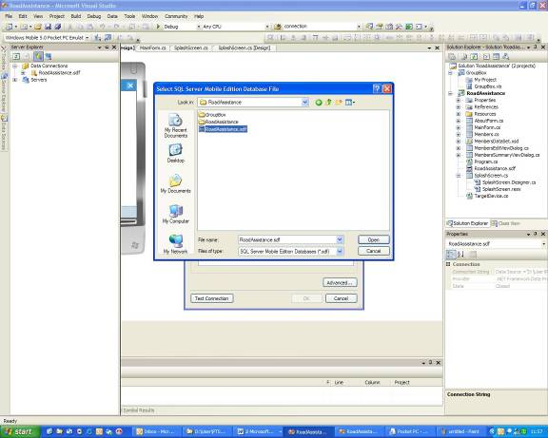
Figure 3 - Add a connection to the RoadAssistance database

- Select the RoadAssistance.sdf database.
- Click the Open button in the Select SQL Server Mobile Edition Database file dialog.
- In the Add Connection dialog, specify the password of the database: !RoadA001.
- Click the Test Connection button to verify that a connection to the database can be established.
- Click OK to close the Test connection succeeded message box.
- Click OK to close the Add Connection dialog.

The newly created connection to the database is now shown in Server Explorer. The next thing you will do is add a data grid to the MainForm to display the assignments table.

- In the Data menu of Visual Studio 2005, select Add New Data Source. The Data Source Configuration Wizard will be shown.

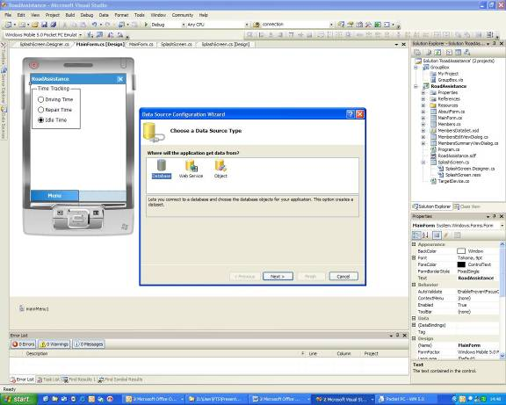
Figure 4 - Data Source Configuration Wizard: Choose a Data Source type
The first thing you will do running this wizard is specifying which data source will be used to get data from. In this sample application, the data source is a database, the RoadAssistance database that was created earlier. The next thing to do is choosing the data connection. The wizard will display existing connections you can select from. It is also possible to create a new connection from within the wizard.

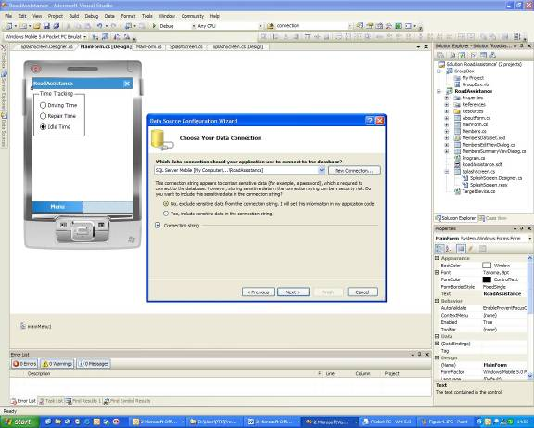
Figure 5 - Data Source Configuration Wizard: Choose your data connection

Make sure that the RoadAssistance database is selected and also make sure to check the exclude sensitive code from the connection string radio button and click the next button. Note: We will add the password to the connection string later in code. Depending on presence or absence of the RoadAssistance.sdf file in your RoadAssistance project, the wizard might ask you if it should add the database to the current project. If you get that question in a MessageBox, answer it by clicking the Yes button.

Finally, the wizard also creates a typed dataset that can be used to bind data to controls in the application. There might be situations where, instead of using dataset you want to bind data to a SQLCeResultSet or directly work on the database itself to limit memory usage and to increase performance. Later on the the Webcast series we will discuss the difference between DataSets and SQLCeResultSets. The last thing to do is choose which database objects are going to be part of the dataset the wizard is about to create.

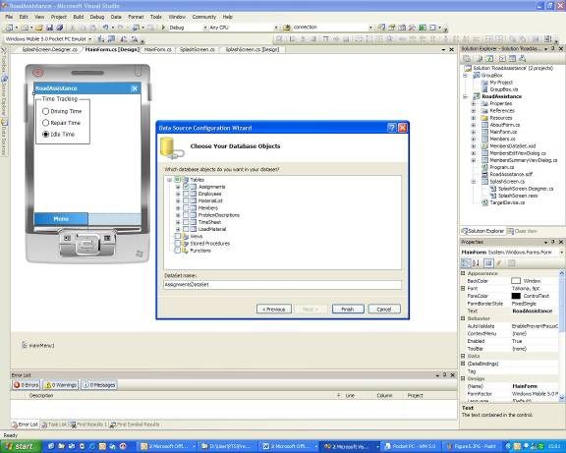
Figure 6 - Data Source Configuration Wizard: Choose your database objects

Since you are only going to create a typed DataSet for the Assignments table, make sure to only select that table, change the default name of the DataSet to AssignmentsDataSet and click Finish. This is all there is to do to create a typed dataset, that can be used to display data from the database in the application, using data binding to bind individual data items to user interface controls. Since assignment information is the most important information of the RoadAssistance application (this is the table with new assignments for theservice engineer), you will now use Visual Studio 2005 to create a data grid that is bound to the Assignments table.
- Make sure that MainForm is displayed in design mode.
- Open the Data Sources window. If it is not already visibile, select Data and Show Data Sources from the Visual Studio menu.
- Expand the AssignmentsDataSet in the Data Sources window and drag the Assignments table (preceded by the little combobox item) to the main form.
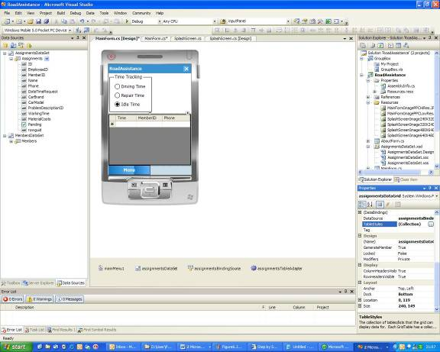
Figure 7 - Adding data bound controls to the application

Set the following properties for the data grid that you just added to the form:

- Location = 0, 119
- Size = 240, 149
- Dock to Bottom
- You can also limit the amount of data displayed in the datagrid, by modifying the TableStyles property. This is not essential for proper operation of the application, so it is not described further.

You will now use Visual Studio to automatically create an AssignmentsSummaryViewDialog and an AssignmentsEditViewDialog.

- Select the newly added assignmentsDataGrid in the designer and click on the little arrow that is displayed at the right hand corner of the datagrid.
- From the popup menu that is displayed, select generate data forms. This will automatically add two additional forms to your project to show / edit assignments.

Visual Studio also added an extra menu entry to your MainForm’s menu, called New. Code is already inserted automatically to display the AssignmentsEditViewDialog to enter new assignments. Also, code is inserted to display details of assignment when you click on a cell inside the datagrid. To commit to the Windows Mobile UI Guidelines, you need to place the New menu entry as the left entry on the menu.

- Select the New menu entry and drag it to the left of the Menu menu entry.

Right now there are a few more things to add to the code that the Visual Studio just added to the MainForm. When you add a new record in the AssignmentsDataSet using the New menu of the MainForm, one of the fields that need to be entered is a field containing a GUID, used for Merge Replication with the back-end server. Since you don’t want your user to enter a GUID manually, this should be done in code.

- Locate the newMenuItemMenuItem_Click event handler in the source file MainForm.cs.
- Replace the first statement in this event handler - assignmentsBindingSource.AddNew(); - by the following statements:

// Provide a GUID for the record to add, since it is needed for Merge Replication.
DataRowView newRowView = (DataRowView)assignmentsBindingSource.AddNew();
AssignmentsDataSet.AssignmentsRow newRow = (AssignmentsDataSet.AssignmentsRow)newRowView.Row;
newRow.rowguid = System.Guid.NewGuid();

Another thing is that new records are only added to the AssignmentsDataSet; they are not added to the database yet. To do so, you have to add some extra functionality.

- In the newMenuItemMenuItem_Click event handler, immediately under the ShowDialog statement add the following code:

if (assignmentsDataSet.HasChanges())
{
assignmentsTableAdapter.Update(assignmentsDataSet);
}

Add the same code (from step 20) to the assignmentsDataGrid_Click event handler as well. The result of these statements is that whenever the data set has changes, the changes are copied to the database as well.

To finish the design of the MainForm’s user interface you will add one more control to the form.

- From the Visual Studio Tool Box, drag a PictureBox to the form.
- Select the just added picture box.
- Set the following properties to the picture box:
Location = 131, 11; Size = 106,102

Finally you will add some code to properly connect to the database and to fill the picture box with an image.

- In the editor, locate the MainForm_Load event handler in the source file MainForm.cs, and look for the comment starting with TODO:
- Replace the comment with the following statement:

this.assignmentsTableAdapter.Connection.ConnectionString += ("Password = " + Properties.Resources.SQLMOBILE_PASSWORD + ";");

This statement adds a password to the connection string, so you can connect to the RoadAssistance database on the device. NOTE: A string containing the password is already available in the project’s resources. The default password is “!RoadA001”. If you are using another password for your RoadAssistance database, simply change the SQLMOBILE_PASSWORD string accordingly.

- To add an image to the picture box, you should now place the cursor immediately under the closing brace of the ‘if’ statement where you added the statement in step 22.
- Add the following code, which will display an image in either normal or high resolution (the images are already stored in the project’s resources).

// Setup screen correctly for resolution and orientation.
Graphics g = CreateGraphics();
if (g.DpiX == 96) // Low resolution
pictureBox1.Image = Properties.Resources.MainFormImagePPCLowRes;
else
pictureBox1.Image = Properties.Resources.MainFormImagePPCHiRes;
g.Dispose();

The code you just added will execute in parallel with displaying the SplashScreen when the RoadAssistance application is started.

To make sure that you have not made any errors in the MainForm, rebuild the solution using the Build menu or F6. Suppose you didn’t get compilation errors, you can now run the RoadAssistance application and you should see an image and the newly created assignments data grid after the application has initialized.

Dealing with different display orientation modes.

Even though the code is fully functional, there is no support yet on the MainForm to deal with different display orientation modes. This is the last functionality you are going to add in today’s exercise. This time what you will do is create a new screen layout dynamically whenever the display orientation of the device changes.

- Add a new method to MainForm with the following code:

private void ReInitializeForm(TargetDevice.DeviceType deviceType)
{
this.SuspendLayout();
if (deviceType == TargetDevice.DeviceType.PocketPC240X320 || deviceType == TargetDevice.DeviceType.PocketPC480X640)
{
assignmentsDataGrid.Location = new Point(0, 119);
assignmentsDataGrid.Size = new Size(240, 149);
assignmentsDataGrid.Dock = DockStyle.Bottom;

groupBox1.Location = new Point(3, 3);
radioButtonDrivingTime.Location = new Point(16, 29);
radioButtonRepairTime.Location = new Point(16, 55);
radioButtonIdleTime.Location = new Point(16, 81);

pictureBox1.Visible = true;

this.AutoScaleDimensions = new System.Drawing.SizeF(96F, 96F);
this.AutoScaleMode = System.Windows.Forms.AutoScaleMode.Dpi;
}
else
{
assignmentsDataGrid.Location = new Point(0, 0);
assignmentsDataGrid.Size = new Size(192, 188);
assignmentsDataGrid.Dock = DockStyle.Left;

groupBox1.Location = new Point(195, 39);
radioButtonDrivingTime.Location = new Point(208, 65);
radioButtonRepairTime.Location = new Point(208, 91);
radioButtonIdleTime.Location = new Point(208, 117);

pictureBox1.Visible = false;

this.AutoScaleDimensions = new System.Drawing.SizeF(96F, 96F);
this.AutoScaleMode = System.Windows.Forms.AutoScaleMode.Dpi;
}
this.ResumeLayout(true);
Invalidate();
Update();
}

This code will change the layout of the controls on the screen depending on the currently selected display orientation. When the device is used in Landscape mode the picture is not displayed and the groupbox is displayed to the right hand side of the datagrid. In Portrait mode the groupbox and the picture are displayed on top of the datagrid. Similar to what you have seen before when you added the SplashScreen and the AboutBox (a few weeks ago), you will make use of the class TargetDevice to get informed about changes in display orientation.

- Add the following instance variable to MainForm (for instance immediately under the AutoResetEvent that you added earlier):

private TargetDevice device;

- Add the following statement as first statement in MainForm’s constructor to create or get the instance of TargetDevice:

device = TargetDevice.Instance();

Like you have seen before, the application will be informed about changes in display orientation by subscribing to an event. There is one thing to keep in mind though. The MainForm might be hidden by other forms of the application or by other applications, but the form is active as long as the RoadAssistance application is active. This leads to some interesting issues. If you just add an DisplayModeChanged event handler, the MainForm will be displayed each time the display orientation of the device changes, even when the MainForm was not visible at the time of the change in display orientation. To prevent against that, you should subscribe to the DisplayModeChanged event when the form is visible and unsubscribe when the form is invisible. However, this brings up another problem. What if the display orientation changes when the MainForm is invisible? By unsubscribing from the DisplayModeChanged event, you loose track of display orientation changes. Therefore, each time the MainForm becomes visible, you should re-initialize its controls. The .NET CF has two events that will be fired when a form is displayed and when it is hidden. You will use both events.

- Open the MainForm screen in designer mode.
- Go to the properties, select the form events and double click on the Activated event. A MainForm_Activated event is now added to MainForm.cs, and the cursor is located in the event handler in the MainForm.cs file.
- Add the following code to the MainForm_Activated event handler:

ReInitializeForm(device.GetType(this.ClientSize));
device.OnDisplayModeChanged += new TargetDevice.DisplayModeChanged(device_OnDisplayModeChanged);

The MainForm_Activated event is fired whenever the MainForm becomes visible. In the event handler you subscribe to the DisplayModeChanged event and you make sure that the screen is displayed properly. Note: If you are copying and pasting the preceding code, an event handler device_OnDisplayModeChanged is not automatically created for you by Visual Studio, so it is best to really type in the preceding code yourself.

- Open the MainForm screen in designer mode.
- Go to the properties, select the form events and double click on the Deactivate event. A MainForm_Deactivate event is now added to MainForm.cs, and the cursor is located in the event handler in the MainForm.cs file.
- Add the following code to the MainForm_Deactivate event handler:

device.OnDisplayModeChanged -= new TargetDevice.DisplayModeChanged(device_OnDisplayModeChanged);

- Locate the device_OnDisplayModeChanged event handler, put the cursor in it and replace the original code by the following:

ReInitializeForm(e.DeviceType);

You are now done with today’s exercise. Rebuild the solution using the Build menu or F6. Deploy it to the device or the emulator. Experiment with the newly added code and don’t hesitate to dynamically change display orientation mode, no matter what you are running in the application.

