Microsoft Dynamics CRM Connector for Microsoft Dynamics GP Guide

March 2006

Information in this document, including URL and other Internet Web site references, is subject to change without notice. Unless otherwise noted, the companies, organizations, products, domain names, e-mail addresses, logos, people, places, and events depicted in examples herein are fictitious. No association with any real company, organization, product, domain name, e-mail address, logo, person, place, or event is intended or should be inferred. Complying with all applicable copyright laws is the responsibility of the user. Without limiting the rights under copyright, no part of this document may be reproduced, stored in or introduced into a retrieval system, or transmitted in any form or by any means (electronic, mechanical, photocopying, recording, or otherwise), or for any purpose, without the express written permission of Microsoft Corporation.

Microsoft may have patents, patent applications, trademarks, copyrights, or other intellectual property rights covering subject matter in this document. Except as expressly provided in any written license agreement from Microsoft, the furnishing of this document does not give you any license to these patents, trademarks, copyrights, or other intellectual property.

© 2006 Microsoft Corporation. All rights reserved.

Microsoft, MS-DOS, Windows, Windows Server, Windows Vista, Active Directory, BizTalk, and Outlook are either registered trademarks or trademarks of Microsoft Corporation in the United States and/or other countries.

All other trademarks are property of their respective owners.

Table of Contents

Introduction 3
Who Should Use This Guide 3
Terminology 4
Reference Documentation 6
Chapter 2: Overview 9
Overview 9
Configurations 13
Architecture of Microsoft CRM Connector for Microsoft Dynamics GP 14
Chapter 3: Installation Instructions 21
Installation Guidelines for Microsoft CRM Connector for Microsoft Dynamics GP 21
Installation Instructions for Microsoft CRM Connector for Microsoft Dynamics GP 32
Required Steps You Must Take Before You Run Setup 34
Installation Verification 52
Adding Additional Microsoft CRM Servers 53
Configure Integration Using the Settings and Administration Tool 54
Migrate Records 65
Uninstall Instructions 68
Upgrading to Microsoft Dynamics GP 9.0 73
Chapter 4: Customer, Account, and Contact Entities 74
Customer, Account, Contact, and Orders Data 74
Address Data Mapping 80
Known Issues and Limitations 80
Chapter 5: Order and Invoice Entities 83
Orders Created in Microsoft Great Plains 83
Orders Created in Microsoft CRM 3.0 85
Known Issues and Limitations 96
Chapter 6: Item and Product Entities 98
Item/Product Data Mapping 99
Volume Price Schedules and Quantity Price Breaks 100
Price Levels and Product Price Lists 102
Known Issues and Limitations 106
Chapter 7: Integration Tools 109
Settings and Administration Tool 109
Data Synchronization Tool 123
Integration Monitor 134
Chapter 8: Customizing Integration 139
Modify the Existing Integration Logic 141
Add an Application Entity to Integration 141
Add a Link to a .NET Component 146
Entity Attribute Mapping 148
Known Issues and Limitations 151
Chapter 9: Operating and Maintaining 152
Maintaining and Operating Your Microsoft CRM Connector for Microsoft Dynamics GP 152
Best Practices for a Secure Integration Environment 157
Chapter 10: Troubleshooting 159
Installation Issues 159
Integration System Issues 161
Entity Issues 161
Sales Document Issues 163
Integration Tools Issues 163
Appendix A: Entity Attribute Mappings 166
Microsoft CRM 3.0 to Microsoft Great Plains Entity Attribute Mappings 166
Microsoft Great Plains to Microsoft CRM 3.0 Entity Attribute Mappings 168

Chapter 1

Introduction
Welcome to Microsoft Dynamics™ CRM Connector for Microsoft Dynamics GP. This product integrates either Microsoft CRM 3.0 Professional or Microsoft CRM 3.0 Small Business Edition with Microsoft® Great Plains® versions 8.0 and 9.0. Only U.S. English editions of Microsoft Great Plains are supported.
With Microsoft CRM Connector for Microsoft Dynamics GP, customer, item, and price information from Microsoft Great Plains is transferred regularly to Microsoft CRM, giving you access to up-to-date information from Microsoft Great Plains. For example, salespeople can enter orders in Microsoft CRM using customer data from Microsoft CRM or Microsoft Great Plains.
This guide contains the information you need to successfully integrate Microsoft CRM with Microsoft Great Plains including planning, installation of hardware and software, and operating tasks for integrating and maintaining the two applications.
This guide is divided into three parts:
Part 1: Overview and Installation
● Chapter 1: Introduction
● Chapters 2 and 3: Overview and installation of Microsoft CRM Connector for Microsoft Dynamics GP

Part 2: Integrating Entities
● Chapters 4 through 6: Understanding how data transfers occur with customers, accounts, contacts, products, orders, invoices, and pricing
Part 3: Customizing, Operating, and Troubleshooting
● Chapter 7: Microsoft CRM Connector for Microsoft Dynamics GP tools
● Chapter 8: Customization
● Chapter 9: Operating and Maintaining
● Chapter 10: Troubleshooting

Who Should Use This Guide
This guide is written for the computer system administrator and reflects the wide range of expertise in computer systems that can be required of a system administrator. It also takes into account the varying sizes of organizations that use Microsoft CRM Connector for Microsoft Dynamics GP. For example, some smaller organizations might not have a full time system administrator, or might contract this function to an independent consultant or other organization. Other, larger organizations might have a full-time administrator and a functioning IT department with a number of employees.
This guide assumes that an organization implementing Microsoft CRM Connector for Microsoft Dynamics GP may have the services of an independent software vendor (ISV) or value-added reseller (VAR), who is partnered with Microsoft, and can help you with the process of customizing your Microsoft CRM Connector for Microsoft Dynamics GP installation.

Terminology
The following terms are used in Microsoft CRM Connector for Microsoft Dynamics GP:
Application integration component (AIC)
An adapter or connector that integrates Microsoft BizTalk® Server and Microsoft CRM, or Microsoft Great Plains. AICs provide BizTalk Server with the ability to communicate directly with applications, using the Component Object Model (COM).
BizTalk Server 2004 Partner Edition
A Microsoft product that provides the tools and infrastructure companies need to exchange business documents among various platforms and operating systems regardless of the application being used to process a business document.
Data migration
A set of activities whose purpose is to move data from a legacy application (the source system) to a new application in order to preserve core business knowledge.
Data Synchronization Tool
A graphical tool that you can use to migrate existing data from Microsoft CRM to Microsoft Great Plains, or Microsoft Great Plains to Microsoft CRM. The Data Synchronization Tool can also be used for ongoing data synchronization between the two applications.
Document
An electronic instance of one-to-many schemas. Usually documents are sent between two processes. The terms document and message are interchangeable.
Document definition
A set of properties that represents a specific document. Document definition properties include a pointer to a document specification and can include global tracking fields and selection criteria.
Document type
A designation that identifies a document's purpose. In Microsoft CRM Integration, a specification is based on the type of document it will represent, such as an invoice, order, or customer record.
Entity
A type of record that is part of the Microsoft CRM system or the Microsoft Great Plains system. Orders, invoices, accounts, customers, products, or items are all examples of an entity.
Entity Instance
A specific occurrence of an entity. A particular Microsoft Great Plains customer record, an address, or a Microsoft CRM order, are each examples of an entity instance.
Entity instance link
A link that is made between two application entity instances. For example, a particular Microsoft Great Plains customer might be linked to a corresponding Microsoft CRM account. Changes that are made to one of the linked entity instances are reflected in the other linked entity instance. Entity instance links are defined in the Microsoft CRM Connector for Microsoft Dynamics GP mappings.
Envelope
A structured set of information that wraps and accompanies an instance of a message, which often describes message delivery and process information. Envelopes can be nested.
Integration
The sharing of data that was entered in one application together with another application. An integrated record is one that has been linked between the two applications, and then synchronized. After this process occurs, synchronized data exists in both Microsoft CRM and Microsoft Great Plains. For example, if a customer record in Microsoft Great Plains has a corresponding account record in Microsoft CRM, it is an integrated record.
Integration system
The components and services that interact with Microsoft CRM and Microsoft Great Plains to enable the movement and transformation of data between the two applications.
Integration Monitor
A tool you can use to view, track, and resubmit integration messages between Microsoft Great Plains and Microsoft CRM.
Interchange
A collection of one or more document instances that makes up a single transmission and is exchanged from application to application.
Map
An XML file that defines the correspondence between the records and fields in one specification and the records and fields in another specification. A map contains an Extensible Stylesheet Language (XSL) style sheet that BizTalk Server uses to perform the transformation described in the map.
Message
An electronic instance of a one-to-many schema. Usually messages are sent between two processes. The terms “message” and “document” are interchangeable.
Message Queue
A temporary repository for messages that are in transit, which lets applications communicate with each other. Applications that use a message queue do not require an immediate response from either a client or a server. This gives applications the flexibility to handle routine pauses within business processes.
Orchestration
An orchestration functions similar to a flowchart, where the flowchart represents a particular executable business process.
Port
A send and receive point of contact for an application. A port is used as the incoming and outgoing boundary for the security and transmission of messages.
Publish
To produce an XML-formatted document for a particular set of data. The document is then made available to BizTalk Server for processing.
Receive Adapter
A COM or .NET-based component that receives messages between applications through BizTalk.
Receive Pipeline
A pipeline that is used to channel messages after they have been received by a Receive Adapter but before they are published to the BizTalk MessageBox database.
Send Adapter
A COM-based or .NET-based component that links one application to a BizTalk message transport. The Send Adapter is the starting point for sending messages from one application to another.
Schema
The definition of the structure of an XML file. A schema contains property information that pertains to the records and fields within a structure.
Settings and Administration Tool
A tool you can use to specify the way you want data to be created in Microsoft CRM when it originates in Microsoft Great Plains and how you want data to be created in Microsoft Great Plains when it originates in Microsoft CRM. In addition, you can specify the mapping of predefined drop-down list (picklist) fields between Microsoft CRM and Microsoft Great Plains applications.
Stored procedure
A compiled collection of SQL statements and control-of-flow language designed to run quickly.
Synchronization
The process by which data in Microsoft CRM is updated to match the corresponding data from Microsoft Great Plains, and data in Microsoft Great Plains is updated to match the corresponding data in Microsoft CRM.
XML schema definition language (XSD)
A language that lets you to define the structure and data types for XML documents. An XML schema defines the elements, attributes, and data types that conform to World Wide Web Consortium (W3C) XML standards. A schema provides uniformity of data within an organization. For example, XSD lets you to create a schema that defines the ordering of elements, for example, the child elements a parent element can contain.

Reference Documentation
Instructions for installing prerequisite and supporting software are contained in the individual product documentation for that software. A documentation source list is provided for your reference.
● Microsoft Windows® 2000 Server and Microsoft Windows 2000 Advanced Server
For information, see http://www.microsoft.com/windows2000/default.mspx.
● Microsoft Windows Server 2003, Standard Edition and Enterprise Edition
For information, see http://www.microsoft.com/windowsserver2003/default.mspx.
● Microsoft Windows Small Business Server 2003
For information about Microsoft Windows Small Business Server 2003, see http://www.microsoft.com/windowsserver2003/sbs/default.mspx.
● Microsoft CRM version 3.0
For information, see http://www.microsoft.com/BusinessSolutions/crm/default.mspx
● Microsoft Great Plains
For information, see http://www.microsoft.com/BusinessSolutions/GreatPlains/default.mspx.
● Microsoft Exchange 2000 Server and Microsoft Exchange Server 2003
For information, see http://www.microsoft.com/exchange/default.mspx.
● Microsoft SQL Server 2000
For information, see http://www.microsoft.com/sql/default.mspx.
● Microsoft BizTalk Server 2004 Partner Edition
For information, see http://www.microsoft.com/biztalk/default.mspx.
● Internet Information Services (IIS)
For information, see http://www.microsoft.com/windows2000/en/server/iis/.
For information about IIS 6.0, see the IIS 6.0 documentation.
● Microsoft Message Queuing
For information, see http://www.microsoft.com/windows2000/technologies/communications/msmq/default.mspx.
● Microsoft Data Access Components (MDAC) 2.7 or MDAC 2.8
For information, see http://msdn.microsoft.com/data/Default.aspx.
● Microsoft XML information and downloads for Microsoft XML 4.0 SP2
For information, see http://msdn.microsoft.com/xml/default.aspx.
● Microsoft .NET Framework version 1.1
For information, see http://www.microsoft.com/net/default.mspx.

Microsoft CRM Integration for Great Plains Documentation
In addition to this guide, the following references are available to help you use Microsoft CRM Connector for Microsoft Dynamics GP:
● Microsoft CRM Connector for Microsoft Dynamics GP Release Notes
The Release Notes contains late-breaking information about this release of Microsoft CRM Connector for Microsoft Dynamics GP. Release Notes content supersedes any information found in this guide or in any other help-related information.

Chapter 2

Chapter 2: Overview
Historically, businesses have purchased enterprise applications from different vendors over several years, resulting in a variety of applications running on several platforms. Because each application was designed to fulfill a specific task, such as warehousing or customer relationship management (CRM), integration with other applications was not common. As a result, integration of internal business applications, such as a CRM system and Microsoft® Great Plains®, was expensive and time-consuming.
Disparate systems not only struggle with the issue of integration, but also of synchronization. In the past, the answers to enterprise application integration (EAI) problems were often complicated and costly. Not any longer. Microsoft CRM Connector for Microsoft Dynamics GP, combined with innovative solutions like Microsoft BizTalk® Server 2004, provide the ability to easily automate and streamline the flow of a company’s internal business data. With Microsoft CRM Connector for Microsoft Dynamics GP, EAI processes can be put in place at costs far lower than would be possible by paying developers to create custom communication applications. Microsoft CRM Connector for Microsoft Dynamics GP enables internal data exchange that is more accurate and efficient than can be achieved by manual processes.
In this guide, Microsoft CRM 3.0 is the application used to manage business contacts, track leads, enter sales orders, and perform other sales and marketing activities. Microsoft Great Plains is the application that performs accounting functions and manages your company’s chart of accounts and customer, vendor, item, employee, and other records.

Important To better understand Microsoft CRM Connector for Microsoft Dynamics GP and how it works, you need a solid understanding of BizTalk Server 2004. For more information about BizTalk Server, see the BizTalk Server 2004 Help.

Overview
Microsoft CRM Connector for Microsoft Dynamics GP integrates Microsoft CRM 3.0 sales capabilities with Microsoft Great Plains accounting and financial management functionality.
The following figure shows how Microsoft CRM Connector for Microsoft Dynamics GP integrates between the Microsoft CRM 3.0 system and the Microsoft Great Plains system.
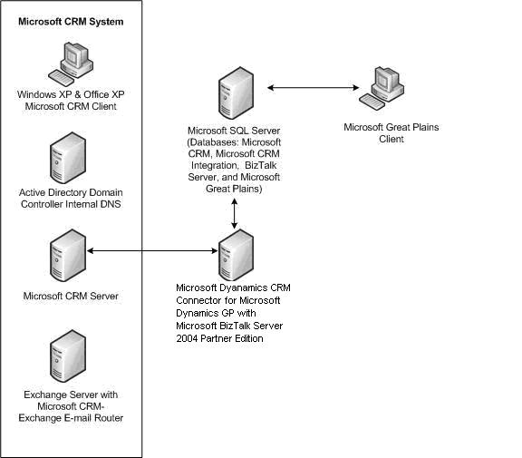
Figure 2.1 Microsoft CRM Connector for Microsoft Dynamics GP system overview

Microsoft CRM 3.0 System
In general, the Microsoft CRM 3.0 system is used to manage business contacts, track leads, enter sales, and perform other sales, marketing, and customer service activities. It accomplishes these tasks by relying upon the technologies and functionality provided by the following:

Microsoft CRM 3.0 Server
Microsoft CRM 3.0 is built on Microsoft .NET technologies and offers flexible n-tier client/server architecture. The Microsoft CRM 3.0 server operates as a middle tier between other Microsoft server products, such as Microsoft SQL Server, Microsoft Exchange Server, IIS, and Web clients running in Microsoft Internet Explorer or through Microsoft Outlook. Additional functionality is provided for reporting, and managing deployment and workflow.

Active Directory Domain Controller Internal DNS
The Microsoft CRM 3.0 system is dependent on Microsoft Active Directory®, which is the directory service for Microsoft Windows® Server. Active Directory stores information about objects on the network and makes this information available for authorized administrators and users. It provides administrators with a hierarchical view of the network and a single point of administration for all network objects. Central to Active Directory, Microsoft Exchange 2000 Server, and Microsoft CRM 3.0 is the resolution of names through DNS. Proper name service lets users locate resources on the network.

Exchange 2000 Server or Exchange Server 2003 with Microsoft CRM 3.0-Exchange E-Mail Router
You can integrate e-mail with Microsoft CRM 3.0 using Microsoft Exchange 2000 Server or Exchange Server 2003, which is an enterprise messaging system that is rich in functionality and is versatile enough to service a wide range of organizations. The Microsoft CRM 3.0-Exchange E-Mail Router is a software component that provides an interface between the Microsoft CRM 3.0 system and Exchange 2000 Server or Exchange Server 2003. E-mail enters the Microsoft CRM 3.0 system through this Router, which is installed on your Exchange 2000 Server or Exchange Server 2003 computer.

Microsoft CRM 3.0 Client
The client is a computer that accesses the server application, which can be a Windows 2000, Windows XP, or Windows Server 2003 computer running Microsoft Office XP or Microsoft Office 2003 Editions by using the Microsoft CRM 3.0 Web client or the Microsoft CRM 3.0 Outlook client.

Microsoft CRM Connector for Microsoft Dynamics GP
Microsoft CRM Connector for Microsoft Dynamics GP is a solution for integrating Microsoft CRM 3.0 and Microsoft Great Plains. It provides ongoing synchronization of data as well as data migration and correlation between the two systems. Microsoft CRM Connector for Microsoft Dynamics GP is built on top of Microsoft BizTalk Server 2004 Partner Edition and supports the synchronization of data between business applications by providing:
● Components that can publish data from a line-of-business (LOB) application based on set parameters. For example, one parameter may be set based on the update of an entity.
● A mechanism that delivers messages between the two systems.
● A mechanism for transforming data and adding necessary business logic.

Microsoft BizTalk Server 2004 Partner Edition
Microsoft BizTalk Server 2004 Partner Edition works with Microsoft CRM Connector for Microsoft Dynamics GP to provide data transformation and application integration features to synchronize your Microsoft Great Plains and Microsoft CRM 3.0 data. The integration server is a computer on which the Microsoft CRM Connector for Microsoft Dynamics GP integration server component has been installed and configured. This server hosts the appropriate BizTalk Server 2004 services functionality, such as data translation, encryption, digital signing, and document tracking, to manage document exchange between other servers and applications that are external to the BizTalk Server group. The server queues and dequeues incoming and outgoing documents to and from the MessageBox database, respectively, calling the appropriate Component Object Model (COM) methods to transform, serialize, sign, encrypt or decrypt, and transport documents. Therefore, it acts as both the receiver for documents and the processor of documents.

Microsoft SQL Server 2000
Microsoft SQL Server 2000 includes a comprehensive set of solutions that meet the data storage and analysis requirements of electronic commerce, data warehousing, and mobile computing environments. And, because of its scalability, Microsoft SQL Server is the ideal solution for handling Microsoft CRM 3.0, Microsoft CRM Connector for Microsoft Dynamics GP, and Microsoft Great Plains data storage needs. Microsoft SQL Server is used to create the following database for an integrated solution:
Integration <user-defined>. The Microsoft CRM Connector for Microsoft Dynamics GP database name is defined during the installation process. By default, the database is named CRMIntegration30. This database stores information about the connection to Microsoft CRM 3.0 and Microsoft Great Plains, in addition to the storage for the Microsoft CRM Connector for Microsoft Dynamics GP settings.

Besides this database, there are five databases associated with BizTalk Messaging Services:
Tracking (BizTalkDTADb). This database stores business and health monitoring data about messages that are tracked by the BizTalk Server tracking engine.
HWS Administration (BizTalkHwsDb). This database stores administration information for Human Workflow Services.
Biztalk Management (BizTalkMgmtDb). This database stores information about different artifacts, such as orchestrations, receive locations, and send ports.
BizTalk Master MessageBox (BizTalkMsgBoxDb). This database stores all subscriptions for messages. Each BizTalk server group can have only one master MessageBox. However, additional MessageBox databases can be added.
Business Rules Engine (BizTalkRulesEngineDb). This database is the repository for vocabularies, rules, and policies.

Microsoft Great Plains
Microsoft Great Plains is the application that performs accounting functions and manages your company’s chart of accounts and customer, vendor, item, employee, and other records. Both Microsoft Great Plains 8.0 and Microsoft Dynamics GP 9.0 are supported with Microsoft CRM Connector for Microsoft Dynamics GP.

International Support
Microsoft CRM Connector for Microsoft Dynamics GP supports Microsoft CRM 3.0 English releases only. In addition, Microsoft CRM Connector for Microsoft Dynamics GP and Microsoft Great Plains can be installed only on U.S. English versions of Microsoft Windows. Microsoft CRM Connector for Microsoft Dynamics GP, Microsoft CRM 3.0, and Microsoft Great Plains must all be installed on the same language version of Windows.

Record Transfer for Microsoft Great Plains
For situations where a new installation of Microsoft CRM 3.0 is introduced into an environment where an established Microsoft Great Plains installation exists, data must be migrated from Microsoft Great Plains to Microsoft CRM 3.0. This migration process is completed by using the Data Synchronization Tool. The Data Synchronization Tool is a graphical user interface tool that you can use to initiate the transfer of data from one application to the other. As soon as you have completed the installation of Microsoft CRM Connector for Microsoft Dynamics GP and configured the integrations settings that you want using the Settings and Administration Tool, you must complete the migration process by using this Data Synchronization Tool. For more information about how to complete this task, see "Migrating Records from Microsoft Great Plains" in Chapter 3, "Installation Instructions."

Configurations
When you can configure your hardware environment for integration between Microsoft CRM 3.0 and Microsoft Great Plains, you should consider your processing needs and expected transaction volume. A multiple server configuration will give you better performance, but it costs more. A single-server configuration, on the other hand, cost less, but you may see some performance issues in the amount of time required to process data.

Configuration and Hardware Requirements
There are minimum configuration and hardware requirements that you must meet to successfully integrate Microsoft CRM 3.0 with Microsoft Great Plains. The following configurations assume that the server is either an Active Directory domain controller or an Active Directory domain member server that has access to an Active Directory domain controller, as well as access to DNS and Exchange servers.
The following configurations are supported when you install Microsoft CRM Connector for Microsoft Dynamics GP:
● Single-Server Configuration
● Two-Server Configuration
● Three-Server Configuration

Single-Server Configuration
For smaller user bases, a single server configuration is supported where Microsoft CRM 3.0, Microsoft Great Plains, and Microsoft CRM Connector for Microsoft Dynamics GP are all installed on a single-server including the SQL Server databases.
The server operating systems that are supported in a single server configuration are as follows:
● Windows Server 2003 Enterprise, Standard, and Web editions with Service Pack 1 (SP1)
● Windows Small Business Server 2003 Premium Edition with Service Pack 1 (SP1)

Multi-Server Configurations
To get the best performance, we recommend that you use the following configuration for a multi-server implementation.
● All servers in the configuration run Windows 2003 Server.
● The Microsoft CRM Connector for Microsoft Dynamics GP integration database and Microsoft CRM 3.0 databases are located on separate computers running SQL Server.

Two-Server Configuration
For increased performance, Microsoft CRM Connector for Microsoft Dynamics GP can be installed in a configuration where Microsoft Great Plains and Microsoft CRM 3.0 are installed on separate servers. Microsoft CRM Connector for Microsoft Dynamics GP can be installed on either the server where Microsoft Great Plains is installed or the server where Microsoft CRM 3.0 is installed.
The server operating systems that are supported in a two server configuration are as follows:
● Windows Server 2003 Enterprise and Standard editions with Service Pack 1 (SP1)
● Windows 2000 Server and Windows 2000 Advanced Server editions with Service Pack 4 (SP4)

Three-Server Configuration
For best performance results, Microsoft CRM Integration 3.0 can be installed and configured in a three-server configuration, where Microsoft CRM 3.0, Microsoft Great Plains, and Microsoft CRM Connector for Microsoft Dynamics GP are installed on separate servers.
The server operating systems that are supported in this configuration are as follows:
● Windows Server 2003 Enterprise and Standard editions with Service Pack 1 (SP1)
● Windows 2000 Server and Windows 2000 Advanced Server editions with Service Pack 4 (SP4)

Important
● Service Pack 1 is required for both Windows Server 2003 versions and Windows Small Business Server 2003.
● Windows Small Business Server 2003 Standard Edition is not supported.
● Windows 2000 Datacenter and Windows Server 2003 Datacenter are not supported.
● Microsoft Virtual Server 2005 is not supported to host virtual instances of Microsoft CRM Connector for Microsoft Dynamics GP in a production environment. This is due to system performance limitations with Virtual Server.

Architecture of Microsoft CRM Connector for Microsoft Dynamics GP
Information is transferred regularly between Microsoft CRM 3.0 and Microsoft Great Plains by the BizTalk Server 2004 Partner Edition integration components. Microsoft CRM Connector for Microsoft Dynamics GP handles integrating new data and updating that data.
The following provides a brief description of components that enable integration between the two systems:
eConnect. Microsoft Great Plains eConnect Enterprise Application Integration (EAI) offers fast and accurate access to an extensive set of Great Plains back office document transactions. eConnect uses SQL Server to house all of the back office business logic.
Adapter interfaces. Microsoft CRM Integration 3.0 defines inbound and outbound adapters. Adapters are used to connect Microsoft CRM 3.0 and Microsoft Great Plains to BizTalk Server integration services. This connection becomes the pipeline for sending and receiving messages between the two applications.
Metadata and application integration component (AIC). Microsoft CRM Connector for Microsoft Dynamics GP uses Microsoft CRM 3.0 post-callouts to publish data to Microsoft Great Plains.
BizTalk Messaging Services. This is a component of BizTalk Server. BizTalk Messaging Services include pipelines for sending and receiving messages, orchestrations, subscription logic, tracking of messages, integrity, and security.

The following figure shows the various components involved in transferring data between Microsoft Great Plains and Microsoft CRM 3.0.
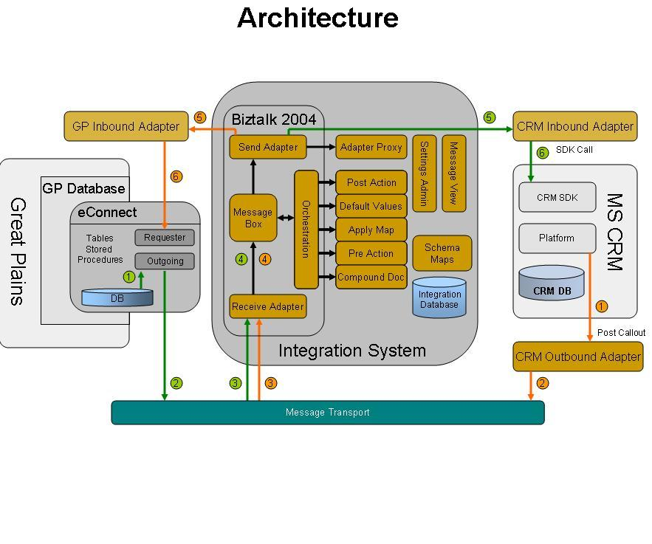
Figure 2.2 Microsoft CRM Connector for Microsoft Dynamics GP architecture

Sending a Microsoft Great Plains document to Microsoft CRM 3.0
To illustrate the integration process and how an integration message flows through the architecture, a basic scenario of creating a customer in Microsoft Great Plains is described.
1. The Microsoft Great Plains Outbound Adapter publishes the customer creation XML messages to a message queue.
2. The BizTalk message queue Receive Adapter collects the XML messages from the message queue and submits them to the BizTalk Receive Pipeline.
3. The BizTalk Receive Pipeline takes the XML messages from the Receive Adapter, converts the XML messages to a generic format, and then submits them to the BizTalk Message Box.
4. BizTalk orchestration retrieves the messages from the Message Box. Then, a Microsoft .NET assembly is called that determines the message dependencies and inserts those dependencies into the integration database.
5. BizTalk orchestration then loops through each dependency in the integration database and, if required, resolves the dependency by submitting the dependency to the Inbound Adapter.
6. BizTalk orchestration then calls another .NET assembly that transforms the messages by applying a map, and then submits the new messages to the Message Box.
7. The messages are retrieved from the Message Box by the BizTalk Send Adapter that submits a request to the Microsoft CRM 3.0 Inbound Adapter to publish the messages to the Microsoft CRM 3.0 database.

A reverse, but similar sequence of events occurs when an account or contact is created in Microsoft CRM 3.0 and then published to Microsoft Great Plains.

Data Latency Issues
One way to help keep data in synchronization is to keep the time stamps on the servers that contain the data synchronized. To do this, you can use the Windows Time service. Click Start, point to Programs, point to Administrative Tools, and then click Services. Verify that the Status for Windows Time is set to Started. If not, you must start the service.
Even if your servers are synchronized for time, you may still experience issues with data synchronization due to latency between the time a request is made and applied in System A and the latency between the time the request is made and applied in System B.
For example, in Figure 2.3 a user creates a customer in Microsoft Great Plains, which is then automatically created in Microsoft CRM 3.0 as an account at Time 0. A Microsoft CRM 3.0 user updates the account in Microsoft CRM 3.0, which is then updated in Microsoft Great Plains at Time 1. The user then makes another update to the account in Microsoft CRM 3.0 and sends an update to Microsoft Great Plains at Time 2. However, a user in Microsoft Great Plains modifies the customer information and sends an update to Microsoft CRM 3.0 at Time 3 prior to reaching the updates made in Microsoft CRM 3.0 at time 2. The changes to Account A at Time 2 were not received before the update made to Customer 1 at Time 3. The result is that the data modifications at Time 2 were lost and the data modifications at Time 3 are all that remain. This scenario is not likely to occur, however, you should be aware of it. The only way to avoid this potential issue is to have data mastered in one system. This means that users are only allowed to make updates or modifications to data in one system even though you allow users to create new data in both systems.

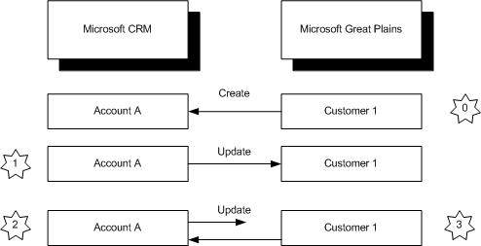
Figure 2.3 Data synchronization latency example

Important If you change the time zone setting on the server that is running the eConnect Outgoing Service, the eConnect Outgoing service will no longer send updates to the Microsoft CRM 3.0 system. To resolve this issue, you must restart the Microsoft Great Plains eConnect outgoing service. To restart the service, click Start, point to Programs, point to Administrative Tools, click Services, right-click Microsoft Business Solutions – Great Plains eConnect Outgoing Service, and then click Restart.

Information Flow
After Microsoft CRM Connector for Microsoft Dynamics GP is installed, any new data you create, whether you create it in Microsoft CRM 3.0 or in Microsoft Great Plains, will be published to the other system and synchronized with future modifications provided you have created the necessary base-line information, such as unit of measure schedules, in Microsoft Great Plains.
Entity information is synchronized between Microsoft CRM 3.0 and Microsoft Great Plains in the following ways:
● Information in Microsoft Great Plains about items/products, prices, system values (units of measure, shipping methods, and payment terms), and inventory quantities are sent to, or synchronized with, Microsoft CRM 3.0 where it can be used on orders entered in Microsoft CRM 3.0. This data is sent from Microsoft Great Plains to Microsoft CRM 3.0 only.
● Information in Microsoft CRM 3.0 about accounts, contacts, addresses, and orders is sent to, or synchronized with, customer and address information in Microsoft Great Plains. Similarly, information in Microsoft Great Plains about customers and address information, is sent to, or synchronized with, Microsoft CRM 3.0.
● Orders can be created in both Microsoft CRM 3.0 and Microsoft Great Plains. After an order is submitted from either Microsoft CRM 3.0 or Microsoft Great Plains, it can still be modified in either Microsoft CRM 3.0 or Microsoft Great Plains, and then resubmitted for integration provided the order has not been transferred, voided, or deleted. If an order is created in Microsoft CRM 3.0 for a new account, the information is used to create an order along with a new customer record in Microsoft Great Plains. Data synchronization occurs when the order is submitted.
● Microsoft CRM 3.0 accounts, contacts, addresses, and orders can be published. However, if you choose not to publish accounts, contacts, and addresses, orders will also not be published.
● Microsoft Great Plains customers, addresses, products, and orders/invoices can be published. However, if you choose to not publish customers, addresses, or products, orders/invoices will also not be published.
● Functional currency is the currency that is defined for the Microsoft Great Plains company that is integrated with Microsoft CRM 3.0.

Types of Information Shared
An application entity supports either read actions or a combination of read, create, update, and delete actions for integration.
In an integrated environment, Microsoft Great Plains is considered the master application, so some actions are not supported with Microsoft CRM 3.0 entities. For example, you cannot create, update, or delete products or invoices in Microsoft CRM 3.0.

Important After you install Microsoft CRM Connector for Microsoft Dynamics GP, you can no longer create or update the following entities in Microsoft CRM 3.0:
● Invoices
● Unit groups and units
● Price lists and prices
● Products

The following table illustrates the actions that are supported for each application entity that can be integrated.
Microsoft Great Plains
Microsoft Great Plains Entity | Supported Actions
Customer | Read, Create, Update, Delete
Product | Read, Create, Update, Delete
Product Site | Read, Create, Update, Delete
Sales Order | Read, Create, Update, Delete
Order Type | Read, Create, Update, Delete
Invoice | Read, Create, Update, Delete

Microsoft CRM 3.0
Microsoft CRM 3.0 Entity | Supported Actions
Account | Read, Create, Update, Delete
Contact | Read, Create, Update, Delete
Product | Read
Product Site | Read
Sales Order | Read, Create, Update, Delete
Order Type | Read
Invoice | Read

The following types of information can be transferred from Microsoft Great Plains to Microsoft CRM 3.0:
● Item/product information (includes product type code)
● Customer information (includes customer class, customer ID, shipping methods, currencies, payment terms, e-mail information, credit limit amount, and status)
● Units of measure
● Inventory quantities
● Orders
● Order status
● Invoice
● Invoice status
● Price level
The following types of information can be transferred from Microsoft CRM 3.0 to Microsoft Great Plains:
● Account information (includes account number and account category code, which is used for the customer class field in Microsoft Great Plains, and shipping method, payment terms, e-mail information, credit limit amount, and status)
● Contact information (includes shipping method, payment terms, e-mail information, credit limit amount, and status)
● Addresses
● Orders (includes shipping method and payment terms)

Important
● Names of salespeople and commission information are not transferred from Microsoft CRM 3.0 to Microsoft Great Plains. In addition, Microsoft Great Plains quotes, back orders, and returns are not transferred to Microsoft CRM 3.0.
● By default, leads are not transferred between Microsoft CRM 3.0 and Microsoft Great Plains.

Truncating Data
The number of characters allowed for a field in Microsoft CRM 3.0 is not always the same as the number of characters allowed for a corresponding field in Microsoft Great Plains. When a string field is longer in the system sending the data than in the one receiving the data, the information is truncated.
In most circumstances, Microsoft CRM 3.0 fields are longer than the Microsoft Great Plains field that they are linked to. For example, if a contact’s last name was Alexieva-Bosseva, when the Customer ID was created, it will appear as Alexieva-B. This is because the Customer ID field is limited to 15 characters in Microsoft Great Plains.
Details regarding specific field character limits are included in tables that provide field mapping information. The field mapping tables are located in the customer, order, and item chapters later in this document.

Chapter 3

Chapter 3: Installation Instructions
This chapter contains the information you need to complete your installation of Microsoft Dynamics CRM Connector for Microsoft Dynamics GP. It includes the hardware and software requirements and guides you through the installation process.
You must meet the minimum server configuration for Microsoft CRM Connector for Microsoft Dynamics GP to work correctly. Before you install Microsoft CRM Connector for Microsoft Dynamics GP, review the “Configurations” section in Chapter 2, “Overview.”

Installation Guidelines for Microsoft CRM Connector for Microsoft Dynamics GP
You can perform a complete installation of Microsoft CRM Connector for Microsoft Dynamics GP that includes all the settings and administration components, Microsoft Business Solution eConnect and Microsoft BizTalk Server 2004 Partner Edition Service Pack 1 (SP1), which provides the messaging, schema importation, and mapping components. You cannot perform a silent install of Microsoft CRM Connector for Microsoft Dynamics GP. You can use Remote Desktop to install Microsoft CRM Connector for Microsoft Dynamics GP remotely as long as Terminal Services is not running in Application mode.

Important Before you install the software, review the Release Notes file for Microsoft CRM Connector for Microsoft Dynamics GP. It contains important, late-breaking information.

For the integration process to function correctly, Microsoft Dynamics CRM 3.0, Microsoft CRM Connector for Microsoft Dynamics GP, and Microsoft Great Plains must all reside in the same domain.
The Microsoft SQL Server databases for Microsoft Great Plains, Microsoft CRM 3.0, and Microsoft CRM Connector for Microsoft Dynamics GP must all have the same sort order collations.
Microsoft CRM Connector for Microsoft Dynamics GP supports only Microsoft CRM 3.0 U.S English releases; it can be installed only on U.S. English versions of Microsoft Windows. Microsoft CRM Connector for Microsoft Dynamics GP, Microsoft CRM 3.0, and Microsoft Great Plains must all be installed on the same language version of Windows.
Microsoft CRM Connector for Microsoft Dynamics GP can only be installed with Microsoft CRM 3.0 and Microsoft Dynamics Great Plains 8.0 or 9.0. Microsoft CRM Connector for Microsoft Dynamics GP does not support Microsoft Business Solutions CRM version 1.0, Microsoft Business Solutions CRM 1.2, or Microsoft Business Solution Great Plains 7.5 or earlier versions.
The Microsoft SQL Server for Microsoft CRM Connector for Microsoft Dynamics GP database should reside on the same server on which you are installing Microsoft CRM Connector for Microsoft Dynamics GP. Additionally, the Microsoft CRM Connector for Microsoft Dynamics GP database should reside on the default instance of SQL Server. Named instances of SQL Server are not supported.

Best Practices and Guidelines to Optimize Performance
The following best practices and guidelines can help you achieve optimal performance with Microsoft CRM Connector for Microsoft Dynamics GP:
● The ideal configuration has three or more servers: one that has Microsoft CRM 3.0, a second server that has your Microsoft Great Plains application, and a third server that has Microsoft CRM Connector for Microsoft Dynamics GP installed on it. Microsoft CRM 3.0 and Microsoft Great Plains applications must have access to the Microsoft CRM Connector for Microsoft Dynamics GP installation server to exchange data.
● You can also create a configuration in which Microsoft CRM Connector for Microsoft Dynamics GP is installed on the server that has your Microsoft Great Plains application while Microsoft CRM 3.0 is located on another server.
● It is not recommended that you install Microsoft CRM Connector for Microsoft Dynamics GP on the server that has Microsoft CRM 3.0, because you might experience performance degradation. However, such a configuration is supported for smaller user bases (75 or less) if you are using Microsoft Windows Small Business Server 2003.

Note For more information about configurations, see the "Configurations" section in Chapter 2, "Overview."

● Microsoft CRM Connector for Microsoft Dynamics GP logs error messages to the Application log in Event Viewer. Similarly, the eConnect component logs messages to the eConnect log in Event Viewer. As a result, the Application log and eConnect log can become full, which will affect the performance of your server. To optimize performance, increase the Maximum log size setting for the Application log and the eConnect log. Additionally, set the log size property for both logs to overwrite events as needed.
To do this, click Start, point to Programs, point to Administrative Tools, and then click Event Viewer. Right-click Application or eConnect, and then click Properties. On the General tab, in the Log size area, type a new number in the Maximum log size box, select Overwrite events as needed, and then click OK.

Integration System Requirements
Before you can set up integration for Microsoft CRM 3.0 and Microsoft Great Plains, you must have the following software installed:
● Microsoft CRM 3.0 Professional or Microsoft CRM 3.0 Small Business Edition
● Microsoft Great Plains 8.0 Standard or Professional editions with Microsoft SQL Server 2000 Service Pack 4 or Microsoft Dynamics GP 9.0 Standard or Professional with Microsoft SQL Server 2000 Service Pack 4.

Only U.S. English editions of Microsoft Great Plains are supported. For installation and hardware requirements for Microsoft CRM 3.0, see the Microsoft CRM 3.0 Implementation Guide. For information about Microsoft Great Plains installation and hardware requirements, see the Microsoft Great Plains installation instructions.

Requirements for Transferring Orders
For orders to transfer from Microsoft CRM 3.0 to Microsoft Great Plains, you must have a company address listed in Microsoft Great Plains. You can use the Company Setup window to verify that the address exists. If an address does not exist, you must add one.
Add a company address in Microsoft Great Plains
1. Open Microsoft Great Plains.
2. On the Tools menu, point to Setup, point to Company, and then click Company.
3. If an address already exists:
In the Address ID box, click Lookup.
Select an address in the Address ID column, and then click Select.
Click OK.
Or
If no address exists, enter the address information in the following fields of the Company Setup window, and then click OK:
● Address ID
● Name
● Contact
● Address
● City
● State
● ZIP Code
● County
● Country

In addition to a company address, you also need to register and set up the following modules. These modules are required for integration with Microsoft CRM 3.0:
● General Ledger
● Receivables Management
● Sales Order Processing
● Inventory Management

Note If you do not have all four modules, for example, if you do not have the Sales Order Processing module in Microsoft Great Plains Standard or Professional Release for Microsoft SQL Server, you will not be able to integrate sales order or invoice data.

Within these modules, you must set up the following types of information:
● Tax details and tax schedules
● Shipping methods
● Payment terms
● Units of measure and unit of measure schedules
● Price groups, price levels, and price lists
● Sites, items, and item site assignments
● Customer classes, customers, and customer addresses
● Sales Order Processing comments

International and Language Support
The following international/language constraints apply to Microsoft CRM Connector for Microsoft Dynamics GP:
● The U.S. English version of Microsoft CRM 3.0 is supported.
● The U.S. English version of Microsoft Great Plains 8.0 is supported.
● All locales for Microsoft CRM 3.0, Microsoft Great Plains, and Microsoft CRM Connector for Microsoft Dynamics GP servers must be the same. Only the U.S. English version of Microsoft Windows is supported.
● Multicurrency can be set up in Microsoft Great Plains; however, Microsoft CRM Connector for Microsoft Dynamics GP will only synchronize data for the functional currency.
● Value added tax is not supported.
● Only certain standard and extended ASCII characters are supported. Specific ASCII characters include the following:

● 128-175 (except 158, 159, and 169), 225, 241, 248, 253

Note For a list of ASCII characters, see msdn.microsoft.com/library/default.asp?url=/library/en-us/vsintro7/html/_pluslang_ascii_character_codes_chart_2.asp.

Hardware and Software Requirements
This section includes information about minimum hardware requirements, software requirements, and configuration options to install Microsoft CRM Connector for Microsoft Dynamics GP. For more detailed information and configuration instructions, see the section “Software Requirements” later in this chapter.

Minimum Hardware Requirements
The minimum hardware requirements for a complete installation of Microsoft CRM Connector for Microsoft Dynamics GP are as follows:
● Single processor server (3-GHz processor), such as Pentium 4 Xeon or comparable
● 2 gigabyte (GB) of RAM or higher, depending on your system
● 20-GB hard disk
● CD drive
● Network adapter card (10/100 MB Ethernet)
● VGA or Super VGA monitor with a resolution of at least 1024 x 768 pixels
● Microsoft Mouse or compatible pointing device

Software Requirements
The following lists describe the software and components required for a Microsoft CRM Connector for Microsoft Dynamics GP system. Many components are automatically installed when you run the Microsoft CRM Connector for Microsoft Dynamics GP installation. In addition, you will find a list of services that must be started after you install Microsoft CRM Connector for Microsoft Dynamics GP.

Components That Must Be Installed Before You Run Setup
The following software and components must be installed before you can install Microsoft CRM Connector for Microsoft Dynamics GP.

Important You must install all the required components on the NTFS file system formatted drive C of your computer.

Supported Operating Systems
● Microsoft Windows Small Business Server 2003 that has Service Pack 1 (SP1)
● ASP.NET must be installed and registered before you install Microsoft CRM Connector for Microsoft Dynamics GP.
● Microsoft Distributed Transaction Coordinator (DTC) must be installed and enabled before you install Microsoft CRM Connector for Microsoft Dynamics GP.

Or
● Microsoft Windows 2000 Server that has Service Pack 4 (SP4). (ASP.NET must be installed and registered before you install Microsoft CRM Connector for Microsoft Dynamics GP.)
Or
● Microsoft Windows 2000 Advanced Server that has SP4. (ASP.NET must be installed and registered before you install Microsoft CRM Connector for Microsoft Dynamics GP.)
Or
● Microsoft Windows Server 2003, Enterprise or Standard Edition that has Service Pack 1 (SP1)
● ASP.NET must be installed and registered before you install Microsoft CRM Connector for Microsoft Dynamics GP.
● Microsoft Distributed Transaction Coordinator (DTC) must be installed and enabled before you install Microsoft CRM Connector for Microsoft Dynamics GP.

Windows Server Components Required
● NTFS file system (installation drive C must be formatted for NTFS)
● Message Queuing (must be installed and running)
● Internet Information Services (IIS) 5.0 or later versions (must be installed and running)
● World Wide Web Publishing Service (must be installed and running). This service is installed with IIS.
● If you install Microsoft CRM Connector for Microsoft Dynamics GP on Windows Server 2003 Standard Edition, Windows Server 2003 Enterprise Edition, or Windows Small Business Server 2003 Premium Edition, you must also install ASP.NET and DTC.

Note For Windows 2000, you may need to run the aspnet_regiis.exe -r command to register the Microsoft .NET Framework.

Other Software Components Required
● Microsoft Internet Explorer 6
● Microsoft XML Parser (MSXML) 4.0 with SP2
● SQL XML 3.0 SP2
● Windows Installer 3.1 (Windows 2000 only)
● Microsoft .NET Framework version 1.1 SP1

Important Microsoft .NET Framework 2.0 is not supported with Microsoft CRM Connector for Microsoft Dynamics GP.

Components Installed During Microsoft CRM Connector for Microsoft Dynamics GP Setup
Unless a component is already installed on your computer, all the following components are automatically installed when you install Microsoft CRM Connector for Microsoft Dynamics GP.
● Microsoft CRM 3.0 Adapter
● Microsoft Great Plains Adapter including Microsoft Business Solutions – eConnect versions 8 with SP4 or 9
● Microsoft CRM Connector for Microsoft Dynamics GP System
● Microsoft BizTalk Server 2004 (Partner Edition) with SP1
● Microsoft .NET Framework 1.1

Services That Must Run Before Installation
The following services must be started on the computer where Microsoft CRM Connector for Microsoft Dynamics GP components are to be installed.
● IIS Admin Service
● Message Queuing
● MSSQLSERVER
● SQLSERVERAGENT
● World Wide Web Publishing Service

Services That Must Start After Installation
After you install Microsoft CRM Connector for Microsoft Dynamics GP, the following services must run. If you are experience problems with integration, verify that these services are running. It is best practice to set these services to start automatically:
● BizTalk Service BizTalk Group: BizTalkServerApplication
● BizTalk Service BizTalk Group: MBSIntSendHost
● Microsoft Great Plains eConnect Outgoing Service versions 8 or 9

Important By default, the service startup type for the BizTalk services (“BizTalk Service BizTalk Group: BizTalkServerApplication” and “BizTalk Service BizTalk Group: MBSIntSendHost” is set to manual. These services must be restarted each time the server is restarted. We recommend that you not set the startup type for these services to “Automatic”. This can cause issues with some servers when the system restarts after a shutdown.

Server Operating System Requirements
The following sections provide specific details about the requirements for installing Microsoft CRM Connector for Microsoft Dynamics GP, as well as instructions for necessary configurations.

Microsoft Windows Small Business Server 2003
Microsoft Windows Small Business Server 2003 is the flexible network solution designed to help small businesses. The integrated Windows Small Business Server 2003 is a one-computer server solution that supports up to 75 client computers. Integrating state-of-the-art server software, including Microsoft Windows Server 2003, Microsoft SQL Server 2000, Microsoft Exchange Server 2003, and Microsoft Internet Security and Acceleration (ISA) Server 2000. Windows Small Business Server 2003 can help you take advantage of the rapidly changing Internet, manage and grow customer relationships, and enhance your company's productivity. Adding Microsoft CRM Connector for Microsoft Dynamics GP provides the integration you need to keep data in Microsoft CRM 3.0 and Microsoft Great Plains synchronized.

Important Windows Small Business Server 2003 Premium Edition is the only edition of Windows Small Business Server that is supported with Microsoft CRM Connector for Microsoft Dynamics GP.

Windows Small Business Server 2003 with SP1 Setup installs and configures application components through a single, integrated setup utility that checks disk space, system compatibility, and dependencies. It also significantly reduces the complexity of installation by automatically setting many common parameters to default settings and consolidates the number of screens encountered during installation.
If Windows Small Business Server 2003 with SP1 is not installed on your computer, and you want to use it for your Microsoft CRM Connector for Microsoft Dynamics GP installation, insert the Windows Small Business Server 2003 with SP1 CD into the CD drive and follow the instructions on your screen. The setup wizard guides you through the steps necessary to install Windows Small Business Server 2003.
For more information about Windows Small Business Server 2003, see:
● Windows Small Business Server 2003 home page, located at http://www.microsoft.com/windowsserver2003/sbs/default.mspx
● Windows Small Business Server 2003 Getting Started Guide, located at http://www.microsoft.com/downloads/details.aspx?displaylang=en&familyid=483b6e22-8ed2-420b-915e-96d469347fb2
● Windows Small Business Server product documentation, located at http://www.microsoft.com/windowsserver2003/sbs/techinfo/productdoc/default.mspx
● “Backing Up and Restoring Windows Small Business Server 2003,” located at http://download.microsoft.com/download/b/d/8/bd8e1a40-d202-429a-8eb7-26300d62bcc9/BKU_BkupRstr.doc
● Windows Small Business Server 2003 "Troubleshooting," located at http://download.microsoft.com/download/5/6/1/561c9fd7-0e27-4525-94ec-4d2d38f61aa3/TSHT_SBS.htm
● Technical Resources for Windows Small Business Server 2003, located at http://www.microsoft.com/windowsserver2003/sbs/techinfo/default.mspx

Computer Requirements for Windows Small Business Server 2003 Premium Edition
The following table lists the minimum computer equipment requirements and suggestions for Windows Small Business Server 2003 Premium Edition that is recommended for up to 5 concurrent Microsoft CRM 3.0 and Microsoft Great Plains users on each server.
Component | Requirement | Recommendation
Processor | Dual Intel Pentium 4 Xeon 3 GHz or comparable single CPU speeds | Dual Intel Pentium 4 Xeon or comparable single CPU speeds
Memory | 2 GB of RAM | 2 GB of RAM is the minimum requirement. However, 3 GB or higher, depending on your system configuration, is recommended.
Hard disk | 20 GB available hard disk space | SCSI hard drives partitioned with RAID 5 depending on your system configuration
Modem | No modem | Two modems, one for Shared Fax Service and one for Remote Access Service, Shared Modem Service, and Internet Security and Acceleration Server dial-up service
CD drive | CD drive | CD drive
Network Adapter card | 1 Network adapter card (10/100 MB Ethernet) | 2 Network adapter cards (10/100 MB Ethernet)
Video card | Video graphics adapter capable of 256 colors and 800 X 600 pixels | Video graphics adapter capable of 256 colors and 800 X 600 pixels

Hardware is the most common cause of performance problems in a Small Business Server network. You can optimize the performance of Small Business Server components — especially Exchange Server 2003 and SQL Server 2000 — by considering the following:
● Memory (RAM). Additional physical memory is often the key to improved performance, especially for Exchange Server 2003. To maximize server performance, be sure to increase system RAM.
● Redundant array of independent disks (RAID) hardware. Using multiple, fast small computer system interface (SCSI) drives (7200 RPM or faster) and individual SCSI disk controllers can improve input/output (I/O) processing as well as read/write times. When you are running SQL Server 2000 and you expect heavy file sharing and printing on your Small Business Server network, consider using RAID.

Microsoft Windows 2000 Server or Advanced Server
Microsoft Windows 2000 Server Service Pack 4 (SP4) or Advanced Server with SP4 can be used for your Microsoft CRM Connector for Microsoft Dynamics GP installation. If you choose one of these Windows 2000 versions, you must also install Message Queuing and Internet Information Services (IIS).
If Windows 2000 Server or Advanced Server is not installed on your computer, and you want to use one of these Windows 2000 versions, insert the Windows 2000 Server or Advanced Server CD into your CD drive and follow the on-screen instructions. The setup wizard guides you through the steps necessary to install Windows 2000 Server or Advanced Server. For more information, see the Windows 2000 Web site (http://www.microsoft.com/windows2000/default.mspx).

Requirements for Installing Microsoft CRM Connector for Microsoft Dynamics GP on Windows 2000 Server or Advanced Server
If either Windows 2000 Server or Windows 2000 Advanced Server is already installed on your computer, check to make sure that you meet the following requirements:
● Use only alphanumeric characters in the computer name. Microsoft SQL Server supports a limited character set in server computer names.
● Make sure the partition you are installing Microsoft CRM Connector for Microsoft Dynamics GP on is formatted with the NTFS file system. If the drive is not formatted for NTFS, it must be converted to the most recent version of NTFS before you run Setup.
● If your installation did not include SP4, you must install it. For installation instructions, see the following topic, “Windows 2000 SP4.”
● If you do not have Message Queuing or Microsoft Internet Information Services (IIS) installed, you must install them before you install the Windows 2000 Server or Advanced Server Service Pack. Use the following procedure to install these services:
1. Click Start, click Control Panel, and then double-click Add or Remove Programs.
2. In the Add or Remove Programs dialog box, click Add/Remove Windows Components.
3. On the Windows 2000 Components page, in the Components list, click Message Queuing Services. If IIS is not installed, click Internet Information Services (IIS) and then click Next. On the Message Queuing Type page, click Next.
4. Select Message Queuing will not access a directory service, and then click Next.
5. On the Windows 2000 Components page, click Finish.

Windows 2000 SP4
To install Windows 2000 SP4, follow these instructions.
● Insert the Windows 2000 SP4 CD into the CD drive and follow the on-screen instructions.
You can also visit the download area of the Windows 2000 Web site (http://www.microsoft.com/windows2000/downloads/servicepacks/sp4/) to install Windows 2000 SP4.

Microsoft Windows Server 2003
If Windows Server 2003, Standard Edition or Enterprise Edition, is not installed on the computer that you want to install Microsoft CRM Connector for Microsoft Dynamics GP on, insert the Windows Server 2003, Standard Edition or Enterprise Edition, CD into your CD drive and follow the instructions that are on your screen. The setup wizard guides you through the steps to install Windows Server 2003. For more information, see the Windows Server 2003 Web site (http://www.microsoft.com/windowsserver2003/default.mspx).
If Windows Server 2003, Standard Edition or Enterprise Edition, is already installed on your computer, check to make sure that you meet the following requirements.

Requirements for Windows Server 2003
● Use only alphanumeric characters in the computer name because Microsoft SQL Server supports a limited character set in server computer names.
● If Active Directory® is installed on Windows 2000 Server or Advanced Server and you plan to install Microsoft CRM 3.0 Integration on Windows Server 2003 with SP1, Standard Edition or Enterprise Edition, you must provide the servers access to the Microsoft CRM Connector for Microsoft Dynamics GP server. For more information, see “Provide Access to Message Queuing on the Microsoft CRM Connector for Microsoft Dynamics GP Server” later in this chapter.
● Format the partition by using the NTFS file system. The Windows Server 2003 partition must be converted to the most recent version of NTFS before you run Setup.
● If you do not have Message Queuing or IIS installed, you must install them using the following procedure:

1. Click Start, point to Control Panel, and then click Add or Remove Programs.
2. In the Add or Remove Programs dialog box, click Add/Remove Windows Components.
3. On the Windows Components Wizard page, select Application Server, and then click Details.
4. In the Application Server dialog box, select Message Queuing, double-click Message Queuing, select Common, and then click OK.
5. Select Internet Information Services (IIS) and then click OK.
6. On the Windows Components Wizard page, click Next.
7. On the Completing the Windows Components Wizard page, click Finish.

Upgrading From Windows 2000 to Windows Server 2003
After you upgrade a Windows 2000 server computer that is running the Microsoft CRM Adapter component to Windows Server 2003, you must grant the Microsoft CRM access user account write permission to the c:\WinDir\Temp folder, where WinDir is the folder where Windows is installed. The CRM access user is specified during Microsoft CRM Connector for Microsoft Dynamics GP Setup. For more information about the Microsoft CRM access user, see the “Integration User Accounts and User Group to Create” section later in this chapter.

Internet Explorer 6
Microsoft Internet Explorer 6 is required. Microsoft CRM Connector for Microsoft Dynamics GP uses Internet Explorer to run the Settings and Administration Tool. If you do not have Internet Explorer 6 installed, you can install Microsoft Internet Explorer 6 with Service Pack 1 (SP1) from the following Microsoft Web site:
http://www.microsoft.com/downloads/details.aspx?FamilyID=1E1550CB-5E5D-48F5-B02B-20B602228DE6&displaylang=en

MSXML 4.0 SP2
If the server that you are installing Microsoft CRM Connector for Microsoft Dynamics GP on does not have MSXML 4.0 Service Pack 2 (SP2), you must install it before running Setup. If you do not have MSXML 4.0 SP2 installed, you can install it from the following Microsoft Web site:
http://www.microsoft.com/downloads/details.aspx?FamilyID=3144b72b-b4f2-46da-b4b6-c5d7485f2b42&displaylang=en

Microsoft .NET Framework Version 1.1 SP1
If the server where you are installing Microsoft CRM Connector for Microsoft Dynamics GP does not have Microsoft .NET Framework version 1.1 version Service Pack 1 (SP1) installed, you must install it before you run Setup.
Download Microsoft .NET Framework version 1.1 from the following Microsoft Web site:
http://www.microsoft.com/downloads/details.aspx?FamilyID=262d25e3-f589-4842-8157-034d1e7cf3a3&displaylang=en
Download Microsoft .NET Framework version 1.1 SP1 from the following Microsoft Web site:
http://www.microsoft.com/downloads/details.aspx?familyid=A8F5654F-088E-40B2-BBDB-A83353618B38&displaylang=en

SQLXML 3.0 SP2
If the server where you are installing Microsoft CRM Connector for Microsoft Dynamics GP does not have SQLXML 3.0 SP2, you must install it before running Setup. If you do not have SQLXML 3.0 SP2 installed, you can download it from the following Microsoft Web site:
http://www.microsoft.com/downloads/details.aspx?FamilyID=4c8033a9-cf10-4e22-8004-477098a407ac&DisplayLang=en

Installation Instructions for Microsoft CRM Connector for Microsoft Dynamics GP
You use the Setup Wizard (Setup.exe) to install Microsoft CRM Connector for Microsoft Dynamics GP. The Setup Wizard is a step-by-step process in which you select options that correspond to specific integration components.
When Microsoft CRM Connector for Microsoft Dynamics GP is installed, you will be able to integrate Microsoft CRM 3.0 and Microsoft Great Plains data, and access the Settings and Administration, Data Synchronization, and Integration Monitor tools. These tools are available from the Start menu. Click Start, point to Programs, point to Microsoft CRM Connector for Microsoft Dynamics GP, and then click the name of the tool you want to use.
The Settings and Administration Tool runs in Microsoft Internet Explorer. Therefore, you can also type http://localhost:portaddress in the Address bar in Internet Explorer, where portaddress is the network port address that you specified during installation, to open the Settings and Administration Tool.
When you run Microsoft CRM Connector for Microsoft Dynamics GP Setup, make sure that your user account is a member of the Active Directory integration security group. You must specify this group before you run Setup. The integration group is described in detail in the next section, “Required Steps You Must Take Before You Run Setup.”
The Setup utility of Microsoft CRM Connector for Microsoft Dynamics GP silently installs BizTalk Server 2004 Partner Edition SP1.
If you have customized any of the schemas associated with Microsoft CRM 3.0 before you install Microsoft CRM Connector for Microsoft Dynamics GP, you must use the Settings and Administration Tool to publish them and update them in Microsoft BizTalk Server. If you want to integrate maps associated with the schemas with Microsoft Great Plains, you must modify the schemas. For more information about publishing custom schemas, see the customization section in this guide. After you install Microsoft CRM Connector for Microsoft Dynamics GP, schemas and maps will be located in the following Web directories, where <INSTALL_DIR> is the directory where Microsoft CRM Connector for Microsoft Dynamics GP has been installed.:

● Microsoft CRM 3.0 schemas:
<INSTALL_DIR>\SchemaMaps\CRMSchemas

● Microsoft Great Plains schemas:
<INSTALL_DIR>\SchemaMaps\GPSchemas

● Maps, which use these schemas, are located in the following directories:
<INSTALL_DIR>\SchemaMaps\MapsCRMGP.

Complete a New Installation or an Upgrade
This section explains how to upgrade or complete a new installation of Microsoft CRM Connector for Microsoft Dynamics GP that includes all integration components including Microsoft BizTalk Server 2004 Partner Edition, which provides the messaging, schema importation, and mapping mechanisms.
During setup, BizTalk Server 2004 is automatically configured to have all the necessary components, such as pipelines, ports, and transports, which are used to transfer data between Microsoft CRM 3.0 and Microsoft Great Plains. A log file, which reports errors that occur during setup, is created during installation on the system hard disk drive. The name of the log file is “IntInstall.log”.

Component Installation and Order
Microsoft CRM Connector for Microsoft Dynamics GP installs three main components:
● Microsoft CRM 3.0 adapter
● Microsoft Great Plains adapter
● Microsoft CRM Connector for Microsoft Dynamics GP system

The Microsoft CRM 3.0 adapter must be installed on the computer where Microsoft CRM 3.0 is installed. Similarly, the Microsoft Great Plains adapter must be installed from the computer where the Microsoft Great Plains database is located.
Therefore, if you have an environment where there will be three separate servers for integration; one server for Microsoft CRM 3.0; a second server for Microsoft Great Plains; and a third server where the Microsoft CRM Connector for Microsoft Dynamics GP system will be installed, you must complete the following steps:
1. Run Setup and complete the installation of the Microsoft CRM 3.0 adapter component on the computer where Microsoft CRM 3.0 is installed.
2. Run Setup and complete the installation of the Microsoft Great Plains adapter component on the computer where the Microsoft Great Plains database is located.
3. Run Setup and complete the installation of the Microsoft CRM Connector for Microsoft Dynamics GP system component. (This computer must be on a supported operating system with SQL Server 2000 SP4.)

The follow table lists each component, location, and the order that the component must be installed:
Installation Order | Component | Installation Location
1 | Microsoft CRM adapter | Microsoft CRM 3.0 server
2 | Microsoft Great Plains adapter | Microsoft Great Plains server
3 | Microsoft CRM Connector for Microsoft Dynamics GP system (includes BizTalk 2004 Partner Edition SP1) | Microsoft CRM Connector for Microsoft Dynamics GP system server

Important
● The Microsoft Great Plains adapter may be installed before the Microsoft CRM 3.0 adapter. However, the Microsoft CRM Connector for Microsoft Dynamics GP system must be installed after both the Microsoft CRM 3.0 adapter and Microsoft Great Plains adapter are installed.
● For information about the operating systems, software, hardware, and configurations that are required to install Microsoft CRM Connector for Microsoft Dynamics GP for Great Plains, see the “Configurations” section of chapter 2, “Overview.”

Required Steps You Must Take Before You Run Setup
The computer that you use to install Microsoft CRM Connector for Microsoft Dynamics GP must exist in the Computers folder of Active Directory. Additionally, the Microsoft CRM 3.0, Microsoft Great Plains, and server computer where Microsoft CRM Connector for Microsoft Dynamics GP will be installed must be in the same Active Directory domain.

Important To run Setup, you must have Administrator group membership on the local computer and at least Domain Users security group membership in Active Directory.

Prerequisites for Installation
The following prerequisites must be fulfilled before you run Microsoft CRM Connector for Microsoft Dynamics GP Setup.
- The Microsoft Great Plains company that you integrate must have at least one item price list created. This is required by Setup to identify whether multi-currency is enabled or not.
- During the Microsoft GP Adapter installation portion of Setup, users must not use Microsoft Great Plains to access the Microsoft Great Plains company database that will be integrated with Microsoft CRM.
- The user account that is used to run the Setup program must be a member of the Integration user group. Note that, after you add your user account to the Integration user group, you must log off and then log back on before you can run Setup. For more information about this user group, see the following section named "Integration User Accounts and User Group to Create."
- If the server on which you are installing the Microsoft CRM Connector for Microsoft Dynamics GP is a domain controller, the integration user must also be a member of the Administrators group on the local machine.
- If the Microsoft CRM 3.0 database is located on a different server than the server on which the installation of the Microsoft CRM Adapter is to be installed, the user running setup must have the following permissions:
● SQL Server administrator permissions on the Microsoft CRM 3.0 database server.
● Database owner of the Microsoft CRM 3.0 database and metabase.

● Make sure that the currency decimal settings for both Microsoft Great Plains and Microsoft CRM 3.0 are using the same format, for example, a decimal followed by two places. To view the decimal place settings format in Microsoft CRM 3.0, start the Microsoft CRM 3.0 Web client, click Settings, under Settings click Settings, click Organization Settings, and then click System Settings. To view the decimal place settings format in Microsoft Great Plains, start the Microsoft Great Plains application, click Tools, point to Setup, point to System, and then click Currency.
● You must create three user accounts and one user group in Active Directory. For more information about this requirement, see the next section titled "Integration User Accounts and User Group to Create."
● If the Active Directory directory service is running on Windows Server 2003 computers and Microsoft CRM Connector for Dynamics GP is installed on a Windows 2000 Server computer, “Downlevel Client Support” for Message Queuing must be installed and running on the Active Directory server computers. This component enables the Message Queuing 3.0 server to provide directory service support for Message Queuing 1.0 clients. For instructions about how to install this component, see Message Queuing 3.0 online Help. To open Message Queuing 3.0 online Help on a computer that has Message Queuing 3.0 installed, follow these steps:
1. Click Start, click Run, type compmgmt.msc and then click OK.
2. In the Computer Management window, expand Services and Applications, and then right-click Message Queuing.
3. Click Help.

Prerequisites for a Multiple Computer Configuration
● If you plan to install Microsoft CRM Connector for Microsoft Dynamics GP on two or more server computers, you must install and enable the Distributed Transaction Coordinator (DTC). For more information about this requirement, see the following section titled "Distributed Transaction Coordinator (DTC)."
● In a multiple server configuration, the user account that is used to log on and run the MSSQLSERVER service on the integration server computer must be authorized for delegation. To verify and grant this permission, follow these steps:
1. On the integration server computer, click Start, click Run, type services.msc, and then click OK.
2. Right-click MSSQLSERVER, click Properties, click the Log On tab, and, if This account is selected, observe the user name or observe if Local System account is selected.
3. On a domain controller, click Start, click Run, type dsa.msc, and then click OK.

● If Local System account is selected, follow these steps:
Expand Computers, right-click the integration server computer, click Properties, on the General tab click to select Trust Computer for Delegation, and then click OK.
● If This account is selected, follow these steps:
Expand Users, right-click the user account that is used to log on and run the MSSQLSERVER service, click Properties, click the Account tab, in the Account options list, click to select Account is trusted for delegation, and then click OK.
4. Restart the integration server computer.

Integration User Accounts and User Group to Create
Microsoft CRM Connector for Microsoft Dynamics GP supports Active Directory on Microsoft Windows 2000 Server, Microsoft Windows 2000 Advanced Server, Microsoft Windows Server 2003 Standard Edition, or Microsoft Windows Server 2003 Enterprise Edition.
Before you run Setup, you must create three separate Active Directory user accounts and one security group that will be used for each integration component.
The user accounts and group that must be created are listed in the following table.
User or Group Role | Characteristics | Example Names Used | Integration Component
CRM 3.0 Access User | Domain User, member of the CRM Privileged User Security Group (PrivUserGroup), valid CRM user who has the Sales Manager security role | CRMAccessUser | Microsoft CRM 3.0 adapter  Microsoft CRM Connector for Microsoft Dynamics GP system
Great Plains Access User | Domain User, this user must be the same as specified in the eConnect Setup. | GPAccessUser | Microsoft Great Plains adapter  Microsoft CRM Connector for Microsoft Dynamics GP system
Integration User Group | Domain User Group, Global scope | IntUserGroup | Microsoft CRM Connector for Microsoft Dynamics GP system  Microsoft CRM 3.0 adapter  Microsoft Great Plains adapter
Integration User | Domain User, member of above Integration User group | IntUser | Microsoft CRM Connector for Microsoft Dynamics GP system

Important
● The above groups must be created before you run Setup.
● The user account that is used to run the Integration Server component installation of the Microsoft CRM Connector for Microsoft Dynamics GP Setup program must be a member of the Integration User Group.
● If the user that is specified for any of the integration user accounts (CRMAccessUser, GPAccessUser, or IntUser) is the currently logged on user, the password that is entered during Setup will not be validated by the Setup program. Therefore, you must make sure you enter the correct password or Setup will not complete.
● After you create the Integration User Group, add the Integration Tools Access User as a member of that group.
● We strongly recommend that you limit the group membership of the integration security group to only those users who will administer the integration environment. This is because the integration group will have access to integration tools that, if used incorrectly, can cause the system to malfunction.

To create an Active Directory user or group, click Start, point to Administrative Tools, and then click Active Directory Users and Computers on a domain controller in the domain where Microsoft CRM 3.0 and Microsoft Great Plains are installed. For more information about creating a user or group, click Help, Help Topics in Active Directory User and Computers.

Distributed Transaction Coordinator (DTC) For Windows Server 2003
If you plan to install Microsoft CRM Connector for Microsoft Dynamics GP on two or more server computers, you must install and enable the Distributed Transaction Coordinator (DTC). DTC must be installed and enabled on each server where the Microsoft Great Plains adapter, Microsoft CRM 3.0 adapter, and Microsoft CRM Connector for Microsoft Dynamics GP system components are installed.
To install and enable network DTC access, follow these steps:
1. Click Start, point to Control Panel, and then click Add or Remove Programs.
2. Click Add/Remove Windows Components.
3. Select Application Server, and then click Details.
4. Select Enable Network DTC Access and then click OK.
5. Click Next.
6. Click Finish.
7. Click Start, point to Programs, point to Administrative Tools, and then click Component Services.
8. Expand Component Services, expand Computers, right-click My Computer, and then click Properties.
9. Click the MSDTC tab, and then click Security Configuration.
10. In the Security Settings area, select the Network DTC Access check box, and then select the Network Administration, Network Transactions, and Allow Remote Clients check boxes.
11. On the Security Configuration dialog box, click OK. If you are prompted to start the DTC service, click Yes.
12. Click the COM Security tab, under Launch and Activation Permissions click Edit Limits, and make sure that the Everyone group has Allow permissions for all launch and activation types.
13. Click OK two times.
14. Stop and then restart the Distributed Transaction Coordinator service.
15. Stop and then restart Microsoft SQL Server and the other resource manager services that participate in the distributed transaction, such as Microsoft Message Queuing.

Information Required During Setup
To install all integration components, Setup requires the following information:
● The Microsoft CRM Connector for Microsoft Dynamics GP components that you want to install. The choices are as follows:
● Microsoft CRM adapter
● Microsoft Great Plains adapter
● Microsoft CRM Integration Server

● The server name where Microsoft CRM 3.0 is installed, Microsoft CRM access user, and password. For more information about this user account, see the “Integration User Accounts and User Group to Create” section earlier in this chapter.
● The server name where Microsoft Great Plains is installed, Microsoft Great Plains company, Microsoft Great Plains access user, and password. For more information about this user account, see the “Integration User Accounts and User Group to Create” section earlier in this chapter.
● An Active Directory security group (Integration User Group) that will be used to run Microsoft CRM Connector for Microsoft Dynamics GP tools. For more information about this security group, see the “Integration User Accounts and User Group to Create” section earlier in this chapter.
● IP port number that will be used to run the Settings and Administration Tool. This port number should be between 1025 and 65535.

Note The Settings and Administration Tool requires a port that is not used by an existing application.

● eConnect user account, password, and Microsoft Great Plains company. This account must be the same account that was specified as the Great Plains Access User during the Microsoft CRM Connector for Microsoft Dynamics GP Setup. Also, you must select the company database for the Great Plains Company that you selected for the Microsoft Great Plains Adapter component in the previous step. For more information about this user account, see the “Integration User Accounts and User Group to Create” section earlier in this chapter.

Installation Instructions for New Microsoft CRM Connector for Microsoft Dynamics GP Systems
To install Microsoft CRM Connector for Microsoft Dynamics GP in an environment that is not already integrated by using Microsoft CRM Connector for Microsoft Dynamics GP, you must complete the following tasks:
1. Complete the requirements before running Setup. For more information about the requirements, see the previous section named “Required Steps You Must Take Before You Run Setup.”
2. Run the Setup program to install Microsoft CRM Connector for Microsoft Dynamics GP.
3. Configure Microsoft CRM Connector for Microsoft Dynamics GP settings by using the Settings and Administration Tool.
4. Migrate records using the Data Synchronization Tool.

Note For information about the supported hardware and software configurations, see the “Configurations” section in chapter 2 “Overview.”

Installation Instructions for Upgrading Earlier Versions of Microsoft CRM Integration
You can upgrade Microsoft Business Solutions CRM Integration for Great Plains version 1.2 or Microsoft Business Solutions CRM Integration for Great Plains version 1.8 to Microsoft CRM Connector for Microsoft Dynamics GP. When you run Setup, the following integration mechanisms will be updated:
● Integration Messages
● Links
● Mappings between attribute values

Important
● Microsoft CRM Connector for Microsoft Dynamics GP can upgrade the database for Microsoft Business Solutions CRM Integration for Great Plains version 1.2 or Microsoft Business Solutions CRM Integration for Great Plains version 1.8. To perform this upgrade, you must uninstall these earlier versions and point to the version 1.2 or 1.8 database during the installation of Microsoft CRM Connector for Microsoft Dynamics GP to perform an upgrade.
● Before you run Setup to upgrade your previous version of Microsoft Business Solutions CRM Integration for Great Plains, we strongly recommend that you back up your integration database.
● You cannot use Setup to upgrade Microsoft CRM Connector for Microsoft Dynamics GP for Great Plains version 1.0. You must first upgrade the 1.0 version to either version 1.2 or version 1.8.
● Setup does not upgrade customizations such as custom entities or custom entity attribute mappings.

Run the Microsoft CRM Connector for Microsoft Dynamics GP Setup Program
Run Setup from CD or a network share or copy the Microsoft CRM Connector for Microsoft Dynamics GP installation files to your local computer.
Double-click Setup.exe. The Installation Wizard guides you through the steps necessary to install Microsoft CRM Connector for Microsoft Dynamics GP.
1. On the Microsoft CRM Connector for Microsoft Dynamics GP Setup page, click Next.
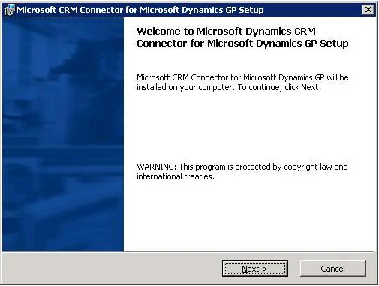
2. On the License Agreement page, read the agreement and, if you agree, click I accept this license agreement, and then click Next.
Additionally, you can print the license agreement by clicking Print.

3. On the Microsoft CRM Connector for Microsoft Dynamics GP Components page, click to select the components that you want to install. To install all components (required for a new installation on a single computer), click to select Microsoft CRM Integration Server, Microsoft Great Plains Adapter, and Microsoft CRM Adapter.
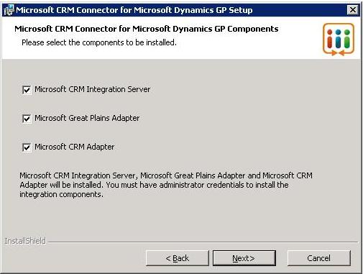

Important
● These steps assume that all integration components are to be installed on a single server. If you are installing the integration components on separate computers, you must run Setup on each server for each component in the correct order. For information about how to run Setup for a multiple server integrated environment, see the “Component Installation and Order” section earlier in this chapter.
● The Microsoft CRM adapter must be installed on the server computer where Microsoft CRM 3.0 is installed.
● The Microsoft Great Plains adapter must be installed on the server computer where the Microsoft Great Plains database is located.

Click Next.

4. If this is a new installation of Microsoft CRM Connector for Microsoft Dynamics GP, on this page click Create new database, and then type the name that you want to give the integration SQL database in the Integration database name box. By default, the database name is CRMIntegration30.
Alternatively, if this is an upgrade installation from Microsoft CRM Integration for Great Plains version 1.2 or 1.8, click Upgrade from existing Microsoft CRM Integration database (1.2/1.8), and then type the name of the existing integration database in the Integration database name box.
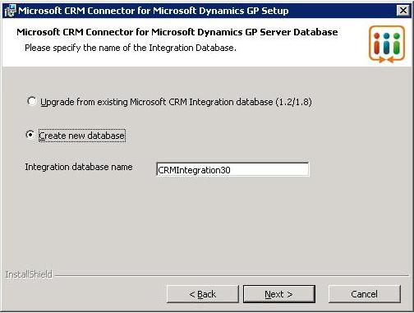

Click Next.

5. On this page, type the Microsoft CRM access user (the user account name information that will be used to access Microsoft CRM 3.0) and password. In the following example, TESTDOM is the Active Directory domain where the Microsoft CRM access user account resides, and CRMAccessUser is the user account that you created for Microsoft CRM 3.0 access earlier. Note that Setup might not verify the password for the user account specified, so use caution when typing the password.
For information about the permissions required for the Microsoft CRM access user, see the previous section “Integration User Accounts and User Group to Create.”
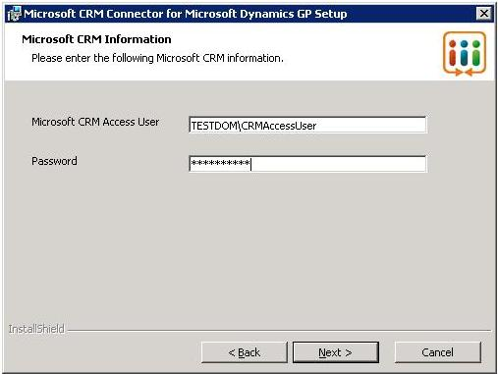

Click Next.

6. On this page, you must select the Microsoft Great Plains company that you want to integrate with Microsoft CRM 3.0 in the Great Plains Company list.
Then, type the Microsoft Great Plains user (the user account that will be used to access Microsoft Great Plains). In the following example, TESTDOM is the Active Directory domain where the integration user account resides, and GPAccessUser is the user account for Microsoft Great Plains access that you created earlier. Note that Setup might not verify the password for the user account specified, so use caution when typing the password.
For information about the permissions required for this user account, see the previous section “Integration User Accounts and User Group to Create.”
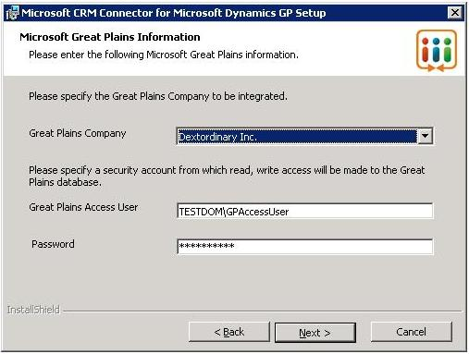

Important
● You can only integrate Microsoft CRM 3.0 with a single Microsoft Great Plains company. Multiple companies are not supported.

Click Next.

7. On this page, you must type the Integration User Group in the Integration User Group box. Only members of this group will be allowed to run the Microsoft CRM Connector for Microsoft Dynamics GP tools.
Additionally, you must enter the Integration User (the user account that will be used to run the integration services) in the Integration User box. This user account must be a member of the Integration User Group. In the following example, TESTDOM is the Active Directory domain where the Integration User account resides, IntUserGroup is the user group for Microsoft CRM Connector for Microsoft Dynamics GP access, and IntUser is the Microsoft CRM Connector for Microsoft Dynamics GP user account that you created earlier. Type the user account password in the Password box. Note that Setup might not verify the password for the user account specified, so use caution when typing the password.
For information about the permissions required for the group and user account, see the previous section “Integration User Accounts and User Group to Create.”
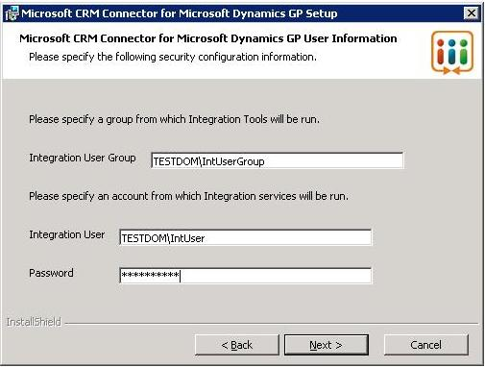

Click Next.

8. On this page, you can click Browse to change the location of where Microsoft CRM Connector for Microsoft Dynamics GP will be installed. By default, Microsoft CRM Connector for Microsoft Dynamics GP Setup installs the integration components in the “c:\Program Files\Microsoft Dynamics\Microsoft Dynamics CRM Connector for Microsoft Dynamics GP” folder. Do not specify remote locations and removable drives as installation locations.
Additionally, you must type the network IP port number in the Please specify the port for the Settings and Administration Tool box that you want to use to run the Settings and Administration Tool. By default, the port number entered is 5560. If you use the default port number, after you finish Setup you can start the Settings and Administration Tool by typing http://localhost:5560/loader.aspx in the Microsoft Internet Explorer address box.
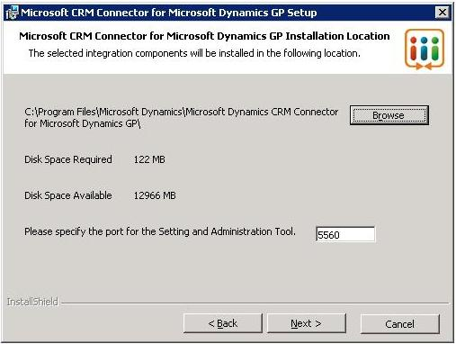

Important Do not enter a port number that is already used by another application. This port number must be between 1025 and 65535.

Click Next.

9. If there are errors or warnings encountered during the prerequisites check, the Prerequisites Check Completed page appears. If no errors are present, you can click Next to continue Setup.
However, if there are one or more errors, the page below appears and you must review the information in the box and resolve each issue. Setup cannot continue if there are any errors listed. In the following example, SQLXML SP2 must be installed on the server before Setup can continue. For more information about Microsoft CRM Connector for Microsoft Dynamics GP installation requirements, see the “Required Steps You Must Take Before You Run Setup” section earlier in this chapter.
Additionally, observe the warnings and, if necessary, correct the issue. If only warnings are listed, you can continue Setup. However, we recommend that you consider how the issue that is listed in the warning will affect your integration system and if necessary, resolve it. After you have resolved all errors and considered all warnings, click Back, and return to step 8 to continue setup.
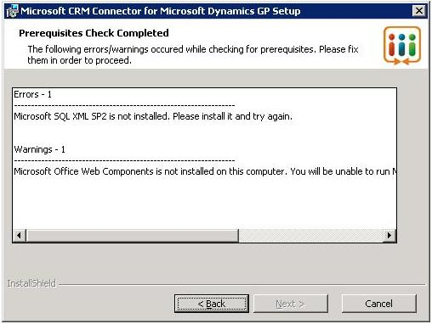

10. On the Summary page, verify the list of setup details, and then click Install.

The eConnect 8.0/9.0 Setup page appears.

11. On the Customer Information page, type the User Name, Organization, and whether you want eConnect to be available to all users or only the currently logged on user, and then click Next.

12. On the Select Type page, select Complete.
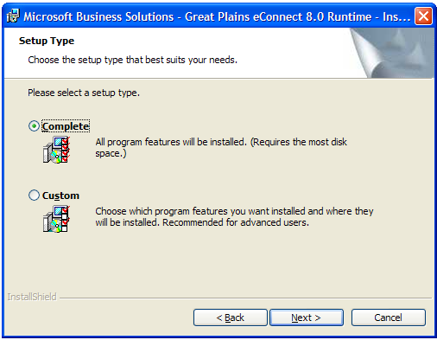
Click Next.

The Microsoft OLE Provider for SQL page appears.

13. Click the ellipsis button (…) to configure the data link properties that will connect the Microsoft Great Plains server.
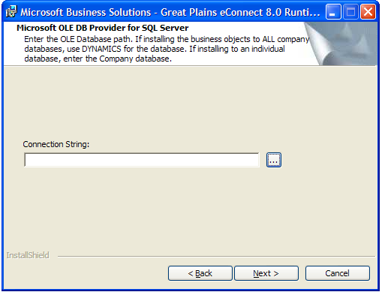

14. On the Data Link Properties dialog box, select a name for the Microsoft Great Plains database server or enter a server name. You can type "." (without the quotation marks) to select the local machine because Setup is running on the Microsoft Great Plains database server. Then, click to select Use Windows NT Integrated security. In the Select the database on the server list, you must select the database for the Microsoft Great Plains company that you selected in the previous step. In this example, GreatPlainsCompanyDatabaseName is the Microsoft Great Plains database name for the company that is selected for integration with Microsoft CRM 3.0.
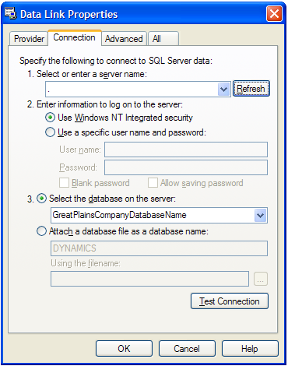

Click OK.

15. On the Ready to Install the Program page, click Install to begin the installation.
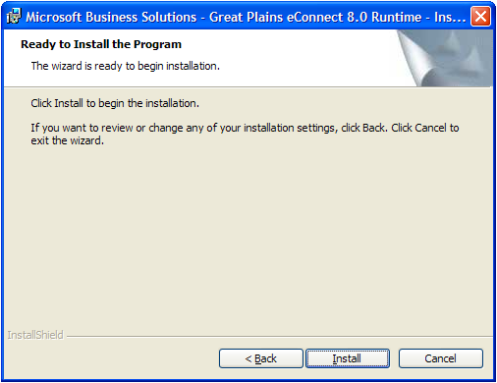
16. On the eConnect Services/COM+ Package Login Information page, you must provide the same domain and Microsoft Great Plains access user information that was provided in the previous step. In the following example, TESTDOM is the Active Directory domain where the Integration user account resides, and GPAccessUser is the user account for the Microsoft Great Plains access user that you specified earlier. For information about the permissions required for this user account, see the previous section “Integration User Accounts and User Group to Create.” Type the password for the user account in the Password box.

Important To complete the installation of eConnect, you must provide the same user credentials that were entered in the Great Plains Access User box.

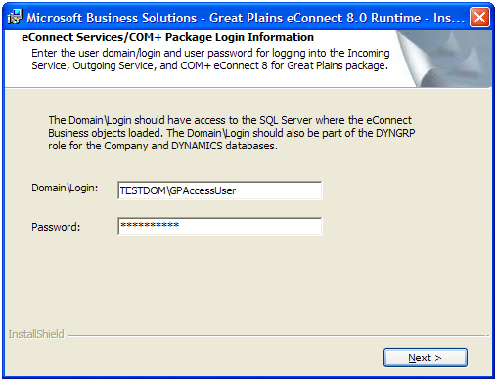

Click Next.

17. On the Microsoft CRM Connector for Microsoft Dynamics GP Registration page, click Next. To register Microsoft CRM Connector for Microsoft Dynamics GP leave Register Now checked, and then follow the instructions that are on your screen.

Important If you choose to register Microsoft CRM Connector for Microsoft Dynamics GP, you must exit the Registration Wizard before you can continue Setup.

18. On the Microsoft CRM Connector for Microsoft Dynamics GP Setup Completed page, click Finish.

Important After you successfully complete Setup, we strongly recommend that you install the required updates for Microsoft CRM 3.0, eConnect version 8 or 9, and BizTalk Server 2004 Partner Edition before you use Microsoft CRM Connector for Microsoft Dynamics GP. For more information about the required updates, refer to the Release Notes.

Installation Verification
As soon as Setup is finished, you should verify the installation and review the setup log for errors or events that may have occurred during Setup.

Service and COM+ Component Verification
Verify that the following services are running by using the Services MMC snap-in. To do this, click Start, click Run, type services.msc, and then click OK.
● Message Queuing. This service must be running on the Microsoft CRM server, the Microsoft Great Plains server, and the integration server. If it is not running, you must start it.
● Microsoft Business Solutions - Great Plains eConnect Outgoing Service 8.0 (or 9.0). This service must be running on the Microsoft Great Plains server. If the service is not running, you must start it.
If the services fail to start, follow these steps:

1. Right-click Microsoft Message Queuing, and then click Start.
2. Right-click Microsoft Business Solutions - Great Plains eConnect Outgoing Service 8.0 (or 9.0), click Properties, and then click the Log On tab.
3. Make sure that the user name in the This account box is the user account, with the correct password, that you specified as the Microsoft Great Plains access user during Setup. If not, type the credentials in the This account and Password boxes, and then click OK.
4. Right-click Microsoft Business Solutions - Great Plains eConnect Outgoing Service 8.0 (or 9.0), and then click Start.

Verify that the following component services are running on the Microsoft Great Plains server:
● eConnect 8 for Great Plains (or eConnect 9 for Great Plains)
● MbsIntegration.GpInbound

To do this, follow these steps:
1. Click Start, point to Programs, point to Administrative Tools, and then click Component Services.
2. Expand Component Services, expand Computers, expand My Computer, and then expand COM+ Applications.
3. Right-click eConnect 8 for Great Plains, and then click Start. If you receive a message that the component cannot start, right-click eConnect 8 for Great Plains, click Properties, click the Identity tab, and then retype the domain, user name, and password using the Microsoft Great Plains access user that you specified during Setup, click OK, and then start the component.
4. Right-click MbsIntegration.GpInbound, and then click Start. If you receive a message that the component cannot start, right-click MbsIntegration.GpInbound, click Properties, click the Identity tab, and then retype the domain, user name, and password using the Microsoft Great Plains user that you specified during Setup, click OK, and then start the component.

Viewing Setup Log Files
The primary log files for BizTalk Server 2004 are c:\BTSSetup.log and c:\configlog.txt. Log files for other setup activities are located in the C:\IntInstall.log folder. If errors occurred during installation of BizTalk Server 2004, you can review these logs to help diagnose the problem.

Adding Additional Microsoft CRM Servers
By default, Microsoft CRM Connector for Microsoft Dynamics GP supports a single Microsoft CRM 3.0 Server computer. However, you can add additional Microsoft CRM 3.0 Server computers to the integration system. To do this, follow these steps.

Important Before you add an additional Microsoft CRM Server computer to integration, you must install the Microsoft CRM adapter on that Microsoft CRM server computer.

1. On the Integration server, click Start, click Run, type compmgmt.msc, and then click OK.
2. Expand Message Queuing, expand Public Queues, right-click mscrm_integration_mscrm, and then click Properties.
3. If the integration server component is installed on a computer running Windows Server 2003, in the mscrm_integration_mscrm Properties dialog box click the Security tab, click Add, select the identity of the Microsoft CRM application pool (CRMAppPool) for the server that is running Microsoft CRM 3.0 that you want to add, and then click OK.

Important
If Microsoft CRM is running on the Windows 2000 operating system, you must add ComputerName$ to the mscrm_integration_mscrm queue, where ComputerName is the name of the computer that is running Microsoft CRM 3.0 that you want to add.

If Microsoft CRM is running on Windows 2003, and the CRMAppPool identity is configured to use the Network Service account, you must specify the application pool user as NameofServer$, where NameofServer is the name of the new server that you are adding to the integration system.

4. On the Integration server, click Start, point to Programs, point to Administrative Tools, and then click Component Services.
5. Expand COM+ Applications, expand Computers, expand My Computer, and then expand MbsIntegration.SyncIntegration, expand Roles, under Roles, expand CRM User Group, under that right-click Users, click New, click User, enter the identity of the Microsoft CRM application pool (CRMAppPool) for the server that you want to add, and then click OK.
6. Right-click on MbsIntegration.SyncIntegration, click Shut down, right-click MbsIntegration.SyncIntegration, and then click Start.

Important
If Microsoft CRM is running on the Windows 2000 operating system, you must add ComputerName$ to the Users, where ComputerName is the name of the computer that is running Microsoft CRM 3.0 that you want to add.

If the Microsoft CRM server is running on Windows 2003, and the CRMAppPool identity is configured to use the Network Service account, you must specify the application pool user as NameofServer$, where NameofServer is the name of the new server that you are adding to the integration system.

Configure Integration Using the Settings and Administration Tool
After you complete Setup, you must verify and configure the integration settings that you want. The user who runs the Settings and Administration Tool must be a member of the Active Directory integration user group. This group is specified during Setup.
To start the Settings and Administration Tool, start Internet Explorer, and then type the following address in the Address box, where port is the port number that you entered during Setup.
http://localhost:port/loader.aspx
The Settings and Administration Tool contains two main areas, the Settings area and the Administration area. Because much of Microsoft CRM Connector for Microsoft Dynamics GP lets you configure integration logic separately for each application, there are separate sub-areas under the main areas for Microsoft CRM and Microsoft Great Plains. Additionally, under the Administration area, there is an Integration Server sub-area, which is used for settings that are specific to the integration system.
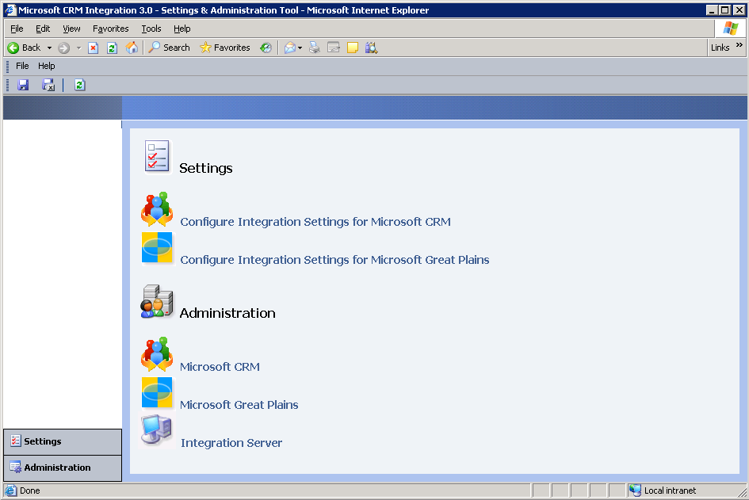

For more information about using the Settings and Administration Tool, see the “Data Synchronization” section in chapter 7, “Integration Tools.”
Because the Settings and Administration Tool runs in application mode, none of the toolbars for Microsoft Internet Explorer are available. You can refresh any page in the tool by clicking Refresh or by pressing F5.
The following sections discuss the integration settings. Microsoft CRM Connector for Microsoft Dynamics GP is installed with default settings that are configured for the typical integration environment. However, we recommend that you verify all default settings after you run Setup, and make changes as needed.
The most common steps you should take to verify and, if necessary, change the settings are:
Step 1: Select the Entity Records to Publish.
Step 2: Select the Default Values for Microsoft CRM 3.0.
Step 3: Select whether Microsoft Great Plains Customers are published to Microsoft CRM as account or as contacts.
Step 4: Select the Default Values for Microsoft Great Plains.
Step 5: Select how Microsoft Great Plains customer records are published to Microsoft CRM.
Step 6: Select how Microsoft Great Plains order and invoice records are published to Microsoft CRM.

Step 1: Select the Entity Records to Publish
By default, Microsoft CRM Connector for Microsoft Dynamics GP is configured to integrate all supported entity records for both Microsoft CRM 3.0 and Microsoft Great Plains. Therefore, customer/account/contact, sales order and invoice, addresses, and items/products are all integrated.
To change the Microsoft CRM records that are published to Microsoft Great Plains, click Settings, click Microsoft CRM, click Published Entities, and then make the changes that you want.
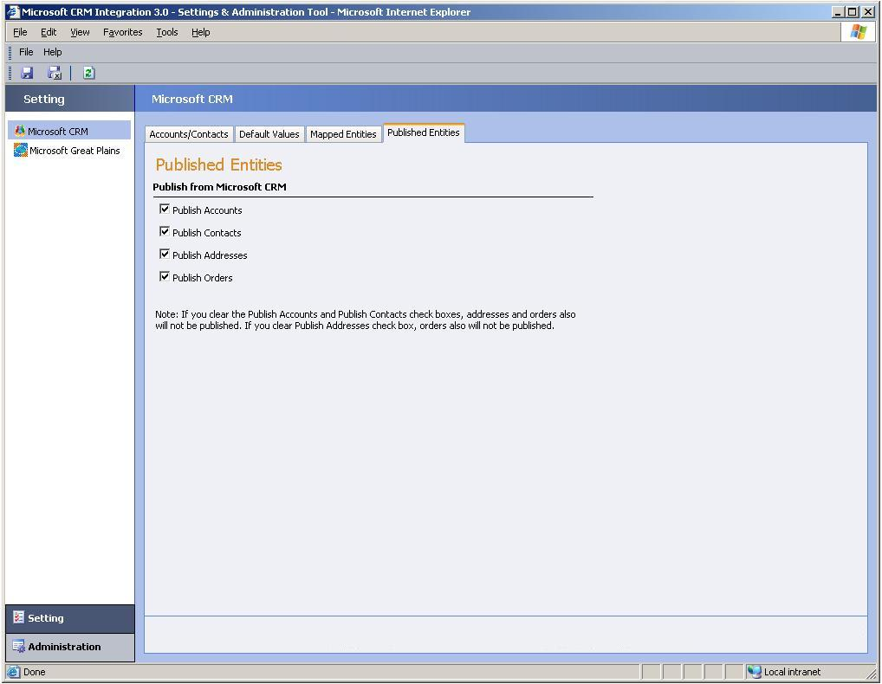

To change the Microsoft Great Plains records that are published to Microsoft CRM, click Settings, click Microsoft Great Plains, click Published Entities, and then make the changes that you want.
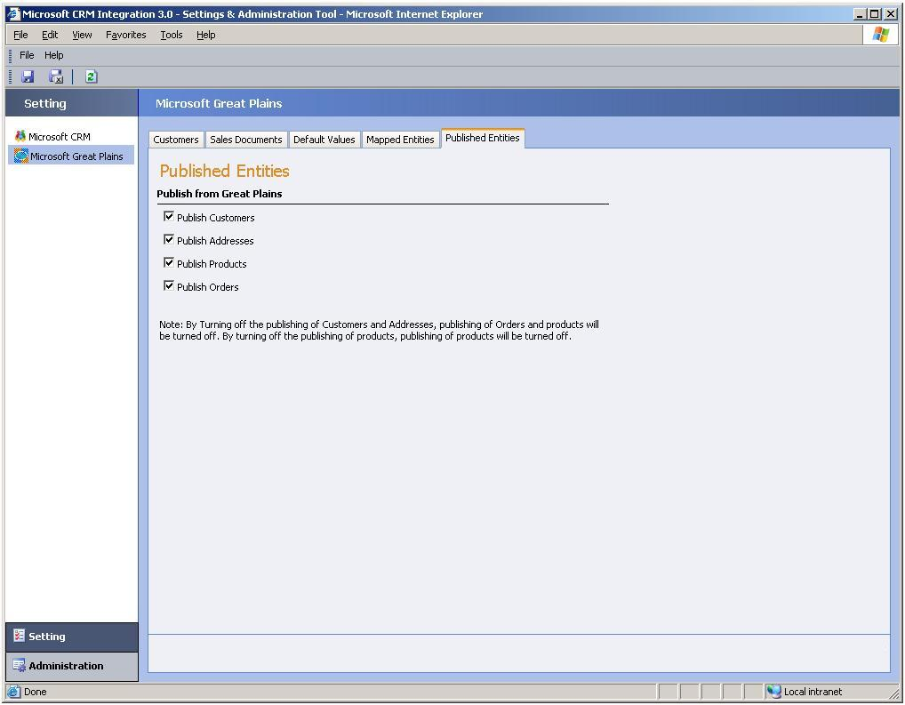

Step 2: Select the Default Values for Microsoft CRM 3.0
Select the default values for Microsoft CRM 3.0 account, contact, order, and invoice records. These values will be used when the source application entity field does not contain a value.

Verify and configure the Microsoft CRM default values
Click Settings, click Microsoft CRM, and then click the Default Values tab.
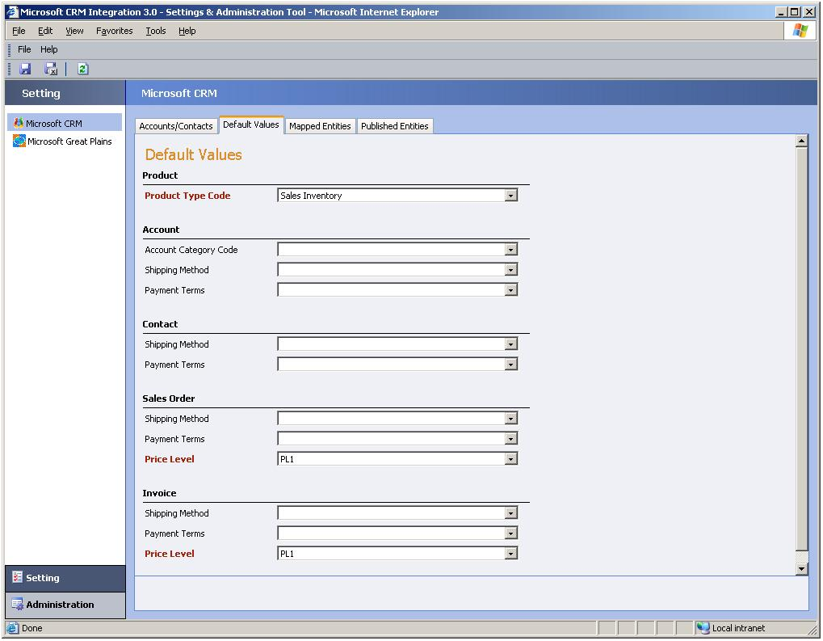
On this tab, the following areas are displayed:
● The Product area, which contains the following option:
● Product Type Code. Choose the default Product Type Code for Products that will be created in Microsoft Great Plains and published to Microsoft CRM 3.0. By default, no Product Type Code is selected. The choices are Miscellaneous Charges, Services, and Flat Fees.
● The Account area, which contains the following options:
● Account Category Code. Choose the default account category for accounts that will be created in Microsoft Great Plains and published to Microsoft CRM 3.0. By default, the choices are Preferred Customer or Standard. This information will appear in the Category field on the Details tab of the account form in Microsoft CRM 3.0.
● Shipping Method. Choose the default shipping method for accounts that will be created in Microsoft Great Plains and published to Microsoft CRM 3.0.
● Payment Terms. Choose the default payment terms for accounts that will be created in Microsoft Great Plains and published to Microsoft CRM 3.0. These values are obtained from the Microsoft CRM 3.0 server computer. By default, the choices are Net 30, 2% 10, Net 30, Net 45, Net 60. This information will appear in the Payment Terms field on the Administration tab of the account form.
● The Contact area, which contains the following options:
● Shipping Method. Choose the default shipping method for contacts that will be created in Microsoft Great Plains and published to Microsoft CRM 3.0.
● Payment Terms. Choose the default payment terms for a contact. These values are obtained from the Microsoft CRM 3.0 server computer. By default, the choices are Net 30, 2% 10, Net 30, Net 45, Net 60. This information will appear in the Payment Terms field on the Administration tab of the account form.

● The Sales Order area, which contains the following options:
● Shipping Method. Choose the default shipping method for sales orders that will be created in Microsoft Great Plains and published to Microsoft CRM 3.0. By default, the choices are Airborne, DHL, FedEx, UPS, Postal Mail, Full Load, and Will Call.
● Payment Terms. Choose the default payment terms for sales orders that will be created in Microsoft Great Plains and published to Microsoft CRM 3.0. These values are obtained from the Microsoft CRM 3.0 server computer. By default, the choices are Net 30, 2% 10, Net 30, Net 45, Net 60.
● Price Level. Select the default price level for sales orders that will be created in Microsoft Great Plains and published to Microsoft CRM 3.0. These values are fetched from the Microsoft CRM 3.0 Server computer.

● The Invoice area, which contains the following options:
● Shipping Method. Choose the default shipping method for invoices that will be created in Microsoft Great Plains and published to Microsoft CRM 3.0. These values are fetched from the Microsoft CRM 3.0 server computer. By default, the choices are Airborne, DHL, FedEx, UPS, Postal Mail, Full Load, and Will Call.
● Payment Terms. Choose the default payment terms for invoices that will be created in Microsoft Great Plains and published to Microsoft CRM 3.0. These values are obtained from the Microsoft CRM 3.0 Server computer. By default, the choices are Net 30, 2% 10, Net 30, Net 45, Net 60.
● Price Level. Select the default price level for sales orders that will be created in Microsoft Great Plains and published to Microsoft CRM 3.0. These values are fetched from the Microsoft CRM 3.0 Server computer.

Step 3: Select whether Microsoft Great Plains Customers are published to Microsoft CRM as accounts or as contacts
Choose whether to have Microsoft Great Plains customer records published to Microsoft CRM as account records or as contact records. To do this:
Click Settings, click Microsoft CRM, and then click the Accounts/Contacts tab.
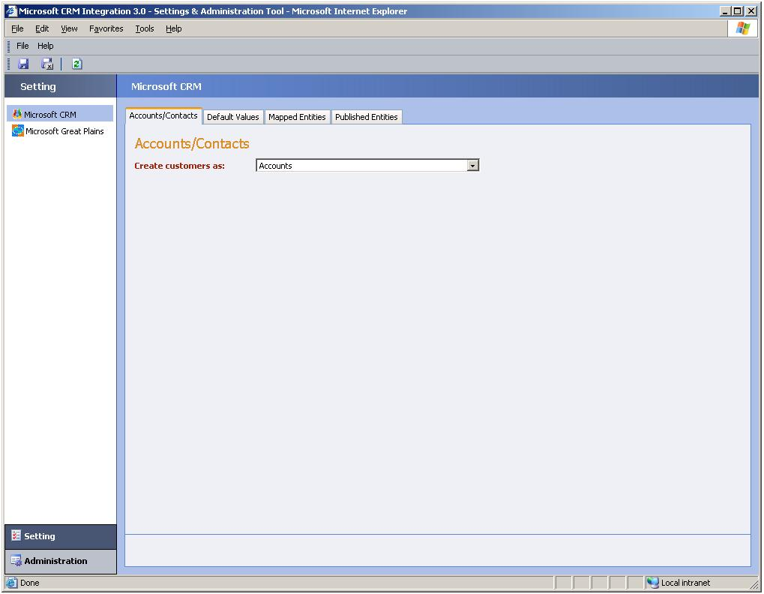
On this tab, click to select Accounts if you want Microsoft Great Plains customers published to Microsoft CRM as accounts. Alternatively, click to select Contacts if you want Microsoft Great Plains customers published to Microsoft CRM as contacts.

Step 4: Select the Default Values for Microsoft Great Plains
Select the default values for Microsoft Great Plains customer, order, and invoice records. These values will be used when the source application entity field does not contain a value.

Verify and configure the Microsoft Great Plains default values
Click Settings, click Microsoft Great Plains, and then click the Default Values tab.
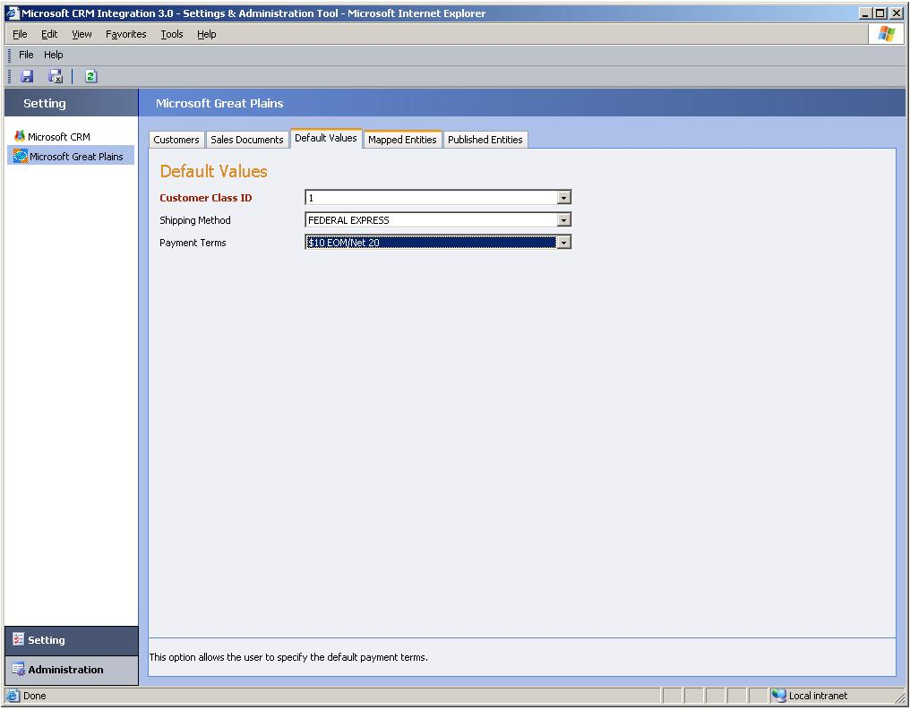
On this tab, the following options are displayed:
● Customer Class ID. Choose the default customer class ID for customers that will be created in Microsoft CRM 3.0 and published to Microsoft Great Plains. This list is populated from the Microsoft Great Plains Class ID list.
● Shipping Method. Choose the default shipping method for customers that will be created in Microsoft CRM 3.0 and published to Microsoft CRM 3.0. This list is populated from the Microsoft Great Plains Shipping Methods list.
● Payment Terms. Choose the default Microsoft Great Plains payment term for customer that will be created in Microsoft CRM 3.0 and published to Microsoft CRM 3.0. This list is populated from the Microsoft Great Plains Payment Terms list.

Step 5: Select how Microsoft Great Plains customer records are published to Microsoft CRM
Click Settings, click Microsoft Great Plains, and then click the Customers tab.
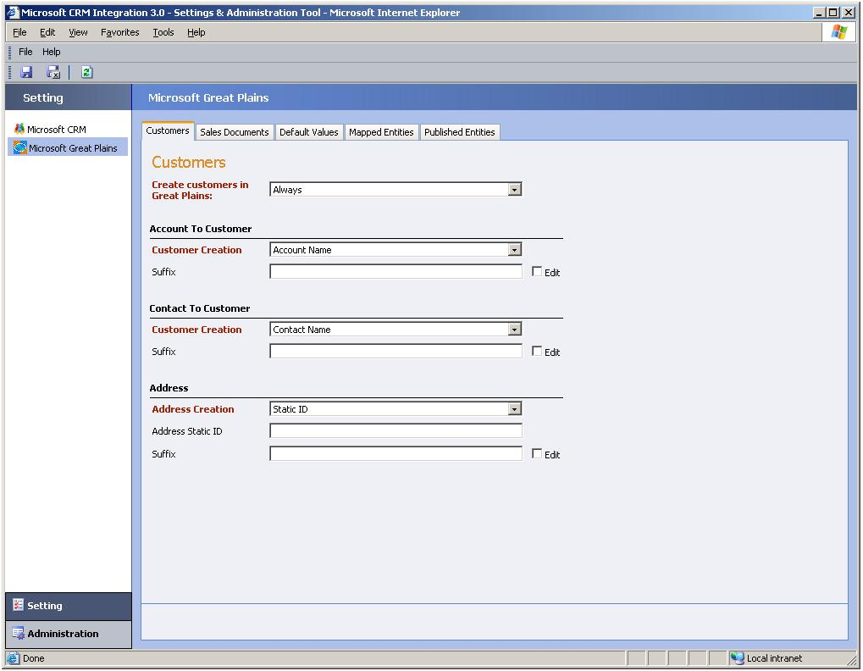
On this tab, the following areas are displayed:
● The Customers area, which contains the following option:
● Create customers in Great Plains. You can choose when you want customer records published in Microsoft Great Plains. You can have customer records published when Microsoft CRM 3.0 accounts or contacts are created by selecting Always, or have customer records created only when an order is submitted from Microsoft CRM 3.0 by selecting On order only.
● The Account to Customer area, which contains the following options:
● Customer Creation. You can choose how the customer ID is created for new customers that are created in Microsoft Great Plains. By default, the only option available is Account Name.
● Suffix. The customer ID is generated using the account or contact name. If the customer ID is already used, a suffix is added to the customer ID. You can set the suffix that will be appended to the customer ID. This suffix is incremented by one for each instance of the duplicate account name. By default, the suffix begins at 1.

● The Contact to Customer area, which contains the following options:
● Customer Creation. You can choose how the customer ID is created for new customers that are created in Microsoft Great Plains. By default, the only option available is Contact Name.
● Suffix. The customer ID is generated using the account or contact name. If the customer ID is already used, a suffix is added to the customer ID. This suffix is incremented by one for each instance of the duplicate account name. By default, the suffix begins at 0.

● The Address area, which contains the following options:
● Address Creation. The Address ID for new addresses created in Microsoft Great Plains can be created by using a static ID (created by the integration system), the Microsoft CRM 3.0 address name for the associated address, or the Microsoft CRM 3.0 phone number for the associated address.
● Address Static ID. If you select Static ID in the Address Creation list, you can specify the ID that will be used to generate the address ID in Microsoft Great Plains.
● Suffix. In case the Address ID generated using the Microsoft CRM 3.0 address name already exists, a suffix is appended to the address name. This suffix is incremented by one for each instance of the duplicate Address ID. By default, the suffix begins at 1.

Step 6: Select how Microsoft Great Plains order and invoice records are published to Microsoft CRM
Click Settings, click Microsoft Great Plains, and then click the Sales Documents tab.
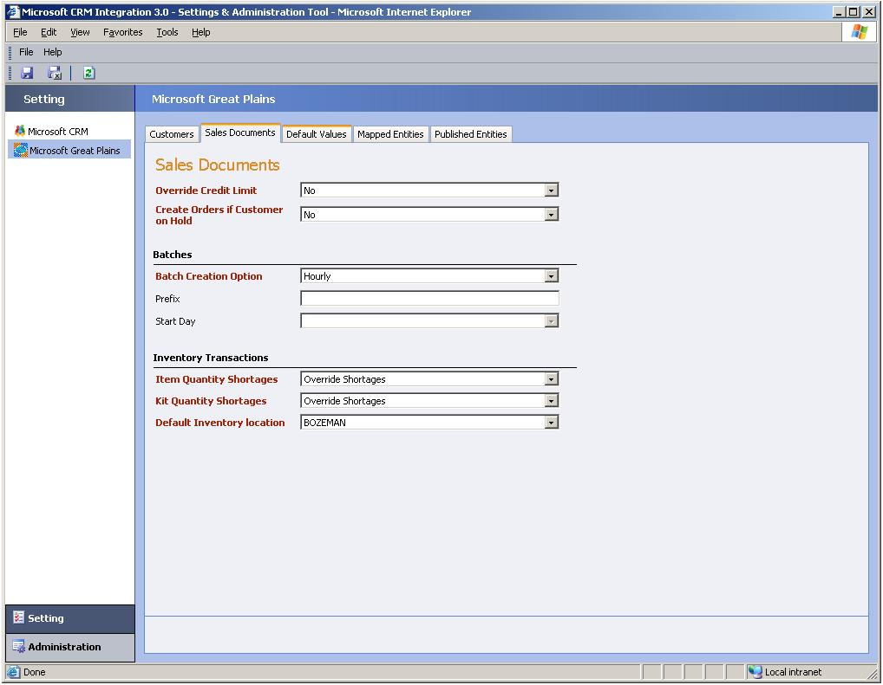
On this tab, the following areas are displayed:
● The Sales Documents area, which contains the following options:
● Override Credit Limit. This option lets you specify whether sales orders should be published to Microsoft Great Plains for customers who have exceeded their specified credit limit. You can select either yes or no. By default, this option is set to no so that orders will not be created if the customer has exceeded their credit limit.
● Create Orders if Customer on Hold. This option lets you specify whether sales orders should be published to Microsoft Great Plains for customers who have been put on hold in Microsoft Great Plains. You can select either yes or no. By default, this option is set to no so that orders will not be created if the customer is on hold.

● The Batches area, where you configure how batches are managed. The Batches area contains the following options:
● Batch Creation Option. Choose whether batch IDs should be created hourly, daily, or monthly.
● Prefix. You can type an alphanumeric prefix to add to the beginning of the batch IDs that are generated.
● Start Day. If you select Weekly in the Batch Creation Option list, you can select the day of the week to start each batch.

● The Inventory Transactions area, which contains the following options:
● Item Quantity Shortages. Select how quantity shortages are handled for sales orders that are published to Microsoft Great Plains. The following options are available:
● Override Shortages. By selecting this option, you can choose to have all orders that have quantity shortages published to Microsoft Great Plains.
● Back Order All. By selecting this option, you can choose to have the entire quantity in the sales order that is published to Microsoft Great Plains back ordered if a quantity shortage occurs.
● Back Order Balance. By selecting this option, you can choose to have the quantity shortage in the sales order that is published to Microsoft Great Plains back ordered.

● Kit Quantity Shortages. Select how kit quantity shortages are handled for sales order published to Microsoft Great Plains.
● Default Inventory Location. Choose the default Microsoft Great Plains inventory location for sales orders published to Microsoft Great Plains. This list is populated from the Microsoft Great Plains Site ID list.

Migrate Records
In situations where data does not exist in one of the applications, you can use the Data Synchronization Tool to migrate existing data. For example, it is likely that you have a new installation of Microsoft CRM 3.0 and you want to migrate data that is already established in Microsoft Great Plains.
After you complete Microsoft CRM Connector for Microsoft Dynamics GP Setup and configure the Settings and Administration Tool, data can be migrated from one application to the other. The following section primarily discusses data migration from Microsoft Great Plains to Microsoft CRM 3.0; however, similar steps apply to environments that migrate data from Microsoft CRM 3.0 to Microsoft Great Plains.

Entity Synchronization Dependency Order
There are entity dependencies that must be considered before you migrate data by using the Data Synchronization Tool. Below are three different integration scenarios when migrating data from Microsoft Great Plains to Microsoft CRM 3.0 where you must synchronize entities in a specific order.

All Entities and Sales Document Integration Dependency Order
If you are integrating all available entity types or if your integration environment includes sales documents (orders or invoices), you must synchronize entities in the following order:
1. UoM Schedule
2. UoM
3. Price Level
4. Order Type
5. Site
6. Item
7. Customer
8. Customer Addresses
9. Sales Documents (orders and invoices)

Item and Product Entity Only Integration Dependency Order
If you are integrating only item and product entity types, you must synchronize in the following order:
1. UoM Schedule
2. UoM
3. Price Level
4. Site
5. Item

Customer and Address Only Integration Dependency Order
If you are integrating only customer and address entity types, you must synchronize in the following order:
1. Customer
2. Customer addresses (do not perform this step if you only want to integrate customer records)

Important
● You cannot migrate a single unit of measure (UoM). When you migrate a UoM from Microsoft Great Plains to Microsoft CRM 3.0, the UoM schedule and all other UoMs that are associated with that UoM schedule will be migrated.
● Only Microsoft Great Plains sales orders with inventoried items can be migrated. Write-in items are not supported when migrating sales orders.
● When you synchronize the UoM Schedule, all UoMs that are associated with the schedule will be synchronized.
● Migration of Microsoft CRM invoice entity instances is not supported.

Steps For Migrating Data
To migrate all available entity data, use the following steps. You can use similar steps to migrate a more limited integration such as item and product entity-only or customer entity-only scenarios.
1. Click Start, point to All Programs, point to Microsoft CRM Connector for Microsoft Dynamics GP, and then click Data Synchronization Tool.
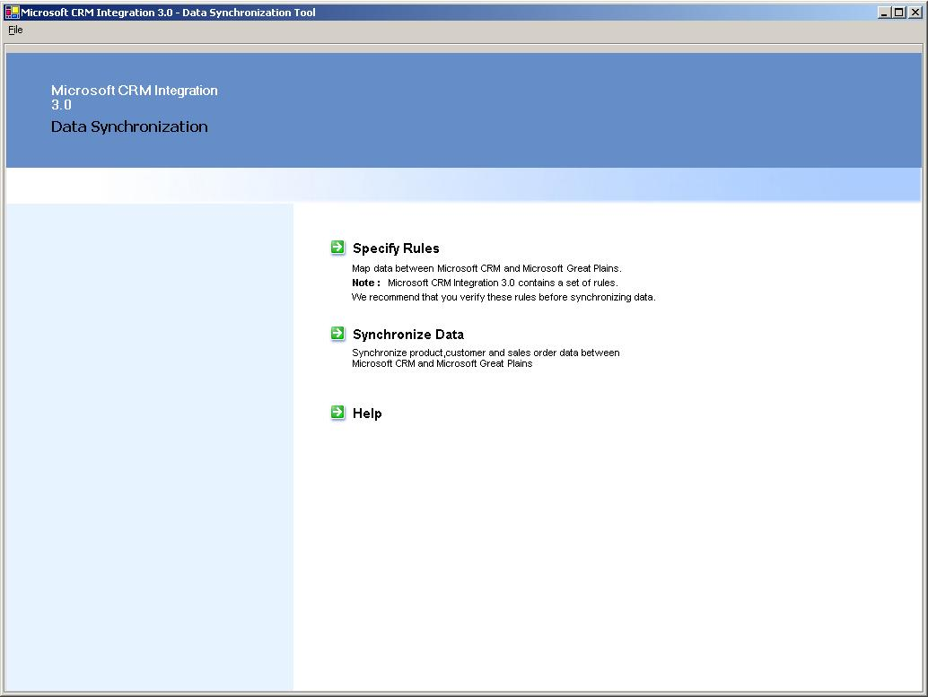
2. On the Data Synchronization start page, click Synchronize Data.
3. In the Source Application list, click Microsoft Great Plains, and in the Entity list (next to the Source Application list) click UoM Schedule.
4. Make sure that Microsoft CRM is selected in the Destination Application list and that Unit Group is selected in the Entity list (next to the Destination Application list).
5. In the Records list, click Unmatched, and then click Display.
6. Review the list of unmatched records. To do this, in the List Of Records click to select the check box next to the UoM Schedule unmatched records. The list should contain all records that are to be migrated to Microsoft CRM 3.0, as shown in the following illustration.
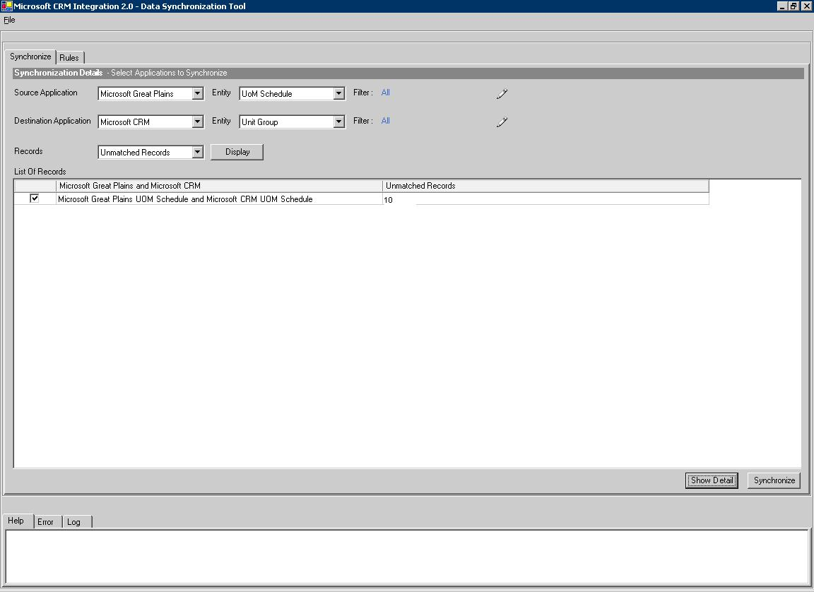
6. Click Synchronize.
7. Repeat this step for the each entity type that is in the dependency list. In this example, the next entity in the list is UoM.

Uninstall Instructions
The following instructions provide information about how to remove Microsoft CRM Connector for Microsoft Dynamics GP and components.

Important
● You must perform these uninstall steps before you can reinstall Microsoft CRM Connector for Microsoft Dynamics GP.
● If you cancel Setup before it is finished, you can try removing the incomplete integration installation by copying all the installation files to the installation folder and then run Microsoft.MbsIntegration.Setup.Uninstall.exe. Microsoft.MbsIntegration.Setup.Uninstall.exe is located in the bin folder where the Microsoft CRM Connector for Microsoft Dynamics GP installation files are located.
● The Microsoft CRM Connector for Microsoft Dynamics GP uninstall process will remove all programs that installed during Setup such as BizTalk Server and eConnect. However, if errors occur during uninstall on the computer where the integration server component is installed, you can try to remove the following programs from Add or Remove Programs:

● Microsoft BizTalk Server 2004 Service Pack 1 – (SP1)
● Microsoft BizTalk Server 2004
● If errors occur during uninstall on the computer where the Microsoft GP Adapter component is installed, you can try to remove the following program from Add or Remove Programs:
● Microsoft Business Solutions – Great Plains eConnect 8.0 (or 9.0)

Remove Microsoft CRM Connector for Microsoft Dynamics GP Components
1. Click Start, point to Settings, point to Control Panel, and then click Add or Remove Programs.
2. Click Microsoft CRM Connector for Microsoft Dynamics GP, click Change, and then click Next.
3. In the Microsoft CRM Connector for Microsoft Dynamics GP Setup dialog box, click Remove existing component, and then click Next.
4. Click to check the components that you want to Uninstall. Available options are Microsoft CRM Integration Server, Great Plains Adapter, and Microsoft CRM Adapter.
5. Follow the instructions that are on your screen.
6. To remove integration components that are installed on another server computer, you must repeat steps 1 through 5 on each computer that has an integration component installed.
7. Remove the following BizTalk Server groups.
● BizTalk Application Users
● BizTalk Isolated Host Users
● BizTalk Server Administrators
● SSO Administrators
● SSO Affiliate Administrators

For more information about Active Directory Users and Computers, see the Windows Server Help.
8. On the computer where the integration server component is installed, remove the BizTalk SQL security logins. These are not removed by Add or Remove Programs uninstall. To remove the SQL logins that were created by BizTalk Server, start Enterprise Manager and delete the following logins in the Security folder, where computer_name is the name of the computer where BizTalk Server is installed:
● computer_name\BizTalk Application Users
● computer_name\BizTalk Isolated Host Users
● computer_name\BizTalk Server Administrators
● computer_name\SSO Administrators

For more information about Enterprise Manager, see the SQL Server Help.
9. On the computer where the integration server component is installed, remove the integration server and BizTalk Server databases. These are not removed by Add or Remove Programs uninstall. To remove the databases, start Enterprise Manager and delete the following databases:
● BAMArchive.
● BamPrimaryImport.
● BizTalkDTADb.
● BizTalkMgmtDb.
● BizTalkMsgBoxDb.
● BizTalkRuleEngineDb.
● SSODB.
● Integration. This is the integration database. By default, this database is named CRMIntegration30. You can delete this database if you do not plan on reinstalling Microsoft CRM Connector for Microsoft Dynamics GP.

10. On the computer where the integration server component is installed, remove Enterprise Single Sign-On (SSO). To do this, in Add or Remove Programs, click Microsoft Enterprise Single Sign-On, click Remove, and then follow the instructions that are on your screen.
11. Verify that the following folders and all subfolders are removed. If the following folders are not removed, delete them.
● Microsoft CRM Connector for Microsoft Dynamics GP installation folder. By default, Microsoft CRM Connector for Microsoft Dynamics GP Setup installs files to the “c:\Program Files\Microsoft Dynamics\Microsoft CRM Connector for Microsoft Dynamics GP” folder.
● c:\Program Files\Microsoft BizTalk Server 2004
● c:\Program Files\Microsoft Great Plains\eConnect8 (or eConnect9)
● Installation folder where the Microsoft CRM Connector for Microsoft Dynamics GP. Delete this folder only if you do not plan on reinstalling Microsoft CRM Connector for Microsoft Dynamics GP.

Verification Steps to Perform After Uninstall
The following table details what steps to take to verify whether each part of Microsoft CRM Connector for Microsoft Dynamics GP is removed, and if not, how to manually remove it.
Component | Verification Steps | Details
COM+ applications | Run the command dcomcnfg. Under Console Root, expand Component Services-, expand Computers, expand My Computer, and then expand COM+ Applications. | Microsoft CRM computer: Verify that MbsIntegration.CrmInbound and  MbsIntegration.CRMPagesProxy are deleted. If not, right-click and then click Delete.  Microsoft GP computer: Verify that MbsIntegration.GPInbound is deleted. If not, right-click and then click Delete.  Integration Server component computer: Verify that MbsIntegration.SyncIntegration is deleted. If not, right-click and then click Delete.
Message Queues | Verify that the message queuing service is running. If not, you must start it.  Then, run the Computer Management MMC snap-in (compmgmt.msc) and expand Computer Management, expand Services and applications, and then expand Message Queuing. | Integration Server component computer: Verify that the following message queues exist under Public Queues.  1) mscrm_integration_greatplains  2) mscrm_integration_mscrm  If they exist, delete them.  Verify that the following message queue exist under Private Queues.  1) mscrm_integration_resubmit  If it exists, delete it.
Installation Folders and Files | The HKEY_LOCAL_MACHINE\SOFTWARE \ Microsoft\MSCRMINTEGRATION registry subkey entry InstallDir gives the path of the installation directory. By default, this folder is c:\Program Files\Microsoft Dynamics\Microsoft Dynamics CRM Connector for Microsoft Dynamics GP. | All computers where an integration component is installed. Remove all folders, subfolders, and files under this folder.
Integration Web Site | Start Internet Information Services (IIS) Manager. Expand computer_name, expand Web Sites. By default, this Web site is named Microsoft CRM Integration v3.0. | Integration Server component computer:  Remove the Integration Web Site.
Customizations added to Microsoft CRM | a) To remove the customizations from Order Product entity and Order entity forms, see step a under the Location and Actions column.  b) To change the ‘Submit Order’ action to create Invoice, run the Windows Registry Editor (regedit) and locate the HKEY_LOCAL_MACHINE\SOFTWARE \ Microsoft\MSCRMINTEGRATION subkey. See step b under the Location and Actions column.  c) Remove the “Credit Limit” and “Site Quantity” buttons from the order and product forms, respectively. Do this from the following folder where Microsoft CRM is installed:  c:\CRMInstallFolder\CRMWEB\_Resources.  See step c under the Location and Actions column.  d) Remove the callouts. Do this from the following folder where Microsoft CRM is installed:  c:\CRMInstallFolder\server\bin\assembly.  See step d under the Location and Actions column. | Microsoft CRM Computer:  a) In order to remove CRM customization the CRM user that is logged on should have the System Customizer role.  Verify that the Order Product form no longer has the “Great Plains Site” field.  To do this, in Microsoft CRM click Settings, under Settings click Customization, and then click Customize Entities.  Double-click Order Product, click Forms and Views, double-click Form, click the ‘Great Plain Site’ attribute, click Remove, and then click Save and Close.  Verify that the Order form no longer has the “Default Great Plains Site” field.  To do this, in Microsoft CRM click Settings, under Settings click Customization, and then click Customize Entities.  Double-click Order, click Forms and Views, double-click Form, click the ‘Default Great Plain Site’ attribute, click Remove, and then click Save and Close.  b) Verify if the “Integration Server” subkey is present. If it is present, delete it.  c) Verify whether the isv.config.xml file contains nodes for “Credit Limit” and “Site Quantity” under Order and Product entities, respectively.  If present, remove these nodes.  d) Verify if callout.config.xml contains entries for Microsoft.MbsIntegration. If present, remove integration entries from callout.config.xml, and delete Microsoft.MbsIntegration  .NewCRMOutbound.dll if present.
Registry Entries | HKEY_LOCAL_MACHINE\SOFTWARE \ Microsoft\MSCRMINTEGRATION | Microsoft CRM computer: If this is the last component to be removed, delete the subkey that is described in the Steps and Locations column. If this is not the last component to be removed, set the value of entry CRMInstalled as 0.  Microsoft GP computer: If this is the last component to be removed, delete the subkey that is described in the Steps and Locations column. If this is not the last component to be removed, set the value of entry CRMInstalled as 0.  Integration Server component computer: If this is the last component to be removed, delete the key. If this is not the last component to be removed, set the value of entry CRMInstalled as 0.
Integration Tool Shortcuts | Click Start to verify whether Microsoft CRM Connector for Microsoft Dynamics GP tools shortcuts exist. | Integration Server component computer: If shortcuts exist, go to  c:\WinDir\Document and Settings\All Users\Start menu\Programs and delete the “Microsoft CRM Integration” folder.

Uninstall Issues
The following section provides information about issues that may occur when you try to uninstall Microsoft CRM Connector for Microsoft Dynamics GP.

Cannot Remove eConnect Outgoing Service
After you uninstall the eConnect Outgoing service by using Add or Remove Programs, the eConnect Outgoing service may not be removed completely and remains in a disabled state.
To complete the removal of the eConnect Outgoing service, restart the computer.

Reinstall Instructions
Before you can reinstall Microsoft CRM Connector for Microsoft Dynamics GP, you must uninstall all integration components by following the steps in the previous section titled “Uninstall Instructions.” Then, run the Setup program again.

Important When you select to uninstall only the Integration Server component, you must perform the following procedure after you reinstall the Integration Server component. Note that you do not have to perform this procedure if you uninstall all integration components, and then reinstall them.
1. On the computer where Microsoft Great Plains is installed, restart the eConnect Outgoing service. To do this click Start, click Run, type services.msc, and then click OK. Then, right-click Microsoft Business Solutions – Great Plains eConnect Outgoing Service, and then click Restart.
2. On the computer where the Microsoft CRM 3.0 is installed, run iisreset. To do this, click Start, click Run, type iisreset, and then click OK.

Upgrading to Microsoft Dynamics GP 9.0
If, after you install Microsoft CRM Connector for Microsoft Dynamics GP, you upgrade to Microsoft Dynamics GP 9.0, you must uninstall the Microsoft Great Plains adapter, and then reinstall. To do this, follow these steps:
1. Click Start, point to Settings, point to Control Panel, and then click Add or Remove Programs.
2. Click Microsoft CRM Connector for Microsoft Dynamics GP, click Change, click Next, click Remove existing component, click Next, click to check Great Plains Adapter, and then click Uninstall.
3. To reinstall the Microsoft Great Plains Adapter, run the Microsoft CRM Connector for Microsoft Dynamics GP Setup program. For more information about how to install the Microsoft Great Plains Adapter, see the “Run the Microsoft CRM Connector for Microsoft Dynamics GP Setup Program” section earlier in this chapter.

Chapter 4

Chapter 4: Customer, Account, and Contact Entities
This chapter describes the differences in the ways Microsoft® CRM 3.0 and Microsoft Great Plains® map customer, account, and contact entities. An instance of an entity is synonymous with a record. A customer record in Microsoft Great Plains is the same entity as an account or contact in Microsoft CRM. These terms refer to customer information that is stored in both Microsoft CRM and Microsoft Great Plains. Microsoft CRM uses a globally unique identifier (GUID) to differentiate each account or contact. In Microsoft Great Plains, a unique customer ID is used to differentiate each customer record.
In an integrated environment, customer records can be set up in Microsoft Great Plains, and then published to Microsoft CRM through an application adapter that publishes changes using Microsoft BizTalk® services and Microsoft Message Queuing (MSMQ). The customer records can be used to process orders that are entered in Microsoft CRM.

Customer, Account, Contact, and Orders Data
You can create a new account or contact in Microsoft CRM, and have that account or contact synchronized to Microsoft Great Plains. Alternatively, you can configure Microsoft CRM Connector for Microsoft Dynamics GP so that a new Microsoft CRM account or contact is synchronized with Microsoft Great Plains only when an order is submitted for that account or contact. You choose how accounts and contacts are created in Microsoft Great Plains with the Settings and Administration Tool.
In the Settings and Administration Tool, you can specify to have accounts and contacts published as customers in Microsoft Great Plains. Then, each Microsoft CRM account name becomes the customer name in Microsoft Great Plains. For Microsoft CRM contacts, a combination of the first few letters of the First Name and Last Name fields, up to 15 characters long, become the customer ID in Microsoft Great Plains. In the case of duplicate first name and last name combinations, a numeric suffix is added to the customer ID.
Additionally, in the Settings and Administration Tool, you can choose to have customer records created when an order is submitted. Therefore, if the customer does not already exist in Microsoft Great Plains, a customer record will be created when you submit the order from Microsoft CRM to Microsoft Great Plains. You specify in the Settings and Administration Tool to have Microsoft Great Plains customers created in Microsoft CRM as either accounts or contacts.
With the Settings and Administration Tool, you can also choose whether or not orders for customer records that are on hold in Microsoft Great Plains are transferred from Microsoft CRM. If you set the Create Orders if Customer on Hold option to False, orders for customers who are on hold will not be processed and the data will not be transferred. After the order has failed, you can modify the customer in Microsoft Great Plains and then submit the order again. Additionally, orders for inactive customers are not created in Microsoft CRM.
When a new customer record is created in Microsoft Great Plains from data in Microsoft CRM, and you specify in the Settings and Administration Tool to use an account category code with an associated class ID, the integration system will assign that class ID to the new Microsoft Great Plains customer record. If the account category code you select is not mapped, Microsoft CRM Integration for Great Plains will use the default setting in the Customer Class ID list that is specified in the Settings and Administration Tool. If no account category code is specified in Microsoft Great Plains, the customer will be created without a class ID.
When a class ID is assigned to a customer in Microsoft Great Plains, you can change it after the customer record has been created successfully in Microsoft Great Plains. Selecting a customer class ID results in a record that assumes the attributes of that class ID. The exact attributes will vary depending on how the class ID was set up in Microsoft Great Plains. For example, a user may create a class ID in Microsoft Great Plains that would result in the following default entries for a record coming from Microsoft CRM:
● Currency ID
● Price level (only if the field is blank in Microsoft CRM)
● Payment Terms ID (only if the field is blank in Microsoft CRM)
● Trade Discount
When an account in Microsoft CRM becomes a customer in Microsoft Great Plains, the Customer ID field in Microsoft Great Plains is automatically generated based on the values you specify in the Settings and Administration Tool.

Updating Existing Data
When an update is made in either system, the data is sent to the integration system, which then checks to see whether the corresponding customer or account/contact data exists in the system. If the data does exist, the record is updated. This includes inactive accounts, contacts, or customers.

Important Several of the Microsoft Great Plains fields impose a shorter maximum length than is imposed in Microsoft CRM 3.0. Because of this restriction, entity attribute values can appear truncated.
For example, if you create a Microsoft CRM 3.0 account name that is over one hundred characters long, such as:

This is my place holder account that I keep to verify that all the information that is submitted by me is accurate complete and suitable for my customer

Because Microsoft Great Plains name attribute has a limit of 64 characters, after this entity instance is integrated the account name will appear as follows:

This is my place holder account that I keep to verify that all t

Information about the field value limits is available in tables throughout the "Customer, Account, and Contact Entities:, "Orders and Invoice Entities", and "Items and Product Entities" chapters.

Deleting Existing Data
If a Microsoft Great Plains customer is deleted, the corresponding account or contact in Microsoft CRM is made inactive. However, if an account or contact is deleted in Microsoft CRM, no changes are made to the corresponding customer who exists in Microsoft Great Plains.
If the primary customer address is deleted in Microsoft Great Plains, it will also be deleted from the primary address of the Microsoft CRM account or contact. Similarly, if the primary address is deleted from Microsoft CRM, the address information that is in the primary customer address fields will be removed from Microsoft Great Plains.

Account/Contact and Customer Data Mapping
Microsoft CRM account and contact records are both mapped similarly to Microsoft Great Plains customer records.
Account to Customer Data Mapping
The following table shows how account and customer data is mapped in the user interfaces between a Microsoft CRM account and a Microsoft Great Plains customer.
Microsoft CRM account fields | Character type or limit | Microsoft Great Plains customer fields | Character type or limit
Account Name (on General tab) | 160 | Name and Customer ID | 64
Not Mapped | 20 | Customer ID | 15
E-mail (on General tab) | 100 | Send E-mail Statements (in the Options area) | 80
Payment Terms (on Administration tab) | Not applicable | Payment Terms | Not applicable
Category (on Details tab) | Not applicable | Class ID | Not applicable
Credit Limit (on Administration tab) | Monetary (defined in Microsoft SQL Server™) | Credit Limit | 12 plus 2 decimal places
Credit Hold (on Administration tab) | Bit | Hold | Bit
Price List (on Administration tab) | GUID | Price Level | 10

Customer ID and Account Number Fields
The Customer ID field is required for Microsoft Great Plains customer records and must be unique. The corresponding field in Microsoft CRM, the Account Number field, is optional in Microsoft CRM account records.
When an account is created in Microsoft CRM, the account name is published to Microsoft Great Plains in the Customer ID field. The Customer ID field cannot be more than 15 characters. Therefore, the entire account name might not fit in the Customer ID field and, subsequently, will be truncated during integration.
If there are duplicate account names in Microsoft CRM, a numeric suffix is added to the Microsoft Great Plains customer ID, up to the maximum of 15 characters. This suffix ensures that the customer ID is unique. By default, the suffix is 0 and increments by one for each instance of a duplicate name in Microsoft CRM. For example, using the default suffix, if two account names exist that are Baldwin Museum of Science, integration creates the customer ID for the first instance as Baldwin Museum and the second instance as Baldwin Museum0. You can change the numeric suffix in the Settings and Administration Tool.

E-mail Addresses
When an e-mail address exists for a customer, it is transferred from Microsoft Great Plains to Microsoft CRM. By default, Microsoft CRM includes one field that is displayed on an account or customer form for e-mail addresses. However, you can customize Microsoft CRM to include up to three e-mail addresses for a single account or contact record. Alternatively, Microsoft Great Plains has To, Cc, and Bcc fields, where multiple e-mail addresses, separated by a semi-colon, may be entered.
When synchronization occurs from Microsoft Great Plains to Microsoft CRM, the first three e-mail addresses on the To field in Microsoft Great Plains will be synchronized into the Microsoft CRM database. Because Microsoft Great Plains sorts e-mail addresses alphabetically, the first three e-mail addresses are synchronized into Microsoft CRM.
Similarly, up to three Microsoft CRM account or contact e-mail addresses can be synchronized to the To field in Microsoft Great Plains.
Contact to Customer Data Mapping
The following table shows how contact and customer data is mapped in the user interface between a Microsoft CRM contact and a Microsoft Great Plains customer.
Microsoft CRM contact fields | Character type or limit | Microsoft Great Plains customer fields | Character type or limit
First Name, Middle Name, Last Name (on General tab) | 50 | Name | 64
E-mail (on General tab) | 100 | Send E-mail Statements (in the Options area) | 80
E-mail (on Administration tab) | Bit | Send E-mail Statements (in the Options area) | Bit
Credit Limit (on Administration tab) | Money (defined in Microsoft SQL Server) | Credit Limit | 12 plus 2 decimal places
Credit Hold (on Administration tab) | Bit | Hold | Bit
Payment Terms (on Administration tab) | Not applicable | Payment Terms | Not applicable
Price List (on Administration tab) | GUID | Price Level | 10

Note For database field mapping information, see Appendix A, "Entity Attribute Mappings."

Contact Address Information Synchronization
Microsoft Great Plains contact information is transferred from Microsoft Great Plains to Microsoft CRM. The Contact field in Microsoft Great Plains is transferred to the Address area in the contact form in Microsoft CRM. The format used to store contact information in Microsoft CRM is different from the format that is used in Microsoft Great Plains. In Microsoft Great Plains, a contact name is stored as part of an address record. In Microsoft CRM, contact information is independent of address information only on the primary address page (under Details, click Information in Microsoft CRM). However, on the More Addresses area of the contact record (under Details, More Addresses) in Microsoft CRM, the Microsoft Great Plains contact name does appear.

Customer Name Synchronization
In Microsoft Great Plains, the customer name is a single field; in Microsoft CRM, three fields are used for the contact’s first, middle, and last names. However, these differences are disregarded in the exchange of information. Microsoft CRM Connector for Microsoft Dynamics GP maps customer data to contact data and vice versa if you specify that as the default process for customer creation in Microsoft CRM, by using the Settings and Administration Tool. For example, a contact in Microsoft CRM with a first name of Anne, a middle name of Grethe, and a last name of Hansen will be displayed as Anne Grethe Hansen in Microsoft Great Plains. Therefore, when data is published from Microsoft Great Plains to Microsoft CRM, the second part of the name (Grethe) will be associated with the middle name. The result in Microsoft CRM will be a first name of Anne, a middle name of Grethe, and a last name of Hansen.
When a customer is created in Microsoft Great Plains and transferred to a Microsoft CRM contact, the following mapping of the customer name occurs:
Total number of words in the Microsoft Great Plains Customer Name | Example | How the Microsoft Great Plains customer name is mapped to the Microsoft CRM contact name
Customer name contains one word | Hill | The first word (Hill) is moved to the Last Name field of the Microsoft CRM contact.
Customer name contains two words | Andrew Hill | The first word (Andrew) is moved to the First Name field of the Microsoft CRM contact.  The second word (Hill) is moved to the Last Name field of the Microsoft CRM Contact.
Customer name contains three words | Andrew R. Hill | The first word (Andrew) in the customer name is moved in the First Name field of the Microsoft CRM contact.  The second word (R.) in the customer name is moved to the Middle Name field of the CRM contact.  The third word (Hill) is moved to the Last Name field of the Microsoft CRM Contact.
Customer name contains more than three words | Andrew R. (Andy) Hill | The first word (Andrew) in the customer name is moved in the First Name field of the Microsoft CRM contact.  The last word (Hill) in the customer name is moved to the Last Name field of the CRM contact.  For each word that is in between the first word and the last word, which in this example is R. (Andy), those words are moved to the Middle Name field of the Microsoft CRM Contact.

Address Creation and Synchronization
Customer address information is mapped, linked, and published between Microsoft CRM and Microsoft Great Plains. You choose whether to publish addresses in the Settings and Administration Tool.

Note When you turn off address publication, order publication is also turned off.

Addresses in both Microsoft CRM and Microsoft Great Plains can be distinguished as Primary, Bill To, or Ship To. When a contact or account address in Microsoft CRM has multiple addresses, such as different Ship To and Bill To addresses, those addresses are synchronized in the corresponding Ship To and Bill To addresses in Microsoft Great Plains. The same behavior occurs for Great Plains address types that are synchronized with Microsoft CRM. Additionally, Microsoft Great Plains Statement To addresses are synchronized to Microsoft CRM with an Address Type of Other.
When a new address record is created in Microsoft Great Plains from an address entered on an order in Microsoft CRM, the address ID is created by using the Address options that you selected in the Settings and Administration Tool. The Settings and Administration Tool supports the following address creation components:
● Static ID
● Address name
● Phone number
If you select Static ID, you can supply an alphanumeric ID in the Address Static ID box that will be used to create unique identifiers for addresses.
If you select Address name as the creation component, you can also add a numeric suffix. The suffix is used to generate a unique identifier for each address. The suffix must be a positive number. The suffix will increment with each instance of an address entity and is only used when two address records have the same name or same static ID. After you add a suffix you must select the Edit check box to change it.

Address Creation Using Address Name or Phone Number
If you choose to create a customer address ID based on a phone number and a Microsoft CRM user creates an account or contact record without a phone number, the record will be created in Microsoft Great Plains, but no address will exist for the account or contact. Similarly, if you choose to create a customer address ID based on an address name and a Microsoft CRM user creates an account or contact record without an address name, the record will be created in Microsoft Great Plains, but no address will exist for the account or contact.
For the account or contact address to be transferred with the record information to Microsoft Great Plains by using address name or phone number as the address creation component, you must add the phone number or address name to the account or contact record. The phone number and address name fields are located on the General tab in the Address area for either the account or contact. After you enter the address name or phone number, you must save the record.

Address Synchronization
When customer information is synchronized after the address has been created in Microsoft Great Plains, the address ID from Microsoft Great Plains becomes the address name in Microsoft CRM. When Microsoft CRM sends a new address that is on the main contact or account form to Microsoft Great Plains, the address information appears in the Customer Maintenance card. Alternatively, if the address in a Microsoft CRM account or contact is created in the More Addresses list, the address is synchronized with the additional address list for the corresponding customer in Microsoft Great Plains. The user must select the address from the list of available addresses for the customer for it to appear on the customer card in Microsoft Great Plains.

Address Data Mapping
This section outlines the user interface field mappings for customer addresses between Microsoft CRM and Microsoft Great Plains. For database-level field mappings, see Appendix A, "Entity Attribute Mappings."

Address Data Mapping Between Microsoft CRM and Microsoft Great Plains
The following table shows how address data is mapped in the user interfaces between Microsoft CRM and Microsoft Great Plains. Additional addresses are located on the Microsoft CRM account or contact form under Details, More Addresses.
Microsoft CRM address fields | Character type or limit | Microsoft Great Plains address fields | Character type or limit
Street 1 | 50 | Address (first field) | 30
Street 2 | 50 | Address (second field) | 30
Street 3 | 50 | Address (third field) | 30
City | 50 | City | 30
State/Province | 50 | State | 29
Country/Region | 50 | Country | 20
ZIP/Postal Code | 20 | ZIP Code | 10
Not mapped | Not applicable | UPS Zone | Not applicable
Main Phone | 50 | Phone 1 | 20
Phone 2 | 50 | Phone 2 | 20
Not mapped | 50 | Phone 3 | 20
Fax | 50 | Fax | 20
Address Contact | 150 | Contact | 30
Shipping Method | Not applicable | Shipping Method | Not applicable
Address Name | 200 | Address ID | 15

Note For database field mapping information, see Appendix A, "Entity Attribute Mappings."

Known Issues and Limitations
This section explains the known issues and limitations when integrating customer records with Microsoft CRM and Microsoft Great Plains using Microsoft CRM Connector for Microsoft Dynamics GP.

Tax Schedules
Microsoft CRM cannot handle tax schedule functionality. Therefore, when you create an address in Microsoft CRM, it does not contain a tax schedule. If that address is passed to Microsoft Great Plains, it will not contain a tax schedule. If you create an order in Microsoft CRM for a new customer who was created in Microsoft CRM and use a delivery shipping method, the order will not have taxes calculated until a Microsoft Great Plains user assigns a tax schedule to the order.

Phone Number Creation and Synchronization
When you add a phone number to Microsoft CRM, special characters, such as dashes or parentheses, will be removed when the data is transferred to Microsoft Great Plains. For example, if you entered (123) 555-0100 into Microsoft CRM, the number will appear as 1235550100 in Microsoft Great Plains. Consequently, when the data is sent from Microsoft Great Plains to Microsoft CRM, the phone number with the original dashes and parentheses will be replaced with the same value that appears in Microsoft Great Plains. You should not use special characters. If you must, use only dashes or parentheses.

Credit Limits
By default, the Settings and Administration Tool publishes orders created in Microsoft Great Plains to Microsoft CRM for customers who have exceeded their credit limit. To stop the publication of these orders, in the Settings and Administration Tool, set the Override Credit Limit list to False.
To ensure that credit limits for Microsoft CRM accounts and contacts are accurate, make sure that the Customer Class ID specified in the Settings and Administration Tool (on the Default Values tab under Settings on the Great Plains side tab) allows for unlimited credit or enough credit to allow orders for accounts and contacts created in Microsoft CRM with credit limits to be created in Microsoft Great Plains.
When you set a Microsoft CRM account’s or contact’s credit limit to 100,000,000,000 (100 Billion) or more, the account’s or contact’s credit limit will appear in Microsoft Great Plains as unlimited. Similarly, if a Microsoft Great Plains customer has unlimited credit, the credit limit field in Microsoft CRM will display as 100,000,000,000.

Microsoft CRM More Addresses Address Type Does Not Update in Microsoft Great Plains
When the Address Type value is changed in the Microsoft CRM address form, the corresponding address in Microsoft Great Plains will not update with the new address type. For example, if you change a “More Addresses” Address form in Microsoft CRM from an address type of “Ship To” to “Bill To”, the corresponding address in Microsoft Great Plains will not update with a “Bill To” type, but instead remains as a “Ship To” address.

Microsoft CRM Account and Contact Merge Behavior
The merge feature is used in Microsoft CRM to merge two accounts or two contact records together, where one record must be designated as the master record and the other record must be designated as the subordinate record. In Microsoft CRM, the subordinate record is marked as inactive and the master record contains the merged data. The updated record is reflected in the corresponding Microsoft Great Plains customer record and the corresponding subordinate record in Microsoft Great Plains is marked as inactive. However, if the subordinate record has an outstanding balance, the record will not be marked as inactive in Microsoft Great Plains.

Supported Records That Cannot Be Merged
You cannot merge the accounts or contacts that have a submitted sales order associated with them.

After Order Cancel You Cannot Merge Accounts or Contacts as the Subordinate Record
When you cancel an order in Microsoft CRM, the account or contact that is associated with that order cannot be merged as a subordinate record. This behavior occurs even when the order is cancelled before it is submitted.

Chapter 5

Chapter 5: Order and Invoice Entities
Microsoft® CRM 3.0 and Microsoft Great Plains® have similar order entry systems, but they do differ in some ways. Understanding their differences and the behavior that occurs within an integrated environment is important for successful order and invoice processing. For example:
● After the two applications become integrated, invoice creation functionality in Microsoft CRM 3.0 is turned off.
● Orders may be created, updated, and deleted in both systems. When a user clicks Submit Order in Microsoft CRM 3.0, the order will be sent for integration and appear in Microsoft Great Plains.

● If a sales order is transferred to a back order in Microsoft Great Plains, the back order quantity is updated in Microsoft CRM 3.0. However, if the back order is transferred to an invoice, the quantity on the invoice is not updated on the original order.

Note If the transaction series does not start with an order, for example, the transaction begins when an invoice is created that was not transferred from an order, quantity updates will not occur and the invoice will not be linked to an order. This behavior is true even if the order is created later in the transaction.

The following sections outline how each application deals with orders and invoices and how orders and invoices affect data transactions between the two applications. Additionally, these sections describe how user interface fields are mapped between Microsoft CRM 3.0 and Microsoft Great Plains.

Orders Created in Microsoft Great Plains
You can use the Settings and Administration Tool to specify that, when an order is created in Microsoft Great Plains, it is published in Microsoft CRM 3.0. If an existing order is updated in Microsoft Great Plains, it is also updated in Microsoft CRM 3.0.
In Microsoft Great Plains you can specify a value for the Miscellaneous field on sales orders and invoices, which is used to calculate the extended price. However, Microsoft CRM 3.0 orders and invoices do not have this field, and this field is not mapped to any Microsoft CRM 3.0 field. The result is that when order or invoice data that contains the Miscellaneous field is transferred from Microsoft Great Plains to Microsoft CRM 3.0, the total on the Microsoft CRM 3.0 order or invoice appears as though it is incorrect. The value, in fact, will be accurate even though it appears not to be.
If the order originated in Microsoft Great Plains, the address Name field on orders and invoices in Microsoft CRM 3.0 are updated using the Microsoft Great Plains address ID. However, when you make a change to the address name in Microsoft CRM 3.0, the address ID will not change in Microsoft Great Plains.

Important Several of the Microsoft Great Plains fields impose a shorter maximum length than is imposed in Microsoft CRM 3.0. Because of this restriction, entity attribute values can appear truncated.
For example, if you create a Microsoft CRM 3.0 account name that is over one hundred characters long, such as:

This is my place holder account that I keep to verify that all the information that is submitted by me is accurate complete and suitable for my customer

Because Microsoft Great Plains name attribute has a limit of 64 characters, after this entity instance is integrated the account name will appear as follows:

This is my place holder account that I keep to verify that all t

Information about the field value limits is available in tables throughout the "Customer, Account, and Contact Entities:, "Orders and Invoice Entities", and "Items and Product Entities" chapters.

Deleted and Voided Orders/Back Orders
The following behavior applies to deleted and voided orders and back orders in Microsoft Great Plains:
● If an order is deleted by a user in Microsoft Great Plains, the Status Reason field on the Administration tab on the Microsoft CRM 3.0 order form for the deleted order will be set to No Money. However, the Status field that displays state information and is located in the lower-left corner of the order form will be set to Canceled. You can change the value that appears in the Status Reason column by customizing the form. For more information about customizing forms, see Microsoft CRM 3.0 online Help. After you have customized a form, see Chapter 8 “Customizing Integration” for more information.
● If a line item is deleted in Microsoft Great Plains, the corresponding line item is canceled from the order in Microsoft CRM 3.0 and the order header information is modified to reflect the appropriate pricing information. Note that you should not delete line items when you delete an order. However, in some cases the line items may be passed to the messaging system before the header information. If this occurs, the line items on the canceled order are deleted.
● If an order is voided in Microsoft Great Plains, the corresponding order in Microsoft CRM 3.0 will have its state information set to Canceled.
● When an item on an order or invoice is transferred to a back order in Microsoft Great Plains, the Back Ordered field in the Order Product form in Microsoft CRM 3.0 is updated with the correct quantities. However, if the back order is deleted in Microsoft Great Plains, the back ordered quantity is not updated in Microsoft CRM 3.0.

Order/Back Order Publication
When a Microsoft Great Plains order is transferred to a back order, an update occurs to the original order in Microsoft CRM 3.0 indicating the quantity that has been back ordered. However, because Microsoft Great Plains does not store back ordered items in a single location within a single document, it can make calculating back ordered items in Microsoft CRM 3.0 difficult. To ensure all back ordered items are accounted for, Microsoft CRM Connector for Microsoft Dynamics GP searches all back orders in the work table, aggregates all the quantities for a specific line item, and associates that data with the original document stored in Microsoft CRM 3.0.
Changes regarding quantity back ordered and quantity shipped on orders that are non-repeating are made to the original order. Changes regarding quantity back ordered and quantity shipped on orders that are repeating are not made to the original order. Rather, invoices are generated only for repeating orders.

Orders Created in Microsoft CRM 3.0
Use the Settings and Administration Tool to specify if you want orders published from Microsoft CRM 3.0 to Microsoft Great Plains. When orders are submitted from Microsoft CRM 3.0 by clicking Submit Order on the order form, an order message is sent to the integration system. During this process, the integration system notes that it needs an account or contact with the order and requests the information corresponding to the order from Microsoft CRM 3.0. Orders created in Microsoft CRM 3.0, once submitted, can be modified in Microsoft CRM 3.0 unless the order is transferred, voided, or deleted in Microsoft Great Plains.
Records and data related to the order, such as account or contact information, can also be created or updated in Microsoft CRM 3.0 and synchronized to Microsoft Great Plains.
You can add a write-in product on orders created in Microsoft CRM 3.0 and submitted to Microsoft Great Plains. Additionally, a single order, which has each line item shipped to a different location, can be submitted from Microsoft CRM 3.0 and fulfilled by Microsoft Great Plains.
When submitting orders from Microsoft CRM 3.0, make sure that the customer has a credit limit specified in Microsoft Great Plains. By default, the order will fail because the Settings and Administration Tool override credit limit option is set to false. To allow the order to be transferred to Microsoft CRM 3.0, you must set the Override Credit Limit option to True in the Settings and Administration Tool.

Note If you set an account’s or a contact’s credit limit to 100,000,000,000 (1 billion) or more, the credit limit will appear in Microsoft Great Plains as unlimited. And, if a Microsoft Great Plains customer has unlimited credit, it will appear as 100,000,000,000 in Microsoft CRM 3.0.

When an order is created in Microsoft CRM 3.0 and the product is sold, the quantity is deducted from the default company-wide site specified in Microsoft Great Plains (meaning the product will be pulled out of inventory from that site). However, if you select another site in the Default Inventory Location list in the Settings and Administration Tool, that site will be used.
When a billing address is sent in conjunction with an order from Microsoft CRM 3.0 to Microsoft Great Plains, the integration system checks to see if the billing address exists in Microsoft Great Plains. If it does exist, it is referenced on the order. If it does not exist, Microsoft Great Plains creates the address for the corresponding customer.
Microsoft CRM 3.0 does not handle order fulfillment on orders. Order fulfillment is handled according to the order type that is selected in the Microsoft CRM 3.0 order form.
Orders created in Microsoft CRM 3.0 that specify information in the Shipped, Back Ordered, and Canceled fields of the order product form are overwritten by Microsoft Great Plains. This occurs when Microsoft Great Plains data for that order is updated and sent to Microsoft CRM 3.0.
If you enter address information in the Bill To section on the Address tab of an order, and the order is submitted to Microsoft Great Plains, the address is added to the customer’s information in Microsoft Great Plains. When Microsoft Great Plains sends the data back to Microsoft CRM 3.0, the address information from the Bill To section is added to the Account or Contacts More Addresses tab and the Address Name field contains the Microsoft Great Plains Address ID. You can edit this name to match the name you specified on the order.

New Fields Created for Microsoft CRM 3.0 Orders
Microsoft CRM Connector for Microsoft Dynamics GP creates two fields on the General tab of the Microsoft CRM 3.0 order form. These fields are required for all Microsoft CRM 3.0 orders:
● Default Great Plains Site. This list is generated from the Site ID list in Microsoft Great Plains.
● Great Plains Order Type. This list is generated from the Sales Type ID for orders in Microsoft Great Plains.
Additionally, Microsoft CRM Connector for Microsoft Dynamics GP creates a field on the General tab of the Microsoft CRM 3.0 Order Product form. This field is optional for all products that are added to the order.
● Great Plains Site. This list is generated from the Site ID list in Microsoft Great Plains. By using this field, you can select the Microsoft Great Plains site to allocate product inventory.

Important These attributes are a critical part of Microsoft CRM Connector for Microsoft Dynamics GP system functionality. If you choose to modify or customize these attributes or the associated entities, we strongly recommend that you exercise caution and perform the necessary backup measures before making changes.

Quantity Shortages on Orders
If there are quantity shortages for products that are in an order, Microsoft Great Plains will override the shortage if you select Override Shortages from the Item Quantity Shortages drop-down list in the Settings and Administration Tool. For example, if the total quantity in Microsoft Great Plains is 100 T47 Mountain Bikes and an order is sent from Microsoft CRM 3.0 to Microsoft Great Plains for 120 T47 Mountain Bikes, Microsoft CRM Connector for Microsoft Dynamics GP will override the shortages and send the order to Microsoft Great Plains.

Use Default and Override Pricing Behavior for Orders Created From Quotes
Microsoft CRM 3.0 includes a feature where prices on quotes, orders, and invoices can use system pricing or manual pricing where prices can be "written in" to the sales document. By default, Microsoft CRM 3.0 quotes, orders, and invoices use the Use Default option where prices are system generated. In an integrated environment, all prices are locked and will not fluctuate when system pricing changes occur.
The following behavior occurs when a quote is converted to an order in Microsoft CRM 3.0:
● If a quote that is set to use the Use Default option is converted to an order, the prices will be locked using Microsoft Great Plains system pricing.
● If a quote that is set to use the Override Price option is converted to an order, the prices will be locked on the prices that are written in to the Microsoft CRM 3.0 quote.

Order Data Mapping
This section outlines the user interface field mappings for orders between Microsoft CRM 3.0 and Microsoft Great Plains. For database-level field mappings, see Appendix A, "Entity Attribute Mappings."

Order Field Mapping from Microsoft CRM 3.0 to Microsoft Great Plains
The following table shows how order fields are mapped in the user interface from Microsoft CRM 3.0 to Microsoft Great Plains. The first ten rows below Microsoft CRM 3.0 (from Street 1 to Name) represent the fields related to the Bill To Address and map to the Customer ID address fields in Microsoft Great Plains. The following ten rows (the second Street 1 instance to the second Name instance) represent the fields related to the Ship To Address and map to the order in Microsoft Great Plains.
Microsoft CRM 3.0 field | Character type or limit | Microsoft Great Plains field | Character type or limit
Street 1 | 50 | Address 1 | 30
Street 2 | 50 | Address 2 | 30
Street 3 | 50 | Address 3 | 30
City | 50 | City | 30
State/Province | 50 | State | 30
ZIP/Postal Code | 20 | Zip Code | 10
Country/Region | 50 | Country | 20
Phone | 50 | Phone 1 | 20
Fax | 50 | Fax | 20
Street 1 | 50 | Address 1 | 30
Street 2 | 50 | Address 2 | 30
Street 3 | 50 | Address 3 | 30
City | 50 | City | 30
State/Province | 50 | State | 30
ZIP/Postal Code | 20 | Zip Code | 10
Country/Region | 50 | Country | 20
Phone | 50 | Phone 1 | 20
Fax | 50 | Fax | 20
Name | 100 | Document Number | 16
Customer | 100 | Customer ID/Customer Name | 66 (This limit may be reduced based on truncation that can occur with the account or contact name in Microsoft CRM 3.0.)
Detail Amount ($) | Money | Subtotal | Decimal
Order Discount (%) | Money | Trade Discount (can be the Percent, Amount, or both fields) | Decimal
Order Discount ($) | Money | Trade Discount (can be the Percent, Amount, or both fields) | Decimal
Freight-Amount ($) | Money | Freight | Decimal
Total Amount ($) | Money | Total | Decimal
Total Tax ($) | Money | Tax | Decimal
Price List | GUID | Price Level | Not applicable
Shipping Method | Not applicable | Shipping Method | Not applicable
Payment Terms | Not applicable | Payment Terms | Not applicable
Description | 2000 | Comment | Text

Notes
● The tax is not transferred from Microsoft CRM 3.0 to Microsoft Great Plains because Microsoft Great Plains calculates the tax.
● The Decimal type is set to five places.
● The Microsoft CRM 3.0 Prices Locked option is always set to true.
● The Miscellaneous field in Microsoft Great Plains does not map to any field in Microsoft CRM 3.0. When you create an order in Microsoft Great Plains, which has pricing information that includes miscellaneous pricing, and the order is sent to Microsoft CRM 3.0, the pricing information in the order may not appear to be correct. For example, if a Microsoft Great Plains order had pricing as follows:

● Detail Amount: $ 60.00
● Trade Discount: $ 0.05
● Freight: $ 0.09
● Miscellaneous: $ 0.20
● Tax: 0.02
The total amount is $60.00 - $ 0.05 + $ 0.09 + $ 0.20 + $ 0.02 = $ 60.26

However, the corresponding order in Microsoft CRM 3.0 will appear as:
● Order Discount: $ 0.05
● Order Discount %: 0.00
● Freight: $ 0.09
● Tax: $ 0.02
The total amount is: $ 60.26

But if you applied the same formula as was mentioned earlier, it is:
● $60.00 - $ 0.05 + $ 0.09 + $ 0.02 = $ 60.06.

Order Header Mapping from Microsoft Great Plains to Microsoft CRM 3.0
Order headers are mapped in the user interface from Microsoft Great Plains to Microsoft CRM 3.0 in a very similar manner as that of order headers going from Microsoft CRM 3.0 to Microsoft Great Plains. The following table details the mappings. The Customer ID address fields in Microsoft Great Plains map to the Bill To Address fields in Microsoft CRM 3.0.
Microsoft Great Plains field | Character type or limit | Microsoft CRM 3.0 field | Character type or limit
Address 1 | 30 | Street 1 | 50
Address 2 | 30 | Street 2 | 50
Address 3 | 30 | Street 3 | 50
City | 30 | City | 50
State | 30 | State/Province | 50
Zip Code | 10 | ZIP/Postal Code | 20
Country | 20 | Country/Region | 50
Phone 1 | 20 | Phone | 50
Fax | 20 | Fax | 50
Name | 16 | Name | 200
Address 1 | 30 | Street 1 | 50
Address 2 | 30 | Street 2 | 50
Address 3 | 30 | Street 3 | 50
City | 30 | City | 50
State | 30 | State/Province | 50
Zip Code | 10 | ZIP/Postal Code | 20
Country | 20 | Country/Region | 50
Phone 1 | 20 | Phone | 50
Fax | 20 | Fax | 50
Name | 16 | Name | 100
Comment | Text | Description | 2000
Trade Discount (Amount) | Decimal | Order Discount ($) | Money
Total minus Freight minus Tax | Decimal | Pre-Freight Amount ($) | Money
Not mapped | Not applicable | Order Discount (%)  (automatically set to zero) | Money
Freight | Decimal | Freight Amount ($) | Money
Total | Decimal | Total Amount ($) | Money
Tax | Decimal | Total Tax ($) | Money
Subtotal | Decimal | Detail Amount ($) | Money
Price Level | Not applicable | Price List | GUID
Shipping Method | Not applicable | Shipping Method | Not applicable
Payment Terms | Not applicable | Payment Terms | Not applicable
Document Number | 16 | Name (on General tab) | 300

Line Item Mapping from Microsoft CRM 3.0 to Microsoft Great Plains
The following table shows how line items (details of orders) are mapped in the user interface between Microsoft CRM 3.0 and Microsoft Great Plains.
Microsoft CRM 3.0 line item | Character type or limit | Microsoft Great Plains line item | Character type or limit
Quantity | Decimal | Quantity Ordered | Decimal
Unit | String | U of M | String
Product | String | Item Number | String
Manual Discount ($) | Money | Markdown | Money
Product Description | String | Item Number (only mapped for write-in products) | String
Volume Discount ($) | Money | Not mapped | Not applicable
Price Per Unit ($) | String | Unit Price | String
Extended Amount ($) | Money | Extended Price | Money
Pricing | Decimal | Not mapped | Not applicable
Amount ($) | Money | Not mapped | Not applicable
Tax ($) | Money | Not mapped | Not applicable
Shipped (displayed on the Delivery tab) | Decimal | Not mapped | Not applicable
Back Ordered (displayed on the Delivery tab) | Decimal | Not mapped | Not applicable
Canceled (displayed on the Delivery tab) | Decimal | Not mapped | Not applicable
Street 1 (displayed on the Address tab) | 50 | Address | 30
Street 2 (displayed on the Address tab) | 50 | Address | 30
Street 3 (displayed on the Address tab) | 50 | Address | 30
City (displayed on the Address tab) | 50 | City | 30
State/Province (displayed on the Address tab) | 50 | State | 30
ZIP/Postal Code (displayed on the Address tab) | 20 | Zip Code | 10
Country/Region (displayed on the Address tab) | 50 | Country | 20
Phone (displayed on the Address tab) | 50 | Phone 1 | 20
Fax (displayed on the Address tab) | 50 | Fax | 20
Name (displayed on the Address tab) | 200 | Not mapped | 16

Notes
● Product Description only maps to Item Number for write-in products.
● Description is not mapped to Microsoft Great Plains, but if the product is a kit item, Microsoft Great Plains will overwrite the description with information describing the kit components.
● Volume Discount is not mapped to Microsoft Great Plains because Great Plains does not contain a similar field. Microsoft CRM 3.0 orders that have data entered in the Volume Discount field will be overwritten with a value of 0 after synchronization occurs.
● For database field mapping information, see Appendix A, "Entity Attribute Mappings."

Extended Price Calculations
Microsoft CRM 3.0 calculates the extended price as follows:
(Unit Price – Volume Discount) * Quantity – Manual Discount
Whereas, Microsoft Great Plains calculates extended price as follows:
(Unit Price – Markdown Amount) * Quantity
To convert from Microsoft Great Plains to Microsoft CRM 3.0, the following conditions are true:
1. Microsoft CRM 3.0 Unit Price = Microsoft Great Plains Unit Price
2. Microsoft CRM 3.0 Manual Discount = (Microsoft Great Plains Markdown Amount * quantity)
3. The Volume Discount is zeroed out in Microsoft CRM 3.0.

To convert from Microsoft CRM 3.0 to Microsoft Great Plains, the following formulas are used:
● Microsoft Great Plains Unit Price = (Microsoft CRM 3.0 Unit Price – Microsoft CRM 3.0 Volume Discount)
● Microsoft Great Plains Markdown Amount = (Microsoft CRM 3.0 Manual Discount/quantity)

Line Item Mapping from Microsoft Great Plains to Microsoft CRM 3.0
Line items (details of orders) are mapped in the user interface from Microsoft Great Plains to Microsoft CRM 3.0 in a very similar manner as that of line items going from Microsoft CRM 3.0 to Microsoft Great Plains. The following table details the mappings.
Microsoft Great Plains line item | Character type or limit | Microsoft CRM 3.0 line item | Character type or limit
Quantity Fulfilled | Decimal | Shipped (displayed on the Delivery tab, but only when the order has been posted to an invoice) | Decimal
Quantity Ordered | Decimal | Quantity | Decimal
Quantity | Not applicable | Back Ordered (displayed on the Delivery tab, but only when the order has been posted to an invoice) | Decimal
Quantity Canceled | Decimal | Canceled (displayed on the Delivery tab) | Decimal
U of M | String | Unit | String
Item Number | String | Product | String
Markdown | Money | Manual Discount ($) | Money
Item Number plus U of M (only mapped for write in products) | String | Product Description | String
Not mapped | Not applicable | Volume Discount ($) (automatically set to zero) | Money
Unit Price | String | Price Per Unit ($) | String
Extended Price | Money | Extended Amount ($) | Money
Not mapped | Not applicable | Pricing | Decimal
Quantity Ordered multiplied by the Unit Price | Not applicable | Amount ($) | Money
Calculated Tax | Not applicable | Tax ($) | Money
Address | 30 | Street 1 | 50
Address | 30 | Street 2 | 50
Address | 30 | Street 3 | 50
City | 30 | City | 50
State | 30 | State/Province | 50
Zip Code | 10 | ZIP/Postal Code | 20
Country | 20 | Country/Region | 50
Phone 1 | 20 | Phone | 50
Fax | 20 | Fax | 50
Not mapped | 16 | Name | 200

Notes
● When a product kit is transferred, the kit information will appear in the Description field in the Microsoft CRM 3.0 product form.
● Orders and invoices that contain negative price values cannot be synchronized from Microsoft Great Plains to Microsoft CRM 3.0. Negative prices are not supported in Microsoft CRM 3.0.

Shipping method on Microsoft Great Plains order lines may not match shipping method selected on an Order
Microsoft CRM 3.0 and Microsoft Great Plains provide ship-to address information on order line items. However, Microsoft CRM 3.0 does not have a Shipping Method field on the line item. For orders created in Microsoft CRM 3.0, the Shipping Method field on the corresponding Microsoft Great Plains order line displays the shipping method that the address contained in Microsoft Great Plains, regardless of the shipping method specified on the order header in Microsoft CRM 3.0. This may result in issues regarding how items are shipped and how taxes are calculated.
To resolve this issue, you can add a custom field, called Shipping Method, to Microsoft CRM 3.0 (line level). For more information about customizing Microsoft CRM 3.0 with new fields, see Chapter 8, "Customizing Integration."

Ship To Address Phone2 and Phone3 Values Do Not Transfer With Orders Submitted from Microsoft CRM
When you submit an order from Microsoft CRM that includes an integrated Microsoft Great Plains Ship To address that contains values for Phone1, Phone2, and Phone3, only Phone1 is transferred to Microsoft Great Plains. This behavior occurs because, by default, Microsoft CRM Ship To address forms do not contain second and third phone fields. To work around this behavior, you can customize the address form entity in Microsoft CRM, and then map those attributes by using the Settings and Administration Tool. For more information about how to customize Microsoft CRM, view the Microsoft CRM 3.0 Help. For more information about attribute mapping, see Chapter 8, "Customizing Integration."

Invoices
Invoices are created in Microsoft Great Plains when you use the sales transfer documents feature. It is also possible to have invoices as stand-alone documents that do not have any order associated with them. In an integrated system, you can create invoices only in Microsoft Great Plains. The create invoice feature is disabled in Microsoft CRM 3.0 and replaced with the submit order feature when the system is integrated with Microsoft Great Plains.
Using the Settings and Administration Tool, you can specify to have none or all invoices published. If you specify not to have invoices published, orders that are transferred to an invoice in Microsoft Great Plains will not be published to Microsoft CRM 3.0.
An invoice that is attached to an order references the order on the Administration tab of the Microsoft CRM 3.0 invoice form. With Microsoft CRM 3.0, there can be more than one invoice associated with an order. For example, if you transfer an order to a back order, the back ordered quantity will be reflected in the Microsoft CRM 3.0 order. You can view this on the Delivery tab of the Order Product form. However, if that order is then transferred to an invoice, the quantity on the original order will not be updated in Microsoft CRM 3.0. This behavior also occurs with an order that is transferred to an invoice, and then transferred to a back order.
Invoices can be viewed in Microsoft CRM 3.0, but payments against invoices can be made only in Microsoft Great Plains. You can customize integration to allow payments to be entered in Microsoft CRM 3.0. If an invoice is voided in Microsoft Great Plains, it appears as canceled in Microsoft CRM 3.0. If an invoice is posted in Microsoft Great Plains, there is no change to how the invoice appears in Microsoft CRM 3.0.
When an invoice is posted in Microsoft Great Plains that has one or more item types that are Services, the invoice status in Microsoft CRM 3.0 displays Booked. For all other item types, the invoice status in Microsoft CRM 3.0 displays Billed.

Important Invoice payment information associated with an order will not be sent to Microsoft CRM 3.0.

Invoice Data Mapping
This section outlines the user interface field mappings for invoices between Microsoft CRM 3.0 and Microsoft Great Plains. For database-level field mappings, see Appendix A, "Database Mapping Between Microsoft CRM 3.0 and Microsoft Great Plains."

Order Processing Header and Invoice Field Mapping from Microsoft Great Plains to Microsoft CRM 3.0
The following table shows how order processing header information fields and the base invoice fields are mapped from Microsoft Great Plains to Microsoft CRM 3.0. The first ten rows below Microsoft CRM 3.0 (from Street 1 to Name) represent the fields related to the Bill To Address and map to the Customer ID address fields in Microsoft Great Plains. The following ten rows (the second Street 1 instance to the second Name instance) represent the fields related to the Ship To Address and map to the order in Microsoft Great Plains.
Microsoft Great Plains field | Character type or limit | Microsoft CRM 3.0 field | Character type or limit
Address 1 | 30 | Street 1 | 50
Address 2 | 30 | Street 2 | 50
Address 3 | 30 | Street 3 | 50
City | 30 | City | 50
State | 30 | State/Province | 50
Zip Code | 10 | ZIP/Postal Code | 20
Country | 20 | Country/Region | 50
Phone 1 | 20 | Phone | 50
Fax | 20 | Fax | 50
Name | 16 | Name | 200
Address 1 | 30 | Street 1 | 50
Address 2 | 30 | Street 2 | 50
Address 3 | 30 | Street 3 | 50
City | 30 | City | 50
State | 30 | State/Province | 50
Zip Code | 10 | ZIP/Postal Code | 20
Country | 20 | Country/Region | 50
Phone 1 | 20 | Phone | 50
Fax | 20 | Fax | 50
Name | 16 | Name | 200
Customer ID/Customer Name | String | Customer | GUID
Comment | Text | Description | 2000
Trade Discount (Amount) | Decimal | Order Discount ($) | Money
Total minus Freight minus Tax | Decimal | Pre-Freight Amount | Money
Not mapped | Not applicable | Order Discount (%)  (automatically set to zero) | Money
Freight | Decimal | Freight Amount | Money
Total | Decimal | Total Amount | Money
Tax | Decimal | Total Tax | Money
Subtotal | Decimal | Detail Amount | Money
Price Level | Not applicable | Price List | GUID
Shipping Method | Not applicable | Shipping Method | Not applicable
Payment Terms | Not applicable | Payment Terms | Not applicable
Document Number | 16 | Name (on General tab) | 300

Notes
● For invoices, the order processing document number is mapped to the invoice name.
● The Decimal type is set to five places.
● The Microsoft CRM 3.0 Prices Locked option is always set to true.
● For database field mapping information, see Appendix A, "Entity Attribute Mappings."

Order Processing Work and Invoice Detail Mapping from Microsoft Great Plains to Microsoft CRM 3.0
The following table shows how order processing work information fields and the invoice detail base fields are mapped from Microsoft Great Plains to Microsoft CRM 3.0.
Microsoft Great Plains field | Character type or limit | Microsoft CRM 3.0 field | Character type or limit
Not mapped | Not applicable | Back Ordered | Decimal
Quantity Fulfilled | Decimal | Shipped | Decimal
Quantity Canceled | Decimal | Canceled | Decimal
U of M | String | Unit | String
Item Number | String | Product | String
Billed Quantity | Decimal | Quantity | Decimal
Markdown | Money | Manual Discount | Money
Unit Price | Money | Price Per Unit | Money
Extended Price | Money | Extended Amount | Money
Tax Amount | Money | Tax | Money
Address | 30 | Street 1 | 50
Address | 30 | Street 2 | 50
Address | 30 | Street 3 | 50
City | 30 | City | 50
State | 30 | State/Province | 50
Zip Code | 10 | ZIP/Postal Code | 20
Country | 20 | Country/Region | 50
Phone 1 | 20 | Phone | 50
Fax | 20 | Fax | 50
Address ID | 16 | Name | 200
Non Inventory | Not applicable | Select Product | Not applicable

Notes
● The Pricing field is always set to override pricing. The Select Product field is also set to write in if the product in Microsoft Great Plains is a non-inventory item. If an invoice has a write-in product in Microsoft Great Plains, the item number is passed to the product description.
● The Decimal type is set to five places.
● For database field mapping information, see Appendix A, "Entity Attribute Mappings."

Updates to Quantity
If the quantity on an invoice changes, it does not change the quantity shipped on the original order. The corresponding invoice in Microsoft CRM 3.0 is updated if you specified to have orders and invoices published using the Settings and Administration Tool.

Deleted or Voided Invoices
The following behavior applies to invoices that are deleted or voided in Microsoft Great Plains:
● If an invoice is deleted from Microsoft Great Plains, it is canceled in Microsoft CRM 3.0.

Note You should not delete invoice line items when you delete an invoice. In some cases, the line items may be passed to the integration system before the header information. If this occurs, the line items on the canceled invoice are deleted.

● If a line item is deleted in Microsoft Great Plains, the corresponding line item is deleted in Microsoft CRM 3.0 and the invoice header in Microsoft CRM 3.0 is updated to reflect the new price.
● If an invoice is voided in Microsoft Great Plains, the state of the invoice will be set to Closed and the status set to Canceled in Microsoft CRM 3.0. However, a voided invoice will not affect the quantity shipped or quantity back ordered from the original order.

Known Issues and Limitations

This section explains the known issues and limitations when integrating order or invoice records with Microsoft CRM 3.0 and Microsoft Great Plains using Microsoft CRM Connector for Microsoft Dynamics GP.

Single Schedule Tax Schedules Are Not Supported with Integration
Tax schedules provide a method of grouping the tax details that apply to companies, items, customers, or vendors. Although Microsoft Great Plains supports both advanced and single tax schedules, Microsoft CRM Connector for Microsoft Dynamics GP supports only advanced tax schedules. This limitation exists because eConnect, a component of Microsoft CRM Connector for Microsoft Dynamics GP, does not support single tax schedule tax calculations.

Using Will Call as the Shipping Method
If you set the shipping method to Will Call on a Microsoft CRM 3.0 order, and then submit that order to Microsoft Great Plains, the order will be updated with shipping and billing addresses from Microsoft Great Plains. This behavior occurs because shipping and billing information is required with order processing in Microsoft Great Plains. You view and select the shipping method on the Shipping tab in the Microsoft CRM 3.0 order form.
This same behavior also occurs when a Microsoft CRM 3.0 order that does not contain shipping or billing information is submitted to Microsoft Great Plains. You view and add shipping and billing information on the Addresses tab in the Microsoft CRM 3.0 order form.

Invoice Activity Does Not Display in Notes
When you create and then post an invoice without saving it in Microsoft Great Plains, the integrated Microsoft CRM 3.0 invoice may not display the invoice post information in the Notes tab of the invoice form. Similarly, when you void an invoice in Microsoft CRM, information is not recorded in the notes section of the form. This behavior occurs because Microsoft CRM Connector for Microsoft Dynamics GP does not record the Notes details until one of the following is true:
● The invoice form is closed.
● The Microsoft Great Plains client is closed.

Invoice Does Not Update After Partial Transfer
If an invoice that is created in Microsoft Great Plains is processed as fulfilled with no quantity back order and is then partially transferred to a back order, the integrated record unexpectedly appears in Microsoft CRM as a completed invoice with a status of partial instead of invoiced.

Repeating Order on Second Transfer Does Not Update in Microsoft CRM
If a repeating order is transferred to an invoice either fully or partially in Microsoft Great Plains, the order will change to a fulfilled state with a partial status in the corresponding order in Microsoft CRM. However, when the same repeating order is again transferred to an invoice, either fully or partially, the status of the order does not update to reflect the correct status in Microsoft CRM and the Notes tab on the order form does not record the updated state of the order.

Microsoft CRM Outlook Client Behavior When Viewing Microsoft Great Plains Sites and Site Quantity
The Microsoft CRM Outlook client exhibits the following behavior, when either online or offline, when viewing Microsoft Great Plains sites and site quantity. Note that, the Microsoft CRM Web client correctly displays the available sites and site quantities for the selected product.
The Microsoft CRM Outlook client when online displays Microsoft Great Plains sites and site quantities as follows:
● In the Microsoft Great Plains site lookup. All Microsoft Great Plains sites are displayed and the quantity associated with those sites is not displayed.
● On the Product form Site Quantity list. The sites with available product quantities for the selected product are displayed and the quantity is displayed in the Quantity column.

The Microsoft CRM Outlook client when offline displays Microsoft Great Plains sites and site quantities as follows:
● In the Microsoft Great Plains site lookup. No Microsoft Great Plains sites and no quantities are displayed.
● On the Product form Site Quantity list. The Site Quantity button is not available on the form.
To locate the Microsoft Great Plains site lookup, in the Microsoft CRM Web client create a new Order, add the required information and then click Save. Then, click Existing Products, click New Order Product, in the Order Product form click lookup next to the Great Plains Site box. In the Microsoft Great Plains site list, the quantity is displayed in the Quantity column.
To locate the Product form Site Quantity list, click Settings, under Settings click Settings, and then click Product Catalog. Then, click Products, double-click a product, under Details click Site Quantity. The quantity is displayed in the Quantity column.

Chapter 6

Chapter 6: Item and Product Entities
When a new row is added to the Item Master table in Microsoft® Great Plains®, a new product is created in Microsoft CRM 3.0. Any updates made in Microsoft Great Plains will be updated in Microsoft CRM 3.0.
The following item types are supported:
● Sales Inventory
● Kit
● Discontinued
● Miscellaneous Charges
● Services
● Flat Fee

After your systems have been integrated, you cannot create products in Microsoft CRM 3.0. However, you can write in products in Microsoft CRM 3.0 on orders. Because write-in products do not have an item record or unit of measure associated with them, Microsoft Great Plains will default to each for all write-in product units of measure (U of M).
If an item is discontinued in Microsoft Great Plains, the corresponding product in Microsoft CRM 3.0 will be deleted. As soon as a product is made inactive, you cannot add it to an order in Microsoft CRM 3.0. The same is true for deleted items. If you delete an item in Microsoft Great Plains, the corresponding product in Microsoft CRM 3.0 will be made inactive.

Important Several of the Microsoft Great Plains fields impose a shorter maximum length than is imposed in Microsoft CRM 3.0. Because of this restriction, entity attribute values can appear truncated.
For example, if you create a Microsoft CRM 3.0 account name that is over one hundred characters long, such as:

This is my place holder account that I keep to verify that all the information that is submitted by me is accurate complete and suitable for my customer

Because Microsoft Great Plains name attribute has a limit of 64 characters, after this entity instance is integrated the account name will appear as follows:

This is my place holder account that I keep to verify that all t

Information about the field value limits is available in tables throughout the "Customer, Account, and Contact Entities:, "Orders and Invoice Entities", and "Items and Product Entities" chapters.

Item/Product Data Mapping
This section outlines the user interface (UI) field mappings for item and product data between Microsoft Great Plains and Microsoft CRM 3.0. For database-level field mappings, see Appendix A, “Entity Attribute Mappings.”

Inventory Item Mapping from Microsoft Great Plains to Microsoft CRM 3.0
The following table shows how inventory items in the Microsoft Great Plains user interface are mapped to products in Microsoft CRM 3.0.
Microsoft Great Plains Item Attributes | Character Type or Limit | Microsoft CRM 3.0 Product Attributes | Character Type or Limit
Description | 100 | Name | 100
Shipping Weight | Decimal | Stock Weight | Decimal
Item Type | Integer | Product Type | Integer
Not mapped | Not applicable | Created On | DateTime
Not mapped | Not applicable | Last Modified On | DateTime
List Price | Money | List Price | Money
Quantity On Hand | Decimal | Quantity On Hand | Decimal
Current Cost | Decimal | Current Cost | Money
Standard Cost | Decimal | Standard Cost | Money
Item Number | 30 | ID | 100
Quantity Decimals | Integer | Decimals Supported | Integer
Not mapped | Not applicable | Description | String
Default Selling U of M | 9 | Default Unit | GUID
U of M Schedule ID | 11 | Unit Group | GUID
Default Price Level (not on the main UI) | 11 | Default Price List | GUID

Substitute Product Mapping from Microsoft Great Plains to Microsoft CRM 3.0
If there are substitute products, the mapping in the following table occurs.
Microsoft Great Plains Attribute | Character Type or Limit | Microsoft CRM 3.0 Attribute | Character Type or Limit
Item Number | String | Product ID (automatically generated by Microsoft CRM 3.0) | GUID
Alternate Item 1, Alternate Item 2 | String | Substitute Product ID | GUID

Inventory Quantities
As product quantities change in Microsoft Great Plains, they are updated in Microsoft CRM 3.0. The data synchronization of inventory quantities is independent of the synchronization for other product data, and is a Microsoft Great Plains to Microsoft CRM 3.0 data transfer; inventory quantities cannot be changed in Microsoft CRM 3.0.
In addition, the date and time that inventory quantities are synchronized with the Microsoft Great Plains system is displayed in Microsoft CRM 3.0. This field is updated with the date and time on the Microsoft Great Plains server each time inventory quantities are synchronized.

Product Kits and Kit Components
If a product is part of a kit in Microsoft Great Plains, the products that comprise that kit are transferred to Microsoft CRM 3.0. For example, if Microsoft Great Plains contains a bicycle tube-patch kit that is comprised of several individual products (cement, sandpaper, large patches, and small patches), when data is transferred to Microsoft CRM 3.0, the following products will be created:
● Bike tube patch
● Cement
● Sandpaper
● Large patches
● Small patches

Microsoft CRM 3.0 does not have unit of measure and quantity as properties of kit components and therefore this information is not able to pass directly into corresponding fields. However, this information is passed from Microsoft Great Plains to Microsoft CRM 3.0 and placed in the Description field for the product being created. By default, on order and invoice products, the Description field is not visible on the form. However, if the form has been customized so that the Description field is visible and kit items are ordered in Microsoft CRM 3.0 and content is added to the Description field, when the order is submitted from Microsoft CRM 3.0 to Microsoft Great Plains and then comes back to Microsoft CRM 3.0, the content in the Description field will be replaced with the kit component information.

Item Mapping from Microsoft Great Plains to Products in Microsoft CRM 3.0 for Kits
The following table shows how items in Microsoft Great Plains are mapped to products in Microsoft CRM 3.0 for kits.
Microsoft Great Plains Attribute | Character type or limit | Microsoft CRM 3.0 Attribute | Character type or limit
Item Number | String | Product ID (This is automatically generated by Microsoft CRM 3.0.) | GUID
Item Kit Maintenance Description area | Not applicable | Description (The data appears as Distribution Quantity | Unit of Measure | Product Number.) | String
Component Item Number | String | Associated Product | GUID

When a kit item is transferred to Microsoft CRM 3.0, the integration system looks up the Microsoft CRM 3.0 keys that correspond to the Item Number and the Component Item Number fields in Microsoft Great Plains and, if they exist, sends them to Microsoft CRM 3.0.
Write-in products are sent to Microsoft Great Plains with the line item indicating that the item is a write-in product and is not an inventory item.

Volume Price Schedules and Quantity Price Breaks
Pricing information from Microsoft Great Plains, such as price lists and quantity price breaks, are used to create the price information used in Microsoft CRM 3.0. In Microsoft Great Plains there is a one-to-many relationship between the item/product and product price list. Whereas, in Microsoft CRM 3.0 there is a many-to-many relationship between products and price lists, as well as discount types and discounts. In addition to this, when Microsoft Great Plains transfers a product and price list to Microsoft CRM 3.0, it creates a price list, discount type, and discount base that is used exclusively by the product.

Quantity Price Breaks and Volume Discounts
If an item in Microsoft Great Plains has a quantity price break, volume discounts will be set up in Microsoft CRM 3.0. This volume pricing schedule will have the same name as the Microsoft CRM 3.0 product combined with the price level and currency. For example, Microsoft Great Plains item 100XLG, with the unit of RETAIL would have the Microsoft CRM 3.0 volume discount 100XLG-RETAIL-Each-Discount. Discount amounts calculated for each range of quantities displayed in Microsoft CRM 3.0 will be based on price values in Microsoft Great Plains. All volume discounts created in Microsoft Great Plains will be based on the Simple discount method. The prices and discount amounts displayed in Microsoft CRM 3.0 will be recalculated each time synchronization takes place.
For example, suppose a business offers quantity discounts based on the number of items purchased at one time. Microsoft Great Plains quantity discount schedule for an item might be set up as listed in the following table.
Quantity range | List price
1 -10 | $150.00
11 – 999,999,999,999 | $125.00

When this price list is synchronized with Microsoft CRM 3.0, the list price of the item will always be the higher amount of the list price. In the previous example, the list price is $150.00. Microsoft Great Plains presents discounts as a percentage of the total; whereas, Microsoft CRM 3.0 presents discounts as an amount or a percentage. The volume discount for the previous example is as listed in the following table.
Quantity range | Volume discount
1 -10 | 0.0%
11 – 999,999,999,999 | 16.67%

The amount is calculated based on the list price and the unit of measure price.

Note Microsoft CRM 3.0 does not support multicurrency. Therefore, in an integrated solution you will not want to use multicurrency. However, you must set up at least one currency, give your Microsoft Great Plains company access to that currency, and set it up as the company’s functional currency, if you use Multicurrency Management. Microsoft CRM Connector for Microsoft Dynamics GP will support only Microsoft Great Plains functional currency. You use the Multicurrency Setup page in Microsoft Great Plains to set up the company’s functional currency.

Rounding Effects on Orders
Microsoft Great Plains and Microsoft CRM 3.0 may not display the same total for an order that uses trade discounts. If you submit an order from one system with a trade discount and then view the total for each order in both systems, you will notice that the totals on each order do not match. The total for the order in the Sales Transaction Entry window of Microsoft Great Plains will be one cent less than the total that is displayed for the same order in Microsoft CRM 3.0. The values that are displayed in the order fields are populated by the Microsoft Great Plains database. The specific fields that deal with trade discounts are set to two decimal places. Microsoft Great Plains adheres to the two decimal place truncation. So, even if you set the system to round up, it will not.

Price Levels and Product Price Lists
Product price lists in Microsoft CRM 3.0 are derived from item pricing information in Microsoft Great Plains. Product price lists in Microsoft CRM 3.0 consist of Microsoft Great Plains price levels and functional currency. For example, for every price level/U o M/currency combination in Microsoft Great Plains, there will be a corresponding product price list in Microsoft CRM 3.0 that is based on the Microsoft Great Plains functional currency. The functional currency can be viewed in the Settings and Administration Tool.
Each price list contains price list line items, which are made up of an item number-unit of measure combination for each item number. For example, the price list line item for a Microsoft Great Plains item number of ANSW-ATT-1000 might be "each = $129" and "case = $600." This information is displayed in Microsoft CRM 3.0 as listed in the following table.
Product | Price list
ANSW-ATT-1000_Each | $129.00
ANSW-ATT-1000_Case | $600.00

In Microsoft CRM 3.0, one product can be associated with multiple product price lists; each product price list can have multiple products associated with it.
When a new price list is created in Microsoft Great Plains, a new product price list will be created in Microsoft CRM 3.0 along with any discount information. If the price list is updated in Microsoft Great Plains, the corresponding product price list and discount will also be updated in Microsoft CRM 3.0. If the price level in Microsoft Great Plains is deleted, the corresponding product price list will be deleted in Microsoft CRM 3.0.

Important
● If you use a price level that is not integrated, any data that uses the price level will not be transferred. This includes class IDs that inherit a price level attribute.
● The discount associated with the product price list in Microsoft CRM 3.0 will only be deleted if it is specifically deleted from Microsoft Great Plains.

Although Microsoft CRM 3.0 will send the quantity and price for a particular line item, the price is calculated in Microsoft Great Plains based on the price specified in the Extended Amount field in Microsoft CRM 3.0.

Price Method Publication
Microsoft Great Plains only publishes price levels for the currency that is being used in Microsoft CRM 3.0.
The following pricing methods are available in Microsoft Great Plains and Microsoft CRM 3.0:
● Currency Amount
● % of List Price
● % Markup - Current Cost
● % Markup - Standard Cost
● % Margin - Current Cost
● % Margin - Standard Cost

By default, pricing information will be synchronized between Microsoft Great Plains and Microsoft CRM 3.0 based on which pricing method is used in Microsoft Great Plains.
Microsoft CRM Connector for Microsoft Dynamics GP converts all price lists into currency amounts prior to transferring the pricing information to Microsoft CRM 3.0. So even if you specify the Pricing Method field to be % of List Price, the pricing method will be displayed as Currency Amount in Microsoft CRM 3.0.
Price lists differ between Microsoft Great Plains and Microsoft CRM 3.0. In Microsoft Great Plains, the prices listed in the Item Price List Maintenance window indicate the unit price that will be used on a sales document for that price level combination. In Microsoft CRM 3.0, pricing is based on how much the base price is discounted. The actual unit price is not calculated until the product is used on an order. For example, in Microsoft Great Plains pricing information appears as:
● WHSALE1, case, 1-10: Price = $807.50
● WHSALE1, case, 11 or more: Price = $712.50

However, in Microsoft CRM 3.0, pricing for WHSALE1 and case appears as:
● base price (amount) = $870.50
● 1-10: discount = $0.00
● 11-999,999,999: discount = $158.00

Product and Pricing Data Mapping
This section outlines the user interface (UI) field mappings for product and pricing data between Microsoft Great Plains and Microsoft CRM 3.0. For database-level field mappings, see Appendix A, “Entity Attribute Mappings.”

Price Levels Mapping from Microsoft Great Plains to Product Price Lists in Microsoft CRM 3.0
The following table shows how price levels in Microsoft Great Plains are mapped to price levels in Microsoft CRM 3.0.
Microsoft Great Plains Price Level Attributes | Character Type or Limit | Microsoft CRM 3.0 Product Price List Attributes | Character Type or Limit
Price Level | String | Name | String
Description | String | Description | String

Item Price Lists Mapping from Microsoft Great Plains to Product Price Lists in Microsoft CRM 3.0
The following table shows how item price lists in Microsoft Great Plains are mapped to product price lists in Microsoft CRM 3.0.
Microsoft Great Plains Price List Attributes | Character Type or Limit | Microsoft CRM 3.0 Product Price List Attributes | Character Type or Limit
Item Number | 32 (String) | Product | GUID
Price Level | 12 (String) | Price List | GUID
U of M | 10 (String) | Unit | GUID
Not applicable | Not applicable | Discount List | GUID
Selling Option | Integer | Quantity Selling Option | Integer
Round Policy | Integer | Rounding Policy | Integer
Round Option | Integer | Rounding Option | Integer
Round Amount | Money | Rounding Amount | Integer

Item Price Lists Mapping from Microsoft Great Plains to Discount Types in Microsoft CRM 3.0
The following table shows how item price lists in Microsoft Great Plains are mapped to discount types in Microsoft CRM 3.0.
Microsoft Great Plains Price List Attributes | Character Type or Limit | Microsoft CRM 3.0 discount type Attributes | Character Type or Limit
Generated by the ItemMaster.Description, PriceList, U of M – Discount. | Not applicable | Name | String
If Microsoft Great Plains has a currency as the discount type, Microsoft CRM 3.0 will display Amount when the price lists are sent from Microsoft Great Plains to Microsoft CRM 3.0. | Not applicable | Amount | Decimal
If Microsoft Great Plains doesn’t have currency as the discount type, Microsoft CRM 3.0 will display Percentage when the price lists are sent from Microsoft Great Plains to Microsoft CRM 3.0. | Not applicable | Percentage | Decimal

Item Price Lists Mapping from Microsoft Great Plains to Discounts in Microsoft CRM 3.0
The following table shows how item price lists in Microsoft Great Plains are mapped to discounts in Microsoft CRM 3.0.
Microsoft Great Plains Price List Attributes | Character Type or Limit | Microsoft CRM 3.0 Discount Attributes | Character Type or Limit
Start Quantity | Money | Start Quantity | Decimal
End Quantity | Money | End Quantity | Decimal
Price | Money | Amount | Money
Percentage | Money | Percentage | Decimal

Notes
● Both the discount header and the discount in Microsoft CRM 3.0 are constructed from the price list in Microsoft Great Plains.
● If the Price field is used in Microsoft Great Plains, the Percentage field is not, and vice versa.

Pricing Synchronization Limitations
Although you can set the currency amount for a product price list to a negative value in Microsoft Great Plains, Microsoft CRM 3.0 does not support negative currency amounts. Therefore, all currency amounts must use positive integers for all data transactions between Microsoft CRM 3.0 and Microsoft Great Plains systems.

Pricing Information Changes
The following behavior applies to how pricing information is affected in an integrated system:
● When a price level is modified in Microsoft Great Plains, the changes are reflected in Microsoft CRM 3.0.
● All product, pricing, discount types, and discount level items are mastered in Microsoft Great Plains. Therefore, products and price lists become read-only in Microsoft CRM 3.0 and cannot be changed.

Sales Tax
Microsoft Great Plains calculates taxes for orders. Taxes appear in Microsoft CRM 3.0 after the order has been updated with the tax information in Microsoft Great Plains. However, because Microsoft CRM 3.0 and Microsoft Great Plains calculate the extended amount differently, the extended amount on orders and invoice products may appear incorrect in Microsoft CRM 3.0. For example:
If a product on an order in Microsoft CRM 3.0 has an amount of $20, and a tax amount of $1.20, the expected value for the Extended Amount field in Microsoft CRM 3.0 would be $21.20. However, because Microsoft Great Plains does not include sales tax in the extended price, the Extended Amount field will appear as $20. The total sales tax amount will appear correctly on the order’s General Information page and the Total Amount field will be correct.
Taxes are calculated only if the ship-to address used on the order contains a tax schedule in Microsoft Great Plains. If the address does not contain a tax schedule, you must manually select a tax schedule on the Microsoft Great Plains order, at which point tax will be calculated and sent to Microsoft CRM 3.0. If the ship-to address for an order is a drop-ship address, no tax schedule will be assigned.

Unit of Measure
A unit of measure must exist in Microsoft Great Plains to send pricing data to Microsoft CRM 3.0. Products from Microsoft Great Plains must have a default unit of measure. The unit of measure for a product is passed to Microsoft CRM 3.0 with the product.

Unit of Measure Header Mapping from Microsoft Great Plains to Microsoft CRM 3.0
The following table shows how unit of measure header information is mapped from Microsoft Great Plains to Microsoft CRM 3.0.
Microsoft Great Plains fields | Character type or limit | Microsoft CRM 3.0 fields | Character type or limit
U of M Schedule | 10 | Name | 200
U of M Schedule Description | 30 | Description | More than 200

Unit of Measure Detail Mapped from Microsoft Great Plains to Microsoft CRM 3.0
The following table shows how unit of measure detail (line item) information is mapped from Microsoft Great Plains to Microsoft CRM 3.0.
Microsoft Great Plains Attributes | Character Type or Limit | Microsoft CRM 3.0 Attributes | Character Type or Limit
U of M Schedule | 10 | Name | 200
U of M Schedule Description | 30 | Description | More than 200

Deleting a Unit of Measure
If the unit of measure is deleted from Microsoft Great Plains, it is also deleted in Microsoft CRM 3.0. If a unit of measure schedule is deleted from Microsoft Great Plains, the corresponding header and all units in Microsoft CRM 3.0 are also deleted. If the unit of measure schedule is used by default on a product, the product must be deleted prior to deleting the schedule. However, if you delete a unit of measure schedule from Microsoft Great Plains and it is associated with an active or inactive product, it is not deleted from Microsoft CRM 3.0.

Known Issues and Limitations
This section explains the known issues and limitations when integrating customer records with Microsoft CRM 3.0 and Microsoft Great Plains using Microsoft CRM Connector for Microsoft Dynamics GP.

Microsoft CRM Order with Empty Address Field in Order Product Form May Not Be Integrated Correctly
A Microsoft CRM sales order that does not have an address for the product in the Order Product form may not integrate correctly. To reproduce this issue:
1. Create and submit an order in Microsoft CRM 3.0 that contains product details, but does not contain an address.
2. When the order is integrated with Microsoft Great Plains, the customer default Ship To address will not match the mapped address field in Microsoft CRM 3.0. Therefore, the address records will not be linked and will appear in the Data Synchronization Tool as an unmatched record.
When you synchronize the unmatched record two instances of the same order will be created in the destination application.

Microsoft CRM 3.0 Does Not Support Single-Range Quantity Price Breaks
Although you can specify quantity price breaks in Microsoft Great Plains for a single range, for example 1 to 1 or 2 to 2 (meaning one price break if a customer buys 1 item, another price break if the customer buys 2 of the items), Microsoft CRM 3.0 does not support this type of quantity price break. To resolve this issue, all quantity price breaks in Microsoft Great Plains cannot have the same from and to quantities. Therefore you could not have quantity price breaks from 1 and to 1. However, you can have a quantity price break so that from 1 to 2 items receives one quantity price break; whereas 3 to 4 items receive another.

Volume Discounts Greater Than 100 Percent
Although you can specify a discount greater than 100 percent for a product on an order in Microsoft CRM 3.0, it is not recommended that you do this because Microsoft Great Plains does not support discounts greater than 100 percent.

Microsoft CRM “Prices Locked” Option Must Not Be Enabled on Quotes and Orders
When you submit an order that uses the default pricing option from Microsoft CRM to Microsoft Great Plains, that order is updated with pricing information from Microsoft Great Plains. Subsequently, the order is set with override pricing. Additionally, the Order Product form in Microsoft CRM is updated with information obtained from Microsoft Great Plains. If lock pricing is enabled on the order, some price and tax related fields on the Order Product form field cannot be updated. This behavior can cause the Order Product form to display price and tax data that is not correct. This behavior only occurs on the Order Product form (order details), the Order form displays the correctly calculated price and tax data.
By default, a quote that is transferred to an order has price locking enabled. Therefore, you must manually click Use Current Pricing on the Order form to turn off price locking.
Because of this behavior, we recommend that you not submit orders from Microsoft CRM that have price locking enabled. For more information about the Microsoft CRM price locking option, see the Microsoft Dynamics CRM 3.0 online Help.

Unit of Measure Changes Not Updated With Override Price
Orders submitted from Microsoft CRM 3.0 can use one of the following pricing options:
● Override Price
● Use Default

By default, when an order is submitted in Microsoft CRM 3.0, the Override Price feature is enabled.
If you make a change to the unit of measure for a product that is on the order, and you do not select the Use Default option on the order form, the submitted order will not be recalculated by Microsoft Great Plains to reflect the change to the unit of measure. In order for Microsoft Great Plains to recalculate the order you must click Override Price on the Microsoft CRM 3.0 order form before you submit the order.

Microsoft Great Plains Sales Order May Not Get Published in Microsoft CRM
Some sales orders that are created in Microsoft Great Plains may not get published in Microsoft CRM. This behavior occurs when the sales order is fully transferred to a back order or invoice before the sales order is saved. To work around this behavior, you must save the sales order before transferring to a back order or invoice.

Credit Limit Verification Does Not Include Discount
When an order is submitted from Microsoft CRM, the credit limit verification process is calculated on the total amount and does not calculate discount amounts that may be associated with the sales transaction.

Chapter 7

Chapter 7: Integration Tools
This section helps you understand the tools you use to implement integration between Microsoft® CRM 3.0 and Microsoft Great Plains®. The tools included with Microsoft CRM Connector for Microsoft Dynamics GP are:
● Settings and Administration Tool
● Data Synchronization Tool
● Integration Monitor

Settings and Administration Tool
The Settings and Administration Tool is designed to help you configure the business logic settings and data integration between Microsoft CRM 3.0 and Microsoft Great Plains. The Settings and Administration Tool runs as a Web application in Microsoft Internet Explorer 6 or later versions.
The tool is accessible from the Start menu. On the Start menu, point to Programs, point to Microsoft CRM Connector for Microsoft Dynamics GP, and then click Settings and Administration.

Important After you make changes in the Settings and Administration Tool, you must save the modified settings to the integration database. To do this, click Save on the Settings and Administration Toolbar. To update the information that is displayed on the current tab, click Refresh on the Settings and Administration Toolbar.

The following sections provide an overview of each feature in the Settings and Administration Tool.

Administration
Under Administration, the Settings and Administration Tool contains three areas, one for Microsoft CRM 3.0, one for Microsoft Great Plains, and one for the integration server. To access the Administration area, click Administration in the lower-left pane of the Settings and Administration Tool.

Microsoft CRM 3.0 Area
This area contains the following two tabs.
The Microsoft CRM tab contains the following options:
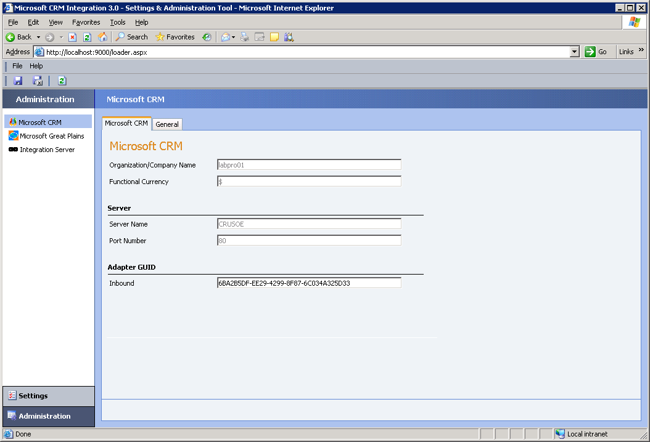
Organizational/Company Name. This is the Microsoft CRM 3.0 organization name. This value is read-only.
Functional Currency. This is the Microsoft CRM 3.0 functional currency. This is the currency type that is sent from Microsoft Great Plains to Microsoft CRM 3.0 for sales orders and price lists. If multi-currency is not enabled in Microsoft Great Plains this field will appear empty. This value is read-only.

Important If multi-currency is not enabled in the Microsoft Great Plains company that is integrated with Microsoft CRM, the functional currency will not appear in the Settings and Administration Tool. For more information about this issue, see the “Prerequisites” section in “Chapter 3 Installation.”

Server Name. This is the name of the server where Microsoft CRM 3.0 is running. This value is read-only.
Port Number. This is the Internet protocol TCP port that is used by Microsoft CRM Connector for Microsoft Dynamics GP. This value is read-only.
Inbound. This is the inbound adapter GUID for Microsoft CRM 3.0. If you develop your own Microsoft CRM 3.0 inbound adapter GUID for Microsoft CRM Connector for Microsoft Dynamics GP, you must add the new GUID in this box.
The General tab contains the following options:
Retry Interval. Set the number of seconds before integration messages are retried.
Retry Count. Set the number of attempts to retry a message.
BizTalk Server 2004 Polling Interval (seconds). Set the number of seconds that will pass before BizTalk Server 2004 will poll for new messages.
BizTalk Server 2004 Batch Size. Set the batch size.

Microsoft Great Plains Area
This area contains the following two tabs.
The Microsoft Great Plains tab contains the following options:
Organizational/Company Name. This is the Microsoft Great Plains company name. This value is read-only.
Functional Currency. This is the Microsoft Great Plains functional currency. This is the currency type that is sent from Microsoft Great Plains to Microsoft CRM 3.0 for sales orders and price lists. This value is read-only.
Server Name. This is the name of the server where Microsoft Great Plains is running. This value is read-only.
Inbound. This is the inbound adapter GUID for Microsoft Great Plains. If you develop your own Microsoft Great Plains inbound adapter for Microsoft CRM Connector for Microsoft Dynamics GP for Great Plains, you must add the new GUID in this box. You can change the inbound adapter GUID.
The General tab contains the following options:
Retry Interval. Set the number of seconds before integration messages are retried.
Retry Count. Set the number of attempts to retry a message.
BizTalk Server 2004 Polling Interval (seconds). Set the number of seconds that will pass before BizTalk Server 2004 will poll for new messages.
BizTalk Server 2004 Batch Size. Set the batch size.
eConnect Polling Interval (seconds). Set the number of seconds that will pass before the eConnect component will poll for new messages.

Integration Server Area
This area contains the following tabs and functions:
Application Status. This tab provides a list of the integration services (Microsoft CRM, Microsoft Great Plains, eConnect, Message Queuing, and BizTalk Server 2004) and their corresponding status.
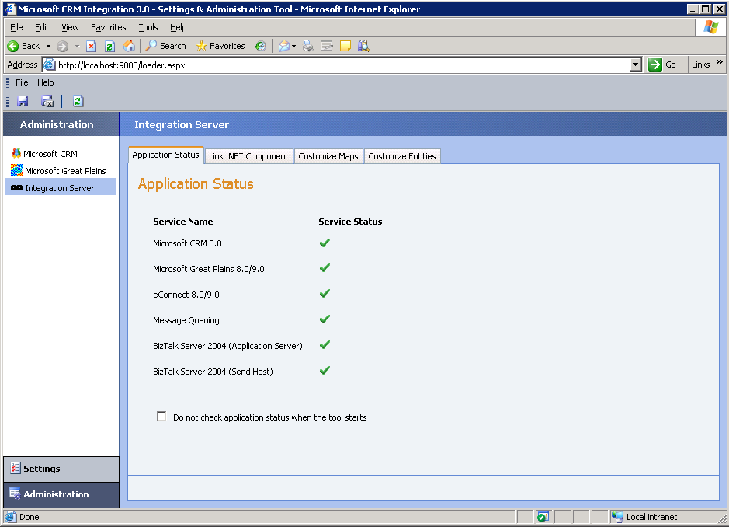
A (green check mark) indicates that the service is running. Conversely, (red X) indicates that the service is not running.
Additionally, an integration service may indicated that it is not running by displaying , if a COM+ component that the service depends on, is not running. For example, if the MbsIntegration.SyncIntegration COM+ component is not running on the integration server, the Message Queuing service may display , even though the Message Queuing service is running.
The following table displays the integration services and corresponding COM+ components that each service depends on.
Integration Service | COM+ Component | Server Location
Message Queuing | MbsIntegration.SyncIntegration | Integration Server
BizTalk Server 2004 (Application Server) | MbsIntegration.SyncIntegration | Integration Server
BizTalk Server 2004 (Send Host) | MbsIntegration.SyncIntegration | Integration Server
SQL Server | MbsIntegration.SyncIntegration | Integration Server
Microsoft CRM 3.0 | MbsIntegration.CrmInbound | Microsoft CRM 3.0 Server
Microsoft Great Plains 8.0/9.0 | MbsIntegration.GpInbound | Microsoft Great Plains Server
eConnect 8.0/9.0 | MbsIntegration.GpInbound | Microsoft Great Plains Server

You can view a COM+ component service by using the Component Services MMC snap-in. To start the Component Services MMC snap-in, click Start, point to Programs, point to Administrative Tools, and then click Component Services.
If you want to avoid the status check when you start the Settings and Administration Tool, click to check the Do not check application status when the tool starts checkbox on the Application Status tab.

Link .NET Component. On this tab, you can configure the custom logic that will be used when a message of the linked schema is delivered to the integration system. With this feature, you can link a Microsoft .NET component with the Microsoft CRM 3.0 schema that will be called each time the Microsoft CRM 3.0 schema, such as an account schema, is received.
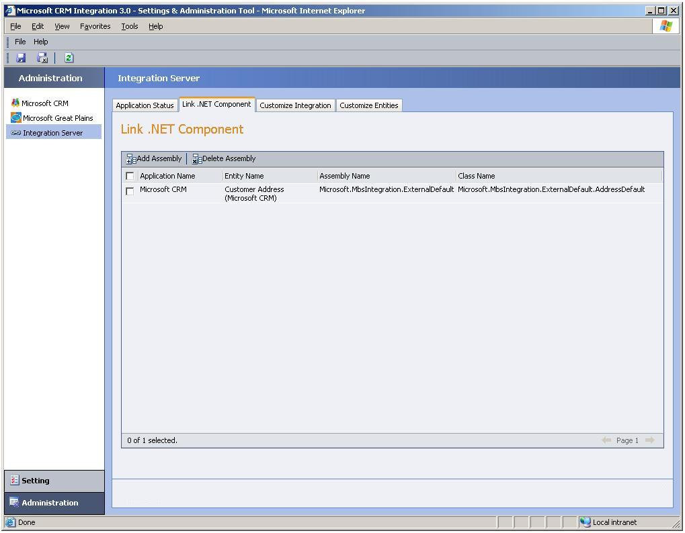
For example, you can create a .NET component that contains custom logic that would create an account number in Microsoft CRM each time a Microsoft CRM 3.0 account schema is received. Then, on this tab you can link the .NET component to the integration system. More information and an example for linking a .NET component are available in Chapter 8 “Customizing Integration.”

Customize Integration. This tab includes a list of schema and map assemblies. From this area, you can customize integration by adding new entities, new map assemblies (.DLL files), or delete existing mapped entities. More information and an example of customizing integration are available in Chapter 8 “Customizing Integration.”
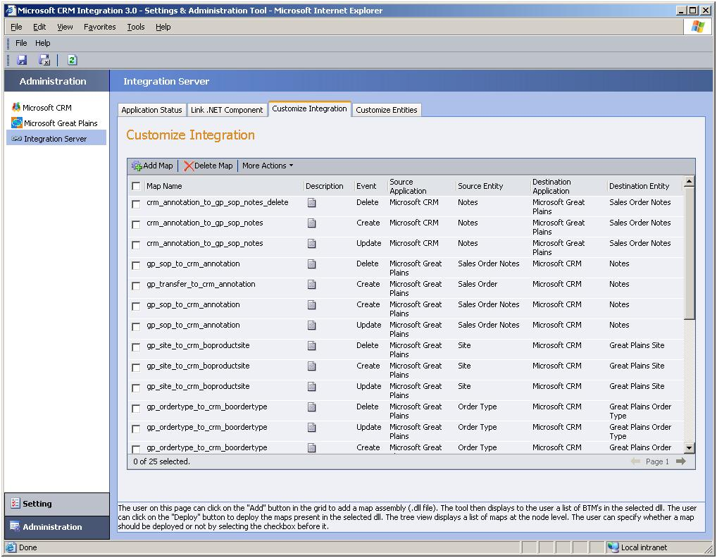

Customize Entities. This tab displays a list of Microsoft CRM 3.0 and Microsoft Great Plains entities. On this tab you can also add custom entity key parts or delete existing entity key parts. A key part displays the name of the XML nodes that are part of the primary key for each entity instance schema that is integrated. More information and an example of customizing integration are available in Chapter 8 “Customizing Integration.”
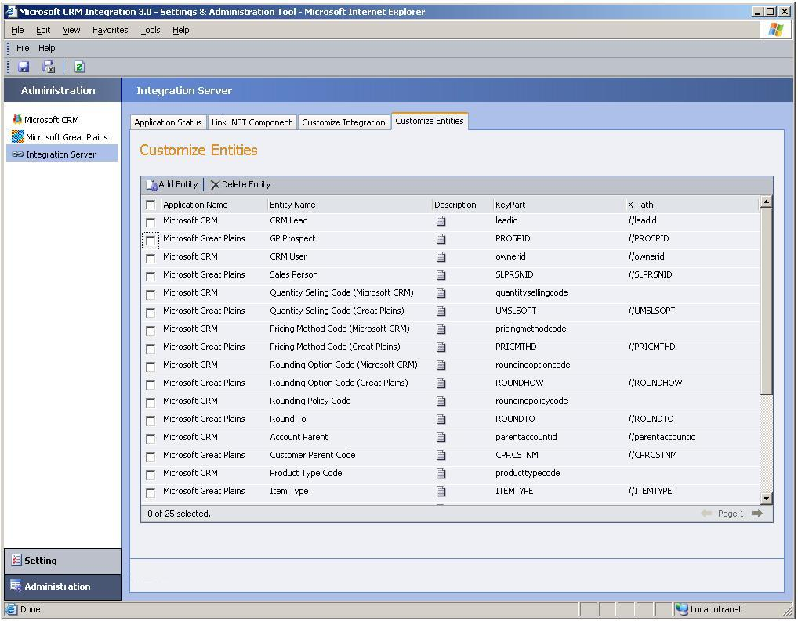

Settings
To switch to the Settings area, click Settings in the lower-left pane of the Settings and Administration Tool. Under Settings, there are the following areas:

Microsoft CRM 3.0 Area
This area contains the following tabs and functions:
Accounts/Contacts. This tab contains a list that determines whether Microsoft Great Plains customers are published to Microsoft CRM 3.0 as contacts or accounts.
Default Values. On this tab, you can configure the default settings for Microsoft CRM 3.0 account, contact, order and invoice records. These values will be used when the source application entity field does not contain a value. This tab contains the following areas:
● The Product area, which contains the following option:
● Product Type Code. Choose the default product type code for items that are published from Microsoft Great Plains to Microsoft CRM 3.0. By default, the product type code is Sales Inventory. Additional choices are Miscellaneous Charges, Services, and Flat Fees. This is a required field.
● The Account area, which contains the following options:
● Account Category Code. Choose the default account category that is used when publishing Microsoft Great Plains customer records to Microsoft CRM 3.0. By default, the choices are Preferred Customer or Standard. This information will appear in the Category field on the Details tab of the account form in Microsoft CRM 3.0.
● Shipping Method. Choose the default shipping method for accounts that will be created in Microsoft Great Plains and published to Microsoft CRM 3.0. By default, the choices are Airborne, DHL, FedEx, UPS, Postal Mail, Full Load, and Will Call.
● Payment Terms. Choose the default payment terms for an account. By default, the choices are Net 30, 2% 10, Net 30, Net 45, Net 60. This information will appear in the Payment Terms field on the Administration tab of the account form.
● The Contact area, which contains the following options:
● Shipping Method. Choose the default shipping method for contacts that will be created in Microsoft Great Plains and published to Microsoft CRM 3.0. By default, the choices are Airborne, DHL, FedEx, UPS, Postal Mail, Full Load, and Will Call.
● Payment Terms. Choose the default payment terms for contacts that will be created in Microsoft Great Plains and published to Microsoft CRM 3.0. By default, the choices are Net 30, 2% 10, Net 30, Net 45, Net 60.

● The Sales Order area, which contains the following options:
● Shipping Method. Choose the default shipping method for sales orders that will be created in Microsoft Great Plains and published to Microsoft CRM 3.0. By default, the choices are Airborne, DHL, FedEx, UPS, Postal Mail, Full Load, and Will Call.
● Payment Terms. Choose the default payment terms for sales orders that will be created in Microsoft Great Plains and published to Microsoft CRM 3.0. By default, the choices are Net 30, 2% 10, Net 30, Net 45, Net 60.
● Price Level. Choose the default price level for sales orders that are created in Microsoft Great Plains and then published to Microsoft CRM 3.0.

● The Invoice area, which contains the following options:
● Shipping Method. Choose the default shipping method for invoices that will be created in Microsoft Great Plains and published to Microsoft CRM 3.0. By default, the choices are Airborne, DHL, FedEx, UPS, Postal Mail, Full Load, and Will Call.
● Payment Terms. Choose the default payment terms for invoices that will be created in Microsoft Great Plains and published to Microsoft CRM 3.0. By default, the choices are Net 30, 2% 10, Net 30, Net 45, Net 60.
● Price Level. Choose the default price level for sales invoices that are created in Microsoft Great Plains and then published to Microsoft CRM 3.0.

Mapped Entities. On this tab you can view and customize the Microsoft CRM 3.0 attribute mappings.
To display an entity attribute link, click the field name in the Field Name list.
For example, to view the default attribute mappings for the payment terms of a Microsoft CRM 3.0 account, click Account Payment Terms in the Field Name list. By default, the following attribute mappings are displayed in the Settings and Administration Tool:
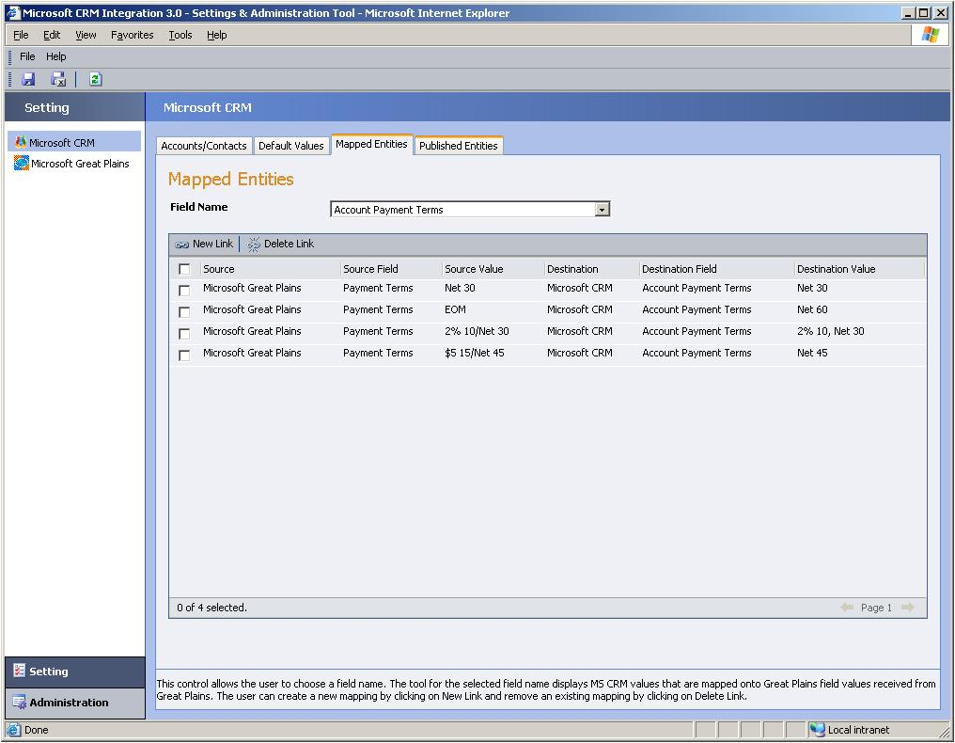
Additionally, on this tab you can delete an existing entity field link or add a new entity field link.

Published Entities. On this tab you select what entities you want to publish to Microsoft Great Plains.
For example, if you want only Microsoft CRM 3.0 contacts published to Microsoft Great Plains, click to clear Publish Accounts, Publish Addresses, and Publish Orders.

Note If you turn off address publication on this tab, order publication is also turned off.

Microsoft Great Plains Area
Under Settings, this area contains the following tabs and functions:
Customers. On this tab you can configure the customer and account entity instances that are published from Microsoft CRM 3.0 to Microsoft Great Plains. This tab contains the following areas:
● The Customers area, which contains the following option:
● Create Customers As. You can choose how you want customer records published in Microsoft Great Plains. You can have customer records published when Microsoft CRM 3.0 accounts or contacts are created by selecting Always, or have customer records created only when an order is submitted from Microsoft CRM 3.0 by selecting On order only. This is a required field.
● The Account To Customer area, which contains the following options:
● Customer Creation. You can choose how you want Microsoft CRM 3.0 account record names published in Microsoft Great Plains. By default, the only option available is the account name. This is a required field.
● Suffix. You can set the suffix that you want that will append to the customer ID. Because Microsoft Great Plains customer IDs are generated using an account name, a numeric suffix is added to the customer ID in Microsoft Great Plains when duplicate account names exist. This suffix is incremented by one for each instance of the duplicate account name. By default, the suffix begins at 0.

● The Contact To Customer area, which contains the following options:
● Customer Creation. You can choose how you want Microsoft CRM 3.0 contact record names published in Microsoft Great Plains. By default, the only option available is the contact name. This is a required field.
● Suffix. You can set the suffix that you want that will append to the customer ID. Because Microsoft Great Plains customer IDs are generated using a contact name, a numeric suffix is added to the customer ID in Microsoft Great Plains when duplicate contact names exist. This suffix is incremented by one for each instance of the duplicate contact name. By default, the suffix begins at 0.

● The Address area, which contains the following options:
● Address Creation. Select from this list to determine how address IDs are published to Microsoft Great Plains. Available options are static ID that is created by the integration system, the Microsoft CRM 3.0 address name for the associated address, or the Microsoft CRM 3.0 phone number for the associated address. This is a required field.
● Address Static ID. If you select Static ID in the Address Creation list, you can add the ID that will be used to generate the address ID in Microsoft Great Plains.
● Suffix. You can set the suffix that you want that will append to the address ID. This suffix will be appended to the address ID. If a duplicate address ID exists, a suffix will be added. This suffix is incremented by one for each instance of the duplicate address ID. By default, the suffix begins at 0.

Sales Documents. On this tab you can configure customer credit options, batch creation, and inventory settings.
The Sales Document tab contains the following areas:
● The Sales Documents area, which contains the following options:
● Override Credit Limit. This option lets you specify whether Microsoft Great Plains sales orders for a customer that has exceeded the specified credit limit will be published to Microsoft CRM 3.0. By default, this option is set to false. This is a required field.
● Create Orders if Customer on Hold. This option lets you specify whether Microsoft Great Plains sales orders for a customer that is on hold will be published to Microsoft CRM 3.0. By default, this option is set to false. This is a required field.

● The Batches area, which is where you configure how batches are managed, contains the following options:
● Batch Creation Option. Choose whether batch IDs should be created hourly, daily, or monthly. This is a required field.
● Prefix. Type a alphanumeric prefix that will be used to create the batch ID.
● Start Day. If you select Weekly in the Batch Creation Option list, you can select the day of the week to start each batch.

● The Inventory Transactions area, which contains the following options:
● Item Quantity Shortages. Select how Microsoft Great Plains orders that have quantity shortages are published to Microsoft CRM 3.0. This is a required field. The following options are available:
● Override Shortages. By selecting this option, you can choose to have all orders that have quantity shortages published to Microsoft CRM 3.0.
● Back Order All. By selecting this option, you can choose to have all back orders published to Microsoft CRM 3.0. For example, if an order has a quantity of 10 items, and 5 of the items are back ordered, all 10 items will appear as back ordered in Microsoft CRM 3.0.
● Back Order Balance. By selecting this option, you can choose to have all back orders published to Microsoft CRM 3.0. For example, if an order has a quantity of 10 items, and 5 of the items are back ordered, only the 5 back ordered items will appear as back ordered in Microsoft CRM 3.0.

● Kit Quantity Shortages. Select how Microsoft Great Plains orders that have kit quantity shortages are published to Microsoft CRM 3.0. This is a required field.
● Default Inventory Location. Choose the default Microsoft Great Plains inventory location that will be published to Microsoft CRM for sales orders. This list is populated from the Microsoft Great Plains Site ID list. This is a required field.

Default Values. On this tab you can set the default values for Microsoft Great Plains features. The following options are:
● Customer Class ID. Choose the default customer class ID that will be used for records published to Microsoft CRM 3.0. This list is populated from the Microsoft Great Plains Class ID list. This is a required field.
● Shipping Method. Choose the default shipping method that will be used for records published to Microsoft CRM 3.0. This list is populated from the Microsoft Great Plains Shipping Methods list.
● Payment Terms. Choose the default Microsoft Great Plains payment term that will be used for records published to Microsoft CRM 3.0. This list is populated from the Microsoft Great Plains Payment Terms list.

Mapped Entities. On this tab you can view and customize the Microsoft Great Plains attribute mappings.
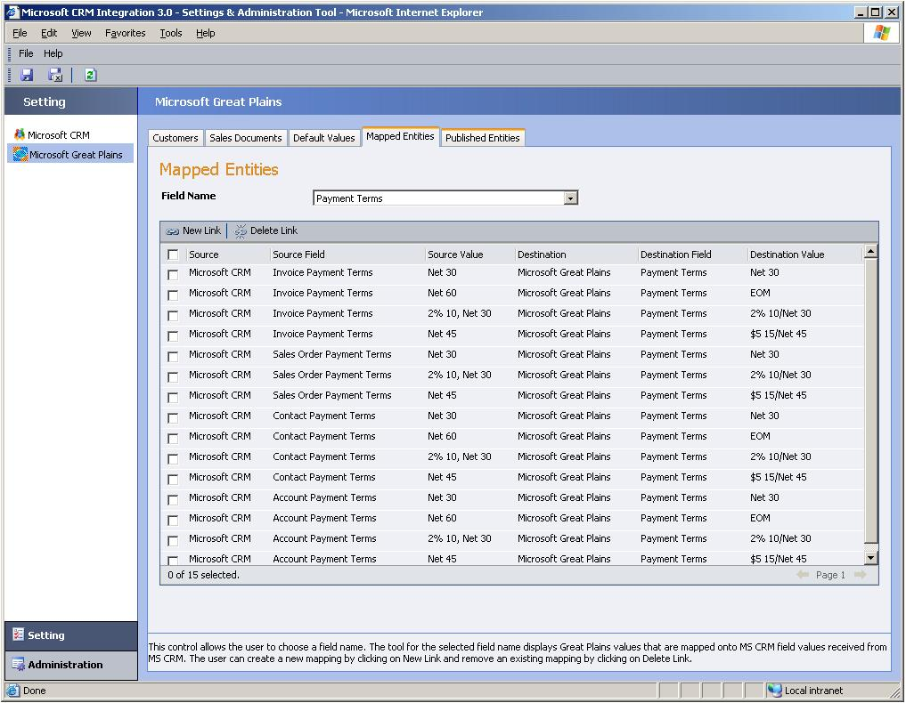
To display an entity attribute link, click the field name in the Field Name list. Additionally, on this tab you can delete an existing entity field link or add a new entity field link. For example, to view the default attribute mappings for the shipping method of a Microsoft Great Plains account, click Shipping Method in the Field Name list.
Published Entities. On this tab you select what entities you want to publish to Microsoft CRM 3.0. For example, if you want only Microsoft Great Plains customers published to Microsoft CRM 3.0, click to clear Publish Addresses, Publish Products, and Publish Orders.

Note If you turn off product publication on this tab, order publication is also turned off.

Data Synchronization Tool
The Data Synchronization Tool is a graphical tool that you can use to synchronize customer, address, product, order, and invoice data between Microsoft CRM 3.0 and Microsoft Great Plains. The Data Synchronization Tool performs the following functions:
● Migrates data from Microsoft CRM 3.0 to Microsoft Great Plains
● Migrates data from Microsoft Great Plains to Microsoft CRM 3.0
● Synchronizes data that exists in both Microsoft CRM 3.0 and Microsoft Great Plains

Note Data migration is discussed in the Migrate Records section of Chapter 3 Installation Instructions.

The Data Synchronization Tool can only be installed and run from the server where Microsoft CRM 3.0 Integration with Great Plains is installed. Additionally, this tool can only be used by a user who is a member of the Microsoft Active Directory® integration group. This group is specified during Microsoft CRM Connector for Microsoft Dynamics GP Setup.
After you install Microsoft CRM Connector for Microsoft Dynamics GP you can migrate data from one application to the other. Migration is typically a one way synchronization process from the source application to the destination application. This process is common for companies that have been using Microsoft Great Plains and have recently installed Microsoft CRM 3.0 and now want to populate Microsoft CRM 3.0 with Microsoft Great Plains data.
Similarly, you can use the Data Synchronization Tool to manage the synchronization of existing data between Microsoft CRM 3.0 and Microsoft Great Plains.

Data Synchronization Tool Components
The Data Synchronization Tool has the following main components:
● Rules
● Record View Classifications
● Synchronize Function

Rules
The Data Synchronization Tool uses rules to classify linked and unlinked records. In this context, a record is an instance of an entity, such as a certain customer record or a particular order. In an integrated environment, a linked record is a record that has a corresponding entity instance in the destination application.
Rules establish how records are classified. There are five different classifications of linked records that illustrate the degree to which a particular record is linked. For more information about these classifications, see the “Record View Classifications” section later in this chapter.
By default, the Data Synchronization Tool provides a comprehensive set of rules for all entities that can be integrated. However, if you choose, you can delete or modify the default rules or expand the default set of rules by creating your own.

Supported Entities and Attributes
The following table lists the Microsoft CRM 3.0 entities and attributes for each entity that are supported by using the Data Synchronization Tool.
Microsoft CRM 3.0 Entity | Microsoft CRM 3.0 Entity Attributes
Account | Customer, Phone, City, State, Zip
Contact | Customer, Phone, City, State, Zip
Address | Phone, City, State, Zip
Price List | Name, Description
Unit Group | Name, Description
Unit | UOM Schedule Name, Base UOM, Quantity, Name
Product | Name, Standard Cost, Current Cost
Sales Order (Order) | Bill To Name, Bill To Address Line1, Bill To Address Line2, Bill To Address Line3, Bill To City, Bill To State/Province, Bill To Zip/PostalCode, Bill To Country, Bill To Phone, Bill To Fax, Ship To Name, Ship To Address Line 1, Ship To Address Line 2, Ship To Address Line 3, Ship to City, Ship To State/Province, Ship To Zip/PostalCode, Ship To Country, Ship To Phone, Ship To Fax, Order Type, Freight Amount, Total Tax($), Default Site, Total Amount($), Shipping Method
Sales Order Detail | Ship To Address Name, Ship To Address: Street 1, Ship To Address: Street 2, Ship To Address: Street 3, Ship to Address: City, Ship To Address: State/Province, Ship To Address: Zip/PostalCode, Ship To Address: Country/Region, Quantity Ordered, Requested Ship Date
Invoice | Bill To Name, Bill To Address Line1, Bill To Address Line2, Bill To Address Line3, Bill To City, Bill To State/Province, Bill To Zip/PostalCode, Bill To Country, Bill To Phone, Bill To Fax, Ship To Name, Ship To Address Line 1, Ship To Address Line 2, Ship To Address Line 3, Ship to City, Ship To State/Province, Ship To Zip/PostalCode, Ship To Country, Ship To Phone, Ship To Fax, Order Type, Freight Amount, Total Tax($), Default Site, Total Amount($), Shipping Method
Invoice Detail | Ship To Address Name, Ship To Address: Street 1, Ship To Address: Street 2, Ship To Address: Street 3, Ship to Address: City, Ship To Address: State/Province, Ship To Address: Zip/PostalCode, Ship To Address: Country/Region, Invoice Quantity

The following table lists the Microsoft Great Plains entities and attributes for each entity that is supported by the Data Synchronization Tool.
Microsoft Great Plains Entity | Microsoft Great Plains Entity Attributes
Customer | Customer, Phone, City, State, Zip
Address | Phone, City, State, Zip
Price Level | Name, Description
UOM Schedule | Name, Description
UOM | UOM Schedule, Base UOM, Quantity, UOM Name
Item | Description, Standard Cost, Current Cost
Sales Order | SOP Number, Bill To Contact, Bill To Address Line1, Bill To Address Line2, Bill To Address Line3, Bill To City, Bill To State, Bill To Zip, Bill To Country, PHONE1, PHONE2, PHONE3, Ship To Name, Ship To Address Line 1, Ship To Address Line 2, Ship To Address Line 3, Ship to City, Ship To State, Ship To ZipCode, Ship To Country, Freight ($), Total Tax($), Default Site ID, Total ($), Shipping Method
Sales Order Line | Ship To Address Name, Ship To Address: Street 1, Ship To Address: Street 2, Ship To Address: Street 3, Ship to Address: City, Ship To Address: State/Province, Ship To Address: Zip/PostalCode, Ship To Address: Country/Region, Quantity Ordered, Requested Ship Date
Invoice | Bill To Contact, Bill To Address Line1, Bill To Address Line2, Bill To Address Line3, Bill To City, Bill To State, Bill To Zip, Bill To Country, PHONE1, PHONE2, PHONE3, Ship To Name, Ship To Address Line 1, Ship To Address Line 2, Ship To Address Line 3, Ship to City, Ship To State, Ship To ZipCode, Ship To Country, DocID, Freight ($), Total Tax($), Default Site ID, Total ($), Shipping Method
Invoice Order Line | Ship To Address Name, Ship To Address: Street 1, Ship To Address: Street 2, Ship To Address: Street 3, Ship to Address: City, Ship To Address: State/Province, Ship To Address: Zip/PostalCode, Ship To Address: Country/Region, Invoice Quantity

By default, Discount, Discount Type, and Discount List entities are not supported.

Record View Classifications
Rules determine how a record will be classified and subsequently appear in the records view of the Data Synchronization Tool. With the default set of rules, records that are in the Microsoft Great Plains and Microsoft CRM 3.0 databases are collected and displayed by the Data Synchronization Tool into one of six different classifications. The classifications are based on the records link status and whether the rules for the entity are fully satisfied, partially satisfied, or not satisfied. A record that is not linked to a destination record can assume a matched, partially matched, unmatched, conflicting, or unresolved category.
For example, in an environment where there is an established implementation of Microsoft Great Plains with data and a new installation of Microsoft CRM 3.0 that has no existing data, the Data Synchronization Tool will display all records for Microsoft Great Plains as unmatched. This is because, since there is no corresponding data in the destination application (Microsoft CRM 3.0), no link between records can exist.
A record, such as a customer, may have a referenced record, such as additional address records.
Records that are linked have the following record view category:
● Linked Records: These record pairs and any referenced records are matched to a destination record and a link exists in the integration system. The link ensures that any changes made to one record are reflected in the other record. Linked record pairs suggest that the record pairs have been successfully synchronized at least one time. With this category, no further classification exists.
The following list describes each of these five record view categories for records that are not linked:
● Matched Records: These records are fully matched and as defined in the rules, are not linked to a destination record. Both mandatory and optional rules for the entity pair are satisfied.
● Partially Matched Records: These records are not linked to a destination record and all mandatory rules for the entity pair are matched; however at least one optional rule is not matched.
● Unmatched Records: These records are not linked to a destination record and no matching record is found in the destination application. Therefore, there is no entity pair. If you are migrating data from Microsoft Great Plains to Microsoft CRM, all Microsoft Great Plains records are classified as unmatched.
● Conflicting Records: These records are not linked to a destination record and more than one record in the destination application is identified as a match. Conflicting records can occur when there are duplicate records in the destination application or if the rules that are defined are too permissive.
● Unresolved Records: This record’s parent record does not have a link to a destination record. For example, a customer address that has a parent customer record that is not linked will be in the unresolved records category.
To view record categories, you select a source application, such as Microsoft Great Plains and a destination application, such as Microsoft CRM. The records that are displayed represent a one way relationship, from the source application to the destination application. Because the Data Synchronization Tool displays links and matches that are one way, the same entity instance pair may appear in different categories, depending on the source and destination application.
For example, if there is a duplicate entity instance in Microsoft CRM 3.0, the Data Synchronization Tool will display the following depending on which is selected as the source or destination application:

Source Application | Destination Application | Record Classification
Microsoft Great Plains | Microsoft CRM 3.0 | Conflicting Records
Microsoft CRM 3.0 | Microsoft Great Plains | Matched Records

When you view data, review each application for both source and destination to get a complete picture of the status for entity instance pairs.

Synchronize
After you click Synchronize, you cannot stop, reverse, or undo the process. Therefore, you must preview and verify all records before you synchronize. When you are sure you have the entity records that you want to synchronize, click Synchronize.

Delete
The Data Synchronization Tool provides a feature to delete unmatched records in Microsoft CRM. You can delete unmatched records by selecting the record in the list, click Show Detail, select the records that you want to delete in the unmatched records list, and then click Delete.
This option is available for the following entities:
● Product
● Unit Group
● Unit
● Invoice
● Invoice Detail
● Price Level

Note When you delete a Microsoft CRM invoice by using the Data Synchronization Tool, the invoice will not be deleted, but instead will be closed with a status reason of canceled.

Entity Pairs That Support Synchronization
The Data Synchronization Tool supports linking, migrating, correlating the following entity pairs from Microsoft CRM 3.0 to Microsoft Great Plains. For more information about entity publishing, see the “Types of Information Shared” section in chapter 2, “Overview.”
The following table describes the Data Synchronization Tool migrate and link support for Microsoft CRM and Microsoft Great Plains entities.
Entity Pair | Microsoft CRM to Great Plains Migrate and Link Support? | Great Plains to Microsoft CRM Migrate and Link Support? | Correlate and Link Support?
CRM Account – GP Customer | Yes | Yes | Yes
CRM Contact – GP Customer | Yes | Yes | Yes
CRM Address – GP Address | Yes | Yes | Yes
CRM Sales Order – GP Sales Order | Yes | Yes | Yes
CRM Invoice – GP Invoice | No | Yes | Yes
CRM Sales Order Detail – GP Sales Order Item | Yes | Yes | Yes
CRM Invoice Detail – GP Invoice Item | No | Yes | Yes
CRM Product – GP Item | No | Yes | Yes
Unit Group - UOMSchedule | No | Yes | Yes
Unit – UoM | No | Yes | Yes
Price List – Price Level | No | Yes | Yes
Order Type-Order Type | No | Yes | Yes
Site-Site | No | Yes | Yes

Correlating Data by Using the Data Synchronization Tool
Besides migrating data, you use the Data Synchronization Tool to correlate data that already exists in both Microsoft Great Plains and Microsoft CRM 3.0. When you correlate existing data, you should first search and review the following two unlinked record categories because these record categories typically suggest a discrepancy:
● Conflicting Records. Unlinked records in this category suggest a discrepancy, where an entity instance matches with two or more destination entity instances. For example, a Microsoft Great Plains customer may match with two similarly named accounts in Microsoft CRM . In such cases, you can choose which destination record to link with the source record using Data Synchronization .
● Partially Matching Records. Unlinked records in this category suggest an incomplete match between a source application entity record and a destination application entity record. To resolve this, you can replace the source application entity record contents with the destination application entity record or vice versa.

After you have resolved the conflicting and partially matching records, you can synchronize the matching and unmatched records.

Data Correlation Step By Step

The following section discusses the typical steps an integration administrator might use to synchronize integration data by using the Data Synchronization Tool.

Step 1: Start the Data Synchronization Tool
The Data Synchronization Tool can only be installed and run from the server where Microsoft CRM Connector for Microsoft Dynamics GP is installed. To start the Data Synchronization Tool, click Start, point to Programs, point to Microsoft CRM Connector for Microsoft Dynamics GP, and then click Data Synchronization.

Step 2: Review Default Rules
By default, Microsoft CRM Connector for Microsoft Dynamics GP includes several integration rules for each entity. The list of rules is comprehensive and complete and should apply to most integration environments. You should review and verify all rules before you synchronize data by using the Data Synchronization Tool.
To examine the default rules, click Specify Rules from the Data Synchronization Tool start screen. On the Rules tab, select the source application in the Source Application list, and then select the destination application from the Destination Application list. Data is synchronized from the source application to the destination application.
Next, select the entities where you want to examine or modify rules. Click the entity that you want in the Entity list for the source application, and then click the entity in the Entity list for the corresponding destination application.
For example, you can review the default rules for Microsoft Great Plains customer record synchronization to Microsoft CRM 3.0 account records. To do this, select Microsoft Great Plains as the source application and Customer as the source entity, and then select Microsoft CRM 3.0 as the destination application and Account as the destination entity. The default rules for the entity pair is displayed in the List of Rules list.
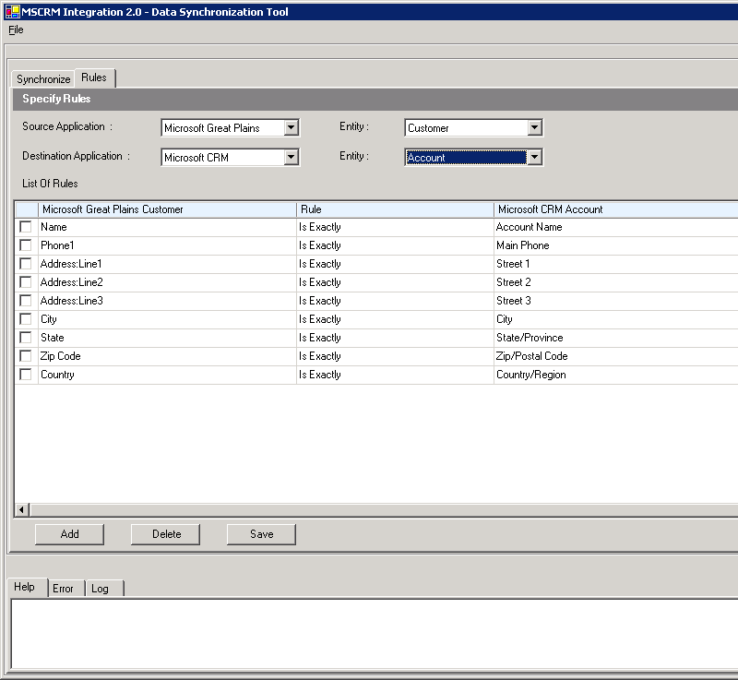
Figure 7.1 A list of rules for the Microsoft Great Plains Customer entity
Each entity contains attributes, such as Name, Phone1, and Zip Code. Each default rule maps a source application attribute to a destination application attribute and provides the logic for how entities are synchronized. By clicking an item in the list, you can change the item. In this window, you can also create new rules or delete existing rules.
Rules have the following components:
● Source Application. Data is transferred from the source application to the destination application. In this example, Microsoft Great Plains is the source application.
● Destination Application. In this example, Microsoft CRM 3.0 is the destination application.
● Entity. This is the entity for the source and destination applications.
● Rule. This is a condition that is used to determine how records are matched. The following options are available:

● Contains. For a rule to be true, the source field value must contain part of the destination field value. For example, if the source field is “aabbcc” and the destination field is “aabb”, the rule would be true. You can select this condition for string fields, but not numeric fields.
● Is Contained In. For a rule to be true, the destination field value must contain a part of the source field value. For example if the destination field is “aabbcc” and the source field is “aabb”, the rule would be true. You can select this condition for string fields, but not numeric fields.
● Is Exactly. For a rule to be true, the two fields must match exactly. This condition can be used for fields that have string values. Fields that contain numeric values can only use this condition.

● Mandatory/Optional: You select Mandatory or Optional to determine whether the rule will be processed as either mandatory or optional. This component establishes how a record is classified, such as matched, partially matched, or unmatched.
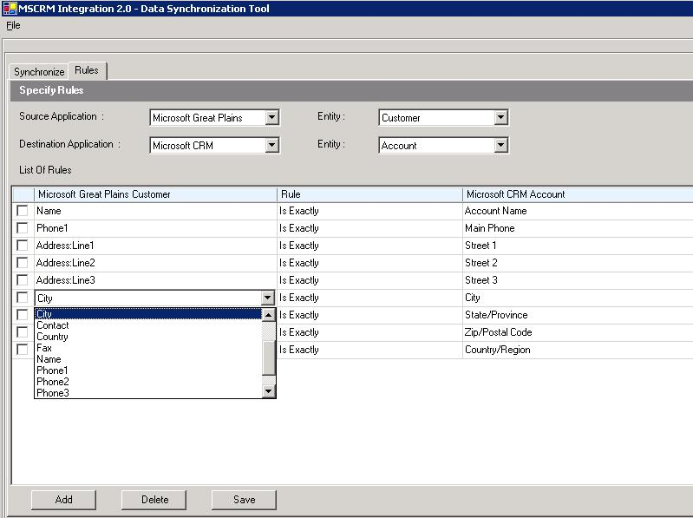
Figure 7.2 Viewing the available attributes in a rule for the City attribute

Important The default rules that are included with Microsoft CRM Connector for Microsoft Dynamics GP are designed to suit most Microsoft CRM 3.0 and Microsoft Great Plains integration environments. Before synchronizing data by using the Data Synchronization Tool, verify the default set of rules and, if necessary, modify them to meet the needs of your integration environment.

Step 3: Select the Applications, Entities, Classification, and Dates to Synchronize
After you have reviewed the default rules, you can synchronize existing data. To synchronize, click the Synchronize tab, and then select the source and destination applications. Data is synchronized from the source application to the destination application.

Select the Source and Destination Applications and Entities
For example, if you want to transfer Microsoft Great Plains customer records to Microsoft CRM 3.0 account records, click Microsoft Great Plains in the Source list, and then click the Customer in the Entity list. Then, click Microsoft CRM 3.0 in the Destination list, and then click Account in the Entity list.
You cannot select the same application for both the source and destination.

Choose a Record Classification
You must also select a record classifications view. You can select a particular classification, such as Unresolved Records, or select All Records to display all record classifications.
When you are updating entities that already exist in both applications, it is better to review the partially matched records, conflicting records, and unmatched records categories. The matched records classification will display records that are already fully matched and as such will synchronize as expected.

Filter On a Date or Range of Dates
Click All for each Date control to select a date or a date range. This will display only the records that correspond to the date you select. Note that there are separate date filters for both the source and destination applications.

Note When you display Microsoft Great Plain Unit of Measure (UoM) records or UoM Schedule records, you cannot filter on date. When you click Display, all UoM or UoM Schedule entity records will appear in the list. This is because Microsoft Great Plains does not support a modified date attribute for those entities.

When you have the source and destination applications, the record classification and the dates that you want, click Display. Information that is similar to the following figure is displayed.
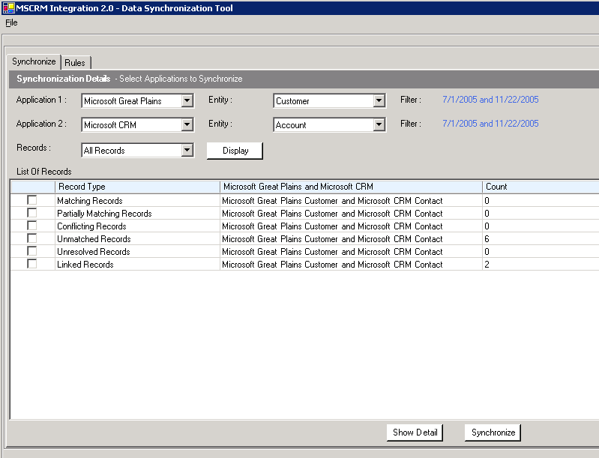
Figure 7.3 Selecting customer records to synchronize
In the List of Records list, note the Count column. This column displays the number of records for the associated classification. In Figure 7.3, there are six records that are classified as unmatched.

Step 4: Review and Verify the Records
To view the records from the list, click Show Detail. A window that is similar to the following is displayed.
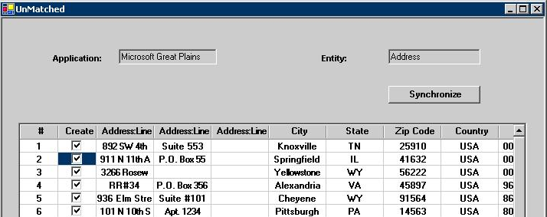
Figure 7.4 Record Details View
This list displays all the records that are a result of the selections that you made earlier.
You use this list to verify each record before committing it for synchronization. You can remove any record that is in the list from synchronization. To do this, click to clear the check box in the Create column for the corresponding record.

Step 5: Synchronize
When you have verified that you have the records that you want to synchronize, click Synchronize.
The action that follows depends on the record classification. For Matched Records, the Data Synchronization Tool creates a link between the source and destination applications.
For Unmatched Records, an entity instance is created in the destination application. For example, when a Microsoft CRM 3.0 account that has an Unmatched Record classification is synchronized, a customer record will be created in Microsoft Great Plains.

Important
● We recommend that you review the list of records that you select before you synchronize them.
● The view details feature is not available for records that have the Linked Records classification.
● After you click Synchronize, you cannot undo or reverse the transfer of records that have been submitted for synchronization.
● After you have synchronized an entity instance pair, you cannot synchronize the same entity instance pair again.

Migrating Data
For environments where one application does not contain data, the Data Synchronization Tool can be used to migrate data from one application to the other. Before you migrate data by using the Data Synchronization Tool, you must install Microsoft CRM Connector for Microsoft Dynamics GP and configure integration by using the Settings and Administration Tool. After you successfully migrate data for all entities from one application to the other, the two systems will be fully integrated. For more information about how to migrate data from Microsoft Great Plains to Microsoft CRM 3.0, see the “Migrating Records from Microsoft Great Plains” section in Chapter 3, “Installation Instructions.”

Integration Monitor
The Integration Monitor tool is a graphical tool that you can use to view the status of integration messages as they pass through the integration system. The main Integration Monitor tool window displays messages in a list that can be filtered by application, entity type, event, status, and date.
The Integration Monitor tool can only be installed and run from the server where Microsoft CRM Connector for Microsoft Dynamics GP is installed. To start the Integration Monitor tool, click Start, point to Programs, point to Microsoft CRM Connector for Microsoft Dynamics GP, and then click Integration Monitor.
By using the Integration Monitor you can perform the following functions:
● View information about messages including the XML contents and the link details.
● Determine why a message is failing to synchronize and resubmit the failed message.
● Create, open, and save queries that are used to filter and view messages.
The Integration Monitor tool can only be used by a user who is a member of the Microsoft Active Directory integration group. This group is created during Microsoft CRM Connector for Microsoft Dynamics GP setup. If a user who is not a member of this group, tries to run the tool the following message is displayed before the tool exits:
You do not have the required privileges to run this tool.

Viewing Messages
Integration Monitor is a powerful monitoring and troubleshooting tool. For example, if some records are not synchronizing correctly, you can use the tool to identify, analyze, and resubmit those messages to the integration system. To do this, click All Failure Messages from the Queries menu to display a list of all failed messages.
To further refine the list of messages that appear in the main Integration Monitor window, you can select from the following options:
● Application. Select the source application, Microsoft CRM 3.0 or Microsoft Great Plains, that you want to review integration messages for. Alternatively, you can select All to display messages from both applications.
● Entity. Select the type of entity that you want, such as Customer (Great Plains customer) or account (Microsoft CRM account).
● Event. Select the type of message event. The available options are create, update, or delete. You can select All to query all events.
● External ID. This identifier determines the display attribute for an entity instance. The display attribute is used to identify or query entity instances in Integration Monitor. For example, the Microsoft Great Plains customer entity uses the customer name attribute by default as the display attribute. To refine customer entity instance searches, you can query by using the customer name that is in Microsoft Great Plains, by typing the name in the External ID field. Also, all Microsoft Great Plains customer entity instances will use the display attribute to display the customer name in the External ID column. To view or change the display attribute, click Preferences on the View menu.
● Status. Choose the message status. Available options are succeeded, processing, timed out, and failed.
● Internal ID. To further refine your query, you can type the internal identifier for integration messages that are associated with a type of entity. The internal ID is the primary key for the entity instance. Because the primary key is unique for each entity instance, you can search using the internal ID to query messages associated with a specific entity instance.
● Date range. Enter a start and end date to view a list of messages over a period.
● Date. Enter a date to view a list of message for a specific date.

After you have the search criteria that you want, click Apply to view the list of messages.

Saving and Opening a Query
To save your search, click Save As, on the File menu. Integration Monitor query files are saved with a file name extension of .imq.
To open a saved query, click Open, on the File menu, select the query that you want, and then click Open.
Additionally, you can quickly open a recently opened query by selecting the query on the File menu.

Default Queries
Several default queries are included with the tool. You can run a query by clicking the search type that you want from the Queries menu. The default queries are located in the \config\IntMonitor\SystemViews folder where Microsoft CRM Connector for Microsoft Dynamics GP is installed.
The following default queries are available:
● All messages
● All messages of a current date
● All messages of last week
● All message of last month
● All messages of Accounts
● All messages of Customers
● All messages of Microsoft CRM Sales Orders
● All messages of Microsoft Great Plains items
● All failure messages
● All success messages

Note Click Refresh on the View menu to update the list of messages.

Preferences
The Preferences section lets you view and define the display attribute. The display attribute determines what attribute will be used to display an entity in the Integration Monitor tool. For example, for the Microsoft CRM 3.0 contact entity, you can choose to display the entity by using the first name or the last name attribute.
To view or change the display attribute mapping, click Preferences on the View menu.

Message Information Details
In the lower pane are several tabs that display operational information for the integration and specific details for the selected message. The following tabs are available:
● Content. When you click the Content tab, the XML contents of the message are displayed in generic format.
● Link. The Link tab displays the message ID, entity, and the source application for the selected message. Click Retrieve to display the XML contents for both source and destination applications that are specific to the entity instance.
● Status. On this tab, the following information is displayed:
● Message ID. This is the unique ID for the selected message.
● Integration Components Map. This map displays a visual representation of the operational status for the integration components that correspond to the selected message. Components that have a green color have successfully processed the message. Alternatively, components that have a red color have not been successful in processing the message.
● Status. This field displays the status of the selected message. A message can have a status of success, ignored, timed out, processing, or failed.
● Problem. This provides information about a message that has failed. For example, a message may have a problem description of Message timed out in map. If no problem is detected, this field will display None.
● Recommended Steps. This displays the recommended steps to take to resolve a message that has failed.

● Related Messages. This tab displays information about messages that relate to the selected message.
The following two related message types are displayed:
● Associated Events. This list displays messages that are related to the selected message. For example, a Microsoft CRM 3.0 account create message will display the update and delete messages that are received for that entity instance.
● Parent/Child Messages. This list displays messages that have a parent or child relationship with the selected message. For example, a Microsoft CRM 3.0 address entity has a parent entity of either a Microsoft CRM 3.0 account or contact.

● Log. This tab displays a list of details that are recorded during each stage of integration. You can use this information to track a failed message and determine the point where the failure occurred. The log information is recorded from the time the source application entity is submitted to the integration system.
You can hide or display the message details pane. To do this, right-click a message in the list, and then click Message Details. To copy the message information that is displayed in the list, right-click the message that you want, and then click Copy.

Integration Monitor Message Logging
By default, the logging detail for integration messages is set to level 1, which records errors and warnings. The logging detail can be changed in the Windows Registry MessageComponentLogLevel subkey, where 0 is the lowest level and 4 is the most verbose level of logging. The MessageComponentLogLevel subkey uses a REG_SZ data type and is located at the following registry path:
HKEY_LOCAL_MACHINE\SOFTWARE\Microsoft\MSCRMINTEGRATION\Loggers\
The possible logging level values for integration messages are:
Value | Flag | Description
0 | LOG_LEVEL_ERROR | Logs only error messages
1 | LOG_LEVEL_INFO | Logs only error messages and warnings
2 | LOG_LEVEL_FINE | Logs error messages, warnings, and some information
3 | LOG_LEVEL_FINER | Logs error messages, warnings, and information
4 | LOG_LEVEL_FINEST | Logs error messages, warnings, and detailed information

Resolving Integration Failures
When data is not updating from the source application to the destination application, the Integration Monitor tool can be used to diagnose the failure, determine the cause, and then resubmit the failed message.

Example Problem Scenario
Your company has been running Microsoft CRM Connector for Microsoft Dynamics GP for Great Plains 2.0 and customer data has been synchronizing successfully between the two applications. However, you notice that customer records that were created this morning in Microsoft Great Plains do not appear in Microsoft CRM 3.0.
1. Start the Integration Monitor Tool.
2. In the Application list click Microsoft Great Plains, in the Entity list click Customer, in the Status list click Failed, click Date, and then type in today’s date.
3. Click Apply.
4. In the message list, click to select the message that has Test displayed in the External Entity ID column.
5. Click the Status tab in the lower part of your screen. In the integration diagram, you notice that the Send Adapter component is red, which indicates a problem with that component. Observing the Problem and Recommended Steps areas, you are instructed to view the logs.
6. Click the Logs tab in the lower part of your screen, to review additional information about the failure.
7. Because the failure occurred during the Microsoft Great Plains send adapter to the Microsoft CRM inbound adapter, which are both COM+ applications, you start the Component Services MMC snap-in to verify that all related integration COM+ components are functioning correctly.
8. You expand MbsIntegration.CrmInbound, and notice that Microsoft.MbsIntegration.NewCrmInboundAdapter.CrmInboundImp has been disabled. You right-click Microsoft.MbsIntegration.NewCrmInboundAdapter.CrmInboundImp and click Enable to re-enable the COM+ application.
9. You switch back to Integration Monitor, click the Status tab and notice that the Send Adapter component is now displayed in green, which indicates that the component is functioning.
10. You click the first failed message in the list, and then, holding the shift key, you click the last failed message in the list. Then, you right-click the selected messages click Resubmit. This will resubmit the selected messages for integration.
11. You verify in Microsoft CRM 3.0 that the all Microsoft Great Plains customer records that failed previously are now transferred.

Message Resubmit
You can resubmit a message for integration that is failed, ignored, or timed out. For example, if the eConnect service has shut down, you may experience integration messages sent from Microsoft Great Plains that have timed out. After you restart the eConnect service, you can complete the transfer of data by resubmitting the integration messages. To resubmit a message to the integration system, right-click the messages that you want to resubmit for integration, and then click Resubmit. You can also resubmit messages by clicking Resubmit on the Action menu.

Message Terminate
You can terminate a message that is in a processing state for an unusual amount of time. When you terminate an integration message, the message state is transferred from processing to failed. When the message is in a failed state, it can be resubmitted.

Transfer Order or Invoice to Backorder Behavior
The following behavior occurs in Integration Monitor with orders or invoices where the quantity is transferred to a back order.
● Some quantities are transferred to a back order (partial transfer). When a partial transfer occurs with an order or invoice in Microsoft Great Plains, the integration message will process and Integration Monitor will display a status of Succeeded for the integration message.
● All quantities are transferred to back order (full transfer). When a full transfer occurs with an order or invoice in Microsoft Great Plains, the integration message will not be processed and Integration Monitor will display a status of Ignored for the integration message.
● Newly created back order transaction (back order). When a newly created back order transaction occurs with an order or invoice in Microsoft Great Plains, the integration message will not be processed and Integration Monitor will display a status of Ignored for the integration message.

Chapter 8

Chapter 8: Customizing Integration
The sections in this chapter explain how you can customize integration. These sections also provide a few simple customization examples as well as code samples. The information that follows assumes that the reader is familiar with Microsoft Visual Studio .NET 2003 or later versions and the Microsoft BizTalk Server 2004 SDK.
Microsoft CRM Connector for Microsoft Dynamics GP provides flexibility by allowing you to customize integration in several different ways. This chapter discusses the following three methods that you can use to customize integration.
● Modify the existing integration logic
● Add an application entity to integration
● Add or remove a link to a .NET component

Microsoft CRM Connector for Microsoft Dynamics GP BizTalk Server Project Customization
Microsoft CRM Connector for Microsoft Dynamics GP uses the BizTalk Server project named SchemaMaps. Before you can customize the SchemaMaps project, you must perform the following steps on the integration server:
1. Start Visual Studio .NET 2003 and add the following BizTalk Server project to a new blank solution, where InstallationFolder is the folder on the Microsoft CRM Connector for Microsoft Dynamics GP CD or the installation folder where Microsoft CRM Connector for Microsoft Dynamics GP installation files are located:
● InstallationFolder \SchemaMaps\MapsCRMGP
2. Then, add the following additional BizTalk Server projects to the solution.
● InstallationFolder \SchemaMaps\CRMSchemas\CRMSchemas.btproj
● InstallationFolder \SchemaMaps\GPSchemas\GPSchemas.btproj
3. In the MapsCRMGP.btproj project, make sure that the following BizTalk Server references are present. If they are missing you must add them.
● c:\BizTalkServer2004 installation folder\Microsoft.BizTalk.DefaultPipelines.dll
● c:\BizTalkServer2004 installation folder\Microsoft.BizTalk.GlobalPropertySchemas.dll

4. Add a reference to the following .dll file:
● CD_Drive:\installation folder\bin\Microsoft.MbsIntegration.FunctoidsCRMGP.dll
5. If you want to change the existing schema, add a reference to your custom .dll file, if the following .dll file references exist, remove them, and then compile:
● Microsoft.MbsIntegration.GPSchemas.dll.
● Microsoft.MbsIntegration.CRMSchemas.dll
6. You must provide a strong name file before you compile your schema project. Ensure that the delay sign is set to false. To set a delay sign of true, you must update the registry so that the strong name validation is ignored. For more information about strong name generation, see the Microsoft .NET Framework documentation.
Mapping Custom Schema Entities
You must map the source application entity schema definition (.xsd) file to the destination application entity schema file. Microsoft CRM 3.0 schemas, Microsoft Great Plains schemas, and maps between the two applications are located in the following folders of the Microsoft CRM Connector for Microsoft Dynamics GP CD or the installation folder where Microsoft CRM Connector for Microsoft Dynamics GP installation files are located:
• InstallationFolder\SchemaMaps\MapsCRMGP
• InstallationFolder\ Integration\SchemaMaps\GPSchemas
• InstallationFolder\Integration\SchemaMaps\CRMSchemas

Modify the Existing Integration Logic
You can modify the existing integration logic. For example, you can remove an entity from integration or edit integration entity attribute mappings by using the Mapped Entities tab or the Settings and Administration Tool.

Remove an Entity from Integration
You can remove an entity from integration by using the Settings and Administration Tool. To do this, follow these steps:
1. Click Start, point to Programs, point to Microsoft CRM Connector for Microsoft Dynamics GP, and then click Settings and Administration Tool.
2. Click the Administration tab, under Administration click Integration Server, and then click the Customize Entities tab.
3. Click to select the check box next to the entity that you want to delete.
4. Click Delete Entity.
5. Click OK.

Important
● An entity can only be deleted if no maps have been deployed and no integration messages associated with the entity have been processed by the integration system.
● Deleting an entity from the integration system can cause unexpected behavior or cause integration to not function correctly. Therefore, exercise caution when you delete an entity from integration.

Add an Application Entity to Integration
This section describes how you can integrate Microsoft CRM 3.0 entities with Microsoft Great Plains by creating mappings. By creating integration mappings, you can map custom entities or entities that are not mapped “out of box” in Microsoft CRM Connector for Microsoft Dynamics GP.

Prerequisites to Entity Integration Customization
Before you can add an entity to integration, you must replace the eConnect runtime version that is installed by Microsoft CRM Connector for Microsoft Dynamics GP Setup with the eConnect Developer Edition.
After you install the eConnect Developer Edition you must also run the eConnectSet.sql script that can be found at the following locations:
● <install-dir>\database\GP\eConnect8 (if Microsoft Great Plains 8.0 is installed)
● <install-dir>\database\GP\eConnect9 (if Microsoft Dynamics GP 9.0 is installed)

The eConnectSet.sql script must run on the Microsoft Great Plains database server. To run the SQL script, follow these steps:
1. Start the Microsoft SQL Server Query Analyzer. To do this click Start, point to Programs, point to Microsoft SQL Server, and then click Query Analyzer.
2. Open the file eConnectSet.sql from the above location.
3. Select the Great Plains company database from the list.
4. If you have a deployment configuration where the Great Plains server is running on a different computer than the Integration server, you must replace the string “.\MSCRM_Integration_GreatPlains” with “<Integration server>\MSCRM_Integration_GreatPlains” in the above file, where <Integration server> is the name of the computer where the Microsoft CRM Integration Server component is installed.
5. Run the SQL script.

How to Add an Entity to Integration
By default, Microsoft CRM Connector for Microsoft Dynamics GP does not integrate Microsoft CRM leads with Microsoft Great Plains prospects. However, you can use BizTalk Server 2004 tools and the Settings and Administration Tool to customize integration by creating mappings that will link lead entities with prospect entities.
Adding an entity involves the following procedures:
1. Obtain the preexisting or custom source application entity schema definitions to be included in integration.
2. Obtain the preexisting or custom destination application entity schema definitions to be included in integration.
3. Add the application entities to integration.
4. Add the application entity mappings to integration.

Before you can create custom Microsoft CRM Connector for Microsoft Dynamics GP mappings, you must have the following software development tools installed:
● Microsoft Visual Studio .NET 2003
● Microsoft BizTalk Server 2004 SDK

Important The Microsoft BizTalk Server SDK component is included with Microsoft BizTalk 2004 Partner Edition. However, this component requires Microsoft Visual Studio .NET 2003 before you can install it.

To install Microsoft BizTalk Server 2004 SDK, perform the following steps on the integration server:
1. Install Microsoft Visual Studio .NET 2003.
2. Click Start, point to Control Panel, and then click Add or Remove Programs.
3. Click Microsoft BizTalk Server 2004, and then click Change/Remove.
4. Click Modify, and then click Next.
5. Click to check Development, click to check SDK, and then click Next. (If you do not have Microsoft Visual Studio .NET 2003 installed, these options will not be available.)
6. Click Install, click Finish, and then exit Add or Remove Programs.

Example: Mapping Lead to Prospect
By default, Microsoft CRM Connector for Microsoft Dynamics GP does not integrate Microsoft CRM lead entities with Microsoft Great Plains prospect entities. However, you can create this mapping. The following steps illustrate how to map Microsoft CRM lead entities with Microsoft Great Plains prospects.

Step 1: Obtain the Source Application Entity Schema Definitions
To customize integration by using custom entities, you must have the associated entity schemas. Entity schemas are defined in an .XSD file. With Microsoft CRM entity schemas, you have two options for obtaining the schema definitions.
● Use the Microsoft CRM 1.2 entity schema definitions.
● Create your own entity schema definitions. To do this, open http://MicrosoftCRM_ServerName/sdk/list.aspx , where MicrosoftCRM_ServerName is the name of the computer that is running Microsoft CRM 3.0. List.aspx displays a list of Microsoft CRM 3.0 entities and attributes to use to create schema definitions.

Important
Microsoft CRM Connector for Microsoft Dynamics GP uses the Microsoft Business Solutions CRM 1.2 schema definitions. Microsoft Dynamics CRM 3.0 schema definitions are not compatible with Microsoft CRM Connector for Microsoft Dynamics GP. Therefore, when customizing integration, use the Microsoft CRM 1.2 schema definitions.
The Microsoft CRM 1.2 schema definitions are available on MSDN at the following location:
http://msdn.microsoft.com/library/default.asp?url=/library/en-us/CrmSdk1_2/htm/v1d2objectschemas.asp

The Microsoft CRM schema must use the following namespace:
● http://www.microsoft.com/mbs/crm/schemas/2004
This is the Microsoft CRM 1.2 namespace. If you use a schema with a different namespace, such as the Microsoft CRM 3.0 namespace, then the map transformation may fail. When the transformation fails, the error message that will be returned by the Integration Monitor tool is “root element is missing.”

Step 2: Create the Microsoft Great Plains Prospect Entity Schema
Microsoft Great Plains entities must be created before you can customize integration. When creating Microsoft Great Plains entity schema definitions, please note the following:
● Incoming schemas: This schema is used by the Microsoft CRM to Microsoft Great Plains mapping. The Microsoft Great Plains incoming sample schema is located in the following folders:
● Econnect version 8. c:\program files\microsoft greatplains\econnect8(or econnect9)\XML Schemas\Incoming XSD individual schemas
● Econnect version 9. c:\program files\microsoft greatplains\econnect9\XML Schemas\Incoming XSD individual schemas

● Outgoing schemas: This schema is used by the Microsoft Great Plains to Microsoft CRM mapping. These schemas are not available and must be created. To obtain these schemas, do the following:

1. Deploy the new custom entity in the econnect_out_setup table. The econnect_out_setup table is located in the Microsoft Great Plains company database. To do this, you must run a SQL script to populate the econnect_out_setup table with the Microsoft Great Plain prospect node data. An example SQL query is provided in the “Econnect_out_setup SQL Query” section later in this chapter.
2. Create the prospects that you want by using Microsoft Great Plains.
3. Select the XML file for the entity that you created previously from the queue. To do this, click Start, point to Programs, click eConnect 8 (or eConnect 9), and then click eConnect MSMQ Control. You can use this tool to read the xml message from the MSMQ queue.
4. Open the project by using the BizTalk Mapper and create the schema definition file (XSD) by following the node structure that is in the file.

● Deploy a new doctype in the econnect_out_setup table. For more information about how to do this, see the eConnect Help.

Note The eConnect incoming and eConnect outgoing schemas have different schema definitions.

Step 3: Create the Mappings and Compile the DLL File
To create the mappings, follow these steps:
1. Start Visual Studio .NET 2003 and open a new BizTalk project. Then, add existing schemas and then create a new map. To do this, right-click the solution and then click Add existing file. Then, select the source and destination schemas. To create a new map, select a new file with a file extension of .btm.
2. Using BizTalk Mapper, open the Microsoft Great Plains prospect entity schema file.
3. Create the mappings by clicking and dragging to create the connection attributes connections that you want.
4. Compile to create a DLL file, such as leadtoprospects.dll.

Step 4: Add the Entities to the Integration System
To map the entities that were created in the previous step, such as the lead entity to the prospect entity, follow these steps:
1. In the Settings and Administration Tool, click Administration, click Integration Server, and then click the Customize Entities tab.
2. Click Add Entity, and then enter the following information in the Add New Entity dialog box:
● Application Name. Select the application associated with the entity. Available options are Microsoft CRM and Microsoft Great Plains.
● Entity Name. Select the entity to add.
● Entity Display Name. Type the name that will be used to display the entity. For example, you can type Lead if you are adding a lead entity.
● Entity Description. Type a description for the entity. For example, you can type “Leads are potential customers.”
● Schema File Path. Type the path to the schema file (.xsd) associated with the entity or click Browse to locate the file.
● Add Key Part. You must add a primary key part. To do this, follow these steps:

1. Type the primary key part in the box. For example, if you are adding the lead schema, you must type the lead primary key part, which is leadid.
2. Type the Xpath of the key part name Xpath box. For example, type //leadid.
3. To add additional key parts, click Add Key Part and repeat the previous steps.
3. Click OK.

Step 5: Add the Mapping File to the Integration System
1. Click the Customize Maps tab.
2. Click Add Map, select the mapping file (.DLL), and then click OK.
3. In the Add Schema/Map Assemblies dialog box, enter the following information:
● Map Name. Select the map name from the list.
● Map Description. Enter a description for the mapping.
● Event. Select create, update, or delete as the event for the mapping. You must create a separate mapping for each event. For example, if you want Microsoft CRM leads to be created and updated whenever a prospect is created or updated in Microsoft Great Plains, you must add two separate mappings for each create and update event.
● Source Application. Select either Microsoft CRM or Microsoft Great Plains as the source application.
● Source Entity. Select the entity for the source application.
● Destination Application. Select either Microsoft Great Plains or Microsoft CRM as the destination application.
● Destination Entity. Select the entity for the destination application.
4. Click Deploy Maps.
5. Click OK.
6. If the entity is deployed for Microsoft Great Plains, you must restart the eConnect service on the Microsoft Great Plains computer. To do this, click Start, click Run, type services.msc, and then click OK. Right click Microsoft Business Solutions - eConnect Outgoing Service 8.0 (or 9.0), and then click Restart.
7. If the entity is deployed for Microsoft CRM, reset the IIS services on the integration server computer. To do this, click Start, click Run, type iisreset, and then click OK.
8. If the map refers to some other .dll file, the user must manually put those dll files in the GAC (global assembly cache). This is because the Settings and Administration Tool will deploy only the map .dll file but not the referred dll file.

Add a Link to a .NET Component
This section describes how you link a custom developed .NET component .DLL file that can be used when an integration event occurs. For example, the following .NET component sample code creates or updates the Microsoft Great Plains customer name each time a Microsoft CRM account or contact entity instance is transferred to Microsoft Great Plains. In this example, the Microsoft Great Plains customer entity will display the name as “I am customized!!”

using System;
using System.Xml;
using Microsoft.MbsIntegration.OrchHelperUtils.OrchMessageInterface;

namespace ConvertMessage
{
/// <summary>
/// Summary description for Class1.
/// </summary>
public class Class1 : IConvertMessage
{
public Class1()
{
//
// TODO: Add constructor logic here
//
}
#region IConvertMessage Members

public System.Xml.XmlDocument CustomizeMessage(System.Xml.XmlDocument sourceXmlDoc, System.Xml.XmlDocument transformedXmlDoc)
{
// TODO: Add Class1.CustomizeMessage implementation

XmlNode customNode1 = transformedXmlDoc.SelectSingleNode("//CUSTNAME");
if(customNode1 != null)
customNode1.InnerText = "I am customized!!";
return transformedXmlDoc;
}

#endregion
}
}

Linking a .NET Component
To link a .NET component, follow these steps.
1. Start the Settings and Administration Tool. To do this, click Start, point to Programs, point to Microsoft CRM Connector for Microsoft Dynamics GP, and then click Settings and Administration Tool.
2. Click the Administration tab, under Settings click Integration Server, and then click the Link .NET Component tab.
3. Click Add .NET Component.
4. In the Link .NET Component dialog box, enter the following information:
● Application Name. Select the application that will be the destination of the .NET components action. For example, if you are transforming XML from Microsoft Great Plains to Microsoft CRM, you must select Microsoft CRM as the application name. Then, each time an event occurs with the entity, such as a create event or an update event, the .NET component is invoked. Select the application that hosts the entity. Then, each time an event occurs with that entity, such as a create event or an update event, the .NET component is invoked. In the previous example, the application name to select is Microsoft CRM.
● Entity Name. Select the name of the entity that will invoke the .NET component, such as a Microsoft CRM account entity. In the previous example, the entity name to select is Account.
● Assembly Path. Type or browse to the location of the .NET component .DLL file to link to the integration system.
● Class Name. Select the class name that you want to use for the .NET component that you selected in the Assembly Path box. This list will populate automatically with the class names that are in the .NET component .DLL file.
5. Click OK.

Important
● If you make a change to the custom .NET component .DLL file and then recompile the file, you must rename the DLL file to a different name. Then, using the Settings and Administration Tool you must delete the existing .NET component link and then re-deploy the revised .DLL file as a new link. To keep the same .DLL file name, delete the .NET component link, stop the BizTalk Server services, and then delete the .DLL file in the bin folder where Microsoft CRM Connector for Microsoft Dynamics GP is installed.
● You must provide a strong name file before you compile your .NET component. Ensure that the delay sign is set to false. To set a delay sign of true, you must update the registry so that the strong name validation is ignored.

Entity Attribute Mapping
Microsoft CRM Connector for Microsoft Dynamics GP includes several common entity attribute mappings between Microsoft Great Plains and Microsoft CRM 3.0. This section provides an example of how to create custom mappings between Microsoft CRM 3.0 and Microsoft Great Plains for entity attribute values.
For example, by default Microsoft CRM Connector for Microsoft Dynamics GP does not map the Microsoft Great Plains Miscellaneous attribute with a Microsoft CRM 3.0 entity attribute. The Miscellaneous field is located on the sales order card in Microsoft Great Plains. The miscellaneous attribute is not mapped because Microsoft CRM 3.0 sales orders do not include a miscellaneous charges field as an “out of box” attribute for the order or invoice entities. However, you can add an attribute to the order and invoice entities in Microsoft CRM 3.0 that can be used for miscellaneous charges, and then you can map the Microsoft Great Plains miscellaneous field to the custom field you create in Microsoft CRM 3.0.
To create the mapping for Microsoft Great Plains sales orders to Microsoft CRM orders, follow these steps:

Important
● After you customize and publish an entity in Microsoft CRM, your must run the iisreset command for the customization to take effect.
● The steps below do not include mapping invoice entities.

1. Create and publish the custom attribute, miscellaneous field, in the order header form of the order entity in Microsoft CRM 3.0. For more information about how to add custom entity attributes, see the Microsoft CRM 3.0 online Help.
2. Start Visual Studio .NET 2003, open the CRMSchemas.btproj that is located on the Microsoft CRM Connector for Microsoft Dynamics GP CD, and add the miscellaneous field that was published in step 1.
3. Compile the CRMSchemas.btproj project.
4. Open the MapsCRMGP.btproj BizTalk Server project that is located on the Microsoft CRM Connector for Microsoft Dynamics GP CD, and update the reference to point to the new crmschemas.dll file.
5. Map the miscellaneous field to the corresponding miscellaneous field that is on the Microsoft Great Plains sales order card.
6. Compile the MapsCRMGP.btproj project.

Important You must save your custom MapCRMGP.btproj (MapsCRMGP.dll) file using a different .dll file name, such as MapsCRMGPcustom.dll. You cannot redeploy the same file name using the Settings and Administration Tool.
If you choose to deploy a new map for an event between two entities, the previous map will be replaced and will no longer be applied. Only one map, which is the last deployed map, can be applied. If you need to perform a customization over an existing map you must use the BizTalk Map project that corresponds to it.

If you choose to deploy a new map for an event between two entities, the previous map will be replaced and will no longer be applied. Only one map, which is the last deployed map, will be applied. If you need to perform a customization over an existing map you must use the BizTalk map project that corresponds to it.

7. Start the Settings and Administration Tool. To do this, click Start, point to Programs, point to Microsoft CRM Connector for Microsoft Dynamics GP, and then click Settings and Administration Tool.
8. Add the map to integration. To do this, click Administration, click Integration Server, click Customize Maps, click Add Map, locate and click the newly compiled .dll file, click Open, and then enter the following information:
● Map Name. Under Map Name select the map name.
● Map Description. You can enter a short description for the map, such as Misc field map.
● Event. Select the event that will occur for the mapping to take effect. Choices are create, update, or delete. You must create a separate mapping for each event.
● Source Application. Select the source application. To map the miscellaneous field, select Microsoft Great Plains.
● Source Entity. Select the source entity. To map the new miscellaneous field, select Sales Order.
● Destination Application. Select the destination application. To map the new miscellaneous field, select Microsoft CRM.
● Destination Entity. Select the destination entity. To map the new miscellaneous field, select Order.

9. Click Deploy Maps, and then in the All maps deployed successfully dialog box, click OK.

Econnect_out_setup SQL Script
The following sample SQL script populates the econnect_out_setup table with the Microsoft Great Plains node data. This script is for illustration purposes. You should create your own SQL script to prepare the eConnect_Out_Setup table for customization. For more information about eConnect, see the eConnect Help.

insert into eConnect_Out_Setup
(QUEUEPATH,
QUEUE_ENABLED,
DOCTYPE,
INSERT_ENABLED,
UPDATE_ENABLED,
DELETE_ENABLED,
TABLENAME,
ALIAS,
MAIN,
PARENTLEVEL,
ORDERBY,
INDEX1,
INDEXCNT,
TRIGGER1,
TRIGGERCNT,
DATACNT,
DATA1,
DATA2,
DATA3,
DATA4,
DATA5,
DATA6,
DATA7,
DATA8,
DATA9,
DATA10,
DATA11,
DATA12,
DATA13,
DATA14,
DATA15,
DATA16,
DATA17,
DATA18
)
VALUES (
'test\MSCRM_Integration_GreatPlains',
1,
'Int_Prospect',
1,
1,
1,
'SOP00200',
'PROSPECT',
1,
0,
1,
'PROSPID',
1,
'PROSPID',
1,
18,
'CUSTNAME',
'CNTCPRSN',
'ADDRESS1',
'ADDRESS2',
'ADDRESS3',
'CITY',
'STATE',
'ZIP',
'COUNTRY',
'CUSTCLAS',
'PHONE1',
'PHONE2',
'PHONE3',
'PRCLEVEL',
'FAX',
'SHIPMTHD',
'CREATDDT',
'MODIFDT'
);

Known Issues and Limitations
This section explains the known issues and limitations when customizing integration using Microsoft CRM Connector for Microsoft Dynamics GP.

Custom Integration Maps and .NET Components Should Be Trusted
We strongly recommend that you only deploy maps and .NET components that come from a trusted source. When you replace an integration map (assembly) or add a custom .NET component by using the Settings and Administration Tool, that code will be executed in the context of the integration system. The component, if malicious, can potentially modify entries in the integration and application databases causing data loss or causing the integration system, Microsoft Great Plains, and Microsoft CRM to fail.

Settings and Administration Tool Requires Full Queue Path
When you customize integration, you must provide a full queue path in the queuepath column of the eConnect setup SQL table (eConnect_Out_Setup) by using the computerName\QueueName format. You must use the computerName\QueueName format even when you customize integration on a single server configuration.

Unexpected Integration Messages with Ignored Status Appear In Integration Monitor
After you deploy a custom entity to the integration system, you may notice that, when viewing integration messages in Integration Monitor, additional integration messages with a status of ignored appear. This behavior only occurs when you integrate Microsoft Great Plains custom entity instances. These integration messages do not suggest a problem with the integration system and can safely be ignored.

Integration Monitor Restart Required After New Entity Is Added
After you add and deploy a new entity in the Settings and Administration Tool, you must restart Integration Monitor to view integration messages that are associated with the new entity.

Chapter 9

Chapter 9: Operating and Maintaining
This chapter discusses best practices for maintaining and operating Microsoft® Dynamics CRM Connector for Microsoft Dynamics GP. It does not provide information about how to properly maintain and operate your Microsoft Dynamics CRM 3.0 or Microsoft Business Solutions - Great Plains systems. For more information about those systems, see the Microsoft CRM 3.0 Implementation Guide or Great Plains documentation. In addition, this chapter describes how to plan and implement a usable and reliable backup and restoration system.

Maintaining and Operating Your Microsoft CRM Connector for Microsoft Dynamics GP
There are two primary components you can use to manage your Microsoft CRM Connector for Microsoft Dynamics GP server computer. The first is a stored procedure, used to limit the number of messages stored in the messaging engine. The second is Microsoft BizTalk® Server Administration, which is the administration tool provided by BizTalk Server that enables system administrators to efficiently and effectively administer all installations of BizTalk Server.

Stored Procedure: int_DatabaseCleanup
There are three integration tables, IntMessageBodyHeader, IntMessageBodyData, and IntMessageComponentLog, which store information about messages that have been processed by the Microsoft CRM Connector for Microsoft Dynamics GP database. If maintenance is not performed on these tables, they will grow indefinitely until your computer no longer has disk space to handle the messages or other processes.

Important
● Do not use the int_DatabaseCleanup stored procedure until record transfer from Microsoft Great Plains has been successfully completed and verified.
● The int_DatabaseCleanup stored procedure will not remove any child messages of a compound message in a non-final state (NEW or PROCESSING – 4 or 6). In addition, it will not remove the entire message until all portions are removed.

To maintain the tables, Integration Setup creates a job with name “Clean Integration Messages” that uses the int_DatabaseCleanup stored procedure to do the following tasks:
● Remove all messages in a requested state and time. The tables affected include:
● IntMessageBodyHeader
● IntMessageBodyData
● IntMessageComponentLogs

● Set up a job to clean up the Microsoft CRM Connector for Microsoft Dynamics GP database

You can also create a new job or modify the “Clean Integration Messages” job to clean up the Microsoft CRM 3.0 database, by using the follow steps:
1. On the Start menu, point to Programs, point to Microsoft SQL Server, and then click Enterprise Manager.
2. Expand Microsoft SQL Servers, expand SQL Server Group, expand your integration server, expand Management, expand SQL Server Agent, and then click Jobs.
3. In the results pane, right-click and select New Job.
4. In the Name box, type a name for the job. For example, “Microsoft CRM Connector for Microsoft Dynamics GP Database Cleanup.”
5. From the Owner drop-down list, select the integration user account.
6. Click the Steps tab, and then click New.
7. In the Step name box, type a name for the step. For example, “Clean up all failed messages.”
8. From the Database drop-down list, select the integration database.
9. In the Command box, type exec [dbo].[int_DatabaseCleanup] @pState = -1, @pMinutesAged = 600.
10. For the @pState = -1, you can use any one of the following numbers:
● SUCCESS = 0,
● FAILED = 1,
● PARTIAL_FAIL = 2,
● TIMEOUT = 3,
● IGNORE = 5

-1 will delete messages in all the mentioned states (0, 1, 2, 3, 5)
11. For the @pMinutesAged = 600, you can replace the 600 with any specified amount of time. All the messages older than @pMinutesAged minutes with an @pState state will be removed.
12. On the Schedules tab, click New Schedule.
13. In the Name box, type a name.
14. In the Schedule Type area, specify a time to run the job, and then click OK.
15. Click OK.

We recommend that you set up a Microsoft SQL Server Agent job to run at a set interval to clean the tables of messages that have succeeded, failed, partially failed, ignored, or are timed out. You can set up one job with five steps, one step for each of the states, or five different jobs to handle each of the five states. The following procedure describes how to create one job for one state with a set interval for when the job will be run. To create one job for all five states, repeat steps 4 through 10.

BizTalk Server Administration
BizTalk Server Administration can be used to manage the BizTalk Server components as they relate to Microsoft CRM Connector for Microsoft Dynamics GP. BizTalk Server Administration provides a central user interface from which you can:
● Add and manage servers installed with BizTalk Server in server groups.
● Configure server group properties, such as the location for the Shared Queue and Tracking databases.
● Configure and manage receive functions.
● View and manage queues.

For complete information about how to use BizTalk Server Administration, see the following sections of the online Help, which can be accessed on the Start menu, by pointing to Programs, pointing to Microsoft BizTalk Server 2004, and then clicking BizTalk Server Documentation:
● Introducing BizTalk Server 2004. This section provides detailed conceptual information that is essential to understanding BizTalk Server Administration. It covers administrative tasks such as creating server groups, defining receive functions, and creating databases to manage, view, and log document activity in BizTalk Server.
● Deployment. This section provides information about how to install and configure BizTalk Server.
● Troubleshooting. This section provides a centralized location for information related to troubleshooting BizTalk Server.

Backing Up and Restoring Microsoft CRM Connector for Microsoft Dynamics GP
If you are going to be able to recover from any scenario, you must make sure that you back up all the appropriate information and keep a copy. A backup plan should be created for these databases and rehearsed to make sure that if a disk or other failure occurs, the maximum amount of data is recoverable.
Backing up and restoring your Microsoft CRM Connector for Microsoft Dynamics GP server involves the following files:
● The Microsoft CRM Connector for Microsoft Dynamics GP program files that are located in the folder that you specified during Setup. By default, this folder is C:\Program Files\Microsoft Dynamics\Microsoft Dynamics CRM Connector for Microsoft Dynamics GP. These files include dynamic-link libraries (DLLs) and configuration files.
● The Microsoft CRM Connector for Microsoft Dynamics GP server database files.

Backing Up Program Files, Specifications, and Maps
After you install Microsoft CRM Connector for Microsoft Dynamics GP, you should make a copy of the folders listed in the previous sections in addition to all of their content. This is particularly important if you are planning to customize any of the forms in Microsoft CRM 3.0 or want to map custom fields in Microsoft Great Plains. If you do any customizations, you must modify the specifications and maps. If you experience validation issues as a result of the changes, you can restore the original specifications and maps.

Backing up Databases
A back up of the Integration database should be performed by using SQL Server Enterprise Manager. The database should have full database backups and transaction log backups. It is important to back up this database because it serves as the linking database between Microsoft CRM 3.0 and Microsoft Great Plains.
In addition, because Microsoft CRM 3.0, Microsoft CRM Connector for Microsoft Dynamics GP, and Microsoft Great Plains are all components of one solution, you should also back up your Microsoft CRM 3.0 and Microsoft Great Plains databases when you are backing up your Microsoft CRM Connector for Microsoft Dynamics GP database.

Restoring
The following sections address different failure scenarios and explain how a restore would take place in each case. The assumption is a complete server failure.

Important When you restore a Microsoft CRM 3.0, Microsoft Great Plains, or Microsoft CRM Connector for Microsoft Dynamics GP database, you must also restore all the databases that make up the integration system. This is because the databases work together to establish an integrated system. Therefore, if the Microsoft CRM Connector for Microsoft Dynamics GP database requires restoration, you should also restore your Microsoft CRM 3.0 and Microsoft Great Plains databases.

Failure of SQL Server
In the event of a failure of SQL Server, you must restore the Microsoft CRM Connector for Microsoft Dynamics GP database from a backup. The following steps are required to return Microsoft CRM Connector for Microsoft Dynamics GP to full functionality.
1. Install the operating system, ensuring that Microsoft Windows® 2000 Server or Microsoft Windows Server 2003 is in the same domain as the Microsoft CRM Connector for Microsoft Dynamics GP server computer. You should use the same server name and disk structure. If you must change either of these, additional steps are required to properly restore SQL Server and replication. For more information, see the SQL Server documentation.
2. Install SQL Server.
3. If you have a valid backup of the integration database, restore that backup.

Note that this scenario deals with a worst-case situation, that is, total failure of the SQL Server. In less critical circumstances, for example the failure of a single disk, you may just need to restore a single database to recover the environment.
For more information about failure recovery for SQL Server, see "Designing a Backup and Restore Strategy" on the MSDN Web site (msdn.microsoft.com/library/default.asp?url=/library/en-us/adminsql/ad_bkprst_63eh.asp).
For information about restoring the Microsoft CRM 3.0 databases, see the "Restore" topic in Chapter 28, "Disaster Recovery" in the Microsoft CRM 3.0 Implementation Guide.

Failure of Microsoft CRM 3.0 Server and/or the Microsoft Great Plains Server
Restoring Microsoft CRM Connector for Microsoft Dynamics GP as a result of a failure due to the Microsoft CRM 3.0 server and/or the Microsoft Great Plains server is relatively simple. When you have determined that either the Microsoft CRM 3.0 server or the Microsoft Great Plains server has failed, the following steps must be performed to recover:
1. Stop the BizTalk services. To do this, click Start, click Run, type services.msc, and then click OK. Right-click the following services, and then click Stop.
● BizTalk Service Group: BizTalkServerApplication
● BizTalk Service Group: MBSIntSendHost

2. Restore the Microsoft CRM 3.0 server or the Microsoft Great Plains server.
3. Start the BizTalk services. To do this, click Start, click Run, type services.msc, and then click OK. Right-click the following services, and then click Start.
● BizTalk Service Group: BizTalkServerApplication
● BizTalk Service Group: MBSIntSendHost

For information about restoring Microsoft CRM 3.0, see chapter 28, "Disaster Recovery" in the Microsoft CRM 3.0 Implementation Guide. For information about restoring Microsoft Great Plains, see the Great Plains documentation.

SQL Server Transaction Log File Size Control
If you do not manage SQL Server database transaction log files, they can quickly expand to take up all available hard disk space on the integration server computer. Therefore, we recommend that periodically shrink the log file for the BizTalk Server 2004 and Microsoft CRM Connector for Microsoft Dynamics GP databases. To reduce the file size of transaction log first you need to run the BACKUP LOG command and then run the DBCC SHRINKFILE to actually shrink the file. For more information about how to use the BACKUP LOG and DBCC SHRINKFILE commands, see the following Microsoft Knowledge Base article:
http://support.microsoft.com/kb/272318?spid=2852&sid=global

For a list of the SQL Server database names used by Microsoft CRM Connector for GP, see the “Microsoft SQL Server 2000” section in chapter 2, “Overview.”

Database Relocation to Different Time Zone Implications
Integration messages that are in process or that are newly created may not be completed successfully when the integration database is moved to a time zone that is earlier than the timestamps that are on the integration messages. This behavior can occur when the following is true:
● You restore the integration database to a time zone that is earlier then the time zone where the integration database was last saved.
● You restore that database before the time that is time-stamped on the integration messages that are in process.

These integration messages will not successfully complete because the integration system identifies and categorizes an integration message that has a timestamp earlier than the current time with a status of ignored.
To avoid this behavior, do not bring the integration database online in a time that is earlier than the time that the database was last saved. For example, if the database was last saved at 7:30 p.m. on July 1, 2006 in a remote zone, make sure that when the integration database is brought back online it is not before 7:30 p.m. on July 1, 2006 in the local time zone.

Integration User Accounts Password Change
If a password change occurs for any of the integration user accounts, you must manually set the password for the corresponding service or COM+ component.
The user accounts specified during installation are used for the services listed below:
User or Group Role | Service or COM+ Component
CRM 3.0 Access User | - MbsIntegration.CrmInbound COM+ component (on Microsoft CRM server)  - MbsIntegration.CRMPagesProxy COM+ component (on Microsoft CRM server)
Great Plains Access User | - MbsIntegration.GPInbound COM+ component (on Microsoft Great Plains server)  - eConnect 8.o or 9.0 for Great Plains COM+ component (on Microsoft Great Plains server)  - Microsoft Business Solutions - Great Plains eConnect Outgoing Service 8.0 (on Microsoft Great Plains server)
Integration User | - MbsIntegration.SyncIntegration COM+ component (on Integration server)  - BizTalk Service BizTalk Group : BizTalkServerApplication service (Integration server)  - BizTalk Service BizTalk Group : MBSIntSendHost service (Integration server)

Best Practices for a Secure Integration Environment
This section discusses methods and best practices that you can use to make your Microsoft CRM Connector for Microsoft Dynamics GP system more secure.

IPsec
Internet protocol security (IPsec) is designed to encrypt data as it travels between two computers, to help protect the data from modification and interpretation. IPsec is a key line of defense against internal, private network, and external attacks. If your integration system is configured on multiple servers, we recommend that you implement IPsec for integration traffic. For more information about IPsec, see the following:
● http://www.microsoft.com/windowsserver2003/technologies/networking/ipsec/default.mspx
● http://support.microsoft.com/kb/265112/en-us

Integration User Group
Because the integration user group that you created during Microsoft CRM Connector for Microsoft Dynamics GP setup has access to integration tools, we strongly recommend that you limit the group membership of the integration security group to only those users who administer the integration environment. The integration tools, such as Settings and Administration Tool, Integration Monitor, and Data Synchronization can all significantly affect data transfer, and if used incorrectly, can cause the integration system to work unexpectedly or cause the integration system to malfunction.

Change of Password
The following user accounts that are specified during installation are used for the services listed below. If the password for any of these user accounts is changed, you must manually set the password for the corresponding services.
User or Group Role | Service or COM+ Component
CRM 3.0 Access User | MbsIntegration.CrmInbound COM+ component (on the Microsoft CRM server)  MbsIntegration.CRMPagesProxy COM+ component (on the Microsoft CRM server)
Great Plains Access User | MbsIntegration.GPInbound COM+ component (on the Microsoft Great Plains server)  eConnect 8 or 9 for Great Plains COM+ component (on the Microsoft Great Plains server)  Microsoft Business Solutions - Great Plains eConnect Outgoing Service 8.0 service (on the Microsoft Great Plains server)
Integration User | MbsIntegration.SyncIntegration COM+ component (on the Integration server)  BizTalk Service BizTalk Group : BizTalkServerApplication service (on the Integration server)  BizTalk Service BizTalk Group : MBSIntSendHost service (on the Integration server)

Enterprise Single Sign-On Security Recommendations
After you install Microsoft CRM Connector for Microsoft Dynamics GP we recommend that you back up the Microsoft BizTalk Server 2004 master secret. If you lose the master secret all the information stored in the single sign-on (SSO) system will be permanently lost and your system may fail to work correctly. To back up the master secret, use the ssoconfigu.exe utility. To do this, start a command prompt, move to the “Drive:\Program Files\Common Files\Enterprise Single Sign-On” folder, where Drive is the disk drive where Windows Server is installed, and then type “ssoconfig -backupsecret mybackup.bak.”

Chapter 10

Chapter 10: Troubleshooting
This chapter is designed to assist you in resolving issues that arise from integrating Microsoft Dynamics CRM 3.0 with Microsoft Business Solutions - Great Plains. Due to the complex interrelationships between these systems, problems may result from a number of different issues.
For information about how to troubleshoot general data integration issues between Microsoft CRM and Microsoft Great Plains, see the “Resolving Integration Failures” section in chapter 7, “Integration Tools.”

Installation Issues
This section discusses the various issues that may occur during or just after installation of Microsoft CRM Connector for Microsoft Dynamics GP.

Cannot Stop WMI Service During Installation
During Setup, when BizTalk Server 2004 is installing, you cannot stop the Windows Management Instrumentation (WMI) service. To work around this issue, wait 15 minutes after the Setup program completes or log on locally to the computer and, using Task Manager, stop the Microsoft SMS Agent Host Service process named CCMExec.exe.

Registration Wizard Does Not Appear When You Select “Register Now” During Setup
When you click Next while the Register now check box is selected and then click Finish while the Start Settings and Administration Tool check box is checked, the Registration Wizard may not appear on your screen and integration messages that are in process from Microsoft Great Plains to Microsoft CRM will not complete. To resolve this issue, you must restart the MbsIntegration.CRMInbound COM+ component on the Microsoft CRM server computer. To do this, follow these steps on the Microsoft CRM server computer:
1. Click Start, point to Programs, point to Administrative Tools, and then click Component Services.
2. Expand Component Services, expand Computers, expand My Computer, and then expand COM+ Applications.
3. Right-click MbsIntegration.CrmInbound, and then click Start.

Reinstall of BizTalk Server 2004 Does Not Complete
When you try to reinstall BizTalk Server 2004, the Setup program does not complete. To work around this issue, you must uninstall the Enterprise Single Sign-On (SSO) service and then delete the SSODB database. To uninstall Enterprise SSO, use Add or Remove Programs and remove the program named “Microsoft Application Enterprise Single Sign-On”. To delete the SSODB database use Enterprise Manager.

COM+ Calls Fail in a Multiple Server Configuration or Com+ Calls Fail after Upgrade from Windows 2000 to Windows Server 2003
After you install Microsoft CRM Connector for Microsoft Dynamics GP in a multiple server configuration, COM+ calls fail. Alternatively, you may experience COM+ call failures after you upgrade one or more integration servers that are in a multiple server configuration from Windows 2000 Server to Windows Server 2003. To resolve this issue, make sure Data Transaction Coordination (DTC) is installed and that DTC is enabled for remote client and remote administration.
To install and enable network DTC access, follow these steps:
1. Click Start, point to Control Panel, and then click Add or Remove Programs.
2. Click Add/Remove Windows Components.
3. Select Application Server, and then click Details.
4. Select Enable Network DTC Access and then click OK.
5. Click Next.
6. Click Finish.
7. On the Start menu, point to Programs, point to Administrative Tools, and then click Component Services.
8. Expand Component Services, expand Computers, right-click My Computer, and then click Properties.
9. Click the MSDTC tab, and then click Security Configuration.
10. In the Security Settings area, select the Network DTC Access check box, and then under Client and Administration, click to select the Allow Remote Clients and Allow Remote Administration check boxes.
11. On the Security Configuration dialog box, click OK. If you are prompted to start the DTC service, click Yes.
12. Click the COM Security tab, under Launch and Activation Permissions click Edit Limits, and then add the integration user group with permissions for all launch and activation types.
13. Click OK two times.
14. Stop and then restart the Distributed Transaction Coordinator service.
15. Stop and then restart Microsoft SQL Server and the other resource manager services that participate in the distributed transaction, such as Microsoft Message Queuing.

Event Viewer Error Entry Message “Temporary class could not be created”
You may receive a “Temporary class could not be created” entry in the MBSIntegration source of the Event Viewer application log. These entries can occur after you upgrade the integration server from Windows 2000 to Windows Server 2003. To resolve this issue, you must delegate the Network Service Account and the CRM_WPG group write permissions to the Windows temp folder. By default, the Windows temp folder is located at c:\Windows\temp.

Integration System Issues
This section discusses the various issues that may occur with the Microsoft CRM Connector for Microsoft Dynamics GP system.

Some Entity Attribute Values Become Truncated After Integration
Several of the Microsoft Great Plains fields impose a shorter maximum length than is imposed in Microsoft CRM 3.0. Because of this restriction, entity attribute values can appear truncated.
For example, if you create a Microsoft CRM 3.0 account name that is over one hundred characters long, such as:
This is my place holder account that I keep to verify that all the information that is submitted by me is accurate complete and suitable for my customer
Because Microsoft Great Plains name attribute has a limit of 64 characters, after this entity instance is integrated the account name will appear as follows:
This is my place holder account that I keep to verify that all t
More information about the field value limits is available in tables in the "Customer, Account, and Contact Entities, "Orders and Invoice Entities", and "Items and Product Entities" chapters.

Integration Messages May Fail With a Problem Description of Timed Out
Some entities may not update as expected. When you run the Integration Monitor, messages have a Status of Timed Out and a Log description that displays Message time out in map.
This behavior can occur when there are integration messages in transit and one or more of the following services are restarted:
● IIS Admin Service
● World Wide Web Publishing Service
● MSSQLSERVER
● BizTalk Service BizTalk Group: BizTalkServerApplication
● BizTalk Service BizTalk Group: MBSIntSendHost
To resolve this behavior, make sure the services are running and then resubmit all messages that have timed out by using the Integration Monitor.

Entity Issues
This section discusses the various issues that may occur with all entities during integration.

Microsoft CRM Owner Field Is Not Updated For Entity Instances
When the Salesperson ID field for an entity instance is updated in Microsoft Great Plains, the corresponding entity instance Owner field in Microsoft CRM may not be updated. For the Owner field to be updated, you must provide an attribute mapping in the Settings and Administration Tool. To do this, follow these steps:
1. Start the Settings and Administration Tool, click Settings, click Microsoft CRM, and then click the Mapped Entities tab.
2. In the Field Name list, select Microsoft CRM User, and then click New Link.
3. In the Great Plains Salesperson list, select the salesperson that you want to map to a Microsoft CRM user.
4. In the Microsoft CRM User list, select the Microsoft CRM user that you want to map to the Microsoft Great Plains salesperson that you selected in step 3.
5. Repeat steps 3 and 4 for each Microsoft Great Plains salesperson that you want to map.

Data Latency Occurs Because of Entity Dependencies
Some entities that are dependent on other entities, such as child entities that are dependent on parent entities, may be transferred to the destination application after the new or updated parent entity already appears in the destination application.
For example, when you save a newly created account in Microsoft CRM that includes a primary address on the Account form and a second address on the More Addresses form, the second address that is transferred may not appear in Microsoft Great Plains the same time the account and address that are on the Account form appear. However, a short time later, the second address does appear. This behavior occurs because the second address that is located on the Microsoft CRM Account form is dependent on the account entity (and primary address) being transferred before it can be transferred.

Unexpected Behavior May Occur When Entity Attribute Pairs Are Both Updated At the Same Time
Attribute values for an entity instance pair may contain data that does not appear consistent when the entity instance is submitted for integration. This behavior can occur when the attribute values are updated at virtually the same time.
For example, when a particular Microsoft CRM 3.0 account is integrated with a Microsoft Great Plains customer and the following updates occur at the same time:
● The Street 1 field in Microsoft CRM 3.0 is changed from Old Street to New Street.
● The address line 1 field in Microsoft Great Plains is changed from Old Avenue to New Avenue.

After the account and customer entity instances are integrated, the following may occur:
● The Street 1 field in Microsoft CRM 3.0 will display New Avenue.
● The address line 1 field in Microsoft Great Plains will display New Street.

This behavior occurs because Microsoft CRM Connector for Microsoft Dynamics GP does not contain a mechanism to resolve message contention.

User Cannot Start Any of the Integration Tools
After you create a new Integration user group and add a user, the user is unable to start one or more of the Microsoft CRM Integration tools such as the Data Synchronization Tool or the Settings and Administration Tool. The error message that the user receives may describe that the user does not have the proper permissions to run the tool.
The resolve this behavior, the user must log off the computer where Microsoft CRM Connector for Microsoft Dynamics GP is installed before starting one or more of the Integration tools. This behavior occurs because Microsoft Active Directory directory service permissions do not take affect until the user has logged off and then logged back on.

Sales Document Issues
This section discusses the various issues that may occur with sales document integration.

You Receive an Error Message When You Try to Submit an Order from Microsoft CRM 3.0
This behavior can occur if the currency decimal settings for both Microsoft Great Plains and Microsoft CRM 3.0 do not match. To view the decimal place settings format in Microsoft CRM 3.0, start the Microsoft CRM 3.0 Web client, click Settings, under Settings click Settings, click Organization Settings, and then click System Settings. To view the decimal place settings format in Microsoft Great Plains, start the Microsoft Great Plains application, click Tools, point to Setup, point to System, and then click Currency.

Microsoft CRM Orders Fail to Submit When Multibin is Enabled in Microsoft Great Plains
If multibin capability is enabled in Microsoft Great Plains, orders may fail to submit in Microsoft CRM. To resolve this behavior, use either of the following options:
● Check Use Separate Fulfillment Process for the Microsoft Great Plains sales transaction type, which is on the Sales Order Setup card.
● Select a default sales order fulfillment bin for each inventoried item.

Integration Tools Issues
This section discusses the various issues that may occur when using the Settings and Administration Tool, the Data Synchronization tool, and the Integration Monitor tool.

User Cannot Start Any of the Integration Tools
In order to run the Settings and Administration Tool, the Data Synchronization tool, and the Integration Monitor tool, a user must be a member of the integration users group. This group is specified during Setup. As a work around, you can run the tool by using the “run as” option, which allows you to use a different user name and password. To do this, right-click the tool that you want to run, click Run as, click The following user, and then type the user name and password of a user that is a member of the integration users group.

Important After you run Setup and add your user account as a member of the integration user group, you must logoff and log back on to run the integration tools.

Settings and Administration Tool
The following section discusses the issues that may occur when using the Settings and Administration Tool.

Integration User Group Member Cannot Open the Settings and Administration Tool
Even though the user has membership in the integration user group, the user cannot open the Settings and Administration Tool. This issue may occur if Microsoft Internet Explorer has the “Prompt for user name and password” setting enabled. To resolve this issue, open Internet Explorer and on the Tools menu, click Internet Options, click the Security tab, click Local Internet, click Custom Level, and then under User Authentication click Automatic logon with current name and password.

Data Synchronization
The following section discusses the issues that may occur when using the Data Synchronization.

Items Appear in Data Synchronization Tool as Unmatched
Microsoft Great Plains items appear as unmatched in the Data Synchronization Tool whether the Unit of Measure (UoM) associated with the item is linked to a Microsoft CRM 3.0 unit or not. If you choose to migrate Microsoft Great Plains items for those item entity instances that are not linked to a Microsoft CRM unit, the migration will fail.
This behavior occurs because the item's associated UoM Schedule must be integrated before the item can be integrated. To resolve this behavior, you must migrate the associated UoM Schedule before migrating the item.
For more information about synchronization order dependencies, see the "Entity Synchronization Dependency Order" section in chapter 3, "Installation Instructions."

Integrated Microsoft CRM Orders That Are Invoiced/Backordered Appear As Unmatched in the Data Synchronization Tool
Integrated Microsoft CRM 3.0 orders that are transferred to invoice or backordered appear as unmatched in the Data Synchronization tool when Microsoft CRM is selected as the source application and Microsoft Great Plains is selected as the destination application. This behavior occurs because Microsoft Great Plains orders that are fully invoiced or backordered are transferred to history while Microsoft CRM does not have this distinction. Therefore, these orders appear as unmatched records in the Data Synchronization tool.

Some Items May Not Synchronize After Integration Database Restore
When you restore a backup of the integration database, records that were integrated after the backup was performed may not synchronize. This problem can occur with the following scenario:
1. Perform a backup of the integration database.
2. Create entity instances such as unit of measure (UoM), items, price levels, and price lists.
3. After all entity instances are integrated, restore the integration database. Restoring the integration database will delete all entity instance links.
4. Start the Data Synchronization Tool. Observe that item instances are under the Unmatched Records category. Try to synchronize an item entity instance.
The synchronization fails. This problem occurs because the UoM and price level entity instances are not integrated.

Microsoft CRM Order with Empty Address Field in Order Product Form May Cause Inconsistencies When Synchronized
When an order is submitted from Microsoft CRM 3.0 to Microsoft Great Plains that does not contain an address in the Ship To field, integration will add the Microsoft Great Plains customer default Ship To address.
If the integration database is restored, the Ship To address fields can become unmatched because the Ship To address for the order in Microsoft CRM 3.0 no longer contains the Ship To address information from Microsoft Great Plains. Then, when you use the Data Synchronization Tool to link the order instances, the order pair will appear as unmatched when using the default set of rules that are included with the Data Synchronization Tool. If you synchronize the order pair under these conditions, two instances of the same order can occur.
To correctly match the order pair, you must change the default set of rules such that the Ship To address rules for orders are deleted. To delete rules, locate the rules in the List of Rules list, click to select the check box next to each rule that you want to delete, and then click Delete.

Microsoft CRM Orders or Invoices That Are Canceled Do Not Appear in the Data Synchronization Tool
When an order or invoice is deleted in Microsoft Great Plains, that order or invoice becomes canceled in Microsoft CRM 3.0. This behavior will cause matched records to become unmatched. To avoid this situation, the Data Synchronization Tool only matches active orders and active invoices.

Appendix A

Appendix A: Entity Attribute Mappings
This section describes Microsoft CRM Connector for Microsoft Dynamics GP entity attribute mappings.

Microsoft CRM 3.0 to Microsoft Great Plains Entity Attribute Mappings
The following tables illustrate how entity attributes are mapped from Microsoft CRM 3.0 to Microsoft Great Plains. The names that appear in the Microsoft Great Plains and Microsoft CRM 3.0 columns reflect the names that appear in the user interface (UI) of the respective application.
Some attribute mappings, such as payment terms, shipping method, and freight terms can be set in the Settings and Administration Tool. For more information about these mappings, see the “Settings and Administration Tool” section in chapter 7 “Integration Tools.”

Account to Customer Data Mapping
The following table illustrates how account to customer data is mapped from a Microsoft CRM 3.0 account to a Microsoft Great Plains customer.
Microsoft CRM 3.0 Account Attribute Name | Microsoft Great Plains Customer Attribute Name
Account Name | Customer Name + Customer ID
Owner | Salesperson ID
Main Phone | Phone 1
Street 1 | Address: Line 1
Street 2 | Address: Line 2
Street 3 | Address: Line 3
City | City
State/Province | State
ZIP/Postal Code | ZIP Code
Country/Region | Country

Note
● Microsoft CRM 3.0 Account Name attribute is populated with a combination of Microsoft Great Plains Customer Name and Customer ID. For more information about this mapping, see the "Account/Contact and Customer Data Mapping" section in Chapter 4 "Customer, Account, and Contact Entities."
● The AccountNumber field is only in sync with the Customer ID field when data is passed from Microsoft Great Plains to Microsoft CRM 3.0. If a new account is created in Microsoft CRM 3.0 and data is entered in the AccountNumber field, the Customer ID field in Microsoft Great Plains will not reflect this data because the Customer ID field is populated with the Account Name data when data is passed from Microsoft CRM 3.0 to Microsoft Great Plains.
● The Owner field to Salesperson ID is a string mapping. By default, the Microsoft CRM Owner field will be populated with the value “Integration User”, which is an integration system account. You can create a custom string map between the Owner (Microsoft CRM) and Salesperson ID (Microsoft Great Plains) attributes to assign a valid Microsoft Great Plains user. To add a string map, start the Settings and Administration Tool, click the Mapped Entities tab in the Settings area, and then click New Link. For more information about string mapping, see chapter 8, “Customizing Integration.”

Contact to Customer Data Mapping
The following table illustrates how contact to customer data is mapped from a Microsoft CRM 3.0 contact to a Microsoft Great Plains customer.
Microsoft CRM 3.0 Contact Attribute Name | Microsoft Great Plains Customer Attribute Name
First Name | Customer Name
Middle Name | Customer Name
Last Name | Customer Name
Business Phone | Phone 1
Street 1 | Address: Line 1
Street 2 | Address: Line 2
Street 3 | Address: Line 3
City | City
State/Province | State
ZIP/Postal Code | ZIP Code
Country/Region | Country

Note Contacts and orders that are created in Microsoft CRM 3.0 are transferred to Microsoft Great Plains customer records by using a combination of first, middle, and last name. For more information about this process, see the “Customer Name Synchronization” section in Chapter 4, “Customer, Account and Contact Entities.”

Address Data Mapping
The following table illustrates how address data is mapped from Microsoft CRM 3.0 to Microsoft Great Plains.
Microsoft CRM 3.0 Address Attribute Name | Microsoft Great Plains Address Attribute Name
Street 1 | Address: Line 1
Street 2 | Address: Line 2
Street 3 | Address: Line 3
City | City
State/Province | State
ZIP/Postal Code | ZIP Code
Country/Region | Country
Phone | Phone 3
Address Contact | Contact

Order to SOP Data Mapping
The following table illustrates how orders are mapped from Microsoft CRM 3.0 to Microsoft Great Plains.
Microsoft CRM 3.0 Order Attribute Name | Microsoft Great Plains SOP Attribute Name
Date | Date
Bill to Address: Name | Bill to Address: Address Code
Bill to Address: Street 1 | Bill to Address: Line 1
Bill to Address: Street 2 | Bill to Address: Line 2
Bill to Address: Street 3 | Bill to Address: Line 3
Bill to Address: City | Bill to Address: City
Bill to Address: State/Province | Bill to Address: State
Bill to Address: ZIP/Postal Code | Bill to Address: ZIP Code
Bill to Address: Country/Region | Bill to Address: Country
Bill to Address: Phone | Phone 1
Ship To Address: Name | Ship To Address: Address Code
Ship To Address: Street 1 | Ship To Address: Line 1
Ship To Address: Street 2 | Ship To Address: Line 2
Ship To Address: Street 3 | Ship To Address: Line 3
Ship To Address: City | Ship To Address: City
Ship To Address: State/Province | Ship To Address: State
Ship To Address: ZIP/Postal Code | Ship To Address: ZIP Code
Ship To Address: Country/Region | Ship To Address: Country
Freight Amount | Freight
Total Tax | Tax
Default Site | Default Site ID
Total Amount | Total
Address Contact | Contact
Name | Name
Address Name | Address ID

Microsoft Great Plains to Microsoft CRM 3.0 Entity Attribute Mappings
The following tables illustrate how entity attributes are mapped from Microsoft Great Plains to Microsoft CRM 3.0. The names that appear in the Microsoft Great Plains and Microsoft CRM 3.0 columns reflect the names that appear in the user interface (UI) of the respective application.

SOP Line Items to Order Details Data Mapping
The following table illustrates how order headers are mapped from Microsoft Great Plains to Microsoft CRM 3.0.
Microsoft Great Plains SOP Line Item Attribute Name | Microsoft CRM 3.0 Order Detail Attribute Field
Item Number | Product Id
Ship To Address: Name | Ship To Address: Address ID
Ship To Address: Line 1 | Ship To Address: Street 1
Ship To Address: Line 2 | Ship To Address: Street 2
Ship To Address: Line 3 | Ship To Address: Street 3
Ship To Address: City | Ship To Address: City
Ship To Address: State/Province | Ship To Address: State
Ship To Address: ZIP/Postal Code | Ship To Address: ZIP Code
Ship To Address: Country/Region | Ship To Address: Country
Quantity Ordered | Quantity
Contact | Address Contact

*Volume discount pricing calculations:
Microsoft CRM 3.0 calculates the extended price as follows:
(Unit Price – Volume Discount) * Quantity – Manual Discount
Whereas, Microsoft Great Plains calculates the extended price as follows:
(Unit Price –Markdown Amount) * Quantity
In order to convert from Microsoft Great Plains to Microsoft CRM 3.0, the following formulas are used:
Microsoft CRM 3.0 Unit Price = Microsoft Great Plains Unit Price
Microsoft CRM 3.0 Manual Discount = (Microsoft Great Plains Markdown Amount * quantity)

Note
● The Volume Discount is zeroed out in Microsoft CRM 3.0.
● If a Microsoft Great Plains order includes an amount in the Miscellaneous field, the total amount of the order as it appears in Microsoft CRM 3.0 may be greater than the amount calculated from the extended amount, tax, and discount fields. This behavior occurs because Microsoft CRM 3.0 order forms do not include a field for miscellaneous charges.

In order to convert from Microsoft CRM 3.0 to Microsoft Great Plains, the following formulas are used:
Microsoft Great Plains Unit Price = (Microsoft CRM 3.0 Unit Price – Microsoft CRM 3.0 Volume Discount)
Microsoft Great Plains Markdown Amount = (Microsoft CRM 3.0 Manual Discount/quantity)

SOP to Invoice Data Mapping
The following table illustrates how sales order processing header information and the invoice fields are mapped from Microsoft Great Plains to Microsoft CRM 3.0.
Microsoft Great Plains SOP Attribute Name | Microsoft CRM 3.0 Invoice Attribute Name
Date | Date
Bill to Address: Contact | Bill to Address: Name
Bill to Address: Line 1 | Bill to Address: Street 1
Bill to Address: Line 2 | Bill to Address: Street 2
Bill to Address: Line 3 | Bill to Address: Street 3
Bill to Address: City | Bill to Address: City
Bill to Address: State | Bill to Address: State/Province
Bill to Address: ZIP Code | Bill to Address: ZIP/Postal Code
Bill to Address: Country | Bill to Address: Country/Region
Phone 1 | Bill to Address: Phone
Ship To Address: Name | Ship To Address: Name
Ship To Address: Line 1 | Ship To Address: Street 1
Ship To Address: Line 2 | Ship To Address: Street 2
Ship To Address: Line 3 | Ship To Address: Street 3
Ship To Address: City | Ship To Address: City
Ship To Address: State | Ship To Address: State/Province
Ship To Address: ZIP Code | Ship To Address: ZIP/Postal Code
Ship To Address: Country | Ship To Address: Country/Region
Freight | Freight Amount
Tax | Total Tax
Total | Total Amount

SOP Line Items to Invoice Details Data Mapping
The following table illustrates how order processing work information and the invoice detail base fields are mapped from Microsoft Great Plains to Microsoft CRM 3.0.
Microsoft Great Plains SOP Line Item Attribute Names | Microsoft CRM 3.0 Invoice Detail Attribute Names
Item Number | Product Id
Ship To Address: Name | Ship To Address: Contact
Ship To Address: Line 1 | Ship To Address: Street 1
Ship To Address: Line 2 | Ship To Address: Street 2
Ship To Address: Line 3 | Ship To Address: Street 3
Ship To Address: City | Ship To Address: City
Ship To Address: State/Province | Ship To Address: State
Ship To Address: ZIP/Postal Code | Ship To Address: ZIP Code
Ship To Address: Country/Region | Ship To Address: Country
Invoice Quantity | Quantity
Contact | Address Contact

Item to Product Data Mapping
The following table illustrates how inventory items are mapped from Microsoft Great Plains to Microsoft CRM 3.0.
Microsoft Great Plains Item Attribute Names | Microsoft CRM 3.0 Product Attribute Names
UoM Schedule | Unit Group
Description | Name
Current Cost | Current Cost
Standard Cost | Standard Cost
List Price | List Price
Item Type | Product Type
Shipping Weight | Stock Weight
Quantity on Hand | Quantity on Hand

Price Level and Price List Mapping
The following table illustrates how price levels in the Microsoft Great Plains database are mapped to product price lists in the Microsoft CRM 3.0 database.
Microsoft Great Plains Price Level Attribute Names | Microsoft CRM 3.0 Price List Attribute Names
Price Level | Name
Description | Description

Unit of Measure Schedule
The following table illustrates how unit of measure schedule is mapped from Microsoft Great Plains to Microsoft CRM 3.0.
Microsoft Great Plains Unit of Measure Schedule (UoM) Attribute Name | Microsoft CRM 3.0 Unit Group
UoM Schedule ID | Name
Description | Description
Base UoM | Base Unit

Unit of Measure
The following table illustrates how unit of measure detail (line item) information is exchanged between the Microsoft CRM 3.0 database and the Microsoft Great Plains database.
Microsoft Great Plains Unit of Measure (UoM) Attribute Name | Microsoft CRM 3.0 Unit Attribute Name
Name | Name
Equivalent | Base Unit
Quantity | Quantity

Integration Monitor Entity External ID (Entity Attribute) Mappings
The following table displays the attributes for each entity that can be used as the entity external ID. This display attribute is used to display the attribute value in the External ID column of the Integration Monitor tool.
Entity | Attributes for Entity External ID
MS CRM Account | Account Number, Account ID, Account Name
MS CRM Contact | Last Name, Contact Id, Main Phone
MS CRM Address | Address Name, City, Phone Number, Zip Code
MS CRM Order | Order Number, Order Id, Order Name
MS CRM Order Product | Order Number, Product
GP Customer | Customer Number
GP Address | Address Code, Zip Code, Telephone1
GP Item | Item Code, Description
GP UoM | GP UoM Code
GP UoM Schedule | GP UoM Code
GP Price List | Item Code, Currency, Price Level, UoM
GP Sales Order | Sales Order Document No., Customer, Batch No.
GP Sales Order Line Item | Sales Order Document No., Product
GP Invoice | GP Invoice Document No, Customer, Batch No.
GP Invoice Line Item | GP Invoice Document No, Product

