

Table of Contents

What Is Microsoft Visual Studio Team System? 4
Microsoft Visual Studio Team System Overview 4
Visual Studio 2005 Team Suite 5
Visual Studio 2005 Team Edition for Software Architects 5
Visual Studio 2005 Team Edition for Software Developers 5
Visual Studio 2005 Team Edition for Software Testers 6
Visual Studio 2005 Team Test Load Agent 6
Visual Studio 2005 Team Foundation Server 6
MSDN Subscription Licensing Update 7
MSDN Subscription Changes 7
MSDN and Visual Studio Team System 7
Licensing Migraion 8
Software Assurance Benefits 11
How are MSDN Subscriptions Acquired? 11
How are MSDN Subscriptions licensed? 12
Visual Studio System Team Channel Availability 12
Resources 13
Frequently Asked Questions (FAQs) 13
Transition Paths 13
Transition Timing & Communication 14
Transition Pricing & Licensing 15

Table of Figures

Figure 1: Visual Studio Team System Overview 5
Figure 2: Visual Studio Team System Components 6
Figure 3: MSDN Professional and MSDN Premium 7
Figure 4: Visual Studio Team System MSDN Subscription Options 8
Figure 5: Licensing Migration Roadmap 9
Figure 6: MSDN Default Transitions 9
Figure 7: MSDN Universal Transition Options 10
Figure 8: Upgrade Transitions 10

© 2005 Microsoft Corporation. All rights reserved.

Microsoft, Windows, Windows Server System, Visio, Visual Basic, Visual C++, and Visual Studio are either registered trademarks or trademarks of Microsoft Corporation in the United States and/or other countries.

Content is subject to change. The information contained in this document represents the current view of Microsoft Corporation on the issues discussed as of the date of publication. Because Microsoft must respond to changing market conditions, it should not be interpreted to be a commitment on the part of Microsoft, and Microsoft cannot guarantee the accuracy of any information presented after the date of publication.
Actual prices may vary. Microsoft does not set final prices for licenses purchased from resellers. Final prices and payment terms are determined by agreement between the customer and its reseller. This document is for informational purposes only. MICROSOFT MAKES NO WARRANTIES, EXPRESS OR IMPLIED, IN THIS SUMMARY.

Visual Studio 2005 Team System Licensing Guide updated: October 2005

What Is Microsoft Visual Studio Team System?
Today’s software systems are comprised of numerous distributed services, spanning platforms, protocols, and programming languages, all with significant impact on the operations environment. Moreover, teams have become increasingly specialized and geographically distributed. Successful deployment of modern solutions depends on bridging the communication gap between development and operations so that the entire IT department is represented early and often throughout the software lifecycle.
Microsoft is releasing a set of new lifecycle tools for software development called Microsoft® Visual Studio® 2005 Team System. Visual Studio 2005 Team System expands software development teams to increase the predictability of the software development process, shorten the development lifecycle, and engage IT departments to deliver greater business value. The new Visual Studio Team System expands significantly on Microsoft’s demonstrated successes in delivering highly productive tools, by offering businesses tightly integrated and extensible lifecycle tools to increase the predictability of their software development process. With Visual Studio Team System, organizations can:
- Reduce the complexity of delivering modern service-oriented solutions that are designed for operations.
- Facilitate collaboration among all members of a software team, speeding development time and ensuring the predictability and reliability of the development process.
- Customize and extend the Team System with their own internal tools and process frameworks, or choose from over 450 supplemental products from over 190 partners.

Microsoft Visual Studio Team System Overview
Microsoft Visual Studio 2005 Team System offers project leaders and software development teams quick, big-picture views of projects, helping them to provide predictable results. Extending the Rapid Application Development (RAD) principles of Microsoft Visual Basic® and Microsoft Visual C#®, Visual Studio 2005 Team System contains immediately intuitive and discoverable features and a clean, elegant user interface that reduces complexity of the overall application lifecycle. Visual Studio 2005 Team System is tightly integrated, enabling development teams to enforce quality early and often using proven practices and methodologies. Visual Studio 2005 Team System shares data and authentication mechanisms, delivering an unprecedented level of integration and security for lifecycle tolls, thereby facilitating communication among participants in the software development lifecycle. Visual Studio 2005 Team System is built from the ground up with integration in mind. All tools share common data schemas and authentication mechanisms. Changes in projects are not only reflected in other tools, but also to other developers. In this manner, project leaders can truly dictate and gain knowledge about their projects every step of the way, and development teams can communicate with one another more effectively.
Visual Studio Team System consists of a group of tightly related products (Figure 1: Visual Studio Team System Overview), which will be described in the following sections. For readers interested in the details of product components, Figure 2 on page 6 provides a detailed visual image of the Visual Studio Team System components.
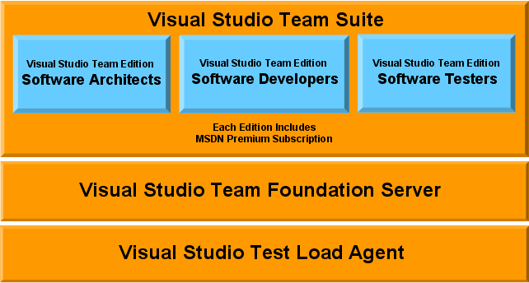
Figure 1: Visual Studio Team System Overview

Visual Studio 2005 Team Suite
Visual Studio 2005 Team Suite is a productive, integrated, and extensible software lifecycle management tool. It is a bundle of Visual Studio 2005 Team Edition for Software Architects, Visual Studio 2005 Team Edition for Software Developers, and Visual Studio 2005 Team Edition for Software Testers. Team Suite provides:
- Integrated Web services modeling tools that will enable you to design for operations.
- Code quality and performance tools for building mission-critical applications.
- Load testing tools for helping meet the rigorous performance demands of enterprise-class applications.

Visual Studio 2005 Team Edition for Software Architects
Visual Studio 2005 Team Edition for Software Architects integrates application design tools for service-oriented development. Its visual designers enable architects, operations managers, and developers to design service-oriented solutions that can be validated against their operational environments. Application design tools include:
- Support for Service-Oriented Architecture (SOA) projects.
- Tools for visualizing logical network infrastructure.
- Deployment design tools for validating applications work within correct networks.

Visual Studio 2005 Team Edition for Software Developers
Visual Studio 2005 Team Edition for Software Developers includes code quality and performance tools. The advanced development tools enable teams to build reliable, mission-critical services and applications, and cover critical functions such as:
- Static code analyzers report on security and performance issues during development
- Integrated unit test and code coverage tools increase application quality
- Low-level load testing tools for workstations
- Code profiling tools providing analysis of performance issues

Visual Studio 2005 Team Edition for Software Testers
Visual Studio 2005 Team Edition for Software Testers includes load testing tools for Web applications and services. Its advanced load testing tools enable teams to verify the performance of applications prior to deployment, through components such as:
- Web test authoring tools for quickly authoring load test scripts
- Load testing tools for authoring and running distributed load tests
- Integrated tools for sharing load test results with other members of the team

Visual Studio 2005 Team Test Load Agent
Visual Studio 2005 Team Test Load Agent is a supplemental test load solution for use with Visual Studio Team Edition for Software Testers. It enables organizations to simulate more users and to more accurately test the performance of the Web applications and servers. It can simulate about 1,000 users per processor, managing load testing on multiple processors through an integrated controller. It is licensed per processor.

Visual Studio 2005 Team Foundation Server
Visual Studio 2005 Team Foundation Server provides collaboration capabilities for more efficient team communication. It is an extensible team collaboration server that enables all members of the extended IT team to effortlessly manage and track the progress and health of projects. Features include source code control, work schedules, bug tracking and more.
Users who access Team Foundation Server require a client access license (CAL). Full details are in the licensing agreement.

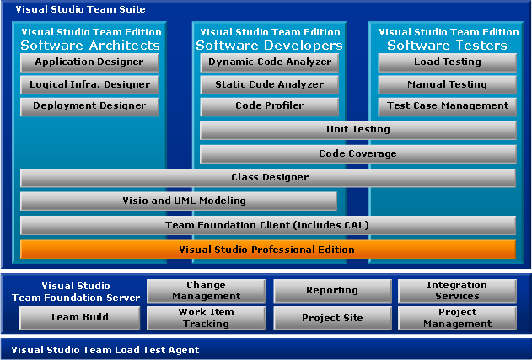
Figure 2: Visual Studio Team System Components
MSDN Subscription Licensing Update

MSDN Subscription Changes
The MSDN® subscription structure is changing due to the transformation of the Visual Studio product line.
MSDN Library and MSDN OS remain the same.
Although the benefits of MSDN Professional remain the same, it is now directly linked to support for Visual Studio Professional.
MSDN Enterprise and MSDN Universal are being replaced by a single license—MSDN Premium. The new license consists of the same benefits as MSDN Universal (Figure 3: MSDN Professional and MSDN Premium).

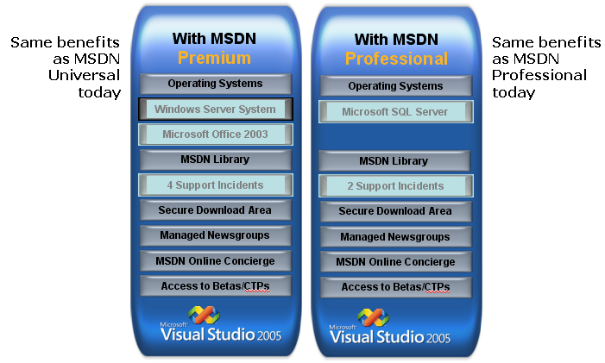
Figure 3: MSDN Professional and MSDN Premium

MSDN and Visual Studio Team System
When customers purchase licenses for Visual Studio Team Suite or a role-based Visual Studio Team component product, they will have a choice of purchasing an appropriate MSDN License (Figure 4: Visual Studio Team System MSDN Subscription Options).
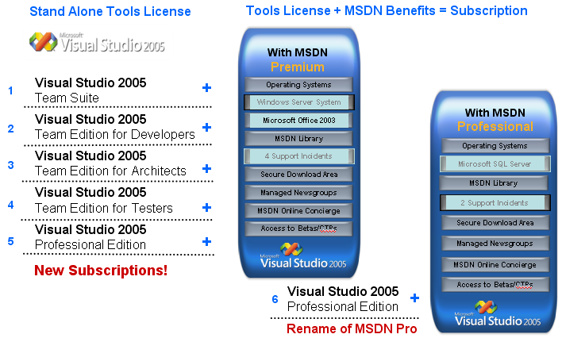
Figure 4: Visual Studio Team System MSDN Subscription Options

Licensing Migration
Due to the changes in both MSDN and the Visual Studio product line, a migration strategy is defined so that all customers will understand the options available for moving from the old MSDN licenses to the new licensing structure. The Licensing Migration Roadmap (Figure 5) shows an overview of transition options that can occur prior to the end of a customer’s current licensing period. Those transitions and renewals will all be described in more detail within this section.
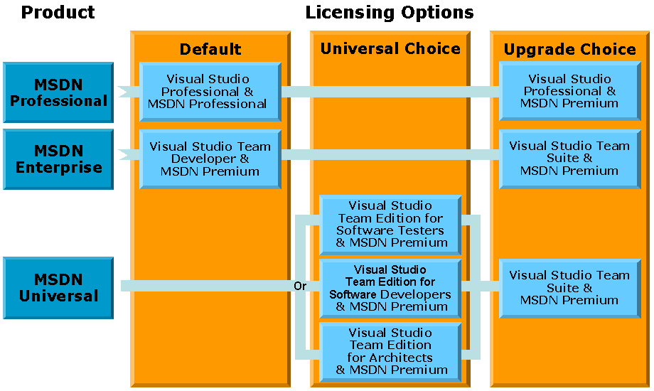
Figure 5: Licensing Migration Roadmap

Default Transitions
In October 2005, MSDN Professional and MSDN Enterprise customers will be automatically transitioned to new subscriptions (Figure 6). MSDN Professional customers will receive the new versions of MSDN Professional and Visual Studio Professional. MSDN Enterprise customers will automatically be transitioned to MSDN Premium and Visual Studio Team Edition for Developer.
Volume Licensing customers will see changes in the MSDN Subscriptions Administration System.
North American Retail and Direct customers will see the changes in the customer services site http://na.msdn.microsoft.com.
EMEA Retail and Direct customers will see the changes in the customer services site http://eu.msdn.microsoft.com.
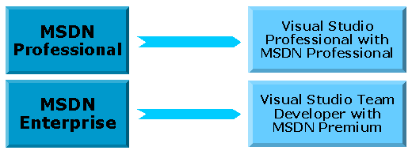
Figure 6: MSDN Default Transitions

MSDN Universal Transitions
MSDN Universal customers will not automatically transition. Rather, they can choose to transition to any one of the three Visual Studio Team role-based editions (Figure 7). MSDN Universal customers will receive a 180-day trial of Visual Studio Suite to assist in the decision process. The transition choice can be made any time before the end of the current MSDN Subscription or Agreement period.
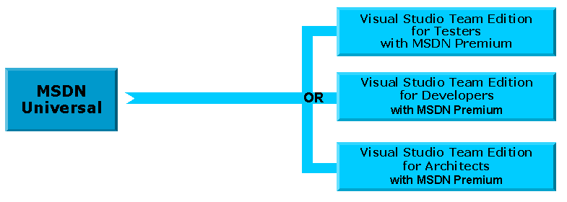
Figure 7: MSDN Universal Transition Options

Upgrade Transitions
There are special promotional step-up options for customers who want to upgrade to more powerful Visual Studio products (Figure 8).
Visual Studio Team role-based step-up upgrades are available as of October, 2005 and Visual Studio Professional step-up upgrades are available as of December, 2005.
The step-up SKUs are available in all programs except for Open License; these customers will not receive upgrade pricing.

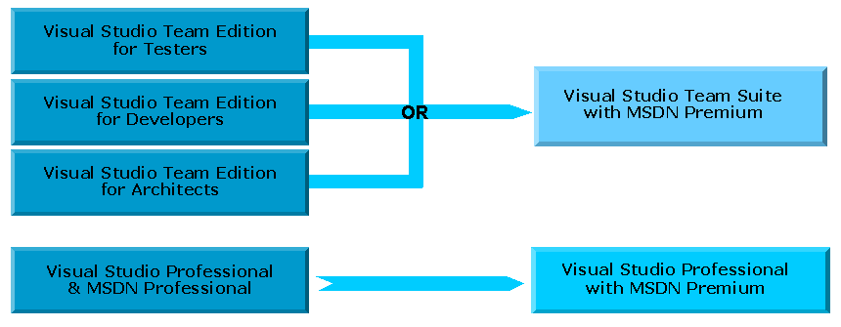
Figure 8: Upgrade Transitions

Software Assurance Benefits
Software Assurance is an expanded maintenance program that provides a broad-range of benefits that help organizations maximize the value of Microsoft technology. They help minimize customer licensing costs and increase business productivity. MSDN subscriptions are the Software Assurance (SA) offering for Team System client products. With an MSDN Premium Subscription, customers will also receive the rights to the next released version of their Team System client product if the new version was released during the term of their SA coverage.

How are MSDN Subscriptions Acquired?
Individuals can acquire subscriptions by purchasing them directly from Microsoft, over the telephone or through Microsoft online sites for customers in North America and EMEA. All individuals, except for those in Latin America, can also purchase subscriptions through your preferred Microsoft reseller or retailer. Depending on the reseller, purchase can be made at stores, online, or through telephone sales.
Organizations can acquire MSDN subscriptions through licensing agreements such as:
- Enterprise Agreements
- Select Agreements
- Open License
- Open License Value/Open Value Subscriptions
Academic Institutions can acquire subscriptions through the MSDN Academic Alliance or the MSDN Academic Alliance High School.
Microsoft Partners and ISVs can acquire subscriptions through the Certified Partner Program/ISV Empower.
For members of the Microsoft Partner Program, Microsoft also offers, as part of membership benefits, a specific number of complimentary MSDN Subscriptions ; the number varies depending on the partner program. These complimentary licenses provide single-user licenses with the right to use the MSDN Subscription software and benefits only during the duration of the program membership. Partners who need perpetual use rights or additional license need to purchase MSDN Subscriptions through traditional retail or Volume Licensing channels.

How Are MSDN Subscriptions Licensed?
Generaly, usage rights are limited to software design, development, testing, and demonstration scenarios. As an exception to this, one copy of Microsoft Office per licensee may be used for general business use.

NOTE: Microsoft Project and Microsoft Visio® use rights are also limited to design, development, test and demo rights. Rights to use MSDN expire when the corresponding Visual Stuidio liecenses expire. If the corresponding license to use Visual Sudio is perpetual, then the rights to use MSDN are likewise perpetual.
- Licenses acquired through Partner Programs
- Microsoft provides non-perpetual use rights for duration of program membership
Each subscription is licensed on a per named user basis:
- Anyone using subscription benefits must have a valid license
- Servers loaded any number of computers with any number of connections
- Licenses cannot be transferred to other unlicensed users

Visual Studio System Team Channel Availability

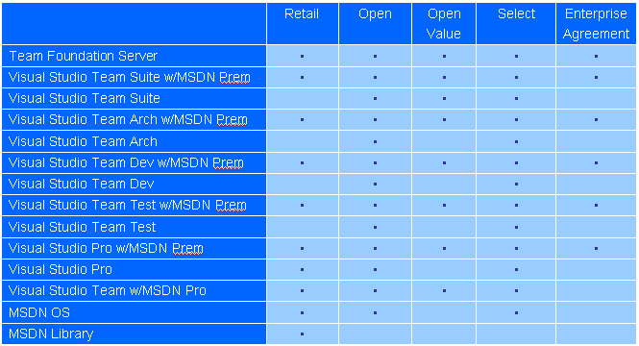

Resources
The following are links to resources about MSDN:
- Visual Studio Team Systems editions: http://msdn.microsoft.com/howtobuy/vs2005/editions/team/
- Visual Studio 2005 Developer Center: http://lab.msdn.microsoft.com/vs2005/

Frequently Asked Questions (FAQs)

Transition Paths
Why are MSDN Subscriptions changing?
MSDN Subscriptions are changing because of the new Visual Studio Team System.
What is the transition plan for existing subscribers that have acquired subscriptions through special program, for example Microsoft Partner Programs?
Transition paths will vary and will be communicated through respective program communications.
What version of Visual Studio 2005 will be included in MSDN AA?
Visual Studio 2005 Professional will ship to MSDN AA members and be made available through the secure download site.
Visual Studio Team System tools will be made available by special request.
Why are MSDN Universal and MSDN Enterprise subscribers being transitioned to one of the Visual Studio Team System role subscriptions?
MSDN Subscriptions offerings, which present the best way to buy Microsoft developer tools, will be aligned with the expanded line of Visual Studio products to ensure that existing customers have the latest technologies. Visual Studio Team System role-based subscriptions help software teams collaborate to reduce the complexity of delivering modern service-oriented solutions.
What happens to a subscriber who does not make a transition choice prior to the expiration of the existing Volume Licensing agreement or retail Subscription?
An MSDN Universal subscriber who does not indicate a subscription transition choice will continue to receive all existing MSDN Universal benefits, including the MSDN Universal monthly mailer media kits, until the subscription expires.
In addition, MSDN Universal subscribers will receive Visual Studio 2005 Professional Edition along with the 180-day trial versions of the Visual Studio Team Suite and the Visual Studio Team Foundation.
What are the differences in products and benefits between the MSDN Universal subscription and one of the Visual Studio Team System subscriptions?
The question is answered in two places in this document. The following are links to the appropriate headings:
- MSDN and Visual Studio Team System
- Figure 6: MSDN Default Transitions
What are the product and benefit differences between the MSDN Enterprise subscription and the Visual Studio 2005 Team Developer with MSDN Premium subscription?
MSDN Premium subscription is similar to the old MSDN Universal subscription, so MSDN Enterprise subscribers receive upgraded service. In addition, MSDN Enterprise subscribers receive the Visual Studio Team Edition for Developers enterprise software package.
What should an MSDN Universal subscriber do if the subscriber needs more than one Visual Studio Team System role product?
The Visual Studio 2005 Team Suite presents the best alternative in this situation. MSDN Universal subscribers can choose to purchase the upgrade to the Visual Studio 2005 Team Suite with MSDN Premium Subscription.

Transition Timing and Communication
By when does an MSDN Universal or MSDN Enterprise subscriber need to indicate a transition selection or choice?
MSDN Enterprise subscribers do not need to make a choice; they will automatically be transitioned to MSDN Premium and Visual Studio Team Edition for Developers.
MSDN Universal subscribers can choose at any time before the end of their current subscription period. They will then need to choose before they renew to the new subscription program.
How should an existing MSDN Universal or MSDN Enterprise subscriber communicate a transition subscription choice?
No selection or choice is required by an MSDN Enterprise subscriber.
Options for MSDN Universal subscribers are described in How are MSDN Subscriptions Acquired?
Will MSDN Universal and MSDN Enterprise be available for purchase after the release of Visual Studio Team System?
With the launch of Visual Studio 2005, existing MSDN Universal and MSDN Enterprise subscriptions will be removed from Microsoft price lists and no longer be offered for sale to new customers.
However, Volume Licensing customers who purchase MSDN Universal or MSDN Enterprise licenses through an Enterprise Agreement, can continue to "true-up" on MSDN Universal or MSDN Enterprise for the remaining duration of their agreements.
What happens to MSDN Universal and MSDN Enterprise licenses purchased as "true-ups" through Enterprise Agreements after the release of Visual Studio Team System?
The same transition mechanics will apply to these MSDN Universal and MSDN Enterprise licenses purchased as "true-ups" through Enterprise Agreements after the release of Visual Studio Team System.
Will trial or evaluation options be made available for the Visual Studio Team System products?
The Beta 2 version of the Visual Studio Team System will be made available online and shipped to active MSDN Professional, Enterprise, and Universal subscribers at no additional cost.
Upon release of Visual Studio 2005, a 180-day trial version of the Visual Studio Team Suite and Visual Studio Team Foundation will be sent to MSDN subscribers. These trials are full versions that expire 180 days after installation.
Can an MSDN Enterprise or MSDN Universal subscriber change a transition selection after communicating a transition subscription choice?
MSDN Enterprise subscribers automatically receive the MSDN Premium Subscriptions for the Visual Studio 2005 Team Editions for Software Developers and have no other option.
MSDN Universal subscribers can change their transition choice preferences freely until the release of Visual Studio Team System, at which point their selections are locked. MSDN Universal subscribers will receive the evaluation versions of the Visual Studio Team System to evaluate prior to making a transition choice.
MSDN Universal subscribers (who have already made a selection) and MSDN Enterprise subscribers who would like to move to another role-based subscription will have to purchase the other subscription at the full price or take advantage of any existing promotions.
MSDN Universal or MSDN Enterprise subscribers can also upgrade to the Visual Studio 2005 Team Suite subscription.

Transition Pricing and Licensing
Why are MSDN Universal and MSDN Enterprise subscribers in Microsoft Volume Licensing being transitioned to the Software Assurance products for the Visual Studio Team System?
MSDN Subscriptions currently represents the Software Assurance vehicle for Visual Studio customers. With release of Visual Studio 2005, Software Assurance will be offered for the Visual Studio Team System and will instead include MSDN Subscription features and benefits.
Are there additional costs for MSDN Universal or Enterprise subscribers transitioning to a Visual Studio Team System role subscription during the term of a subscription or Volume Licensing agreement?
No, there are no additional license fees to transition.
Are there additional costs for MSDN Universal or Enterprise subscribers who have transitioned to one of the Visual Studio Team System Subscriptions at renewal of the subscription or Volume Licensing agreement?
At the end of the existing subscription or Volume Licensing agreement, MSDN Universal and MSDN Enterprise subscribers can renew at the renewal or Software Assurance prices of the Visual Studio Team System for their current role (Developer, Architect, Tester) subscription.
Because MSDN Enterprise subscribers will be transitioned to the MSDN Premium Subscription for Visual Studio 2005 Team Edition for Software Developers. And because this subscription offers a more comprehensive range of products, prices are higher than prices for MSDN Enterprise.
MSDN Universal subscribers who choose to upgrade to one of the Visual Studio Team System role subscriptions can pay a different renewal or Software Assurance price depending on the licensing program or purchasing channel.
What does an MSDN Universal or Enterprise subscriber pay to obtain one of the Visual Studio Team System role subscriptions after expiration of their subscription or Volume Licensing agreement?
If an MSDN Universal or MSDN Enterprise subscriber allows the existing retail subscription or Volume Licensing agreement to expire (that is, the subscriber does not renew), the customer will have to pay the full retail subscription price or License with Software Assurance (L&SA) price (in Microsoft Volume Licensing programs) to obtain one of the Visual Studio Team System subscriptions after expiration.
What if the MSDN Universal or MSDN Enterprise subscriber wants to renew after expiration of the retail subscription or Volume Licensing agreement?
Standard Microsoft policies are applicable to customers who decide they want to renew their agreement after expiration of the existing retail subscription or Volume Licensing agreement.
Do product use rights (PURs) change for an MSDN Universal or MSDN Enterprise subscriber transitioned to one of the Visual Studio Team System role subscriptions?
No. There are no changes to the product use rights for an MSDN Universal or MSDN Enterprise subscriber upgraded to one of the Visual Studio Team System role subscriptions.
At the end of the subscription or Volume Licensing agreement, will customers who transitioned to one of the Visual Studio Team System role subscriptions be able to renew at a lower subscription level?
Yes. At the end of the existing retail subscription or Volume Licensing agreement, an MSDN Universal or MSDN Enterprise subscriber can choose to renew at another MSDN Subscription level (besides the other Visual Studio Team System role-based or Suite subscriptions) at the renewal or Software Assurance prices depending on the applicable licensing program.
Can an MSDN Universal or Enterprise subscriber continue to use the Visual Studio Team System tool received as a result of the transition if the subscriber moves to another subscription at renewal?
Yes. The MSDN Universal or MSDN Enterprise subscriber is entitled to a perpetual license of the Visual Studio Team System product received through the transition. The subscriber can continue to use the Visual Studio Team System product received even if the subscriber decides to move to another subscription at renewal.

