Overview  Country or Region: United Kingdom  Industry: Transportation and logistics—Aviation  Customer Profile  Established in 1995, low-cost airline easyJet is now the second largest in Europe. It carries more than 35 million passengers a year on flights to 108 destinations.  Business Situation  easyJet aims to forge a new lead over its competitors by redefining the travel portal. The company wants to offer customers the most intuitive site ever experienced.  Solution  easyJet is adopting the latest-release Microsoft® software and services to support its site, including the new geospatial features in Microsoft SQL Server® 2008 and a Microsoft Silverlight™ interface.  Benefits  - Customers inspired.  - Business boosted.  - Brand developed.  - IT administrators supported.  - Agility increased.  - Unique service provided.     |  |  | “The Microsoft technologies give us a site that will help us attract customers who weren’t previously supported, and we’ll see an increased basket size through efficient up-selling of ancillary products.”  Andrew Berks, Brand Communications Manager, easyJet
 |  |  | From its inception, low-cost airline easyJet led the market through its use of the Internet as a ticket distribution channel. Today, easyJet aims to redefine the travel portal to offer customers the most intuitive site ever experienced. A proof of concept, taking advantage of the latest-release Microsoft® software and services, has demonstrated the transformation in progress. The new geospatial features in Microsoft SQL Server® 2008 database software will allow customers to extract detailed geographical information about their destination. Microsoft Silverlight™ browser plug-in offers a seamless interface, new levels of flexibility, and inspiring travel options and services. Once complete, the Web site will meet the needs of all easyJet customers. The company expects that this unique service will not only leave competitors behind, but will also lead to significant revenue increases.
 |  |  | 

Situation
easyJet offers customers safe, good value air travel services at low prices. Customer care and convenience are core to the United Kingdom-based business, and by removing “frills” from air travel, easyJet has offered some of the lowest fares since its inception in 1995. The success of this philosophy is reflected in a 15 per cent annual growth rate at easyJet.

The innovative use of technology is also central to this success, helping the airline grow to become one of Europe’s largest carriers, offering services to 108 destinations in Europe. From early on, easyJet used the Internet as a channel for selling flight tickets to customers. In this way, it was able to reduce distribution costs while supporting customers throughout the bookings process in a way that many competitors were unable to emulate.

Paul Curtis is Head of Application Architecture for easyJet, and responsible for the design of easyJet applications and defining the roadmap for these systems in the future. He explains that it has always been important to embrace new concepts, while remaining focused on the company philosophy. “We were the first to introduce the Internet as a distribution channel. None of our competitors within the travel industry, or even in other industries, were doing what we were doing at the time. This gave us a significant edge over the competition, and we were clearly innovators within our sector.”

easyJet has run its business on Microsoft® technology for several years, but the company’s rapid expansion has given it little time to create a new architecture to support this growth. Instead, easyJet kept pace with market demands by bolting on new technologies as they were needed. More than 10 years on, as the competition finally catches up, easyJet is keen to adopt a more structured development approach. It also aims to align with the “Web 2.0” vision for Web-based services—or genuine interactivity between the Web and the user. The organisation intends to forge a new lead by redefining the travel portal—bridging the gap between what the customer expects from a Web site, and what is currently on offer. Its strategy involves taking a closer look at today’s customer—what they want from a travel portal—and tailor a Web site to meet those needs.

Andrew Berks, Brand Communications Manager, easyJet, says: “We developed a reputation among our passengers of being innovative and forward thinking because of our online distribution. We need to stay ahead of that curve and retain our brand value.”

“We developed a reputation among our passengers of being innovative and forward thinking because of our online distribution. We need to stay ahead of that curve and retain our brand value.”
Andrew Berks, Brand Communications Manager, easyJet

Until now, the easyJet Web site has offered an easy booking system for customers who have a set destination in mind and know exactly when they want to travel. But the company’s research has revealed that consumers are often more flexible. “Only around 40 per cent of customers know precisely when and where they want to go when they visit our site,” says Curtis. “That leaves as many as 60 per cent of customers who are looking for inspiration and ideas, and would consider varying dates and offers. For example, customers often have a set budget in mind, but are open to new destinations. Most travel portals don’t support these people, and customers spend a lot of time searching around for the best deals.”

Today, easyJet permits the sale of ancillary products, such as insurance or car hire, on the basket page of the booking process, or through a separate micro site. The organisation saw an opportunity to deliver these products at a much more appropriate time during the travel lifecycle. “At the moment, we’re restricted by where we can up-sell additional services,” says Berks. “It makes more sense for these services to be delivered at the exact point in the process when they become useful to the customer.”

Solution
The Windows Server® 2003 operating system, with Internet Information Services version 6.0, currently support the easyJet Web site. At the end of 2007, the company upgraded from Microsoft SQL Server® 2000 database software to SQL Server 2005, and this will continue to support the company’s transactional database. Upgrades such as these are easily achievable for easyJet because it holds an Enterprise Agreement with Microsoft. This is a premium Microsoft Volume Licensing programme for large customers that have made a strategic decision to deploy Microsoft technology across their enterprises.

Curtis explains: “Our licensing deal gives us everything we need in terms of access to the key products we use and the development tools we require. It also means we benefit from the services of Microsoft technicians and architects to help us in delivering our new strategy.”
“Our licensing deal gives us everything we need in terms of access to the key products we use and the development tools we require. It also means we benefit from the services of Microsoft technicians and architects to help us in delivering our new strategy.”
Paul Curtis, Head of Application Architecture, easyJet

easyJet is investing in the latest-release
Microsoft software and services to support
its Web vision—a new site that offers a far more intuitive service than today’s customers have experienced.

“We want people to get from point A to point B as quickly as possible, but we want to really fine-tune their experience,” says Curtis. To start, easyJet engaged user experience and design specialists Flow Interactive and Splendid to help deploy Gadgets for Windows® Sidebar—easy-to-use mini programs that provide users with information at a glance—in the Windows Vista® operating system. They have also realised the need to carry out an infrastructure overhaul to support the wider easyJet vision. A proof of concept was created in just six weeks, and this has already shown the significant transformation set to take place.

The Architecture: SQL Server 2008
Microsoft SQL Server 2008 offers services well beyond simple relational database storage. It now meets the needs of the next generation of data-driven applications, and forms the basis of one of the key new features in the easyJet Web site. SQL Server 2008 now offers strong support for new data types, including unstructured data such as documents and images. Support for the management of advanced geospatial data has also been added. This helps developers to extend and use location-based information in applications and perform operations based on this data.

At easyJet, developers have used these tools to create a new data repository that supports new geospatial information within the Web site, combining it with other data sources. In short, this will mean customers can extract detailed geographical information about their chosen destination. Many sites today can answer queries such as which attractions are available within 15 miles of the airport. SQL Server 2008 takes this several steps further.

“A visitor can choose an airport and request information on attractions within a 15-minute drive,” says Curtis. This works because SQL Server 2008 can store points on a geometric plane. Curtis says: “We can store a polygon (shape created by joining up points on the map) that shows the distance they can travel based on road speed, congestion, and many additional
factors. SQL Server 2008 offers users a much richer map experience and ties in all
the other external data sources available.”

Windows Server 2008 Enterprise
easyJet is supporting its infrastructure with the Windows Server 2008 Enterprise operating system on Intel-based hardware, offering vast improvements to the way administrators can manage their environment. The key for easyJet is that Windows Server 2008 is designed for the Web. It offers the latest-release Web server for developing and hosting Web applications, Internet Information Services 7.0 (IIS 7).

New capabilities within this technology, such as its componentised architecture, as well as powerful diagnostic and troubleshooting features, are designed to dramatically improve the way Web solutions are developed, deployed, and managed. This will help easyJet to better support a steadily increasing volume of traffic. “The Web site must be able to cope with demand as effectively as possible and ensure that all of our customers get a swift service,” says Curtis.

Peter Otto, User Experience Designer, Flow Interactive, says: “To help users find the lowest fares, we needed to create a user interface that quickly returned large amounts of fare data. The new Windows Server 2008 system architecture ensures we can return data at lightning speed, and this provides users with the responsiveness they’re looking for.”
“To help users find the lowest fares, we needed to create a user interface that quickly returned large amounts of fare data. The new Windows Server 2008 system architecture ensures we can return data at lightning speed, and this provides users with the responsiveness they’re looking for.”
Peter Otto, User Experience Designer, Flow Interactive

Microsoft Visual Studio 2008
The Microsoft Visual Studio® 2008 development system also offers vast enhancements from earlier releases, designed to help developers rapidly deliver

rich user experiences. Curtis says: “A core team of developers can write the framework code for applications and then expose it to the rest of the team through wizard-like features. This means that when developers create a new application by using Visual Studio 2008, they can build the framework without having to rewrite any code. Instead, they can spend their time developing the functionality for that particular feature.”

The Microsoft Language Integrated Query (LINQ) is a key feature of the Microsoft .NET Framework 3.5, released in conjunction with Visual Studio 2008. It adds native data querying capabilities to languages based on the .NET Framework. This means developers can write code for different data sources without having to use specialised languages for each, helping to accelerate the development process further.

“We used LINQ to develop the interface between objects in the SQL Server 2008 database, and this made the experience very quick,” says Curtis. “With just three weeks to build the whole solution, it was essential that these technologies were easy for the development team to use.”

Developers also used Microsoft Expression® Studio suite of design and media applications. Included within this suite, Microsoft Expression Blend™ offers a professional design tool for creating rich graphical interfaces for Web and desktop applications. Beau Ginbey, Interaction Designer, Splendid, says: “Expression Blend provided us with a seamless workflow to ensure our designs were ready for the developers to work with, giving us pixel perfect results. It breaks down the barriers that can exist between the user-experience and development teams, helping them work together on one big project, as opposed to separate chunks of work.”

The User Experience
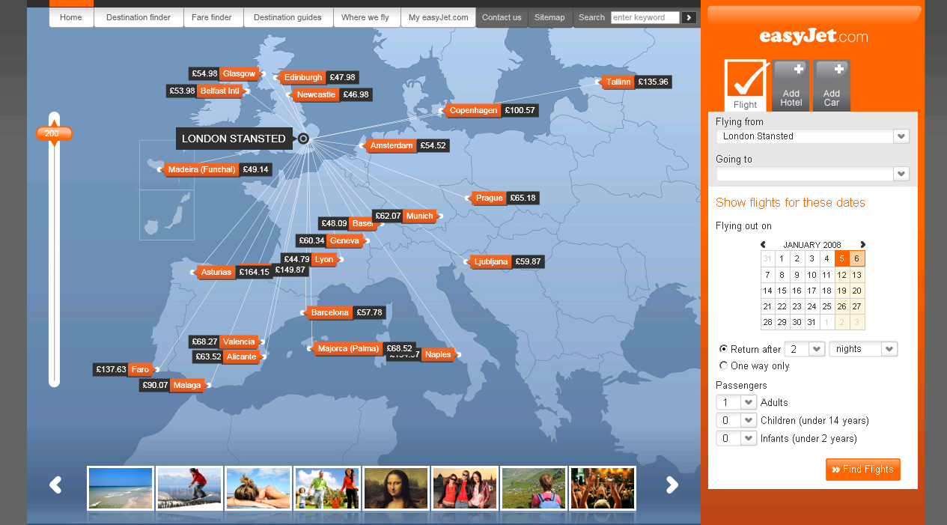
Figure 1
New geospatial data
stored in Microsoft SQL
Server 2008 reveals
destinations on a map
that correspond to a
customer’s own
parameters, such as his or
her budget limit.
A programme of research by Flow Interactive and Splendid helped developers to understand customer needs throughout the travel lifecycle. By using these findings, they built a rich, seamless user interface that could expose the destinations and additional information now available
through the geospatial functionality in SQL Server 2008.

Microsoft Silverlight™ is a cross-browser, cross-platform plug-in for delivering the next generation of media experiences and rich interactive applications for the Web. The easyJet team has used Silverlight to build a smooth interface to help users to explore destinations in detail. It integrates with Microsoft Virtual Earth, so developers can layer the location-relevant data on top of the Virtual Earth map images.
Customers who have set dates and destinations in mind can book quickly and easily by using a simple menu. A customer who is less sure of their destination can specify the dates that they’d like to travel and their preferred departure location. The map will then identify all the locations they can travel to within those dates and display fares in real time.

“Users can quickly compare where they can go on a given date and how much it will cost, without having to submit multiple searches,” says Otto. The interface overlays prices—the least expensive return fares available—which are revealed at each of the destination points. Curtis explains: “Using Silverlight, we can incorporate a sliding bar at the left side of the screen, which helps the user to set their budget for that trip. Moving the slider up or down reveals or hides destinations according to their cost criteria.” This is shown in figures 1 and 2.
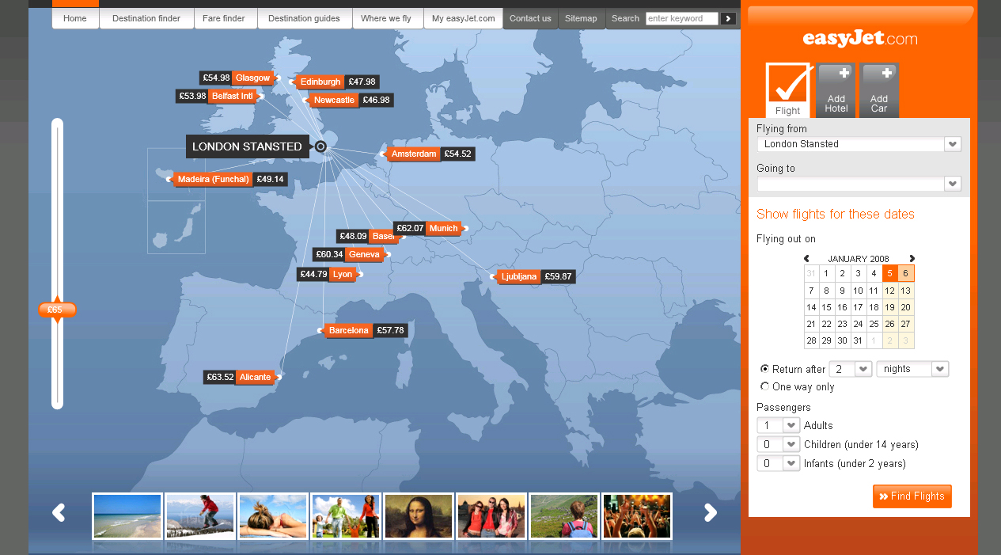
Figure 2
Users can manipulate a sliding
bar on the left of the screen to
hide or reveal destinations according to cost, giving them a more visual image of suitable travel possibilities.
Filters at the bottom of the screen offer inspirational images that represent particular activities, and can be selected by customers to tailor their booking. For example, summer holiday destinations are depicted by an image of a family on a beach, or an image of a museum might illustrate a culturally oriented location. Customers can choose as many filters as they like, and these dynamically update the map to show the destinations that meet their criteria, as shown in figure 3.

A customer can click on a destination and the map zooms in to reveal more information, such as popular resorts and destinations close by, as shown in figure 4.

Again, the links and associated information are displayed in an easy-to-read way, presenting relevant ancillary information at the most appropriate time in the process.

“All this information is offered in a single, seamless interface, whereas standard Web sites can only do this by constantly loading new Web pages,” says Curtis.

From here, the customer can select the destination guide link to explore even further, exposing details such as local weather forecasts, places to stay, and local airport information, as shown in figure 5.
A video guide is displayed as part of the destination information. When selected, Microsoft Silverlight streams videos about the chosen destination in full screen, as shown in figure 6.

Benefits
The proof of concept at easyJet has proven to the business the ways in which the new travel portal will transform the customer experience in 2008. The technologies support a site that offers customers far greater flexibility when booking than competitors can provide, and many intuitive, useful services, without inundating the customer with information.

Figure 3
Customers can filter options with the help of inspirational images displayed at the bottom of the screen. For example, summer holiday destinations are depicted by a beach.
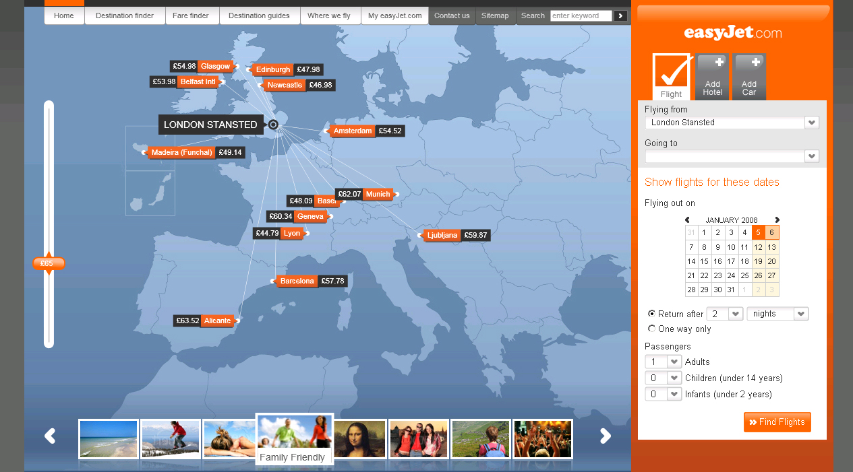
The site represents the needs of all of customers, from those who know exactly where they want to go, to those with only a budget in mind. The company believes that this unique Web site will attract large numbers of new customers, and ultimately result in far more bookings with easyJet.

Easy-to-Use, Intuitive Site Inspires Customers
By using these integrated technologies, the easyJet Web site is quickly moving from being a transactional site, to one with vast usability features. According to Curtis, the site ties in content generated from easyJet trusted providers, such as hotel reviews from Trip Advisor, so will become far more of a destination for travellers than a place where people simply go to book. Services such as car hire will be offered at a more compelling point in the process, helping customers make buying decisions while considering transport to places of interest.

Customers today spend a lot of time researching for the most cost-effective fare. The new easyJet site, however, will help them quickly identify the best value seats that meet their requirements, reducing the time they spend looking for what they want. It will also help them explore new destinations. Curtis says: “You may have a weekend free and fancy going somewhere new. All you have in mind is a particular weekend and a budget. The new site allows you to set your own parameters and quickly reveals all the options available.”
Figure 4
By selecting Barcelona as a
destination, the customer can
see popular nearby resorts, as
well as information such as
car hire, revealed here when
the user is most likely to need
to consider local
transportation.

He explains that the new Web site now easily represents the needs of all customers, as opposed to 40 per cent previously. “We cater for all customers, from those who know exactly where they’re going and when, to those who don’t know when or where, but are looking for inspiration and ideas.”

Delivery of Greater Choice Boosts Business
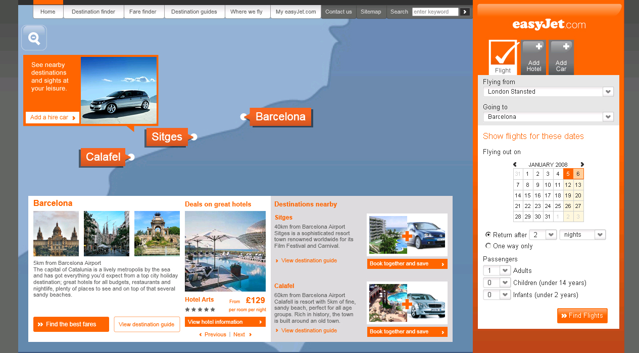
Ultimately, the organisation hopes that this transformation will lead to a dramatic increase in customer numbers. According to Curtis, a 1 per cent increase in conversion of users would result in a £19 million (U.S.$37 million) revenue increase.

“For any online business, increasing customer conversion is the foundation of success,” he says. “It’s one thing to have a strategy that brings more people to your Web site—we can do that through increased marketing and search optimisation. But ultimately it’s about converting that increased traffic into actual transactions. Our research shows that the only way to get people to buy on your Web site is to ensure they find what they’re looking for, and that is exactly what we can do with our user-centric site.”

The new strategy at easyJet is not completely without risk. Curtis explains that until the business takes the leap, it can’t know for sure how varying factors, such as changes in customer behaviour, might affect the outcome. But he believes that easyJet has minimised these risks by examining all possible issues in the proof of concept, and focused on user needs during its design. “Our prototypes have been used by real people, and we have incorporated their feedback, so our site is tailored to what people like.”

The initiative opens up many new sales opportunities for easyJet. The company can offer additional products on the site without the restrictions of before, giving customers greater choice. Berks says: “The scope for new business is now endless. The Microsoft technologies give us a site that will help us attract customers who weren’t previously supported, and we’ll see an increased basket size through efficient up-selling of ancillary products.”

Innovation Reflects Developing Brand Image
Figure 5
Microsoft SQL Server 2008 stores imagery and other data, such as local restaurants or nightlife, making it available in destination guides. The page also incorporates live services, such as weather forecasts.
In some ways, the new site challenges the image that consumers have come to identify with easyJet. Feedback from the proof of concept has shown that users consider the site looks expensive for a “no-frills” brand. But, as Curtis says, the Web site will help to counter the association of no frills with low quality. “As a brand, we’re demonstrating that easyJet can maintain the core ethos of being no frills and remove unnecessary cost, but still give a greater user experience to customers, and offer all the additional information they require. The key is to ensure people see the feature-rich site as a destination they can go to research travel, without thinking that the fares must be more expensive. It’s the way we’re developing our brand.”
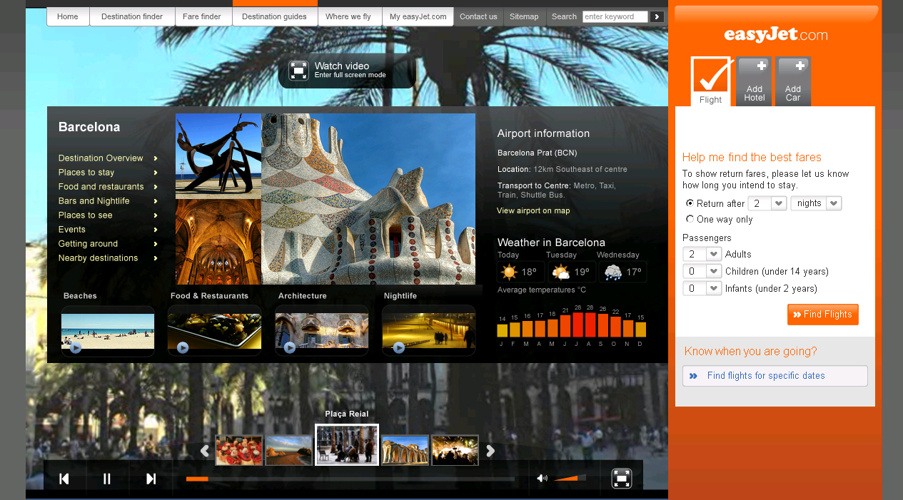

From the start, easyJet has led the market as the first airline to offer most of its services online, and Curtis believes that its new site is, once again, unique. “Looking at the Internet today, nothing comes close to offering what we will offer with this cutting-edge Web site, not only within the travel sector, but within any sector that I’ve seen,” he says.

Sophisticated Technologies Inspire and Support IT Administrators
Using the latest Microsoft technologies has given easyJet the flexibility and the tools to achieve these ambitious goals without restriction. SQL Server 2008 makes the innovative new geographical features of the site possible, without creating vast amounts of work for the developers. “In the past, we would have had to employ a lot of mapping and computer-aided design specialists who have worked in geographical companies,” says Curtis.

“With SQL Server 2008, developers can write some simple code and leave it up to the database to do all the complex calculations. It’s really simple for our team to use and we had it up and running in a couple of days.”

IIS 7 in Windows Server 2008 offers administrators greater control, helping them to be more proactive in the way systems are monitored. “IIS 7 gives us a far clearer view of the health of our Web servers. When we start to experience slow downs, or issues with a particular server, we can react much faster. This is critical for easyJet because 98 per cent of our business runs through the Web site. If we were to lose the site, we’d be out of business within days.”
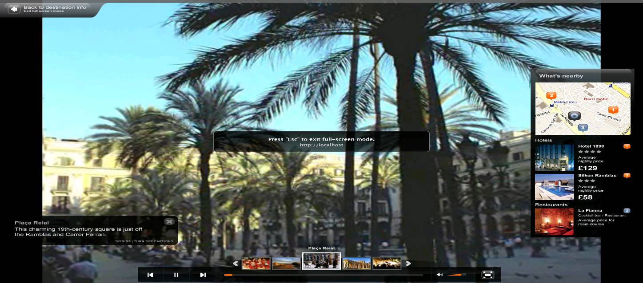
Figure 6
By clicking the “Watch video” button in the destination guide,
the customer is treated to a full-screen video account of the area, streamed using Microsoft Silverlight.
The easyJet development department is split into separate teams that deal with different areas, such as database development, Web code development, or presentation. Visual Studio 2008 is set to help improve collaboration across these teams with its integrated tools for architecture, design, and development.

Curtis says: “Using Visual Studio 2008, our three teams can work independently, but their work can be consolidated in a single development environment. The technology gives us a really good integrated view of the whole application, while maximising the performance and productivity of the team.”

Software-Plus-Services Model Increases Agility
As easyJet has grown, it has adopted numerous large systems that are hosted internally, and the organisation believes that this approach is starting to affect the company’s agility. By moving to a software-plus-services approach, the business can offer a far richer user experience. “Using a software-plus-services model, we can consume Web services from external companies, such as those that supply us with weather information, hotel reviews, and other external sources,” says Curtis. “These can be integrated into our environment much faster and reduce the time to market for new offerings on the site.

“Software plus services is also a much more cost-effective model with which to work. easyJet simply pays for the service it consumes rather than having to make a large, up-front investment. For example, with Microsoft Virtual Earth, we only pay for the images that we display on the page.”

Technology Roadmap Supports Dramatic Growth
For many organisations, incorporating such a large-scale change to a channel that is fundamental to the business could prove daunting. But Curtis remains confident in the technology decisions that the team has made, and believes that they will secure the organisation’s future. “The way Microsoft evolves its technology makes it easy for us to create new strategies and achieve our goals without introducing much cost and complexity. We can develop an architecture that meets our needs with no significant risks.”

easyJet can now easily support the substantial growth that the business experiences. Curtis says: “An average growth of 15 per cent a year means 15 per cent more traffic, more transactions, and more visitors to our Web site, and we expect this number to increase. We believe our infrastructure can support that growth, especially with the robust, scalable Windows Server 2008 operating system supporting the business.”

Berks says that the proof of concept has clearly demonstrated how Microsoft technologies have ensured the delivery of easyJet’s business needs in a very short time. “Our success with this project has only been possible because of the close relationship we have had with Microsoft. The easyJet vision is to be the world’s leading low-cost airline, and we believe these technologies will help us to get there.”
Windows Server 2008, SQL Server 2008, and Visual Studio 2008
For More Information
For further information about Microsoft products and services, please visit
www.microsoft.com/uk or call 0870 60 10 100*

For hearing impaired customers with a Minicom, contact: 0870 50 30 400*

*Lines are open 8am–6pm, Monday to Friday. Please note, numbers prefixed 0870 will be charged at national call rates. For details of national call rate charges, please contact your telecommunications provider.

For more information about Flow Interactive products and services, visit the Web site at:
www.flow-interactive.com

For more information about Splendid products and services, visit the Web site at:
www.howsplendid.com

For more information about easyJet products and services, visit the Web site at:
www.easyJet.com

This case study is for informational purposes only. MICROSOFT MAKES NO WARRANTIES, EXPRESS OR IMPLIED, IN THIS SUMMARY.

Document published March 2008

Software and Services  - Microsoft Server Product Portfolio  - Windows Server 2008 Enterprise  - Microsoft SQL Server 2008  - Microsoft Visual Studio 2008  - Technologies  - Microsoft Silverlight  - Internet Information Services 7.0 | - Services  - Microsoft Virtual Earth

Windows Server 2008, SQL Server 2008, and Visual Studio 2008 provide a secure and trusted foundation for creating and running your most demanding applications. Combined, the products offer advanced security technology, developer support for the latest platforms, improved management and Web tools, flexible virtualisation technology to optimise your infrastructure, and access to relevant information throughout your organisation.

For more information about Windows Server 2008, go to:
www.microsoft.com/windowsserver2008

For more information about SQL Server 2008, go to:
www.microsoft.com/sql/2008/default.mspx

For more information about Visual Studio 2008, go to:
www.microsoft.com/vstudio.

