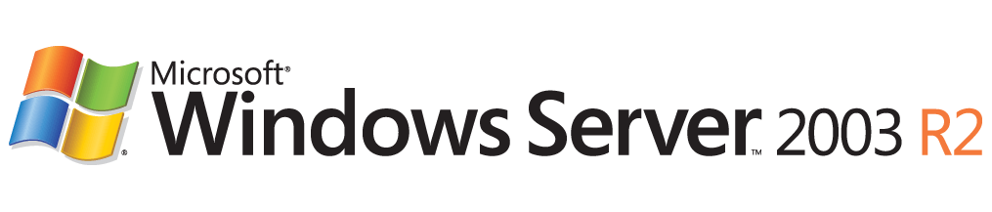

Extending Your Active Directory Schema for New Features in Windows Server 2003 R2
Microsoft Corporation
Published: December 2005
Author: Jim Groves
Editor: Jim Becker

Abstract
Certain new features in the Microsoft® Windows Server™ 2003 R2 operating system require network administrators to extend the Active Directory™ directory service schema. This document explains the circumstances that require a schema extension. It also explains the steps that you take to extend the Active Directory schema.

Information in this document, including URL and other Internet Web site references, is subject to change without notice. Unless otherwise noted, the example companies, organizations, products, domain names, e-mail addresses, logos, people, places, and events depicted herein are fictitious, and no association with any real company, organization, product, domain name, e-mail address, logo, person, place, or event is intended or should be inferred. Complying with all applicable copyright laws is the responsibility of the user. Without limiting the rights under copyright, no part of this document may be reproduced, stored in or introduced into a retrieval system, or transmitted in any form or by any means (electronic, mechanical, photocopying, recording, or otherwise), or for any purpose, without the express written permission of Microsoft Corporation.
Microsoft may have patents, patent applications, trademarks, copyrights, or other intellectual property rights covering subject matter in this document. Except as expressly provided in any written license agreement from Microsoft, the furnishing of this document does not give you any license to these patents, trademarks, copyrights, or other intellectual property.
© 2005 Microsoft Corporation. All rights reserved.
Microsoft, Active Directory, Windows, and Windows Server are either registered trademarks or trademarks of Microsoft Corporation in the United States and/or other countries.
The names of actual companies and products mentioned herein may be the trademarks of their respective owners.

Contents
Extending Your Active Directory Schema in Windows Server 2003 R2 5
New Active Directory Schema Requirements 5
Extending the Schema for Windows Server 2003 R2 6
Conclusion: Extending Your Active Directory Schema 7

Extending Your Active Directory Schema in Windows Server 2003 R2
Windows Server 2003 R2 was designed to be as compatible as possible with previous versions of the Windows Server operating system. This compatibility applies to the Active Directory schema that is used by Windows Server 2003 R2. Unless you are planning to install three particular new features or to use a computer running Windows Server 2003 R2 as a domain controller, it is not necessary to change your current Active Directory schema. However, if you plan to install any of the three new features or to use a computer running Windows Server 2003 R2 as a domain controller, you must first prepare Active Directory by extending the schema to accommodate the needs of these features. The following features require an extension of the Active Directory schema:
• Distributed File System (DFS) Replication Service
• Print Management Console
• Identity Management for UNIX
This document outlines the requirements for updating your existing Active Directory schema to support these new features. Read this document and follow the recommendations in it before attempting to install any of these three features on a computer running Windows Server 2003 R2.

New Active Directory Schema Requirements
Network architects are understandably protective of the Active Directory schema. Changes to the Active Directory schema are replicated across an entire forest. Therefore, they require careful planning. Ill-advised changes to the schema can interfere with applications that rely on Active Directory.
Microsoft requires schema extensions to support new and changed features only when the schema that is provided by earlier versions of Windows Server cannot be adapted to meet the needs of the new features. In Windows Server 2003 R2, three new features require that you extend the existing schema before you attempt to deploy them. The following table explains why each of these features requires a schema extension.

DFS Replication Service | Requires that new object classes be added to the domain naming context to contain replication groups and content sets. Also requires that new object classes be added to the computer object class in the domain naming context to contain computer-specific settings to support DFS replication.
Print Management Console | Requires a new object class to contain information about printers so that their connections can be deployed.
Identity Management for UNIX | Requires new object classes to represent items in a Network Information Service (NIS) map.

These new object classes are defined in a file named Sch31.ldf, which is located on the Windows Server 2003 R2 installation CD.
When you extend the schema, you do not have to upgrade your existing domain controllers to Windows Server 2003 R2; they can continue to run Windows 2000 Server or Windows Server 2003. Note, however, that Identity Management for UNIX must be installed on a Windows Server 2003 R2 domain controller. DFS Replication Service and Print Management Console can run on any computer running Windows Server 2003 R2.
You must also extend the schema the first time that you upgrade an existing domain controller to Windows Server 2003 R2 or you install Active Directory on a computer running Windows Server 2003 R2 to make it a domain controller. You must extend the schema before you perform either of these actions for the first time in an existing forest. If you install Active Directory on a computer running Windows Server 2003 R2 to make it the first domain controller in a new forest, you do not have to extend the schema. The schema extension occurs automatically as the forest is created.

Extending the Schema for Windows Server 2003 R2
Before you install one of the new features that is described in New Active Directory Schema Requirements or you add a domain controller running Windows Server 2003 R2 to a forest for the first time, you must first extend the schema with the Adprep tool. Use the following procedure to apply Windows Server 2003 R2 schema extensions to the Active Directory schema.
To apply Windows Server 2003 R2 schema extensions to the Active Directory schema
1. Insert the second Windows Server 2003 R2 installation disc in the CD drive of the domain controller that holds the schema master operations role (also known as flexible single master operations (FSMO)).
2. Log on to the computer as a member of the Schema Admins group.
3. Click Start, point to All Programs, point to Accessories, and then click Command Prompt.
4. At the command prompt, type the following commands, substituting the drive letter of the CD drive for drive:
drive:
cd \cmpnents\R2\adprep
adprep /forestprep

Conclusion: Extending Your Active Directory Schema
Windows Server 2003 R2 includes a number of new features that require the addition of several new object classes in the Active Directory schema. You must extend the Active Directory schema before you do any of the following for the first time in your Active Directory forest:
• Install any of the following components on a computer running Windows Server 2003 R2:
• Distributed File System (DFS) Replication Service
• Print Management Console
• Identity Management for UNIX
• Upgrade a domain controller to Windows Server 2003 R2
• Install Active Directory on a computer running Windows Server 2003 R2 to make it a domain controller
To extend the Active Directory schema, you run the Adprep tool before you install any of these components for the first time in a forest or before you add a computer running Windows Server 2003 R2 to an existing forest. After you extend your Active Directory schema, you do not have to make any further changes to your schema to meet the requirements of Windows Server 2003 R2.

