Microsoft Office Excel Add-in for SQL Server Analysis Services
Improving business performance and profitability with powerful analytics and reporting functionality

Business Intelligence for Everyday Decisions

In today’s competitive business world, success is built on the business agility required to anticipate emerging trends and instantly transform your organization's strategy and processes to focus on new opportunities.

To help companies to achieve this level of business agility, Microsoft offers a comprehensive business intelligence solution that connects people, data, and business processes.

Created to deliver the right information to the right people at the right time by utilizing powerful, yet familiar end user reporting and analysis tools, Microsoft business intelligence solutions enable organizations of all sizes to improve responsiveness to new business opportunities by empowering employees to make faster, better-informed decisions. The results can include:

- Visibility in Excel into business trends
- Robust reporting and analytics
- Flexible, cost-effective business intelligence solutions
- Anytime, anywhere access to business data

Microsoft Office Excel Add-in for SQL Server Analysis Services

The Microsoft Office Excel Add-in for SQL Server Analysis Services is a new business intelligence offering that enables employees to use Microsoft Excel to access relevant information and quickly create customized reports.

Fig.1 - Easily author free-form and structured reports

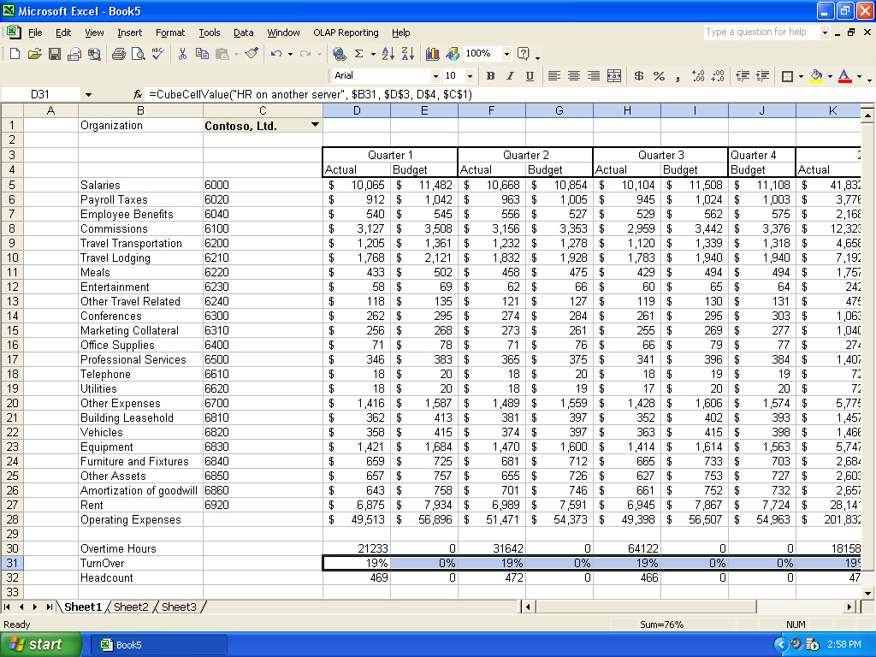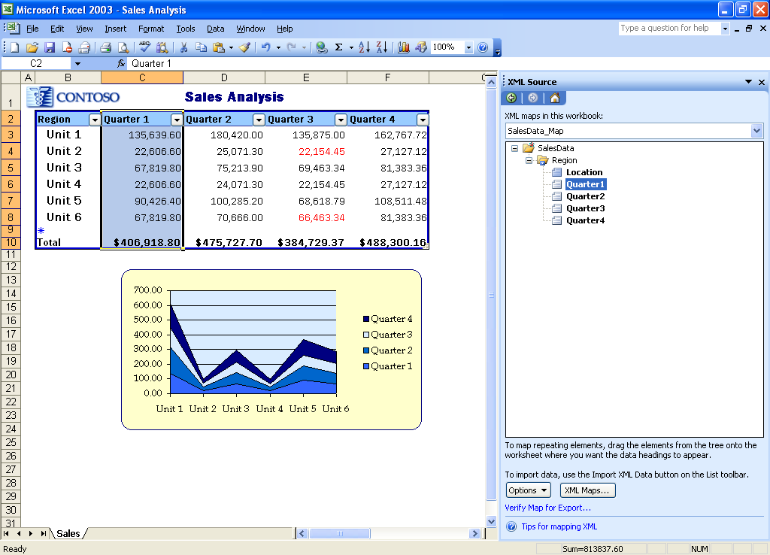

Using the Excel Add-in for Analysis Services, your organization can utilize Microsoft Office Excel 2002 SP3 or Microsoft Office Excel 2003 to access and integrate relevant information from multiple SQL Server Analysis Services cubes , perform in-depth analysis, and develop sophisticated reports that will improve vital business activities such as planning, budgeting, and forecasting.

Compatible with Microsoft Office Excel 2003 or Excel 2002 (SP3), the Excel Add-in for Analysis Services can improve data analysis, shorten reporting cycles, and enhance your company's ability to respond to customers.

Interactive Analysis and Reporting

Built to extend the features and functionality of Microsoft Office Excel - one of the most widely used reporting and analysis tools - the Excel Add-in for Analysis Services enables users to access and analyze data from multiple Analysis Services cubes, and create rich, customized reports directly in Excel. With the Excel Add-in for Analysis Services, individual users can manage the reporting cycle from beginning to end and eliminate the need to cut and paste data from multiple systems.

- Access: Easily create and maintain connections to multiple Analysis Services cubes, ensuring data consistency and integrity, and integrate data from multiple Analysis Services cubes into a single report.

- Analyze: Conduct detailed analysis using native Excel capabilities. Extend the richness of analysis with “what if” analysis and drill through capabilities.

- Author: Take advantage of flexible free form and structured report layouts that are easily personalized and refreshed. Minimize end user training due to Excel’s popularity and reduce reliance on IT to publish and distribute rich, interactive reports.

Key Business Benefits

With the Excel Add-in for Analysis Services, enterprises have powerful new capabilities to gain access to critical business data stored in multiple sources and improve the speed and quality of decisions. The Excel Add-in for Analysis Services not only reduces the time and required to train users, but it also eliminates the need for enterprise’s to support specialized reporting systems and tools. The key business benefits of the Excel Add-in for Analysis Services include:

- Real-time visibility into business trends
- Increased speed and quality of decision-making
- Streamlined data analysis that shortens reporting cycles and saves resources
- Increased reporting flexibility through rich, highly customized, and refreshable reports
- Access to relevant information from multiple Analysis Services cubes

Delivering Business Intelligence to the Critical Roles in Your Organization

Business intelligence has a profound impact on business agility because it gives important groups within an organization the specific view of strategic and operational data that is required for success. The Excel Add-in for Analysis Services Server offers these benefits to the critical groups in your organization:

- Finance: Financial analysts and planners can gain better visibility into financial performance and improve reporting.
- Operations: Operations managers can easily analyze operating metrics identify cost savings opportunities and improve asset utilization.
- Sales and Marketing: Sales and marketing professionals can use reliable metrics and strategies to meet performance and customer satisfaction goals.
- Human Resources: Human resource professionals can track employee performance trends to increase employee retention and productivity.

Fig.2 – Dynamically access, analyze and format business data

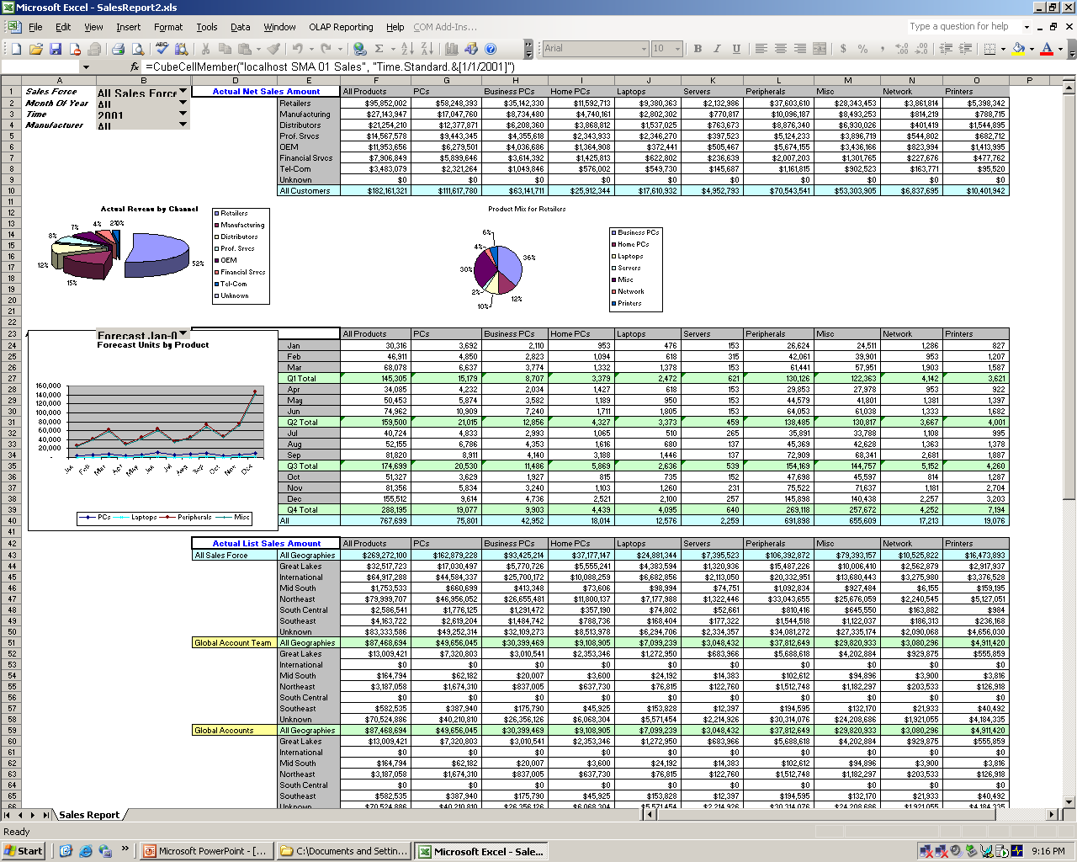

Meeting the Needs of a Broad Range of Industries

The Excel Add-in for Analysis Services has the power and versatility to address critical business issues across a wide range of industries, including:

- Financial Services: Reduce transaction costs and respond more quickly to new opportunities.
- Government: Improve the visibility and flow of information among agencies and their constituents.
- Healthcare: Enhance patient safety and improve the efficiency of healthcare delivery.
- Manufacturing: Optimize alignment of manufacturing processes and strategic objectives.
- Retail: Track changing market and consumer dynamics in real time.
- Telecommunications: Improve customer service and increase customer retention.
Key Technical Features

Tightly integrated with Microsoft SQL Server 2000 and Analysis Services, the Excel Add-in for Analysis Services extends the reporting and analysis features and native functionality of Microsoft Office Excel. The add-in provides a comprehensive set of tools that makes it easy to link to disparate data sources, manage queries, build sophisticated reports in multiple layouts, perform write back, and much more. The key components of the Excel Add-in for Analysis Services include:

- Cube Metadata Manager: Retrieves and shares OLAP cube information.
- Query Manager: Consolidates and executes queries and returns the results; also performs write back to cubes.
- Report Builder User Interface: The “task pane” interface used to build reports.
- Report Metadata Manger: Maintains report layout and enables report interactions like focus, eliminate, expand/collapse, and drillup/drilldown.
- Report Manager: Creates and manages formulas and presents query results in Excel cells.

System Requirements

The Microsoft Office Excel Add-in for SQL Server Analysis Services is based on the following Microsoft products and technologies:

- Microsoft Office Excel 2003 or Excel 2002
- Microsoft SQL Server 2000 Analysis Services
- Microsoft Windows Server 2003 or 2000

Why Microsoft?

Microsoft offers a comprehensive set of integrated servers, tools, and applications that deliver powerful and cost effective business intelligence solutions aimed at improving the speed and quality of decision making at all levels of an organization. Solutions like the Microsoft Office Excel Add-in for SQL Server Analysis Services enable employees to use familiar tools to access and analyze data and create sophisticated reports with once unimaginable speed and accuracy.

Learn more about the Microsoft Office Excel Add-in for SQL Server Analysis Services at http://www.microsoft.com/office/solutions/accelerators/exceladdin/. Fore more information about Microsoft Business Intelligence, visit http://www.microsoft.com/bi.

