

Microsoft CRM Best Practices
Upgrading Unsupported Microsoft CRM 1.2 Environments to Microsoft CRM 3.0

Published: August 2005

This is a preliminary document and may be changed substantially prior to final commercial release of the software described herein.

The information contained in this document represents the current view of Microsoft Corporation on the issues discussed as of the date of publication. Because Microsoft must respond to changing market conditions, it should not be interpreted to be a commitment on the part of Microsoft, and Microsoft cannot guarantee the accuracy of any information presented after the date of publication.

This White Paper is for informational purposes only. MICROSOFT MAKES NO WARRANTIES, EXPRESS OR IMPLIED, AS TO THE INFORMATION IN THIS DOCUMENT.

Complying with all applicable copyright laws is the responsibility of the user. Without limiting the rights under copyright, no part of this document may be reproduced, stored in or introduced into a retrieval system, or transmitted in any form or by any means (electronic, mechanical, photocopying, recording, or otherwise), or for any purpose, without the express written permission of Microsoft Corporation.

Microsoft may have patents, patent applications, trademarks, copyrights, or other intellectual property rights covering subject matter in this document. Except as expressly provided in any written license agreement from Microsoft, the furnishing of this document does not give you any license to these patents, trademarks, copyrights, or other intellectual property.

© 2005 Microsoft Corporation. All rights reserved.

Microsoft, Active Directory, Windows, and Windows Server are either registered trademarks or trademarks of Microsoft Corporation in the United States and/or other countries.

The names of actual companies and products mentioned herein may be the trademarks of their respective owners.
Table of Contents

Purpose 1
Planning Your Upgrade 1
Review Unsupported Scenarios 1
Database Customizations 2
Database Integration 3
Form Customizations 5
IIS Modifications 6
Custom Application Development 8
ISV Solutions 9
Best Practices: Upgrading Non-Supported Environments 10
Validate the Environment 10
Resolve Non-Supported Issues 13
Database Modifications 13
Unsupported Modifications 13
Example Issue: New Field added to AccountBase table 14
Resolution: Remove custom fields prior to upgrading to 3.0 15
Microsoft CRM 3.0 Supported Database Modifications 22
Form Modifications 24
Unsupported Modifications 24
Example Issue: Manually Renaming Entities 24
Resolution: Rename entities with CRM 3.0 26
Resolution: Add new entities with CRM 3.0 30
Example Issue: Modify forms to link to external applications 32
Resolution: Utilize IFRAMES in CRM 3.0 32
Example Issue: Modifying Activities 35
Resolution: Modify activities using the 3.0 Customize Entities 35
Example Issue: Activity view modifications 37
Resolution: Use Customize Entities in 3.0 to modify all views 38
Important Notes 41
Appendix 42
CRM Backup Procedures 42
Disable Publishing 45
Remove Remaining Replication System Objects 46

Purpose
The purpose of this document is to assist you in a successful upgrade from Microsoft CRM 1.2 to Microsoft CRM 3.0. This document will address various unsupported Microsoft CRM 1.2 scenarios and what steps would assist in making your CRM environment a Microsoft supported environment prior to upgrading to Microsoft CRM 3.0. This technical white paper should be considered as a supplement to the Microsoft CRM Implementation Guide found on your Microsoft CRM documentation CD.

Planning Your Upgrade
Each Microsoft CRM installation should be evaluated prior to upgrading to version 3.0 to determine if it is a supported environment. Upgrading to Microsoft CRM 3.0 assumes that your existing 1.2 environment is a Microsoft supported environment. Before beginning any upgrades you should make sure you have properly backed up your existing Microsoft CRM 1.2 environment. Please reference the CRM backup procedures found in the appendix of this document.

Review Unsupported Scenarios
The following list of unsupported scenarios is examples of what you should look for within your CRM environment. This is not an all inclusive list but rather ideas of what you should look for within your environment.

Database Customizations
Unsupported database customizations are defined as customizing the Microsoft CRM database without using Microsoft CRM administrative tools (i.e. Deployment Manager). This would include adding or modifying tables, indexes, stored procedures, views, and/or triggers to the Microsoft CRM databases. Review the changes made to your CRM environment to determine if your organization will need to address this scenario.

- Review tables, views and stored procedures to determine if any noticeable modifications have been made to your environment.
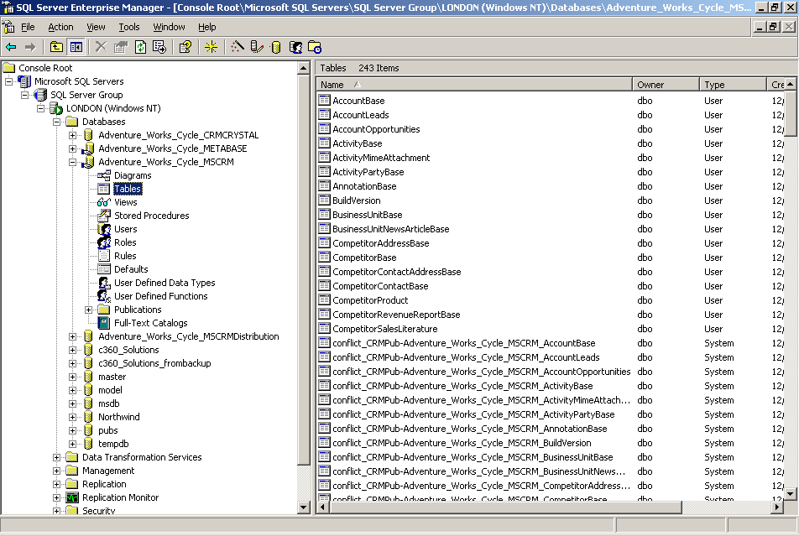

- Make note of any obvious customizations and continue with your analysis.

Database Integration
Unsupported database integration customizations are defined as direct calls to the Microsoft CRM databases without using the CRM SDK. This would include any database procedures that update the Microsoft CRM data structure and any 3rd party applications that connect to Microsoft CRM without utilizing the SDK.

- Review the SQL jobs on your CRM database server to determine what is running and what it might be updating within CRM.
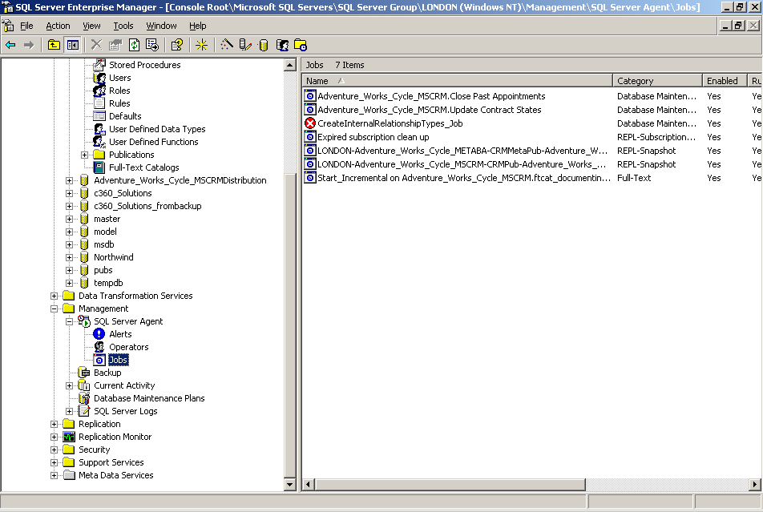

- Check Scheduled Tasks under Control Panel on the CRM server to see what might exist.
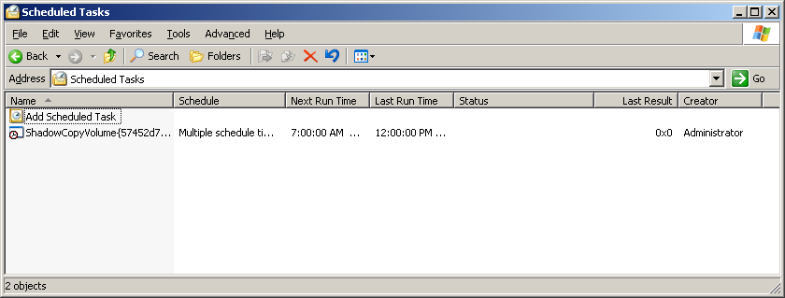

- Check Task Manager on the CRM server to see what additional processes might be running that could be used for database integration.
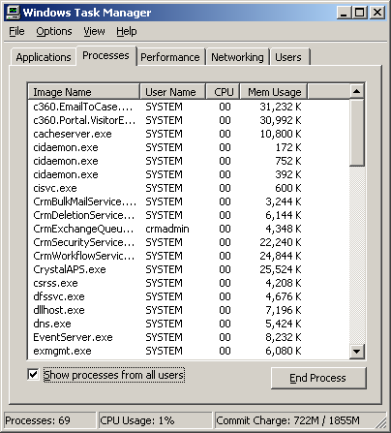
NOTE: Check “Show processes from all users”

- Make sure you have updated backups of all integration components (including source code and runtime components) in case you need to modify or reinstall them after the upgrade to Microsoft CRM 3.0.

Form Customizations
Microsoft CRM form customizations made to the CRM application without using the CRM customization tools are considered unsupported. More specifically, modifications made directly to .apsx, .css, .htm, .js, .xml, .jpg, or .gif files are not supported by Microsoft. The only exceptions would be the .config files where the CRM SDK directed you to update the file to support customizations.

- Review Microsoft CRM system customization settings to check that any form customizations are controlled through the customize forms feature of this administrative tool.
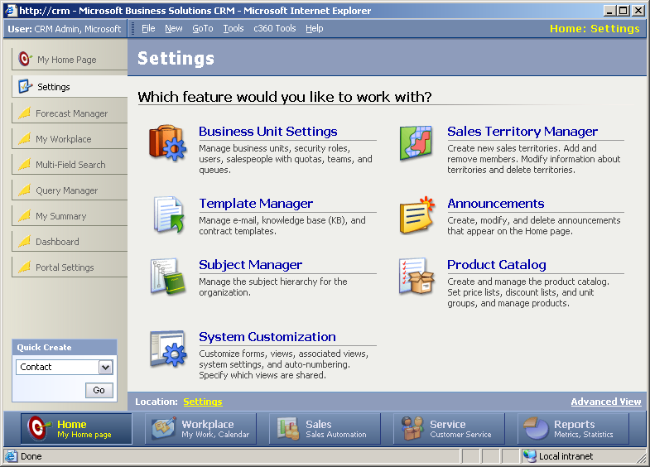

- Create a backup of all form customizations prior to proceeding with the installation of Microsoft CRM 3.0 (manual backup of custom forms and a CRM Deployment Manger export of all supported forms within CRM).

IIS Modifications
Modifications to the CRM website settings or metabase within IIS are considered unsupported. However, Microsoft CRM does support installing CRM on a non-default website within IIS. Review your IIS setting on the CRM web server.

- Open Internet Information Services Manager on the CRM web server and click on the Microsoft CRM web site.
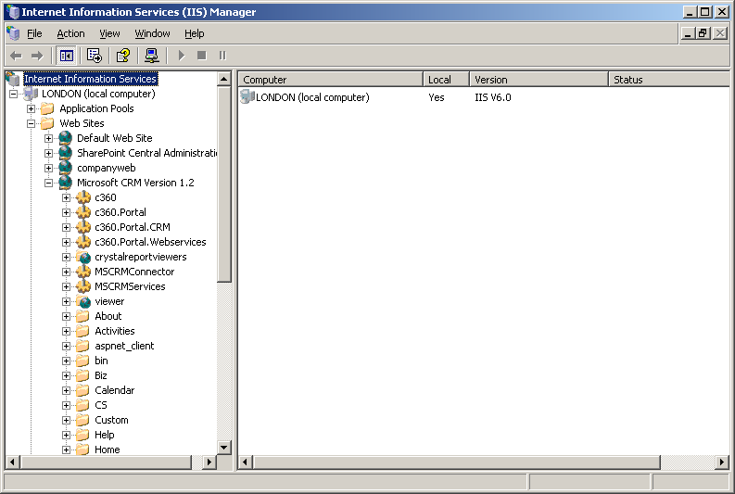

- Validate default CRM settings are in place (check these settings against the Implementation Guide that is part of the documentation CD found with your CRM 1.2 CD’s).
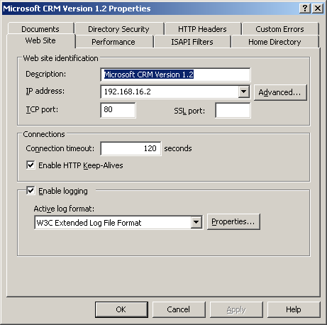

- Make sure you have a current backup of all system files on your web server prior to upgrading Microsoft CRM 3.0.

Custom Application Development
Custom code that utilizes Microsoft CRM APIs, methods and/or web services that are not published in the CRM 1.2 SDK are considered unsupported. This will require you to check with anyone who has developed an application to run with Microsoft CRM to make sure they are fully utilizing the functionality within the SDK and not making calls directly to the CRM database or web files.

- Check for source files in the home directory and sub folders of the CRM web site.
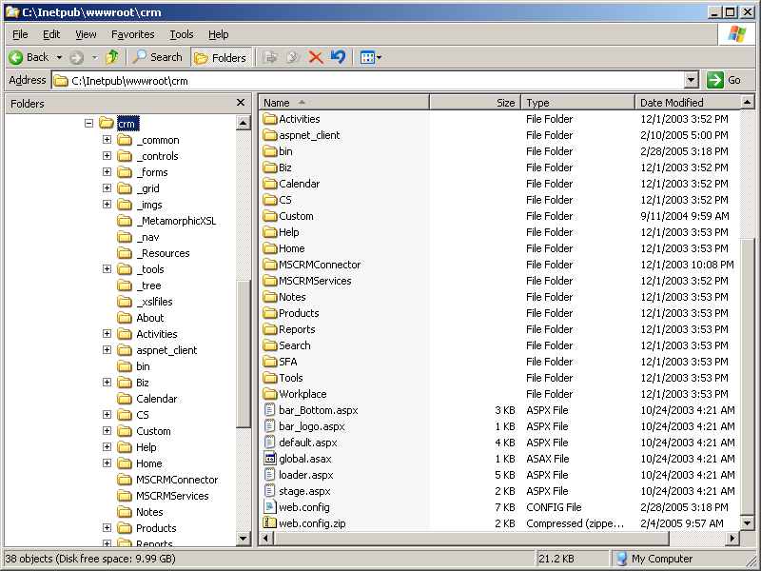

- Make sure you have a current backup of all system files on your web server prior to upgrading Microsoft CRM 3.0.

ISV Solutions
Each ISV Solution for Microsoft CRM will be going through a certification process to make sure their products work with CRM 3.0. Before you upgrade your environment you will want to check with the ISV who developed your solution to determine if their application will work under the new 3.0 platform. If you are unfamiliar with the name of the ISV you can check the .config files on the CRM server to help identify 3rd party solutions.

- Navigate to the home directory of your CRM web site and check the _Resources directory for the file called isv.config to look for ISV solution names.
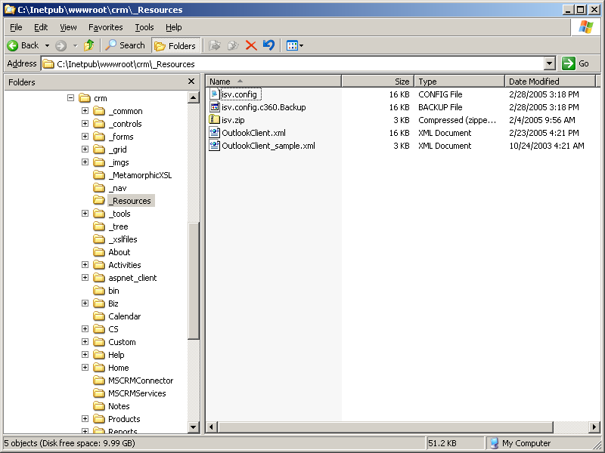

- Make sure you have a current backup of all system files on your web server prior to upgrading Microsoft CRM 3.0.

Best Practices:
Upgrading Non-Supported Environments
Once you have reviewed your existing CRM environment and documented the areas that may be of issue you can begin the installation of Microsoft CRM 3.0. The new setup routine comes with two diagnostic wizards that will provide another level of checks prior to the CRM installation. These wizards will help identify any prerequisite software that needs to be installed for CRM 3.0 and determine if there are any modifications to the existing environment that will prevent the application from successfully installing.

Validate the Environment
Make sure that all the users are disconnected from CRM prior to upgrading to 3.0. You should also confirm that all remote users have gone online to help prevent any unwanted data loss. Insert the CD for the Microsoft CRM 3.0 Server installation into the CRM application server and follow the directions.

- Review the list of required software and install any prerequisites before continuing the installation.

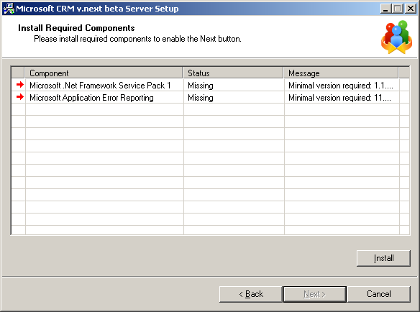

- Click Next once all of the prerequisite software has been installed.

- As you continue with the CRM installation the Diagnostic Wizard will appear. This is a new tool with Microsoft CRM 3.0 and it is used to help identify issues that may arise that would prevent a successful implementation of Microsoft CRM.
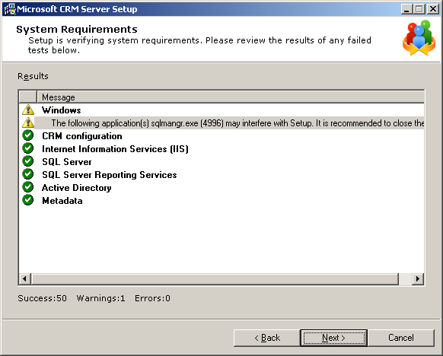

- Prior to proceeding with the installation of Microsoft CRM 3.0 all the validation tests must past with a positive check. If any of them fail the wizard will prevent you from proceeding with the installation. In some cases you will receive a warning message which simply means you should be aware of the issue but the setup procedure will allow you to proceed.
- If you receive an error message during installation a red X will appear in the wizard.
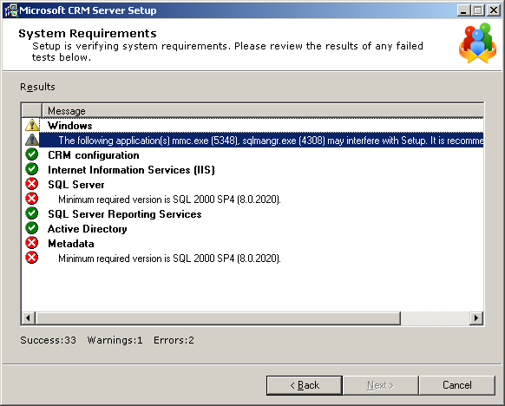

- Details of the error will appear. You can double click on the error message for additional information.

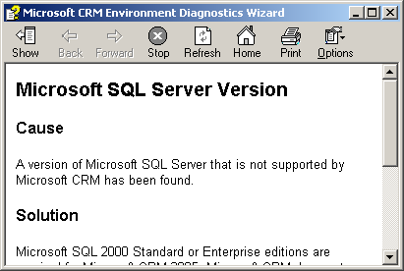

Resolve Non-Supported Issues

Database Modifications
If you have made modifications to the tables in Microsoft CRM your upgrade to Microsoft CRM 3.0 will fail. In this section we will explain what needs to be done to the CRM database in order to be successful with the CRM 3.0 upgrade.

Unsupported Modifications
Microsoft CRM does not support modifications made directly to the CRM databases. If you have made any modifications to the CRM tables in SQL you will experience issues upgrading to CRM 3.0. These are a few examples you should look for prior to upgrading your environment.

- Adding custom triggers
- Adding custom tables
- Removing data while ignoring Foreign Key restraints
- Modifying views
- Modifying stored procedures
- Modifying the design of existing data fields
- Modifying replication
- Inserting, updating and deleting records directly against the CRM databases (without using the CRM SDK)

Document all modifications you have made to CRM 1.2 prior to beginning your upgrade to CRM 3.0. Database modifications will either prevent the upgrade from performing or will be overwritten during the upgrade process. The Microsoft CRM Diagnostic Wizard will inform you of any items that will prevent you from upgrading to CRM 3.0.

Example Issue: New Field added to AccountBase table
Field Name AddOnField was added to the AccountBase table in Microsoft CRM. This field was an Integer of size 4. The addition of this field has caused the upgrade of Microsoft CRM to fail.

- Error message in the Diagnostic Wizard.
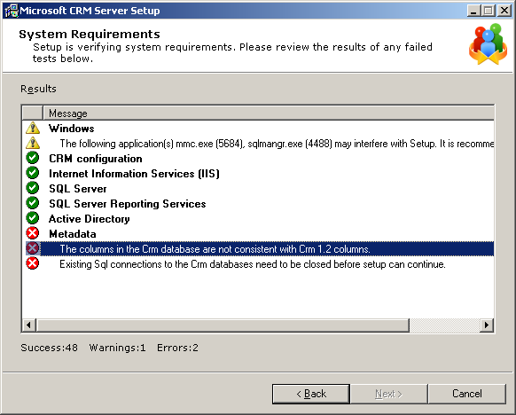

The installation of CRM 3.0 will not allow you to proceed until this issue is resolved. At this point you will want to consult with the individuals responsible for making this modification to make sure you understand the necessity of this additional field in the database structure.

- Details of error message.
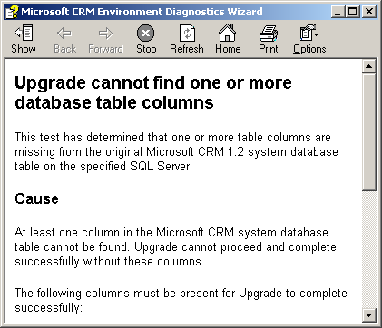

Resolution: Remove custom fields prior to upgrading to 3.0
- Copy the existing data in the tables prior to making any modifications.
IMPORTANT: It is extremely important to not only copy this data but make sure you have a proper backup of your CRM database.
- Open SQL Enterprise Manager on the CRM database server.
- Navigate to the table(s) containing the manually added data fields.
- Right mouse click on the table name and click on All Tasks – Export Data.

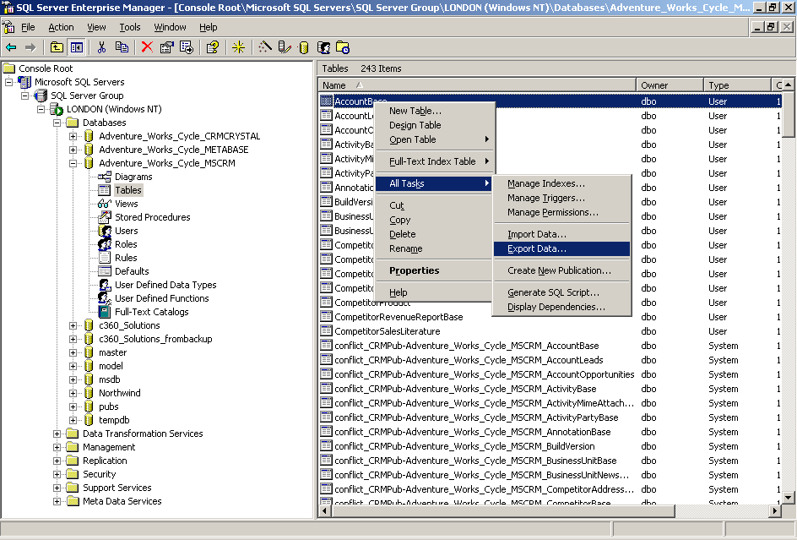

- The Data Transformation Services wizard will allow you to export your data.
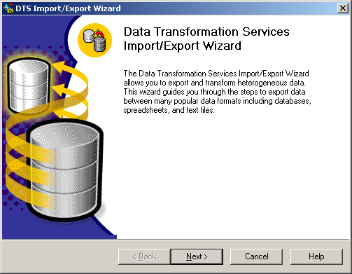
- Select the MSCRM database for your organization.
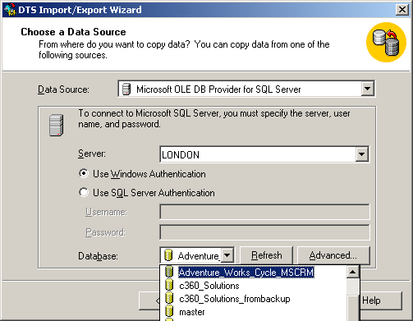

- Select the destination for your data extract (copy data to…) i.e. Select Microsoft Excel 97-2000.

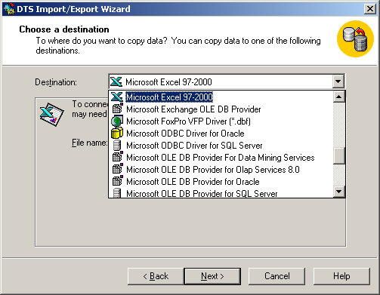
- Create a file for the output and save it to a location you will remember and click Save – Next.
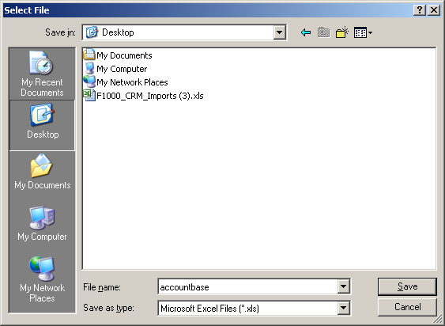

- Select Copy table(s) and view(s) from the source database and click Next.
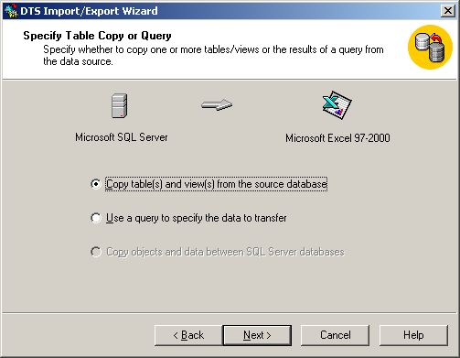
- Select the data to copy (AccountBase in this example) and click Next.
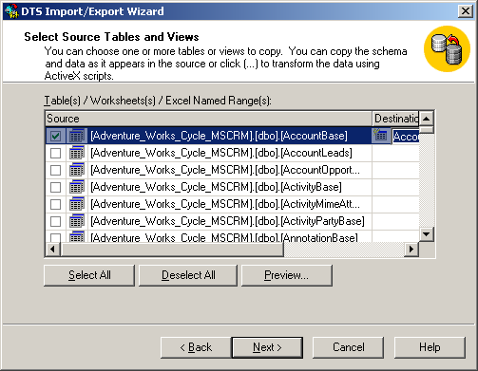
- Choose Run immediately and click Next.
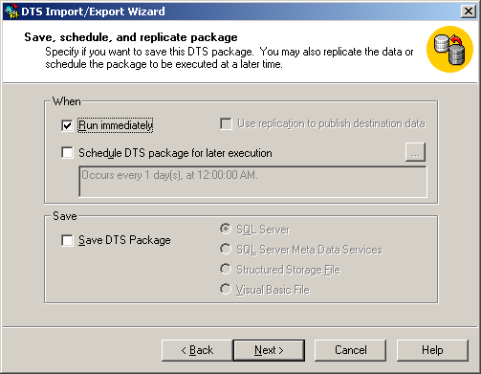
- Click Finish.
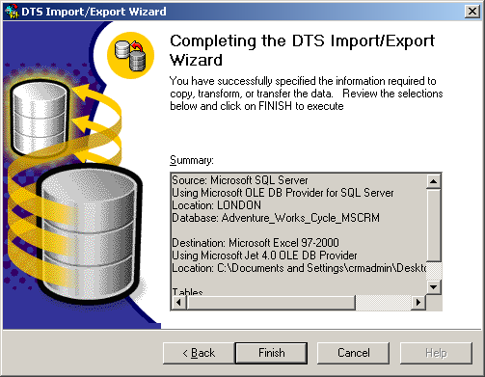
- You are now ready to make modifications to the AccountBase table to prepare it for upgrading to CRM 3.0.
- Before making modifications to the table you will need to make sure Publishing has been turned off. See Disable Publishing in the Appendix.
- Go to Enterprise Manager on the CRM SQL server and right mouse click on the table name called AccountBase. Select Design Table.
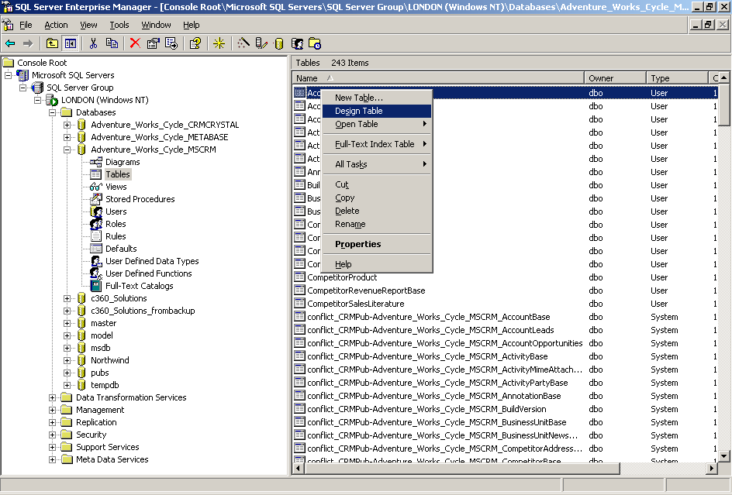

- Right mouse click on the column to be deleted and click on Delete Column.
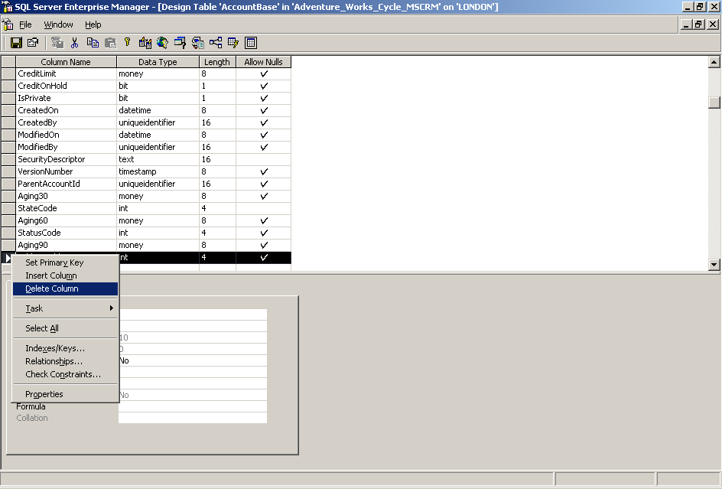

- Click on Save to save the table changes.
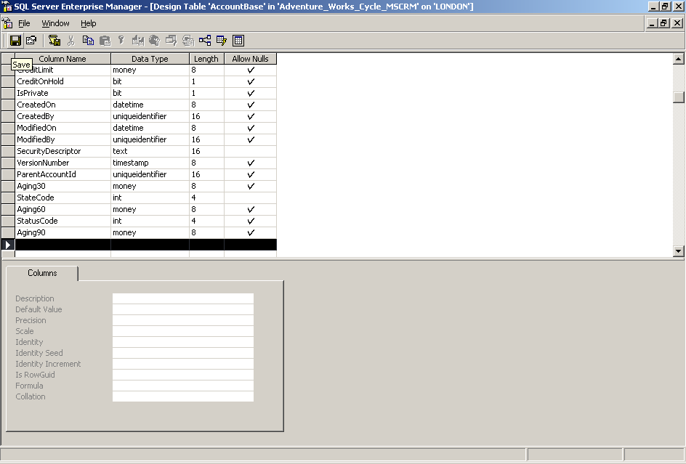

- Close the screen and try upgrading to CRM 3.0 again.

Microsoft CRM 3.0 Supported Database Modifications
If your environment meets any of the criteria above you will need to remove these modifications prior to proceeding with the upgrade to 3.0. Once you have removed these modifications you can upgrade to 3.0 and then use the Customize Entities Workflow Manager, or the CRM 3.0 SDK to recreate these data fields.
- Customize Entities is found under the Settings – Customization – Customize Entities link.

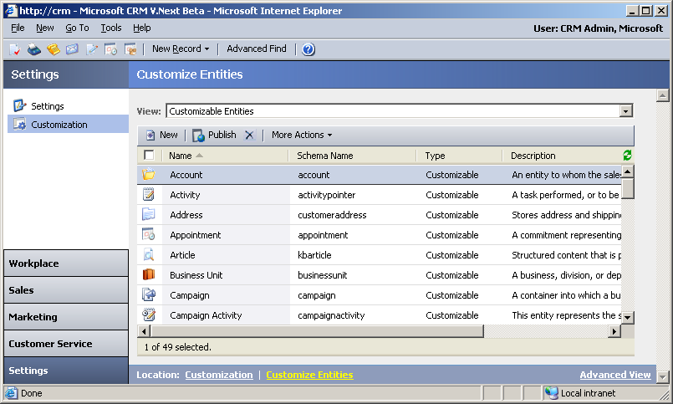

- Workflow Manager can be found on the CRM application server under the CRM program files.
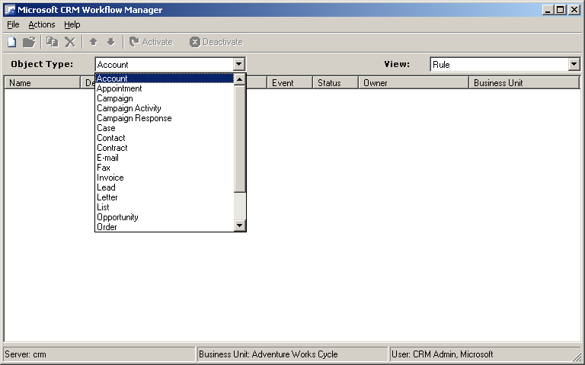

Form Modifications
If you have made modifications to the CRM forms in Microsoft CRM your upgrade to Microsoft CRM 3.0 will work successfully but any modifications made to the forms will be lost. Microsoft CRM 3.0 provides additional ways to make form modifications. These additions should be reviewed to understand how your organization can configure Microsoft CRM to support your business needs. In this section we will review some common modifications made to CRM forms and review how you can resolve the issue either before upgrading or by using new features in Microsoft
CRM 3.0.

Unsupported Modifications
In this example we discussed manually updating 1.2 forms to include new entities or renaming existing entities. Other modifications to look for include:
- Adding fields directly to the CRM web files (.aspx, .js, .xml, etc.)
- Removing data from web files
- Modifying CRM views (outside of the CRM administrative tool)
- Inserting scripting logic directly to the CRM web files
- Creating custom dialog boxes to restrict data on a page
- Adding custom buttons directly to the forms without using the SDK
- Modifying the .config and .xml files by adding your own code

In each one of these examples the code that you modified in CRM 1.2 will be overwritten by the upgrade to CRM 3.0. It is very important to document your modifications prior to upgrading to 3.0.

Example Issue: Manually Renaming Entities
Microsoft CRM 1.2 does not support changing entity names so customers have taken the liberty to modify the forms directly by making changes to the native web files (like .aspx files). Any modifications made directly to the form files without using the CRM Deployment Manager and Customize Form application will be lost upon upgrading to CRM 3.0. Before upgrading you will want to identify all changes made directly to the forms so that you can recover these changes after the upgrade completes.

- Check the settings in IIS to identify the Home Directory of your CRM files.
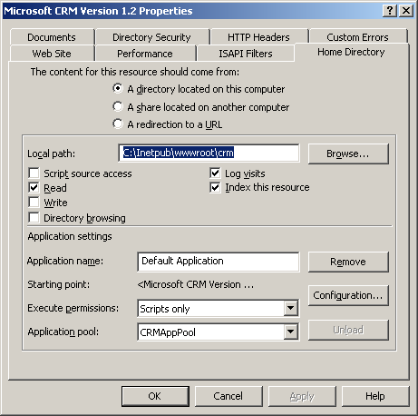
- Identify the files that have been modified by checking file dates on the CRM application server.
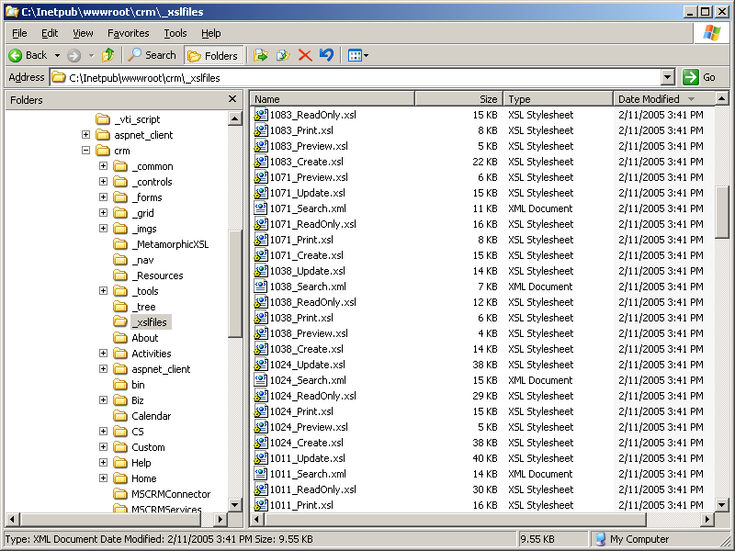

- Carefully document the specific changes that were made to the files.
NOTE: There are some changes that simply are not supported by Microsoft CRM. You should fully read and understand the Implementation Guide for Microsoft CRM as well as the SDK documentation. These documents will define what is supported with the Microsoft CRM application.

Resolution: Rename entities with CRM 3.0
Microsoft CRM 3.0 allows you to make your own modifications to CRM entities. This includes modifying existing entities as well as creating your entities from scratch. The upgrade to CRM 3.0 will overwrite the modifications you manually made to the source files in 1.2. Make sure you have carefully documented all of the modifications you have made in order to recreate these changes in 3.0.

- Upgrade your CRM environment to 3.0.
- After successfully upgrading to CRM 3.0 you will want to access the administrative tools to recreate your previously unsupported modifications.
- Open the web browser and launch the URL to your CRM web site.
- Click Settings on the menu bar.
- Click Customization on the menu bar.
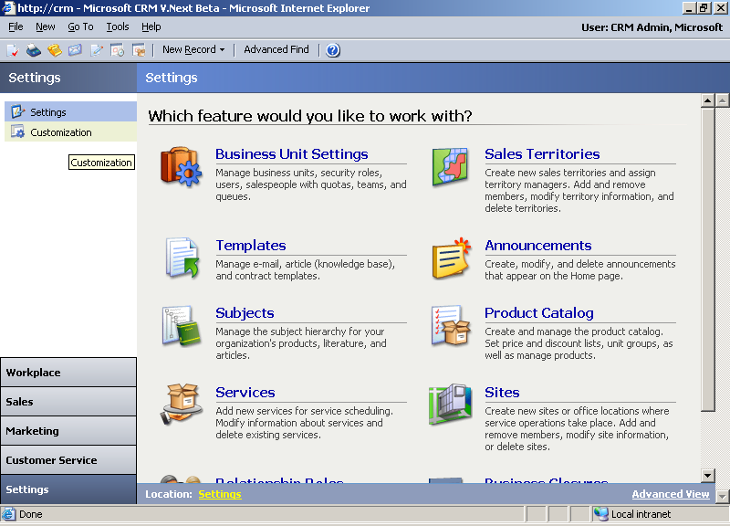

- Click Customize Entities.
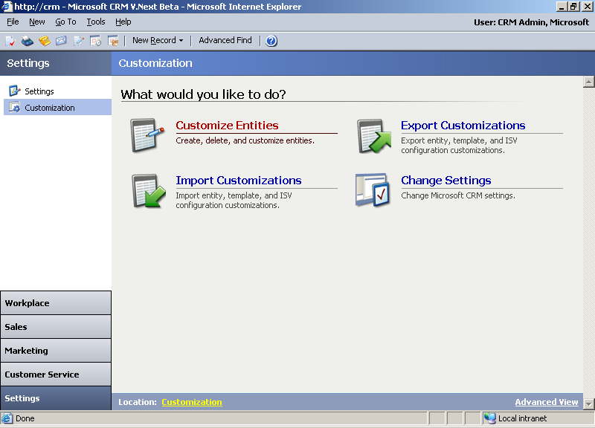

- Double click Accounts to modify the Accounts entity.
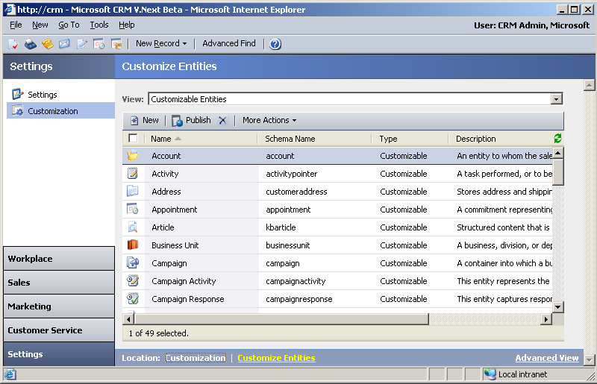

- Use this screen to make changes to the entity name.
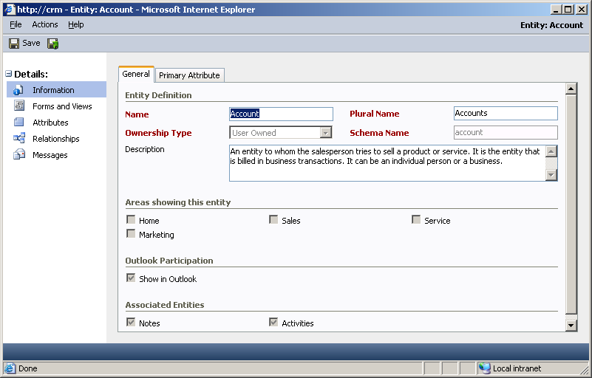

- Modify the entity to fit your business needs (i.e. Change Accounts to Vendors).
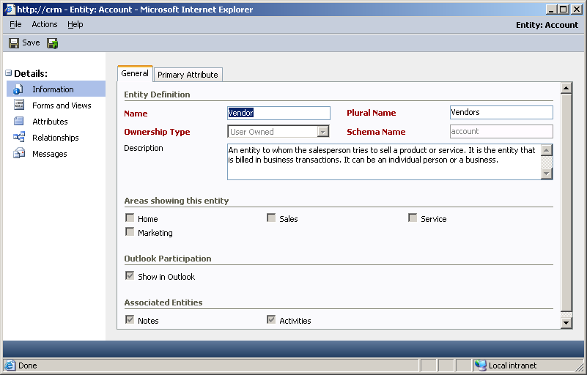

- Make these changes to all entities as defined by your business needs.

Resolution: Add new entities with CRM 3.0
Microsoft CRM 1.2 does not allow you to create your own entities. If you have created custom entities you should replace this functionality with the add entity functionality included with CRM 3.0.

Check your CRM 1.2 application to see if you have created entities that are not
listed below.

- Leads
- Accounts
- Contacts
- Opportunities
- Competitors
- Products
- Sales Literature
- Quotes
- Orders
- Invoices
- Cases
- Contracts
- KB Articles/Manager
- Activities

You will want to document any modifications that appear to be non-CRM related items. The CRM upgrade to 3.0 will overwrite any modifications that you have made to the CRM forms.

NOTE: If you have made additions using the CRM 1.2 SDK and created your own forms then these changes will stay in place. You may have to modify the isv.config file to expose these changes after you upgrade to 3.0.

After you upgrade to 3.0 you will want to add new CRM entities by using the add entity function from the CRM administrative tool.

- Click on Settings – Customization and choose Customize Entities.

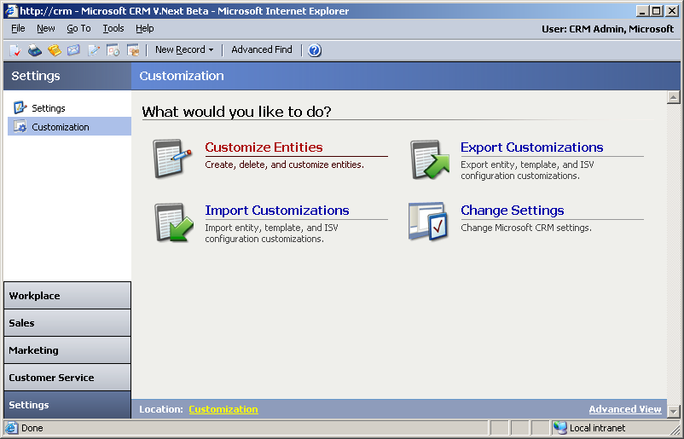

- Click on New to create a new custom entity.
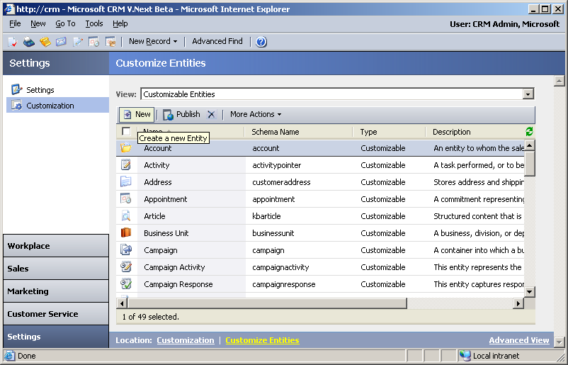

- Review the fields for creating a new entity. CRM 3.0 allows you to not only create new entities but integrate them to existing entities in CRM. Examine how you modified CRM 1.2 to determine the best way to create new entities in CRM 3.0.
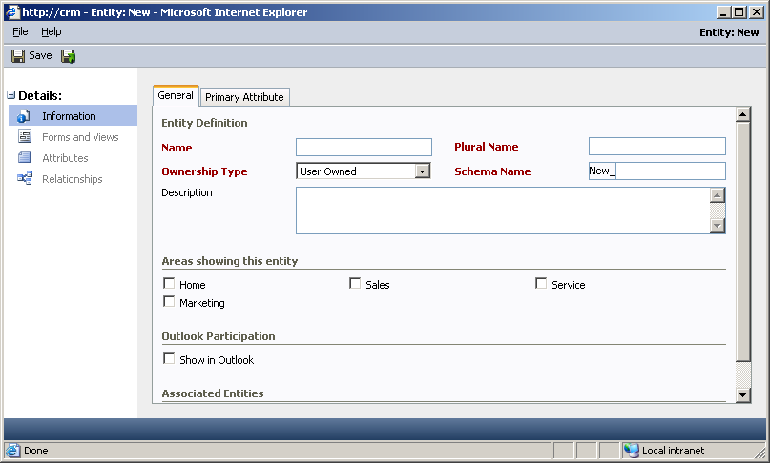

NOTE: It is important to understand that Microsoft CRM only supports modifications that can be made with the CRM administrative tools or through the SDK. Any changes made outside of these applications may cause issues within your CRM environment and are not supported by Microsoft.

Example Issue: Modify forms to link to external applications
Modifying 1.2 CRM forms to link directly to external applications is not supported. This would include any modifications made directly to the forms and not adhering to the rules defined in the 1.2 SDK.

Resolution: Utilize IFRAMES in CRM 3.0
As it was stated earlier, any modifications made to the CRM forms and application files will be overwritten during the upgrade to 3.0. After you complete the upgrade to 3.0 you will want to use IFRAMES to link to external applications.

Defined: IFRAME element defines an inline frame for the inclusion of external objects including other HTML documents

- To create an IFRAME with CRM 3.0 you will need to modify the entity that will contain the new IFRAME.
- Click on Settings – Customization and choose Customize Entities.

- Select the entity where you would like to add the IFRAME.
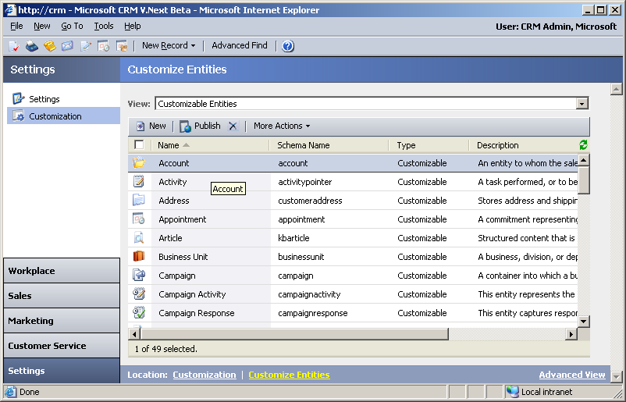

- Select Forms and Views and click on the item called Form.
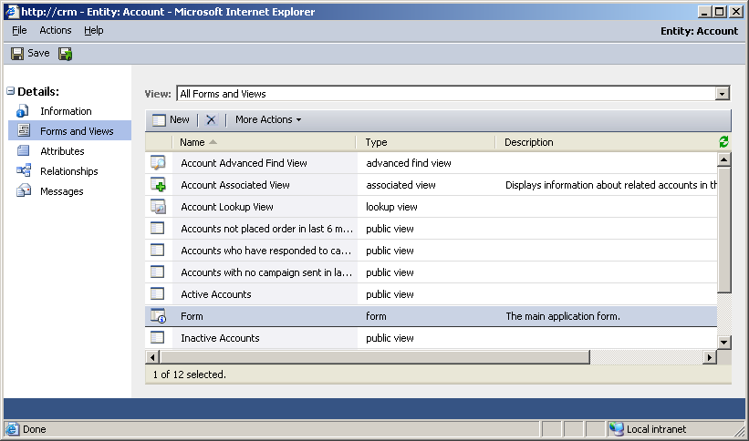

- This screen is similar to CRM 1.2 as it allows you to maintain the entity form (in this case the Account form). It is on this screen you have the ability to add an IFRAME and link to external content.
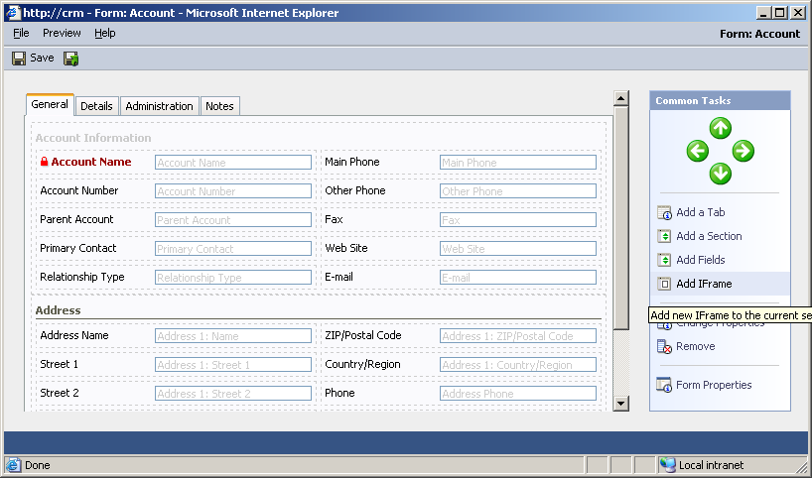

IFRAMES provide a lot of flexibility within your CRM application to expose external data directly from a CRM form. You can learn more about how to use the new CRM IFRAMES by reading the help file on IFRAMES included with the CRM documentation CD.

Example Issue: Modifying Activities
Modifications and integration to activities within CRM 1.2 will most likely break after upgrading to CRM 3.0. This includes any modifications made to activities using the 1.2 SDK and reports that you created based off of the existing activity field structure within SQL server. In order to provide more flexibility with activities in CRM 3.0 the architecture behind them in 1.2 was completely redesigned.

Resolution: Modify activities using the 3.0 Customize Entities

- Prior to upgrading to CRM 3.0 review any reports, integration and modifications that involve using activities in 1.2. Document all of these scenarios as they will have to be reconfigured after you upgrade to CRM 3.0.
- Read the CRM 3.0 SDK to understand how to re-write your integration and reporting scenarios using the new activity architecture.
- Investigate the new customization capabilities for activities in CRM 3.0 to fully understand what is supported in the new environment.
- Identify specific activity types that need to be modified and create custom properties to support your business needs.
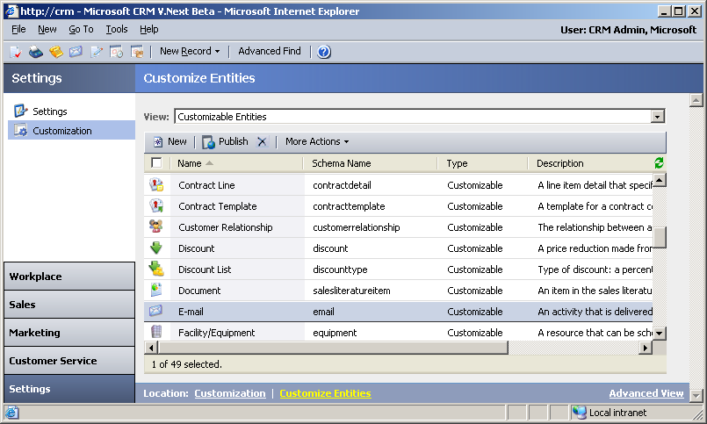

- Define what was needed in CRM 1.2 and add these new properties to CRM 3.0 using the entity modification tool.

  - Information
  - Forms and Views
  - Attributes
  - Relationships
  - Messages

- Create new attributes for the specific activity entity.
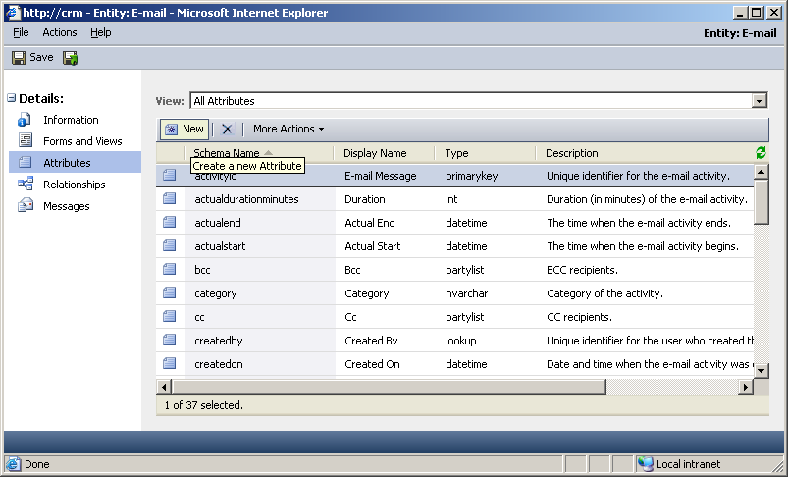
- Create/Modify views to display the business critical information for your users.
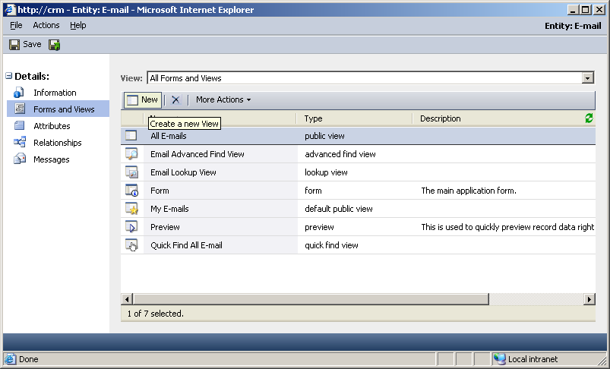

Example Issue: Activity view modifications
Microsoft CRM 1.2 was limited in its ability to customize activities and the views used to display activities. Some organizations have been known to modify views in an unsupported way by making direct calls to the viewManager.aspx page and loading the id for the preferred view. Before upgrading to CRM 3.0 you will want to take note of the modifications you have made to your views to make sure that all fields are properly displayed in the new CRM application.

- Check your default activity views to determine if additional fields have been added.
  - Columns should read
    - Activity Subject
    - Type
    - Status
    - Priority
    - Due Date

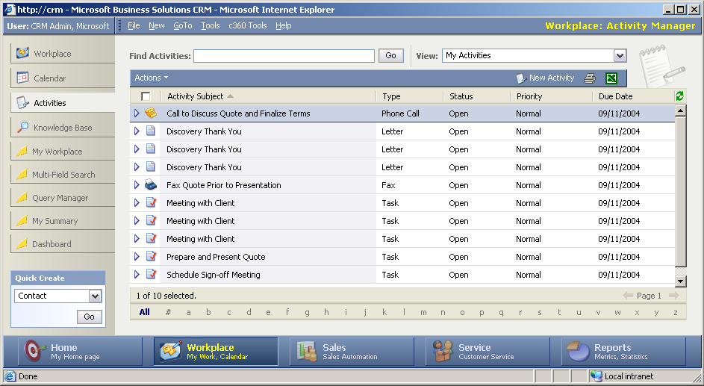
- If you have made modifications to this view your screen might look something like this.
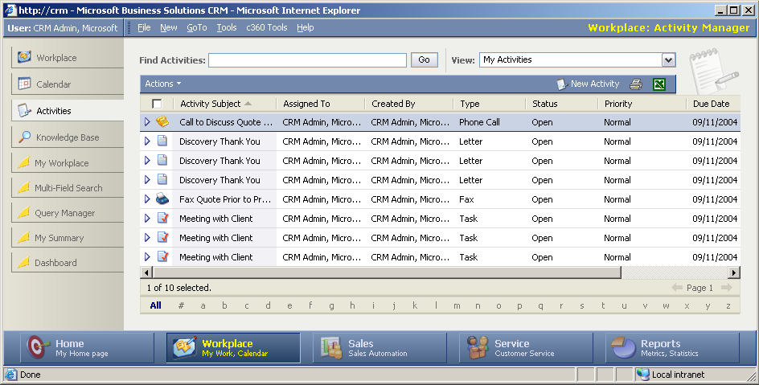

- Document all of your modifications prior to upgrading to CRM 3.0.
- Changes made to views will not cause the upgrade to fail but it is important to understand that the architecture for activities has been completely redesigned in CRM 3.0.

Resolution: Use Customize Entities in 3.0 to modify all views
- After documenting all of your changes you can begin the upgrade to CRM 3.0. Even though the views were modified through unsupported methods the upgrade to 3.0 will still work properly.

- Once the upgrade is complete you should utilize the Customize Entities feature of CRM 3.0 to maintain the activity views. You can also use this feature to add new fields to activity forms.
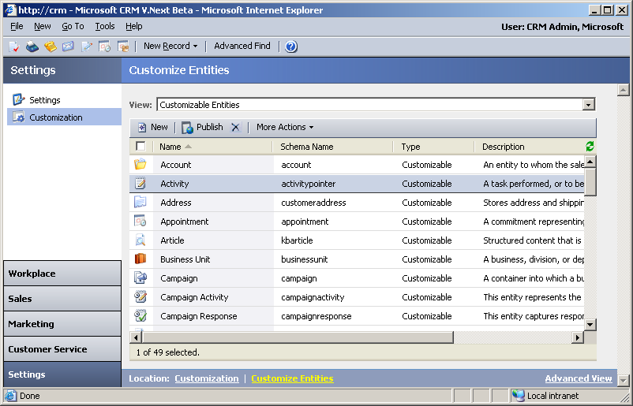

- Click on Views to modify existing views or to create new views (new functionality included with CRM 3.0).
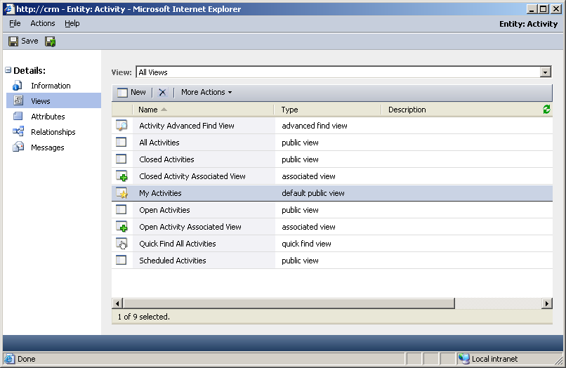

- Validate your changes that were made in 1.2 shows up in the new 3.0 activity views. If they are not present you can utilize this new feature to make modifications to your activity views.
NOTE: CRM 3.0 separates each activity in the list of entities to maintain. Activities like appointment, e-mail, task, etc. are each listed as an entity within the master list. You can add/remove fields from each specific entity to track specific information pertaining to that activity type.
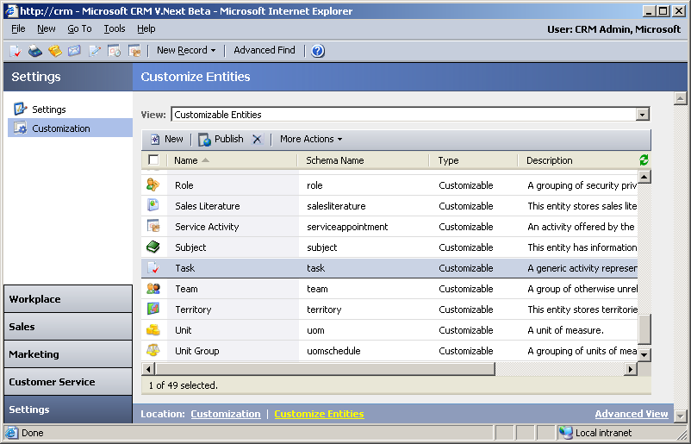

Important Notes
As you prepare to upgrade CRM 1.2 to CRM 3.0 you should make sure you have addressed the following points.

- Do you have a complete backup of CRM 1.2 and all the associated server and database files?
- Do you have good documentation of any integration components between CRM and 3rd party applications?
  - The SDK for CRM 3.0 is different than the SDK for CRM 1.2
  - The documentation for the CRM 3.0 SDK is found on your CRM 3.0 documentation CD
- Have you identified all ISV solutions currently running on your 1.2 platform?
  - Contact the individual ISV to determine if their product is certified to run on 3.0 or if you need to upgrade to a newer version of code
- Reports have changed in CRM 3.0 so make sure you reference the Implementation Guide to understand how your reports will migrate to the new reporting platform.
  - The Implementation Guide is found on the Documentation CD for
CRM 3.0
- Always check Microsoft’s CRM websites for updated information.
  - CustomerSource: https://mbs.microsoft.com/customersource
  - Microsoft CRM Product Information: http://www.microsoft.com/crm

Appendix

CRM Backup Procedures
Before you upgrade your Microsoft CRM 1.2 environment make sure you have reviewed the following steps.
Backup
- Microsoft CRM databases
  - Open SQL Enterprise Manager on the CRM database server
  - Expand SQL Server Instance and find the CRM databases
  - Right click [Organization Unit Name]_MSCRM database and choose All Tasks - Backup Database
  - Choose whether to back up to disk or tape
  - Repeat steps for
    - [Organization Unit Name]_METABASE
    - [Organization Unit Name]_CRMCrystal
- System data
  - Backup your system files including the operating system and system state (to tape or disk)
  - Backup data related to Microsoft CRM
    - IIS Metabase
    - ISV.config
    - Web.config
    - OutlookCleint.xml
    - Registry
- Backup Microsoft CRM customizations
- Logon to the Microsoft CRM application server
- Open the Microsoft CRM Deployment Manager
- Right mouse click on Deployment Manager and choose All Tasks – Export Cusotmization…
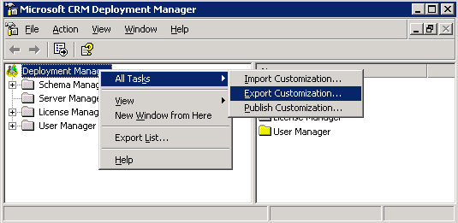

- Choose a location to save your file and write this down for future reference
- Backup Crystal Reports
  - Use the Backup Crystal tool found in the Microsoft CRM Redeployment Tools application to backup your Crystal reports used in Microsoft CRM.
NOTE: We recommend you back up your Crystal Reports prior to the upgrade to prevent unwanted data loss.
  - Download the Microsoft CRM Redeployment Tool from:
http://www.microsoft.com/downloads/details.aspx?FamilyID=bfced393-61db-49af-9a50-4a90b311fa7d&DisplayLang=en
Extract the files and navigate to the ReportsTool folder
  - Run the BackupCrystal.exe to create backups of your Crystal Reports.
  - Make sure you have separate backups of any custom Crystal Reports created for Microsoft CRM.
- Backup Custom Crystal Reports
  - Install Crystal Reports version 9.2.2 Developer Edition on a client PC (See Crystal Reports installation guide).
  - Install Crystal Reports Enhancement for CRM 1.2 (Located on the Microsoft CRM installation disc 4).
  - Open Crystal Reports and choose File - Logon APS.
  - Enter CRM server name in APS field and enter Crystal Enterprise password (by default this should be blank unless your organized changed the password).
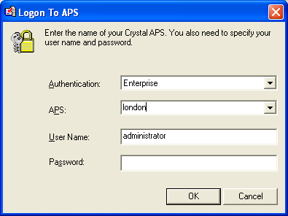
  - After Logon completes, click Open, choose “Enterprise” on left pane.
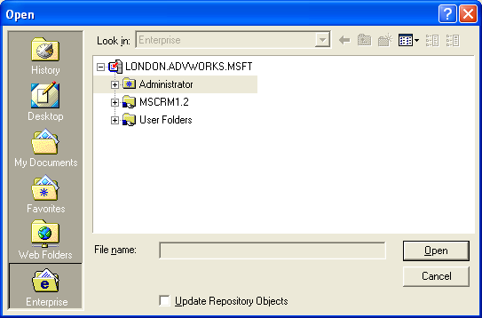
  - Drill down through MSCRM 1.2, choose the custom report you want
to open.
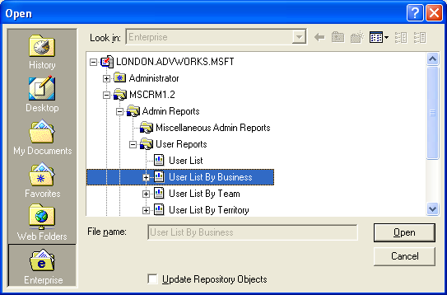
  - Once report is open click Save As and choose a name and location for the file.
NOTE: Save all files to a location other than the database server
NOTE: All custom Crystal Reports will have to be re-written in SQL Reporting Services, after upgrading to CRM 3.0.

Disable Publishing
- Open SQL Enterprise Manager and from the toolbar click on Tools – Replication – Disable Publishing.
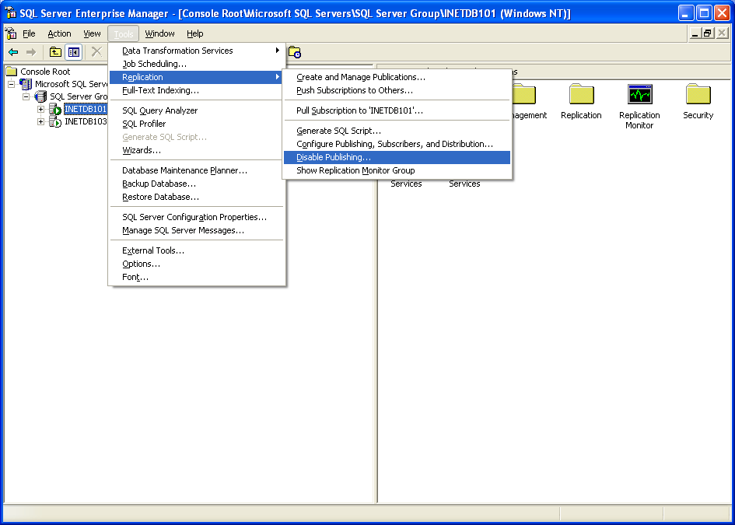
- Choose “Yes Disable Publishing on (servername)”.
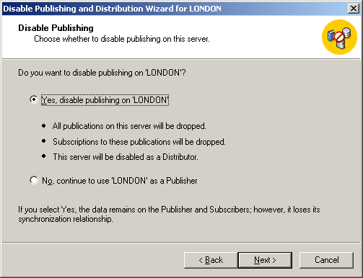
- Review selections and click Finish.

Remove Remaining Replication System Objects
After you disable publishing, run the following script to clean up any remaining replication system objects.
Important Execute this script against the [Organization_Unit_Name]_MSCRM database only.
SET NOCOUNT ON
CREATE TABLE ASReplicationObjects
(
name sysname,
type char(2),
crdate datetime
)

DECLARE @objectName sysname
DECLARE @objectType sysname

DECLARE @sqlStatement nvarchar(1024)
DECLARE @sqlStatementBegin sysname
DECLARE @sqlStatementAndType sysname
DECLARE @sqlStatementDropTrigger sysname
DECLARE @sqlStatementDropProcedure sysname
DECLARE @sqlStatementDropView sysname
DECLARE @sqlStatementDropTable sysname

SET @sqlStatementBegin = N'IF EXISTS (SELECT name FROM sysobjects WHERE
name = N'''
SET @sqlStatementAndType = N''' AND type=N'''
SET @sqlStatementDropTrigger = N''') DROP TRIGGER '
SET @sqlStatementDropProcedure = N''') DROP PROCEDURE '
SET @sqlStatementDropView = N''') DROP VIEW '
SET @sqlStatementDropTable = N''') DROP TABLE '

--Delete triggers.
SET @objectType = N'TR'
insert into ASReplicationObjects
select name, type, crdate from sysobjects where (type=@objectType) and
(name like N'del_%' or name like N'ins_%' or name like N'upd_%' )
order by name

select count(*) from ASReplicationObjects as CountTriggers

DECLARE trigger_cursor CURSOR FOR
SELECT name FROM ASReplicationObjects WHERE type = @objectType

OPEN trigger_cursor
FETCH NEXT FROM trigger_cursor INTO @objectName
WHILE @@FETCH_STATUS = 0
BEGIN
SET @sqlStatement = @sqlStatementBegin + @objectName +
@sqlStatementAndType +@objectType + @sqlStatementDropTrigger +
@objectName
PRINT @sqlStatement
EXEC sp_executesql @stmt = @sqlStatement
FETCH NEXT FROM trigger_cursor INTO @objectName
END

CLOSE trigger_cursor
DEALLOCATE trigger_cursor

DELETE ASReplicationObjects

--Delete stored procedures.
SET @objectType = N'P'
insert into ASReplicationObjects
select name, type, crdate from sysobjects where (type =@objectType) and
(name like N'sp_cft_%' or name like N'sp_ins_%' or
name like N'sp_sel_%' or name like N'sp_upd_%' or name like N'sel_%')
order by name

select count(*) from ASReplicationObjects as CountStoredProcedures_cft_ins_sel_upd

DECLARE storproc_cursor CURSOR FOR
SELECT name FROM ASReplicationObjects WHERE type = @objectType

OPEN storproc_cursor
FETCH NEXT FROM storproc_cursor INTO @objectName
WHILE @@FETCH_STATUS = 0
BEGIN
SET @sqlStatement = @sqlStatementBegin + @objectName +
@sqlStatementAndType +@objectType + @sqlStatementDropProcedure +
@objectName
PRINT @sqlStatement
EXEC sp_executesql @stmt = @sqlStatement
FETCH NEXT FROM storproc_cursor INTO @objectName
END

CLOSE storproc_cursor
DEALLOCATE storproc_cursor

DELETE ASReplicationObjects

--Delete stored procedures, for example, %xp and _% . 53 sp, for each –
--Replication setup.
SET @objectType = N'P'
insert into ASReplicationObjects
select name, type, crdate from sysobjects where (type =@objectType) and
(name like N'%xpand_%' or name like N'%p_cft_%')
order by name

select count(*) from ASReplicationObjects as CountStoredProceduresLikeExpand

DECLARE storproc_cursor2 CURSOR FOR
SELECT name FROM ASReplicationObjects WHERE type = @objectType

OPEN storproc_cursor2
FETCH NEXT FROM storproc_cursor2 INTO @objectName
WHILE @@FETCH_STATUS = 0
BEGIN
SET @sqlStatement = @sqlStatementBegin + @objectName +
@sqlStatementAndType +@objectType + @sqlStatementDropProcedure +
@objectName
PRINT @sqlStatement
EXEC sp_executesql @stmt = @sqlStatement
FETCH NEXT FROM storproc_cursor2 INTO @objectName
END

CLOSE storproc_cursor2
DEALLOCATE storproc_cursor2

DELETE ASReplicationObjects

--Delete views.
SET @objectType = N'V'
insert into ASReplicationObjects
-- In case views should be removed from metabase.
select name, type, crdate from sysobjects where (type='V') and
(name like N'ctsv_%' or name like N'tsvw_%' or name like N'CRMPub%'
or name like N'CRMMetaPub%')
order by name

select count(*) from ASReplicationObjects as CountViews

DECLARE view_cursor CURSOR FOR
SELECT name FROM ASReplicationObjects WHERE type = @objectType

OPEN view_cursor
FETCH NEXT FROM view_cursor INTO @objectName
WHILE @@FETCH_STATUS = 0
BEGIN
SET @sqlStatement = @sqlStatementBegin + @objectName +
@sqlStatementAndType +@objectType + @sqlStatementDropView +
N'['+@objectName +N']'
PRINT @sqlStatement
EXEC sp_executesql @stmt = @sqlStatement
FETCH NEXT FROM view_cursor INTO @objectName
END

CLOSE view_cursor
DEALLOCATE view_cursor

DELETE ASReplicationObjects

--Delete tables.
SET @objectType = N'U'
insert into ASReplicationObjects
select name, type, crdate from sysobjects where (type='U') and
(name like N'%onflict_%' )
order by name

select count(*) from ASReplicationObjects as CountTables

DECLARE table_cursor CURSOR FOR
SELECT name FROM ASReplicationObjects WHERE type = @objectType

OPEN table_cursor
FETCH NEXT FROM table_cursor INTO @objectName
WHILE @@FETCH_STATUS = 0
BEGIN
-- "-" in table name has a syntax problem, so add [] around table name.
SET @sqlStatement = @sqlStatementBegin + @objectName +
@sqlStatementAndType +@objectType + @sqlStatementDropTable +
N'['+@objectName + N']'
PRINT @sqlStatement
EXEC sp_executesql @stmt = @sqlStatement
FETCH NEXT FROM table_cursor INTO @objectName
END

CLOSE table_cursor
DEALLOCATE table_cursor
DELETE ASReplicationObjects
DROP TABLE ASReplicationObjects

This is a preliminary document and may be changed substantially prior to final commercial release of the software described herein.

The information contained in this document represents the current view of Microsoft Corporation on the issues discussed as of the date of publication. Because Microsoft must respond to changing market conditions, it should not be interpreted to be a commitment on the part of Microsoft, and Microsoft cannot guarantee the accuracy of any information presented after the date of publication.

This White Paper is for informational purposes only. MICROSOFT MAKES NO WARRANTIES, EXPRESS OR IMPLIED, AS TO THE INFORMATION IN THIS DOCUMENT.

Complying with all applicable copyright laws is the responsibility of the user. Without limiting the rights under copyright, no part of this document may be reproduced, stored in or introduced into a retrieval system, or transmitted in any form or by any means (electronic, mechanical, photocopying, recording, or otherwise), or for any purpose, without the express written permission of Microsoft Corporation.

Microsoft may have patents, patent applications, trademarks, copyrights, or other intellectual property rights covering subject matter in this document. Except as expressly provided in any written license agreement from Microsoft, the furnishing of this document does not give you any license to these patents, trademarks, copyrights, or other intellectual property.

© 2005 Microsoft Corporation. All rights reserved.

Microsoft, Active Directory, Windows, and Windows Server are either registered trademarks or trademarks of Microsoft Corporation in the United States and/or other countries.

The names of actual companies and products mentioned herein may be the trademarks of their respective owners.

