**Dear Colleagues,**

**The Asklepios Hospital Barmbek in Hamburg** was officially opened last Friday, February 24. Based on the **partnership between Asklepios, Microsoft and Intel**, this hospital is now able to set **new standards for state-of-the-art information technology in the healthcare system** and serves as a **reference center in the healthcare sector**.

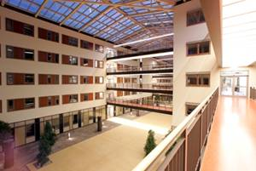

The opening of the Asklepios Clinic Barmbek is convincing proof that the times really are changing in the healthcare sector. This new hospital, operated by the Asklepios Group, combines architectural, organizational and information technology-related innovations and is the reference center for ongoing developments in the healthcare system.

“The Asklepios Hospital Barmbek is based on the tradition of the past and the medicine of the future for the people of the present,” commented Hans-Friedrich Guenther, Commercial Director of the Asklepios Hospital Barmbek, describing the overall concept of the new hospital. In order to be able to meet these challenges, the Asklepios Hospital Barmbek is taking full advantage of new concepts and technologies. With this network-oriented, information-oriented approach, the clinic creates the ideal prerequisites for the Asklepios Future Hospital Program, which was initiated by the Asklepios Group in cooperation with technology suppliers, Microsoft and Intel. With this program, the initiators aim to work together to develop transferable IT solutions for the healthcare system and to test their relevance for the optimization of treatment and management processes in clinics.

**More than** **500 guests** from the healthcare industry, politics, business and public life accepted the invitation to the opening. The **official opening speeches** were held by the Lord Mayor of Hamburg, Ole von Beust, such high-ranking representatives from Asklepios as **Dr. Bernard Broermann** (founder and sole shareholder of the Asklepios Clinics), **Dr. Joerg Weidenhammer** (Managing Director of the Asklepios Clinics), **Hans-Friedrich Guenther** (Commercial Director of Asklepios Hospital Barmbek) and **Louis Burns** (Vice President and General Manager of Intel Corporation’s Digital Health Group) as well as **Pascal Stolz** (Government Managing Director of Microsoft Worldwide Public Sector). All the partners confirmed their desire to work together more closely and to gradually expand the scope of this project.

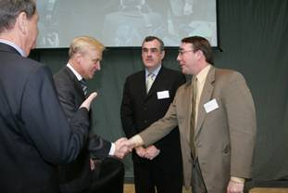

The new Asklepios Hospital Barmbek in Hamburg serves as a **reference center for the “Future Hospital”**. In its atrium, the Barmbek Hospital houses an area open to the general public, which acts as a showroom for the “Future Hospital”. Visitors to the showroom can take a “virtual tour” around the hospital to obtain information on the key areas in which IT solutions have been combined with new processes to enhance the quality of medical treatment, improve efficiency, prevent errors in treatment and reduce costs.

**Dr. Tobias Kaltenbach** (Managing Director of the Asklepios Clinics), **Hannes Schwaderer** (Managing Director at Intel GmbH) and **Christoph Wilfert** (BMO Microsoft Deutschland) officially cut the ribbon to hand over the showroom to the clinic managers, a showroom that presents future-oriented information technologies in such an easy-to-understand, innovative manner for the first time.

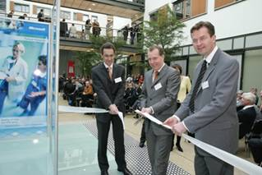

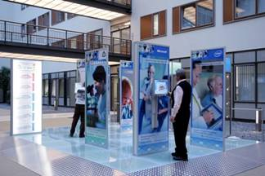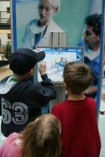

The **media** also displayed a great deal of interest in the official opening: the Financial Times Deutschland, the FAZ and Computerwoche as well as IT/healthcare trade journals and the local media all attended the press conference. We expect this event to generate considerable media response; the first articles have already appeared in Computerwoche, in Hamburger Abendschau as well as in the FAZ.

The first feedback:

•          As the owner of the Asklepios Group, Dr. Broermann is 100% committed to the IT leadership of the Asklepios Group, stressed the long-term nature of the collaboration with Intel and MS and also emphasized that for him it was the first time that IT had played such an integral role in the development of his company.

•          Dr. Günther, Director of the Barmbek Hospital: “This is only the beginning!”

•          Uwe Pöttgen is very enthusiastic about what is happening here and very eager to know what the future holds; he had never experienced anything like this before.

•          Mr. Focke, IT Director at Barmbek: “We are making a difference in the healthcare sector and I am proud to be part of it.”

•          Mr. Praetorius, SIEMENS, “Wow, this is awesome, and the choice of your reference center is a very good one; we have our showpiece in the hospital in Suhl, but who has ever heard of Suhl?”

Needless to say, the opening in Barmbek was **a resounding success** in every respect: **an exciting project, outstanding collaboration with customers, the press and the partners and top-quality teamwork**. That’s why our special thanks go out to the healthcare team under the leadership of **Jens Dommel** with **Andreas Rohne** (Account Manager), **Harald Nawo** (Solution Specialist eHealth), **Frank von Ehren** (MCS Project Leader at Asklepios), **Wolfgang Enking** (Services Sales Management) and many more. Thanks to their dedication, the Future Hospital was set up in just 10 short months.  
   
We would also like to thank **Bettina Zielke** in particular for her creation of the showroom, the content-related scenarios and her work in the organization of the opening event, as well as **Pascal Stolz** and **Christoph Wilfert**, who attended as the official representatives of Microsoft. Special thanks also to **Joachim Krone** (Strategic Alliance Manager EMEA) for all his support during the IOI campaign. And last, but certainly not least, thanks to **Astrid Kasper**, who was responsible for the press work and the press conferences. An outstanding example of teamwork across many different departments!!!  
   
And we certainly do not want to neglect to mention the close cooperation between Asklepios and Intel prior to the opening and their work on the showroom. Many thanks also to **Mandy Wolf** (ZD Marketing, Asklepios Clinics), **Jörg Focke** (Leader at the Innovations Center, Asklepios Clinic Barmbek) and **Laura Conger** (CRS Asklepios Marketing Manager, EMEA, Intel GmbH).

Mit freundlichen Grüßen / Regards

**Wolfgang Branoner**

PSD Germany