Solutions for Small Business

[Insert Partner Copyright Notice or Trademark Notice]  
[Insert Partner Legal and/or Privacy Information]

Dear **[Insert Small Business Owner’s Name]**,

In the past four years, the number of small businesses that rely on the web to drive new business has doubled. If *your* Internet presence isn’t as effective as it could be, we can help. With our solutions, you’ll be able to:

* Create and maintain a customized web site for your business
* Be accessible to your customers 24/7
* Use your brand to make your company look larger
* Launch a search marketing program to get more customers

**Would you like to learn more? Visit** [**http://mslocalbiz.com**](http://mslocalbiz.com) **to view special offers, access small business resources, and learn about other events in your local area.**

Regards,

**[Insert Signature]**

**[Insert Your Name]**

**[Insert Your Title]**

**[Insert Your Partner Name]**

**P.S. Remember, you can find special offers, resources for small business, and information about other events in your area at** [**http://mslocalbiz.com**](http://mslocalbiz.com)**.**

My 5th grader has a  
better web site than you!



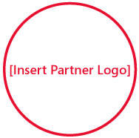C:\Documents and Settings\hkurwa\Desktop\sblogo.jpg