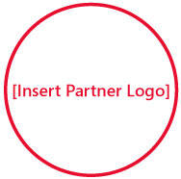C:\Documents and Settings\hkurwa\Desktop\sblogo.jpg

Solutions for Small Business



[Insert Partner Copyright Notice or Trademark Notice]  
[Insert Partner Legal and/or Privacy Information]

Want to use the Internet to drive your business? Build on the information you’ve gathered at this event by taking the next step.

**Visit** [**http://mslocalbiz.com**](http://mslocalbiz.com) **to view special offers, access small business resources, and learn about other events in your local area.**

My 5th grader has a better web site than you!