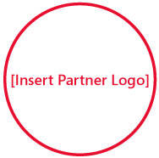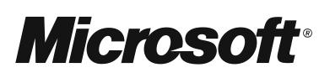

**Instructions for Use - Delete before Printing**

Be sure to:

* Add required information where indicated in red.
* Insert the event registration URL you obtained from [www.microsoftpartnerevents.com](http://www.microsoftpartnerevents.com) or [www.microsoftgroupevents.com](http://www.microsoftgroupevents.com) or your own registration URL.
* Add your logo and that of any event co-sponsors in place of the “Insert Partner Logo” circles. Right-click on one of the circles and select “Change Picture.” Then browse to the folder where you have your logo saved on your computer, select your logo, and click “Insert.” Repeat for any additional logos.  Delete any extra circles.

You may also want to:

* Add an offer from the Microsoft Offer Sheet or one of your own offers.
* Customize the font colors.



Don’t miss this opportunity to meet other local business people, share experiences, and learn how to hang on to more of your customers.

**Please join us! Go to [Insert Partner Registration URL] to register today.   
Visit** [**www.mslocalbiz.com**](http://www.microsoft.com/smallbusiness/local/default.aspx?xid=G0055#Welcome) **to view valuable offers, access small business resources, and learn about other events in your local area. [or Insert current Microsoft or Partner offer here]**

Keep your customer, *your* customer.

**Event info:  
[Month dd, 2008]  
[12:00am-12:00pm]  
[Location Name]  
[Street Address]  
[City, State]**

[Insert Partner Copyright Notice or Trademark Notice]  
[Insert Partner Legal and/or Privacy Information]

Solutions for Small Business