Microsoft  Technical  Document | Technical White Paper
Developing with the MultiPoint SDK Version 1.1: The Map and Quiz Samples
February 10, 2009

Contents
Introduction 3
Getting Started with MultiPoint 3
Managing Device Connections 4
Handling Mouse Arrival and Removal 4
Maintaining Connected Devices and Their Pointer Assignments 5
Managing Pointer Behavior 7
Restricting Pointer Movement 7
Excluding Pointers from a Region on the Screen 9
Assigning Specific Mouse Functions 10
Appendix A: Scenarios 11
The Map Sample Scenario 11
The Quiz Sample Scenario 12

Disclaimer
This document supports a preliminary release of a software product that may be changed substantially prior to final commercial release, and is the confidential and proprietary information of Microsoft Corporation. It is disclosed pursuant to a non-disclosure agreement between the recipient and Microsoft. This document is provided for informational purposes only and Microsoft makes no warranties, either express or implied, in this document. Information in this document, including URL and other Internet Web site references, is subject to change without notice. The entire risk of the use or the results from the use of this document remains with the user. Unless otherwise noted, the companies, organizations, products, domain names, e-mail addresses, logos, people, places, and events depicted in examples herein are fictitious. No association with any real company, organization, product, domain name, e-mail address, logo, person, place, or event is intended or should be inferred. Complying with all applicable copyright laws is the responsibility of the user. Without limiting the rights under copyright, no part of this document may be reproduced, stored in or introduced into a retrieval system, or transmitted in any form or by any means (electronic, mechanical, photocopying, recording, or otherwise), or for any purpose, without the express written permission of Microsoft Corporation.
Microsoft does not make any representation or warranty regarding specifications in this document or any product or item developed based on these specifications. Microsoft disclaims all express and implied warranties, including but not limited to the implied warranties or merchantability, fitness for a particular purpose and freedom from infringement. Without limiting the generality of the foregoing, Microsoft does not make any warranty of any kind that any item developed based on these specifications, or any portion of a specification, will not infringe any copyright, patent, trade secret or other intellectual property right of any person or entity in any country. It is your responsibility to seek licenses for such intellectual property rights where appropriate. Microsoft shall not be liable for any damages arising out of or in connection with the use of these specifications, including liability for lost profit, business interruption, or any other damages whatsoever. Some states do not allow the exclusion or limitation of liability or consequential or incidental damages; the above limitation may not apply to you.
Microsoft may have patents, patent applications, trademarks, copyrights, or other intellectual property rights covering subject matter in this document. Except as expressly provided in any written license agreement from Microsoft, the furnishing of this document does not give you any license to these patents, trademarks, copyrights, or other intellectual property.
© 2009 Microsoft Corporation. All rights reserved.
Microsoft, MultiPoint, and Windows are trademarks of the Microsoft group of companies.
All other trademarks are property of their respective owners.

Introduction
The Microsoft® MultiPoint™ SDK version 1.1 (MultiPoint) is a development framework that enables developers to build applications where multiple mouse devices can connect to one computer simultaneously. Applications built using MultiPoint can handle mouse clicks from different users independently, and can customize each mouse by assigning it a unique pointer. This technology is intended to inspire a spirit of teamwork and collaboration. MultiPoint is designed for use in educational environments where there are not enough computers to supply one for each student.
This document describes how to use MultiPoint to build applications that allow multiple mouse devices. You can use the Map sample and Quiz sample discussed below to expand your knowledge of MultiPoint and create your own original products. Both samples are built using the Windows Presentation Foundation (WPF). In the Map Sample application, all mouse devices are used to participate in a common activity using the full screen; in the Quiz Sample application, each mouse has a separate region of the screen in which to perform its task. Scenarios for both of these applications are described in Appendix A: Scenarios. The complete code for both samples is included with the MultiPoint SDK.
In the three sections of this document, you will learn how to get started building applications with the MultiPoint SDK, how to manage multiple mouse devices, and how to address the unique challenges associated with having multiple active users of an application.

Getting Started with MultiPoint
Working with multiple mouse devices requires that the application accept input from any mouse. The application must also handle the addition and removal of mouse devices. These events should be encapsulated in the constructor of the application’s main window.
In the following code snippet, two different techniques are used to enapsulate event handlers. The first two events are specific to WPF in that they are routed events. The calls to AddMultiPointMouseDownHandler and AddMultiPointMouseMoveHandler encapsulate the event handlers for the mouse-button down event (i.e., MultiPointMouseDown) and the mouse move event (i.e., MultiPointMouseMove) at the correct stage in the routed event stack. The MultiPoint SDK_DeviceArrival and MultiPointSDK_DeviceRemoveComplete events are global MultiPoint events that are raised when mouse devices are added and removed. These events are useful for allowing custom pointers to be assigned to mouse devices or for associating additional information with a mouse.
public WindowMain()
{
MultiPointMouseEvents.AddMultiPointMouseDownHandler(this, new RoutedEventHandler(OnMultiPointMouseDown));
MultiPointMouseEvents.AddMultiPointMouseMoveHandler(this, new RoutedEventHandler(OnMultiPointMouseMove));

MultiPointSDK.Instance.DeviceArrivalEvent += MultiPointSDK_DeviceArrivalEvent;
MultiPointSDK.Instance.DeviceRemoveCompleteEvent += MultiPointSDK_DeviceRemoveCompleteEvent;

Once the main window is loaded, an additional step must be carried out in the Loaded event of the main window. As MultiPoint displays its own pointers, it requires that the system cursor be hidden and that the application window be associated with MultiPoint. MultiPoint then needs to register all current mouse devices and display the default cursors for them. This is all done by calling the Initialize method on the MultipointPointSDK.Instance object.
private void window_Loaded(object sender, RoutedEventArgs e)
{
MultiPointSDK.Instance.Initialize(window);

Managing Device Connections
This section covers how to manage devices, including maintenance of connected devices and their pointer assignments, handling of new mouse devices, and handling the removal of mouse devices.

Handling Mouse Arrival and Removal
When mouse devices are connected or disconnected from a computer, MultiPoint raises the corresponding DeviceArrivalEvent or DeviceRemovalEvent. In the Quiz sample, these events are handled and passed through to the HandleMouseArrival and HandleMouseRemoval methods. When a new mouse is plugged into the computer, a check is made to ensure that the maximum number of players has not been exceeded. The mouse is then assigned a pointer, and a new player is created and associated with the mouse device.
public Player HandleMouseArrival(DeviceNotifyEventArgs e)
{
if (!Common.MouseHelper.CheckIfTooManyMice(MultiPointSDK.Instance, MAX_PLAYERS))
{
Player p = CreateNewPlayerAndAddToList(e.DeviceInfo);
Common.MouseHelper.AssignCursorToMouse(e.DeviceInfo);

QuizMaster.Instance.GameComplete = CheckIfTooFewMice();
When a mouse is removed from the computer, the association between the pointer and the mouse that was set up in the HandleMouseArrival method is removed. The corresponding player is also removed.
public void HandleMouseRemoval(DeviceNotifyEventArgs e)
{
PlayerList.Remove(GetPlayerByDeviceID(e.DeviceInfo.ID));
Common.MouseHelper.RemoveCursorFromMouse(e.DeviceInfo);
QuizMaster.Instance.GameComplete = CheckIfTooFewMice();
}

Maintaining Connected Devices and Their Pointer Assignments
When there are many pointers on the screen, it is important to be able to differentiate the pointers from one another so that each user knows which pointer to follow. MultiPoint enables easy customization of mouse pointers with the CursorColor and CursorImage properties, or the MultiPointMouseDevice method’s DeviceVisual property.
To ensure that no two users are assigned the same pointer, the CursorAssignment class is used to track the assignment of a cursor to a particular mouse device, and then the CursorAssignments class is used to track all cursor assignments throughout the application. CursorAssignments maintains a read-only array of CursorAssignment objects that correspond to each of the cursors available within the application.
public class CursorAssignment
{
public System.Drawing.Bitmap Cursor;
public int MouseID;
}
public sealed class CursorAssignments
{
private static readonly CursorAssignments instance
= new CursorAssignments();
static CursorAssignments() { }
public static CursorAssignments Instance
{
get { return instance; }
}
}

The CursorAssignments class has a public property, Assignments, which is used to return the list of current cursor assignments. This property is a wrapper for the assignments field that is created using the array initialization syntax.
public CursorAssignment[] Assignments
{
get { return assignments; }
}

public CursorAssignment[] assignments = new CursorAssignment[]
{
new CursorAssignment(){Cursor=Properties.Resources.elephant,
MouseID=-1},
new CursorAssignment(){Cursor=Properties.Resources.tiger,
MouseID=-1},

Now that the CursorAssignment and CursorAssignments classes are set up, you can start assigning cursors to mouse devices. Using the FirstOrDefault extension method, the Assignments array can be queried to get the first object that has a MouseID = -1.
public static void AssignCursorToMouse(DeviceInfo mouseObject)
{
CursorAssignment assignment =
CursorAssignments.Instance.Assignments.FirstOrDefault
(ca => ca.MouseID == -1);
MultiPointMouseDevice mouseDevice =
(MultiPointMouseDevice)mouseObject.DeviceVisual;
mouseDevice.CursorImage =
CreateBitmapImage(assignment.Cursor);
assignment.MouseID = int.Parse(mouseObject.DeviceID);
}

Since .png files are stored in Resources as System.Drawing.Bitmap objects, and the MultiPoint SDK requires System.Windows.Media.Imaging.BitmapImage objects, the resources must be passed through a function that converts them to bitmap images. The function then assigns the mouse’s DeviceID to the MouseID in the assignment object to complete the association. When a mouse is removed, the MouseID is set back to -1, making it available for the next mouse to be connected.
Because the number of cursors defined in the CursorAssignments class is finite, this limits the number of mouse devices that can participate in an activity. The CheckIfTooManyMice method is used to determine whether a mouse device that has just been connected should be assigned a pointer. If not, the pointer is hidden by setting the Visible property to false.
public static bool CheckIfTooManyMice(int maxPlayers)
{
if (MultiPointSDK.Instance.MouseDeviceList.Count > maxPlayers)
{
for (int i = maxPlayers;
i < MultiPointSDK.Instance.MouseDeviceList.Count - 1;
i++)
{
((MultiPointMouseDevice)
((DeviceInfo)(MultiPointSDK.Instance.MouseDeviceList[i]))
.DeviceVisual).Visible = false;

Managing Pointer Behavior
With multiple users in an application, it may be necessary to limit mouse movement to certain areas of the screen or exclude mouse devices from a screen region. In many collaborative applications, it is necessary to allocate specific functionality to an individual mouse; for example, a teacher who can control progress through a series of learning activities.

Restricting Pointer Movement
There are times when you may want to limit where pointers can move on the screen. In the Quiz sample application, each pointer is restricted to movement only within its assigned player area. To keep a pointer within a specific area of the screen, the application needs to monitor mouse movement.
In order for MultiPoint mouse events to be raised, a control must implement the IMultiPointMouseEvents interface. The main window of the application must track mouse movement because it is the only control that will receive mouse events regardless of where the mouse pointer is on the screen.
public partial class WindowMain : Window, IMultiPointMouseEvents

This interface is made up of a series of events that must be declared. Each of these events represents a different MultiPoint event that can be encapuslated as part of your application. An event handler for the mouse move event is created once the main window of the application loads.
MultiPointMouseEvents.AddMultiPointMouseMoveHandler
(this, new RoutedEventHandler(MultipointObject_MouseMove));

In the Quiz sample, the MultipointObject_MouseMove event handler simply delegates handling of the event to the PlayerManager class.
void MultipointObject_MouseMove(object sender, RoutedEventArgs e)
{
PlayerManager.Instance.HandleMouseMovement(this, e);
}

Because the PlayerManager class is responsible for maintaining all of the PlayerRegions within the Quiz sample, it monitors the pointers and forces them to stay within the bounds of their assigned region. The mouse’s DeviceID property is used to identify the region to which the mouse belongs.
public void HandleMouseMovement(WindowMain wm, RoutedEventArgs e)
{
MultiPointMouseEventArgs args = e as MultiPointMouseEventArgs;
if (args == null) return;

string deviceID = args.DeviceInfo.DeviceID;
MultiPointMouseDevice deviceVisual
= args.DeviceInfo.DeviceVisual as MultiPointMouseDevice;

for (int i = 0; i < PlayerRegionList.Count; i++)
{
if (PlayerRegionList[i].MouseDevice.DeviceID == deviceID)
{

Based on the located PlayerRegion, the containment rectangle is determined by starting with the upper left corner (i.e., the co-ordinates of 0,0) and constructing a rectangle that corresponds to the width and height of the PlayerRegion. To be safe, a margin of 10 is removed from the rectangle to ensure that the pointer cannot reach the actual edge of the PlayerRegion.
Point screenPosition = deviceVisual.GetPosition();
Point point =
wm.mainWindowWrap.Children[i].PointToScreen(new Point(0.0, 0.0));

Rect rect = new Rect(point.X, point.Y,
PlayerRegionList[i].ActualWidth, PlayerRegionList[i].ActualHeight);
rect.Inflate((double)-10.0, (double)-10.0);

The position of the mouse is tested against the four bounds of the PlayerRegion. If it falls outside of the allowed region, the position is updated to bring the mouse back into the boundary of the PlayerRegion at the last recorded location. Finally, the mouse pointer is updated with the new position, which ensures that it remains in the PlayerRegion.
if (screenPosition.X < rect.Left)
screenPosition.X = rect.Left;

if (screenPosition.X > rect.Right)
screenPosition.X = rect.Right;

if (screenPosition.Y < rect.Top)
screenPosition.Y = rect.Top;

if (screenPosition.Y > rect.Bottom)
screenPosition.Y = rect.Bottom;
deviceVisual.SetPosition((int)screenPosition.X, (int)screenPosition.Y);

Excluding Pointers from a Region on the Screen
In the Map sample, the players are restricted from the Control Panel region on the screen. When a player’s mouse attempts to enter this region, it is forced out again by calling the MultiPointMouseDevice.SetPosition method. The mouse that is assigned to the teacher does not have this restriction and is allowed to enter the Control Panel region.
private void OnMultiPointMouseMove(object sender, RoutedEventArgs e)
{
MultiPointMouseEventArgs args = (MultiPointMouseEventArgs)e;
MultiPointMouseDevice mouseDevice =
args.DeviceInfo.DeviceVisual as MultiPointMouseDevice;

if (CursorAssignments.Instance.TeacherAssignment.MouseID ==
int.Parse(args.DeviceInfo.DeviceID))
{
return;
}

// get the position of the mouse relative to this window.
Point mousePosition = PointFromScreen(mouseDevice.GetPosition());
// get the postion of the control panel offset from the window,
// and create a rect that represents it's co-ordinates
Point borderPosition = controlPanelBorder.TranslatePoint(
new Point(0, 0), this);
Rect borderRect = new Rect(borderPosition,
new Size(controlPanelBorder.ActualWidth,
controlPanelBorder.ActualHeight));

if (borderRect.Contains(mousePosition))
{
// a players mouse has attempted to enter the control panel so
// force it back out again
double y = mousePosition.Y > borderRect.Bottom –
borderRect.Height / 2 ?
borderRect.Bottom : borderRect.Top;
mouseDevice.SetPosition((int)mousePosition.X, (int)y);
}
}

Assigning Specific Mouse Functions
In the Map sample, the teacher’s mouse has special access to the Control Panel; all other mouse devices are excluded from this area. The teacher’s mouse is specified by entering a predefined pattern, in this case an M key press, followed by a right-click within two seconds. A customized pointer is assigned to the teacher’s mouse so that it is clearly identifiable. This is just one example of how to use a pattern of clicks and/or key presses to assign functionality to a specific mouse.
When the application is first started, a timer is created with an event handler that is encapsulated to the Tick event. The timer has an interval of two seconds but is initially idle, awaiting the M key press. An event handler is also encapsulated to the MultiPointMouseDown event so that a click event can be detected.
teacherAssignmentTimer = new DispatcherTimer();
teacherAssignmentTimer.Interval = TimeSpan.FromSeconds(2);
teacherAssignmentTimer.Tick += new EventHandler(teacherAssignmentTimer_Tick);

MultiPointMouseEvents.AddMultiPointMouseDownHandler(this, new RoutedEventHandler(OnMultiPointMouseDownHandler));

The OnKeyPress method is overridden, and the Key property of the event argument is interrogated to determine whether the M key was pressed. If the M key press is detected, the timer starts. The timer raises a Tick event when the two-second interval has elapsed.
protected override void OnKeyDown(KeyEventArgs e)
{
base.OnKeyDown(e);
switch (e.Key){
case Key.M:
if (Common.CursorAssignments.Instance.TeacherAssignment.MouseID == -1)
{
teacherAssignmentTimer.Start();

When a MouseDown event is raised, the first check is whether the timer is enabled – this indicates whether the timer is running. If the MouseDown event was raised due to a right-click, the mouse is assigned as the teacher’s mouse.
private void OnMultiPointMouseDownHandler(object sender,
RoutedEventArgs e)
{
if (teacherAssignmentTimer.IsEnabled)
{
MultiPointMouseEventArgs args =(MultiPointMouseEventArgs)e;
MultiPointMouseDevice deviceVisual =
args.DeviceInfo.DeviceVisual as MultiPointMouseDevice;
if (deviceVisual.RightButton == MultiPointMouseButtonState.Pressed)
{
MouseHelper.AssignTeacherMouse(args.DeviceInfo);

Summary
The Windows MultiPoint SDK is an exciting Microsoft framework enabling developers to build innovative applications involving multiple mouse devices connected to a single computer. The pointers on the computer screen can be customized in many ways to create stimulating activities and educational experiences.
Using MultiPoint, you can manage device connections by designating and maintaining connected devices and their pointer assignments, and easily handle the addition and removal of mouse devices. You can control mouse behavior by restricting pointers to certain areas of the screen and/or excluding them from designated areas. Finally, you can assign a mouse and associated pointer to a specific user and allow special permissions for that user.
The Windows MultiPoint SDK can be utilized to create powerful tools for use in education and other fields. You can use MultiPoint and the examples in this paper to guide you in creating your own original applications.

Appendix A: Scenarios
The Map sample and the Quiz sample are detailed in the following sections.

The Map Sample Scenario
Mrs. Adams is a third-grade teacher at an elementary school in an underprivileged area. The school cannot afford to provide a computer for each child. Mrs. Adams has a classroom of thirty students, each with a wireless mouse device connected to her computer. Her computer display is projected onto a large screen at the front of the classroom.
Today the class is going to engage in an activity based on the Map sample. The objective of the activity is for students to point to a location on the map when prompted by a question on the screen. When the sample starts, the options for the activity are loaded and displayed on the right side of the screen. The first option, Cities Around the World, is loaded automatically, and the first question is displayed above the map.
Figure 1: The Map sample 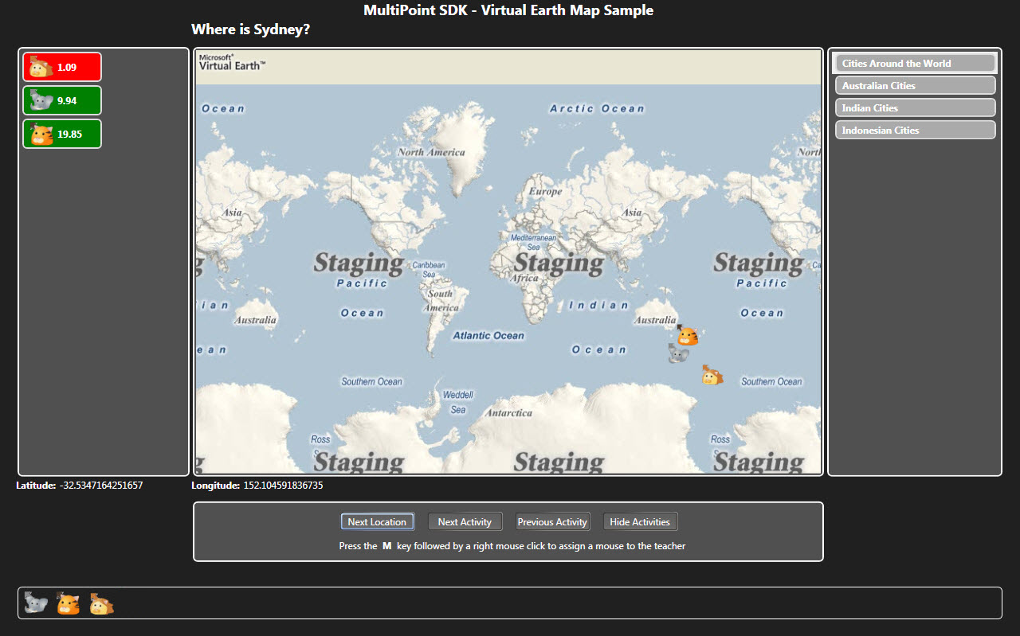

Figure 1 shows the caption “Where is Sydney?” above a map. Three customized pointers that correspond to three players are visible on the map, and are also shown at the bottom of the screen in the Connected Players List. The list on the right side displays the available activity options in the sample.
The application waits for each connected player to click the place on the map that matches the prompted location. Once a player responds, the result is recorded and displayed in the Scoreboard on the left side of the window. The Scoreboard shows the time taken for the student to choose a spot on the map to click, and whether the answer was correct (green) or incorrect (red).
Once all of the connected players have responded to the question, a new caption appears asking for the location of another city. The process repeats until all locations within the activity are completed. The teacher can move ahead to the next location at any time by clicking the Next Location button on the screen. When an activity is finished, the application automatically proceeds to the next one. Activities also can be selected by clicking the Next Activity button on the screen.

The Quiz Sample Scenario
Mrs. Adams’ class will now engage in another activity, this one based on the Quiz sample. Mrs. Adams’ computer display is still projected onto the screen at the front of the classroom, and each student still has a mouse device connected to the teacher’s computer.
In the Quiz sample, there are four separate player areas on the screen. Each player area displays a question, and the player must answer the question by clicking one of the answer button options.
Figure 2: The Quiz Sample 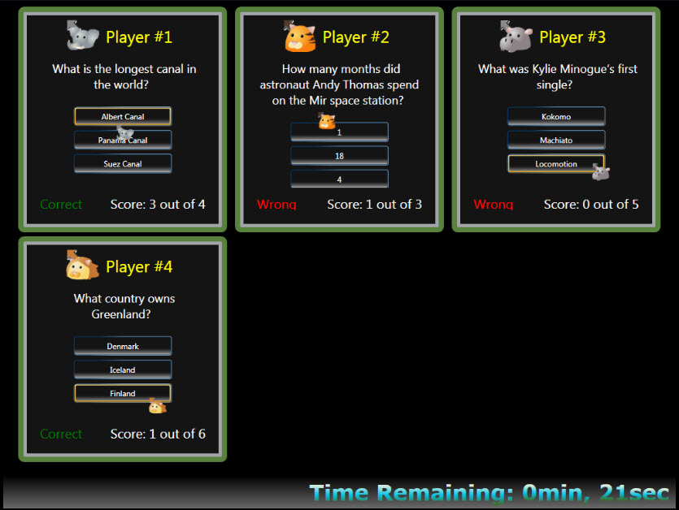

Each player’s pointer is bound to its corresponding player region, so a player can answer only the questions relevant to his or her area. A timer displays a countdown of one minute, and the aim of the sample is to correctly answer as many questions as possible within the given minute.

