
MICROSOFT EXCHANGE HOSTED CONTINUITY
Microsoft® Exchange Hosted Continuity is a business continuity solution that helps protect and provide continuous access to e-mail for a business and its employees.  E-mail has evolved from a simple communication tool into a mission-critical application that supports all aspects of a business. Without access to e-mail, productivity can grind to a halt, and the loss of critical information exchanged through e-mail can be disastrous.  Exchange Hosted Continuity is one of four distinct services in the Microsoft Exchange Hosted Services portfolio. The service provides a security-enhanced and intuitive Web interface through which users can access their previous 30 days of e-mail, as well as compose and send new messages in real time during a primary mail system outage. Exchange Hosted Continuity is deployed over the Internet, which helps minimize up-front capital investment, free up IT resources to focus on value-producing initiatives, and mitigate messaging risks before they reach the corporate network.  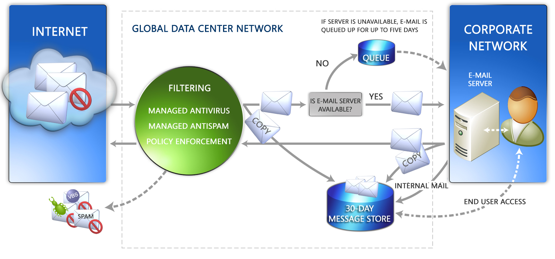  HOW IT WORKS  Microsoft Exchange Hosted Continuity benefits from the in-stream spam and virus protection features provided by Microsoft Exchange Hosted Filtering. As messages pass through the network, a copy of each is made and stored in a security-enhanced 30-day rolling message repository. Similarly, mail sent within the organization is captured through the mail server’s journaling function.  If the primary mail environment should become unavailable, due to a planned or unplanned outage, end users can access the password-protected, off-site message repository at any time to read, compose, and reply to messages. Administrators can use a set of continuity management tools to deliver communications to end users during an outage.  After connection to the primary e-mail system is restored, messages received during the outage are automatically restored. Any messages sent by means of the Web-based interface can be optionally restored to the primary mail system to complete disaster recovery operations. Because it’s always on, Exchange Hosted Continuity can be used to restore messages that may have been lost or deleted from the primary e-mail environment.
  LEARN MORE
  microsoft.com/exchange/services
  BENEFITS
  - Service is always on
  - Captures messages in transit, after they’ve been filtered, helping to keep spam, viruses, and other unwanted content out of the message store
  - Familiar Web-based interface helps minimize the need for end-user training and enable access for end users from virtually any location
  - All system actions are logged and available through the Event Viewer online auditing tool
  - Searchable message store for easy recovery and restoration of individual or all messages
  - Minimizes up-front capital investment
  - Integrates with existing e-mail infrastructure
  - Helps free up administrator time to focus on other projects
ABOUT MICROSOFT EXCHANGE HOSTED SERVICES  Microsoft Exchange Hosted Services offer a cost-effective way for enterprises to actively ensure the security and availability of their messaging environment, while instilling confidence that their messaging processes satisfy internal policy and regulatory compliance requirements. A seamless extension of Microsoft Exchange that operates over the Internet as a service, the complete line of services includes hosted filtering for spam and virus protection; hosted archiving to satisfy compliance requirements and internal policies; hosted encryption to preserve e-mail confidentiality; and, hosted continuity for ongoing access to e-mail during and after disasters. Microsoft Exchange Hosted Services provide value to corporate customers by eliminating upfront capital investment, freeing up IT resources, and removing incoming e-mail threats before they reach the corporate firewall. For more information, visit http://www.microsoft.com/exchange/services
  SOLUTION OVERVIEW
  End-User Functionality
  End users can access their Hosted Continuity mailbox by logging into a security-enhanced Web browser from virtually anywhere. Whether the outage is planned or unplanned, users always have access to e-mail.
  - Compose, receive, and send messages in real time.
  - Familiar user interface requires minimal end-user training.
  - Message repository is filtered upstream, which helps block spam, viruses and other unwanted content.
  - 30 days of previous e-mail is searchable and can be restored to the primary mailbox if necessary.
  - Access the entire company directory for addressing internal messages.
  - No software is required.
  Disaster Recovery Manager Tools
  Tools are built into the system to assist with communication, message management, and user administration.
  - Use the Announcement Board in the application to broadcast communication to the entire user base. Posts are listed chronologically and unique expiration dates can be assigned.
  - Set up the Call Tree by designating Callers and their assigned Callees. In the event of an e-mail outage, the Call Tree report can be used as an alternate method for contacting employees.
  - The Mass Restoration function helps restore mail for the entire organization or a single user. Just set the start and end timestamps and then click Restore.
  - Secondary Disaster Password can be issued globally to help those users who have forgotten their primary password.
  - The Event Viewer helps provide an audit trail for more than 30 different actions taken in the system.
  - A Disaster Recovery Test can be deployed prior to an actual outage. The test reports on user logon success rates.
  - A variety of reports are available on demand or through automated e-mail delivery.
  HOSTED SERVICE BENEFITS
  • Lower total cost of ownership than on-premise solutions
  • Offers a predictable subscription-based payment
  • Simplifies IT environment by minimizing the need to deploy, configure, monitor, and update in-house e-mail security servers and applications
  • Helps increase available bandwidth
  • Helps free up server resources and lower load on CPU
  • Scales to meet the needs of virtually any enterprise
  ANALYST PERSPECTIVE
  “Security, compliance, and business continuity requirements in industries such as healthcare and financial services are placing greater demands on the messaging infrastructure. It’s not enough to handle these challenges with a growing array of stand-alone appliances or point solutions. Managed services are a fundamentally sound method for deploying multiple, integrated services.”
  Michael Osterman,
  President and Founder,
  Osterman Research
  LEARN MORE
  microsoft.com/exchange/services
The information contained in this document represents the current view of Microsoft Corporation on the issues discussed as of the date of publication. This document is for informational purposes only. MICROSOFT MAKES NO WARRANTIES, EXPRESS OR IMPLIED, IN THIS DOCUMENT. © 2006 Microsoft Corporation. All rights reserved. Microsoft is a registered tradmark of Microsoft Corporation in the United States and/or other countries.

