

Making Collaboration the Engine of Team Productivity
A Single Place for File Sharing and Collaboration Using Windows SharePoint Services

Microsoft Corporation
Published: March 2004

Abstract
Windows® SharePoint® Services, the new Web-based collaboration solution of Microsoft Windows Server 2003, enables organizations to take file sharing and collaboration to a new level by helping to improve process efficiency and information worker productivity, increase business agility, and reduce operations costs. This paper outlines Microsoft’s vision of integrated innovation for improving team collaboration—a set of technologies that are designed to work together, from Windows Server 2003 with Windows SharePoint Services to enterprise application servers, smart client applications such as Microsoft Office 2003, and industry-leading development tools.



The information contained in this document represents the current view of Microsoft Corporation on the issues discussed as of the date of publication. Because Microsoft must respond to changing market conditions, it should not be interpreted to be a commitment on the part of Microsoft, and Microsoft cannot guarantee the accuracy of any information presented after the date of publication.
This White Paper is for informational purposes only. MICROSOFT MAKES NO WARRANTIES, EXPRESS, IMPLIED OR STATUTORY, AS TO THE INFORMATION IN THIS DOCUMENT.
Complying with all applicable copyright laws is the responsibility of the user. Without limiting the rights under copyright, no part of this document may be reproduced, stored in or introduced into a retrieval system, or transmitted in any form or by any means (electronic, mechanical, photocopying, recording, or otherwise), or for any purpose, without the express written permission of Microsoft Corporation.
Microsoft may have patents, patent applications, trademarks, copyrights, or other intellectual property rights covering subject matter in this document. Except as expressly provided in any written license agreement from Microsoft, the furnishing of this document does not give you any license to these patents, trademarks, copyrights, or other intellectual property.
Unless otherwise noted, the example companies, organizations, products, domain names, e-mail addresses, logos, people, places, and events depicted herein are fictitious, and no association with any real company, organization, product, domain name, email address, logo, person, place, or event is intended or should be inferred.
© 2004 Microsoft Corporation. All rights reserved.
Microsoft, Active Directory, BizTalk, Exchange, FrontPage, InfoPath, the Office logo, Outlook, PowerPoint, SharePoint, SQL Server, Visual Studio, Windows, Windows Server, and the Windows Server System are either registered trademarks or trademarks of Microsoft Corporation in the United States and/or other countries.
The names of actual companies and products mentioned herein may be the trademarks of their respective owners.
Contents
Introduction 1
Early-Stage Customer Results 2
Windows SharePoint Services: Foundation for a Smart Workspace 4
Better Discoverability 4
Better Communication 5
Improved Business Processes 6
Easier User Adoption 8
Benefits for IT Professionals 10
Powerful Administrative Control and Security 10
A Reliable and Scalable Platform 11
Easy to Manage 11
Easy to Extend and Integrate 12
Partner Ecosystem 14
Roadmap for Incremental Deployment 15
Summary 18
Related Links 19

Introduction
Rapid advances in Internet and related communications technologies, coupled with a round-the-clock business environment, require team members to be in closer contact to achieve their objectives and their organization’s goals. Distributed workforces are an integral part of modern business, yet effective collaboration, though more important than ever before, is often difficult to achieve.
Technologies such as portals, team workspaces, e-mail, presence awareness, instant messaging, and Web-based conferencing comprise a portfolio of collaboration and communication services that connect people, information, processes, and systems both inside and outside the corporate firewall. These IT resources help to solve key information worker challenges, such as:
- Finding information more easily.
- Working more productively in teams.
- Connecting more effectively with others.
- Providing a consistent user experience.
Industry analysts predict that collaboration is rapidly becoming a strategic platform advantage, yet many organizations either already have or will implement such capabilities at the tactical level, purchasing and deploying collaboration technologies in a piecemeal fashion. The end result is likely to be expensive systems that are poorly integrated and costly to maintain.
Microsoft’s guiding vision of integrated innovation addresses these challenges by delivering a comprehensive set of technologies that are designed to work together, from Microsoft® Windows Server™ 2003 with Windows SharePoint® Services, to a full set of plug-and-play enterprise application servers, smart client applications such as Microsoft Office 2003, and industry-leading development tools. Within this integrated technology environment, Windows SharePoint Services provides an extensible foundation for centrally managed collaboration and communication services that are delivered across the full range of client applications and enterprise servers—right to the desktop. Figure 1 illustrates this unified platform.
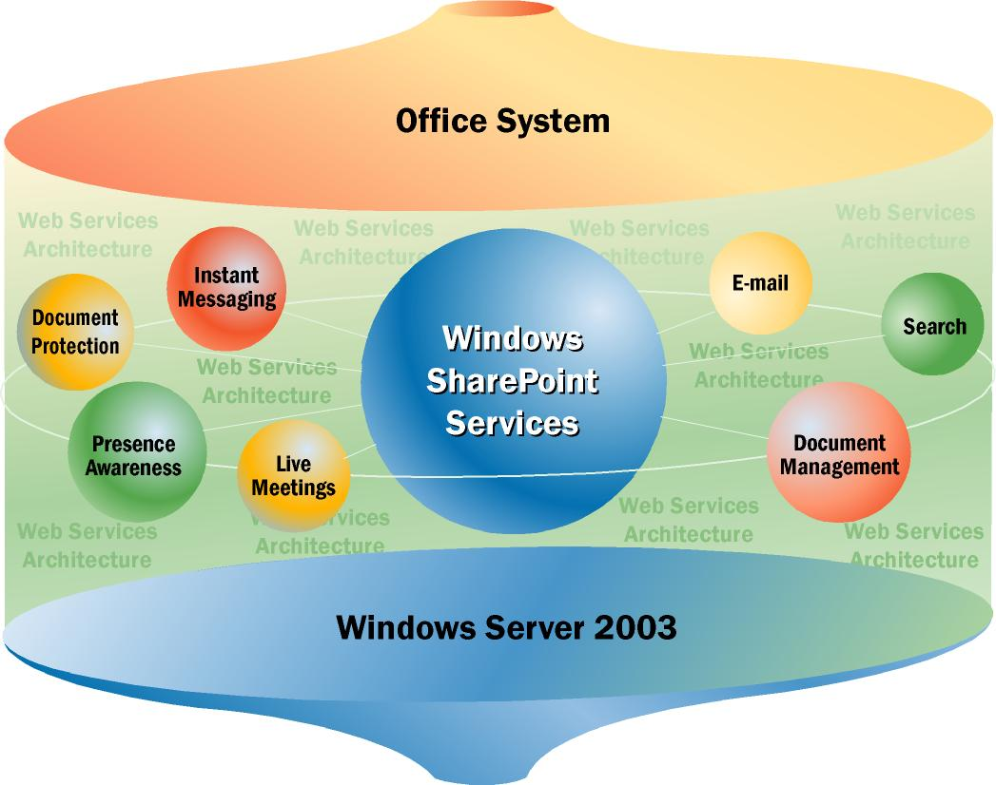
Figure 1. Windows SharePoint Services in Context of Windows Server 2003 and the Microsoft Office System
This unique and powerful architecture is an example of Microsoft’s integrated innovation, a development approach that provides building-block technologies and tools that are designed to work together to help organizations achieve greater process efficiency, market responsiveness, and lower operation costs. This unified platform provides the following advantages:
- Rich out-of-the-box functionality, which enables information workers to become productive quickly and assures IT professionals of quick, cost-effective deployment.
- Integration with everyday tools enables information workers to get started quickly by using familiar tools that enable users to share information and collaborate with peers easily.
- Organization-wide standards provide persistent security, management, and integration as well as uniform retention and compliance policies on a reliable and scalable platform.
- Incremental deployment options enable IT professionals to implement collaboration capabilities within the timeframe and budget determined by their organization.
- Easy and cost-effective extensibility, which is made possible by a rich development and customization environment. These capabilities enable IT professionals to build solutions specific to the needs of any organization and develop managed, hosted services that connect the organization with its customers, partners, and suppliers throughout the value chain.

Early-Stage Customer Results
Results of business value studies conducted independently by Navigant Consulting during 2003 at some of the world’s largest organizations demonstrate the tangible business value achieved by implementing Web-based collaborative workspaces built with Windows SharePoint Services and related Microsoft technologies. Results from these studies demonstrate:
- Shorter project cycle times. Cycle times reductions averaging 34 percent were projected for document creation processes.
- Fewer meetings. Enhanced visibility into project status helped profiled organizations reduce meeting times by an estimated average of 35 percent. .
- Lower travel expenses. Improved access to information is expected to reduce travel expenses by an average of 37 percent.
- Increased productivity. Increases in individual information worker productivity ranging from 0.2 percent to 4 percent are expected from reduced rework, improved access to information, more efficient knowledge capture, and automated status reporting provided by improved collaboration and project management capabilities.
Although these results are specific to the organizations at which the analyses were conducted, they demonstrate the value that can be achieved by an integrated approach to implementing collaboration and communication services.

Windows SharePoint Services: Foundation for a Smart Workspace
Out-of-the-box Windows SharePoint Services capabilities provide the foundation for a smart workspace, a single intranet location that serves as a centralized information hub, where individuals and teams can collaborate and communicate more easily and productively.
Windows SharePoint Services incorporates all of the essential collaboration and communication technologies that information workers use every day in a single Web-based environment that integrates easily with smart client applications such as Microsoft Office. Windows SharePoint Services also integrates with server databases and specialized business applications. This integration enables information workers to access network resources easily, quickly, and efficiently.
Basic Windows SharePoint Services functionality can be extended readily and cost-effectively by adding other Microsoft technologies and services such as Microsoft Exchange® Server 2003, Microsoft Office Live Communications Server 2003, Microsoft Office SharePoint Portal Server 2003, and Microsoft Office Live Meeting 2003 (formerly PlaceWare Conferencing Service), Microsoft Office Project Server 2003, and more.
Through built-in functionality and the extensions provided by Microsoft product and partner solutions, the following key user benefits are possible:
- Better discoverability. Users can easily deploy unified collaborative workspaces to share and manage all of their team information from a single location.
- Better communication. Powerful and flexible tools help keep teams connected and productive, enabling better decisions and stronger relationships with customers, partners, and suppliers.
- Better structured processes. Improved business processes help to increase team efficiency and improve business continuity.
- Better user experience. Delivering collaboration and communication technologies in everyday tools such as Microsoft Office 2003 makes it easy for users to adopt new functionality that can improve their productivity.

Better Discoverability
Information workers require immediate access to the information they use every day as well as access to data that is not on their team site but is stored on the corporate intranet. Windows SharePoint Services enhances information discoverability by providing users with a single Web-based team environment, where they can manage, find, and share their team information. In addition, users can collaborate on documents as well as manage information such as team member availability, calendars, tasks, and lists. This approach provides users with faster, more efficient searches than are possible by using traditional network file shares. Platform capabilities that support better discoverability include:
- Easily customized team workspaces that fit team and individual discovery needs.
- Built-in search capabilities that make it easy for users to find the information they need within a workspace quickly and efficiently.
- Extended search capabilities of Microsoft Office SharePoint Portal Server 2003 that provide additional discoverability by helping users search across team workspaces and other information sources.
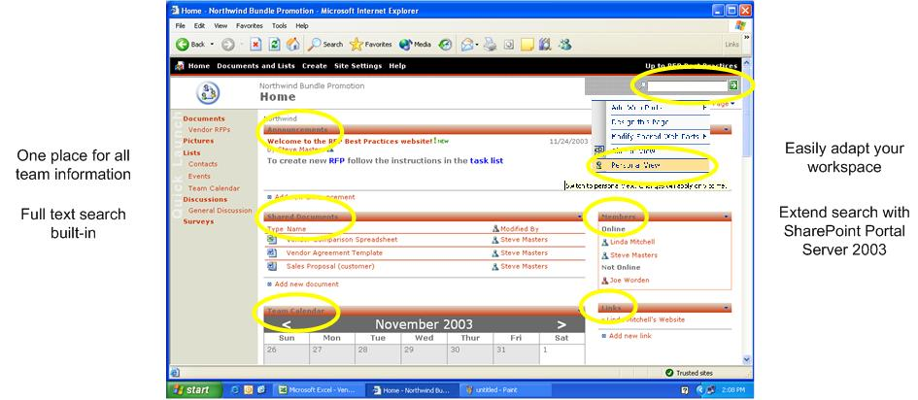
Figure 2. Windows SharePoint Services is a single place to manage team information

Better Communication
Windows SharePoint Services provides powerful and flexible collaboration and communication capabilities to keep teams connected. Team members can stay informed and up-to-date more easily as they articulate issues and strategies, develop consensus, and share vision and responsibilities.
- Keep team members updated and informed. By using built-in alert capabilities, users can be notified when information is added, modified, or deleted. Announcements, surveys, and discussion boards keep team members informed. Users can create shared meeting workspaces to manage agenda items and follow-up actions. Users can also track meeting attendance from within Microsoft Office Outlook® 2003.
- Connect people and information in real time by using Office Live Communication Server 2003. Teams can communicate instantly using audio, video, and data without leaving the programs in which they are working. Microsoft Office Live Communications Server 2003 enables users to share presence status so that everyone knows who is online to work on issues immediately and who is busy, away, on the phone, or at lunch. Integration of presence awareness and instant messaging exists for Microsoft Office 2003 applications including Microsoft Outlook, Microsoft Word, and Microsoft Office SharePoint Portal Server 2003.
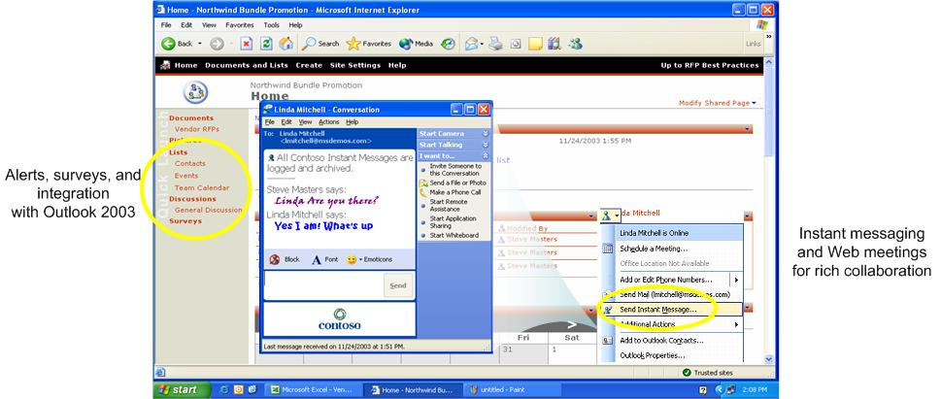
Figure 3. Windows SharePoint Services Integrates with Live Communication Server 2003
- Extend collaboration with Microsoft Office Live Meeting 2003. Integration of Windows SharePoint services with the Office Live Meeting Web conferencing service, Outlook 2003, and Microsoft Office PowerPoint® 2003 extends document collaboration. Microsoft Office Live meeting is a hosted Web conferencing service enabling users to communicate and collaborate with anyone, anywhere using only a PC, an Internet connection, and a telephone. In addition, rich interactivity and the ability to show and share anything on a user’s PC helps users to hold effective meetings with remote participants without the costs and inconvenience of travel.
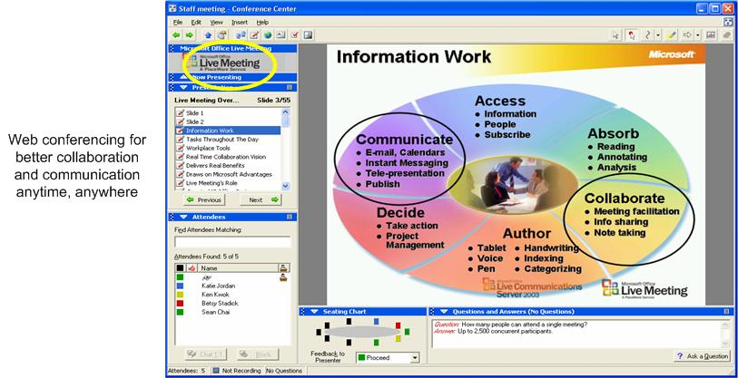
Figure 4. Windows SharePoint Services Integrated with Office Live Meeting 2003 Web Conferencing

Improved Business Processes
Organizations can improve the efficiency of structured team processes and improve business continuity by using build-in and extended Windows SharePoint Services capabilities to improve the efficiency of document creation, review, and protection.
- Create and review documents. Users can more easily and efficiently create and review any type of document with built-in document versioning and check-in and check-out capabilities integrated into team workspaces.
- Extend document protection. Available in Microsoft Office 2003 Professional Edition, Information Rights Management, enabled by Windows Rights Management Services (RMS), lets authors determine how their documents are distributed and used by others. This approach ensures that intellectual property can be classified and used with consistency and security throughout and beyond an organization. When documents are distributed by e-mail or by instant messages, organizations can enforce distribution and handling policies without incurring the costs of additional systems management and support.
Organizations can extend the capabilities of Windows SharePoint Services with specialized programs that make data capture, data management, and project management tasks more efficient.
- Streamline structured workflow processes by using Microsoft Office InfoPath™ 2003 or Microsoft BizTalk® Server 2004. Business processes can be made more efficient by automating formerly manual data capture, description, analysis, and reporting tasks. By integrating structured workflow data collection tools such as Office InfoPath 2003 with Windows SharePoint Services, users can create dynamic forms and publish them in many team sites simultaneously.
BizTalk Server 2004 helps information workers define, monitor, coordinate, and improve business processes in real time.
- Improve business responsiveness and project management by integrating Microsoft Office Project Server 2003 and Microsoft Office Project 2003. Through advanced file management and improved project-related issue and risk tracking, users of team workspaces gain greater visibility into projects and initiatives throughout an organization. This approach provides improved insight into business data and faster, more accurate business decisions.
Figure 5 shows a typical Windows SharePoint Services workspace configured for integrated workflow. Microsoft Office InfoPath 2003 captures data that can be incorporated into server databases.
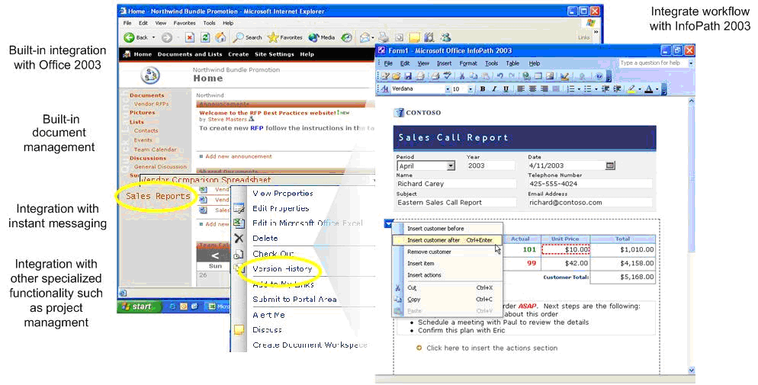
Figure 5. Windows SharePoint Services Helps Improve Business Process Integration

Easier User Adoption
Windows SharePoint Services provides a better user experience by making it easy for users to adopt, use, and modify collaboration services.
- Easy user adoption. It is easy for users to adopt new collaboration tools and services by integrating Web-based team collaboration services into everyday tools such as Microsoft Office, which includes e-mail, instant messaging, and information rights management. The familiar Microsoft Office interface eliminates the need for training to acquaint users with new software and helps users avoids the delays that erode productivity and slow document or project delivery.
- Web browser access. The browser-based interface empowers users to create, access, and modify shared team workspaces on demand and provides users with a single point of access to all of the rich information stored in team workspaces.
- Adapt workspaces to meet team needs. Users can easily adapt team workspaces to fit the needs of specific projects and communities by using built-in and extensible templates, Web Parts, views, and custom lists.
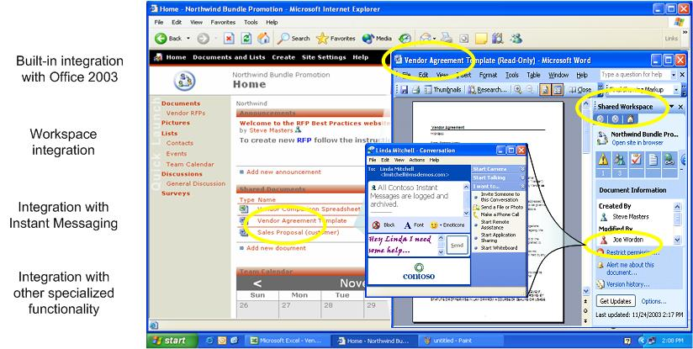
Figure 6. Windows SharePoint Services Team Workspaces Integrated with Microsoft Office 2003

Benefits for IT Professionals
Windows SharePoint Services helps to increase the control and security of an organization’s information resources by deploying a dependable, scalable collaboration infrastructure with easy-to-use administration tools and services.

Powerful Administrative Control and Security
Windows SharePoint Services is built on the Windows Server 2003 platform. As a result, the rich variety of improved security and administrative capabilities built into Windows Server 2003 enable IT professionals to define, monitor, and enforce rules and policies consistently throughout an organization. Specific benefits include:
- More efficient and consistent administrative control. Role-based policies of the Active Directory® directory service enable IT administrators to use pre-established rules and policies to limit access to proprietary information assets. The centralized administration of Active Directory enables IT professionals to establish data access rules once for an entire organization and monitor the rules from a single location. Centralized policy definition enables enforcement throughout organizations of any size and reduces systems management effort and related costs.
- More efficient site life cycle management. Team-based site administrators can maximize Windows SharePoint site efficiency by using automatic e-mail messaging alert capabilities built into Windows SharePoint Services to provide site owners with site status information. By eliminating unused site capacity and the effort of manual site checks and status notification, these automated site monitoring processes help to reduce systems operations and management costs.
- Improved network and site performance. Site quotas and content blocking provide increased control of an organization’s information resources by preventing acceptance of attachments containing restricted file types. Rejecting video and other bulky files rather than storing them on a server and transmitting them on a network can reduce bandwidth usage and storage costs. Rejecting harmful executable (.exe) files can reduce liability and virus-related help desk support requests or system administrator costs.
- Lower systems management costs. Advanced virus protection built into Windows SharePoint Services helps IT professionals deliver system-wide protective services. When IT administrators install an antivirus scanner that is compatible with Windows SharePoint Services, they can also enable the antivirus protection feature for a server, which helps protect all the resources on that server. Fewer virus-related incidents translate into reduced system downtime, higher system availability, fewer help desk calls, and lower systems management costs.
- A more secure extranet solution. Administrators can use cross-forest authentication of Windows Server 2003 to extend extranet collaboration solutions to partners, suppliers, and customers. When deploying Windows SharePoint Services with Live Communications Server 2003, administrators can encrypt server-to-server instant messaging traffic and client-to-server traffic using Transport Layer Security (TLS) and Kerberos or NTLM authentication. Live Communications Server 2003 also delivers text logging and archiving and integrates these features within existing Windows Server 2003 infrastructure and management tools.
Extending faster, more reliable network access with Windows SharePoint Services, Live Communications Server, and MSN® Connect to a wider circle of users can expedite business processes, improve business partner satisfaction, and reduce virus-related and intruder-related system downtime.

A Reliable and Scalable Platform
A reliable and scalable infrastructure enables IT professionals to establish a foundation that can help to reduce network administration effort and total cost of ownership and accommodate future collaboration needs, such as an organization-wide portal strategy or inter-organization communications.
Establishing Windows SharePoint Services team sites provides IT professionals with the following reliability and scalability benefits:
- Cost-effective scale-up. With Microsoft System Architecture and ASP.NET stateless front ends, IT professionals can provide scalable team workspace services in environments that range from a single computer to a clustered server farm. Even in very large environments, system administrators can set up Windows SharePoint Services configurations with multiple, stateless front-end Web servers that support large numbers of user connections and as many database servers as required. Organizations can scale up their Windows SharePoint Services workspace environment without compromising system reliability, security, and performance and without committing substantial additional systems management effort. These capabilities can help IT professionals to expand Windows SharePoint Services and keep systems administration costs under control.
- Continuous system operations of large sites. Windows Server 2003 and SQL Server 2000 technologies such as load balancing and failover enable system administrators to maintain enterprise-class reliability for all team workspace infrastructures. By detecting host failures and redistributing traffic to operational hosts automatically, Windows Server 2003 load balancing capabilities ensure that team sites and mission critical-services based on Windows SharePoint Services are available when and where users need them. The resulting increase in system availability reduces system administration effort and its related costs.
- Reduced site maintenance costs. The Windows Server 2003 platform provides Windows SharePoint Services with a wide variety of infrastructure services help systems administrators manage team workspaces more efficiently. Capabilities such as ASP.NET stateless front ends enable IT professionals to add new computers to a server farm and remove others for upgrades or repair with less time and effort. Faster server setup and maintenance enables organizations to add team sites but keep systems maintenance costs and overall total cost of ownership low.
By using the distributed architecture and flexible deployment options of SharePoint Portal Server 2003, IT professionals can also reduce the costs of connecting, organizing, and supporting large numbers of new Windows SharePoint Services team workspaces. The ability to support server farms with distributed job servers, database servers, search and indexing functionality, and multiple Web interfaces across many Windows SharePoint Services team sites simultaneously enables IT professionals to deliver services to more users more efficiently and reduce repetitive systems management tasks.

Easy to Manage
Simple and easy to use, built-in Windows SharePoint Services functionality enables IT professionals to reduce the complexity and costs of establishing and managing collaborative team sites. With Windows SharePoint Services, IT teams can establish organization-wide standards more easily and enable easier administration by using standardized modular plug-and-play components. Specific systems management benefits include:
- Lower site provisioning costs. Standardized site design templates and easy-to-use site operations tools help IT administrators to provision Windows SharePoint team workspaces quickly. With Windows SharePoint Services, system administrators can help users create sites, control site membership, directly monitor site usage, and moderate content submissions with minimal IT effort and site provisioning costs.
- Reduced site-related support costs. After workspace startup, self-service tools of Windows SharePoint Services enable users to create site templates, share them with one another, and reuse customized, proven site solutions. Because teams handle day-to-day site functionality and administration, user rely less on the IT staff and IT support costs decrease.
- Lower operational costs and TCO. Using the underlying management technologies and tools of the Windows Server 2003 platform, IT professionals can monitor and troubleshoot Windows SharePoint Services team sites with less time and effort. IT professionals can configure Windows SharePoint Services from a centralized location by using Group Policy and the familiar Microsoft Management Console (MMC) graphical user interface, monitor sites with Windows Management Instrumentation (WMI), and administer them remotely with scripts and command-line tools.
- Lower site backup and restore costs. Per-site backup and restore and the centralized user administration capabilities of Windows SharePoint Services help IT professionals to back up and restore team workspaces individually. As a result, IT administrators can avoid the effort and related system management costs of restoring an entire database rather than a small subset of data.
- Lower site management and support costs. IT professionals can use the Microsoft .NET object model to create custom scripts that automate common site management functions and build custom applications on the Windows SharePoint Services platform. Most list data and site settings offer full read/write access. IT administrators can use browser-based administration tools or the command line to manage workspace sites and site collections. These capabilities reduce the effort and costs of site management.

Easy to Extend and Integrate
Windows SharePoint Services provides IT professionals with a collaboration environment that is easy to extend and that can connect disparate applications, solutions, and systems into an integrated platform with less administrative time and effort. Windows SharePoint Services provide these systems management benefits:
- Faster time to usability and reduced development costs. To build integrated collaboration applications quickly and easily, IT professionals can use the development tools of the Microsoft .NET Framework, standard data formats such as Extensible Markup Language (XML), and common tools. The strategy of using the Microsoft .NET Framework, Web services, Microsoft Visual Studio® .NET, and Windows Server 2003 to build SharePoint products and technologies reduces the time, effort, and costs of developing Windows SharePoint Services solutions. Integration of Windows SharePoint Services with Microsoft Office FrontPage® 2003 enables IT professionals to customize team workspaces with less development effort and cost.
- Accelerated return on IT investments. Industry-standard protocols such as XML that enable data exchange between different platforms or applications help IT professionals to extend the value of existing business data and computing systems by linking formerly isolated silos of data and making them available through a Web browser or a traditional productivity program.

Partner Ecosystem
Windows SharePoint Services delivers functionality that can be configured to meet the needs of most teams, work groups, and organizations. Smart workspaces can also be modified with built-in Web parts and templates for more functionality and easier navigation. However, some organizations require specialized capabilities that are available only through dedicated or customized Windows SharePoint Services functionality.
Organizations with internal development resources can create customized solutions by using the development tools discussed previously. Other organizations can take advantage of the rapidly growing Microsoft partner ecosystem, which specializes in providing solutions built on Windows SharePoint Services, Office SharePoint Portal Server 2003, and Live Communications Server 2003.
Some Microsoft partners offer customized solutions that act like plug-ins and provide very specific functionality. When highly specialized SharePoint or Live Communications Server 2003 functionality is required, organizations can engage directly with a Microsoft partner to develop customized solutions.
The Microsoft partner ecosystem, which is dedicated to offering collaboration-focused products and services, is growing daily. Should an organization have need for specialized functionality, for example enterprise project management or Six Sigma, a Microsoft partner has probably already created modular add-ons that can be easily implemented in a new or existing Windows SharePoint Services or Office SharePoint Portal Server environment.
For more information about Microsoft partner products and services, please contact the nearest Microsoft sales office or go to the SharePoint Partner Web site presented in the Related Links section of this document. For highly specialized functionality, many system integrators or independent software vendors are expert in developing custom solutions.

Roadmap for Incremental Deployment
Users are increasingly asking their IT organizations to provide more sophisticated tools for information sharing than are currently offered by traditional file server environments. At the same time, IT professionals are under pressure to provide highly dependable and secure access to file storage and print services and reduce system administration and support costs.
Windows Server 2003 delivers an integrated storage and productivity platform that provides the latest advances in file storage and print services. The platform also enables IT professionals to deploy a richer, more effective environment for information sharing and team collaboration.
Upgrading file servers to Windows Server 2003 enables IT professionals to drive greater business value and increase operational efficiency and security. Windows Server 2003 and Windows SharePoint Services provide IT professionals with multiple options for incrementally building a more effective information sharing and collaboration platform.
Table 1 presents one approach to incremental deployment to optimize an organization’s information sharing environment.
Some organizations may prefer to build out their collaboration and communications infrastructure with unified messaging and instant messaging or focus on information worker access to server or network resources. Whatever an organization’s business requirements, an incremental deployment approach exists that is appropriate for them—there no prescriptive “right” way.
Table 1. Example Approach to Incremental Deployment of Windows Server 2003 and Windows SharePoint Services
Phase | Incremental Deployment | Technology Enabler | Results
Phase 1 | Upgrade file servers | - Windows Server 2003 | - File server upgrades provide self-service data recovery, ubiquitous data access, and intelligent printing services.  - Provides IT benefits, including improved operational efficiency through easier file server consolidation, better management tools, and more flexible data enterprise storage.  - Delivers organizational benefits, including improved dependability and security, better business continuity, improved administrative control and security of sensitive files, and faster, more reliable data access.
Phase 2 | Establish team collaboration capabilities | - Windows SharePoint Services (built-in functionality)  - Built-in Web Parts and templates | - Helps to improve information worker efficiency and productivity through Web-based team workspaces.
Phase 2 | Implement a unified messaging platform | - Microsoft Exchange Server 2003 | - Provides e-mail, group calendaring, and remote e-mail access services that integrate with Web-based team workspaces.
Phase 2 | Integrate collaboration into everyday business processes | - Microsoft Office 2003 | - Integrates collaboration functionality into the productivity tools that information workers use every day helps improve user efficiency and productivity.  - Makes structured data gathering and management processes easier and more efficient by using specialized programs .
Table 1. (Continued)
Phase | Incremental Deployment | Technology Enabler | Results
Phase 3 | Deploy specialized collaborative functionality | - Web Parts  - Templates  - Specialized add-ins | - Enables Microsoft partners to help organizations reduce the costs of adapting smart workspace environments to user needs and specialized markets.
Phase 3 | Extend communications and collaboration functionality by deploying specialized servers | - Microsoft Office Live Communications Server 2003 | - Provides enterprise-ready instant messaging, presence awareness, and an extensible platform that connects people, information, and business processes.
Phase 3 |  | - Microsoft Office Live Meeting 2003 | - Adds Web-based conferencing that can reduce travel expenses and costs of face-to-face events.
Phase 3 |  | - Microsoft Office Project Server 2003 | - Adds enterprise project management, which provides visibility and accountability throughout an organization’s project portfolio.
Phase 3 | Scale up for enterprise applications | - Microsoft Office SharePoint Portal Server 2003 | - Extends team-based collaboration to the intranet and extranet by providing an organizational portal architecture.
Phase 3 | Scale up for enterprise applications | - Microsoft SQL Server 2000 | - Adds enterprise-class data management that provides fault tolerance, increased scalability, and improved reliability.
Phase 3 | Scale up for enterprise applications | - Microsoft BizTalk Server 2004  - Microsoft Host Integration Server 2000 | - Adds data integration that links structured business processes and legacy computing systems.
Phase 4 | Extend collaboration capabilities to customers, suppliers, and partners | - MSN Connect | - Delivers a managed, audited, and logged instant messaging infrastructure for enterprise businesses that connect to the MSN Messenger Service.
Phase 4 | Extend collaboration capabilities to line of business applications | - Various line-of-business applications (will vary by organization)  - Visual Studio .NET and the Microsoft .NET Framework | - Provides a rich set of standardized tools that streamlines business processes and increases the effective use of line of business applications.

Summary
Windows SharePoint Services can help any organization achieve greater business process efficiency, improve information worker productivity, and upgrade collaboration and information storage capabilities that are based on network file shares.
Windows SharePoint Services meets the core requirements of information workers, IT professionals, and their organizations by providing benefits in five key areas:
- Improved individual and team productivity. Information workers have a single location from which they can communicate and collaborate more effectively with their colleagues.
- Improved business processes. Information workers can reduce the time and effort of accessing data from different computing systems, shorten process cycle time by avoiding redundancy and reducing the errors and rework caused by manual business process data capture and reporting methods.
- Improved customer service and relationships. Organizations can gain deeper insight into customer requirements and respond more rapidly to customer concerns by enabling information workers to share information and customer experiences more easily and quickly.
- Lower costs and higher margins. By enabling organizations to standardize on a common collaboration platform based on industry standards, Windows SharePoint Services helps organizations to manage their network computing resources more efficiently and reduce total cost of ownership.
- Improved organization-wide operating efficiency. Organizations can optimize the use of existing communication and collaboration systems and implement systems that provide new functionality by implementing collaboration capabilities incrementally. These new capabilities enable information workers to work more productively in new ways and from virtually any location.
By using the following four-step approach to implementing Windows SharePoint Services as the foundation of a collaboration and communication platform, organizations can improve their business agility and competitive advantage:
- Deploy Windows Server 2003 and take advantage of the key enhancements for better security, manageability, scalability, and reliability across all primary workloads.
- Deploy the built-in functionality of Windows SharePoint Services to enable immediate use of Web-based team workspaces.
- Add specialized collaboration functionality by using templates, add-ons, or customized services.
- Extend these capabilities by adding specialized collaboration and communication services or server-based applications incrementally as organizational business requirements, timeline, and budget allow.
For assistance in designing and configuring a Windows SharePoint Services smart workspace, please consult with a local Microsoft sales office or partner.

Related Links
See the following resources for further information:
- For more information, see the Microsoft Windows SharePoint Services Web site at http://www.microsoft.com/windowsserver2003/technologies/sharepoint/default.mspx
- For developer information, see the SharePoint Products and Technologies section on the MSDN Web site at http://msdn.microsoft.com/sharepoint
- For .NET community resources, see the GotDotNet SharePoint Products and Technologies Web site at http://www.gotdotnet.com/team/sharepoint
- For more information about Microsoft Office 2003, including, Office SharePoint Portal Server 2003, Office InfoPath 2003, Office Live Communication Server 2003, the Office Live Meeting Conferencing Service, and Microsoft Office Project 2003, see the Microsoft Office Online Web site at http://office.microsoft.com/home/default.aspx
- For more information about Windows RMS, see the Windows Rights Management Services technology center at http://www.microsoft.com/windowsserver2003/technologies/rightsmgmt/default.mspx
- For more information about other application servers such as BizTalk Server and SQL Server, see the Microsoft Windows Server System Web site at http://www.microsoft.com/windowsserversystem/default.mspx
For more information about Microsoft Partners, who offer SharePoint-related services or products, see the Microsoft Office System Solutions Directory Web site at http://directory.partners.extranet.microsoft.com
- http://directory.partners.extranet.microsoft.com.

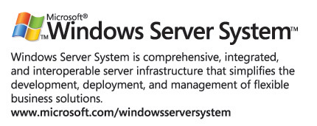
For the latest information about Windows Server 2003, see the Windows Server 2003 Web site at http://www.microsoft.com/windowsserver2003.

Basic Windows SharePoint Services functionality can be extended by adding other Microsoft technologies and services.
For more information about the Microsoft Windows Server System and Microsoft Office System business value studies conducted by Navigant Consulting and to download the white paper, “Process Goldmine: Microsoft Office System Integrated Solutions Delivers Business Value,” see the Microsoft Office System Solutions Deliver Business Value page at http://www.microsoft.com/office/business/value.mspx.
Full text search must be configured using Microsoft SQL Server™ 2000.

