

Exchange Online Developer Guide
Published: April 2009
For the latest information, see http://www.microsoft.com/online.
Table of Contents
Introduction 4
About Exchange Online 4
Features of Exchange Online 4
Exchange Web Services 5
Requirements 5
Using Autogenerated Proxy 5
Proxy Generation 6
Creating a Proxy Reference 7
Adding a Web Reference to a Visual Studio 2008 Project 7
Creating an Exchange Web Services Client Application 11
Available Operations 19
Autodiscover Service 21
Autodiscover Lookup Logic 21
Autodiscover Service Sample Application 21
Integration Scenarios 25
Integration with Microsoft Dynamics AX 4.0 25
Task 1: Create the Wrapper Class 25
Task 2: Add Reference of the Wrapper Class 27
Task 3: Invoke the Wrapper Class 29
Integration with Windows Azure 31
Task 1: Create an Online Project 32
Task 2: Create a Web Cloud Service 35
Task 3: Deploy Web Cloud Service on Windows Azure 45
Windows Azure Resources 47
Generating an Exchange Web Services Proxy for Java 48
Prepare the Java-Related WSDL File 48
Generate the Proxy 48
Create a Java Project 48
Create the Java Client Application 53
More Information 55
Appendix: Autodiscover Sample Application 57
Sample Application Overview 57
Code Sample for Autodiscover Call 58
Index 72

Information in this document, including URL and other Internet Web site references, is subject to change without notice. Unless otherwise noted, the companies, organizations, products, domain names, e-mail addresses, logos, people, places, and events depicted in examples herein are fictitious. No association with any real company, organization, product, domain name, e-mail address, logo, person, place, or event is intended or should be inferred. Complying with all applicable copyright laws is the responsibility of the user. Without limiting the rights under copyright, no part of this document may be reproduced, stored in or introduced into a retrieval system, or transmitted in any form or by any means (electronic, mechanical, photocopying, recording, or otherwise), or for any purpose, without the express written permission of Microsoft Corporation.
Microsoft may have patents, patent applications, trademarks, copyrights, or other intellectual property rights covering subject matter in this document. Except as expressly provided in any written license agreement from Microsoft, the furnishing of this document does not give you any license to these patents, trademarks, copyrights, or other intellectual property.
© 2009 Microsoft Corporation. All rights reserved.
Microsoft, Active Directory, Azure, Forefront, Microsoft Dynamics, Outlook, SharePoint, Visual C#, Visual Studio, Windows, and Windows Mobile are trademarks of the Microsoft group of companies.
All other trademarks are property of their respective owners.

Introduction
This guide describes the Web services that are supported by Microsoft® Exchange Online, a Microsoft Online Services hosted messaging service built on Microsoft Exchange Server 2007.
Developers can use this guide to create Exchange Online client applications that manage Exchange store items and access other Exchange Server functionality that is available in the Exchange Online environment. The guide describes the following:
- How to create an autogenerated Exchange Web Services proxy.
- How to develop applications that integrate with Microsoft Dynamics® AX 4.0 and Windows® Azure™.
- How to use Exchange Web Services to generate a proxy using Java.
The guide also describes how to create an application that calls the Autodiscover service—a Web service that automatically configures Exchange Server 2007 client applications to access the Client Access server.

About Exchange Online
Exchange Online is a hosted enterprise messaging solution based on Microsoft Exchange Server 2007 Service Pack 1. Exchange Online services include advanced e-mail features as well as calendaring, contact, and task management capabilities. Exchange Online also provides built-in spam control and virus scanning to reduce common security risks that are associated with e-mail files.
Exchange Online services are delivered from geographically dispersed Microsoft data centers. Each data center houses a reliable, redundant infrastructure needed to support the service. Exchange Online helps simplify IT management by removing customers’ need to deploy, configure, monitor, update, and upgrade an e-mail solution on premises.

Features of Exchange Online
Exchange Online offers a comprehensive messaging solution with a simple per-user monthly fee. Key features include:
- Mailbox of up to 25 gigabytes (GB) (with additional storage available for purchase), shared calendar, contacts, and tasks.
- Microsoft Office Outlook® Client Connectivity, including Outlook Anywhere.
- Microsoft Office Outlook Web Access.
- Virus and spam filtering via Microsoft Forefront™ Online Security for Exchange.
- Direct Push e-mail for Windows Mobile® 6.0 devices.
- Built-in business continuity and disaster recovery capabilities.
- 99.9% scheduled uptime with financially backed service level agreements.
- Use of HTTPS to help keep Internet access secure.
- Web form–based and phone-based Tier-2 support for IT administrators, 24 hours a day, 7 days a week.
- Sign-In Tool for single sign-on capability.
- Directory Synchronization Tool to help keep on-premises and online versions of the Active Directory® service in sync.
- Coexistence—the ability for some users to be on mail servers on premises and for some to be online.
- Migration tools to help move current mailbox data to the online environment.
For more details, download the document “Service Description for Microsoft Exchange Online Standard” from www.microsoft.com/downloads/details.aspx?familyid=6BEF06C7-3AE6-40A7-A78E-EEA670B4F605&displaylang=en.

Exchange Web Services
Microsoft Exchange Web Services is an application programming interface (API) that applications can use to access data store items on Exchange Server 2007. Third-party developers can use Exchange Web Services to communicate with Exchange Online, which is built on Exchange Server 2007. It provides an extensibility point for clients that connect to Exchange Online and that consume information about user availability, and enables the manipulation of items that are located in the Exchange data store.
The Exchange Web Services interface is exposed as a Simple Object Access Protocol (SOAP)-based Web service. This means that callers must send their requests to Exchange Web Services as SOAP XML messages that are contained in an HTTPS POST request. Exchange Web Services will respond with SOAP XML messages in the HTTPS response. Exchange Web Services is exposed with the Exchange Client Access server role through a Microsoft ASP.NET 2.0 Web service named Exchange.asmx.
Exchange Web Services provides a way for developers to interact with Exchange mailboxes in a manner compatible with Microsoft Office Outlook and Outlook Web Access (OWA). In fact, Outlook Web Access and Exchange Web Services use the same business logic layer as Exchange Web Services for accessing, creating, modifying, and deleting mailbox data.
The Exchange Web Services XML protocol defines a standard messaging format for information exchange between applications and Exchange Online. This format is expressed in the following files:
- Services.wsdl describes a contract between the client and the server.
- Messages.xsd defines the request and the response SOAP messages.
- Types.xsd defines the elements that are used in the SOAP messages.
For more details, download the following documents:
- “Exchange Web Services Reference” at msdn.microsoft.com/hi-in/library/bb204119(en-us).aspx.
- “Exchange Web Services Architecture” at msdn.microsoft.com/en-us/library/aa579369.aspx.
- “What Is Exchange Web Services?” at msdn.microsoft.com/en-us/library/cc500286.aspx.
In the current version of Exchange Online, the following functionality is not supported:
- Public folder support
- Exchange Server administrative functionality

Requirements
Applications that use Exchange Web Services have the following requirements:
- Can access the Exchange Online environment over HTTPS.
- Include interoperability with Office Outlook business logic.
- Implement the business logic that is required for complex calendaring operations (such as creating recurring meetings, and modifying and canceling meetings).
- Provide strong typing.
- Can be used in a managed programming environment such as Microsoft .NET.
- Support automatic generation of a proxy class to provide an object model that abstracts the transport and underlying XML from the developer.
- Create applications that are easily redistributable (so that no libraries are required on client computers).

Using Autogenerated Proxy
Because Exchange Web Services is a SOAP-based Web service, all communication must be over HTTPS with an XML body. The primary way to accomplish this is with proxy objects. The majority of developers choose to program through an autogenerated proxy, using a proxy generator, because communicating by proxy does not require knowledge of SOAP and XML.
Note: Developers who require low-level control, such as for performance tuning or cross-platform development, can manually create an XML application and send it over HTTPS explicitly. If you are using the Microsoft .NET Framework, you can use a class such as WebRequest to do this.
To get started with Exchange Web Services proxy programming, you must create a proxy reference, which is a set of proxy classes that you create by using the Add Web Reference feature of Microsoft Visual Studio®. This task is covered in "Creating a Proxy Reference" later in this guide.
You must then become familiar with the object model that is created by using the Microsoft Visual Studio 2008 proxy generator. For details about this task, see “Creating an Exchange Web Services Client Application” later in the guide.

Proxy Generation
Most Web services include the "contract," which is defined between the service and any clients that might use it. Exchange Web Services includes this contract as a standard Web Services Description Language (WSDL) document named Services.wsdl. The Services.wsdl document is an XML file that lists the methods that can be called, the particular input and output types, and the protocols that are supported.
Users of Exchange Online can access the Services.wsdl file. Typically, the path to this document takes this form:
https://name.mail.microsoftonline.com/ews/Services.wsdl
where name is the company name.
Note: The example URL that is listed above should be accessed using the Autodiscover service. For details, see “Autodiscover Service” later in this guide.
Visual Studio requires this file to create the autogenerated proxies that most developers use when talking to Exchange Web Services. As a developer, you point your proxy generator of choice to the Services.wsdl file, and the proxy generator automatically creates numerous classes with methods and properties that enable your client application to talk to Exchange Web Services.
It is important to keep in mind that while your application is communicating with the autogenerated proxy, the proxy is communicating in SOAP XML over HTTPS to Exchange Web Services. Exchange Web Services responds with SOAP XML, which the proxy then converts to your method response.
Figure 1 illustrates communication between your application code and the proxy within the client, which is independent of the communication between the proxy and Exchange Web Services. The client can communicate using any programming language as long as it sends out and consumes XML. For example, your application code might be talking to the proxy using normal .NET property accessors and method calls, while the proxy communicates via SOAP XML over HTTPS to Exchange Web Services. Exchange Web Services is unaware of the specific arrangement within your client application.

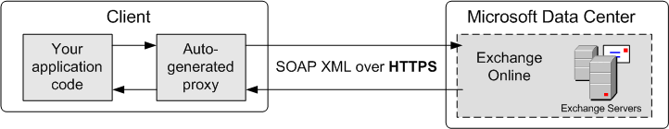

Figure 1.
The Microsoft Visual Studio 2008 integrated development environment (IDE) provides tools that create proxy classes for client applications that consume Web services. As illustrated in Figure 1, these Web services proxy classes act as an interface between client and Web server communications. The proxy classes provide user-friendly abstractions of the XML messages, XML serialization, and formation of the HTTPS requests and responses that are sent between the client and server.

Creating a Proxy Reference
Microsoft Visual Studio provides tools to create a proxy reference, which is a Microsoft.NET proxy class that can be used to communicate with Exchange Web Services. Proxy classes can be generated from many popular IDEs. The examples and reference information in this guide describe proxy classes that are generated by the Visual Studio 2008 IDE. You can also use Microsoft Visual Studio 2005 Express Editions and Visual Studio 2008 Express Editions to create the proxy classes.
Note: Do not use Microsoft Visual Studio 2003 or earlier versions of Visual Studio to generate proxy classes for Exchange Web Services.
This section describes how to create proxy classes by using Visual Studio 2008 and the Add Web Reference user interface. You can use this procedure to create the complete set of proxy classes and enumerations that you need to build a client application. The task involves the following procedures:
- Add a Web reference to a Visual Studio 2008 project.
- Set up the ExchangeServiceBinding proxy class.
Prerequisites: To create proxies, the user must have the following:
- Visual Studio 2008 or Visual Studio 2005 (which includes the Visual Web Developer and C# components)
- An open Visual Studio 2008 solution
- An Exchange Online account with admin privileges

Adding a Web Reference to a Visual Studio 2008 Project
Use the following steps to add a Web reference to a Visual Studio 2008 project.
- In the Solution Explorer pane in Visual Studio 2008, right-click the References node, and then click Add Service Reference.
- 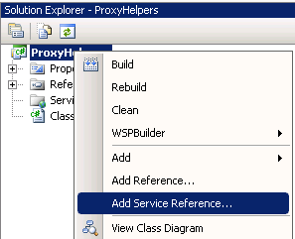

Figure 2.

- In the Add Service Reference window, in the Address box, type the URL of the .wsdl file that describes the location of the Client Access server that hosts Exchange Web Services. The URL should take the following form:
https://name.mail.microsoftonline.com/EWS/Exchange.asmx
where name is the domain name which you have given for the Autodiscover service.
Note: The example URL that is shown accesses the Autodiscover service. Use the Autodiscover service to query for the appropriate URL endpoint for the mailbox user. For details, see “Autodiscover Service” later in this guide.

Figure 3
- Next to the Address box, click Go, to have Visual Studio 2008 attempt to connect to the Web Discovery Service.
- When the Web Discovery Service prompt appears, click Yes to authenticate the request and provide your account credentials.

Figure 4.
- In the Discovery Credential dialog box, enter your user name and password.
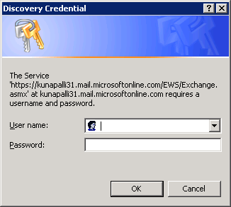

Figure 5.

- In the Add Service Reference window, type ExchangeWebServices in the Namespace box, and then click OK.
This creates the proxy types and members in a file named Reference.cs, and a class code file, typically named Class1.

Figure 6.
- Edit the class code file. In the directives section of the class code file that contains type references to Exchange Web Services, add a reference to the proxy classes. For example, for C#, use the using directive. The using directive takes the following form:
using namespace.ExchangeWebServices
where namespace is the namespace of the class code file.
- Verify the namespace name in the Reference.cs file.
Note: This file may be hidden in Solution Explorer. To show hidden files, toggle the Show All Files button at the top of the Solution Explorer pane.

Setting Up the ExchangeServiceBinding Proxy Class
The ExchangeServiceBinding class contains the methods and properties that are used to send and receive SOAP messages, maintain user credentials, and identify the Exchange Web Services endpoint.
The following code example shows how to set up the ExchangeServiceBinding class with credentials and the URL of the service, and how to create a request.
static void FindExample()
{
// Set up the binding with credentials and URL.
ExchangeServiceBinding binding = new ExchangeServiceBinding();
binding.Credentials = new NetworkCredential("USER", "password", " Domainname");
binding.Url = GetExchangeWebServiceURL(UserID, Password);

Note: Refer to Definition for GetExchangeWebServiceURL in the Appendix of this guide.
// Create the request.
FindItemType request = new FindItemType();
request.ItemShape = new ItemResponseShapeType();
request.ItemShape.BaseShape = DefaultShapeNamesType.Default;
request.Traversal = ItemQueryTraversalType.Shallow;
request.ParentFolderIds = new BaseFolderIdType[1];
DistinguishedFolderIdType inbox = new DistinguishedFolderIdType();
inbox.Id = DistinguishedFolderIdNameType.inbox;
request.ParentFolderIds[0] = inbox;
// Send the request and get the response by using the binding object.
FindItemResponseType response = binding.FindItem(request);
}
To reuse the proxy class for more than one client application, generate the proxy classes into their own class library project; compile the class library and then reuse the resulting assembly dynamic link library (DLL) in all of projects that must talk with Exchange Web Services.

Creating an Exchange Web Services Client Application
You can use Visual Studio 2008 to create a simple Exchange Web Services client application. This section describes the basic Exchange Web Services Create, Read, Update, Delete (CRUD) operations and includes examples of how to set them up and how to handle responses. Use this walkthrough to become familiar with the object model created by using the Visual Studio 2008 proxy generator.
Note: Before you create the client application, you must set up the Visual Studio 2008 project solution on the client application, and then set up the client application project. “Integration with Windows Azure,” later in this guide, describes this process in the Windows Azure environment.
Each of the examples in this section includes the following steps for coding an Exchange Web Services client application:
- Set up the Visual Studio 2008 project on the client application.
- Set up an Exchange Web Services proxy class.
- Create the service binding for Exchange Web Services.
- Create the service request.
- Send the request and get the response.
- Check the status of each response.

CreateItem (Email) Operation
The CreateItem method is used to create e-mail messages. The following example of a CreateItem request shows how to create a new e-mail message, send the message, and save a copy of it in the Sentitems folder.
- Create an ExchangeServiceBinding object, and pass the user credentials and URL of Exchange Web Services to this object.
// Set up the binding with credentials and URL.
ExchangeServiceBinding binding = new ExchangeServiceBinding();
binding.Credentials = new NetworkCredential("USER", "password", " Domainname");
binding.Url = GetExchangeWebServiceURL(UserID, Password);
Note: Refer to Definition for GetExchangeWebServiceURL in the Appendix of this guide.
- Create the CreateItemType request object for a new e-mail message.
CreateItemType createEmailRequest = new CreateItemType();
- Create the MessageDispositionType object to specify how the e-mail will be handled, and add this object to the request created in step 2. The available options are SaveOnly, SendAndSaveCopy, and SendOnly.
createEmailRequest.MessageDisposition = MessageDispositionType.SaveOnly;
createEmailRequest.MessageDispositionSpecified = true;
- Create the TargetFolderIdType object to specify the location of the sent items, and add this object to the request. The available options are shown here.
createEmailRequest.SavedItemFolderId = new TargetFolderIdType();
DistinguishedFolderIdType sentitems = new DistinguishedFolderIdType();
sentitems.Id = DistinguishedFolderIdNameType.inbox;
createEmailRequest.SavedItemFolderId.Item = sentitems;
The available options are shown here:
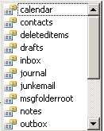

Figure 7.
- Create the MessageType object for a single e-mail message, and pass the subject, e-mail body, sender e-mail address, and recipient e-mail addresses of this message to this object. Add this object to the request.
// Create a single e-mail message.
MessageType message = new MessageType();
message.Subject = "Pass the subject here";
message.Body = new BodyType();
message.Body.BodyType1 = BodyTypeType.Text;
message.Body.Value =”Pass the body text here”
message.Sender = new SingleRecipientType();
message.Sender.Item = new EmailAddressType();
message.Sender.Item.EmailAddress = “Senderemail@xyz.com”;
message.ToRecipients = new EmailAddressType[1];
message.ToRecipients[0] = new EmailAddressType();
message.ToRecipients[0].EmailAddress = “toRecipients@xyz.com”;
message.Sensitivity = SensitivityChoicesType.Normal;

createEmailRequest.Items.Items = new ItemType[1];
createEmailRequest.Items.Items[0] = message;
- Create the CreateItemResponseType object to send a CreateItem request and get the CreateItem response.
CreateItemResponseType createItemResponse = service.CreateItem(createEmailRequest);
ArrayOfResponseMessagesType responses = createItemResponse.ResponseMessages;
ResponseMessageType[] responseMessages = responses.Items;
- Check to determine whether the response message (Error, Warning, or Success) is the correct type.
// Access the response messages.
foreach (ResponseMessageType respMsg in responseMessages)
{
if (respMsg.ResponseClass == ResponseClassType.Error)
{
throw new Exception("Error: " + respMsg.MessageText);
}
else if (respMsg.ResponseClass == ResponseClassType.Warning)
{
throw new Exception("Warning: " + respMsg.MessageText);
}
else if (respMsg.ResponseClass == ResponseClassType.Success)
{
//Action
}
}
- Get the ItemType object of the response. (If needed, add the logic to check and cast for all other types.)
if (respMsg is ItemInfoResponseMessageType)
{
ItemInfoResponseMessageType createItemResp = (respMsg as
ItemInfoResponseMessageType);
ArrayOfRealItemsType aorit = createItemResp.Items;
foreach (ItemType item in aorit.Items)
{
if (item is MessageType)
{
MessageType myMessage = (item as MessageType);
}
}
}

GetItem(Email) Operation
The GetItem method allows the user to access information about e-mail messages. The following example of a GetItem request shows how to create a GetItem request and get the response.
- Create the ExchangeServiceBinding object, and pass the user credentials and URL of Exchange Web service to this object.
// Set up the binding with credentials and URL.
ExchangeServiceBinding binding = new ExchangeServiceBinding();
binding.Credentials = new NetworkCredential("USER", "password", " Domainname");
binding.Url = GetExchangeWebServiceURL(UserID, Password);
Note: Refer to Definition for GetExchangeWebServiceURL in the Appendix of this guide.
- Create the GetItemType object for the GetItem request.
GetItemType request = new GetItemType();
- Create the ItemResponseShapeType object to specify which types of item properties to get, and add this object to the request created in step 2. The available options are AllProperties, Default, and IdOnly.
request.ItemShape = new ItemResponseShapeType();
request.ItemShape.BaseShape = DefaultShapeNamesType.Default;
request.ItemShape.IncludeMimeContent = true;
- Use the FindAllItems method to get the item ID and change key for the item.
- Create the ItemIDType object, set the item ID and change key, and add this object to the request.
ItemIdType itemId = new ItemIdType();
// Get the ID and change key from the message that you obtained
itemId.Id =<ItemId> ;
itemId.ChangeKey = <ChangeKey>;
request.ItemIds = new BaseItemIdType[1];
request.ItemIds[0] = itemId;
- Create the GetItemResponseType object to send a GetItem request and get the GetItem response.
GetItemResponseType response = new GetItemResponseType();
response = service.GetItem(request);
ArrayOfResponseMessagesType aofresponseMessages =
response.ResponseMessages;
ResponseMessageType[] responseMessage = aofresponseMessages.Items;
- Check to determine whether the response message (Error, Warning, or Success) is the correct type.
// Access the response messages.
foreach (ResponseMessageType respMsg in responseMessages)
{
if (respMsg.ResponseClass == ResponseClassType.Error)
{
throw new Exception("Error: " + respMsg.MessageText);
}
else if (respMsg.ResponseClass == ResponseClassType.Warning)
{
throw new Exception("Warning: " + respMsg.MessageText);
}
else if (respMsg.ResponseClass == ResponseClassType.Success)
{
//Action
}
}

UpdateItem(Contact) Operation
The UpdateItem method is used to modify the properties of an existing item in the Exchange store. You can perform three basic update actions on an item: append, delete, and set. The following example of an UpdateItem request shows how to set the body property of the contact item.
- Create the ExchangeServiceBinding object and pass the user credentials and URL of Exchange Web Services to this object.
// Set up the binding with credentials and URL.
ExchangeServiceBinding binding = new ExchangeServiceBinding();
binding.Credentials = new NetworkCredential("USER", "password", " Domainname");
binding.Url = GetExchangeWebServiceURL(UserID, Password);
Note: Refer to Definition for GetExchangeWebServiceURL in the Appendix of this guide.
- Create the UpdateItemType object for the UpdateItem request.
UpdateItemType request = new UpdateItemType();
- Apply the ConflictResolutionType object, and add this object to the request created in step 2. The available options are AlwaysOverwrite, AutoResolve, and NeverOverwrite.
request.ConflictResolution = ConflictResolutionType.AlwaysOverwrite;
- Use the FindAllItems method to get the item ID and change key for the item.
- Create the ItemIdType object to set the item field to the appropriate identifier of the contact item to be updated, and create the ItemChangeType object to update the contact.
ItemIdType contactId = new ItemIdType();
contactId.Id = <ItemId>;
contactId.ChangeKey = <ChangeKey>;

request.ItemChanges = new ItemChangeType[1];
ItemChangeType changeType = new ItemChangeType();

changeType.Item = contactId;
changeType.Updates = new ItemChangeDescriptionType[1];
- Create the SetItemFieldType object to set the item field to identify the type of update needed.
SetItemFieldType setItem = new SetItemFieldType();
setItem.Item = new PathToUnindexedFieldType();
(setItem.Item as PathToUnindexedFieldType).FieldURI = UnindexedFieldURIType.itembody;
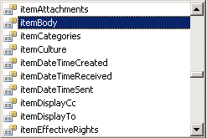

Figure 8.
- Create the ContactItemType object to contain the update.
ContactItemType contact = new ContactItemType();
contact.Body = new BodyType();
contact.Body.BodyType1 = BodyTypeType.Text;
contact.Body.Value = txtSetToContactsBody.Text;
- Create objects to send an UpdateItem request and to get the UpdateItem response.
// Send the update request
UpdateItemResponseType response = service.UpdateItem(request);

// Check the results of the request.
ItemInfoResponseMessageType responseMessage = response.ResponseMessages.Items[0] as ItemInfoResponseMessageType;
ContactItemType contactResponse = responseMessage.Items.Items[0] as ContactItemType;
- Check to determine whether the response message (Error, Warning, or Success) is the correct type.
// Access the response messages.
foreach (ResponseMessageType respMsg in responseMessages)
{
if (respMsg.ResponseClass == ResponseClassType.Error)
{
throw new Exception("Error: " + respMsg.MessageText);
}
else if (respMsg.ResponseClass == ResponseClassType.Warning)
{
throw new Exception("Warning: " + respMsg.MessageText);
}
else if (respMsg.ResponseClass == ResponseClassType.Success)
{
//Action
}
}

DeleteItem Operation
The following example of a DeleteItem request shows how to perform the delete operation of an item from a specified default folder, for example, a mailbox folder. Here the parameter uses the item ID and the change key.
- Create the ExchangeServiceBinding object, and pass the user credentials and URL of Exchange Web Services to this object.
// Set up the binding with credentials and URL.
ExchangeServiceBinding binding = new ExchangeServiceBinding();
binding.Credentials = new NetworkCredential("USER", "password", " Domainname");
binding.Url = GetExchangeWebServiceURL(UserID, Password);
Note: Refer to Definition for GetExchangeWebServiceURL in the Appendix in this guide.
- Create the DeleteItemType object for the DeleteItem request.
DeleteItemType request=new DeleteItemType();
- Use the FindAllItems method to get the item ID and change key for the item.
- Create the ItemIDType object, set the item ID and change key that you created in step 3, and add this object to the request.
ItemIdType[] itemType = new ItemIdType[1];
itemType[0]= new ItemIdType();
itemType[0].Id = <ItemId>;
itemType[0].ChangeKey = <ChangeKey>;
request.ItemIds=itemType;
- Create the DeleteItemResponseType object to send a DeleteItem request and get the DeleteItem response.
DeleteItemResponseType response=new DeleteItemResponseType();
response=service.DeleteItem(request);
// Check the results of the request.
ItemInfoResponseMessageType responseMessage = response.ResponseMessages.Items[0] as ItemInfoResponseMessageType;
ContactItemType contactResponse = responseMessage.Items.Items[0] as ContactItemType;
- Check to determine whether the response message (Error, Warning, or Success) is the correct type.
// Access the response messages.
foreach (ResponseMessageType respMsg in responseMessages)
{
if (respMsg.ResponseClass == ResponseClassType.Error)
{
throw new Exception("Error: " + respMsg.MessageText);
}
else if (respMsg.ResponseClass == ResponseClassType.Warning)
{
throw new Exception("Warning: " + respMsg.MessageText);
}
else if (respMsg.ResponseClass == ResponseClassType.Success)
{
//Action
}
}

Available Operations
Exchange Web Services is a comprehensive, standards-based API that enables custom applications to interact with the Exchange store over HTTPS. Table 1 shows all the available Exchange Web Services operations (methods) that are supported in an Exchange Online environment.
Table 1: Exchange Web Services Operations
Operation | Description
AddDelegate | Adds one or more delegates to a principal's mailbox, and sets specific access permissions.
GetDelegate | Retrieves the delegate settings for a specific mailbox.
UpdateDelegate | Updates delegate permissions on a principal's mailbox.
RemoveDelegate | Removes one or more delegates from a user's mailbox.
CreateItem | Creates items in the Exchange store.
CopyItem | Copies items to a different folder.
DeleteItem | Deletes items in the Exchange store.
FindItem | Identifies items that are located in a specified folder.
GetItem | Gets items from the Exchange store.
MoveItem | Moves items to a single destination folder.
SendItem | Sends e-mail messages that are located in the Exchange store.
UpdateItem | Modifies the properties of existing items in the Exchange store.
CreateFolder | Creates folders, calendar folders, contacts folders, tasks folders, and search folders.
CopyFolder | Copies folders in a mailbox.
DeleteFolder | Deletes folders from a mailbox.
FindFolder | Finds subfolders of an identified folder, and returns properties that describe the set of subfolders.
GetFolder | Gets folders from the Exchange store.
MoveFolder | Moves folders from a specified folder to another folder.
UpdateFolder | Modifies properties of existing items in the Exchange store.
CreateAttachment | Creates either an item or a file attachment and attaches it to the specified item.
GetAttachment | Retrieves existing attachments on items in the Exchange store.
DeleteAttachment | Deletes file attachments and item attachments from an existing item in the Exchange store.
ExpandDL | Exposes the full membership of distribution lists.
ResolveNames | Resolves ambiguous e-mail addresses and display names.
ConvertId | Converts item and folder identifiers between formats that are accepted by Exchange Server 2007.
Subscribe | Subscribes client applications to either push or pull notifications.
Unsubscribe | Ends a pull notification subscription.
GetEvents | Used by pull subscription clients to request notifications from the Client Access server.
SyncFolderHierarchy | Synchronizes folders between the computer that is running Exchange Server 2007 and the client.
SyncFolderItems | Synchronizes items between Exchange Server and the client.
GetUserAvailability | Provides detailed information about the availability of a set of users, rooms, and resources within a specified time window.
GetUserOofSettings | Gets Out of Office (OOF) settings and messages of a mailbox user.
SetUserOofSettings | Sets Out of Office (OOF) settings and messages for a mailbox user.

Autodiscover Service
The Autodiscover service is a Web service that provides the configuration information necessary to create a connection to Exchange Online services. Autodiscover provides a mechanism for locating the settings that a client application (such as Office Outlook 2007) must have in order to connect to Exchange Online.
This section provides examples and descriptions of the messages that are used to retrieve Autodiscover configuration information.
For more details, download and review the following documents:
- “Autodiscover Service Architecture” at msdn.microsoft.com/en-us/library/bb204047.aspx.
- “How to Configure Exchange Services for the Autodiscover Service” at technet.microsoft.com/en-us/library/bb201695.aspx.
- “Autodiscover Reference” at msdn.microsoft.com/en-us/library/aa581522.aspx.

Autodiscover Lookup Logic
This section describes the logic used by the Autodiscover service to retrieve Autodiscover information from Exchange Server. This logic is designed to perform a lookup for service connection point (SCP) URLs, and to send HTTP POSTs to the Autodiscover service to retrieve client profile configuration information.
The generic Autodiscover logic for getting the Autodiscover response is:
- Get the user SMTP address and password (the credentials).
- Get the domain from the e-mail address.
- Get a list of SCP URLs.
- Take one the following actions:
- If the SCP URL list is not empty, send an Autodiscover request for each URL.
- If the SCP URL list is empty, or the Autodiscover response is null, then add two Secure Sockets Layer (SSL) URLs that are built from the domain part of SMTP address. The formats for the two SSL URLs are:
"https://" + domain-name + Autodiscover-path
"https://autodiscover." + domain-name + Autodiscover-path
where Autodiscover-path = @"/autodiscover/autodiscover.xml"
For each of the above SSL URLs send an Autodiscover request.
- If the Autodiscover response is null, then try a non-SSL URL to get SSL to redirect the URL. The format for the non-SSL URL is:
"http://autodiscover." + domain-name + Autodiscover-path
- If the returned redirected URL is not null, this means that it is a valid redirect SSL URL. In this case, attempt to request Autodiscover data.
- Return the Autodiscover response.
For more details about Autodiscover, see the Appendix in this guide.

Autodiscover Service Sample Application
In this section, you create a sample application that calls the Autodiscover service to get the URL for Exchange Web Services and perform a CreateItem (email) request in managed code.
- Create an Autodiscover request object to pass the user name, password, and network credentials as parameters to get an AutodiscoverResponseXml object. (For specific information, see “Creating a Proxy Reference” earlier in this guide.)
- Get the Autodiscover response object.
- Use the response object to get all data container information about Office Outlook, including the Exchange Web Service binding URL.
- The response.OutlookData.User object gathers the user identity data:
- User display name
- User legacy display name
- User deployment ID
- The response.OutlookData.Account object gathers account data:
- AccountType
- Action
- AuthPackage
- RedirectAddr
- SSL
- The response.OutlookData.Account.Protocol object gets the Exchange Web Services binding URL:
if (response.OutlookData.Account.Protocol != null)
{
foreach (AutodiscoverSample.AutoDiscover.ProtocolXml protocolXml in response.OutlookData.Account.Protocol)
{
if (protocolXml.ASUrl !=null)
//Service url
asURL = protocolXml.ASUrl.ToString();
}}
- Create the ExchangeServiceBinding object, and set its URL to the service URL that is returned from the response object of the Autodiscover service.
// pass credential and Service Url
ExchangeServiceBinding service = new ExchangeServiceBinding();
service.Credentials = new NetworkCredential("user", "password", "");
service.Url = GetExchangeWebServiceURL(UserID, Password);
Note: Refer to Definition for GetExchangeWebServiceURL in the Appendix of this guide.
- Create the CreateItemType request object.
CreateItemType createEmailRequest = new CreateItemType();
- Create the MessageDispositionType object to specify how the e-mail will be handled, and add this object to the request that you created in step 5. The available options are SaveOnly, SendAndSaveCopy, and SendOnly.
createEmailRequest.MessageDisposition = MessageDispositionType.SaveOnly;
createEmailRequest.MessageDispositionSpecified = true;
- Create the TargetFolderIdType object to specify the location of the sent items, and add this object to the request.
createEmailRequest.SavedItemFolderId = new TargetFolderIdType();
DistinguishedFolderIdType sentitems = new DistinguishedFolderIdType();
sentitems.Id = DistinguishedFolderIdNameType.inbox;
createEmailRequest.SavedItemFolderId.Item = sentitems;
The available options are shown here:

Figure 9.
- Create the MessageType object for a single e-mail message, and pass the subject, e-mail body, sender e-mail address, and recipient e-mail addresses. Add this object to the request.
// Create a single e-mail message.
MessageType message = new MessageType();
message.Subject = "Pass the subject here";
message.Body = new BodyType();
message.Body.BodyType1 = BodyTypeType.Text;
message.Body.Value =”Pass the body text here”
message.Sender = new SingleRecipientType();
message.Sender.Item = new EmailAddressType();
message.Sender.Item.EmailAddress = “Senderemail@xyz.com”;
message.ToRecipients = new EmailAddressType[1];
message.ToRecipients[0] = new EmailAddressType();
message.ToRecipients[0].EmailAddress = “toRecipients@xyz.com”;
message.Sensitivity = SensitivityChoicesType.Normal;
createEmailRequest.Items.Items = new ItemType[1];
createEmailRequest.Items.Items[0] = message;
- Create the CreateItemResponseType object to send a CreateItem request and get the CreateItem response.
CreateItemResponseType createItemResponse = service.CreateItem(createEmailRequest);
ArrayOfResponseMessagesType responses = createItemResponse.ResponseMessages;
ResponseMessageType[] responseMessages = responses.Items;
- Check to determine whether the response message (Error, Warning or Success) is the correct type.
// Access the response messages.
foreach (ResponseMessageType respMsg in responseMessages)
{
if (respMsg.ResponseClass == ResponseClassType.Error)
{
throw new Exception("Error: " + respMsg.MessageText);
}
else if (respMsg.ResponseClass == ResponseClassType.Warning)
{
throw new Exception("Warning: " + respMsg.MessageText);
}
else if (respMsg.ResponseClass == ResponseClassType.Success)
{
//Action
}
}

Integration Scenarios
This section describes how to integrate Exchange Online with Microsoft Dynamics AX and Windows Azure, using scenarios to illustrate the integration process for each of these products.

Integration with Microsoft Dynamics AX 4.0
This scenario sends out an e-mail notification from Microsoft Dynamics AX 4.0 to the customer when an invoice is raised in the name of that customer. To send this message, Microsoft Dynamics AX communicates with an API that is exposed by a wrapper class of Exchange Web Services.
This scenario requires the creation of a wrapper class that includes a method that receives details from the Microsoft Dynamics AX 4.0 environment and sends mail from Exchange Online using the CreateItem method. The method is triggered from Microsoft Dynamics AX when an invoice is created.
Prerequisite: Microsoft Dynamics AX 4.0 must be installed with the Sales module.
There are three tasks to implement this scenario:
- Task 1: Create a wrapper class to send mail.
- Task 2: Add the reference of the wrapper class to Microsoft Dynamics AX.
- Task 3: Invoke the Microsoft .NET wrapper class when an invoice is posted.

Task 1: Create the Wrapper Class
This section describes the wrapper class method (CreateItemEmailMessage) that is called from Microsoft Dynamics AX 4.0 to send an e-mail notification.
- Create the ExchangeServiceBinding object and set its URL to the Microsoft Exchange Online URL.
// pass credential and Service Url
ExchangeServiceBinding service = new ExchangeServiceBinding();
service.Credentials = new NetworkCredential("user", "password", "");
service.Url = GetExchangeWebServiceURL(UserID, Password);
Note: Refer to Definition for GetExchangeWebServiceURL in the Appendix.
- Create the CreateItemType request object for a new e-mail message.
CreateItemType createEmailRequest = new CreateItemType();
- Create the MessageDispositionType object to specify how the e-mail will be handled, and add this object to the request created in step 2.The available options are SaveOnly, SendAndSaveCopy, and SendOnly.
createEmailRequest.MessageDisposition = MessageDispositionType.SendOnly;
createEmailRequest.MessageDispositionSpecified = true;
- Create the TargetFolderIdType object to specify the location of the sent items and add this object to the request.
createEmailRequest.SavedItemFolderId = new TargetFolderIdType();
DistinguishedFolderIdType sentitems = new DistinguishedFolderIdType();
sentitems.Id = DistinguishedFolderIdNameType.inbox;
createEmailRequest.SavedItemFolderId.Item = sentitems;
The available options are shown here:

Figure 10.
- Create the MessageType object for a single e-mail message, and pass the subject, e-mail body, sender e-mail address, and recipient e-mail addresses of this message to this object. Add this object to the request.
// Create a single e-mail message.
MessageType message = new MessageType();
message.Subject = "Pass the subject here";
message.Body = new BodyType();
message.Body.BodyType1 = BodyTypeType.Text;
message.Body.Value =”Pass the body text here”
message.Sender = new SingleRecipientType();
message.Sender.Item = new EmailAddressType();
message.Sender.Item.EmailAddress = “Senderemail@xyz.com”;
message.ToRecipients = new EmailAddressType[1];
message.ToRecipients[0] = new EmailAddressType();
message.ToRecipients[0].EmailAddress = “toRecipients@xyz.com”;
message.Sensitivity = SensitivityChoicesType.Normal;

createEmailRequest.Items.Items = new ItemType[1];
createEmailRequest.Items.Items[0] = message;
- Create the CreateItemResponseType object to send a CreateItem request and get the CreateItem response.
CreateItemResponseType createItemResponse = service.CreateItem(createEmailRequest);
ArrayOfResponseMessagesType responses = createItemResponse.ResponseMessages;
ResponseMessageType[] responseMessages = responses.Items;
- Check to determine whether the response message (Error, Warning, or Success) is the correct type.
// Access the response messages.
foreach (ResponseMessageType respMsg in responseMessages)
{
if (respMsg.ResponseClass == ResponseClassType.Error)
{
throw new Exception("Error: " + respMsg.MessageText);
}
else if (respMsg.ResponseClass == ResponseClassType.Warning)
{
throw new Exception("Warning: " + respMsg.MessageText);
}
else if (respMsg.ResponseClass == ResponseClassType.Success)
{
//Action
}
}

Task 2: Add Reference of the Wrapper Class
Following are the steps for adding and referencing the wrapper DLL in Microsoft Dynamics AX.
- Expand the application object tree (AOT).
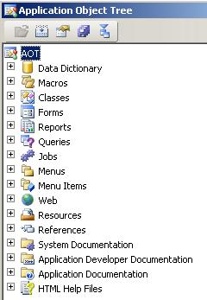

Figure 11.

- Expand and right-click the References node, and then click Add reference.
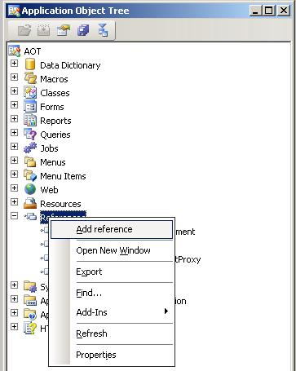

Figure 12.
- In the Add reference window, select the required DLL from the list of DLLs.
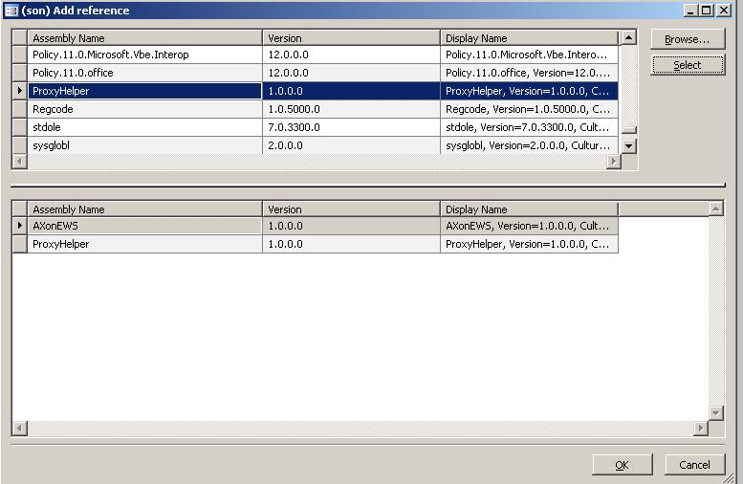

Figure 13.

- Click OK to confirm your selection.
The selected DLL now appears in the References node of the application.
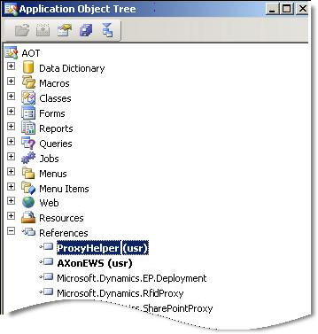

Figure 14.

Task 3: Invoke the Wrapper Class
In this task, you invoke the .NET wrapper class when the invoice is posted.
- Expand the application object tree (labeled AOT), and then select the Forms node.
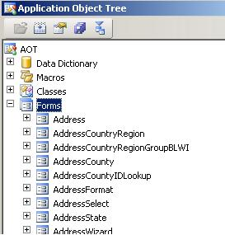

Figure 15.

- In the Forms node, double-click SalesEditLines to open the window that shows all the methods written in the SalesEditLines module.
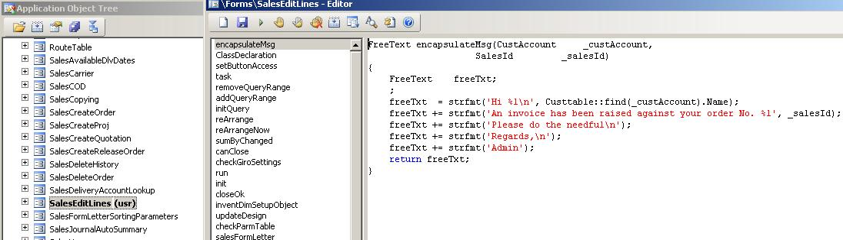

Figure 16.
- Add several lines of code to the default method closeOk. (The snippets that are highlighted in bold red below are customized codes.)
void closeOk()
{
// The variable declaration is done here.
InteropPermission interopPermission;
AXonEWS.AXonEWS axonews;
if (salesParmUpdate)
salesParmUpdate_ds.write();
if (salesParmTable)
salesParmTable_ds.write();
if (salesParmSubTable)
salesParmSubTable_ds.write();
if (salesParmLine)
salesParmLine_ds.write();
if (salesEditLinesForm.giro())
element.checkGiroSettings();
salesFormLetter.initParameters(salesParmUpdate,
print_Combo.selection(),
printFormletter.value(),
printCODLabelChoice,
printCallTagChoice,
printShippingLabelChoice,
usePrintManagement.value());
salesFormLetter.editLinesChanged(editLinesChanged);
salesFormLetter.reArrangeNow(reArrangeNow);
super();
if (salesFormletter.salesTable().SalesStatus == SalesStatus::Delivered)
{
interopPermission = new InteropPermission(InteropKind::ClrInterop);
// The DLL which exposes the API to send the mail is instansiated here.
axonews = new AXonEWS.AXonEWS();
// Now the exposed CreateItemEmailMessage is called here and the mail is send to the customer.
axonews.CreateItemEmailMessage( //Calling the wrapper class method for sending email
custtable::find(salesFormletter.salesTable().CustAccount).Email, //parameter: receiver email id
strfmt('Invoice raised against %1', //subject
salesFormLetter.salesTable().SalesId),
this.encapsulateMsg(
salesformletter.salesTable().CustAccount,
salesFormletter.salesTable().SalesId //body
),
"user@kunapalli31.microsoftonline.com"); //Sender’s email id
Info(strfmt('Customer %1 informed successfully',
salesFormletter.salesTable().CustAccount));
}
}
- In the Editor window, click New to create a function. The X++ code snippet below shows the method for creating the body of the e-mail message.
FreeText encapsulateMsg(CustAccount _custAccount, SalesId _salesId)
{
FreeText freeTxt;
freeTxt = strfmt('Hi %1\n', Custtable::find(_custAccount).Name);
freeTxt += strfmt('An invoice has been raised against your order No. %1', _salesId);
freeTxt += strfmt('Please do the needful\n');
freeTxt += strfmt('Regards,\n');s
freeTxt += strfmt('Admin');
return freeTxt;
}
- Click Save to compile and save your code.
Now when an invoice is raised in Microsoft Dynamics AX, an e-mail notification is sent using Exchange Online.

Integration with Windows Azure
Exchange Web Services can take advantage of the Windows Azure operating system. Windows Azure is a cloud services (Internet-based) operating system that serves as the development, service hosting, and service management environment for the Azure Services Platform. Windows Azure provides developers with on-demand compute and storage services to host, scale, and manage Web applications on the Internet through Microsoft data centers.
This section describes how to create a cloud application that is hosted on Windows Azure. This cloud application contains the following applications:
- A Free/Busy application that gives the availability status of a given user or users on a specific date.
- A Delegate application to add, remove, and update a delegate for a given primary user.
Prerequisite: The cloud application must be hosted on the Microsoft cloud services platform using Microsoft Azure.
You must complete three tasks to implement these applications:
- Task 1: Create an online project in Windows Azure.
- Task 2: Create a Web cloud service that hosts the two Windows Azure applications that are created using Visual Studio 2008 (Microsoft .NET Framework). These applications integrate with Exchange Online.
- Task 3: Deploy the Web cloud service in Windows Azure.

Task 1: Create an Online Project
Following are the steps for creating a project in Windows Azure.
- Log on to the Azure Services Developer Portal at go.microsoft.com/fwlink/?LinkID=130875. The home page is similar to the one shown here:
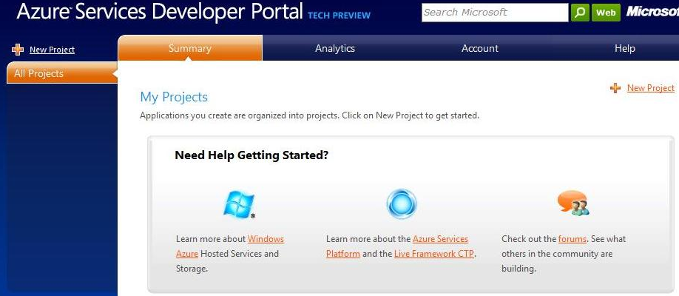

Figure 17.
- Click the New Project link in the upper right corner.
- Click the Hosted Services area.
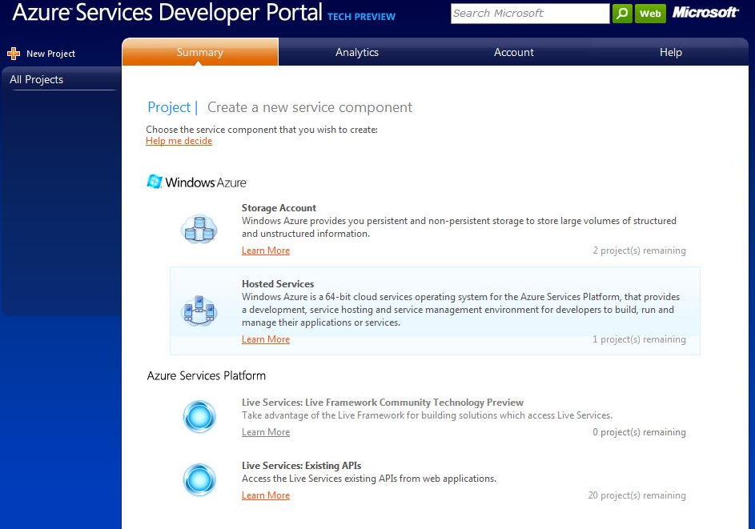

Figure 18.
- On the Project Properties page of the Create a Project window, enter the name for the new project and a description of the project, and then click Next.

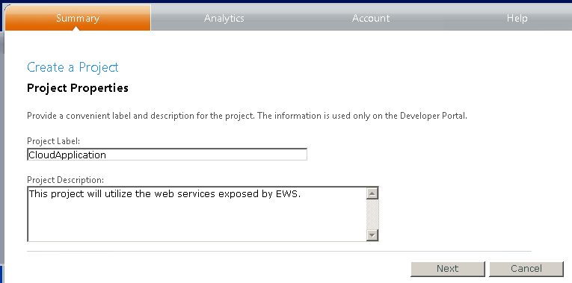

Figure 19.

- On the Hosted Service page, enter the name for the new hosted service, and then click Create.
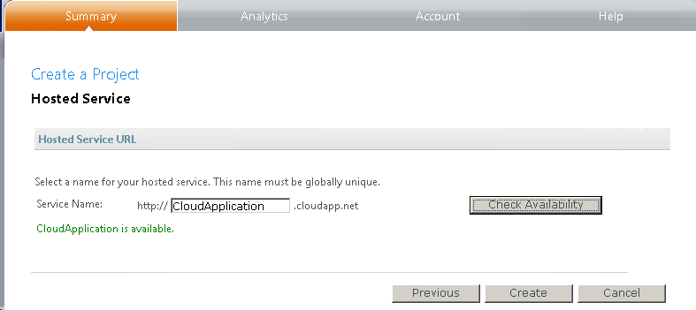

Figure 20.
The project is now created with the following details:
- Application ID
- Domain
- Return URL
- A secret key

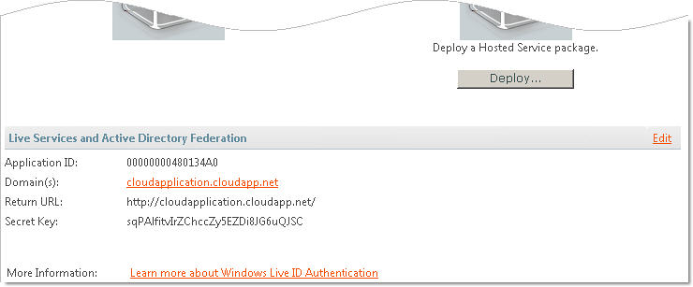

Figure 21.
Note: The application ID that is generated must be entered as the application ID in the Property window of the project later, while developing the cloud application in Visual Studio. (See the screen shot in step 2, Task 2C.)

Task 2: Create a Web Cloud Service
After you create the project in Windows Azure and acquire the application ID for the project, you can create the Web cloud service as a project in Visual Studio 2008.
The Free/Busy and Delegate applications refer to the proxy wrapper class, which references Exchange Web Services. The application creates an object for the proxy class and passes the user credentials and URL of Exchange Web Services. It then captures the list of users, for which the status must be checked and returned.
To create the Web cloud service, perform these three tasks in Visual Studio 2008:
- Task 2A: Create cloud application project solutions.
- Task 2B: Create the Free/Busy and Delegate applications.
- Task 2C: Build and deploy the project solution.

Task 2A: Create Visual Studio Projects
- In Visual Studio 2008, create a new Microsoft Visual C#® project for the cloud application, selecting the Cloud Service project type and the Web Cloud Service template.
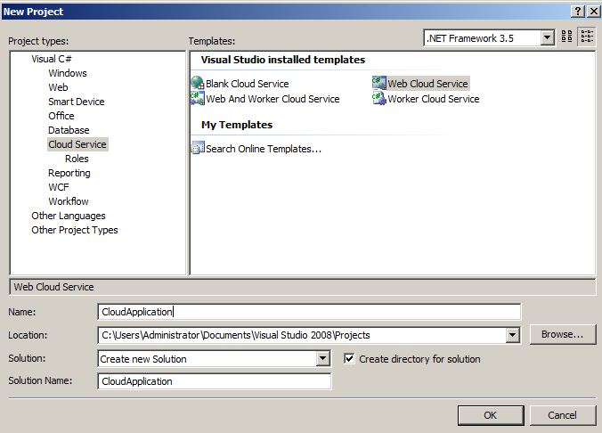

Figure 22.
- Type Cloud Application in the Name field, and click OK.

Task 2B: Create the Free/Busy and Delegate Applications
You can now begin building your applications.

Create the Free/Busy Application
Use the GetUserAvailability method to create the ExchangeServiceBinding object and the Duration object.
- Initialize the start date and end date.
- Create a FreeBusyViewOptionsType object, which specifies the type of free/busy information that is to be returned in response.
FreeBusyViewOptionsType fbViewOptions = new FreeBusyViewOptionsType();
fbViewOptions.TimeWindow = duration;
fbViewOptions.RequestedView = FreeBusyViewType.DetailedMerged;
fbViewOptions.RequestedViewSpecified = true;
fbViewOptions.MergedFreeBusyIntervalInMinutes = 60;
fbViewOptions.MergedFreeBusyIntervalInMinutesSpecified = true;
- Create Mailbox and Email objects for setting up the required properties.
MailboxData[] mailboxes = new MailboxData[1];
mailboxes[0] = new MailboxData();
// Identify the user mailbox to review for free/busy data.
EmailAddress emailAddress = new EmailAddress();
emailAddress.Address = UserEMail;
emailAddress.Name = String.Empty;
mailboxes[0].Email = emailAddress;
mailboxes[0].ExcludeConflicts = false;
mailboxes[0].AttendeeType = MeetingAttendeeType.Required;
- Set the Address and Name properties of the Email object.
- Create a GetUserAvailabilityRequestType object to get the availability information for a user and set all the required time zone parameters of the object.
- Add the mailbox object that you created in step 2 to the GetUserAvailabilityRequestType object.
// Make the request.
GetUserAvailabilityRequestType request = new GetUserAvailabilityRequestType();
// Set the time zone of the request.
request.TimeZone = new SerializableTimeZone();
request.TimeZone.Bias = 480;
request.TimeZone.StandardTime = new SerializableTimeZoneTime();
request.TimeZone.StandardTime.Bias = 0;
request.TimeZone.StandardTime.DayOfWeek = DayOfWeekType.Sunday.ToString();
request.TimeZone.StandardTime.DayOrder = 1;
request.TimeZone.StandardTime.Month = 11;
request.TimeZone.StandardTime.Time = "02:00:00";
request.TimeZone.DaylightTime = new SerializableTimeZoneTime();
request.TimeZone.DaylightTime.Bias = -60;
request.TimeZone.DaylightTime.DayOfWeek = DayOfWeekType.Sunday.ToString();
request.TimeZone.DaylightTime.DayOrder = 2;
request.TimeZone.DaylightTime.Month = 3;
request.TimeZone.DaylightTime.Time = "02:00:00";
// Add the mailboxes to the request.
request.MailboxDataArray = mailboxes;
// Add the view options to the request.
request.FreeBusyViewOptions = fbViewOptions;
- Send the request to get the response from a GetUserAvailability operation.
// Send the request and get the response.
GetUserAvailabilityResponseType response = service.GetUserAvailability(request);
- Create the FreeBusyResponseType object to loop through the FreeBusyResponseArray property of GetUserAvailability response object.
- Create the FreeBusyView object, and then assign the FreeBusyView property to FreeBusyResponseType.
foreach (FreeBusyResponseType fbrt in response.FreeBusyResponseArray)
{
if (fbrt.ResponseMessage.ResponseClass == ResponseClassType.Error){ MessageBox.Show(Result", "Error");
}
else
{
// Show the free/busy stream.
FreeBusyView fbv = fbrt.FreeBusyView;
if (fbv.CalendarEventArray != null)
{
for (int startIndex = 0; startIndex < fbv.CalendarEventArray.Length; startIndex++)
{
MessageBox.Show(“Busy during :", fbv.CalendarEventArray[startIndex].StartTime + "-" + fbv.CalendarEventArray[startIndex].StartTime);
}
}
else
{
MessageBox.Show(Available during ", "Whole day");
}
MessageBox.Show(Result", "Success");
}}

Create the Delegate Application
The Delegate application consists of the AddDelegate, GetDelegate, UpdateDelegate, and RemoveDelegate operations performed on the mailbox of the principal user.

Coding the AddDelegate Operation
The AddDelegate method adds one or more delegates to the mailbox of the principal user and sets specific access permissions.
- Create the ExchangeServiceBinding and RequestServerVersion objects, and pass the user credentials and URL for Exchange Web Services to those objects.
// Set the version, credentials, and Client Access server on ExchangeServiceBinding.
service.RequestServerVersionValue = new RequestServerVersion();
service.RequestServerVersionValue.Version = ExchangeVersionType.Exchange2007_SP1;
// pass credential and Service Url
ExchangeServiceBinding service = new ExchangeServiceBinding();
service.Credentials = new NetworkCredential("user", "password", "");

service.Url = GetExchangeWebServiceURL(UserID, Password);
Note: Refer to Definition for GetExchangeWebServiceURL in the Appendix.
- Create the AddDelegateType request object.
AddDelegateType request = new AddDelegateType();
- Pass the principal's mailbox ID to the ExchangeServiceBinding object.
request.Mailbox = new EmailAddressType();
request.Mailbox.EmailAddress = “User1@ kunapalli31.microsoftonline.com”;
- Set the ExchangeServiceBinding object with the delegates who are given access to the principal user's mailbox.
request.DelegateUsers = new DelegateUserType[2];
request.DelegateUsers[0] = new DelegateUserType();
request.DelegateUsers[0].UserId = new UserIdType();
request.DelegateUsers[0].UserId.PrimarySmtpAddress = “User2@ kunapalli31.microsoftonline.com”;
- Pass the permissions that are granted to each delegate user to the ExchangeServiceBinding object.
request.DelegateUsers[0].DelegatePermissions = new DelegatePermissionsType();
request.DelegateUsers[0].DelegatePermissions.CalendarFolderPermissionLevel = DelegateFolderPermissionLevelType.Reviewer;
request.DelegateUsers[0].DelegatePermissions.CalendarFolderPermissionLevelSpecified = true;
- Create the AddDelegateResponseMessageType object to send an AddDelegate request and get the AddDelegate response.
AddDelegateResponseMessageType response = service.AddDelegate(request);
DelegateUserResponseMessageType[] responseMessages = response.ResponseMessages;
- Create one DelegateUserResponseMessageType object for each attempt to add a delegate user to an account.
foreach (DelegateUserResponseMessageType user in responseMessages)
{
user.ResponseClass.ToString();
user.DelegateUser.UserId.DisplayName;
user.DelegateUser.UserId.PrimarySmtpAddress;
user.DelegateUser.UserId.SID;
}

Coding the GetDelegate Operation
The GetDelegate method retrieves the delegate settings for a specific mailbox.
- Create the ExchangeServiceBinding and RequestServerVersion objects and pass the user credentials and URL for Exchange Web Services to those objects.
// Set the version, credentials, and Client Access server on ExchangeServiceBinding.
service.RequestServerVersionValue = new RequestServerVersion();
service.RequestServerVersionValue.Version = ExchangeVersionType.Exchange2007_SP1;
// pass credential and Service Url
ExchangeServiceBinding service = new ExchangeServiceBinding();
service.Credentials = new NetworkCredential("user", "password", "");

service.Url = GetExchangeWebServiceURL(UserID, Password);
Note: Refer to Definition for GetExchangeWebServiceURL in the Appendix.
- Create the AddDelegateType request object and set the permissions.
GetDelegateType request = new GetDelegateType ();
request.IncludePermissions = true;
- Pass the principal's mailbox ID to the ExchangeServiceBinding object.
request.Mailbox = new EmailAddressType();
request.Mailbox.EmailAddress = User1@ kunapalli31.microsoftonline.com;
- Create the GetDelegateResponseMessageType object to send a GetDelegate request and get the GetDelegate response.
GetDelegateResponseMessageType response = service.GetDelegate(request);
- Create one DelegateUserResponseMessageType object for each attempt to add a delegate user to an account.
foreach (DelegateUserResponseMessageType user in responseMessages)
{
user.DelegateUser.UserId.DisplayName;
user.DelegateUser.UserId.PrimarySmtpAddress;
user.DelegateUser.UserId.SID;
user.DelegateUser.UserId.DisplayName; user.DelegateUser.DelegatePermissions.CalendarFolderPermissionLevel.ToString()
}

Coding the UpdateDelegate Operation
The UpdateDelegate method updates delegate permissions on a principal's mailbox.
- Create the ExchangeServiceBinding andRequestServerVersion objects, and pass the user credentials and URL for Exchange Web Services to those objects.
// Set the version, credentials, and Client Access server on ExchangeServiceBinding.
service.RequestServerVersionValue = new RequestServerVersion();
service.RequestServerVersionValue.Version = ExchangeVersionType.Exchange2007_SP1;
// pass credential and Service Url
ExchangeServiceBinding service = new ExchangeServiceBinding();
service.Credentials = new NetworkCredential("user", "password", "");
service.Url = GetExchangeWebServiceURL(UserID, Password);
Note: Refer to Definition for GetExchangeWebServiceURL in the Appendix.
- Create the AddDelegateType request object.
UpdateDelegateType request = new UpdateDelegateType();
- Pass the principal's mailbox ID to the ExchangeServiceBinding object.
request.Mailbox = new EmailAddressType();
request.Mailbox.EmailAddress = User1@ kunapalli31.microsoftonline.com;
- Use the DelegateUsers method to identify the delegates who are given access to the principal's mailbox, and pass these users to the ExchangeServiceBinding object.
request.DelegateUsers = new DelegateUserType[2];
request.DelegateUsers[0] = new DelegateUserType();
request.DelegateUsers[0].UserId = new UserIdType();
request.DelegateUsers[0].UserId.PrimarySmtpAddress = user@kunapalli31.microsoftonline.com;
- Pass the permissions that are granted to each delegate user to the ExchangeServiceBinding object.
request.DelegateUsers[0].DelegatePermissions = new DelegatePermissionsType();
request.DelegateUsers[0].DelegatePermissions.CalendarFolderPermissionLevel = DelegateFolderPermissionLevelType.Reviewer;
request.DelegateUsers[0].DelegatePermissions.CalendarFolderPermissionLevelSpecified = true;
- Create the UpdateDelegateResponseMessageType object to send an UpdateDelegate request and get the UpdateDelegate response.
UpdateDelegateResponseMessageType response = service.UpdateDelegate(request);
DelegateUserResponseMessageType[] responseMessages = response.ResponseMessages;
- Create one DelegateUserResponseMessageType object for each attempt to add a delegate user to an account.
foreach (DelegateUserResponseMessageType user in responseMessages)
{
user.DelegateUser.UserId.DisplayName;
user.DelegateUser.UserId.PrimarySmtpAddress;
user.DelegateUser.UserId.SID;
user.DelegateUser.ReceiveCopiesOfMeetingMessages.ToString();
user.DelegateUser.ViewPrivateItems.ToString();
}

Coding the RemoveDelegate Operation
The RemoveDelegate method removes one or more delegates from a user's mailbox.
- Create the ExchangeServiceBinding and RequestServerVersion objects, and pass the user credentials and URL for Exchange Web Services to those objects.
// Set the version, credentials, and Client Access server on ExchangeServiceBinding.
service.RequestServerVersionValue = new RequestServerVersion();
service.RequestServerVersionValue.Version = ExchangeVersionType.Exchange2007_SP1;
// pass credential and Service Url
ExchangeServiceBinding service = new ExchangeServiceBinding();
service.Credentials = new NetworkCredential("user", "password", "");

service.Url = GetExchangeWebServiceURL(UserID, Password);
Note: Refer to Definition for GetExchangeWebServiceURL in the Appendix.
- Create the AddDelegateType request object.
RemoveDelegateType request = new RemoveDelegateType();
- Pass the principal's mailbox ID to the ExchangeServiceBinding object.
request.Mailbox = new EmailAddressType();
request.Mailbox.EmailAddress = User1@ kunapalli31.microsoftonline.com;
- To remove delegate users, do one of the following:
- Remove a delegate based on the SMTP address, and then pass this to the ExchangeServiceBinding object.
UserIdType[] uidType = new UserIdType[2];
uidType[0] = new UserIdType();
uidType[0].PrimarySmtpAddress =“User1@kunapalli.microsoftonline.com”;
request.UserIds = uidType;
- Remove a delegate based on the security identifier ID (SID), and pass this to the ExchangeServiceBinding object.
UserIdType[] uidType = new UserIdType[2];
uidType[0] = new UserIdType();
uidType[0].SID= <SID for a delegate User using GetDelegate Operation>;
request.UserIds = uidType;
- Create the RemoveDelegateResponseMessageType object to send a RemoveDelegate request and get the RemoveDelegate response.
RemoveDelegateResponseMessageType response = service.RemoveDelegate(rdtRequest);
DelegateUserResponseMessageType[] responseMessages = response.ResponseMessages;
- Create one DelegateUserResponseMessageType object for each attempt to add a delegate user to an account.
foreach (DelegateUserResponseMessageType user in responseMessages)
{
user.ResponseCode.ToString()
}

Task 2C: Build and Deploy Both Solutions
- In Visual Studio, right-click Cloud Application, and then click Properties.

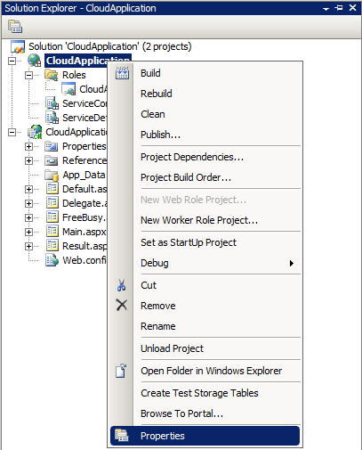

Figure 23.
- In the Properties window, enter the cloud application ID.
Note: To get the application ID, refer to the final illustration in task 1 of this section.
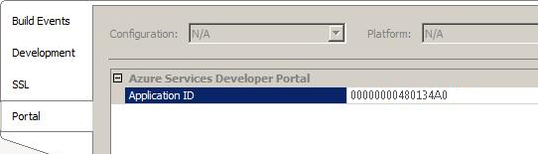

Figure 24.

- In Solution Explorer, right-click the solution, and then click Build Solution.
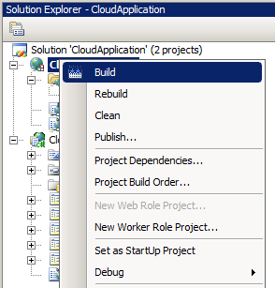

Figure 25.
Now the cloud application solution is ready to be published and deployed in the Windows Azure environment.
- In Solution Explorer, right-click the Cloud Application node, and then click Publish.
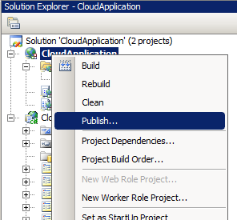

Figure 26.
The cloud application solution is published as two files: a package (.cspkg) file and a configuration (.cscfg) file.
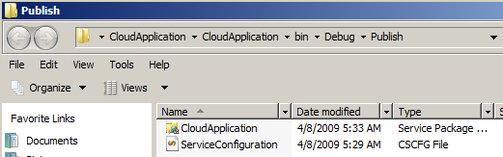

Figure 27.
- Repeat steps 1 through 4 for the Delegate application.

Task 3: Deploy Web Cloud Service on Windows Azure
Sign in to the Azure Services Developer Portal to deploy your projects.
- In the Azure Services Developer Portal, select the Cloud Application project, and click Deploy under Staging to deploy the project in Staging.

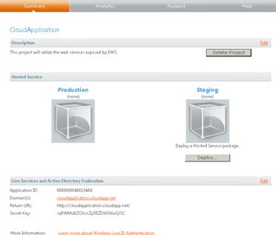

Figure 28.

- On the Staging Deployment page, do the following:
- Under App Package, browse to and select the package file to upload.
- Under Configuration Settings, browse to and select the configuration file to upload.
- Under Properties, enter a unique label for the deployment.
- Click Deploy.

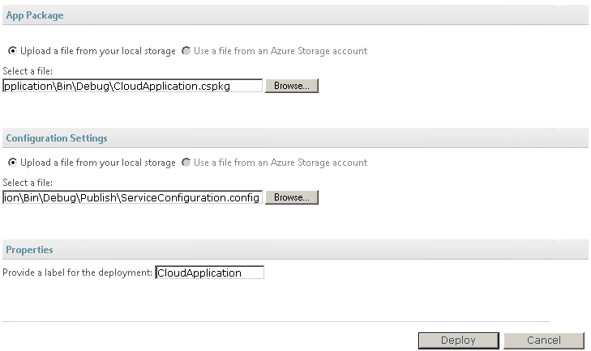

Figure 29.
- After the deployment is complete, click Run to run the application.

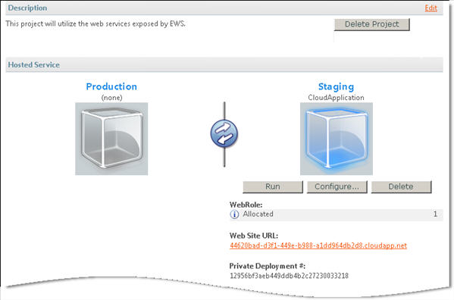

Figure 30.

When the deployment starts, Started appears in the WebRole box.

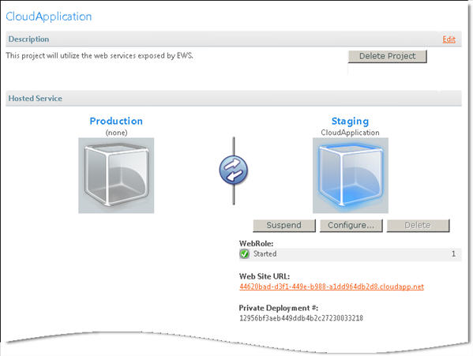
- To access the application after the deployment has finished, click the URL that appears under Web Site URL.

Windows Azure Resources
For more information about Windows Azure and the Azure Services Developer Portal, see “About the Azure Services Platform and Windows Azure” at msdn.microsoft.com/en-us/library/dd179442.aspx.
To download the Windows Azure Software Development Kit, go to www.microsoft.com/downloads/details.aspx?familyid=80e3eabf-0507-4560-aeb6-d31e9a70a0a6&displaylang=en.

Generating an Exchange Web Services Proxy for Java
This section describes how to generate an Exchange Web Services proxy using the CreateItem method for a client application written in Java.
Proxy classes can be generated from many popular IDEs. The examples in this section use the Eclipse IDE to generate the proxy.
Exchange Web Services is described by three files, all of which are required for creating a proxy in Java:
- Services.wsdl describes the contract between client and server.
- Messages.xsd defines the request and response SOAP messages.
- Types.xsd defines the elements used in the SOAP messages.
These three files are used in the following four tasks to create a Java proxy:
- Task 1: Prepare a Java-related WSDL file.
- Task 2: Generate a proxy.
- Task 3: Create a Java project.
- Task 4: Create a Java client application.

Prepare the Java-Related WSDL File
Before you can generate the Java proxy and a Java client with the Eclipse IDE, the <wsdl:service>, <wsdl:binding> and <wsdl:portType> elements are required as part of the Services.wsdl file. Internally, the Eclipse IDE uses an axis framework for generating Java proxies and client applications.
The following code shows how to add the <wsdl:service> element to the Services.wsdl file.
<wsdl:service name="ExchangeService">
<wsdl:port name="ExchangeServicePort" binding="tns:ExchangeServiceBinding">
<soap:address location="https://Kunapalli31.mail.microsoftonline.com /ews/Exchange.asmx" />
</wsdl:port>
</wsdl:service>

Generate the Proxy
To generate the Java proxy with the Eclipse IDE, do the following:
- Install Eclipse IDE 3.3. (Download Eclipse IDE for Java Developers (85 MB).
- Unzip the eclipse-3.3.zip file in c:\eclipse.
- Start Eclipse by using the Eclipse shortcut icon in c:\eclipse.

Create a Java Project
- In the Workspace Launcher dialog box, create a workspace in C:\JavaEWS.

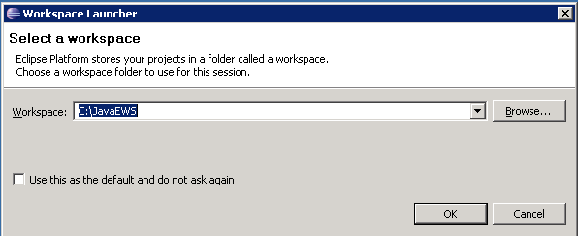

Figure 31.
- Create a new Java project: from the File menu, click New, and then click Java Project.
- In the New Java Project window, on the Create a Java Project page, do the following:
- In the Project name box, enter the name of your project. In this example, the name is EWSJavaProxies.
- Under Contents, select the option Create project from existing source, and browse to the root project folder.
- Click Finish.
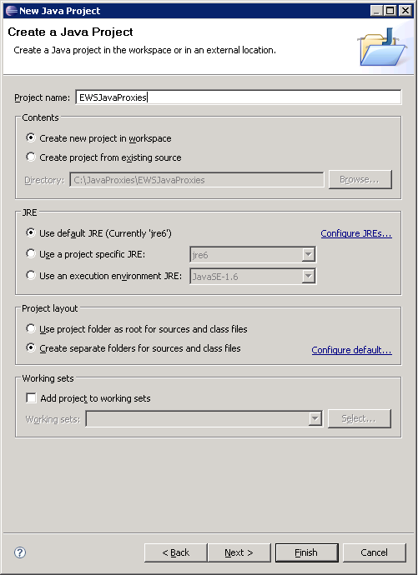

Figure 32.

- Create two new folders named lib and wsdl in the new project:
- Right-click the project name, click New, and then click Folder.
- In the New Folder dialog box, select the project name in the Enter or select the parent folder box.
- In the Folder name box, type lib, and then click Finish.
- Repeat steps a through c for the folder name wsdl.

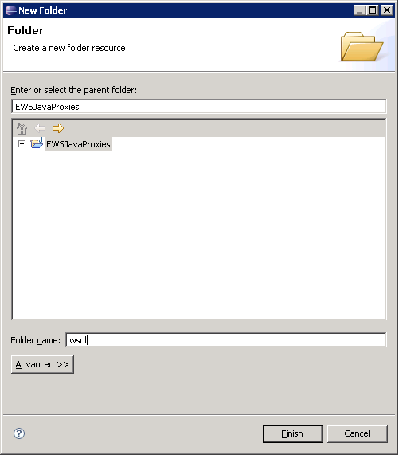

Figure 33.

- Copy the following files to the wsdl folder:
- Services.wsdl
- messages.xsd
- types.xsd
- Copy the following.jar files into the lib folder:
- activation.jar.jar
- axis2-jaxws-api-1.4.jar
- dom4j-1.6.1.jar
- commons-collections-3.2.jar,
- commons-discovery-0.2.jar
- commons-logging-1.0.4.jar
- jaxb-api.jar
- jaxrpc.jar,
- jaxws-api.jar
- saaj.jar
- wsdl4j-1.5.1.jar
- In the wsdl folder, right-click the Services.wsdl file, and then expand the New node, the Others node, the Web Services node, and then the Web Service Client node. This generates proxies by using a predefined plug-in in the Eclipse IDE.

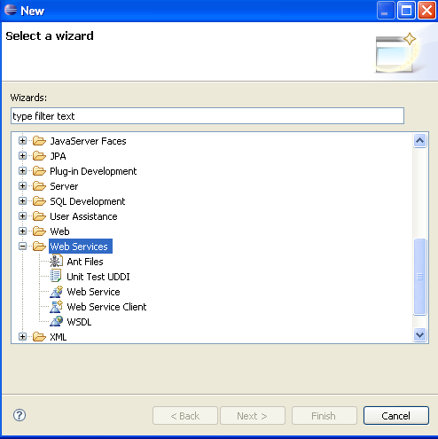

Figure 34.

The Web Services popup window appears.
- Select the Monitor the Web service check box, and then click Finish.

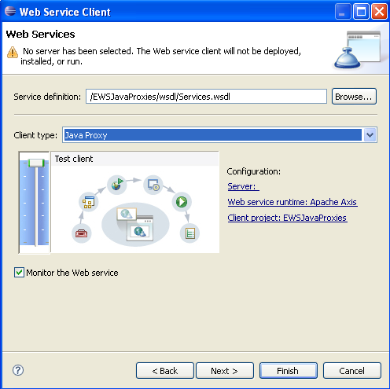

Figure 35.
The proxies for the Services.wsdl file are generated.
- On the Package Explorer tab, view the generated proxy files in the src folder.
The files com.microsoft.schemas.exchange.services._2006.messages and com.microsoft.schemas.exchange.services._2006.types are the two Java packages that were generated as Java proxies.
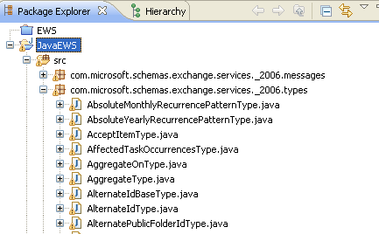

Figure 36.

Create the Java Client Application
This section describes how to create a Java client application that creates a new contact item and saves a copy of it in the default contact folder.
- Create the ExchangeServiceImpl object for the Exchange Web Services binding.
ExchangeServiceImpl service = (ExchangeServiceImpl) new ExchangeServiceLocator().getExchangeServicePort();
- Create the CreateItemType request object.
CreateItemType request=new CreateItemType();
- Create the ContactItemType and EmailAddressDictionaryEntryType objects.
ContactItemType cType=new ContactItemType();
- Set the following properties for ContactItemType.
setFileAs,GivenName, Subject, CompanyName, setDepartment, setSurname, JobTitle
cType.setFileAs(fileAsField);
cType.setGivenName(givenNameField);
cType.setCompanyName(companyNameField);
cType.setSurname(surnameField);
cType.setJobTitle(jobTitleField);
EmailAddressDictionaryEntryType emailAddress=new EmailAddressDictionaryEntryType(); //Email purpose
- Set the EmailAddress1 properties for EmailAddressDictionaryEntryType and add this to the ContactItemType object.
emailAddress.setKey(EmailAddressKeyType.EmailAddress1);
emailAddress.set_value(emailAddressesField);
EmailAddressDictionaryEntryType[]emailArray=new EmailAddressDictionaryEntryType[1];
emailArray[0]=emailAddress;
cType.setEmailAddresses(emailArray);
- Set DictionaryEntryType for the physical address and phone number.
PhysicalAddressDictionaryEntryType pAddDicEntryType=new PhysicalAddressDictionaryEntryType(); //Physical Address
pAddDicEntryType.setKey(PhysicalAddressKeyType.Business);
pAddDicEntryType.setCity(cityField);
pAddDicEntryType.setStreet(streetField);
pAddDicEntryType.setState(stateField);
pAddDicEntryType.setCountryOrRegion(countryOrRegionField);
PhysicalAddressDictionaryEntryType[] physicalAddArray=new PhysicalAddressDictionaryEntryType[1];
physicalAddArray[0]=pAddDicEntryType;
cType.setPhysicalAddresses(physicalAddArray);
PhoneNumberDictionaryEntryType phNoType=new PhoneNumberDictionaryEntryType();
phNoType.setKey(PhoneNumberKeyType.BusinessPhone);
phNoType.set_value(phoneNumberField);
PhoneNumberDictionaryEntryType[] phNoArray=new PhoneNumberDictionaryEntryType[1];
phNoArray[0]=phNoType;
cType.setPhoneNumbers(phNoArray);
- Set the Contact type properties to the CreateItemType request object.
NonEmptyArrayOfAllItemsType items=new NonEmptyArrayOfAllItemsType();
items.setContact(cType);
request.setItems(items);
- Create the TargetFolderIdType object to specify the location of the contact.
TargetFolderIdType targetType = new TargetFolderIdType();
// folder id purpose
DistinguishedFolderIdType dIdType = new DistinguishedFolderIdType();
dIdType.setId(DistinguishedFolderIdNameType.contacts);
targetType.setDistinguishedFolderId(dIdType);
request.setSavedItemFolderId(targetType);

- Create the CreateItemResponseType object to get the response for the CreateItem request object.
CreateItemResponseType itemResponseType=service.createItem(request);

More Information
You can use the following resources to learn more about Exchange Online and other Microsoft Online Services:
- Microsoft Online Services Portal: Learn more about Microsoft Online Services, sign up for free trials, and purchase services.
www.microsoft.com/online/default.mspx
- Microsoft Online Services Blog: Read the latest posts from Microsoft Online Services team members, and stay up to date on new developments.
blogs.technet.com/msonline/
- “Business Productivity Online” (in TechNet): Exchange Online is part of the Business Productivity Online Standard Suite, a group of Microsoft Online Services that include Exchange Online, SharePoint Online, Office Live Meeting, and Office Communications Online. At this TechNet site you can find detailed information about Exchange Online features, and step-by-step instructions about how to set up and configure Microsoft Online Services features.
technet.microsoft.com/en-us/library/ cc580677.aspx
- “Security Features in Microsoft Online” (downloadable Word file): In this white paper, learn how the Microsoft concern for security, as defined in the Trustworthy Computing Initiative, has driven key features in the design, deployment, and operation of the Microsoft Online Services environment.
go.microsoft.com/fwlink/?LinkID=125754&clcid=0x409
- “Service Description for Microsoft Exchange Online Standard” (downloadable Word file): This white paper describes the services and features that are included with the Standard offering of Exchange Online.
www.microsoft.com/downloads/details.aspx?familyid=6BEF06C7-3AE6-40A7-A78E-EEA670B4F605&displaylang=en
- “Exchange Web Services Reference” (in the MSDN Library): Exchange Online provides Exchange Web Services as an extensibility point for client applications that connect to Exchange Online and that consume information about user availability. In addition, Exchange Web Services enables the manipulation of items that are located in the Exchange data store.
msdn.microsoft.com/hi-in/library/bb204119(en-us).aspx
- “Exchange Web Services Architecture” (in the MSDN Library): Applications that use Exchange Web Services can access data store items, locally or remotely, by using a SOAP version 1.1 or SOAP version 1.2 message.
msdn.microsoft.com/en-us/library/aa579369.aspx
- “What Is Exchange Web Services?” (in the MSDN Library):
msdn.microsoft.com/en-us/library/cc500286.aspx
- Microsoft Exchange Server Developer Center (in MSDN): Explore Microsoft Exchange Server capabilities.
msdn.microsoft.com/en-us/exchange/default.aspx
- “Autodiscover Service Architecture” (in the MSDN Library): The Autodiscover service is included in Exchange Online. The Autodiscover service provides client application configuration information, including external and internal URLs, for Web services, such as Availability and Unified Messaging, that are included in Exchange Web Services.
msdn.microsoft.com/en-us/library/bb204047.aspx
- “How to Configure Exchange Services for the Autodiscover Service” (in TechNet): At this TechNet site you can find information about how to configure Microsoft Exchange Online services, such as the Availability service, for the Autodiscover service.
technet.microsoft.com/en-us/library/bb201695.aspx
- “Autodiscover Reference” (in the MSDN Library): The Autodiscover service provides the configuration information necessary to create a connection to a computer running Microsoft Exchange Server 2007. This site provides examples and descriptions of the messages that are used to retrieve Autodiscover configuration information.
msdn.microsoft.com/en-us/library/aa581522.aspx
- “Microsoft Exchange Server 2007 SDK” (downloadable .msi file): This release of the Exchange 2007 SP1 Software Development Kit (SDK) Documentation and Samples provides new and updated documentation and samples for building applications that use Exchange 2007 SP1.
www.microsoft.com/downloads/details.aspx?displaylang=en&FamilyID=7a44a56a-1dfd-4c26-b99a-1e680e914444
- “Windows Azure” (downloadable .msi file): The Windows Azure SDK provides developers with the APIs, tools, documentation, and samples needed to develop Internet-scale applications that run on Windows Azure.
www.microsoft.com/downloads/details.aspx?familyid=80e3eabf-0507-4560-aeb6-d31e9a70a0a6&displaylang=en

Appendix: Autodiscover Sample Application
This appendix provides additional information about Autodiscover methods that you can use to build applications. It uses a sample code available in the Microsoft Exchange Server 2007 Software Development Kit (SDK).
To get started, download documentation and sample code from the SDK at www.microsoft.com
/downloads/details.aspx?familyid=7A44A56A-1DFD-4C26-B99A-1E680E914444&displaylang=en. Then install the SKD and open the Exchange SDK Sample Directory, where you can find the sample code for Autodiscover.

Sample Application Overview
The Autodiscover sample application consists of two components. The first component contains the console interface for the sample.
The second component contains the logic that is used to gather the Autodiscover information. This logic has two parts. The first performs a lookup for service connection point (SCP) URLs from the Active Directory service. The second part sends HTTP POSTs to the Autodiscover service to retrieve the client profile configuration information.
Note: This sample application is intended for instructional purposes and is not meant to be installed in a production environment.
Table 2 shows the methods used in the Autodiscover sample code in the Exchange SDK Sample Directory.
Table 2: Autodiscover Sample Code
Method | Description
GetScpUrlList(string domainName, string ldapPath, ref int maxHops) | Attempts to find the Autodiscover URL by searching through service connection point (SCP) objects found in the Active Directory service.
Discover(string emailAddress, System.Net.NetworkCredential nc, ref int maxHops, bool allowSelfSignedCerts) | Gets the Autodiscover response.
DiscoverTryUrls(string emailAddress, System.Net.NetworkCredential nc, ref int maxHops, System.Collections.Generic.List<string> urls, bool authoritative, bool allowSelfSignedCerts) | Attempts to get the Autodiscover response by using a set of URLs. The URLs are either default URLs or URLs that are defined by the SCP objects.
DiscoverTryUrl(string emailAddress, System.Net.NetworkCredential nc, string url, bool authoritative, bool allowSelfSignedCerts) | Attempts to get the Autodiscover response by using a single URL.
GetRedirectUrl(string domainName) | Attempts to get a SSL redirect URL to the Autodiscover service from a non-SSL URL.
CertificateValidationCallBack(object sender, System.Security.Cryptography.X509Certificates.X509Certificate certificate, System.Security.Cryptography.X509Certificates.X509Chain chain, System.Net.Security.SslPolicyErrors sslPolicyErrors) | Determines whether a certificate is valid.
Contains(System.Collections.ICollection collection, string match) | Identifies a string in a collection.
CheckAndDecrementHops(ref int maxHops) | Decrements a counter that limits the number of attempts to get the Autodiscover information.
IsOutlookDataReturned(AutodiscoverResponseXml autodiscoverResponse) | Looks for valid response data.
IsErrorResponseReturned(AutodiscoverResponseXml autodiscoverResponse) | Determines whether an error response is returned.
ConsoleTrace(string message) | Outputs messages to the console.
SerializeRequest(string emailAddress, System.IO.Stream requestStream) | Generates an Autodiscover request.
DeserializeResponse(System.IO.Stream responseStream) | Returns the Autodiscover response.
GetSiteName() | Gets the site name of the local computer.

Code Sample for Autodiscover Call
The following sections provide code samples that show how to make an Autodiscover service call.
Note: The sample code is based on the Exchange Server 2007 SDK sample directory.

Definition for the GetExchangeWebServiceURL Method
public string GetExchangeWebServiceURL(string UserSMTPAddress, string Password)
{
string URL = "";
string[] args = new string[4];
// Create a network credential object. The current credentials are the default.
System.Net.NetworkCredential nc = null;
args[0] = UserSMTPAddress;
args[1] = "true";
args[2] = UserSMTPAddress;
args[3] = Password;

// Identify the user's e-mail address.
string emailAddress;

// Flag that indicates whether self-signed certificates are allowed.
bool allowSelfSignedCerts = false;

// Process command line arguments.
if (args.Length > 0)
{
emailAddress = args[0];

if ((args.Length > 1) &&
(!string.IsNullOrEmpty(args[1])))
{
if (!bool.TryParse(args[1], out allowSelfSignedCerts))
{
System.Console.Write("..Invalid value for 'allow self-signed certificates' parameter, ");
System.Console.WriteLine("..using default value='{0}'", allowSelfSignedCerts);
};
}

// If user, password, and domain are specified
if (args.Length > 3)
{
nc = new System.Net.NetworkCredential(UserSMTPAddress, Password); ;
System.Console.WriteLine("..using the specified credentials for HTTPS");
}
else
{
System.Console.WriteLine("..using the current credentials for HTTPS");
}

try
{
// Identifies the maximum number of redirections through either SCP pointer or Autodiscover redirects.
int maxHops = 10;

// Call Autodiscover service.
AutodiscoverSample.AutoDiscover.AutodiscoverResponseXml response =
AutodiscoverSample.AutoDiscover.Discover(
emailAddress,
nc,
ref maxHops,
allowSelfSignedCerts);

// Write response to console.
URL = WriteResponse(response);
}
catch (System.Exception e)
{
System.Console.WriteLine(e.ToString());
}
}
return URL;
}

Definition for the Discover Method
public static AutodiscoverResponseXml Discover(
string emailAddress,
System.Net.NetworkCredential nc,
ref int maxHops,
bool allowSelfSignedCerts)
{
CheckAndDecrementHops(ref maxHops);

// Verify parameters.
if (emailAddress == null)
{
throw new System.ArgumentNullException("E-mail address should not be null");
}

string[] emailAddressParts = emailAddress.Split('@');

if ((emailAddressParts.Length < 2) || (string.IsNullOrEmpty(emailAddressParts[1])))
{
throw new System.ArgumentException("Invalid format for e-mail address: domain is not specified");
}

// Get the domain from the e-mail address.
string domainName = emailAddressParts[1];
string userName = emailAddressParts[0];
// Get either a list of SCP URLs or a list with 0 entries.
System.Collections.Generic.List<string> urls = GetScpUrlList(domainName, null, ref maxHops);

// Create the Autodiscover response.
AutodiscoverResponseXml autodiscoverResponse = null;

// Try SCP URLs retrieved from Active Directory to make Autodiscover requests.
if (urls.Count > 0)
{
// Get the Autodiscover response with client configuration information.
autodiscoverResponse = DiscoverTryUrls(
emailAddress,
nc,
urls,
true,
allowSelfSignedCerts,
ref maxHops);

// If a valid Outlook response is returned, stop the search.
if (IsOutlookDataReturned(autodiscoverResponse))
{
return autodiscoverResponse;
}
else
{
// Clear the list of URLs to try two default URLs.
urls.Clear();
}
}

// Add two SSL URLs built from the domain part of SMTP address.
urls.Add("https://" + domainName + AutodiscoverPath);
urls.Add("https://autodiscover." + domainName + AutodiscoverPath);

// Try two SSL URLs.
autodiscoverResponse = DiscoverTryUrls(
emailAddress,
nc,
urls,
false,
allowSelfSignedCerts,
ref maxHops);

// If no response is returned yet
if (!IsOutlookDataReturned(autodiscoverResponse))
{
// Try non-SSL URL to get SSL redirect URL.
string redirectUrl = GetRedirectUrl(domainName);

// If returned redirectUrl is not null it is a valid redirect SSL URL.
// Then attempt to request Autodiscover data.
if (!string.IsNullOrEmpty(redirectUrl))
{
urls.Clear();
urls.Add(redirectUrl);

autodiscoverResponse = DiscoverTryUrls(
emailAddress,
nc,
urls,
false,
allowSelfSignedCerts,
ref maxHops);
}
}

return autodiscoverResponse;
}

Definition for the WriteResponse Method
static string WriteResponse(AutodiscoverSample.AutoDiscover.AutodiscoverResponseXml response)
{
string asURL = "";
if (response != null)
{
if (response.OutlookData != null)
{
if (response.OutlookData.User != null)
{
WriteValue("User/DisplayName", response.OutlookData.User.DisplayName);
WriteValue("User/LegacyDN", response.OutlookData.User.LegacyDN);
WriteValue("User/DeploymentId", response.OutlookData.User.DeploymentId);
}

if (response.OutlookData.Account != null)
{
WriteValue("Account/AccountType", response.OutlookData.Account.AccountType);
WriteValue("Account/Action", response.OutlookData.Account.Action);
WriteValue("Account/AuthPackage", response.OutlookData.Account.AuthPackage);
WriteValue("Account/RedirectAddr", response.OutlookData.Account.RedirectAddr);
WriteValue("Account/SSL", response.OutlookData.Account.SSL);

if (response.OutlookData.Account.Protocol != null)
{
foreach (AutodiscoverSample.AutoDiscover.ProtocolXml protocolXml in response.OutlookData.Account.Protocol)
{
if (protocolXml.ASUrl !=null)
asURL = protocolXml.ASUrl.ToString();
WriteValue("Account/Protocol/Type", protocolXml.Type);
WriteValue("Account/Protocol/ASUrl", protocolXml.ASUrl);
WriteValue("Account/Protocol/AuthPackage", protocolXml.AuthPackage);
WriteValue("Account/Protocol/CertPincipalName", protocolXml.CertPrincipalName);
WriteValue("Account/Protocol/DirectoryPort", protocolXml.DirectoryPort);
WriteValue("Account/Protocol/FBPublish", protocolXml.FBPublish);
WriteValue("Account/Protocol/MdbDN", protocolXml.MdbDN);
WriteValue("Account/Protocol/OABUrl", protocolXml.OABUrl);
WriteValue("Account/Protocol/OOFUrl", protocolXml.OOFUrl);
WriteValue("Account/Protocol/Port", protocolXml.Port);
WriteValue("Account/Protocol/ReferralPort", protocolXml.ReferralPort);
WriteValue("Account/Protocol/Server", protocolXml.Server);
WriteValue("Account/Protocol/ServerDN", protocolXml.ServerDN);
WriteValue("Account/Protocol/ServerVersion", protocolXml.ServerVersion);
WriteValue("Account/Protocol/SSL", protocolXml.SSL);
WriteValue("Account/Protocol/TTL", protocolXml.TTL);
WriteValue("Account/Protocol/UMUrl", protocolXml.UMUrl);

if (protocolXml.OtherXml != null)
{
foreach (object otherXml in protocolXml.OtherXml)
{
WriteXmlNode("Account/Protocol", otherXml as System.Xml.XmlNode);
}
}
}
}
}
}

if ((response.ErrorResponse != null) && (response.ErrorResponse.Error != null))
{
WriteValue("Error/ErrorCode", response.ErrorResponse.Error.ErrorCode);
WriteValue("Error/Message", response.ErrorResponse.Error.Message);
WriteValue("Error/DebugData", response.ErrorResponse.Error.DebugData);
WriteValue("Error/Id", response.ErrorResponse.Error.Id);
WriteValue("Error/Time", response.ErrorResponse.Error.Time);
}
}
return asURL;
}

Definition for the CheckAndDecrementHops Method
private static void CheckAndDecrementHops(ref int maxHops)
{
if (maxHops <= 0)
{
throw new System.ArgumentOutOfRangeException("maxHops", "The number of hops exceeded the limit");
}
maxHops = maxHops - 1;
}

Definition for the GetScpUrlList Method
private static System.Collections.Generic.List<string> GetScpUrlList(
string domainName,
string ldapPath,
ref int maxHops)
{
CheckAndDecrementHops(ref maxHops);

string scpUrl = null;
string fallBackLdapPath = null;
string rootDsePath = null;
string configPath = null;

// The container for SCP pointers and URLs objects from Active Directory
System.DirectoryServices.SearchResultCollection scpDirEntries;

// The list of SCP URLs.
System.Collections.Generic.List<string> scpUrlList =
new System.Collections.Generic.List<string>();

try
{
// Get the LDAP root path.
rootDsePath = (ldapPath == null) ? "LDAP://RootDSE" : ldapPath + "/RootDSE";

// Get the root directory entry.
System.DirectoryServices.DirectoryEntry rootDseEntry =
new System.DirectoryServices.DirectoryEntry(rootDsePath);

// Get the configuration path.
configPath = rootDseEntry.Properties["configurationNamingContext"].Value as string;

// Get the configuration entry path.
System.DirectoryServices.DirectoryEntry configEntry =
new System.DirectoryServices.DirectoryEntry("LDAP://" + configPath);

// Use the configuration entry path to create a query.
System.DirectoryServices.DirectorySearcher configSearcher =
new System.DirectoryServices.DirectorySearcher(configEntry);

// Filter for Autodiscover SCP URLs and SCP pointers.
configSearcher.Filter =
"(&(objectClass=serviceConnectionPoint)" +
"(|(keywords=" + ScpPtrGuidString + ")(keywords=" + ScpUrlGuidString + ")))";

// Identify properties to retrieve using the the query.
configSearcher.PropertiesToLoad.Add("keywords");
configSearcher.PropertiesToLoad.Add("serviceBindingInformation");

// Query Active Directory for SCP entries.
scpDirEntries = configSearcher.FindAll();
}
catch (System.Exception e)
{
// Return the list with 0 entries.
return scpUrlList;
}

// Identify the domain to match.
string domainMatch = "Domain=" + domainName;

// Contains a pointer to the LDAP path of a SCP object.
string scpPtrLdapPath;

foreach (System.DirectoryServices.SearchResult scpDirEntry in scpDirEntries)
{
System.DirectoryServices.ResultPropertyValueCollection entryKeywords = scpDirEntry.Properties["keywords"];

// Identify SCP pointers.
if (Contains(entryKeywords, ScpPtrGuidString))
{
// Get the LDAP path to SCP pointer.
scpPtrLdapPath = scpDirEntry.Properties["serviceBindingInformation"][0] as string;

// If the SCP pointer matches the user's domain, then restart search from that point.
if (Contains(entryKeywords, domainMatch))
{
// Stop the current search, start another from a new location.
return GetScpUrlList(domainName, scpPtrLdapPath, ref maxHops);
}
else
{
// Save the first SCP pointer ldapPath for a later call if a SCP URL is not found.
// Directory entries with a SCP pointer should have only one keyword=ScpPtrGuidString.
if ((entryKeywords.Count == 1) && string.IsNullOrEmpty(fallBackLdapPath))
{
fallBackLdapPath = scpPtrLdapPath;
}
}
}
}

// Get the computer's current site.
string computerSiteName = null;

try
{
computerSiteName = GetSiteName();
}

catch (System.Exception e)
{
}

if (!string.IsNullOrEmpty(computerSiteName))
{
// Search for SCP entries.
string sitePrefix = "Site=";
string siteMatch = sitePrefix + computerSiteName;
System.Collections.Generic.List<string> scpListNoSiteMatch =
new System.Collections.Generic.List<string>();

foreach (System.DirectoryServices.SearchResult scpDirEntry in scpDirEntries)
{
System.DirectoryServices.ResultPropertyValueCollection entryKeywords = scpDirEntry.Properties["keywords"];

// Identify SCP URLs.
if (Contains(entryKeywords, ScpUrlGuidString))
{
// Get the SCP URL.
scpUrl = scpDirEntry.Properties["serviceBindingInformation"][0] as string;

// If the SCP URL matches the exact ComputerSiteName.
if (Contains(entryKeywords, siteMatch))
{
// Priority 1 SCP URL. Add SCP URL to the list if it's not already there.
if (!Contains(scpUrlList, scpUrl))
{
scpUrlList.Add(scpUrl);
}
}

// No match between the SCP URL and the ComputerSiteName
else
{
bool hasSiteKeyword = false;

// Check if SCP URL entry has any keyword starting with "Site="
foreach (string keyword in entryKeywords)
{
hasSiteKeyword |= keyword.StartsWith(sitePrefix, System.StringComparison.InvariantCultureIgnoreCase);
}

// Add SCP URL to the scpListNoSiteMatch list if it's not already there.
if (!Contains(scpListNoSiteMatch, scpUrl))
{
// Priority 2 SCP URL. SCP entry doesn't have any "Site=<otherSite>" keywords, insert at the top of list.
if (!hasSiteKeyword)
{
scpListNoSiteMatch.Insert(0, scpUrl);
}
// Priority 3 SCP URL. SCP entry has at least one "Site=<otherSite>" keyword, add to the end of list.
else
{
scpListNoSiteMatch.Add(scpUrl);
}
}
}
}
}

// Append SCP URLs to the list. List contains:
// Priority 1 URLs -- URLs with an exact match, "Site=<machineSite>"
// Priority 2 URLs -- URLs without a match, no any "Site=<anySite>" in the entry
// Priority 3 URLs -- URLs without a match, "Site=<nonMachineSite>"
if (scpListNoSiteMatch.Count > 0)
{
foreach (string url in scpListNoSiteMatch)
{
if (!Contains(scpUrlList, url))
{
scpUrlList.Add(url);
}
}
}
}

// If no entries found, try fallBackLdapPath if it's non-empty.
if (scpUrlList.Count == 0)
{
if (!string.IsNullOrEmpty(fallBackLdapPath))
{
return GetScpUrlList(domainName, fallBackLdapPath, ref maxHops);
}
}

// Return the list with 0 or more SCP URLs.
return scpUrlList;
}

Definition for the DiscoverTryUrls Method
private static AutodiscoverResponseXml DiscoverTryUrls(
string emailAddress,
System.Net.NetworkCredential nc,
System.Collections.Generic.List<string> urls,
bool authoritative,
bool allowSelfSignedCerts,
ref int maxHops)
{
AutodiscoverResponseXml responseXml = null;

foreach (string url in urls)
{
// Try each URL - send request to Autodiscover and parse the response.
responseXml = DiscoverTryUrl(emailAddress, nc, url, authoritative, allowSelfSignedCerts);

// Check if the response contains data.
if ((IsOutlookDataReturned(responseXml) && (responseXml.OutlookData.Account != null)))
{
// Check if the response contains a redirect.
if (responseXml.OutlookData.Account.Action == "redirectAddr")
{
// Retry Autodiscover with new redirect e-mail address.
string redirectEmailAddress = responseXml.OutlookData.Account.RedirectAddr;
responseXml = Discover(redirectEmailAddress, nc, ref maxHops, allowSelfSignedCerts);
}

// Outlook account data is returned by the Autodiscover service - stop the search.
break;
}

// Check for error response.
else
{
if (IsErrorResponseReturned(responseXml))
{
}
}
}

// Return the successful response.
return responseXml;
}

Definition for the GetRedirectUrl Method
private static string GetRedirectUrl(string domainName)
{
string url = "http://autodiscover." + domainName + AutodiscoverPath;

try
{
// Create the HTTP Web request.
System.Net.HttpWebRequest httpRequest = (System.Net.HttpWebRequest)System.Net.HttpWebRequest.Create(url);

httpRequest.Method = "GET";
httpRequest.AuthenticationLevel = System.Net.Security.AuthenticationLevel.None;
httpRequest.ImpersonationLevel = System.Security.Principal.TokenImpersonationLevel.Anonymous;
httpRequest.AllowAutoRedirect = false;
httpRequest.PreAuthenticate = false;

// Send the request and get the response.
System.Net.HttpWebResponse httpResponse = (System.Net.HttpWebResponse)httpRequest.GetResponse();

// Check if 301 or 302 codes are returned.
if ((httpResponse.StatusCode == System.Net.HttpStatusCode.Moved) ||
(httpResponse.StatusCode == System.Net.HttpStatusCode.Redirect))
{
// Get the redirect URL and verify that it's valid.
string redirectUrl = httpResponse.Headers["Location"];
bool isValidRedirectUrl = false;

if (!string.IsNullOrEmpty(redirectUrl))
{
System.UriBuilder urib = new System.UriBuilder(redirectUrl);

// Check if URI is SSL and that the path matches.
isValidRedirectUrl =
(string.Compare(urib.Scheme, "https", true) == 0) &&
(string.Compare(urib.Path, AutodiscoverPath, true) == 0);
}

// Return the redirect URL.
if (isValidRedirectUrl)
{
return redirectUrl;
}
else
{
}
}

// The default non-SSL end point has not been setup to redirect.
else
{
}
}

catch (System.Net.WebException e)
{
}

// No redirect URL available or it is invalid.
return null;
}

Index

A
Add Service Reference, 7
Add Web Reference, 6, 7
AddDelegateResponseMessageType object, 37
Appendix, 55
Application ID, 33
Application Object Tree, 27
Autodiscover service, 4
Autodiscover Lookup Logic, 21
introduction, 21
sample application, 21
AutodiscoverResponseXml object, 21
autogenerated proxy, 5
Azure Services Developer Portal, 43, 45
C
cloud application, 31
configuration (.cscfg) file, 43
ContactItemType object, 16, 51
Create, Read, Update, Delete (CRUD) operations, 11
CreateItem (Email) Operation, 12
CreateItem method, 12, 25, 46
CreateItem request, 12, 13, 23, 26, 52
CreateItem response, 13, 23, 26
CreateItemResponseType object, 13, 23, 26, 52
CreateItemType request object, 12, 22, 25, 51, 52
D
Definition for GetExchangeWebServiceURL, 56
delegate application, 31
DeleteItem Operation, 17
DeleteItem request, 17
DeleteItemType object, 17
E
Eclipse IDE, 46, 47, 50
Eclipse IDE,, 46
Exchange Online, 4
Exchange Web Services, 5
wrapper class, 25
Exchange Web Services proxy for Java, 46
Exchange.asmx, 5
ExchangeServiceBinding, 7, 10, 11, 12, 14, 15, 17, 22, 25, 34, 36, 37, 38, 39, 40, 46
ExchangeServiceImpl object, 51
ExchangeWebServices, 10
F
FindAllItems method, 14, 15, 17
free/busy application, 31
FreeBusyResponseType object, 35
G
GetDelegate method, 37
GetItem, 14, 19
GetItem method, 14
GetItem request, 14
GetItem(Email) Operation, 14
GetItemResponseType object, 14
GetItemType object, 14
I
ItemChangeType object, 15
ItemIdType object, 15
J
Java client application, 51
M
MessageDispositionType object, 12, 22, 25
MessageType object, 12, 23, 26
Microsoft Dynamics AX 4.0 integration, 25
Microsoft Online Services, 4
Microsoft Visual Studio 2008, 7
N
NET wrapper class, 25
P
package (.cspkg) file, 43
proxy reference tools, 7
R
RemoveDelegate method, 39
RequestServerVersion objects, 36, 37, 39
S
SalesEditLines module, 29
service connection point (SCP), 21
Services.wsdl, 5, 6, 46, 49, 50
SetItemFieldType object, 16
SOAP XML messages, 5
Supported Exchange Web Services operations, 19
T
TargetFolderIdType, 12, 22, 25, 52
U
UpdateDelegate method, 38
UpdateItem method, 15
UpdateItem request, 15, 16
UpdateItem(Contact) Operation, 15
UpdateItemType object, 15
V
Visual Studio 2005, 7
Visual Studio 2008 integrated development environment (IDE), 7
W
Web cloud service, 33
Web Discovery Service, 9
Web Services Description Language (WSDL), 6
Windows Azure, 4, 11, 25, 30, 31, 33, 42, 43, 45, 54
Azure Services Developer Portal, 31

