Enterprise Content Management
Breaking the Barriers to Broad User Adoption

A Microsoft White Paper
Published: July 2006
For the latest information, please see http://www.microsoft.com/office/products/ and http://www.microsoft.com/peopleready

Executive Summary 3
Overview of Enterprise Content Management Drivers and Challenges 4
Keys to Successful ECM 6
Maximize User Acceptance 6
Minimize the Burden on IT 6
Meet Diverse Organizational Needs 7
ECM from Microsoft 9
Overview 9
Key Components of the Microsoft ECM Offering 11
Document Management 13
Records Management 19
Web Content Management 24
Forms Management 28
Conclusion 29
Appendix: Microsoft’s ECM Partner Strategy 30

Executive Summary
Enterprise Content Management (ECM) has become a strategic imperative for organizations experiencing tremendous growth in their volume of information, the need to differentiate themselves through the creation and protection of intellectual capital, and increased legislation requiring access to auditable records. This white paper is aimed at organizations that are considering implementing an ECM system, are in the process of implementing ECM systems, or are rethinking ECM practices as they refine their content management goals.
This white paper examines the state of content chaos that exists in many organizations and provides a view of the major factors to consider in taming the chaos, such as legislative requirements and information management goals that must drive the development of ECM solutions. This paper also reviews the challenges that many organizations face in making information quickly and easily available to users at all levels and in preserving that information for audit and compliance purposes. These challenges are explored both from a technology perspective as well as from a user-adoption perspective.
Also considered is the overall importance of implementing an integrated solution that meets specific needs in all the major ECM areas—records management, document management, Web content management, and forms management. These needs must be met in such a way that the end results benefit information workers across the organization.
Finally, this paper provides a view of how Microsoft is driving innovation in Enterprise Content Management with the upcoming release of Microsoft® Office SharePoint® Server 2007. Office SharePoint Server 2007 provides a broad set of ECM functionality on a unified platform that scales to meet the needs of the most intensive ECM tasks and makes ECM available to every information worker in the organization.

Overview of Enterprise Content Management Drivers
and Challenges
By now, the notion of Enterprise Content Management (ECM) is hardly a new concept for most organizations. As the digital age has facilitated communications, it has brought with it a greater wealth of “content” than ever, in a multitude of formats such as images, text documents, Web pages, spreadsheets, presentations, graphics, drawings, e-mail, video, and multimedia. This explosion of structured and unstructured content can be complex and difficult to manage, and the problem is growing rapidly. A recent study conducted by Accenture indicates that more content will be created in the next two years than in the entire previous history of humankind, and over 93 percent of it will be in electronic form. Moreover, these electronic documents must be integrated with an already complex assortment of paper-based information.
Several major drivers influence ECM platform development. At the forefront are pieces of legislation like the Sarbanes-Oxley Act, which has moved ECM from being a nice-to-have system to being a must-have system. Enforceable document retention policies, systems for managing unstructured information, and consistent records management are all key requirements from a legislative standpoint.
Yet, while concern about legislative requirements and audits may be the key driver for many companies, several other factors are also influential. First, there is the obvious need to exert control over an abundant volume of records and documents, with the resulting benefit of reducing task duplication and minimizing time spent wasted looking for old documents (or worse, re-creating documents from scratch). Then, there is the need to automate business processes in order to facilitate content handling and replace existing manual paper processing, which ultimately results in streamlining workloads and creating greater throughput. And finally, organizations are looking to ECM solutions to help with the process of authoring and publishing this information to the intranet, extranet, and Internet without burdening the IT department.
No doubt, many organizations have already spent time considering strategies for how to structure their content, both from a records-keeping and a document-management standpoint. Some may even have implemented solutions for organizing this information, to varying degrees of success and user satisfaction. Yet in these preliminary considerations and tentative implementations, major challenges to ECM success remind organizations to be thoughtful in finding a solution that is right for them. For instance, among the most overwhelming challenges is the need to ensure user acceptance. Even if users are on board with implementing an ECM solution in principle, they will not embrace a system unless it integrates nicely with their current work style. Such a system must be intuitive to use, and not require users to rely heavily on the IT department. The solution must also fit into the organizational culture; for instance, an organization that operates with strong individual teams is not likely to embrace a solution that rolls out enterprise-wide. Yet these same departments may embrace an overall solution that makes collaboration easier for their teams.
Explicit requirements within each of the major categories of document management, spreadsheet management, records management, Web content management, and forms management need to be addressed in the context of an overall ECM strategy. For instance, in dealing with document management, some of the particular requirements include establishing standardized content types, version control, workflow process, and collaboration; with spreadsheet management, one must have the ability to preserve the integrity of the data, ensuring a “single version of the truth” while at the same time protecting confidential information with comprehensive security controls. In records management, the requirements include establishing retention and expiration policies, and minimizing outdated information within the organization. In terms of Web content management, the requirements include finding a way for non-technical personnel to take control of Web sites within their departments without the need to constantly rely on the IT department. These specific requirements, and more, should all be addressed by an overall ECM solution.
Another challenge that an organization needs to overcome is integrating the various components of ECM. Typically, an organization starts with a need for one or more ECM components to meet a particular business need, but once these components has been deployed, the requirements grow to include other components as well. For example, an organization may start by implementing a records management solution and then quickly find that they also need Web publishing functionality first for their intranet portal and then for their Internet site. So how does an organization gradually build up its ECM strategy by deploying these components in a way that does not require constant user retraining and an architectural and deployment challenge for IT?
An organization usually has one or more ECM solutions already in place that have been deployed in a particular department to address very specific needs. As the organization moves toward having a company-wide ECM strategy, it becomes important for any new solution to be able to interoperate with existing solutions using industry standards.
An ECM solution that is scalable, easy-to-use, integrated, and interoperable with other applications ultimately has the best chance of being successful. Since user adoption is a key contributor to the system’s success, ensuring that users recognize ECM’s usefulness in streamlining their own workloads is very important.

Keys to Successful ECM
Anticipating and responding to potential ECM challenges goes a long way to ensuring a successful implementation. Often these challenges can cause organizations to be paralyzed by fear of choosing the wrong system, but at the heart of that reaction is sometimes a failure to drill down and figure out what the challenge really entails. While ECM goals may be expressed with clarity (e.g., to audit-proof records, to enhance collaboration), ECM challenges are generally more vague and elusive. What does “user acceptance” mean? An organization knows that user acceptance is important, but may be unable to predict the aspects of a system that would trigger resistance in their particular organization.
By breaking down some of the barriers to success more directly, the real requirements for overcoming each become clearer. Three major factors to successful ECM implementation will be examined in greater detail here: first, the elusive user acceptance; second, the need to find solutions to minimize the burden on IT; and third, the need to find a solution that meets diverse organizational needs.

Maximize User Acceptance
Perhaps the most critical factor in ECM success is how well a system is embraced by its users. Even if every other ECM goal is met, any system that fails in this regard will have limited success. On the flip side, users will extol a system that they perceive as streamlining their workday, improving their productivity, and making their jobs easier.
So how can an organization ensure user acceptance? Start by considering the individual user’s goals and needs. Most users already have more work than hours in the day and may not be enthusiastic about a system that adds to the complexity of their tasks, so a successful ECM solution is one that will fit into the user’s routine rather than making the user change to suit the system. If users are asked to add properties to a document, for instance, they will do so more willingly if the opportunity to add these is provided right within the authoring application they are working in.
Systems that require minimal training and enable workers to proceed on their own will ultimately be embraced. Familiar and intuitive interfaces will also help users to accept the system as something that is merely an extension of their current workload rather than an entirely new procedure. For example, providing easy-to-use authoring tools for creating Web content and automating the publishing process encourages business users to embrace ECM and use the Web to communicate with their customers.
Finally, user acceptance will be fastest if users actually recognize the ECM solution as making their personal work life more efficient and streamlined. Solutions that help them find documents more quickly, that expedite approval processes, and that minimize task duplication will be embraced and championed.

Minimize the Burden on IT
ECM also presents a great challenge in terms of implementation. Every solution will no doubt have some bumps in the road to user adoption, but the best fit will be one that minimizes IT input and empowers users to integrate the solution into their own work schedules. If the ECM solution requires extensive IT involvement, professional developers, or consultants to set up new sites and workflow processes, many business needs will be left unresolved even though the organization has invested in the technology to meet these needs. Providing a solution with a manageable learning curve and minimal IT reliance is therefore critical.
By making the responsibility for records management an easy extension of users’ existing workflow, an effective system distributes the responsibility for ECM more evenly across the organization instead of burdening IT. Charging records keeping and document organization to the users most familiar with the records makes sense also from the standpoint that those users will derive the greatest benefit from the organizational system and so will have the greatest personal investment and interest in making sure those records are updated day-to-day.
Perhaps one of the most currently dismal IT bottlenecks is in the area of Web updating. Finding an ECM solution that enables non-technical personnel to take control of their department’s Web properties will not only minimize IT time expenditures, but also give those departments a new confidence to view their Web properties as an opportunity rather than a burden. Neglected intranets may be revitalized and actually become the hubs for information-sharing that they were meant to be, when the departments that benefit from their use are in charge of their updating. Using Web sites for business development will be more attractive for departments when they realize that they do not need to approach IT every time they want to try out a new initiative. Web content management systems that have quality controls built in instill greater confidence in managers who are concerned about new pages matching the high standards already set in the initial site development.
Besides empowering users to be self-reliant and minimizing IT support calls, a solution that is well integrated allows IT to manage a larger system in a centralized manner. Centralized deployment enables the IT department to manage the system consistently across all areas using common tools and deployment models, an equally important time savings for IT.

Meet Diverse Organizational Needs
Finding a suitable ECM system may require a lot of consideration; yet ideally, once that choice is made, that solution will suit an organization’s ECM needs for many years to come. Exercising some foresight as to the long-term goals for the ECM solution is therefore essential. While the initial requirement for ECM development may be limited to a single business function or process, it makes sense to choose a solution that is scalable and could potentially meet wider needs down the road.
With a well-integrated solution, the organization is free to ease its users into the content management process; for instance, by starting with a records management initiative that performs the double duty of immediately ensuring compliance but also getting users accustomed to the system. As users realize the benefit of the records management system, the organization can then proceed to deploy document management or Web content management functionality. A unified solution is critical to this scenario, allowing the second and third deployments to occur smoothly, without extensive IT investment or user re-training. The goal of a single coherent ECM architecture is inherent in this overall approach.
At a macro level, meeting diverse needs means selecting a solution that is highly configurable and a deployment that fits into the organization’s culture. If the organization works most effectively in teams, a departmental- or team-based deployment may be an effective starting point, with a larger overall deployment to follow. In this type of culture, the teams will be more likely to embrace an organization-wide rollout if they first witness its success within their department. On the other hand, if the organization is centralized and accustomed to systems, an enterprise-wide rollout may be most effective from the start. Choosing a system that is extensible enough to be deployed in either manner will provide the greatest flexibility.
Another reality of an organization’s IT environment is the multitude of applications that are currently in place to support different business processes. An ECM solution that integrates easily with a company’s existing applications using industry standards will ultimately have the best chance of success. This way, an organization can continue to reap the benefits of its existing applications that may serve specific functional areas as it deploys an enterprisewide ECM strategy.
Lastly, while an out-of-the-box solution will handle most functions, organizations will have some need to build functionality that is specific to their vertical or compliance requirements. As such, it is important to have a solution that is configurable and customizable without excessive deployment costs or IT/developer training.

ECM from Microsoft

Overview
As part of Office SharePoint Server 2007, due to be released in the second half of calendar year 2006, Microsoft will provide comprehensive ECM capabilities that anticipate the recognized challenges of enterprise content management and deliver an ECM solution that breaks the barriers to broad adoption in an organization.
The Microsoft ECM offering provides organizations with an integrated solution for managing the entire life cycle of different types of content, including documents, forms, images, e-mail messages, instant messages, and more. User acceptance and uptake will be high, thanks to an intuitive interface that integrates with common Microsoft applications such as Microsoft Office Word 2007, Microsoft Office Outlook® 2007, and many types of Web browsers. This integration with familiar tools allows users to make ECM an extension of their normal workload without having to change the way they work.
The key components of an ECM solution, such as Web content management, records management, document management/collaboration, search, and workflow, are provided on a unified platform based on the widely adopted Microsoft SharePoint® Products and Technologies foundation. IT maintenance time is reduced by the fact that the solution can be deployed and managed using common tools and services, and end users can take a more active role in activities like authoring/publishing Web content and declaring business documents as records. Support for industry standards such as Web services and Simple Mail Transport Protocol (SMTP) allow the Microsoft ECM offering to coexist in a heterogeneous environment, and various extensibility mechanisms allow organizations to customize the solution for their vertical or compliance needs.
Microsoft’s overall vision for ECM in Office SharePoint Server 2007 is based on the following tenets that differentiate it from other ECM offerings in the market today.

Design for widespread user adoption
In order to realize its vision for making ECM a solution for every information worker, The Microsoft ECM offering has been designed for ease of use. This ease of use comes from tools and interfaces that are already familiar to users and do not require a lot of training. By basing its ECM solution on the already popular SharePoint Products and Technologies environment, Microsoft offers users a recognizable browser-based interface that is the same, irrespective of the type of content that the user works with.
Deep integration with the Microsoft Office environment makes ECM a natural extension of the authoring process and provides users with an easy way to adopt and support an organization’s ECM strategy. With this integration, the required adjustment will be minimal—users will simply be adding on to their routine documents rather than having to learn new processes.

Deliver an integrated ECM solution
Microsoft’s ECM design philosophy has been to create an integrated ECM solution based on a common framework of components and technologies, and designed for scalability, interoperability, and stability. A unified architecture provides a common set of services such as the Web Part framework, integrated search, integrated user management and user rights, digital rights management, workflow, security model, and collaboration. In addition, it supplies a unified storage infrastructure for storing ECM objects of all types and sizes, including documents, e-mail messages, forms, images, Web content objects, discussion threads, lists, Web links, and more. The unified architecture ensures integration and consistency across the various ECM components, and supports individuals, teams, and business units through intranet, extranet, and Internet sites, without requiring the use of disparate systems for these different scenarios. New functionality can be gradually and easily added without the need to re-architect the underlying infrastructure.
Thanks to this common architecture, users can re-use applications, code, and site content, enabling a common development and deployment experience for developers and IT professionals, respectively. It also means rapid deployment, low training costs, and a minimal burden on IT to deploy and maintain multiple solutions for different business functions.

Design for heterogeneous environments
Being able to coexist and interoperate with the myriad systems available to customers today is fundamental to Microsoft’s design philosophy. Microsoft is committed to openness of architecture, whether it is through published APIs, support for a design philosophy based on common protocols and open standards such as XML and SMTP, or support for Web services.
Integrating with customer hardware, software, and network environments is and always will be a critical requirement. Microsoft is committed to making it easy for customers to leverage their existing IT investments by providing the integration points and “hooks” for interoperability. Of course, Microsoft will continue to add to the already extensive list of Web parts for integration with common applications like SAP so that ECM can extend smoothly into every aspect of the organization’s working life.

Design for extensibility
While committed to delivering a comprehensive set of ECM capabilities out-of-the-box, Microsoft understands that every industry and organization has unique needs. Rather than treating these needs as afterthoughts, Microsoft product teams have devoted substantial efforts to understanding these types of needs and tailoring product extensibility to support them. This extensibility ranges from simple configurability of out-of-the-box capabilities to customization for specific needs using familiar development environments such as Microsoft Office SharePoint® Designer 2007 and the Microsoft Visual Studio® 2005 development system.
For example, ideas of what should happen when a document expires seem to differ from customer to customer. Rather than making an inflexible design decision, Microsoft ECM treats document expiration as an extensible event. Similarly, organizations can build their own content types, policies, and workflows within the Microsoft ECM framework to suit their individual needs. In addition, Microsoft supports an ecosystem of partners and independent software vendors (ISVs) that provide applications and solutions for specific needs.

Key Components of the Microsoft ECM Offering
The figure below represents a conceptual organization of the ECM capabilities in Office SharePoint Server 2007, supported by the next version of Microsoft Windows® SharePoint Services and other 2007 Microsoft Office system applications.

Unified storage architecture
The Microsoft ECM offering is based on a storage architecture that is common across all ECM components. This storage architecture uses the familiar Windows SharePoint Services constructs of items, lists, sites, and site collections to define the repository structure for storing different types of content. The benefit of this is that an organization’s IT department has a consistent way of deploying and managing content repositories irrespective of the solution or type of content, thereby reducing IT maintenance and training costs.

Common services
The Microsoft ECM offering consists of a set of common services that are available across the various ECM components. These include workflow, metadata, policies, library services, security, collaboration, information rights management, Microsoft Excel® Services (a new capability in SharePoint Server 2007 to help protect and manage spreadsheets), and search. This is another advantage of the unified platform that makes a rich set of functionality available consistently across various components. As a result, the same review/approval workflow is available to users working collaboratively in a document management environment, as well as to authors who are developing content in a Web content management environment. Similarly, functionality such as check-in/check-out, versioning, retention and auditing policies, and search are all available in a consistent manner, whether the organization is implementing a document management, a records management, or a Web content management solution. This consistency requires less re-training of users as new ECM components are deployed, and any extensions such as new workflows, policy templates, or search interfaces that were developed by an organization can be re-used.

User interface
As mentioned previously, one of the design goals of the Microsoft ECM offering is to enable widespread adoption in an organization. In order to do this, the ECM functionality in Office SharePoint Server 2007 is made accessible through familiar tools such as various types of Web browsers and in the 2007 Microsoft Office system. While the ECM capabilities are also accessible using previous versions of Microsoft Office products, a number of new integration points in the 2007 Office system client software are specially designed for use by information workers. These include starting a workflow from within the File menu of the client application, notifying users of a pending workflow task within the document, exposing document properties to the user in a document information panel, displaying site policies on the document, and taking library files offline in Microsoft Office Outlook 2007. Third-party client applications can also access Microsoft’s ECM functionality using Web services.

The next few sections describe the various ECM components provided by Microsoft.

Document Management
No matter what departments they work in, every user within an organization will be familiar with the various concerns related to document management. Consider the life cycle of the average document: first the document is created, then saved, then perhaps shared with other users, then perhaps modified by other users. New versions are developed, and all must be tracked and organized.
The Microsoft ECM offering helps organizations realize their document management goals by enabling appropriate policies at every step of the document’s life cycle. Centralized repositories improve information discovery, and policies can be set that facilitate the document’s tracking throughout the organization using labels and bar codes. Additionally, this centralized and managed storage results in an increased ability to predict storage requirements and better protect information assets against unauthorized use and inadvertent loss by providing item-level security and server-side information rights management.
Document management capabilities in Office SharePoint Server 2007 and Windows SharePoint Services harness the collective expertise of the organization and facilitate collaboration through document check-in and check-out, version control, and out-of-the-box workflows to automate the approval/review processes. The following sections describe these capabilities.

Capture content
Successful ECM solutions depend on the ability to capture content, whether existing on paper or electronically, and bring it into a managed environment. Integration with third-party scanning and imaging technology allows paper content such as loan applications, claims, and other documents to be saved in electronic formats within the library along with the required metadata for proper processing. In order to encourage users to store and retrieve content from a centrally managed location, organizations can customize the File Open and File Save dialog boxes to promote these storage locations.

Categorize and organize content
In order to be useful to users within the organization, content must be categorized, saved, and organized appropriately. A central document repository is implemented using a special template that is designed to be the central repository for a division within a company or for an entire organization. These large-scale sites are generally designed, deployed, and managed by a professional IT staff and provide a consistent way for all business units to organize and categorize information.
Most organizations produce sets of documents that play a distinct role in the business and share common characteristics, such as the properties that describe them, the policies that apply to them, and the processes they undergo. For example, pharmaceutical companies create clinical trial reports, and manufacturing companies produce specifications. Content types allow users to define document sets based on their shared behaviors and apply consistent metadata for categorization. Each content type can specify a document template, a schema, edit and display forms, policies, workflow processes, or even customized behaviors. Some common content types, like the Dublin Core Standard Document, are available out-of-the-box. Using content types provides a way to standardize these characteristics across different libraries and sites throughout an organization and provides a way to categorize content in a standard manner.

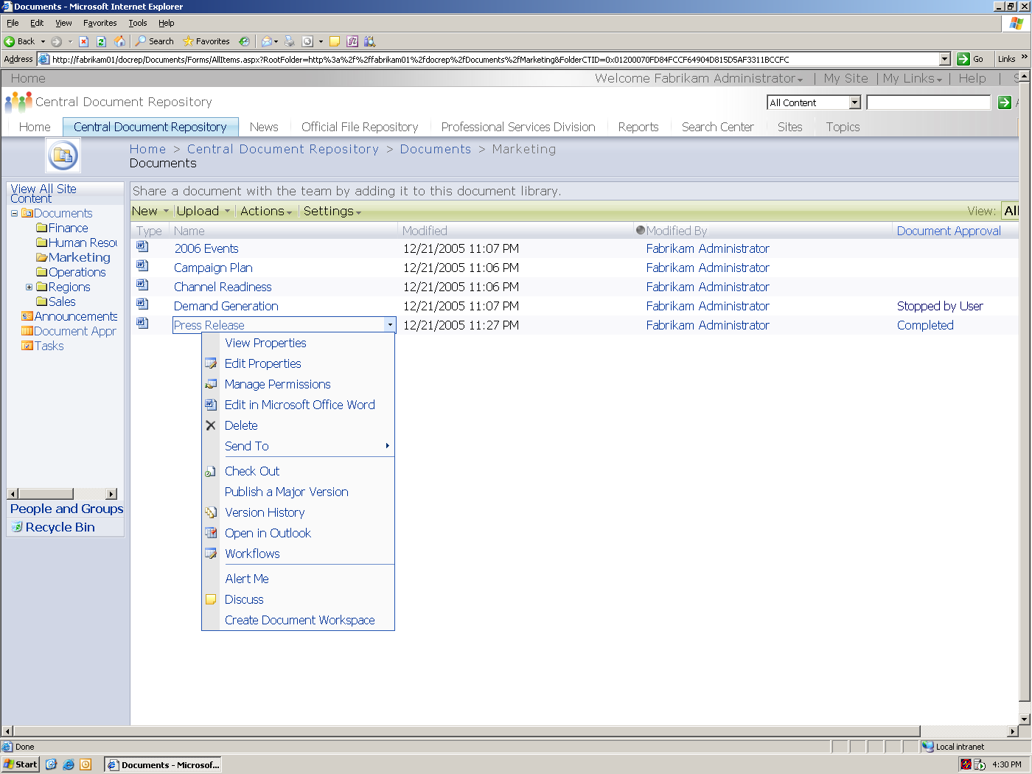

Screenshot showing a managed document repository, which is the central location for storing organizational content.

However, the only way for this process to be successful is if the end users consistently enter the metadata that is defined for a particular content type. To help users do this, a customizable Document Information Panel is shown at the top of the document that allows for entry of metadata and other pertinent information as required by that content type.

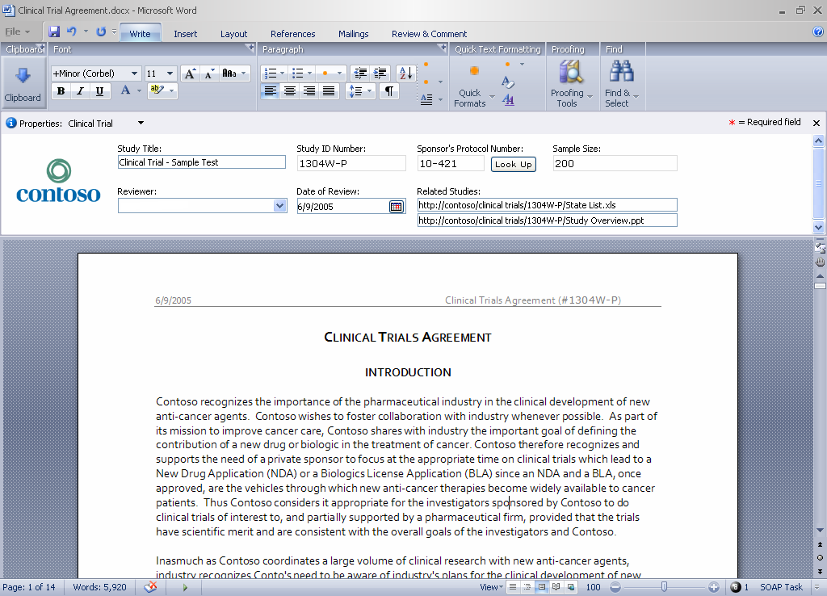

Screenshot showing how end users can easily enter metadata from within Microsoft Office Word 2007

Find and retrieve relevant information
One goal of moving information into a managed environment is to allow users to easily find the relevant information they need to facilitate the re-use of knowledge in an organization. The Microsoft ECM offering has an integrated search engine that uses the latest search algorithms from Microsoft Research to return fast and relevant search results. Users can find information not only from Microsoft’s content repository, but also from multiple sources such as ERP systems and file shares, by using advanced, full-text search from within their integrated organizational portal. This search can include results for various file types and data sources using extensibility mechanisms, and cannot only find information/data, but also the relevant people who are experts in the search topics. These “experts” are found and organized by their degrees of separation from the user based on the user’s known contacts.

Allow for structured document authoring
The ECMA Office Open XML format supported by the 2007 Office system client software, combined with the server-side functionality for specifying content types, gives an organization the ability to set up an environment for authors to create documents with a consistent look and feel, while at the same time facilitating re-use of content. The ECMA Office Open XML format enables an organization to define templates using an XML schema that is most suitable for their business requirements. This schema can consist of tags that correspond to various sections of a document, such as <Executive Summary/>, <MainBody/>, and <Conclusion/>. A template for a particular type of document is created by referencing this predefined XML schema and creating the presentation and layout for the various sections of the document. This template is then associated with a content type, along with associated workflow and information management policies in the document library. When an author initiates a new document of this type, he or she is presented with the template created as above and can use this template to author the document.
This approach also allows an organization to control which fields in the document can be modified, and which are protected from changes (for example, legal disclaimers). Re-use of content is possible because the content is automatically tagged with the appropriate XML code and can be programmatically processed for document assembly, distribution, and conversion.

Collaborate on documents
When multiple authors are likely to be working on the same document, check-out and versioning features are helpful for smoothing out collaboration. The Microsoft ECM solution facilitates collaboration on documents by enabling library functions such as check-in/check-out and major/minor versioning. Requiring authors to check out a document before making changes ensures that everyone collaborating on a document knows who is making edits at any given time.
With major and minor versioning, authors can distinguish a major revision that includes substantive changes from a minor revision of only spelling and wording. The compare versions feature adds further checks to this process by allowing users to compare the differences between any two versions of a document. Item-level security ensures that appropriate rights (e.g., modify, read, and so forth) are given to the various people who are collaborating on the document.
In order to facilitate collaboration, several out-of-the-box workflows are available. These include the approval/review and signature collection workflows. To initiate a review or approval process, an information worker selects the appropriate workflow from the File menu within Microsoft Office Word 2007 and fills out the form to indicate who should participate in the workflow and how long they have to complete the workflow task. This process posts the document to the server if it is not already stored there, creates a task for each of the participants, and sends them an e-mail notification to let them know about the task. When participants receive a notification and open the document, they can click the workflow task in the document and fill in the review or approval completion form. As the workflow proceeds, the organizer can track its progress on the status page.

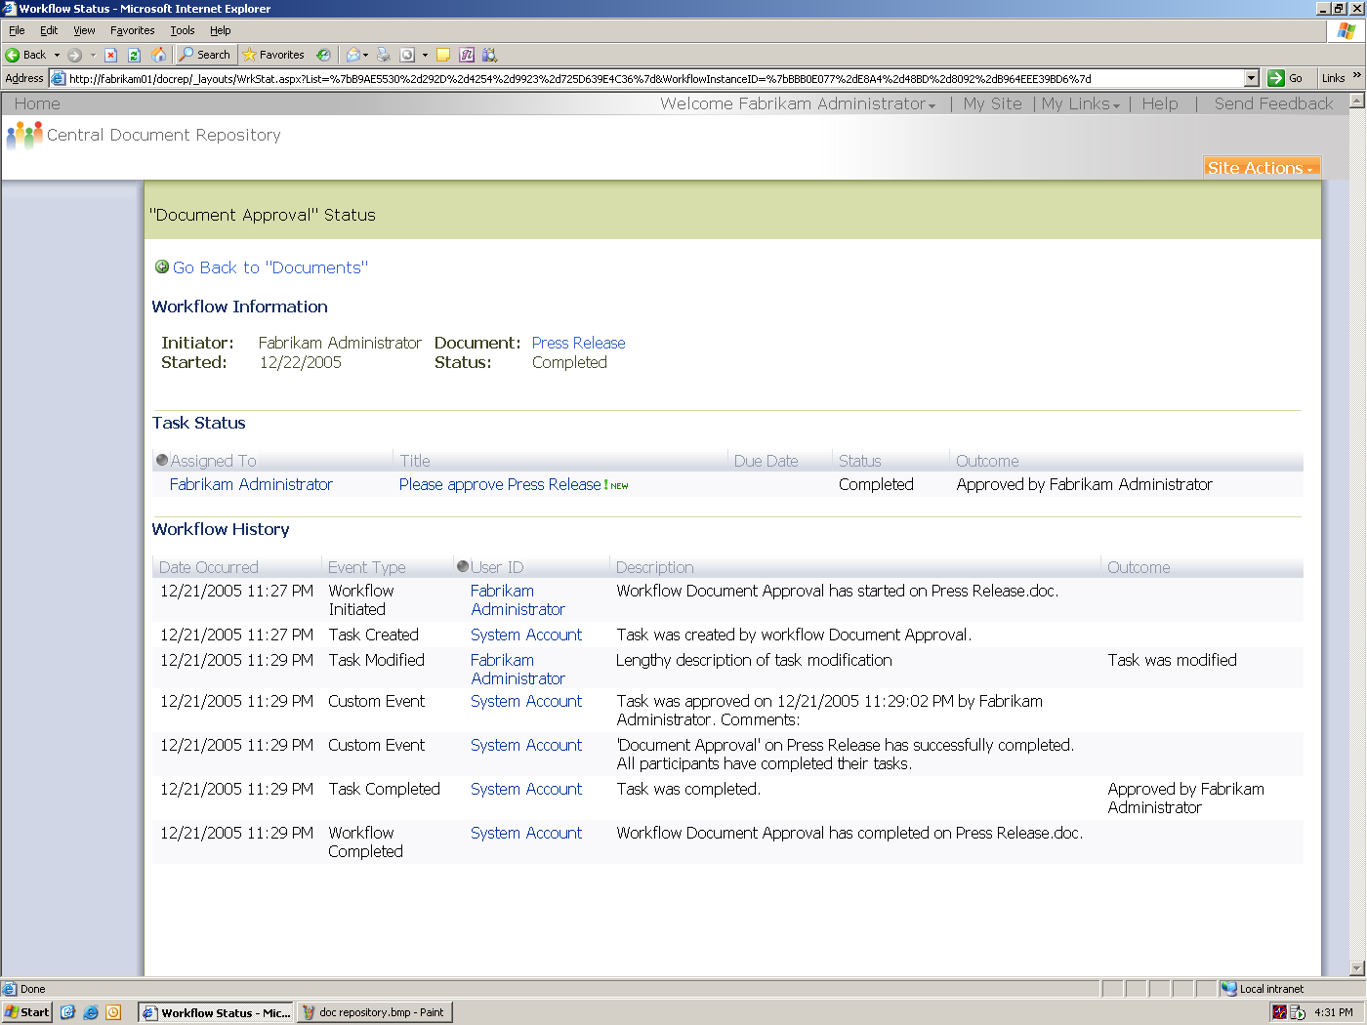

Screenshot showing the tracking of a review/approve workflow.

Set policies to audit usage and track information
When documents leave the repository—for example, as paper printouts or individual files distributed through e-mail—it is important that contextual properties be included in those documents. Labeling and bar code policies enable users to reference important information, such as approvals and associated documents, right from within a document. Label policies can be set to specify which document properties should be included in the label and how the label should be formatted. When a user authors a document that is subject to those policies, the Office application inserts the label directly into the document content and updates the label as needed when the properties change.
Microsoft document management solutions help users close the loop between managed documents and printed copies by automatically assigning individual bar codes to documents. When users work with printouts of documents that include bar codes, they can easily locate the original document by searching for the bar code. After they have retrieved the original, they can determine whether their printed copy is out-of-date or read additional document information stored in the SharePoint library.
For many organizations, it is critical to be able to audit and record events that occur with the content in the organization’s document management server. Microsoft’s document management solution provides several features that enable companies to create and analyze audit trails for their ECM systems, starting with audit policies and a robust audit log that records events, such as when content is viewed, edited, published, and so on. Site administrator actions can also be audited to keep track of local changes to computer configurations that could potentially be used for malicious activities. Reporting on audit logs can help organizations to verify and document regulatory compliance or investigate potential concerns.
It is challenging to implement consistent information management policies across a broad organization with a wide variety of sites. To help organizations overcome this challenge, Microsoft allows policy decision makers such as IT staff, records managers, or compliance officers to define site policies that information workers can apply without worrying about the specific details of the policy.
While the out-of-the-box policy features support many common policies, organizations can have unique needs that require additional policy features. For example, an organization might have a policy that requires files to be saved in a specific format. The policy framework allows organizations and independent software vendors to author custom information management policies that will appear on the policy settings page.

Protect information
In order to protect information in a repository, library owners can set specific security permissions on individual folders or files to ensure that only authorized people have the right to view, change, or delete content from this library. In order to protect documents once they have left the repository (for example when someone downloads a file to their laptop), administrators can set an Information Rights Management (IRM) policy on a library that gets applied to a document when it leaves the repository. This ensures that sensitive formation is not inadvertently sent outside the organization or stolen from a laptop. In some cases, content such as spreadsheets can be protected so that only “published” portions are available via a Web browser. In this way, information that needs to be shared, such as a table, chart, or graph, can be broadly shared while still protecting the confidential information contained within the spreadsheet.

Automate business processes
The Microsoft ECM offering automates business processes by providing workflow capabilities that are integrated with the content repository and forms capabilities. Tasks can be created and assigned to participants with notification to alert them about the task. Participants can follow the progress of a workflow by checking the status page associated with the workflow. In addition to standard status information such as outstanding tasks, the status page also includes history information that is specifically designed by the workflow author. Organizations can create custom workflows using tools such as Microsoft Visual Studio 2005 or Microsoft Office SharePoint Designer 2007, which is the successor product to Microsoft FrontPage®. After a workflow is deployed to a site collection, it appears in the list of workflows that list administrators can add to content types, lists, or libraries. When a workflow is added to a document library or list, the workflow is then available so that users can start the workflow for any item in that list. More information on the workflow foundation capabilities can be found on http://msdn.microsoft.com/windowsvista/

Records Management
Records management has long suffered from being marginalized as a secondary task. Only now, with the need to ensure compliance with government regulations such as the Sarbanes-Oxley Act, are organizations starting to prioritize this important aspect of the business cycle. Imperatives in this area include the need for clearly assigned records management responsibility overall and within departments, the need for continuously updated records that minimize outdated information within the organization, and of course, the ultimate need to maximize transparency and protect the organization from audit and legal worries. Finally, a good records management policy ensures the preservation of vital company information in the case of disaster.
The following sections describe the records management capabilities provided in Office SharePoint Server 2007.

Categorize and organize incoming records
Office SharePoint Server 2007 has ample tools to organize records once they are in the system. After records managers define the file plan for the organization, they can specify the metadata, workflow, and policies required to manage different record types. Document libraries define the organization and hierarchy in which electronic files of all types—including documents, e-mail messages, pictures, and media files—are stored. Content types are also used here to provide a consistent mechanism to describe the properties, policies, and workflows for a specific type of item. In order to properly classify incoming records, records managers can add an item to the record routing list for each record type, specifying the content type, description, storage location, and aliases of other content types to be treated as this kind of record. Incoming records are checked against this table and routed to the appropriate location. These records are also checked for completeness of metadata, prompting the sender to enter this metadata if it is found missing.

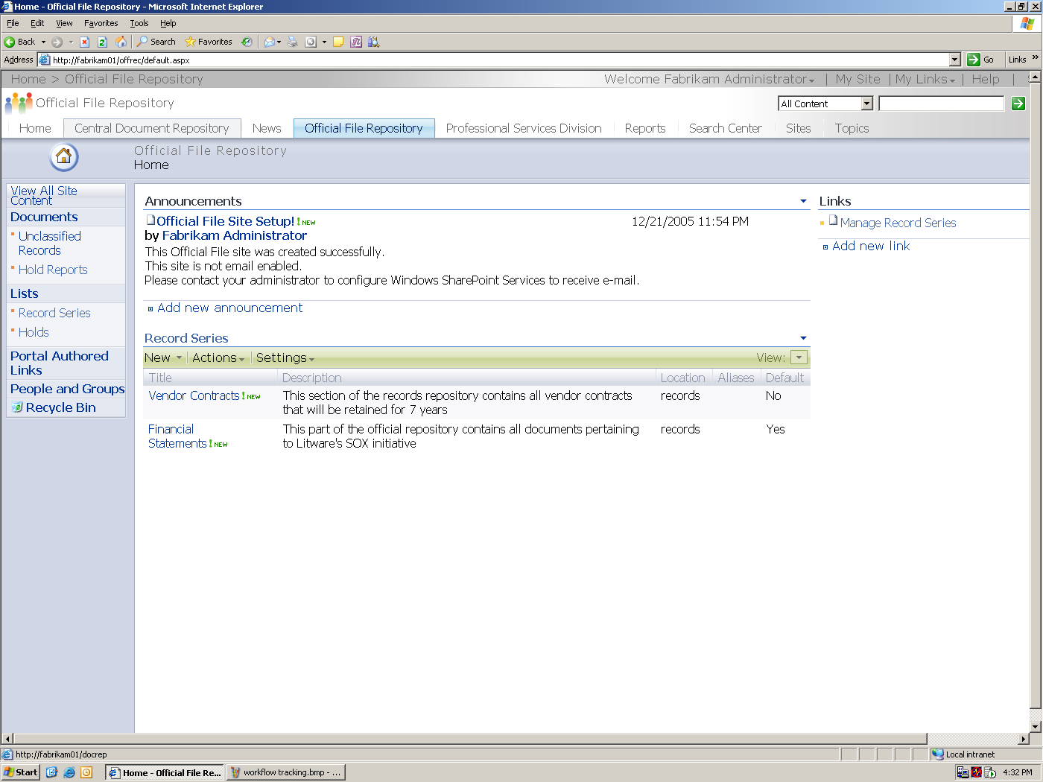

Screenshot showing an organization’s official records repository.

Protect business records
The records repository template has several features that ensure the integrity of the files stored within it. First, it ensures that records are never automatically modified by the system; this means that records uploaded to a records repository and then downloaded again later will always be identical. Second, it has default settings that prevent direct tampering of records, by versioning any changes made to document contents and by auditing specific types of changes. Default permissions are also in place to ensure that only records managers have delete rights, and even this act is audited. Third, it allows records managers to add and maintain metadata on items separately from the record’s metadata, so that information, such as ownership, can be changed without modifying the underlying record.

Manage retention schedules of different record types
Once the organization determines the retention schedules of the various business records, retention policies can be set within the repository to manage their life cycle. An expiration formula calculates the length of time to retain a record, and an expiration action describes what to do with the record when it reaches its expiration date. For example, an expiration action called “Approve this item for destruction” triggers a workflow designed to allow human review of expired items to determine whether those items should be deleted. Extensibility mechanisms can be used to implement additional actions such as “Move to a permanent archive” once a record retention period is reached. Policies can be configured for a specific storage location, or content types can be used to manage each type of record in a consistent way, independent of storage location. For example, to ensure that all contracts are retained uniformly in an organization, their expiration dates can be based on a common property such as the contract execution date.

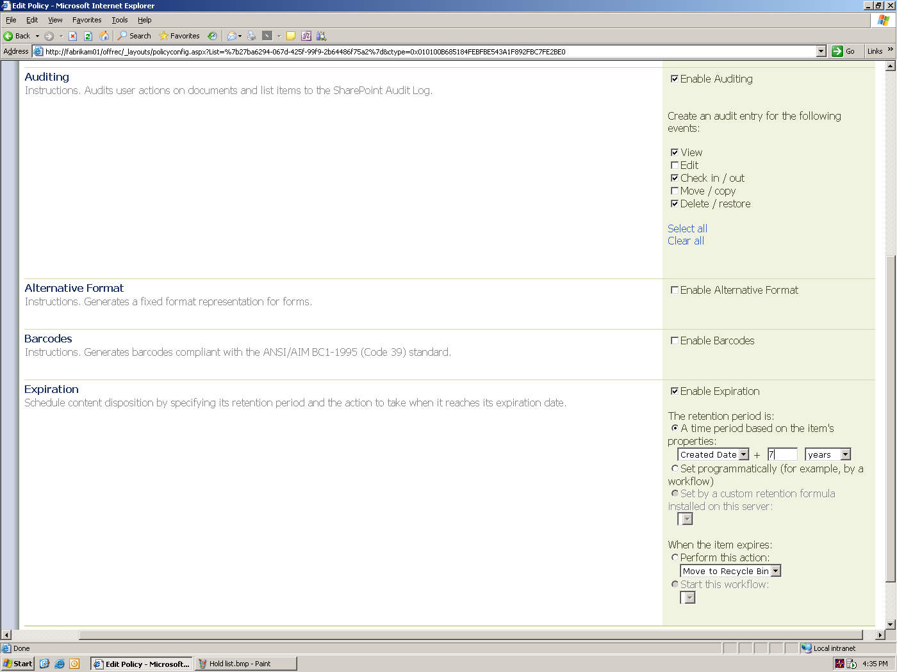

Screenshot showing the policies that can be applied to manage the content life cycle.

Manage e-mail as records
In order to help users declare e-mail messages as records using the familiar Office Outlook 2007 client software, Office SharePoint Server 2007 and Microsoft Exchange Server 2007 have been tightly integrated. IT departments can create organizational folders in Exchange Server 2007 that map to business functions which can then be pushed out to a user’s Outlook 2007 client using Group Policy. Users can simply drag and drop e-mail messages into these folders from their client computer, causing Exchange Server 2007 to auto-copy those e-mail messages to Office SharePoint Server 2007. Any missing metadata is checked for, and the user is alerted via e-mail to fill in the missing information.

Manage legal discovery
A hold feature is designed to respond to events such as litigation by superseding the expiration policy of specified records appropriately to ensure that they could not be deleted manually or automatically during the lifespan of the events. By default, every records repository is provided with a hold list in which each item corresponds to a single hold order. The list provides tools for finding and holding relevant records, viewing the records that are currently on hold, and releasing the hold after the hold order is no longer active.

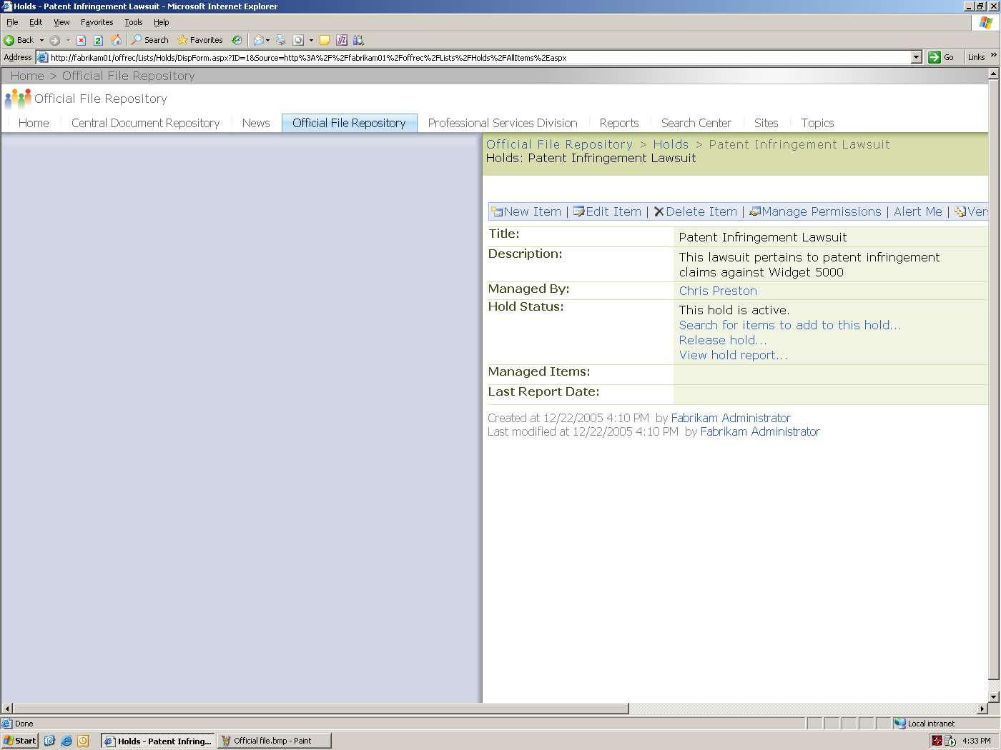

Screenshot showing a hold list created for a particular litigation.

Audit and report on repository usage
In the Microsoft records management solution an auditing policy is turned on by default, and incoming records from the document management repository bring in auditing history. Policy usage reports based on the Office Excel 2007 programs summarize the current state of the records management program, including a list of the full set of record types as defined in a records repository, and the number and relative percentage of items of each type. The records manager can review each report and verify whether the current usage aligns with expectations.

Message Archiving
For organizations with fewer than 5,000 users, Exchange Hosted Archive offers an alternative approach, delivering the message archiving solution as a service. The service is delivered with no additional hardware and software expenses for the customer. Additionally, the service-based solution transfers the burden of application support to Microsoft rather than a company’s IT staff, resulting in lower costs to the customer organization and better use of IT resources. Exchange Hosted Archive captures and makes copies of each message without any latency so that it can be immediately archived and indexed. This is a critical point to note, as it opens up significant archiving opportunities that resolve many of the requirements for an effective message archiving solution. Exchange Hosted Archive allows for real-time message services, such as spam filtering, virus scanning, and policy enforcement, ensuring that only legitimate and clean messages are stored in the archive and delivered to the organization’s e-mail system.

The following diagram shows how Exchange Hosted Archive works in conjunction with the Exchange Hosted Filtering service to copy and archive messages after they have passed through the upstream spam, virus, and policy filters:

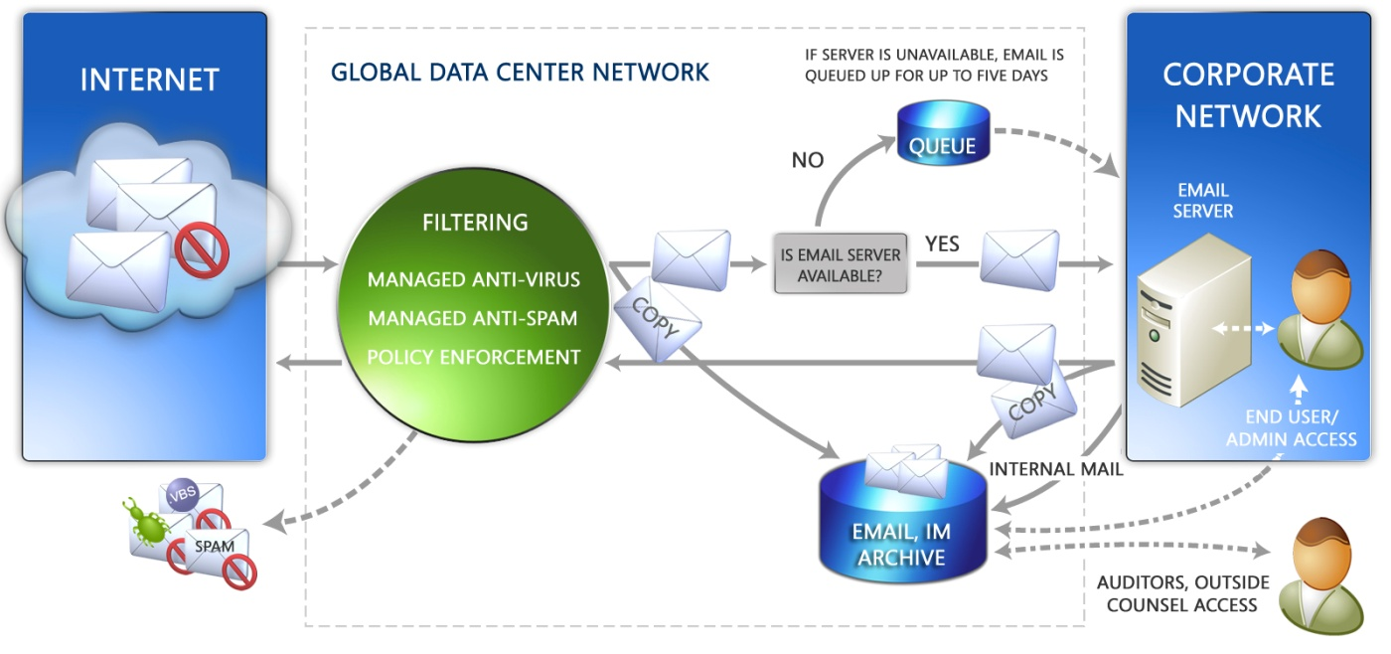

Exchange Hosted Archive captures messages “in stream,” which allows message filtering—such as spam filtering, virus scanning, and policy enforcement—to be performed prior to archiving, improving the efficiency of archiving operations and eliminating unwanted content from the archive.

Conducting audits and reviews are necessary steps in the regulatory compliance process. Exchange Hosted Archive delivers a set of pre-defined reports along with the ability to create customized reports in support of supervisory responsibilities. For example, Microsoft includes a Supervisory Evidentiary Review report to allow supervisors and compliance managers to document and monitor compliance and attest to their adherence to regulations.

Web Content Management
The major goal of the Microsoft Web content management system is to help businesses effectively communicate with employees, partners, and customers; to project a consistent corporate brand; and to put publishing power into the hands of business users. The Microsoft Web content management solution enables organizations to easily manage multiple Web sites and content for multilingual sites and mobile devices, while ensuring that these sites can be updated in a timely manner.
The following sections describe the Web content management capabilities provided in Office SharePoint Server 2007.

Author Web content
Microsoft’s Web content management solution has a rich, Web-based WYSIWYG (what-you-see-is-what-you-get) editor with support for tables, and tools for checking spelling and choosing images. Authors can link to high-value, reusable HTML fragments which serve as the building blocks that allow Web design novices to easily assemble pages. Users can author content within the context of the Web page which allows them to view the content layout as they edit it.
Users can also choose to author content from within the familiar Microsoft Word environment. The system can apply server-side conversion to convert this content into HTML. The product ships with an out-of-the-box converter for Word documents and provides a framework for plugging in other types of converters.
Because Web content management functionality is provided on a unified Microsoft SharePoint Products and Technologies foundation, library functions are available to users to allow them to check in and check out Web pages to ensure that only one person is working on a particular Web page at a time. Versioning is also enabled to facilitate collaborative creation of quality content. Out-of-the-box workflow support for multi-step parallel and serial approval with e-mail similarly allows content creators to enable the desired level of scrutiny on content and to preview it before it goes live to the site.
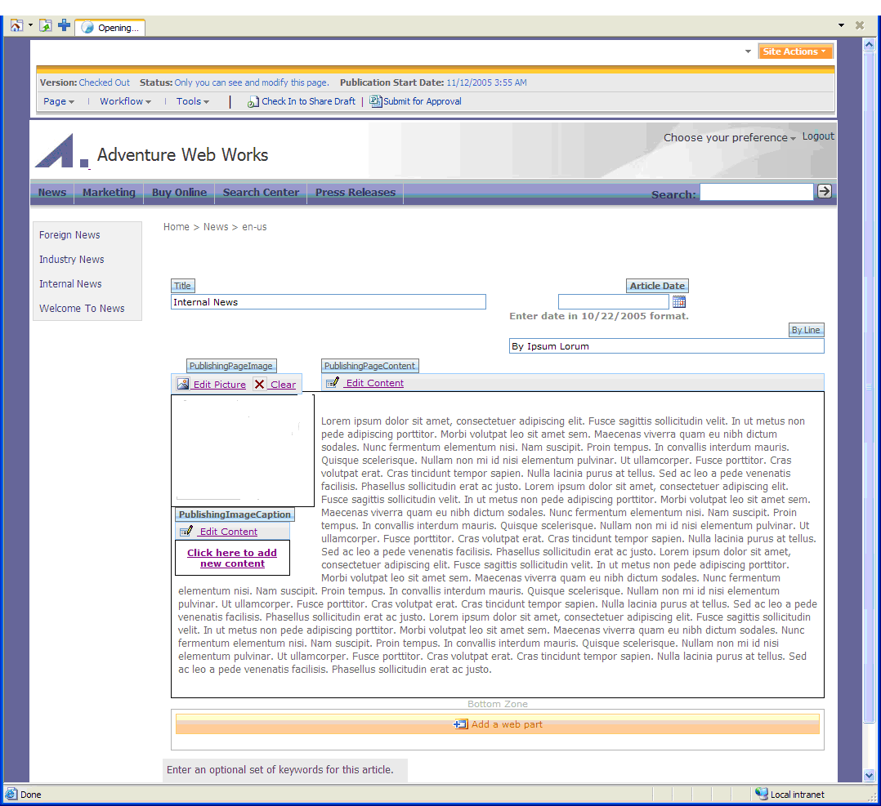

Screenshot showing in-place content authoring on a Web site.

Control content presentation and navigation
The Microsoft Web content management solution gives organizations full control over how information is presented on intranet, extranet, and Internet sites. This includes completely customizable page layouts, which give flexibility over presentation, as well as customizable Microsoft ASP.NET Master pages for navigational flexibility. Navigation controls are provided out-of-the-box, and their behavior can be customized to meet specific needs. For instance, users can use the navigation configuration user interface to configure whether or not this site inherits its global navigation or section navigation from its parent Web site, what sorting mechanism will be used for the sub-items of this Web site, and whether or not to include pages in the set of objects shown in the navigation controls. In addition to displaying the site’s logical Web hierarchy as navigation, it is often useful to be able to display ‘authored links,’ or one-off links that a Webmaster or author added manually. To support this, the system provides a means to create one or more authored links that will show up as additional navigation links. Completely customizable Cascading Style Sheets (CSS)–based styling of all aspects of the site provides further control over the look and feel.
In order to preserve Web site branding, the system provides a way to separate the page content from the page layouts so that users can focus on creating the best possible content without having to worry about the final look and feel. The system automatically combines the content with the layout to generate the final page to be displayed. Since users will need multiple templates with different features (for example, a product page that always requires an associated image versus a press release page that never requires an image), the system supports multiple page layouts to allow for different page types and content to be published into a fixed layout, with appropriate navigation infrastructure and styling.

Publish content to intranet, extranet, and Internet sites
A multi-stage publishing model provides authors with a simple way to publish content to multiple Web sites: site managers can set up automatic publishing of pages to the Web site from the staging system at regular intervals. A Quick Deploy capability is also enabled, which allows authors to immediately move content from staging to production without requiring emergency help from IT. This is particularly useful for content such as breaking news which needs to be published immediately.
The system also provides a consistent mechanism for publishing content to various types of sites, be they divisional or enterprise portals, extranets, or Internet sites. Tight integration with portal functionality in Office SharePoint Server 2007 ensures a straightforward publishing experience. Authors, site managers, and IT administrators have a common set of tools for creating and managing content for these different types of sites and do not have to deal with disparate systems.

Manage variations of content for languages and devices
The Microsoft Web content management solution includes a site-variation management system that enables users to manage the site in several forms, publish in multiple languages, and push content to mobile devices. Sets of related, but translated content hierarchies support this multilingual site capability. In this site-variation management system, site managers can define a series of site variations and mark one such variation as the source variation. Changes to the source variation can be automatically or manually propagated to target variations. This ensures that changes that are made in the sources are properly reconciled in all other variations. A built-in translation workflow is initiated when the source document is created or changed, which triggers an action for someone to translate the contents of the related pages.

Manage site content and deployment
A new Site Manager console provides a File Explorer–like view of the site content. Site managers can use this console to perform batch actions (such as, submit for approval) on a large number of items, as well as run reports across multiple sites in a particular site collection (for example, to see what content is currently checked out). The console is also the place to administer site settings, and to move or copy content between sites.
The goal for content deployment is to manage environments where distinct authoring and production are required. Content deployment is modeled around the idea that a single source site collection can deploy content to one or more destination site collections. A content deployment path defines the relationship between a source and a destination site collection. The source and destination can be in the same server farm, or in different server farms. A site collection can have many outgoing paths. Each path has one or more jobs that define the schedule and scope of individual deployment operations, giving administrators a high degree of flexibility over how deployment is accomplished. By default, deployment jobs operate incrementally, copying only content that has changed since the last successful deployment.

Deliver content to Web users
Organizations can quickly establish a Web presence via starter templates for Internet and intranet sites. To provide an optimal view of the site for users, personalization is enabled, which allows users to have a different experience of the site based on their credentials. Caching provides high rendering performance for Internet sites and features integration with ASP.NET output caching, memory-based object caching, as well as disk-based caching of large content elements such as pictures and documents. A scalable search system allows users to easily find information that has been published to the site. Built-in support is allotted for anonymous access.
For secured sites, forms-based authentication is supported against a variety of membership systems. Out-of-the-box support is provided for Microsoft Active Directory® directory service, Active Directory Application Mode (ADAM), as well as for the Lightweight Directory Access Protocol (LDAP). Integration with additional membership systems is possible using the ASP.NET membership provider model, which Office SharePoint Server 2007 uses as its extension mechanism. The SharePoint 2007 authentication services support Web-based single sign on to ensure that SharePoint deployments using clustered Web front ends achieve higher performance and reliability.

Forms Management
Forms are a key component of any business process and are typically used to capture and validate the data driving the process. They usually hide the complexities of the business process that sits behind it.
The following sections describe the forms capabilities provided in Microsoft Office Forms Server 2007.

Help users to reach more customers, partners, and suppliers
Organizations can create forms that can be filled out using a variety of Web browsers, allowing a large number of people to initiate a business process such as filling out a loan application or entering a customer service request. This can happen via the Internet, extranet, or intranet.

Streamline forms-driven business processes
Once the forms have been filled out with the required information, they can be submitted to various systems for processing. These systems include SharePoint libraries and Web services connected to line-of-business (LOB) systems such as those from SAP and Oracle. The forms can be associated with workflows configured in the SharePoint document library that initiate the business process on the form. Deep integration with Office Outlook 2007 allows forms to be easily exposed in e-mail messages, and data is entered by users directly from the Outlook environment. Form properties can be exposed in Office Outlook 2007 to allow for sorting, filtering, and categorization of these types of e-mail messages.

Design, deploy, and centrally manage forms solutions
Organizations can convert existing forms in Microsoft Office Word 2007 and Excel 2007 to the Microsoft Office InfoPath® 2007 information-gathering system format, thereby jumpstarting the forms solution design process. Users can employ pre-designed template parts to ensure consistency across all form solutions, and use preconfigured data connections to speed up forms solution design. Users are also enabled to easily deploy and upgrade forms solutions by using centralized management tools, which helps maintain a centralized form solution repository.

Conclusion
As enterprise content management becomes a top priority for CEOs and IT executives alike, Microsoft is making an important commitment to ECM solutions.
Microsoft’s vision is to ensure that customers derive the most value from their content and their people, by supporting the entire content life cycle from creation through collaboration, management, publication, re-use, archiving, and expiration.
Microsoft is assuming a role as a leader in the next generation of integrated user-oriented ECM systems that finally break down the barriers to broad ECM adoption. By prioritizing ECM in Office SharePoint Server 2007 and integrating its comprehensive solution with familiar environments, such as Outlook 2007, Word 2007, Microsoft Office PowerPoint® 2007, and Excel 2007, Microsoft is providing companies with an intuitive solution that results in less training time for users and a reduced burden on IT. With an integrated platform that shares common tools, this solution can be easily deployed and managed by the IT department, resulting in further IT cost savings.
In considering the special needs of each ECM component—document management, records management, Web content management, and forms management—Microsoft is providing organizations with an overall solution that addresses a number of use cases out-of-the-box, thereby reducing the time it takes to see a return on investment.
While Enterprise Content Management may seem like a daunting task at first glance, organizations will learn that the Microsoft ECM offering can easily become integral to business processes and a valuable contributor to business success.

Appendix: Microsoft’s ECM Partner Strategy
Microsoft will continue to invest in and add strength to the overall platform by incorporating core services and infrastructure. At the same time, Microsoft is working closely with its solutions partners to help them continue to provide vertical solutions that add value to the Microsoft platform.

The following ECM capabilities/functions are provided by Microsoft partners:
- Imaging – including batch and high-volume scanning, Optical Character Recognition (OCR), and Intelligent Character Recognition (ICR).
- Taxonomy management – tools for managing enterprisewide metadata.
- Archiving – for long-term storage and e-mail journaling.
- Content integration – the ability to search third-party content repositories and move items to/from Office SharePoint Server 2007 and third-party repositories.
- Digital Asset Management – including management of large digital assets such as digital videos, very large digital images, and other large digital objects.
- Vertical and compliance-specific business solutions – vertical solutions for key markets such as Finance, Legal and Professional Services, Government, and Utilities; compliance solutions for Sarbanes-Oxley, HIPAA, and others.

This is a preliminary document and may be changed substantially prior to final commercial release of the software described herein.
The information contained in this document represents the current view of Microsoft Corporation on the issues discussed as of the date of publication. Because Microsoft must respond to changing market conditions, it should not be interpreted to be a commitment on the part of Microsoft, and Microsoft cannot guarantee the accuracy of any information presented after the date of publication.
This white paper is for informational purposes only. MICROSOFT MAKES NO WARRANTIES, EXPRESS OR IMPLIED, IN THIS DOCUMENT.
Complying with all applicable copyright laws is the responsibility of the user. Without limiting the rights under copyright, no part of this document may be reproduced, stored in or introduced into a retrieval system, or transmitted in any form or by any means (electronic, mechanical, photocopying, recording, or otherwise), or for any purpose, without the express written permission of Microsoft Corporation.
Microsoft may have patents, patent applications, trademarks, copyrights, or other intellectual property rights covering subject matter in this document. Except as expressly provided in any written license agreement from Microsoft, the furnishing of this document does not give you any license to these patents, trademarks, copyrights, or other intellectual property.
© 2006 Microsoft Corporation. All rights reserved
The example companies, organizations, products, domain names, e-mail addresses, logos, people, places, and events depicted herein are fictitious. No association with any real company, organization, product, domain name, e-mail address, logo, person, place, or event is intended or should be inferred.
Microsoft, Active Directory, Excel, FrontPage, InfoPath, PowerPoint, SharePoint, the Office logo, Visual Studio, and Windows are either registered trademarks or trademarks of Microsoft Corporation in the United States and/or other countries.
All other trademarks are property of their respective owners.

