

Windows Server 2008 R2 File Services

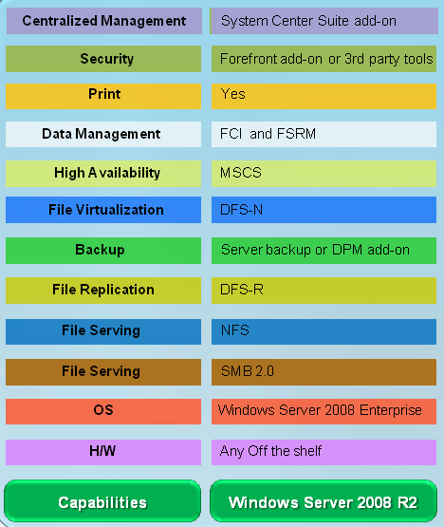

**Windows Server for File Serving Needs**

One of the biggest challenges that IT admins face today is the exponential growth in file storage needs. This trend is the result of numerous business drivers such as regulatory requirements to retain data and increased levels of digitization of content. IT budget cuts have forced CIOs and system admins to manage and deal with this data growth with reduced staff. Enterprises are looking for new and additional ways to cut costs.

Windows Server 2008 R2 offers a cost effective, enterprise ready file serving platform for Windows and mixed environments. It offers an abundance of capabilities that have been requested over the years by IT organizations. Organizations can leverage the extensive file-serving, data management and data protection capabilities found in Windows Server 2008 R2.By adopting Windows Server 2008 enterprises can achieve significant savings on Management, Operations and acquisition costs. This results in the total cost of ownership of the entire file infrastructure.

In some of these cases, IT organizations may look to proprietary NAS solutions targeted at a small or medium business. Instead of deploying these types of solutions, these organizations would be better served by leveraging the extensive file-serving, data management and data protection capabilities found in Windows Server 2008 R2. Windows

**File Serving with Windows Server 2008 R2**

Windows Server 2008 R2 includes numerous enhancements that are directly targeted at increasing the performance, reliability, security, and usability of file serving. Some of the examples include:

**SMB 2.1**

Computers running Windows use a protocol called Server Message Block or (SMB), to share files. (This is also called Common Internet File System or CIFS). SMB 2.1 is the new version of the Server Message Block protocol that ships with Windows Server 2008 R2 and Windows 7. SMB 2.1 further enhances the SMB 2.0 protocol, which was introduced in Windows Server 2008.

Improvements in SMB 2.1 include

* A larger buffer size that can greatly increase file transfer speeds thereby offering improved performance.
* Utilizing network resources more efficiently compared to SMB 1 protocol by reducing the number of roundtrips required to service a request
* Ability to “pipeline” (concurrent I/Os) allowing to perform better over slower WAN connections.
* Caching file data on client even if the file is opened by multiple applications enabling clients to hold on to cache data
* Handles brief network interruptions better than previous versions using a new feature called “durable file handles” that are designed to sustain short network disconnects.

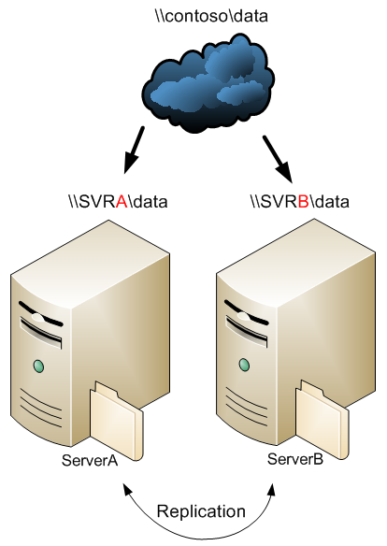**Distributed File System (DFS-N and DFS-R) Improvements**

DFS-N simplifies the management of multiple file servers by aggregating file shares located in different file servers under a single logical folder. DFS-N provides location transparency and redundancy to improve data availability during failure or heavy load scenarios by allowing shares in multiple different locations to be logically grouped under one folder. DFS-R offers file replication capabilities that support remote differential compression to minimize network bandwidth.

Windows Server 2008 includes several new benefits for DFS-R implementations, including an increase from 4 to 16 in the limit of concurrent transfers, as well as asynchronous I/O and improvements to shutdown procedures. Windows Server 2008 also includes additional replication-specific features including performance enhancements and the ability to force a replication to occur immediately. DFS solution in Windows Server 2008 R2 further builds on the enhancements in Windows Server 2008 by enabling support for read only replicas and replication in clustered environments.

**Network File System (NFS)**

Windows Server 2008 R2 offers NFS capabilities that provide a simple and easy-to-use file serving solution for mixed environments. Improvements in Windows Server 2008 R2 include

unmapped user name mapping that eliminates need to configure Unix-to-Windows account mappings for Unix user access

Enhanced sec

Windows Server 2008 R2 also offers enhanced flexibility by providing more than one native method to access the same data - either through SMB for Windows Clients, and NFS for Unix Clients.

**File Classification Infrastructure (FCI) New!**

CIOs are facing increased regulations and data leakage concerns. Managing storage resources is no longer just about the volume or availability of data anymore—it’s also about the enforcement of company policies and knowing how storage is utilized to enable efficient utilization and mitigate risk.

With the introduction of FCI feature in Windows Server 2008 R2 administrators will be able get to the heart of these challenges with built-in, end-to-end data management solution. FCI provides insights into your data and helps manage your data more effectively by automating manual processes with predefined policies based on the data’s business value.

**File Server Resource Management Tools (FSRM)**

Windows Server 2008 R2 also includes a set of tools that offer quota, file screen and report management. These tools can generate a variety of reports on utilized storage, such as the number of duplicate files that are stored and a report of large files. There is also support quota management and real-time file screening to halt the storage of illegal content.

**BranchCacheTM New!**

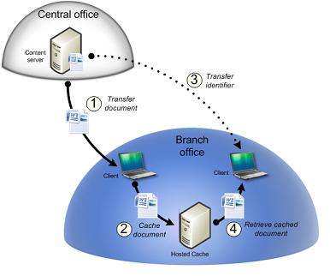Driven by challenges of reducing cost and complexity of Branch IT, organizations are seeking to centralize applications. A direct result of centralization is the increased utilization of the WAN link, and the degradation of application performance. The BranchCache feature in Windows Server 2008 R2 and Windows 7 Client reduces the network utilization on WAN links that connect branch offices and improve end user experience at branch locations, by locally caching frequently used content on the branch office network.  As remote branch clients attempt to retrieve data from servers located in the corporate data center, they store a copy of the retrieved content on the local branch office network. Subsequent requests for the same content are served from this local cache in the branch office, thereby improving access times locally and reducing WAN bandwidth utilization between the branch and corpnet.

**Offline Files**

This feature, in previous releases of Windows, was known as Offline Folders or Intellimirror. Windows Server 2008 R2 significantly improves offline file support with features such as a cached online mode, whereby read operations go to the local cache and write operations go to the cache and the server endpoint. Other changes include better handling of per-user encryption and synchronization, support for differential transfers of large files such as PSTs, and seamless offline and online transitions.

**To learn more about how Windows Server 2008 R2 help   
meet your file serving needs, visit** [www.microsoft.com/windowsserver.](http://www.microsoft.com/windowsserver.)