Windows Azure
Customer Solution Case Study
 |  |  |   Job-Listing Web Site Scales Up Solution, Reduces Costs by More Than U.S.$500,000

Overview  Country or Region: Mexico  Industry: Online job board  Customer Profile  A full service job-listing Web site based in Mexico, OCCMundial.com gathers more than 15 million unique visitors and posts more than 600,000 positions at more than 7,000 companies each year.  Business Situation  To scale up its OCCMatch algorithm to match more resumes and job listings, OCCMundial.com needed to increase its computing capacity while avoiding the costs of expanding its physical infrastructure.  Solution  After evaluating solutions from Google and Amazon, OCCMundial.com decided on the Windows Azure™ operating system to host OCCMatch on the Internet in Microsoft® data centers.  Benefits  - Easy scalability  - Reduced costs  - Enhanced customer value |  |  | “With Windows Azure we’re saving up to $400,000 in hardware costs, plus at least a couple hundred thousand dollars for the staff that it would take to run that infrastructure.”  Eduardo Pierdant, Chief Technical Officer, OCCMundial.com
 |  |  | The job-listing Web site OCCMundial.com connects job seekers with opportunities and optimizes hiring processes for businesses. Headquartered in Mexico City, OCCMundial.com helps to fill more than 600,000 positions a year in Mexican and international job markets. To provide better value to its customers, the company developed a recommendation system it calls OCCMatch to match job openings to candidate resumes. OCCMundial.com wanted to scale up its OCCMatch recommendation system to connect 1.5 million resumes with 80,000 job listings, but its existing computing infrastructure lacked capacity to meet the demand. To avoid significant hardware and other infrastructure costs, OCCMundial.com used the Windows Azure™ platform to host OCCMatch through a Microsoft® data center, providing easy solution scalability and enhancing value for OCCMundial.com customers.
 |  |  | 

Situation
Headquartered in Mexico City, OCCMundial.com provides an online link between job seekers and opportunities, while optimizing hiring processes for businesses. The largest online job site in the Mexican employment market, OCCMundial.com has internationalized its job listings through its association with DirectEmployers.com and JobCentral.com, both based in the United States. OCCMundial.com gathers more than 15 million unique visitors annually, and posts more than 600,000 positions each year at more than 7,000 companies inside and outside of Mexico.

OCCMundial.com is built on Microsoft® ASP.NET technology and hosted through the company’s own data center, an infrastructure of several dozen physical servers running on the Windows Server® 2008 operating system and using Microsoft SQL Server® 2005 data management software to manage core content information on the site.
“For OCCMatch to grow like we expect it to, we would have had to expand our current infrastructure at least tenfold. It would be almost impossible to do that cost-effectively.”
Eduardo Pierdant, Chief Technical Officer, OCCMundial.com

The company developed visual search features based on the Windows® Internet Explorer® 8 Internet browser, using the Microsoft Silverlight™ 2.0 browser plug-in on the home page to display job listings. On the site home page, job seekers can search through and apply for more than 65,000 open job opportunities every day. On separate pages, candidates can post resumes, and hiring managers can post listings and search resumes.

To better connect applicants and opportunities, the company launched a recommendation system called OCCMatch, an algorithm that uses data mining and other models to match job openings to candidate resumes based on parameters such as location, job requirements, skills, and education. In the first three months after the launch, the OCCMatch recommendation system helped 45,000 users, matching resumes and job opportunities more than 10,000 times every day.

Although OCCMatch worked successfully, constraints in computing and storage capacity limited the recommendation system’s power. The company needed to scale up OCCMatch to connect as many as 1.5 million resumes and 80,000 job opportunities; to do so, it would need significantly more computing and storage capacity than it had available. “For OCCMatch to grow like we expect it to, we would have had to expand our current infrastructure at least tenfold,” says Eduardo Pierdant, Chief Technical Officer at OCCMundial.com. “It would be almost impossible to do that cost-effectively.”

OCCMundial.com knew that OCCMatch would help to differentiate its services and provide better value for its customers. It needed to expand OCCMatch while avoiding the costs associated with developing and managing a complex technology infrastructure. At the same time, it wanted to empower its developers to continually enhance the algorithm and deliver even more detailed job matches.

Solution
OCCMundial.com elected to deploy OCCMatch using a MapReduce framework, a software framework originally introduced by Google and widely used on the open source community, which supports parallel distributed computing of large data sets on clusters of computers. The company planned to host the framework on an external, Internet-based network, an application delivery system sometimes referred to as “cloud computing.”

After evaluating several cloud computing solutions, including Google App Engine and Amazon Elastic Compute Cloud (EC2), OCCMundial.com chose the Windows Azure™ cloud services operating system. Windows Azure is a development, service hosting, and service management environment hosted on the Internet in Microsoft data centers.

The company had developed the OCCMatch recommendation system with the Microsoft Visual C#® development tool using the Microsoft Visual Studio® development system, so OCCMundial.com developers could easily implement and scale OCCMatch in the Windows Azure environment. “We are very used to Visual Studio,” says Eduardo Flores, Development Manager at OCCMundial.com. “Developing for Windows Azure is almost the same as what we were already doing.”
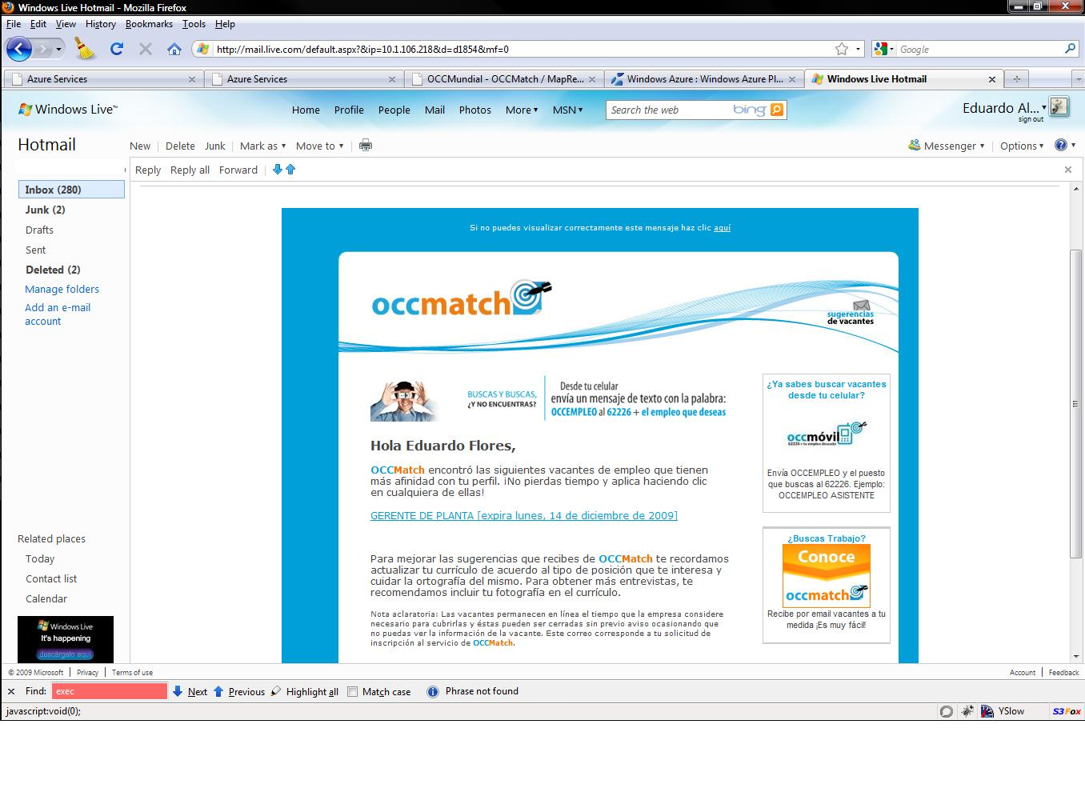

OCCMundial.com is using a software-plus-services model to connect OCCMatch with the Web site. For its Web site infrastructure, the company has deployed Windows Server 2008, SQL Server 2005, and Silverlight 2.0 in its on-premises data center, and it is using Windows Azure computing and storage resources to run the OCCMatch algorithm.
“With the computing power of Windows Azure, we can provide better service for more customers than we ever could with our current infrastructure.”
Eduardo Flores, Development Manager, OCCMundial.com

Running as many as 200 instances of Windows Azure simultaneously, OCCMundial.com can execute millions of OCCMatch operations in parallel—with as much processing power as needed. The system compresses and uploads files to a Blob Storage container, and then it selects information from resumes and job listings to be processed based on specific criteria.

The resulting matches are distributed to other parts of the Web site, and e-mail alerts are automatically sent to job applicants or hiring managers (Figure 1). With the vast computing power and high availability of Windows Azure, OCCMundial.com can process up to 1.5 million resumes two to three times per week.
Figure 1 – When the OCCMatch recommendation system connects job openings to candidate resumes, match alerts are automatically sent to job applicants or hiring managers by e-mail.

Benefits
By hosting its OCCMatch recommendation system with Windows Azure, OCCMundial.com has enhanced its ability to provide better service to more customers, without having to face challenges such as hardware costs or infrastructure reliability. The company can scale up OCCMatch easily and efficiently, enhance the job-seeking and recruiting experience for its customers, and reduce costs, even as the computing requirements of its solution grow.

Easy Scalability
When it was hosted on-premises at OCCMundial.com’s data center, OCCMatch could compute 25,000 resumes against 20,000 job offers. Using Windows Azure, the company can now run OCCMatch up to three times a week and match up to 1.5 million resumes against 80,000 job offers. And with the ability to easily scale up computing capacity, the company has the flexibility to enhance the OCCMatch algorithm.

Reduced Costs
With Windows Azure, OCCMundial.com expects to avoid more than U.S.$500,000 in capital investments and infrastructure support costs. The company can pay for storage and computing power as it needs it, rather than maintaining a peak-load infrastructure that would be underutilized during off-peak periods.

“With Windows Azure we’re saving up to $400,000 in hardware costs, plus at least a couple hundred thousand dollars for the staff that it would take to run that infrastructure,” says Pierdant. “We can use that investment instead to focus on product development.”

Enhanced Customer Value
Instead of working on infrastructure and scalability issues, OCCMundial.com can focus on developing a more complex algorithm, which will provide more targeted matches between resumes and job listings. That will improve the job candidates’ experience and reduce hiring time and costs for recruiters. “With the computing power of Windows Azure, we can provide better service for more customers than we ever could with our current infrastructure,” says Flores.

Windows Azure Platform
The Windows Azure platform provides an excellent foundation for expanding online product and service offerings. The main components include:
For More Information
For more information about Microsoft products and services, call the Microsoft Sales Information Center at (800) 426-9400. In Canada, call the Microsoft Canada Information Centre at (877) 568-2495. Customers in the United States and Canada who are deaf or hard-of-hearing can reach Microsoft text telephone (TTY/TDD) services at (800) 892-5234. Outside the 50 United States and Canada, please contact your local Microsoft subsidiary. To access information using the World Wide Web, go to:
www.microsoft.com

For more information about OCCMundial.com products and services, visit the Web site at:
www.occ.com.mx

Additional Resources:
View: Download: Windows Azure Platform Training Kit

View: Architecting and Developing for Windows Azure

This case study is for informational purposes only. MICROSOFT MAKES NO WARRANTIES, EXPRESS OR IMPLIED, IN THIS SUMMARY.

Document published November 2009

Software and Services  - Windows Azure  - Blob Storage  - Microsoft Visual Studio  - Microsoft Visual C#  - Microsoft Visual Studio | - Technologies  - Microsoft ASP.NET

- Windows Azure. Windows Azure is the development, service hosting, and service management environment for the Windows Azure platform. Windows Azure provides developers with on-demand compute and storage to host, scale, and manage Web applications on the Internet through Microsoft data centers. In addition, Windows Azure serves developers’ connectivity needs through the following services.
- The Service Bus connects services and applications across network boundaries to help developers build distributed applications.
- The Access Control Service provides federated, claims-based access control for REST Web services.
- Microsoft SQL Azure. Microsoft SQL Azure offers the first cloud-based relational and self-managed database service built on Microsoft SQL Server 2008 technologies.

To learn more about the Windows Azure platform, visit:
www.windowsazure.com

