Customer: Egyptian Ministry of Communications and Information Technology
Web Site: www.mcit.gov.eg
Customer Size: 1,000 employees
Country or Region: Egypt
Industry: National Government Agencies

Customer Profile
Established in 1999, the Egyptian Ministry of Communications and Information Technology has helped to expand and strengthen the nation’s telecommunications and IT capabilities.

Software and Services
- Software
- Bing maps for enterprise
- Microsoft Office SharePoint Server 2007
- Microsoft Silverlight
- Services
- SharePoint Deployment Planning Services
- Enterprise Search Deployment Service for Microsoft Office SharePoint Server 2007
- Enterprise Content Management Deployment Service for Microsoft Office SharePoint Server 2007

Microsoft Services
As the consulting, technical support, and customer service arm of the world’s leading software company, Microsoft Services enables the successful adoption, deployment, and use of Microsoft solutions and technologies for all customers.

For more information about Microsoft Services, go to:
www.microsoft.com/microsoftservices
“Microsoft is among the world leaders when it comes to experience building portals.”
Dr. Hoda Baraka, First Deputy to the Minister, Egyptian Ministry of Communications and Information Technology


Business Needs

Situated on the site of Thebes, the ancient Egyptian capital, the modern city of Luxor incorporates roughly one-third of the world’s ancient monuments into what many consider the world’s largest open-air museum. Each year, thousands of tourists from all over the world visit Luxor, but the city wanted to further increase awareness about lodging, recreation, and shopping and make it easier for prospective visitors to plan their trip.

“At a time when people are travelling less, they want to make better choices and know more before they travel,” explains Dr. Samir Farag, Governor of the City of Luxor. “We wanted to give people a comprehensive source of information about Luxor before they travel here, with the goal of increasing our share of the tourism to the region.” Besides drawing more tourists, the city also wanted to bolster the confidence of potential investors about the opportunities available in Luxor for constructing hotels and resorts and investing in agriculture and industry.

Solution
To meet these needs, Luxor partnered with the Egyptian Ministry of Communications and Information Technology (MCIT) to build a Web portal that used the latest technologies to attract potential visitors. The Egyptian MCIT contracted Microsoft® Services and Microsoft Gold Certified Partner LINK Development for a custom engagement to help create the portal.

“The Luxor portal is part of a broader effort by the Egyptian government and private sector to increase competency in digital technologies and employ them in building up industry in Egypt, including tourism and Web development,” says Dr. Hoda Baraka, First Deputy to the Minister for the Egyptian MCIT. “We collaborated with Microsoft Services on over 20 portals in the last few years because of their world-class skills and experience. Microsoft is at the forefront of what is possible with interactive maps and virtual experiences online.”
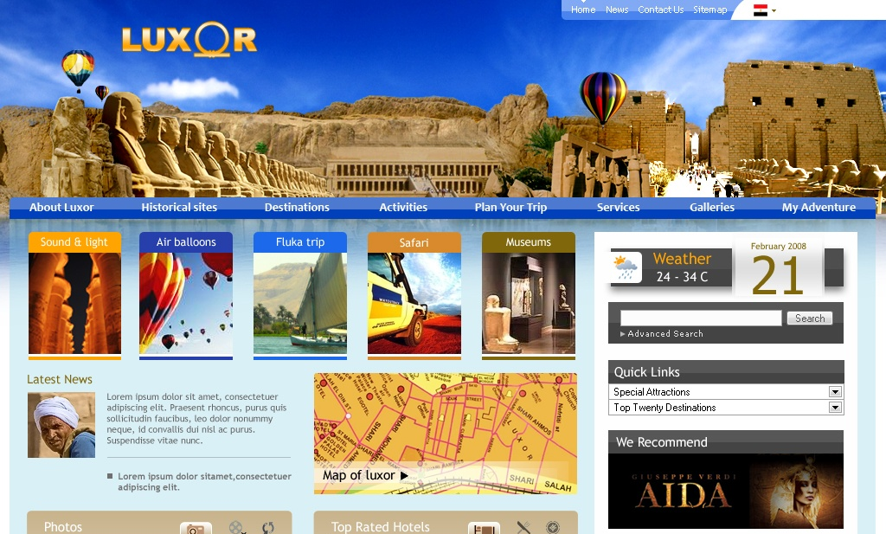
With help from Microsoft Services, the portal team implemented the technology infrastructure and led the planning, design, and development phases. Local partners, including the Egyptian Ministry of Culture and American University in Cairo, provided assistance in compiling the content, including detailed mapping information for the city. Microsoft Services coordinated all these efforts, provided access to software resources, and spent time training local partners in how best to use the Microsoft products and technologies involved. In all, the team included over 30 consultants from local partners and six Microsoft experts.

The portal is the first official city tourism site in all of Egypt and is accessible at www.luxoregypt.org. Visitors to the portal can search a full and official directory of activities, businesses, and antiquities either through traditional navigation or through an interactive map service. The map service provides visitors with unique, intuitive controls, including the ability to display the locations of different categories of amenities, such as ATM machines, restaurants, antique bazaars, museums, and tourist agencies.

Photo and video galleries on the site feature immersive sights and sounds from the Valley of the Kings, Valley of the Queens, Temple of Karnak, and Temple of Luxor. The portal team also incorporated social media aspects into the portal, enabling registered visitors to rate offerings and provide feedback. People who have completed their visit are encouraged to share photo albums of their trip. Currently, the site content is in English, but the portal team is developing Arabic and French versions and planning for German, Japanese, Russian, and Spanish versions.

Benefits
By working with Microsoft Services, Luxor City and the Egyptian MCIT gained a trusted advisor with deep experience building portals based on the latest Web technologies, including Microsoft Office SharePoint® Server, Bing™ maps for enterprise, and Microsoft Silverlight™.

“Microsoft is among the world leaders when it comes to experience building portals,” says Baraka. “In addition, Microsoft Services demonstrates accountability to customers and partners by honoring commitments, providing results, and always striving for the highest quality.”

Access to the Latest Web Technologies
With advice from Microsoft Services, the portal team learned how to best employ leading Web technologies, such as optimized delivery of photos and videos with Silverlight. “The technologies used in the project not only provides our online visitors with a superior experience but also simplifies the administration and maintenance of the portal,” says Baraka.

Knowledge Straight from the Experts
Besides building up the tourism industry, the Egyptian MCIT sought Microsoft out for the project because it wanted to see important technical skills and expertise passed to local Egyptian partners. “Egyptian partners gained a wealth of experience through their engagement with Microsoft Services,” says Baraka. “Working with the latest Microsoft products and technologies is an asset to the industry and we value the partnership.”

Solid Foundation for World-Class Portal
The City of Luxor has received very positive feedback from local businesses and museums regarding the new portal, kindling hopes that tourism and investment will benefit. In addition, the successful launch has attracted the interest of cultural and archeological experts who would like to contribute to the portal’s already extensive content. “This portal built with the help of Microsoft Services provides tourists with an abundance of information that will help them plan their trip,” says Farag. “We are very happy at what Microsoft has helped us do here in Luxor. Everyone in the city thanks them.”

