# logo-sql08.gif

Microsoft SQL Server 2008 R2: The Best Data Platform on Windows Server 2008 R2

White Paper

**Writer:** Martin Ellis (Content Master)

**Technical Reviewer:** Sambit Samal

**Published:** January 2010

**Applies to:** SQL Server 2008 R2

**Summary:** Microsoft SQL Server 2008 R2 and Windows Server 2008 R2 work together seamlessly to provide a data platform that delivers a low total cost of ownership (TCO) and that is equipped to handle the needs of even the most demanding mission-critical applications. In a fast-evolving business environment, this combined platform provides the agility to enable businesses to quickly adapt to changing requirements, the reliability to maintain highly available service provision at scale, and a comprehensive range of tools, features, and functionality to increase IT efficiency and reduce management overhead. Only SQL Server 2008 R2 takes full advantage of the features and performance of Windows Server 2008 R2 to ensure that you get the maximum value out of your investment.

### **Contents**

Contents 1

Introduction 1

1. Reduce Overall TCO 1

1.1. A Unified Platform for Physical and Virtual Infrastructure 1

Enhancements to Hyper-V 2

Reduce Software Acquisition Costs 3

Reduce Licensing Costs and Promote Business Agility 3

Reduce Hardware Procurement and Management Costs 3

Reduce Skill Acquisition Costs 3

1.2. Consolidate Servers to Reduce Costs and Simplify Management 4

Consolidate with Hyper-V 4

Consolidate with Multi-Instance and Multi-Database Support 4

1.3. Leverage Built-in Features and Functionality 6

1.4. Improve Business Decision Making with Business Intelligence 6

2. A Mission-Critical Platform 6

2.1. Ensure Business Continuity and Minimize Revenue Loss 7

Clustering 7

Database Mirroring 8

Dynamic Hardware Partitioning 8

Hyper-V Virtualization Enhancements 8

2.2. Protect Business Assets with Integrated, End-to-End Security 8

Windows Integrated Authentication 8

Transparent Database Encryption 8

Secure Data as It Travels Over the Network 9

Ensure Regulatory Compliance 9

2.3. Increase Business Capacity by Scaling Up 9

Enhanced Hardware Support 9

Optimize Resource Usage by Using SQL Server Resource Governor 9

Data and Backup Compression 10

Increase Business Capacity by Scaling Up Using Virtual Servers 10

3. Optimize IT Efficiency 11

3.1. Manage Proactively 11

3.2. Built-in Administrative Tools 12

Windows Server 2008 R2 Server Manager 12

SQL Server Management Studio 13

Utility Control Point 13

SQL Server Configuration Manager 14

Hyper-V Management Console 14

Windows PowerShell 2.0 14

3.3. Manage Performance and Troubleshoot Effectively 14

Performance Data Collector 14

Windows Reliability and Performance Monitor 14

SQL Server Resource Governor and Windows System Resource Manager 15

SQL Server Profiler 15

3.4. Improve Deployment Efficiency 15

Build a Library of VMs Ready to Deploy 15

Speed Up Database Deployment 16

3.5. More Efficient Web Application Development 16

Conclusion 17

# Introduction

This paper describes the advantages of running the Microsoft® SQL Server® 2008 R2 data management software on the Windows Server® 2008 R2 operating system. It also explains how your organization can maximize its investment by combining these two industry-leading products to provide a low-TCO platform for mission-critical applications with enhanced end-to-end security, management, and development capabilities.

# 1. Reduce Overall TCO

Windows Server 2008 R2 and SQL Server 2008 R2 help you to minimize total cost of ownership (TCO) and maximize return on investment (ROI) for your data platform, while providing the flexibility and features to enable you to meet the challenges of an ever-changing business environment.

## 1.1. A Unified Platform for Physical and Virtual Infrastructure

With its potential for improving efficiency and reducing TCO, virtualization has emerged over the last few years as one of the key areas of change in the enterprise IT environment. However, as virtualization technology has been adopted by more and more organizations, new challenges have inevitably arisen alongside it, including extra software costs, increased IT complexity, and the corresponding need for staff training. These issues are due in part to the use of third-party virtualization products and a lack of integration between the physical and virtual infrastructures.

Windows Server 2008 R2 comes complete with Microsoft Hyper-V™ technology, a built-in virtualization platform that enables administrators to create high-performance, fully integrated virtualization infrastructures. By enabling you to use a single platform for your physical and virtual infrastructure, Hyper-V makes it possible to standardize and simplify your IT environment, which improves efficiency, increases business agility, and helps to drive costs down.

For example, Figure 1 shows a cost comparison for two virtualization solutions, one based on Microsoft Hyper-V and the other on VMware. You can see that the Microsoft solution can be up to six times less expensive than the equivalent VMware solution.

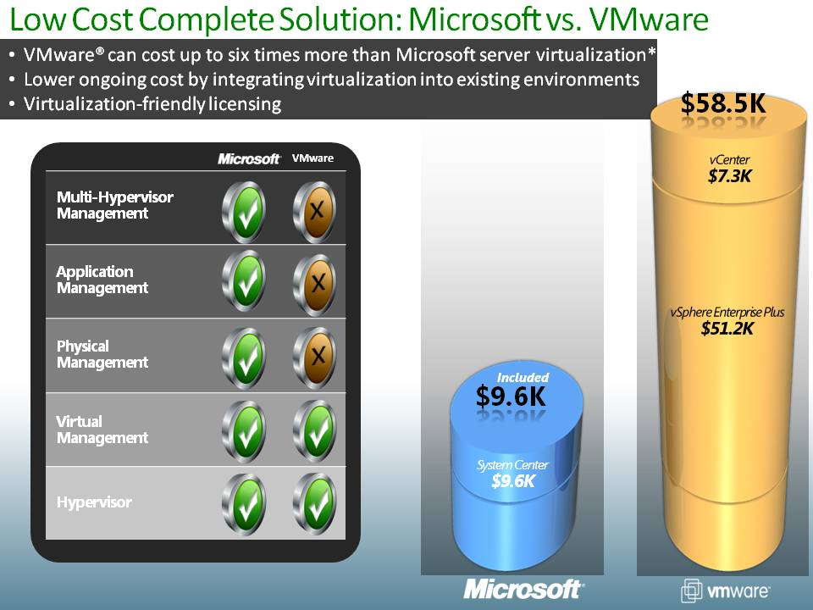

Figure1: Cost comparison of Microsoft virtualization and VMware virtualization

*Based on a comparison of Microsoft System Center Server Management Suite Datacenter with VMware vSphere Enterprise Plus and VMware vCenter Server. The comparison is based on a five-host configuration, with two processors per host, and it includes two years of support costs for each product. No operating system costs are included. The Microsoft solution can use either the free Microsoft Hyper-V Server 2008 R2 hypervisor or an existing Windows Server 2008 R2 hypervisor. Costs are based on Microsoft estimated retail prices and published VMware prices available at <https://www.vmware.com/vmwarestore> as of 08/04/2009 for purchases in the United States. Actual reseller prices may vary.

### Enhancements to Hyper-V

Building on the success of the original Hyper-V release, Windows Server 2008 R2 includes several significant new benefits and enhancements to the Hyper-V platform:

* **Live Migration**. Based on proven Windows Server 2008 failover clustering technology, Live Migration promotes high availability and reduces planned outages by making it possible to move virtual machines (VMs) between host servers without any perceptible interruption in service. In addition to ensuring maximum service availability, Live Migration enables you to optimize hardware resource usage by moving the VMs that host your SQL Server databases between host servers, so you can free up resources on one server, or take advantage of spare capacity on another, without incurring downtime.
* **Improved performance for VMs**. Hyper-V now supports up to 64 logical processors in the host processor pool, and improvements in VM networking, including VM chimney and jumbo frames, further boost VM performance.
* **Improved manageability for the virtual environment**. Manage Hyper-V through the Hyper-V management console and automate Hyper-V administrative tasks by using the Windows PowerShell™ command-line interface. System Center Virtual Machine Manager 2008 R2 is a comprehensive tool for centralized management of the virtual data center.
* **Improved scalability**. With up to 64 processors in the host processor pool, Hyper-V can scale to support more VMs running on the same machine. Additionally, as your databases grow, you can add virtual hard disk (VHD) storage for VMs dynamically, without the need for rebooting, which helps to minimize system downtime.

### Reduce Software Acquisition Costs

Hyper-V provides all of the features and functionality that you expect from an enterprise-class virtualization platform, and because it is a built-in feature of Windows Server 2008 R2, it eliminates the need to purchase third-party virtualization software. Furthermore, because of the deep level of integration of Windows Server 2008 R2 with SQL Server 2008 R2, your database applications can take advantage of the full range of functionality that Hyper-V virtualization offers, ensuring maximum ROI for your organization.

### Reduce Licensing Costs and Promote Business Agility

In a highly competitive environment, the ability to respond quickly to changing business needs is vital. Live Migration enables you to quickly move VMs between host servers, and Windows Server 2008 R2 and SQL Server 2008 R2 licensing conditions allow you to freely move VMs from one licensed host server to another, as and when required, without having to purchase additional licenses. For example, you can move a VM that supports a SQL Server reporting application to a higher-powered server at the end of the month (when large, complex reports may be generated), and then, after report generation is complete, move it back to a lower-powered server again, freeing up resources on the server for use by other applications.

### Reduce Hardware Procurement and Management Costs

Reduce physical server numbers and simplify management by converting existing physical servers to VMs that share a physical host server. Fewer servers mean lower purchase and maintenance costs, and you can make further savings by taking advantage of licensing conditions that allow you to convert from physical to virtual servers (and vice versa) using the same license, making the transition from a physical to a virtual environment more cost-effective.

### Reduce Skill Acquisition Costs

Using software products from different vendors to support your physical and virtual infrastructures increases the administrative burden and requires staff to be trained in each of the technologies that they use. Using a single platform based on Windows Server 2008 R2 and Hyper-V eliminates the ongoing costs of cross-training, and it enables administrative staff to focus on increasing their proficiency in the use of just this one platform, rather than dividing their efforts by learning about multiple technologies.

## 1.2. Consolidate Servers to Reduce Costs and Simplify Management

Typically, server consolidation involves reducing the number of physical servers in the enterprise, and Hyper-V helps you to achieve this by enabling you to run multiple VMs on a smaller number of physical host servers. SQL Server adds increased flexibility for consolidation efforts with support for the installation of multiple instances on a single physical server and multiple databases per instance.

The most immediately obvious benefit of consolidation is the reduction in hardware purchasing costs, but consolidating servers also offers the opportunity to make considerable savings in other areas, including reducing support, cooling, power, and server accommodation costs. Running fewer physical servers in a standardized environment can also simplify administration, freeing up key staff for other important tasks. Furthermore, because consolidation reduces power consumption, it can help organizations to achieve environmental targets. A data platform built upon SQL Server 2008 R2 and Windows Server 2008 R2 provides comprehensive support for server consolidation, ensuring that organizations are able to obtain the maximum benefit from the consolidation initiatives that they undertake.

### Consolidate with Hyper-V

At the core of most consolidation efforts is the change from a purely physical server environment to a mixed physical and virtualized server environment; Windows Server 2008 R2 Hyper-V offers the ideal platform for this. SQL Server 2008 R2 Enterprise licensing conditions enable you to install SQL Server database servers on up to four VMs on a single licensed host server, and SQL Server 2008 R2 Datacenter edition allows for an unrestricted number of virtual database servers on a single licensed host server. Additionally, application mobility enables you to transfer VMs and their corresponding licenses freely between host servers as and when required.

### Consolidate with Multi-Instance and Multi-Database Support

In addition to using Hyper-V, you can use SQL Server 2008 R2 multi-instance support to create multiple databases on a single instance of SQL Server, each of which can be managed and maintained separately. If you require applications to be isolated for reasons of security, the multi-database support included in SQL Server enables you to install multiple isolated SQL Server instances on a single physical or virtual server. Consolidation using VMs and multi-database support is illustrated in figure 2.

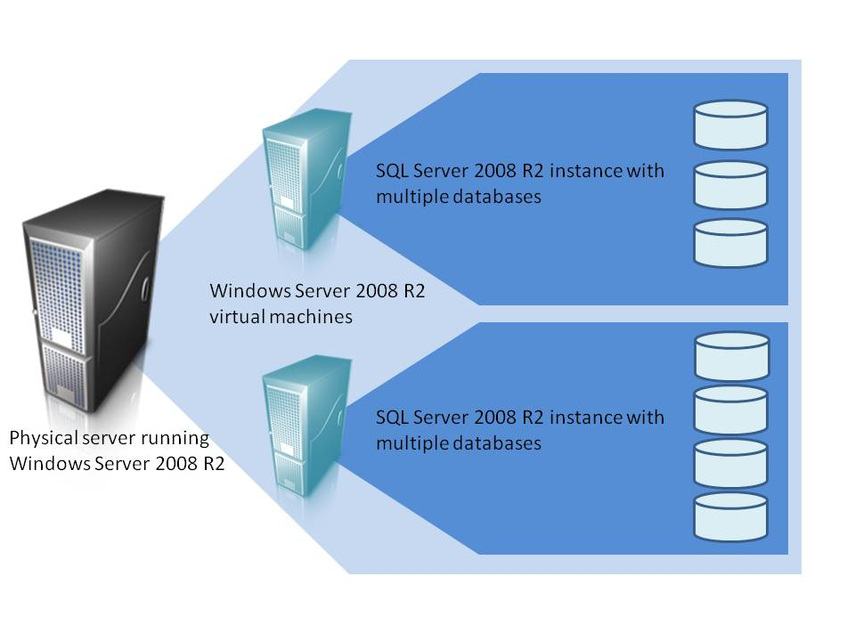

Figure 2: Consolidation using VMs and multi-database support

Although consolidation has demonstrable benefits, it also brings with it a fresh set of challenges, which Windows Server 2008 R2 and SQL Server 2008 R2 are fully equipped to handle:

* **Help ensure high availability**. Maintaining high availability is even more important when there are multiple applications running on each physical server, because any hardware failure has the potential to affect more of your services. Windows Server 2008 R2 and SQL Server 2008 R2 Enterprise support up to 16-node failover clusters and database mirroring to give you the coverage you need to maintain uninterrupted service.
* **Manage competition for resources**. When multiple applications share hardware, there is inevitably competition for resources. Built-in tools make it possible to balance resource usage so that applications can run on the same server without impeding each other’s performance; Windows System Resource Manager enables you to allocate CPU and memory resources to users and applications amongst the different processes (database instances) within the operating system, and SQL Server Resource Governor enables you to define CPU and memory consumption limits for competing workloads (databases) within the SQL Server instance.
* **Manage data storage**. Running more applications typically means generating more data. SQL Server 2008 R2 Enterprise provides data and backup compression to reduce the amount of space required to store your data, which can cut costs significantly. Furthermore, because compression has the added advantage of enhancing I/O performance, applications that use compression will perform better too. SQL Server 2008 R2 extends the compression capabilities of SQL Server 2008 by enabling the compression of UCS-2 Unicode data in addition to non-Unicode data, which is useful for organizations that need to store data in languages that use large character sets. The improved performance offered by data compression can positively impact consolidation efforts by enabling increased consolidation density in situations where I/O is a consolidation limiter.

## 1.3. Leverage Built-in Features and Functionality

Windows Server 2008 R2 and SQL Server 2008 R2 Enterprise provide a complete data platform package, with a comprehensive range of built-in tools and features at no extra cost. Therefore, there is no need to purchase add-ons or third-party products in order to obtain extra functionality, as there is with other database server products. Many of these features contribute towards further lowering TCO; data and backup compression, as previously discussed, reduce storage costs and boost performance, and the new Core Parking feature of Windows Server 2008 R2 automatically powers down CPU cores when workloads are light, helping to reduce power consumption. A comprehensive suite of management tools covers all aspects of database and server management, enabling efficient, centralized, and automated management of your infrastructure.

## 1.4. Improve Business Decision Making with Business Intelligence

In a competitive, fast-changing world, being able to make the right business decisions quickly, using up-to-date information, can mean the difference between success and failure. Windows Server 2008 R2 and SQL Server 2008 R2 provide the business intelligence (BI) functionality and enterprise scalability to deliver invaluable business insights that support the decision-making process and help organizations to spot new business opportunities.

Windows Server 2008 R2 and SQL Server 2008 R2 can scale to support very large data warehouses, and the new Fast Track Reference Architectures from key hardware partners including HP, Dell, IBM, and Bull make it faster and easier to build a high-performance data warehouse than ever before. The sophisticated built-in BI suite in SQL Server 2008 R2, which includes Analysis Services and Reporting Services, provides the tools and functionality to enable you to interrogate very large data stores using sophisticated data-mining algorithms to reveal hidden trends and patterns. You can then present key information in intuitive, eye-catching reports. New features such as PowerPivot for Microsoft Office Excel® 2010 and Report Builder 3.0 put the ability to access business information and create reports into the hands of everyone in the enterprise, and PowerPivot for Microsoft Office SharePoint® 2010 enables users to centrally store and share the reports that they create, so that they are available on demand whenever they are needed.

# 2. A Mission-Critical Platform

The features in Windows Server 2008 R2 and SQL Server 2008 R2 work together to provide a platform for mission-critical functions within your organization.

## 2.1. Ensure Business Continuity and Minimize Revenue Loss

Windows Server 2008 and SQL Server 2008 together provide comprehensive high-availability support to help to ensure that business operations are not interrupted in the event of hardware or software failure.

### Clustering

Unplanned database server downtime can occur because of hardware failures or natural disasters. Typically, organizations protect mission-critical servers from these kinds of failures by deploying server clusters. Windows Server 2008 R2 considerably simplifies the process of setting up and managing failover clustering with a wizard-based cluster validation tool, which helps to ensure that you have adequate hardware resources for a clustered solution.

Windows Server 2008 R2 Enterprise and Datacenter editions reduce the hardware and infrastructure requirements for clustering and support up to 16 nodes in a cluster, enabling you to achieve the highest levels of business continuity. Host Failover Clustering and Guest Failover Clustering extend the provision of clustering to the virtual environment:

* **Host Clustering**. Host Clustering protects against the failure of the physical host server by enabling all guest VMs to failover to another physical server.
* **Guest Clustering**. Guest Clustering provides failover for individual VMs and/or applications. With Guest Clustering, the guest VM represents a cluster node, and it can fail over to another guest VM in the event of the failure of an application or the guest operating system.

The new Cluster Shared Volumes (CSV) feature simplifies the configuration of clustered VMs.

Cluster Shared Volumes is available in versions of Windows Server 2008 R2 and Hyper-V Server 2008 R2 that include the Failover Clustering feature. Volumes that are configured as Cluster Shared Volumes can be accessed by all nodes of a failover cluster. Each node can open and manage files on the volumes. Therefore, different nodes can host different VMs that all have files on the same volume. This design has many advantages, including the following:

* **Easier storage management**. When VMs share volumes, fewer logical units numbers (LUNs) need to be configured and managed to host the same number of VMs.
* **Independent failover of VMs**. Although multiple VMs share the same volume, each VM can fail over, or be moved or migrated, independently of other VMs.
* **No drive letter restrictions**. Cluster Shared Volumes do not need to be assigned a drive letter, so you are not restricted by the number of available drive letters, and you do not have to manage volumes using GUIDs.
* **Enhanced availability**. The Cluster Shared Volumes feature detects and handles many problems that would otherwise cause the storage to be unavailable to VMs. For example, if Cluster Shared Volumes detects a connection problem, it reroutes storage access through another node.
* **Efficient use of storage**. You can make better use of disk space, because you do not need to place each VHD file on a separate disk with extra free space set aside just for that VHD file. Instead, the free space on a Cluster Shared Volume can be used by any VHD file on that LUN. This reduces the total amount of space that must be set aside for expansion and simplifies capacity planning.

### Database Mirroring

To provide greater protection for mission-critical data, SQL Server 2008 R2 implements database mirroring. This provides complete or nearly complete database redundancy in the event of a disaster or planned upgrade. Database mirroring provides a high-availability solution that does not require proprietary hardware, is easy to set up and manage, and provides automatic client redirection. SQL Server 2008 R2 Enterprise protects against page corruption by fetching the mirror version of a corrupt page from the mirror server automatically.

### Dynamic Hardware Partitioning

One significant cause of server downtime is planned maintenance, which typically results from actions such as adding or replacing memory, processors, or input/output devices (network cards and host bus adapters). Windows Server 2008 R2 supports dynamic hardware partitioning, which enables the ‘hot’ addition and replacement of processors and memory modules, without the need to restart the server. This ensures service continuity during hardware upgrades to servers that are running mission-critical SQL Server databases. It also enables mission-critical applications to scale without requiring any planned database server downtime.

### Hyper-V Virtualization Enhancements

The Live Migration feature discussed earlier allows you move VMs between host servers without service interruption, enabling you to carry out planned maintenance, or to move VMs to take advantage of spare capacity, while maintaining availability targets. Furthermore, Dynamic Virtual Machine Storage enables you to add virtual or physical disks to existing VMs without restarting them, so you can manage the growing volumes of data generated by your applications without compromising service continuity.

## 2.2. Protect Business Assets with Integrated, End-to-End Security

Windows Server 2008 R2 and SQL Server 2008 R2 together provide truly integrated end-to-end security to ensure that businesses are able to protect assets and achieve regulatory compliance.

### Windows Integrated Authentication

Windows integrated authentication is based on the tried and tested Kerberos protocol, and it restricts domain and SQL Server access to valid users only. As well as providing a robust first line of defense, Windows integrated authentication simplifies user password management for users, who only need to remember a single set of credentials. Administrators can fine tune the level of access any given user has to specific resources, such as databases or files, by defining permissions on those resources for individual users or groups.

### Transparent Database Encryption

You can prevent data that is stored on disk drives and backup tapes from being compromised if disks are lost or stolen by using Transparent Data Encryption (TDE) to encrypt data. TDE uses proven certificate-based technology to protect sensitive data and encryption keys, and because all encryption and decryption is done within SQL Server, it does not require the modification of any application code. For even greater levels of data protection, Windows Server 2008 provides enhanced Microsoft BitLocker® drive encryption technology that you can use to encrypt all of the hard disks within a computer. You can also reduce the overhead associated with managing cryptographic keys by taking advantage of support for third-party hardware key management modules.

### Secure Data as It Travels Over the Network

You can protect sensitive data as it is transmitted over the network by enabling the built-in Internet Protocol security (IPsec) in Windows Server to encrypt and digitally sign data. IPsec can encrypt any IP data, but to minimize the impact of IPsec on system resources, you can configure policies to specify that only certain types of network traffic should be encrypted, for example, traffic that uses a designated TCP port, or traffic between two named servers.

### Ensure Regulatory Compliance

Compliance is increasingly important to many organizations, especially those that are subject to legislation or industry codes of practice. Two central requirements for any compliance solution are the ability to log events comprehensively and securely and to be able to archive and view these logged events in a central repository.

SQL Server 2008 R2 includes the ability to audit all actions. SQL Server database administrators can log data access events to a file, the Windows Application log, or the Windows Security log. You can audit events with as much detail as you require at both the server and database level. You can also force specific actions, such as stopping the server if the log destination becomes inaccessible.

## 2.3. Increase Business Capacity by Scaling Up

The ever-increasing volumes of data generated by business activities, and the complexities of processing that data, mean that there is a constant pressure on IT departments to enable applications to handle more demanding workloads and deliver higher throughput. Windows Server 2008 R2 and SQL Server 2008 R2 provide the hardware support and management features to enable your organization to scale up enterprise applications without compromising performance and reliability.

### Enhanced Hardware Support

Enable enterprise scalability through improved hardware support that lets you to take advantage of state-of-the-art technology to host more applications, achieve greater throughput, and drive business growth. Windows Server 2008 R2 and SQL Server 2008 R2 support the following:

* Up to 256 logical processors
* Memory in excess of 2 terabytes
* Solid state disks (SSDs)

### Optimize Resource Usage by Using SQL Server Resource Governor

Enterprise applications that share hardware resources will frequently be in competition with each other for access to those resources. This situation typically results in levels of performance that vary unpredictably; for example, resource-intensive workloads may run periodically and dominate resources to the exclusion of other workloads until they have completed. To ensure that that mission-critical workloads run in a more predictable, reliable manner, you can use SQL Server Resource Governor and Windows System Resource Manager. Resource Governor enables you to define limits and assign priorities to individual workloads within a SQL Server instance. Workloads include factors such as users, applications, and databases. By defining limits on resources, you can minimize the occurrence of runaway queries and limit resource usage for workloads to prevent them from monopolizing resources. You can also set priorities to optimize the performance of a mission-critical process while maintaining predictability for the other workloads on the server. You can see some of the configuration options for Resource Governor in figure 3.

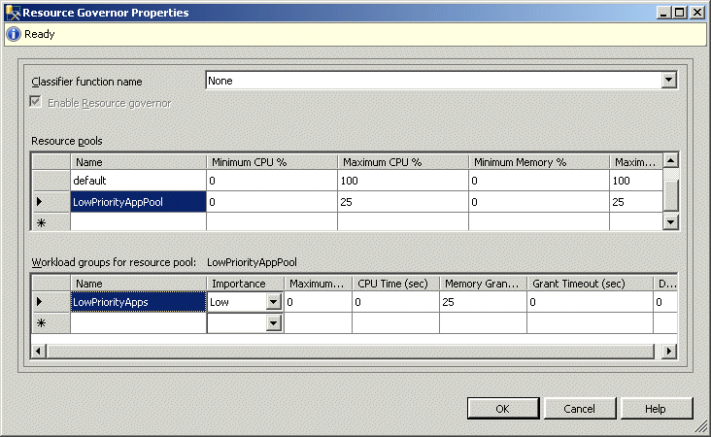

Figure 3: Resource Governor Properties dialog box

### Data and Backup Compression

As your data applications grow, the volume of data that you need to manage grows correspondingly, meaning that you need to provide increased storage space. Additionally, the more data servers process, the more performance will suffer as the required levels of throughput cannot be achieved. SQL Server data compression and backup compression enable you to significantly reduce the amount of storage required to handle the large amounts of data generated by enterprise applications, which translates into easier management and reduced costs. Furthermore, because data compression improves I/O throughput, it also provides better performance. SQL Server 2008 R2 extends the benefits of compression to USC-2 Unicode data, which can be highly beneficial for organizations that deal with international clients and need to store data in a number of different languages using different character sets.

### Increase Business Capacity by Scaling Up Using Virtual Servers

As organizations host more and more database applications on virtualized servers, levels of performance and scalability for these applications must be as close as possible to the levels that you would achieve if they were hosted on physical servers. Windows Server 2008 R2 and SQL Server 2008 R2 deliver performance for virtual environments that is comparable to that of the physical environment, with a range of enhancements that enable Hyper-V to fully exploit hardware resources:

* Scale up host servers to support virtual environments with the support in Hyper-V for up to 64 logical processors in the host processor pool.
* Improve response times for VMs by taking advantage of support for memory in excess of 1 terabyte.
* Reduce networking and I/O bottlenecks with enhanced networking and dynamic VHD I/O improvements.
* Take advantage of hardware advances. SQL Server and Hyper-V supports new hardware from AMD and Intel, such as Extended Page Tables (EPT), to provide better performance.
* Process workloads more quickly with improved VM performance and better memory management.

# 3. Optimize IT Efficiency

A database platform built on Windows Server 2008 R2 and SQL Server 2008 R2 is efficient to manage, so you can achieve higher productivity, improve service level agreement (SLA) compliance, and respond more quickly to the needs of the business. Built-in tools enable faster and better troubleshooting and help you to proactively address performance and compliance issues before they become bigger problems.

## 3.1. Manage Proactively

Windows Server 2008 R2 continues to support the proactive configuration management capabilities of Group Policy. This latest release has been enhanced to extend the configuration settings that can be enforced though Group Policy and to make it easier for administrators to configure Group Policy across the enterprise.

Policy-based management in SQL Server 2008 R2 uses the proactive configuration management capabilities in Windows Server 2008 R2 to define policies that apply to servers, databases, and other objects in your data environment. Well-defined policies can help you to control and manage change proactively within the data services environment. Policy-based management delivers the following benefits:

* **Management by intent**. Policies provide a logical view of the system configuration, which enables you to define the configuration of data services proactively, instead of making changes in response to issues when they arise.
* **Intelligent monitoring**. Policies can monitor and prevent changes to the system that deviate from the configuration you want.
* **Virtualized management**. With policy-based management, you can scale management across multiple servers, which simplifies enforcement of consistent configuration policies across the enterprise.

SQL Server 2008 R2 includes a number of predefined *facets*, which describe sets of configurable settings that relate to a specific aspect of a SQL Server policy-based management target (such as a server or a database). You can define *conditions* that specify the desired state of the settings in a facet and then create *policies* that determine how those conditions are enforced. SQL Server then checks policy compliance on demand or automatically on a scheduled basis. These policies can also reject or log noncompliant changes to targets. You can see some policy configuration options in figure 4.

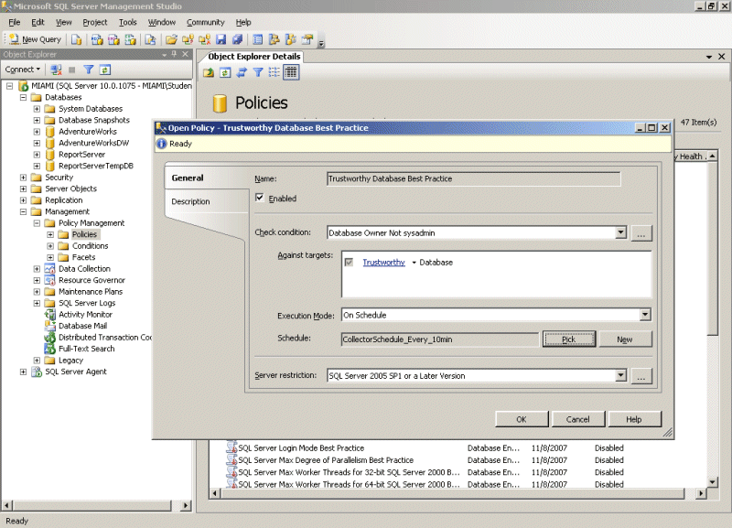

Figure 4: Policy-based management

## 3.2. Built-in Administrative Tools

Windows Server 2008 R2 and SQL Server 2008 R2 provide a comprehensive, built-in suite of tools that makes managing every aspect of the IT environment simpler and more efficient.

### Windows Server 2008 R2 Server Manager

Simplify managing and securing multiple servers roles across your enterprise. Server Manager provides a single location for managing server roles and system information and ensuring compliance with best practices. You can also use Server Manager to manage other servers remotely, from computers running Windows Server 2008 R2 or Windows® 7.

### SQL Server Management Studio

Reduce the effort required to configure, manage, and administer all components of SQL Server, and centrally manage multiple SQL Server instances. The new Utility Explorer and Utility Explorer Content tabs (Figure 5) enable improved centralized management through the provision of drill-down and dashboard views of utilization and policy violation for multiple applications and instances that are enrolled with a Utility Control Point (UCP).

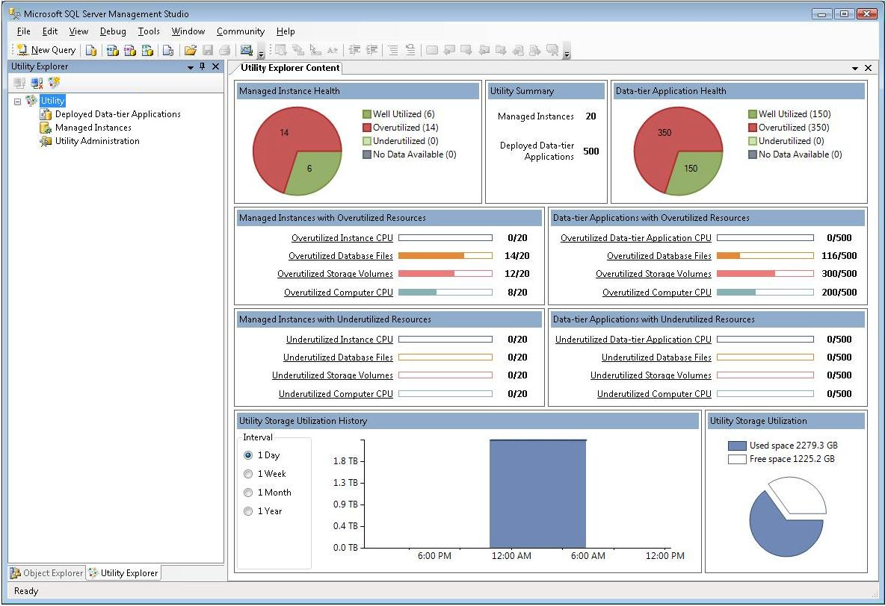

Figure 5: SQL Server Management Studio Utility Explorer

### Utility Control Point

SQL Server 2008 R2 improves the ability to manage multiple servers centrally with UCPs. You can create a UCP by using a simple wizard and enroll multiple instances of SQL Server to it. The UCP collects configuration and performance information—including database file space utilization, CPU utilization, and storage volume utilization—from each enrolled SQL Server instance, every fifteen minutes. You can view this information by using the Utility Explorer and the **Utility Explorer Content** tab in SQL Server Management Studio (Figure 5), which show summary and detailed performance and resource usage information in an easy-to-understand dashboard format. You can also set policies that define resource utilization thresholds so that you can quickly and easily identify over-utilization and under-utilization of resources.

### SQL Server Configuration Manager

Reduce management overhead by managing SQL Server services, including the SQL Server service and the SQL Server Agent service, for multiple instances, from a single console.

### Hyper-V Management Console

Reduce the amount of time required to manage your virtual environment and view key metrics for VMs, such as CPU usage and uptime, by using the Hyper-V Management Console.

### Windows PowerShell 2.0

PowerShell 2.0 is a sophisticated scripting language that has a range of cmdlets for SQL Server that enable you to locate and manipulate SQL Server objects. Use PowerShell 2.0 to automate server management, manage servers remotely, and manage custom configurations.

## 3.3. Manage Performance and Troubleshoot Effectively

Enable faster, more effective troubleshooting, proactively address performance issues, and ensure that you meet SLAs by using a range of dedicated tools.

Windows Server 2008 R2 and SQL Server 2008 R2 performance tools make it possible to pinpoint the causes of performance problems much more quickly, speeding up the troubleshooting process and making management more efficient.

### Performance Data Collector

Performance Data Collector is an integrated framework that you can use to collect, analyze, troubleshoot, and store SQL Server diagnostics information. Performance Data Collector provides an end-to-end solution for performance monitoring that includes low-overhead collection, centralized storage of performance data in a management data warehouse, and analytical reporting of performance data. You can use SQL Server Management Studio to manage collection tasks, such as enabling the data collector, starting a collection set, and viewing system collection set reports. You can also use system-stored procedures and the Performance Data Collector application programming interface to build your own performance management utilities based on Performance Data Collector.

### Windows Reliability and Performance Monitor

Reduce the time it takes to customize performance data collection and event trace sessions by using Windows Reliability and Performance Monitor. This tool provides enhanced monitoring that enables you to track reliability issues and identify performance bottlenecks over extended periods. The information provided by this tool can be extremely useful when you are troubleshooting performance or reliability issues in mission-critical database servers. You can see the resource overview window of the Reliability and Performance Monitor in figure 6.

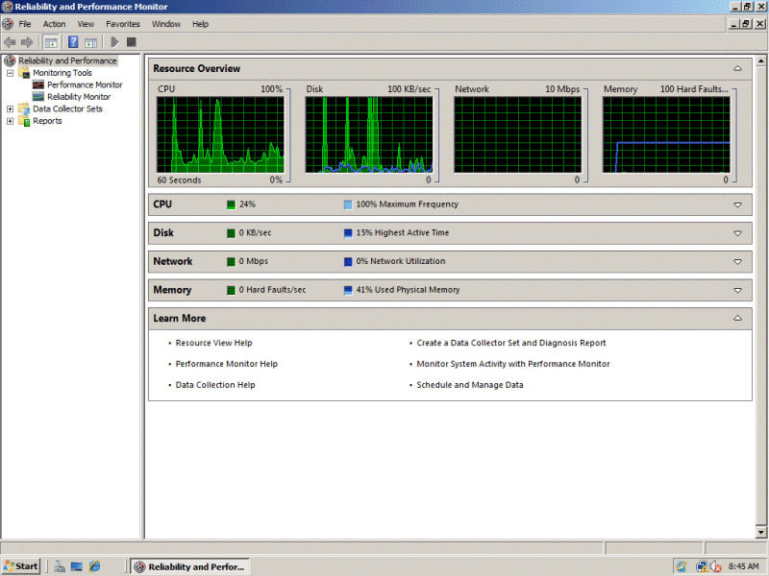

Figure 6: Windows Reliability and Performance Monitor

### SQL Server Resource Governor and Windows System Resource Manager

Address performance issues before they become problematic by using SQL Server Resource Governor and Windows System Resource Manager to manage processor and memory usage on a per-process basis.

### SQL Server Profiler

Reduce the time it takes to find poorly performing queries and identify bottlenecks by using SQL Server Profiler.

## 3.4. Improve Deployment Efficiency

Windows Server 2008 R2 and SQL Server 2008 R2 include tools and features that make it quicker and easier to deploy databases and applications to an enterprise environment.

### Build a Library of VMs Ready to Deploy

Reduce deployment times by creating a library of preconfigured VMs that you can quickly deploy as and when they are required. SQL Server 2008 R2 makes this process easier with the new SQL Server Sysprep utility. Windows Server Sysprep removes the unique Security Identifier (SID) from a Windows installation, so that you can create an image of that machine and deploy it elsewhere without causing a duplicate SID to appear on your network. However, because SQL Server installations also use the operating system’s SID, using Windows Sysprep on a machine that hosts SQL Server will cause problems for the SQL Server installation. The SQL Server SysPrep utility solves this problem by updating SQL Server references to the underlying SID in line with the changes made by Windows Sysprep. This makes it possible to create preprepared images of preconfigured SQL Server instances for physical and virtual machines.

You can also reduce deployment times for physical computers by using the ability in Windows Server 2008 R2 to boot from a VHD, which removes the need to install and configure the operating system. You can deploy .vhd images of Windows Server 2008 R2 to a physical computer by using Windows Deployment Services and then boot the computer directly from the VHD.

### Speed Up Database Deployment

SQL Server 2008 R2 introduces a new single unit of deployment, called a data-tier application (DAC), that speeds up deployments and upgrades. A DAC packages a database’s schema, along with deployment requirements for that database, ready for deployment. You can create packages from existing applications or by using the Microsoft Visual Studio® development system.

## 3.5. More Efficient Web Application Development

As a platform for custom applications, Windows Server 2008 R2 and SQL Server 2008 R2 offer a compelling set of development technologies that makes it possible to build cutting-edge solutions that give your business a real competitive advantage.

Windows Server has always provided a solid platform for application development, and Windows Server 2008 R2 includes Internet Information Services (IIS) 7.5. IIS 7.5 is more than a Web server; it includes a componential architecture for greater flexibility and control and provides a security-enhanced, easy-to-manage platform for developing and reliably hosting Web applications and services. Furthermore, it enables more flexible Web application deployment and streamlined management with full support for both ASP.NET and PHP, providing a unified platform for all Web applications.

IIS 7.5 also provides command-line and graphical management interfaces, powerful timesaving diagnostic and troubleshooting capabilities, and comprehensive extensibility. IIS 7.5 is closely integrated with the .NET Framework 4.0 to provide a powerful platform for building applications that connect users and data, enabling them to visualize, share, and act on information.

IIS 7.5 plays a central role in unifying the Microsoft Web platform technologies—Microsoft ASP.NET, Windows Communication Foundation Web services, and Windows SharePoint Services—and enables you to create powerful, reliable, and feature-rich multi-tier applications that generate a real business advantage.

The powerful application platform of Windows Server provides a solid foundation for new and innovative applications that access and deliver data across organizations, devices, and the Internet. Technologies such as the ADO.NET Entity Framework and Language Integrated Query (LINQ) make it easier for developers to build applications that access data. Innovations such as the Microsoft Sync Framework and ADO.NET Data Services make it possible to deliver data to multiple kinds of device and to build mash-up solutions that combine data from multiple sources across the Web.

These data application platform additions integrate fully with the Database Engine in SQL Server 2008 R2, enabling developers to take advantage of a range of features, including:

* Support for table-valued parameters.
* Native spatial data types.
* Support for XML formats.
* Integration of file stream data into a database.

This class-leading combination enables organizations to use SQL Server 2008 R2 to develop a new generation of data services that go beyond traditional relational data solutions.

# Conclusion

The SQL Server 2008 R2 data platform complements and builds on the foundations provided by Windows Server 2008 R2 to provide a highly scalable and mission-critical platform. Windows Server provides the core infrastructure that SQL Server uses for virtualization, advanced management, availability, performance, and security.

For more information:

SQL Server 2008 R2 site:

<http://www.microsoft.com/sqlserver/2008/en/us/r2.aspx>

Windows Server 2008 R2 site:

<http://www.microsoft.com/windowsserver2008/en/us/default.aspx>

Did this paper help you? Please give us your feedback. Tell us on a scale of 1 (poor) to 5 (excellent), how would you rate this paper and why have you given it this rating? For example:

* Are you rating it high due to having good examples, excellent screen shots, clear writing, or another reason?
* Are you rating it low due to poor examples, fuzzy screen shots, or unclear writing?

This feedback will help us improve the quality of white papers we release.

[Send feedback](mailto:sqlfback@microsoft.com?subject=White%20Paper%20Feedback:%20[Microsoft%20SQL%20Server%202008%20R2:%20The%20Best%20Data%20Platform%20on%20Windows%20Server%202008%20R2]).