

Internet Protocol Security for Microsoft Windows Server 2003

Microsoft Corporation
Published: April 2004
Updated: August 2005

Abstract
The Microsoft® Windows Server™ 2003 operating system includes an implementation of Internet Protocol security (IPsec) as defined by the Internet Engineering Task Force (IETF). IPsec, which is also included in Windows® XP and Windows 2000, provides network managers with a key line of defense in protecting their networks. IPsec exists below the Transport layer, so its security services are transparently inherited by applications. IPsec provides the protections of data integrity, data origin authentication, data confidentiality, and replay protection without having to upgrade applications or train users.



The information contained in this document represents the current view of Microsoft Corporation on the issues discussed as of the date of publication. Because Microsoft must respond to changing market conditions, it should not be interpreted to be a commitment on the part of Microsoft, and Microsoft cannot guarantee the accuracy of any information presented after the date of publication.
This White Paper is for informational purposes only. MICROSOFT MAKES NO WARRANTIES, EXPRESS, IMPLIED OR STATUTORY, AS TO THE INFORMATION IN THIS DOCUMENT.
Complying with all applicable copyright laws is the responsibility of the user. Without limiting the rights under copyright, no part of this document may be reproduced, stored in or introduced into a retrieval system, or transmitted in any form or by any means (electronic, mechanical, photocopying, recording, or otherwise), or for any purpose, without the express written permission of Microsoft Corporation.
Microsoft may have patents, patent applications, trademarks, copyrights, or other intellectual property rights covering subject matter in this document. Except as expressly provided in any written license agreement from Microsoft, the furnishing of this document does not give you any license to these patents, trademarks, copyrights, or other intellectual property.
Unless otherwise noted, the example companies, organizations, products, domain names, e-mail addresses, logos, people, places, and events depicted herein are fictitious, and no association with any real company, organization, product, domain name, email address, logo, person, place, or event is intended or should be inferred.
© 2004 Microsoft Corporation. All rights reserved.
Active Directory, Microsoft, Windows, and Windows Server are either registered trademarks or trademarks of Microsoft Corporation in the United States and/or other countries.
The names of actual companies and products mentioned herein may be the trademarks of their respective owners.
Contents
Introduction 1
Benefits of IPsec in Windows 2
IPsec Scenarios 5
Recommended Scenarios for IPsec 5
Packet Filtering 5
End-to-End Security Between Specific Hosts 6
End-to-End Traffic Through an ISA-Secured NAT 7
Secure Server 8
Domain Isolation 9
Server Isolation 9
L2TP/IPsec for Remote Access and Site-to-Site VPN Connections 10
Gateway-to-Gateway IPsec Tunneling with Third-Party IPsec Gateways 11
Scenarios for Which IPsec is Not Recommended 12
Special Consideration IPsec Uses 12
Securing All Traffic in a Network 13
Securing Traffic over IEEE 802.11 Wireless Networks 13
Home Networking 13
IPsec Deployment Process 15
Creating IPsec Policies 15
Defining IPsec Policy Rules 15
Example of Configuring an IPsec Policy 16
How IPsec Works 18
Summary 20
Related Links 21

Introduction
Without security, both public and private networks are susceptible to unauthorized monitoring and access. Internal attacks might be a result of minimal or nonexistent intranet security. Risks from outside the private network originate from connections to the Internet and extranets. Password-based user access controls alone do not protect data transmitted across a network. The Windows Server 2003 operating system simplifies deployment and management of network security with Internet Protocol security (IPsec) for Windows Server 2003, a robust implementation of the Internet Engineering Task Force (IETF) standards. Windows 2000 and Windows XP also support IPsec.
In today’s interconnected business world of the Internet, intranets, branch offices, and remote access, sensitive information constantly crosses networks. The challenge for network administrators and other information technology (IT) professionals is to ensure that sensitive traffic is:
- Safe from data modification while in transit (data integrity).
- Safe from being read and interpreted while in transit (data confidentiality).
- Safe from being spoofed by unauthenticated parties (data origin authentication).
- Safe from being resubmitted (replayed) to gain unauthorized access to protected resources (anti-replay or replay protection).
IPsec provides network-level data integrity, data confidentiality, data origin authentication, and replay protection for IP-based traffic. IPsec in Windows Server 2003 integrates with the inherent security of the Windows Server 2003 operating system to provide the ideal platform for protecting intranet and Internet communications.

Benefits of IPsec in Windows
Historically, organizations have had to strike a difficult balance between the desire to protect their data communications and the high costs of establishing and maintaining that protection. Security can impose costs that exceed the hardware cost of the network. Most network security strategies have focused on preventing attacks from outside the organization’s network. Firewalls, secure routers, and strong authentication of remote access connections are examples of attempts to defend against external threats. But strengthening a network’s perimeter does nothing to protect against attacks mounted from within. An organization can lose a great deal of sensitive information from internal attacks mounted by employees, supporting staff members, or contractors. Edge devices such as firewalls offer no protection against internal threats. One of the great benefits of IPsec for Windows is the ability to protect against both internal and external attacks.
IPsec in Windows provides the following benefits:
- Transparency of IPsec to users and applications
IPsec is integrated at the Network layer (layer 3), providing security for all IP-based protocols in the TCP/IP suite. With IPsec, there is no need to configure separate security for each application that uses TCP/IP. Instead, applications that use TCP/IP pass the data to the IP protocol, where IPsec can secure it. By eliminating the need to modify applications, IPsec provides for immense savings. In addition, because IPsec is transparent to users, no user training is required.
- Defense-in-depth against vulnerabilities in upper-layer protocols and applications
IPsec protects upper layer protocols, services, and applications. With IPsec enabled, initial packets to access an application or service running on a server, for example, will not even be passed to the application or service until trust has been established through IPsec authentication and the configured protection on packets for the application or service is applied. Therefore, attempts to access or disable applications or services on servers must first penetrate the IPsec protection.
- Restricted access to servers
Using IPsec policy, you can configure a server to only accept specific types of traffic. For example, you can configure an email server to accept only secured email traffic from client computers. The email server discards all other traffic from client computers.
- Customizable security configuration
Administrators can configure IPsec policies to meet the security requirements of an application, computer, group of computers, domain, site, or global organization. IPsec can be customized for use in a wide range of scenarios, including packet filtering, securing host-to-host traffic on specific paths, securing traffic to servers, Layer Two Tunneling Protocol (L2TP)/IPsec for virtual private network (VPN) connections, and site-to-site (also known as gateway-to-gateway) tunneling.
- Integration with the security framework in Windows Server 2003 and Windows 2000
IPsec uses the secure domain in Windows Server 2003 and Windows 2000 as a trust model. By default, IPsec policies use the Active Directory® directory service default authentication method (Kerberos V5 authentication) to identify and trust communicating computers. Computers that are members of a Windows Server 2003 or Windows 2000 Active Directory domain or are in trusted domains can easily establish IPsec-secured communications.
- Centralized IPsec policy administration through Active Directory
Network administrators can assign IPsec policies through Group Policy configuration of Active Directory system containers. This allows the IPsec policy to be assigned at the domain, site, or organizational unit level, eliminating the administrative overhead of configuring each computer separately.
- Support for IETF standards
IPsec supports IETF standards for interoperable, secure communication. IPsec provides an open industry-standard alternative to proprietary IP-based security technologies and network managers can benefit from the resulting interoperability.
IPsec for Windows Server 2003 supports the IPsec protocols published by the IETF and is compliant with the following IETF Requests for Comments (RFCs) and Internet drafts of the IPsec working group:
- RFC 1828: IP Authentication using Keyed MD5
- RFC 1829: The ESP DES-CBC Transform
- RFC 2085: HMAC-MD5 IP Authentication with Replay Prevention
- RFC 2104: HMAC: Keyed-Hashing for Message Authentication
- RFC 2401: Security Architecture for the Internet Protocol
- RFC 2402: IP Authentication Header
- RFC 2403: The Use of HMAC-MD5-96 within ESP and AH
- RFC 2404: The Use of HMAC-SHA-1-96 within ESP and AH
- RFC 2406: IP Encapsulating Security Payload (ESP)
- RFC 2407: The Internet IP Security Domain of Interpretation for ISAKMP
- RFC 2408: Internet Security Association and Key Management Protocol (ISAKMP)
- RFC 2409: The Internet Key Exchange (IKE)
- RFC 2410: The NULL Encryption Algorithm and Its Use with IPsec
- RFC 2411: IP Security Document Roadmap
- RFC 2451: The ESP CBC-Mode Cipher Algorithms
- A GSS-API Authentication Method for IKE (draft-ietf-ipsec-isakmp-gss-auth-0x.txt)
- UDP Encapsulation of IPsec Packets (draft-ietf-ipsec-udp-encaps-02.txt)
- Negotiation of NAT-Traversal in the IKE (draft-ietf-ipsec-nat-t-ike-02.txt)
- Support for Public Key Infrastructure (PKI) standards
IPsec in Windows supports the use of X.509 public key certificates for authentication. This allows trust and secure communication for computers that do not belong to a trusted Windows Server 2003 or Windows 2000 domain, non-Microsoft operating systems, computers that have membership in untrusted domains, and instances in which computer access must be restricted to a smaller group than domain authentication allows. To enhance large-scale certificate deployments, administrators can use Certificate Services in Windows Server 2003 or Windows 2000 to create a certification authority (CA) that issues and renews certificates automatically without user interaction. IPsec in Windows also supports the use of certificates issued by third-party CAs that comply with the X.509 certificate standard.
- Support for automatic cryptographic key management
To provide security, cryptographic keys must be changed regularly. When a network administrator has to do this manually, key management becomes extremely time-consuming. Therefore, either the keys are not changed as frequently as the organization might require, or they are changed on only a few vital computers. Internet Key Exchange (IKE) (RFC 2409) dynamically exchanges and manages cryptographic keys between communicating computers. As a result, the cost of manually changing keys is eliminated and maximum protection can be established and maintained across the organization.
- Hardware acceleration of IPsec cryptographic functions is supported by many network adapters
Windows 2000 introduced an efficient method for network adapters to perform IPsec cryptographic operations in hardware. This method is published in the Driver Development Kit (DDK) and is verified by Windows Hardware Compatibility Lab (WHQL) logo testing. Both Intel and 3Com have developed a variety of network adapters for clients, servers, and mobile platforms and whose drivers are included by default in the Windows releases. These network adapters process IPsec packets as fast as packets without IPsec, at the maximum throughput speed of the network.
For information about the new IPsec features in Windows Server 2003, see New features for IPsec.

IPsec Scenarios
IPsec is a general-purpose security technology that can be used to secure network traffic in many situations. However, you must balance the need for security with the complexity of configuring IPsec policies. Additionally, due to a lack of suitable standards, IPsec is not suitable for some types of connectivity. The following sections describe the scenarios for which Microsoft recommends and does not recommend the use of IPsec.

Recommended Scenarios for IPsec
IPsec is recommended for the following scenarios:
- Packet filtering
- End-to-end security between specific hosts
- End-to-end traffic through an ISA-secured NAT
- Secure server
- Server isolation
- Domain isolation
- L2TP/IPsec for remote access and site-to-site VPN connections
- Gateway-to-gateway IPsec tunneling with third-party IPsec gateways

Packet Filtering
IPsec provides limited stateless firewall capabilities for end systems. IPsec can be configured to permit or block specific types of traffic based on source and destination address combinations and specific protocols and specific ports. For example, nearly all the systems illustrated in Figure 1 can benefit from packet filtering to restrict communication to only specific addresses and ports. You can strengthen security by using IPsec filtering to control exactly the type of communication that is allowed between systems.
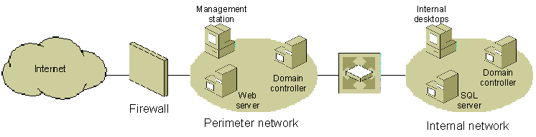
Figure 1 Filtering packets by using IPsec
For example, as illustrated in Figure 1:
- The internal network domain administrator can assign a domain-based IPsec policy to block all traffic from the perimeter network.
- The perimeter network domain administrator can assign a domain-based IPsec policy to block all traffic to the internal network.
- The administrator of the computer running Microsoft SQL Server on the internal network can create an exception to the domain-based IPsec policy to permit structured query language (SQL) protocol traffic to the Web server on the perimeter network.
- The administrator of the Web server on the perimeter network can create an exception to the domain-based policy to permit SQL traffic to the computer running SQL Server on the internal network.
- The administrator of the Web server on the perimeter network can also block all traffic from the Internet, except requests to TCP port 80 (for the HyperText Transfer Protocol [HTTP]) and TCP port 443 (for the Secure Sockets Layer [SSL]), which are used by Web services. This provides additional security against traffic allowed in from the Internet in case the firewall was configured incorrectly or compromised by an attacker.
- The domain administrator can block all traffic to the management station, but allow traffic to the perimeter network.
You can also use IPsec with the NAT/Basic Firewall component of the Routing and Remote Access service to permit or block inbound or outbound traffic. Alternately, you can also use IPsec with the Internet Connection Firewall (ICF) component of Network Connections, which provides stateful filtering. However, to ensure proper IKE management of IPsec security associations (SAs), you must configure ICF to permit UDP port 500 and UDP port 4500 traffic needed for IKE messages. With Windows Server 2003 Service Pack 1 and Windows XP Service Pack 2, you can use IPsec with the Windows Firewall. However, you do not need to configure Windows Firewall with exceptions for IKE traffic.

End-to-End Security Between Specific Hosts
IPsec establishes trust and security from a unicast source IP address to a unicast destination IP address (end-to-end). For example, IPsec can secure traffic between Web servers and database servers or domain controllers in different sites. As shown in Figure 2, only the sending and receiving computers need to be aware of IPsec. Each handles security at its respective end and assumes that the medium over which the communication takes place is not secure. The two computers can be located near each other, as on a single network segment, or across the Internet. Computers or network elements that route data from source to destination are not required to support IPsec.
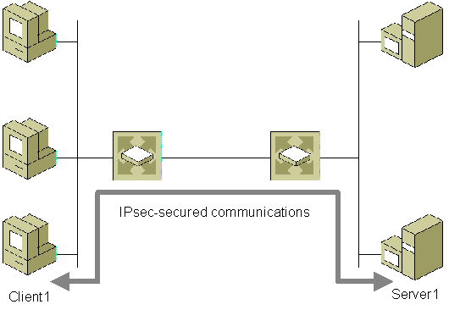
Figure 2 Securing communications between a client and a server with IPsec
Figure 3 shows domain controllers in two forests that are deployed on opposite sides of a firewall. In addition to using IPsec to secure all traffic between domain controllers in separate forests as shown in the figure, you can use IPsec to secure all traffic between two domain controllers in the same domain and between domain controllers in parent and child domains,
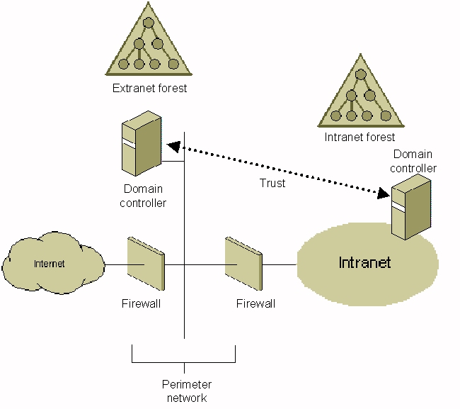
Figure 3 Securing communications between two domain controllers in different forests with IPsec
Note A firewall between IPsec peers must be configured to forward IPsec traffic on UDP source and destination port 500, IP protocol 50 (for Encapsulating Security Payload [ESP] traffic), and IP protocol 51 (Authentication Header [AH] traffic). If network address translation is taking place between the two computers, they must both support IETF IPsec Network Address Translator (NAT)-Traversal and the firewall must be configured to also forward traffic on UDP source and destination port 4500.

End-to-End Traffic Through an ISA-Secured NAT
Windows Server 2003 supports IPsec NAT Traversal (NAT-T). IPsec NAT-T allows traffic to be secured by IPsec when translated by a NAT. For example, IPsec can be used to secure host-to-host traffic through a computer that is running Microsoft Internet Security and Acceleration (ISA) Server and that is functioning as a NAT, if the ISA server does not need to inspect the traffic between the two hosts. In Figure 4, a computer running Windows Server 2003 and ISA Server is functioning as a NAT. The IPsec policy on Server A is configured to secure traffic to the IP address of Server B, while the IPsec policy on Server B is configured to secure traffic to the external IP address of the computer running ISA Server.
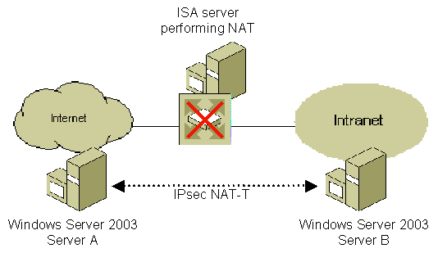
Figure 4 Securing communications through an ISA server performing NAT with IPsec NAT-T

Secure Server
You can require IPsec protection for all client computers that access a server. In addition, you can set restrictions on which computers are allowed to connect to a server running Windows Server 2003. Figure 5 shows IPsec securing an application server.
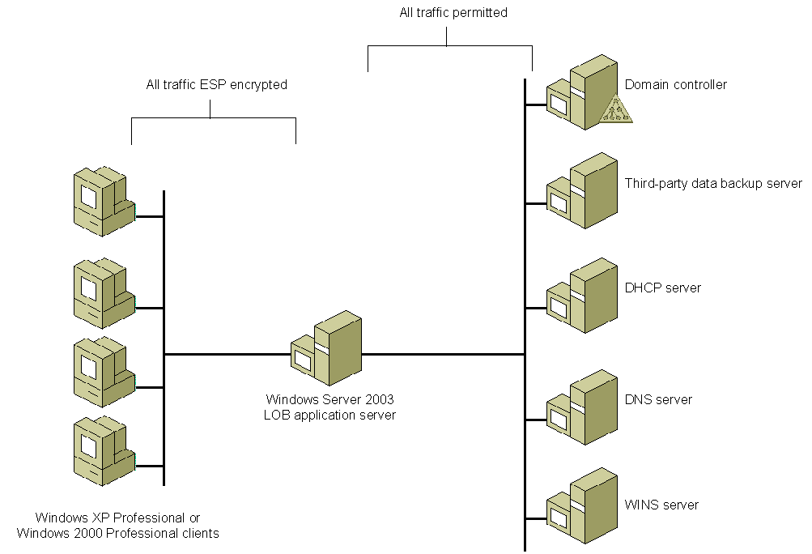
Figure 5 Securing an application server with IPsec
In this scenario, a line of business (LOB) application server in an internal corporate network must communicate with clients running Windows XP Professional or Windows 2000 Professional, a Domain Name System (DNS) server, a Dynamic Host Configuration Protocol (DHCP) server, and a Windows Internet Name Service (WINS) server, an Active Directory domain controller, and a third-party data backup server. The users on the client computers are company employees who access the application server to view their personal payroll information. Because the traffic between the clients and the application server involves highly sensitive data, and because the server should only communicate with other domain members, the network administrator uses an IPsec policy that requires ESP encryption and communication only with member computers in the Active Directory domain.
Other traffic is permitted as follows:
- Traffic between the WINS server, DNS server, DHCP server, and the application server is permitted because WINS servers, DNS servers, and DHCP servers must typically communicate with computers that run on a wide range of operating systems, some of which might not support IPsec.
- Traffic between Active Directory domain controllers and the application server is permitted, because using IPsec to secure communication between domain members and their domain controllers is not a recommended usage.
- Traffic between the third-party data backup server and the application server is permitted because the third-party backup server does not support IPsec.
For more information about secure server deployment, see the Using Microsoft Windows IPSec to Help Secure an Internal Corporate Network Server white paper at http://www.microsoft.com/downloads/details.aspx?FamilyID=a774012a-ac25-4a1d-8851-b7a09e3f1dc9&displaylang=en.

Domain Isolation
To isolate a domain, you can use IPsec, an Active Directory domain, and domain membership to require that domain member computers accept only authenticated and secured communications from other domain member computers. This network policy isolates domain member computers from non-domain member computers.
To configure domain isolation, use Group Policy settings to require that all incoming communication requests be authenticated using Active Directory and that domain member computers can initiate unprotected communications with non-domain member computers. Optionally, you can require that all secured communications be encrypted. You also can configure exceptions so that specific computers that are not domain members can initiate unprotected communications with domain member computers.
For more information about domain isolation, see Server and Domain Isolation Overview Resources and Server and Domain Isolation Deployment Resources.

Server Isolation
To isolate a server, you can use IPsec, an Active Directory domain, and domain membership to require that specific server computers that are domain members accept authenticated and secured communications only from other domain member computers. This network policy isolates specific servers from non-domain member computers. For example, to protect traffic to and from sensitive database servers, you would configure and deploy server isolation Group Policy settings to require secured traffic between database client computers and the database servers.
For group-specific server isolation, you can require that specific server computers that are domain members accept authenticated and secured communications only from other domain member computers that are members of specific Active Directory security groups. Group-specific server isolation provides an additional layer of authorization and isolates specific servers from both non-domain member computers and unauthorized domain member computers. Only an authorized domain member computer can access the isolated server.
For example, you can configure group-specific server isolation settings so that a server that contains sensitive medical information requires secure communications only from computers that meet the following criteria:
- They are domain members.
- They are members of the ConfidentialMedical Active Directory security group.
After you have configured the appropriate Group Policy and server settings, you can allow a new computer to access the isolated server by joining the new computer to the domain and then adding the computer account of the new computer to the ConfidentialMedical Active Directory security group.
For more information about server isolation, see Server and Domain Isolation Overview Resources and Server and Domain Isolation Deployment Resources.

L2TP/IPsec for Remote Access and Site-to-Site VPN Connections
You can use the combination of the Layer Two Tunneling Protocol (L2TP) and IPsec (L2TP/IPsec) for virtual private network (VPN) scenarios. This does not require the configuration and deployment of IPsec policies. Two common scenarios for L2TP/IPsec are securing communications between remote access clients and the corporate network across the Internet and securing communications between branch offices.
A common requirement is securing communications between remote access clients and the corporate network across the Internet. Such a client might be a sales consultant who spends most of the time traveling, or an employee working from a home office. In Figure 6, the remote access VPN server is a computer running Windows Server 2003 and the Routing and Remote Access service that provides edge security for the corporate intranet. The remote client represents a roaming user who requires regular access to network resources and information. An ISP is used as an example to demonstrate the path of communication when the client uses an ISP to access the Internet. L2TP is combined with IPsec to provide a simple, efficient way to build the tunnel and protect the data across the Internet.
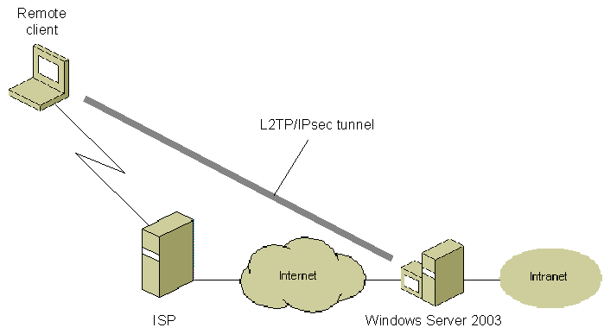
Figure 6 Securing remote access clients with L2TP/IPsec
A large corporation often has multiple sites that require communication—for example, a corporate office in New York and a sales office in Washington. In this case, L2TP is combined with IPsec to provide the VPN connection and protect the data between the sites.
In Figure 7, the routers running Windows Server 2003 provide edge security. The routers might have a leased line, dial-up, or other type of Internet connection. The IPsec SA and L2TP tunnel runs between the routers only and provides protected communication across the Internet.
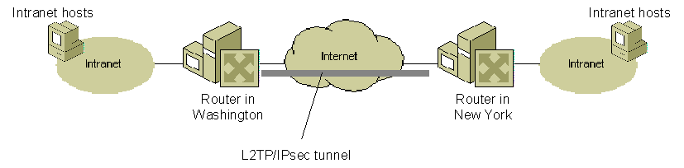
Figure 7 Securing remote access clients with L2TP/IPsec
For more information about L2TP/IPsec VPN connections, see the Virtual Private Networks for Windows Server 2003 and Virtual Private Networks for Windows 2000 Web sites.

Gateway-to-Gateway IPsec Tunneling with Third-Party IPsec Gateways
For interoperability with gateways or end systems that do not support L2TP/IPsec or Point-to-Point Tunneling Protocol (PPTP) VPN site-to-site connections, you can use IPsec in tunnel mode to establish gateway-to-gateway tunnels between sites.
In Figure 8, traffic is being sent between a client computer in a vendor site (Site A) and a File Transfer Protocol (FTP) server at the corporate headquarters site (Site B). Although an FTP server is used for this scenario, the traffic can be any unicast IP traffic. The vendor uses a third-party gateway, while corporate headquarters uses a gateway running Windows Server 2003. An IPsec tunnel is used to secure traffic between the third-party gateway and the gateway running Windows Server 2003.

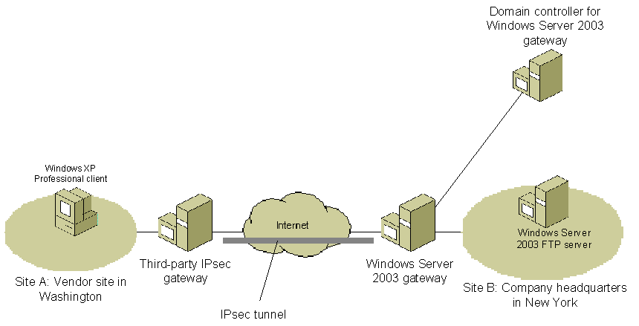
Figure 8 Gateway-to-gateway tunneling between sites

Scenarios for Which IPsec is Not Recommended
IPsec can reduce processing performance and increase network bandwidth consumption. Additionally, IPsec policies can be quite complex to configure and manage. Finally, the use of IPsec can introduce application compatibility issues. For these reasons, IPsec is not recommended for the following uses:
- Securing traffic between domain controllers and domain members
In addition to reduced network performance, using IPsec for this scenario is not recommended because of the complexity of the required IPsec policy configuration and management.
- IPsec tunnel mode for remote access VPN connections
IPsec tunnel mode is not a recommended technology for remote access VPN connections because there are no standard methods for user authentication, IP address assignment, and name server address assignment. Using IPsec tunnel mode for gateway-to-gateway VPN connections is possible using computers running Windows Server 2003. However, because the IPsec tunnel is not represented as a logical interface over which packets can be forwarded and received, routes cannot be assigned to use the IPsec tunnel and routing protocols do not operate over IPsec tunnels. Therefore, the use of IPsec tunnel mode is only recommended as a VPN solution for gateway-to-gateway (site-to-site) VPN connections in which one end of the tunnel is a third-party VPN server or security gateway that does not support L2TP/IPsec. Instead, use L2TP/IPsec or PPTP for remote access VPN connections.

Special Consideration IPsec Uses
The IPsec protocol and implementation in Windows have characteristics that require special consideration in the following scenarios:
- Securing all traffic in a network
- Securing traffic over IEEE 802.11 wireless networks
- Home networking

Securing All Traffic in a Network
You can use IPsec to secure almost all TCP/IP traffic in a network, but you must take into account the following:
- Deployment considerations:
- IPsec can reduce processing performance and increase network bandwidth consumption.
- The IPsec policies that can be needed are complex to configure and manage.
- An inability to agree on IPsec credentials can block all network connectivity for a client.
- Many applications expect Internet Control Message Protocol (ICMP) traffic to always succeed (and quickly) so ICMP traffic may have to be exempted from IPsec policy.
- Network management functions that must inspect the TCP, UDP, and other protocol headers are less effective or cannot function at all, due to IPsec encapsulation or encryption of IP payloads.
- Limitations:
- IPsec cannot secure multicast and broadcast traffic.

Securing Traffic over IEEE 802.11 Wireless Networks
Using IPsec transport mode to protect IEEE 802.11 wireless LAN traffic is not recommended. Instead, you should use Wi-Fi Protected Access 2™ (WPA2™) or Wi-Fi Protected Access™ (WPA™) with IEEE 802.1X authentication. Support for IPsec, configuration management, and trust are required on client computers and servers. Because many computers on a network do not support IPsec or are not managed, it is not appropriate to use IPsec alone to protect all 802.11 wireless LAN traffic. Additionally, IPsec is not optimized for mobile wireless clients that can change IP addresses while roaming across a subnet boundary of a large wireless network.
For more information about WPA2, WPA, and Windows support for 802.11 wireless LAN networking, see the Wireless Networking Web site (http://www.microsoft.com/wifi).

Home Networking
Although IPsec is not optimized for use in general home networking scenarios, when network security administrators deploy IPsec with appropriate scripts and support tools, it can be used effectively on home computers for specific scenarios.
IPsec is not recommended for end-users in general home networking scenarios for the following reasons:
- The IPsec policy configuration user interface is intended for professional network security administrators, rather than end-users. Improper policy configuration can result in blocked communications, and if problems occur, built-in support tools are not yet available to aid end-users in troubleshooting.
- Many home networking applications use broadcast and multicast traffic, for which IPsec cannot negotiate security.
- Many home networking scenarios use a wide range of dynamic IP addresses.
- Many home networking scenarios involve the use of a network address translator (NAT). To use IPsec across a NAT, both IPsec peers must support IPsec NAT-T.
IPsec can be used to connect home computer to an organization intranet for remote access. Network security administrators can use scripts and support tools to deploy IPsec on the home computers of employees who require secure connectivity to the corporate network. For example, an administrator can use a Connection Manager profile to deploy an IPsec policy configuration on home computers. Employees can then establish IPsec-secured connections across the Internet to the corporate network by using the VPN client built-in to Network Connections.
Note In some cases, third-party VPN clients might disable the IPsec service, thus preventing Windows IPsec from being used.

IPsec Deployment Process
Windows Server 2003 has been designed to provide very high levels of data security coupled with ease of implementation and administration. The result is enterprise-wide information security at a low total cost of ownership. Windows Server 2003 provides great flexibility with security, user, and domain policies. The network administrator can apply policies enterprise-wide or down to a single user or workstation. Security policies can then be implemented transparently, with no further intervention required from the network administrator and no retraining of users.

Creating IPsec Policies
An IPsec policy is a collection of general settings and rules that are used to configure IPsec services and that determine IPsec behavior. IPsec policies consist of:
- General IPsec policy settings
Settings that determine the name of the policy, its description, key exchange settings, and key exchange methods. General IPsec policy settings apply regardless of which rules are configured.
- Rules
One or more IPsec rules that determine which traffic IPsec examines, how that traffic is secured and encrypted, and how IPsec peers are authenticated.
After the policies are created, they can be assigned to individual Active Directory domain system containers (domains, sites, organizational units). This allows the IPsec policy to be assigned at the domain, site, or organizational unit level, eliminating the administrative overhead of configuring each computer separately. IPsec for Windows Server 2003 also allows you to configure local IPsec policies, however, local IPsec policies are overridden by domain-based IPsec policies.

Defining IPsec Policy Rules
An IPsec policy consists of one or more rules that determine IPsec behavior. Each IPsec rule contains the following primary configuration items:
- Filter list
A single filter list is selected that contains one or more predefined packet filters that describe the types of traffic to which the configured filter action for this rule is applied.
- Filter action
A single filter action is selected that includes the type of action required (permit, block, or secure) for packets that match the filter list. For the secure filter action, the negotiation data contains one or more security methods that are used (in order of preference) during IKE negotiations and other IPsec settings. Each security method determines the security protocol (such as AH or ESP), the specific cryptographic algorithms, and session key regeneration settings.
- Authentication methods
One or more authentication methods are configured (in order of preference) and used for authentication of IPsec peers during main mode negotiations. The available authentication methods are the Kerberos V5 protocol (used in Active Directory environments), use of a certificate issued from a specified certification authority (CA), or a preshared key.

Example of Configuring an IPsec Policy
As an example of how to configure IPsec policies, consider an organization with a centralized legal department. The network administrators have decided that communications within the legal department have to be authentic and unmodified, but not encrypted. Additionally, communications between the legal department and other departments within the organization must be authentic, unmodified, and encrypted.
IPsec applies the appropriate security policy based on the characteristics of IP packets. For our example, if the communication is between a computer in the legal department and a computer outside the legal department, IPsec for Windows Server 2003 must enforce data origin authentication, data integrity, and data confidentiality. If the communication is between computers inside the legal department, IPsec must enforce data origin authentication and data integrity.
To implement IPsec for the legal department, the administrator would perform the following steps:
- Create an organizational unit for the legal department named "Legal" and place all of the computer accounts of the legal department within it.
- Using the IP Security Policies extension within the Group Policy Editor snap-in (available under Computer Configuration\Security Settings), create an IPsec policy named "Communication for the Legal Department" with the following settings:
A filter list named "Legal intra-department traffic" that specifies that the destination address of packets must match an address on the IP subnets of the legal department and the source address of packets must match an address on the IP subnets of the legal department.
A filter list named "All IP traffic" that specifies any IP traffic.
A filter action named "Secure traffic within the Legal department" that specifies data authenticity and integrity.
A filter action named "Secure traffic outside the Legal department" that specifies data authenticity, integrity, and confidentiality.
A rule named "Legal intra-department communications" which uses the "Legal intra-department traffic" filter list, the "Secure traffic within the Legal department" filter action, and Kerberos authentication.
A rule named "Inter-department communications" which uses the "All IP traffic" filter list, the "Secure traffic outside the Legal department" filter action, and Kerberos authentication.
- Assign the IPsec policy named "Communication for the Legal Department" to the "Legal" organizational unit.
After the IPsec policy is assigned and all computers within the legal department update their Computer Configuration Group Policy settings, IPsec-secured communications is enforced for all communication of the computers in the legal department.
For example, when a computer in the legal department sends a packet to computer in another department, the packet matches the "All IP traffic" filter list, which is associated with the "Inter-department communications" rule, which enforces the use of Kerberos authentication and data origin authentication, integrity, and confidentiality.
When a computer in the legal department sends a packet to another computer in the legal department, the packet matches the "Legal intra-department traffic" filter list, which is associated with the "Legal intra-department communications" rule, which enforces the use of Kerberos authentication and data origin authentication and integrity.
Notice that for intra-department communication, the packets also match the "All IP traffic" filter list. However, the match to the "Legal intra-department traffic" filter list is more specific, and it is chosen over the "All IP traffic" filter list.

How IPsec Works
In the example in Figure 9, a user on Computer A is sending a message to a user on Computer B. IPsec for Windows Server 2003 policies have been deployed on both computers. At the user level, the process of securing the IP packets is transparent.
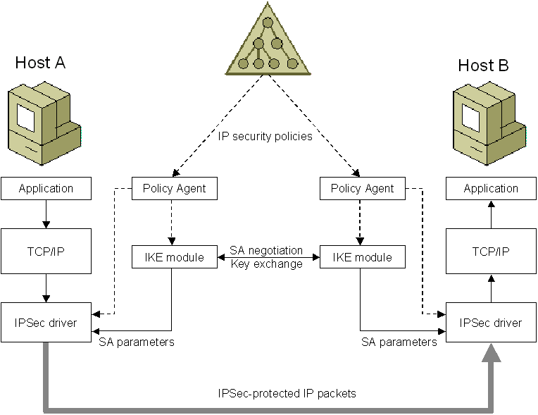
Figure 9 IPsec components
The IPsec policies assigned to the domain system containers of Computer A and Computer B determine the level of security for the communication. The IPsec policies are retrieved by the IPsec Policy Agent and passed to the IKE module and the IPsec driver. The IKE module on each computer uses the negotiation settings of the IPsec policy to perform computer-level authentication, determine the secret key, and how to negotiate the protection of IPsec traffic and IPsec-secured traffic. The IPsec driver uses the IP filter settings of the IPsec policy to determine what types of traffic are to be protected.
Assuming that Computer A and Computer B are not already communicating securely and a message that Computer A sends to Computer B must be secured, IPsec works in the following way:
- The user on Computer A sends a message to the user on Computer B. The message is passed to TCP/IP and is intercepted by the IPsec driver on Computer A.
- The IPsec driver on Computer A checks its outbound IPsec filter list and determines that the message should be secured.
- The action is to negotiate security, so the IPsec driver notifies IKE module to begin negotiations.
- The two computers use IKE to authenticate each other and determine secret keying material, the type of protection for future IKE traffic, and the type of protection for the message that is being sent.
- The sets of parameters that determine the protection, known as security associations (SAs), are sent to the IPsec driver. The IPsec driver uses SA information to protect the message.
- The IPsec-protected message is forwarded to Computer B.
- The IPsec driver on Computer B receives the IPsec-protected message.
- The IPsec driver on Computer B validates authentication and integrity and, if required, decrypts the message.
- The IPsec driver passes the validated and decrypted message to the TCP/IP driver, which passes it to the receiving application on Computer B.

Summary
IPsec for Windows Server 2003 provides network managers with a critically important line of security. Because IPsec for Windows Server 2003 operates below the Transport layer, deploying security is greatly simplified. IPsec for Windows Server 2003 provides the protections of data integrity, data origin authentication, data confidentiality, and replay protection without having to upgrade applications or train users. The implementation of IPsec in Windows Server 2003 is compliant with IETF’s IPsec standards, assuring maximum interoperability with other IPsec solutions in the networking marketplace.
The flexibility and centralized management makes IPsec for Windows Server 2003 easy to administer. Network managers can create centralized custom IPsec policies for Active Directory domain system containers as part of Computer Configuration Group Policy. At a time when network security is increasingly vital, Windows Server 2003 makes it easy for network managers to provide a strong layer of protection to their organization’s information resources.

Related Links
See the following resources for further information:
- Windows IPsec Web site at http://www.microsoft.com/windowsserver2003/technologies/networking/ipsec/default.mspx
- Windows Server 2003 Security Services Web site at http://www.microsoft.com/windowsserver2003/technologies/security/default.mspx
For the latest information about Windows Server 2003, see the Windows Server 2003 Web site at http://www.microsoft.com/windowsserver2003.


