
General Ledger

Microsoft Dynamics™ SL

Benefits
- Tailor to fit your needs
Set up accounts and sub-accounts to meet your operating needs and represent your divisional structure for accounting and reporting purposes with easily configurable and user-definable options that help you better manage your time and business.

- Save time with efficient data entry
Accelerate data entry with transaction
batch options and user-definable default
values that automatically populate data
fields. Help reduce erroneous postings by
defining valid account and sub-account
combinations.

- Improve your decision making
Get the information you need with powerful inquiry and lookup capabilities that facilitate rapid access to information you need to make better business decisions.

- Improve processing time
Streamline monthly and year-end closing
processes by automating routine activities,
allocations, and reports. You can have
multiple sessions open simultaneously, and even execute multiple tasks while others are processing.

- Gain flexible control of your
financial data
Achieve the flexibility to manage your
financial information to fit the way you do
business with multiple posting options and capabilities that let you enter transactions for any prior or future fiscal period and help you manage installments and prepayments at the same time.

- Consolidate financial reporting
Draw on integrated financial reporting to
communicate financial results through
a built-in version of Microsoft Dynamics SL for Analytics Microsoft FRx®.

Capture and analyze the financial information you need to make better business decisions with flexible, integrated capabilities that let you harness your accounting processes to meet the way you do business.

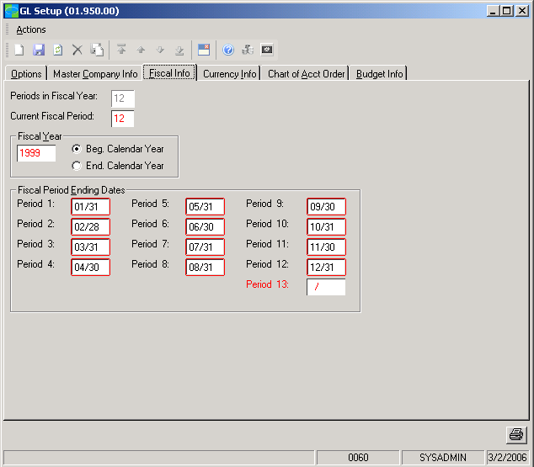

Configure
the appropriate number of periods and customize your fiscal year.

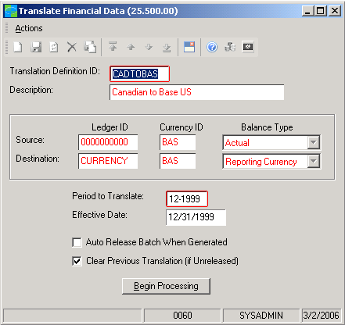

Drill down
instantly from a balance to the supporting source documents for detailed account information

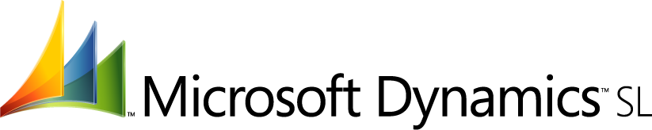

Timely Business Information  features  BENEFITS | Keep accurate records of all your financial data for easy access to timely business information, with the assurance that a complete audit trail underlies your business transactions.
Multiple Ledgers | Multiple book sets can be maintained in a single database, allowing for budgets,  forecasts, and statistical information to be compared in context with your actual  operating results.
Import/Export | Import or export information from other ledgers, companies, currencies,  and databases to consolidate financial information, giving you a complete  picture of your organization — whether a single office or a multi-national  business.
Reliable Controls | Set reference numbering to automatic, manual, or optional at the time of data  entry. Control closing easily by choosing whether to close or keep subsidiary  applications open for activity until the General Ledger application is closed.  The application creates a complete audit trail without the need for additional  reports or controls outside the system.
Microsoft FRx Support | - Summarize balances and drill down to general ledger detail with  Microsoft FRx.  - Use predefined financial statements, modify standard statement formats,  or create your own using Microsoft FRx Report Designer.  - Export formulas into Microsoft Office Excel and IBM’s Lotus 1-2-3  and create passwords to help protect rows, columns, and trees from unwanted changes.
User-Defined Account Structure | - Set up your account/sub-account structure for optimal reporting. Define up to 30 characters in meaningful segments for your general ledger account/sub  account ID structure. Main account numbers can be up to 10 characters long, and sub-accounts up to 20, including as many as eight segments.  - Define and maintain account/sub-account combinations easily.
Multi-Company Support | Report on all companies within your organization. Create inter-company  transactions, maintain centralized cash control, and make multi-company  allocations.
Multi-Entity Consolidation | Consolidate information from different databases with similar and  differing periods, calendar years, and chart of account structures.
Centralized Data Storage | Maintain information for multiple book sets in a single, consolidated Microsoft  SQL Server™ database by setting up multiple ledgers of statistical information,  budgets, financial books, tax books, or a translated set of financials.

For more information about Microsoft Dynamics™ SL, visit: http://www.microsoft.com/dynamics/sl

This document is for information purposes only.
MICROSOFT MAKES NO WARRANTIES, EXPRESS, IMPLIED, OR STATUTORY, AS TO THE INFORMATION IN THIS DOCUMENT.

© 2005 Microsoft Corporation. All rights reserved.
Microsoft, The Microsoft Dynamics Logo, are either registered trademarks or trademarks of Microsoft Corporation or Microsoft Business Solutions ApS in the United States and/or other countries. Microsoft Business Solutions ApS is a subsidiary of Microsoft Corporation.

