“The new SAM program has reduced the customer’s annual software spending by 12 percent.”
Partner: PC-WARE
Web Site: www.pc-ware.com
Partner Size: 1,200
Country or Region: United Kingdom
Industry: Professional services
Customer: European financial services company

Partner Profile
PC-WARE is a global IT services provider with 1,200 employees and subsidiaries in 16 countries. It is a Microsoft® Gold Certified Partner and one of only five European Large Account Resellers for Microsoft.

Software and Services
- Microsoft Server Product Portfolio
- Windows Server® 2003 Standard Edition
- Microsoft Operations Manager 2005
- PC-Ware SAM-System 2005
- Technologies
- Active Directory®
For more information about other Microsoft customer successes, please visit: www.microsoft.com/casestudies
Aman Kahlon, Head of Professional Services, PC-WARE
In 2004, a European financial services company determined that its existing software inventory solution was not identifying all applications installed on employees’ computers. In response, the company worked with Microsoft® Gold Certified Partner PC-WARE to develop a comprehensive Software Asset Management program. Now, the company has reduced software costs, has streamlined IT administration, and is using corporate resources more efficiently.

Business Needs
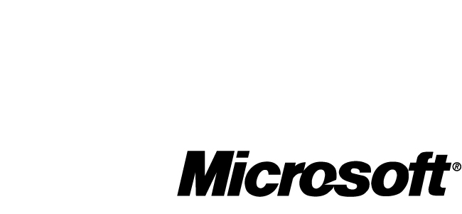

Since 1990, PC-WARE has provided enterprisewide IT services and support for corporate customers throughout Europe, employing 1,200 people in 16 countries. It is a Microsoft Gold Certified Partner and one of only five Large Account Resellers serving the entire European market. Many years of expertise in Software Asset Management (SAM) have earned PC-WARE a large roster of corporate customers that rely on its ability to accurately monitor the status of their software license agreements and policies. These customers generally have between 500 and 5,000 PCs in their organizations containing software distributed under several kinds of licensing agreements.

In 2004, when analyzing its supplier arrangements, a European financial services company discovered that it was unable to identify all software installed on employees’ computers. In addition, the company could not generate a complete list of the software licenses it owned. The company’s existing software inventory product also did not distinguish between licensed software, shareware, freeware, and other digital assets such as fonts and device drivers. As a result, the company could not determine its level of software license compliance or accurately manage its license agreements.

The company had not established a regular schedule for software license inventorying. This contributed to its difficulties in managing software assets. At the time, the company had allocated only one employee to perform the SAM process. In discussions with PC-WARE, the customer decided that an insufficient amount of resources was dedicated to the task.
Solution
The company became a customer of PC-WARE, seeking advice on how to better manage its software assets. PC-WARE proposed applying its own resources and experience to supplement the customer’s existing SAM procedures. The customer agreed, and PC-WARE began the process of generating an accurate baseline list of all of the customer’s software assets. This was the first step in establishing a comprehensive SAM program.

First, PC-WARE replaced the previous software inventory product with its own SAM solution—PC-WARE SAM-System 2005. “Our tool was built from a licensing perspective,” says Aman Kahlon, Head of Professional Services at PC-WARE. “After we ran it, the product provided nearly 100 percent recognition of installed software. At that point, it was easy to reconcile licenses. This tool simplified the whole SAM process.”

When the list of installed software was compared with the list of purchased software licenses, the customer could reconcile the differences by either uninstalling underlicensed software or purchasing additional licenses. PC-WARE also identified overlicensed software. For example, PC-WARE resolved the customer’s underlicensing of Microsoft Project Standard 2000 by applying excess licenses for Microsoft Office Project Standard 2003, bringing the customer into compliance with no cash expenditure required.

Next, PC-WARE helped the customer implement a comprehensive SAM program with the following components:

- PC-WARE SAM-System 2005 is used to regularly monitor the customer’s software assets and licenses.
- PC-WARE tracks and resolves new licensing discrepancies on the customer’s behalf as soon as they occur.
- PC-WARE provides the customer with monthly reports on the status of its software assets. These reports provide detailed information about software license allocation in an easy-to-read format.
- The customer restricts software installation on the PCs by disabling USB port access and by establishing an enterprisewide group policy through the Active Directory® service in the Windows Server® 2003 operating system.

Benefits
As a result of working with PC-WARE to plan and implement a robust SAM program, the customer has benefited by reducing its annual expenditure for software by 12 percent. The company also has become more familiar with its IT administration processes. As a result, the customer manages its IT infrastructure more effectively, allocates in-house personnel more productively, and is better able to plan for changing software needs.

- Lower software costs. By eliminating overlicensing of its software assets, the customer reduced its overall software costs. “Many customers don’t realize that they can gain significant savings by identifying excess licenses,” says Kahlon. “In this case, the new SAM program has reduced the customer’s annual software spending by 12 percent. SAM has put the customer into a better position of understanding its licenses and of insuring it doesn’t buy excess software in the future.”
- Streamlined IT administration. By being involved in the planning of the new SAM program, the customer has a much better understanding of its IT environment and can manage that environment more effectively. “Without a robust SAM program, a customer lacks the ability to properly control the software that ends up in its organization,” says Kahlon. “But with SAM, the customer is better able to manage its IT infrastructure. For example, with its new SAM program, our financial services customer has been able to plan upgrades and deploy software much easier. In addition, the company’s whole process of IT administration has been streamlined.”
- More efficient allocation of personnel. Because PC-WARE is now responsible for administering software licenses, the customer has been able to save the time and money it used to spend in consolidating its software asset license reports. “With SAM, the customer’s time and labor were actually reallocated, and the customer has been more productive as a result,” says Kahlon.
- Improved insight into software needs. Increased knowledge of its current software assets gives the customer a clearer idea of its future software needs. “The customer is looking to consolidate its server environment, and we’ve helped the IT staff understand it better. The customer is also invested in Microsoft Operations Manager 2005, which helps to control and monitor the servers. The company is better able to plan and organize its infrastructure to make it more efficient and, of course, lower the cost,” says Kahlon.

“I think this has been a successful project,” concludes Kahlon. “I know the customer is quite pleased.”

