Microsoft Web Platform
Customer Solution Case Study
 |  |  |   Ammunition Maker Uses Software-plus-Services to Boost Web Traffic and Sales

Overview  Country or Region: United States  Industry: Manufacturing  Customer Profile  Founded in 1866, Winchester Ammunition, based in East Alton, Illinois, is the legendary brand name of guns and ammunition used more than a century ago by Buffalo Bill and Annie Oakley.  Business Situation  Winchester’s customers wanted interactive ballistics information on the company’s products, but Winchester had no effective way to provide it.  Solution  The company created a ballistics calculator using a software-plus-services approach and Microsoft Silverlight 2, which enabled it to easily produce versions for the Web, Microsoft Surface, and other formats.  Benefits  - Enhancing the customer experience  - Boosting Web traffic by an estimated 20 percent  - Cutting time-to-market in half |  |  | “Using Silverlight and Windows Presentation Foundation to implement our software-plus-services architecture … cut months off our time–to-market.”  Jeff Fattic, Solution Architect, Quilogy
 |  |  | Winchester Ammunition, one of the legendary names in U.S. manufacturing, recognized that its most frequent customers wanted in-depth, dynamic information on the ballistics of the company’s products—but the company’s static brochures and Web site did not always engage each and every customer. So, Winchester created a ballistics calculator, using a software-plus-services architecture and technologies including Microsoft Silverlight 2. The result can be easily adapted for the Web, trade show booths, and even in-store kiosks and phones. By educating consumers about Winchester products, the calculator will enhance the user experience—it’s expected to help to create more satisfied and loyal customers, and to increase sales and market share. Web traffic is estimated to increase by 20 percent.
 |  |  | 

Situation
Established in the 1800s, Winchester has seen the rise of the Internet, the first automobile, and even the original light bulb. There isn’t much in the way of technology that Winchester hasn’t been around to greet. And to use.
“We looked at a lot of approaches, but decided that software-plus-services would provide customers with the best experience, regardless of how they were accessing the calculator.”
Brett Flaugher, Vice President of Sales and Marketing, Winchester Ammunition

One secret to the company’s success, according to its executives, directly relates to the strategy of keeping an increasingly venerable brand relevant and fresh by embracing new technologies. The company was one of the first in its industry to host a Web site that not only published information, but also included tools that made it easier for customers to use that information.

The company has launched several Web site redesigns over the past 13 years, to ensure that customers experience a fresh and relevant Web site. The latest redesign, initiated in 2008, prompted Winchester and its Web design and hosting provider, Quilogy, a Microsoft Gold Certified Partner, to conduct site surveys and focus groups to identify whether Winchester.com met the needs of the company’s customers.

To start, Winchester recognized that its Web visitors were a mixture of experienced, occasional, and novice hunters and shooters. The third most popular reason they cited for going to the Web site was for ballistics information—that is, information on how bullets and specific loads will perform in a variety of guns and under variables such as wind speed, altitude, range, and scope site height.

But when the company looked at its core customers, the experienced hunters (who also constitute the largest segment of site visitors), ballistics information jumped to the number one reason for visiting the site. Focus groups confirmed that fact.

And yet Winchester and its competitors were not providing that information to their customers. Winchester did provide downloadable brochures with ballistics information, but as static data. The information could not be manipulated by users, and some data could essentially be out of date as soon as it was published. Some companies provided Internet-based tools to make it possible for customers to generate ballistics information on bullets. But these tools didn’t allow customers to compare several products, and they did not allow users to enter a complete range of variables (wind, altitude, and so on).

As Winchester and Quilogy personnel began to think about producing a ballistics calculator, they realized the need extended beyond Winchester.com. Such a calculator could be a marketing asset at highly trafficked trade shows. It could be the basis for in-store kiosks at gun shops. It might even be the basis for a mobile application. Any solution that they developed would have to take flexibility into account.

Solution
To provide that flexibility, Winchester and Quilogy turned to a software-plus-services solution in which the business logic of the ballistics calculations are provided as a high-level service to an independent software application—including, but not limited to, an application on the new Winchester Web site. (See Figure 1.)

“We looked at a lot of approaches but decided that software-plus-services would provide customers with the best experience, regardless of how they were accessing the calculator,” says Brett Flaugher, Vice President of Sales and Marketing, Winchester Ammunition. “They wouldn’t have to download and install an application, and we could provide a highly visual experience tailored to the way that customers were accessing the calculator.”

With the architectural direction established, Winchester and Quilogy then considered their options for technology. Under traditional circumstances, an application with the highly visual, even animated interface that Winchester wanted would have been designed in Adobe Flash.

But these circumstances weren’t traditional. Winchester envisioned its ballistics calculator powering several applications and running on several hardware platforms. Flash technology would have required the development team to create a separate Flash front end for each version—and then to maintain all those versions and keep them synchronized. Winchester had worked extensively with Flash in the past, but now it wanted one solution that would work across multiple versions of the ballistics calculator.

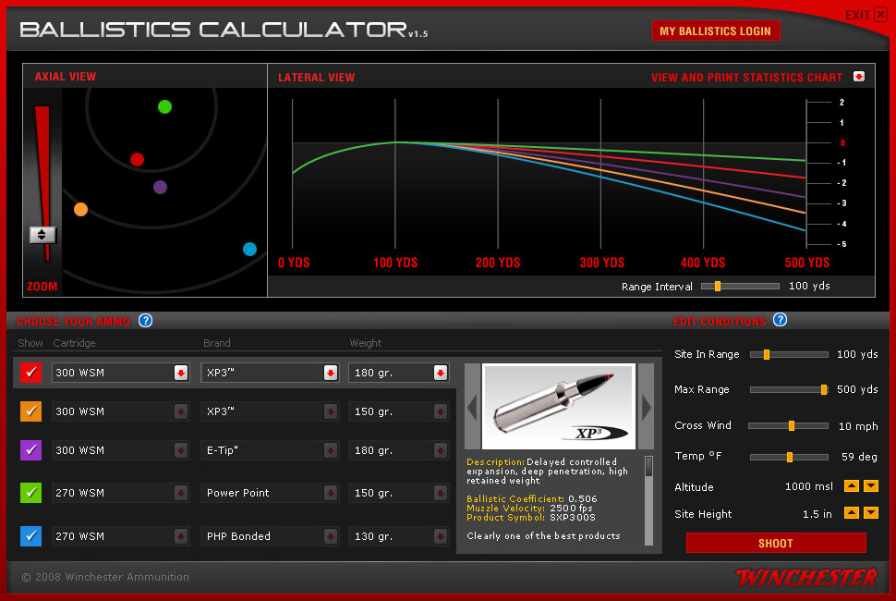
Figure 1. The ballistics calculator provides a rich visual environment that enables users to easily understand the effect of parameters, such as a cross wind, on the trajectory of Winchester bullets.

Quilogy recommended a technology that it was already using in the media players on its Web site to animate text and graphics: the Microsoft Silverlight 2 browser plug-in. Winchester knew it would increase the visual appeal of the calculator solution. Silverlight animates the Web-based version of the calculator, and Winchester easily ported the Silverlight code to Windows Presentation Foundation, of which Silverlight is a subset, for the trade show version of the calculator.

Because Internet access is uncertain at trade shows, this version of the calculator must be able to run when a device is not connected to the Internet. Windows Presentation Foundation helps to ensure that the compelling visual elements of the Web version are also present offline.

And to make the calculator visible and useful for the throngs of visitors that Winchester regularly welcomes to its trade show booths, Quilogy recommended that Winchester use the Microsoft Surface software and touch computing platform for the display. Microsoft Surface is a revolutionary surface-computing platform that responds to natural hand gestures and real-world objects. The Microsoft Surface version of the ballistics calculator has been so successful that Winchester won the Most Innovative Product award for it from the SHOT Show trade show—one of the first times that the award has been given for a product that is not a gun-related or firearms-related accessory.
“One of the biggest benefits of the ballistics calculator is that it provides a phenomenal tool to educate customers on the value of our products in a way we couldn’t easily educate them before.”
Brett Flaugher, Vice President of Sales and Marketing, Winchester Ammunition

Other key technology elements of the ballistics calculator are also adopted from the Microsoft application platform. The Web version of the calculator runs as a Web part in Microsoft Office SharePoint Server 2007, which Winchester chose for its Web site, according to Flaugher, “because of the greater control it gave us over the Web site and the ability it gave us to update the content easily, using out-of-the-box workflows.”

The Web version of the calculator uses Microsoft SQL Server 2008 Enterprise data management software; the Microsoft Surface version uses SQL Server 2008 Express. The Web version uses Internet Information Services to serve ASP.NET Web pages, and both versions are hosted on the Windows Server 2008 operating system.

Benefits
Winchester Ammunition expects its ballistics calculator based on the software-plus-services model to help boost sales of products among current customers, increase the number of total customers and market share, and increase the profitability of sales by cutting support costs related to sales.

Enhancing the Customer Experience
“One of the biggest benefits of the ballistics calculator is that it provides a phenomenal tool to educate customers on the value of our products in a way we couldn’t easily educate them before,” says Flaugher. “We want customers to understand the performance abilities of all of our products, so that they can decide which ones are the best ones for them in any given hunting or shooting situation. We didn’t have a way to drive home the value of these products in highly specific situations before. Now, we do. It defines our leadership position in the industry.”

It also means that the customer’s experience in hunting or shooting is more likely to be successful because he or she now has the knowledge to purchase the most appropriate product. “A more successful customer is a happier customer,” says Flaugher. “We can envision the ballistics calculator helping to improve customer satisfaction and loyalty, which in turn means that new customers will likely come to us and existing customers will more likely stay with us. That means increased sales and market share.”

Boosting Web Traffic by an Estimated
20 Percent
Winchester executives envision that the ballistics calculator will boost traffic to Winchester.com and, as a result, help to expand the company’s total customer base and market share.

“We are anticipating about a 20 percent increase in Web traffic due to the ballistics calculator,” says Flaugher. “Ballistics is a great topic to showcase in our industry, and when customers do a Web search, they are seeing our ballistics calculator and coming to our Web site. The ballistics calculator is part of our larger effort to provide all the information that customers need in one place, so that we can convert a significant share of those additional Web visitors into new customers.”

Cutting Time-to-Market in Half
By adopting a software-plus-services approach and using the Microsoft application platform for its software development, including Silverlight and Windows Presentation Foundation, Quilogy estimates that it cut its time-to-market for the first two versions of the ballistics calculator in half.
“We are anticipating about a 20 percent increase in Web traffic due to the ballistics calculator.”
Brett Flaugher, Vice President of Sales and Marketing, Winchester Ammunition

“If we had used Flash, we’d have had to re-create our ballistics calculator for each platform,” says Jeff Fattic, Solution Architect at Quilogy. “Using Silverlight and Windows Presentation Foundation to implement our software-plus-services architecture, we could port the presentation tier for the Web version of the ballistics calculator almost directly to the Microsoft Surface version. That cut months off our time-to-market. In this highly competitive market, getting to market first is an enormous plus for our client.”

Nor are the Web and Microsoft Surface versions of the ballistics calculator the only ones that Winchester envisions. Because the ballistics calculations are provided as a service to the application, Winchester can easily provide those calculations in other ways, including applications for mobile devices, calculators for DVD distribution by the marketing department, and for downloading to laptops used by Winchester sales personnel conducting demonstrations. The ballistics calculations can also be provided to other types of applications, such as engineering applications that help to design, rather than to sell, Winchester products.

Time-to-market for future applications will also be shorter with this architecture. “By exposing the calculation engine as a Web service and using client software to create a satisfying user experience, we’ve created an application architecture that provides tremendous flexibility and agility, so that we can quickly adjust to changing customer needs and marketing strategies,” says Fattic.

Microsoft Web Platform
For More Information
For more information about Microsoft products and services, call the Microsoft Sales Information Center at (800) 426-9400. In Canada, call the Microsoft Canada Information Centre at (877) 568-2495. Customers in the United States and Canada who are deaf or hard-of-hearing can reach Microsoft text telephone (TTY/TDD) services at (800) 892-5234. Outside the 50 United States and Canada, please contact your local Microsoft subsidiary. To access information using the World Wide Web, go to:
www.microsoft.com

For more information about Quilogy products and services, call (636) 947-9393 or visit the Web site at: www.quilogy.com

For more information about Winchester Ammunition products and services, visit the Web site at:
www.olin.com

This case study is for informational purposes only. MICROSOFT MAKES NO WARRANTIES, EXPRESS OR IMPLIED, IN THIS SUMMARY.

Document published January 2010

Software and Services  - Microsoft Server Product Portfolio  - Microsoft SQL Server 2008 Enterprise  - Microsoft SQL Server 2008 Express  - Windows Server 2008 Enterprise  - Microsoft Office  - Microsoft Office SharePoint Server 2007 | - Technologies  - ASP.NET  - Internet Information Services  - Microsoft Silverlight 2  - Microsoft Surface  - Windows Presentation Foundation 3.5  Partner  - Quilogy

Design, develop, and deliver innovative Web solutions for your business. The Microsoft Web Platform offers all the tools, technologies, and server software necessary to create satisfying Web experiences.

To learn more, go to:
www.microsoft.com/web

