

Technical Overview of Microsoft Identity Integration Server 2003 with Service Pack 1

Microsoft Corporation
Published: December 2004
Updated: August 2005

Abstract
Microsoft Identity Integration Server 2003 (MIIS) enables the integration and management of identity information across multiple repositories, systems, and platforms. MIIS augments Active Directory by providing broad interoperability capabilities including: integration with a wide range of identity repositories; provisioning and synchronizing identity information, including password synchronization & management, across multiple stores; and brokering changes to identity information by automatically detecting updates and sharing the changes across systems.
This white paper details the improvements and many new features being made available with MIIS 2003 that make it a strategic component of any identity management implementation.

The information contained in this document represents the current view of Microsoft Corporation on the issues discussed as of the date of publication. Because Microsoft must respond to changing market conditions, it should not be interpreted to be a commitment on the part of Microsoft, and Microsoft cannot guarantee the accuracy of any information presented after the date of publication.
This document is for informational purposes only. MICROSOFT MAKES NO WARRANTIES, EXPRESS OR IMPLIED, AS TO THE INFORMATION IN THIS DOCUMENT.
Complying with all applicable copyright laws is the responsibility of the user. Without limiting the rights under copyright, no part of this document may be reproduced, stored in or introduced into a retrieval system, or transmitted in any form or by any means (electronic, mechanical, photocopying, recording, or otherwise), or for any purpose, without the express written permission of Microsoft Corporation.
Microsoft may have patents, patent applications, trademarks, copyrights, or other intellectual property rights covering subject matter in this document. Except as expressly provided in any written license agreement from Microsoft, the furnishing of this document does not give you any license to these patents, trademarks, copyrights, or other intellectual property.
The example companies, organizations, products, people and events depicted herein are fictitious. No association with any real company, organization, product, person or event is intended or should be inferred.
© 2004 Microsoft Corporation. All rights reserved.
Microsoft, Active Directory, Visual Basic, Visual C++, Visual C#, Visual Studio, Windows, the Windows logo, Windows NT, and Windows Server are either registered trademarks or trademarks of Microsoft Corporation in the United States and/or other countries.
The names of actual companies and products mentioned herein may be the trademarks of their respective owners.

Contents
Introduction to Microsoft Identity Integration Server 2003 1
Capabilities 2
Identity Integration Feature Pack for Microsoft Windows Server Active Directory 4
Enterprise Edition 4
Benefits 4
Architectural Overview 6
Connected Data Sources 6
Management Agents 6
Connector Space 7
The Metaverse 8
New Features and Capabilities 9
Attribute Flow and Precedence 9
Custom Extensions 10
Visual Studio .NET 11
The Microsoft .NET Framework Security Solution 11
Data Lineage 11
MIIS 2003 Database 12
High Availability and Clustering 13
Identity Manager 14
Metaverse Search 16
Password Management 17
Preview Mode 18
Provisioning 19
Deprovisioning 19
Windows Management Instrumentation 20
Summary 21
Related Links 22

Introduction to Microsoft Identity Integration Server 2003
In most enterprises today, each individual application or system has its own user database or directory to track who is permitted to use that resource. Identity and access control data reside in tens and hundreds of different directories and applications such as specialized network resource directories, mail servers, human resource, voice mail, payroll, and many other applications.

Each application or system has its own definition of the user’s “identity” (name, title, ID numbers, roles, membership in groups). Many have their own password and process for authenticating users. Each has its own tool for managing user accounts, and sometimes they have dedicated administrators responsible for this task. Further, most enterprises have multiple processes for requesting resources and for granting and changing access rights. Some of these are automated, but many are paper-based. Many differ from business unit to business unit even when performing the same function.

Administration of these multiple repositories often leads to time-consuming and redundant efforts in administration and provisioning. It also causes frustration for users, requiring them to remember multiple IDs and passwords for different applications and systems. The larger the organization, the greater is the potential variety of these repositories and the effort required to keep them updated. This labyrinth of inefficient processes and overlapping systems can have significant consequences for the following:

Cost Containment and Productivity
- New employees and contractors wait days to receive access to needed applications.
- Helpdesk staff, managers, IT staff, and human resources staff devote endless hours to completing forms, entering and updating user data, setting up accounts, and resetting passwords.

Security
- Departing employees, contractors, customers, and business partners retain access to systems for long periods, and “orphaned” (invalid) user accounts proliferate.
- The organization can’t meet audit requirements or comply with government regulations.

Customer Service and Supply Chain Integration
- Customer service and cross-selling opportunities are impeded by incomplete views of customer data.
- Customer Web initiatives and supply chain integration projects are hobbled because enterprises can’t confidently expose IT systems and sensitive information to outside parties.

Microsoft Identity Integration Server (MIIS) 2003 can help solve this chaos. MIIS is a system that manages and coordinates identity information from multiple data sources in an organization, enabling you to combine that information into a single, logical view that represents all of the identity information for a given user or resource.

Capabilities
The following sections describe the capabilities of MIIS 2003.

Centralizing Identity Information
In most organizations, identity information exists in many different connected data sources, which can result in the duplication of identity information, incompatible data formats, and requiring administrators to have access to multiple connected data sources.
To solve the issues that result from identity data residing in multiple sources, MIIS can:
- Combine the data for a specific person or resource creating a single entry that contains some or all of the identity information from each connected data source.
- Present a single, unified view that contains some or all of the attributes from the different connected data sources, regardless of whether the connected data sources are compatible.
- Provide one location from which administrators, applications, and users can access or manage the identity information for a specific object.
Managing Identity Information
Different directories often contain conflicting identity information about the same person or resource. In addition, the department or IT group that owns and manages the data in a specific connected data source usually believes that their data is authoritative compared to similar data that resides in a different connected data source. In these cases, data owners are often reluctant to give up control of their data.
To solve issues resulting from conflicting identity information, MIIS can:
- Manage the flow of identity information between connected data sources to resolve conflicts in identity information throughout the organization.
- Determine what specific identity information to import from each connected data source.
- Establish rules to determine which directory contains the authoritative value for a specific attribute and have MIIS update the other connected data sources with that authoritative value.
Managing Changes to Identity Information
Because an organization's identity information is often contained in different connected data sources, a change made to data in one connected data source is not automatically made in all of the other connected data sources. To reflect the change throughout the organization requires administrators to make the changes manually in each connected data source. Unmanaged identity information can become unorganized, resulting in identity information that is unsynchronized throughout the organization.
To solve issues resulting from changes to identity information, MIIS can:
- Detect any change to identity information, regardless of where the change originates.
- Automatically propagate changes to identity information, including additions, deletions, and suspensions of users (also known as provisioning) to all connected data sources.
- Ensure that changes made to an attribute or objects are appropriate based on their authoritative source.
Broad Connectivity
MIIS leads the industry with regard to connectivity capabilities. Out-of-the-box connectivity to most network operating systems (NOS), e-mail, database, directory, application, and even flat-file access gives you the power to connect to the plethora of disparate sources of identity information in your company—all without the need to install software of any kind on the target systems.
MIIS ships with the “Management Agents” that will allow you to integrate with many different types of repositories. Here is a sample list of the connectivity capabilities of MIIS:
Type of system | Examples
Network Operating Systems and Directory Services | Microsoft Windows NT®, Active Directory®, Active Directory Application Mode, IBM Tivoli Directory Server, Novell eDirectory, SunONE/iPlanet Directory, X.500 systems, and other metadirectory products
E-mail Systems | Lotus Notes and Domino, Microsoft Exchange 5.5, 2000, and 2003
Application Systems | PeopleSoft, SAP, ERP¹, telephone switches, XML and DSML based systems
Database Systems | Microsoft SQL Server™, Oracle, Informix, dBase, IBM DB2
File-based Systems | DSMLv2, LDIF, CSV, delimited, fixed width, attribute value pairs
¹Connectivity to the PeopleSoft, SAP, and ERP systems can be achieved by connecting to the underlying databases or by interfacing to a flat-file export from these systems.
Management agents are shipped to work “out of the box.” Companies that have requirements to extend or modify a particular management agent can do so easily using any number of languages.
Microsoft Identity Integration Server 2003 is available in two editions (MIIS 2003 Enterprise Edition or Identity Integration Feature Pack for Microsoft Windows Server Active Directory). You can choose the edition that best suits your requirements.

Identity Integration Feature Pack for Microsoft Windows Server Active Directory
This feature pack has been designed to integrate identity information between multiple Active Directory forests or between Active Directory and Active Directory Application Mode (ADAM). The Identity Integration Feature Pack for Microsoft Windows Server Active Directory enables a customer to:
- Automatically synchronize users, and their associated information, in one Active Directory forest as contacts in other Active Directory forests.
- Selectively synchronize only the user or organizational units that are necessary.
- Synchronize domain local, global, or universal groups across forests.
- Synchronize Exchange 2000 and Exchange 2003 global address lists across forests.
- Synchronize identity information between Active Directory and ADAM instances.
- Provision users across forests.
The Identity Integration Feature Pack for Microsoft Windows Server Active Directory requires Microsoft SQL Server 2000 Standard Edition or Enterprise Edition as its back-end store and must be installed on a Microsoft Windows Server 2003, Enterprise Edition, server.

Enterprise Edition
The Microsoft Identity Integration Server 2003, Enterprise Edition, provides classic directory synchronization functionality that enables a customer to synchronize and provision identity information across a wide variety of stores and systems.
MIIS 2003, Enterprise Edition, requires Microsoft SQL Server 2000 Enterprise or Standard Edition as its back-end store.

Benefits
Customers who deploy MIIS 2003 can expect to benefit in a number of ways including:
Administrative cost reduction. MIIS ensures consistency and data integrity throughout your enterprise by automatically propagating and brokering the changes that occur to identity information in your disparate systems. Powerful brokering capabilities allow you to take control of how and when these changes are maintained and processed. By translating and interchanging identity information across heterogeneous systems you can now provide your users with a consistent and accurate representation of your company’s identity information.
Business process integration. MIIS includes powerful provisioning capabilities that allow you to automatically provision NOS, e-mail, and other accounts across your enterprise. Directory-enabled account provisioning allows you to reach new levels of efficiency by reducing the amount of manual processing that must occur between systems when you, for example, hire a new employee.
Improved consistency and data integrity. MIIS allows you to enforce ownership of identity information across the enterprise. Without the ability to assign and enforce ownership, identity data can lose integrity. For example, without ownership of an employee’s “title” being defined in the human resources system, the user might have the ability to update his or her own title from the e-mail system’s address book. With multiple identity repositories, identity ownership becomes increasingly important. MIIS can ensure that data that has been improperly changed is changed back to the proper value based on which system “owns” that particular attribute.
Increased security. MIIS helps ensure that the information throughout the enterprise is consistent and up to date. Coupled with the integration of business rules and provisioning, any changes in an employee’s status can be propagated throughout your enterprise quickly and efficiently. For example, when employees leave the organization, MIIS can automatically suspend their accounts thereby reducing the risk of a security breach.

Architectural Overview
There are several components that make up the overall MIIS 2003 environment. The primary components are connected data sources, management agents, connector space, and the metaverse.

Connected Data Sources
A connected data source is a directory, database, or other data repository that contains identity data to be integrated with MIIS. Connected data sources can be enterprise directories, e-mail directories, NOS directories, human resource databases, or data in flat files, such as LDIF, XML, or delimited text.

Management Agents
A management agent links a specific connected data source to MIIS. The management agent is responsible for moving data from the connected data source and MIIS. When data in MIIS is modified, the management agent can also export the data out to the connected data source to keep the connected data source synchronized with MIIS. Generally, there is at least one management agent for each connected directory. MIIS 2003, Enterprise Edition, includes management agents for the following identity repositories:
- Active Directory
- Active Directory Application Mode (ADAM)
- Attribute-value pair text files
- Comma separated value files
- Delimited text files
- Directory Services Markup Language (DSML) 2.0
- Exchange 5.5, Exchange 5.5 Bridgehead
- Exchange 2000 and Exchange 2003 Global Address List (GAL) synchronization
- Fixed-width text files
- IBM DB2, IBM Tivoli Directory Server
- LDAP Directory Interchange Format (LDIF)
- Lotus Notes/Domino 4.6/5.0/6.0
- Novell eDirectory
- Sun/iPlanet/Netscape directory 4.x/5.x (with “changelog” support)
- Microsoft SQL Server 2000, SQL Server 7.0
- Microsoft Windows NT 4 Domains
- Oracle 8i/9i
- Informix, dBase, ODBC and OLE DB support via SQL Server Data Transformation Services
Management agents contain rules that govern how an object's attributes are mapped, how connected directory objects are found in the metaverse, and when connected directory objects should be created or deleted.
A significant benefit of the MIIS implementation of management agents is that no additional software needs to be deployed on the connected systems. This results in a lower total cost of ownership since additional software components do not need to be managed across multiple platforms.
Identity data that is collected by management agents is stored within MIIS in two logical namespaces: connector space and the metaverse.

Connector Space
The connector space (CS) is a storage area, or staging area, that is used by management agents to move data into and out of a connected data source. Each connected data source has its own logical area in the CS, which is managed by its corresponding management agent. The CS is essentially a mirror of the related connected data source, with each object in the connected data source having a corresponding entry in the CS. The connector space does not contain the connected directory object itself, but a subset of the object's attributes, as defined by the management agent.
The CS was designed to provide a number of benefits that are not available to users of other products.
The CS contains all of the attributes of interest from a connected directory, database, or file. Because this identity data is available in the CS, a company can easily explore this information without having to query the originating stores. This makes it easier to access the data and eliminates the need to program against the multiple stores where the identity information originated, especially where those stores are being used in production under well-defined work loads that would not benefit from ad hoc query activity.
The CS also tracks the “state” of an object and its attributes. Specifically, when synchronizing with its connected store the CS will contain both the current state of the object/attribute along with the new state—should it have changed—along with any additions or deletions that occurred in the connected store. By having this state available in CS it is possible to inspect the change and programmatically change it. Depending on business rules that govern the way MIIS performs provisioning, such state changes (an employee in the human resource database is terminated) could cause MIIS to perform some action like disabling a mail account or a network OS account and making sure resultant changes take place on the state of the appropriate CS objects that are known to be linked to the entry whose state change caused this to happen.
The CS provides complete transparency to all operations that will happen to an object whether they are additions, deletions, or renames--in addition to any attribute level operations such as a value changed or deleted. This provides an administrator the capability to inspect, report on, or e-mail any changes before they are actually processed.
Connectors and Disconnectors
Within the connector space there are two types of objects: connector objects and disconnector objects.
- A connector object is linked to an object in the metaverse.
- A disconnector object is not linked to any object in the metaverse.
When you propagate a new object from a connected data source to connector space, a disconnector object is created automatically (that is, it is not associated with an object in the MIIS yet). The projection and join rules in the management agent determine whether the object can be created in the metaverse, and thus become a connector object. Typically, it is recommended that you project objects to the metaverse and then create a link. However, there may be some objects, such as administrator accounts, that you do not want to exist in the metaverse. By designating these as disconnector objects in the connector space, they cannot be created in the metaverse, and thus, are not synchronized to other connected directories.
The advantage of having disconnector objects is that an administrator can simply flag an account as a disconnector, and it will no longer be synchronized with other connected sources. Without writing a single line of code the administrator can simply use the MIIS management interface to change an entry from a connector to a disconnector object. Other products require hand coding of every exception.

The Metaverse
The metaverse is a set of tables within MIIS that contain the integrated (“joined”) identity information from multiple connected sources. All identity information about a specific person, which is stored in multiple connected sources, is synthesized into a single entry in the metaverse.
When you run a management agent, changes that you made to objects in the connected sources are written to the connector space, rules and disconnector filters are then applied, and the resulting data is then written to the metaverse if import flow rules detect that this data should be written to the metaverse. The metaverse then sends those changes to the connector space of other connected directories with which the object is synchronized, and their respective management agents then propagate the changes to those connected directories based on the rules defined in the management agents for those connector spaces.

New Features and Capabilities
The following sections give a brief overview of some of the new features and capabilities of MIIS 2003.

Attribute Flow and Precedence
Attribute flow is the process of pushing changes to an object's attributes into and out of the metaverse. Attribute flow rules are defined by the attribute mappings in the management agent. When changes to an object's attributes are detected in the connector space or in the metaverse, attributes are flowed according to their mappings and precedence.
Import attribute flow (from the connector space to the metaverse) is defined at the metaverse level and applied when a connector space change is received, and export attribute flow (from the metaverse to the connector space) is defined at the management agent level, and applied when a metaverse change is received.
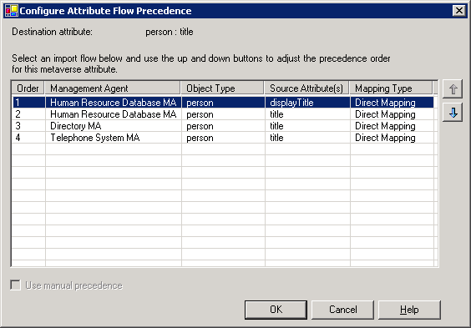
Attribute flow rules are governed by attribute precedence, or ranking. When multiple management agents, or data sources, define attribute mappings into the same destination metaverse attribute, one data source should be defined as having precedence, in order to maintain data integrity.
In the screen shot below you can see that the “title” attribute will be obtained from the Human Resource Database MA “display title” field, and if it is not present in that field, it will be obtained from the “title” attribute. If not present in that attribute, it will be taken from the “title” attribute in the Directory MA, and finally from the “title” attribute in the Telephone System MA. Attribute precedence also allows a higher precedence source to override a lower precedence source. So, in this example, while the title may be obtained from the Telephone System MA, should the title ever appear in the Human Resource or Directory MA, this will overwrite the title that was obtained from the Telephone System MA. The same is true if the display title in the Human Resource Database MA is ever present; it will have precedence over the other sources of this attribute.
Attribute precedence gives you the flexibility to define multiple sources from which an attribute may be sourced while at the same time allowing you to define the precedence of these sources.
Attribute precedence does not require any programming whatsoever. Other products require custom programming to handle this common occurrence.

Custom Extensions
While most administrative tasks can be accomplished using Identity Manager, Microsoft Identity Integration Server 2003 administrators can customize the way management agents and the metaverse work by creating custom extensions. Custom extensions are created using a programming language such as Microsoft Visual Basic® .NET, Visual C++®.NET, or Visual C#® .NET. They are implemented as a Microsoft .NET Framework class library, or dynamic link library (DLL), and are stored in the extensions folder of the MIIS root directory.
The following types of custom extensions are supported by MIIS 2003:
Rule extension | Description
Management agent | A management agent custom extension is applied to data as it flows to and from a connected data source to the connector space. Each management agent can have only one set of rules extension code built into a single assembly.
Metaverse | A metaverse custom extension is applied to data as it is processed when something causes a change to a metaverse entry. The metaverse can have only one extension.
A custom extension can be used to perform special actions such as:
Catch exceptions. Some exceptions are allowed during synchronization while other exceptions should cause synchronization to abort. You can use a custom extension to decide whether to continue or abort synchronization when an exception occurs.
Check for attribute values. You can use a custom extension to verify if an attribute contains an expected value.
Construct a distinguished name. When a change occurs to an object in the metaverse, a connected directory might require a new distinguished name. You can use a custom extension to create a distinguished name for a connected directory.
Create a unique naming attribute in the metaverse. Each object in the metaverse might require a unique naming attribute. You can use a custom extension to check that a proposed value for a naming attribute is unique, and to construct unique naming attributes.
Create a new connector space entry. As part of adding new objects to the metaverse, a custom extension can automatically create new entries in the connector space for connected systems.
Enable or disable a user account in Active Directory. When the status of a person associated with a user account changes, corresponding changes in Active Directory must also occur. A custom extension can enable or disable a user account in Active Directory as a result of a change in a connected system.
Set an initial password in Active Directory. When you add a new user to the metaverse, you might have to set an initial password. You can set an initial password for a user through a custom extension.
These are just some examples of the kinds of things that custom rules extensions can do.

Visual Studio .NET
Visual Studio® .NET is a complete set of development tools for building ASP Web applications, XML Web services, desktop applications, and mobile applications. It is also used to build custom extensions to Microsoft Identity Integration Server 2003. Visual Basic .NET, Visual C++ .NET, and Visual C# .NET all use the same integrated development environment (IDE), which allows them to share tools and facilitates in the creation of mixed-language solutions. In addition, Visual Studio .NET supports the .NET Framework, which provides a common language runtime and unified programming classes.
Rather than being forced to build extensions using only one language (for example, Perl) or hard-to-understand XSLT/XML transformations, an MIIS 2003 administrator may extend MIIS using any Visual Studio .NET language. Additionally, there are many Visual Studio .NET partners who provide additional language support for those administrators who happen to prefer programming in Visual Perl, Visual Python, Pascal, or even COBOL. The rich IDE of Visual Studio .NET provides an easily understood object model with rich debugging tools. A developer can easily set breakpoints, debug rules, re-evaluate rules, and so on.

The Microsoft .NET Framework Security Solution
Extending MIIS 2003 through the use of Visual Studio .NET also automatically takes advantage of the Microsoft .NET Framework security architecture. The .NET Framework security solution is based upon the concept of managed code, with security rules enforced by the common language runtime (CLR). Most managed code is verified to ensure type safety, as well as the well-defined behavior of other properties. In verified code, a method declared as accepting a 4-byte value, for example, will reject an attempted call with an 8-byte parameter as not type safe. Verification also ensures that execution flow transfers only to well-known locations, such as method entry points—a process that eliminates the ability to jump execution to an arbitrary location.
Verification prevents code that is not type safe from executing, and catches many common programming errors before they cause damage. Common vulnerabilities—such as buffer overruns, the reading of arbitrary memory, or memory that has not been initialized and arbitrary transfer of control—are no longer possible. This benefits the MIIS administrator, because the code they run is checked before it executes. It also benefits developers, who will find that many of the common bugs that have traditionally plagued development are now identified and prevented from causing harm.
The CLR also enables unmanaged code to run, but unmanaged code does not benefit from these security measures. Specific permissions are associated with the capability to call into unmanaged code, and a robust security policy will ensure that those permissions are conservatively granted. The migration from unmanaged code to managed code will, over time, reduce the frequency of calls to unmanaged code.

Data Lineage
This is an exciting and innovative new feature of MIIS 2003. In any identity management system changes to objects and attributes can potentially come from many different sources. Data lineage allows an administrator or operator to understand how an object or attribute was created, changed, or deleted. It allows you to easily view the rules that were applied by any management agent that resulted in the change.
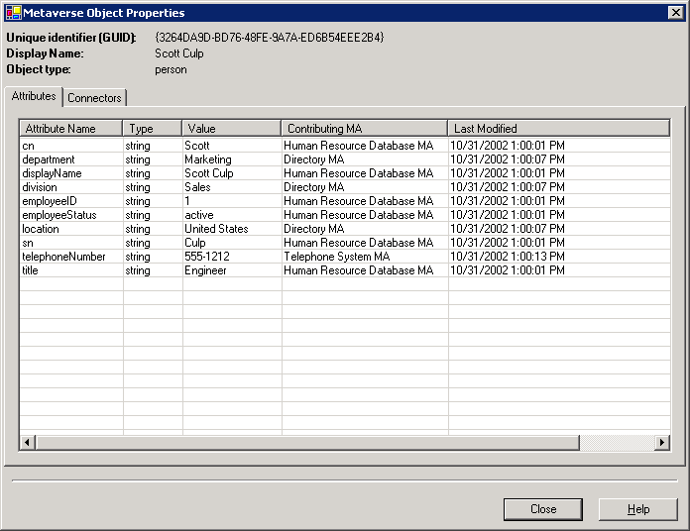
In the example above you can see the metaverse entry for Scott Culp. On the left side of the screen you can see the list of all of Scott’s attributes. The “Contributing MA” column shows from which management agent each attribute was populated. The “Last Modified” field shows the last time that a particular attribute was changed. In this particular example it is easy to see that the “telephoneNumber” attribute was changed at 1:00:13 PM and that it was the “Telephone System MA” that was responsible initiating this change.
Data lineage not only makes it easy for an operator or administrator to track how an object or attribute has changed, but it also provides an audit of these changes. No other product offers this powerful capability.

MIIS 2003 Database
MIIS 2003 uses Microsoft SQL Server 2000 as its database. A reliable, scalable, high-performance database is the foundation for e-business success. SQL Server 2000 was created to provide all of the tools and functionality your enterprise needs to create and maintain Web-enabled, database-powered applications. Rich support for Extensible Markup Language (XML), easy Web access to database information, and powerful analysis tools, coupled with high availability and tight security, help innovative companies to rewrite the rules of business and ensure the flexibility needed to respond rapidly to future changes. Tools that offer extremely fast development capabilities give companies new levels of flexibility, drastically reducing the time it takes to develop applications.
SQL Server 2000 can be indexed for extremely fast searches, has its own set of monitoring and maintenance tools, and is tightly integrated with Windows Server 2003, Enterprise Edition. You can install SQL Server 2000 on the same server running MIIS and Windows Server 2003, Enterprise Edition, or you can install SQL Server 2000 on a remote server.
SQL Server 2000 is used to store a variety of MIIS information and data, such as:
- Multi-valued attribute data
- Management agents
- Custom extensions
- Connector space data
- Metaverse data
- Metaverse to connector space link data
- Management agent run profiles
- Management agent run history
- Object joiner log

High Availability and Clustering
Along with performance and scalability, enterprises demand availability of the applications they use. Achieving high availability requires a whole solution, part of which includes SQL Server 2000 server failover clustering.
Failover clustering is a process in which the operating system and SQL Server 2000 work together to provide availability in the event of an application failure, hardware failure, or operating-system error. Failover clustering provides hardware redundancy through a configuration in which mission critical resources are transferred from a failing machine to an equally configured server automatically. Failover clustering also allows system maintenance to be performed on a computer while another node does the work. This benefit can also ensure that system downtime due to normal maintenance is minimized.
For more information regarding SQL Server 2000 visit http://www.microsoft.com/sql.

Identity Manager
Identity Manager is the administrative interface for MIIS 2003. It includes a number of components.
Operations
Use Operations to track the run history of all management agents, including their status, errors, and synchronization statistics. You can also run management agents, edit the management agent run history list, save management agent run histories to file, and view the properties of an object in connector space.
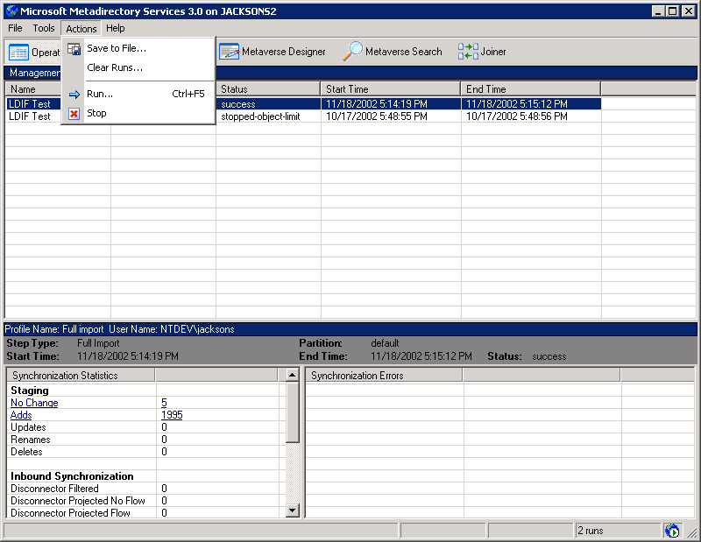
The graphic above shows a screen shot from the Identity Manager. Notice how easy it is to run or stop a management agent. In the lower left pane you see that in the last run of the management agent five records did not change and 1,995 were added. By clicking “No Change” or “Adds” links, you can easily review which records were not changed or which ones were added. Operational information is easy to access in MIIS 2003.
Management Agents
Use the Management Agents task to create and edit management agents, configure run profiles for each management agent, or import or export management agents. You can also view import statistics and errors for the most recent run of a management agent.
Metaverse Designer
Use the Metaverse Designer task to create new object types in the metaverse, or to delete object types from the metaverse. In addition, you can add, edit, or delete attributes from any object type in the metaverse. This is also where you will specify attribute flow precedence for an object type.
Metaverse Search
Use Metaverse Search to create and edit search queries based on object type and attribute values. You can also import and export queries. From the search results, you can view the properties of the object in the metaverse.
Joiner
Use the Joiner task to see the disconnected objects for a management agent. You can use Joiner to manually join a disconnected connector space object to a metaverse object, or to project a connector space object into the metaverse. You can also use Joiner to disconnect an object from the metaverse.
Management Agent Rules
Management agents can contain several types of rules and filters that determine how objects and their attributes are processed when the management agent is run. You can define these rules in the user interface or by using a custom extension. A management agent can contain the following rules categories.
Management Agent Rules Categories
Attribute mappings define relationships between attributes of connector objects and attributes of metaverse objects. You use attribute mappings to flow attributes from the connector space to the metaverse, or to join a connector object to a metaverse object. You can specify the following kinds of mappings.
Mapping Type | Description
Direct mapping | Defines a direct relationship between a single source attribute and a single destination attribute. The destination attribute is assigned the value of the source attribute which cannot be modified by a custom extension. An example would be to map employeeID to userID.
Custom extension | Defines a direct relationship between multiple source attributes and a single destination attribute. An example would be to map firstName and lastName to fullName.
Constant | Defines a single destination attribute and the constant string value that the attribute will have.

Join rules determine the association of a connector object with a metaverse object. Join rules have two parts that are always paired: search criteria and resolution. The search criteria always consist of metaverse attributes, listed by precedence. When you run a management agent, a join search is applied to each object in the connector space, which attempts to find a corresponding object in the metaverse. When a search returns any results, the resolution rules determine whether:
- None of the objects are acceptable, in which case the next search criteria is evaluated.
- Exactly one of the objects is acceptable, in which case it is joined with the connector object.
- More than one of the objects is acceptable, in which case the join operation fails.
Projection rules are run after join rules and determine whether and how a management agent projects a connector space object to the metaverse. Management agents apply projection rules to objects where a join has failed or was not configured. Projection rules only configure the object class of the projected object. Attributes are configured using attribute flow rules. A projection rule exists for each object type in the connector space and can be a declarative rule or a custom extension rule.
Declarative rules define a basic object class mapping, where the source and target classes are selected from the available connector space and metaverse class types.
Custom extension rules enable users to write a custom extension that can examine the source object and determine whether it is projected to the metaverse, and if so, with what object class.
Stay disconnector filter determines whether the management agent even attempts to join or project a connector space disconnector object to the metaverse. It is the first rule that is applied to a connector space object. After you run a management agent, all objects in the connected directory are represented in the connector space. However, there may be some object types, such as administrative accounts or users in a particular division that the MIIS administrator wants to prevent from ever linking to a metaverse object. You can configure the stay disconnector filter to block these objects from linking to the metaverse.
Deprovisioning rules determine what happens to a connector space object after it has been disconnected from a metaverse object. You can do any of the following:
- Make the connector object a normal disconnector object.
- Make the connector object an explicit disconnector object.
- Delete the object from the metaverse.
- Call a custom extension. This enables you to evaluate the connector space object before you make it a disconnector or delete it. In addition, you can modify the objects attributes, such as setting a user account to disabled.

Metaverse Search
Use the Metaverse Search to find entries that exist in your metaverse, and look at the attribute values provided by your import attribute flow rules as you configured in management agents. In addition to attributes, object types, and basic naming information, you can easily see linked entries in as many connector spaces for which the metaverse entry has a connector. Along with each of these linked entries, you can see how the link was created (for example, via join rules, projection rules, provisioning rules, or manually using the joiner). As mentioned earlier, each change to a metaverse entry has a lineage, and from this view, it is possible to see what was changed, by which management agent, and the date and time of the change.
In addition to being able to perform these functions through the Identity Manager’s Metaverse Search task, these functions can be performed using the Windows Management Instrumentation (WMI) automation interface. This allows the creation of scripts or applications that can determine the metaverse state of any entry, and can return all of the pertinent information about its connectors. One obvious example of this is the password management integration scenario. Third-party password management applications can use this WMI interface to search the metaverse and get a related list of connectors, thus saving their application the work of maintaining separate persistent join data, which is a costly and end-user intensive effort.

Password Management
Password management accounts for some of the highest IT costs in enterprises. The cost of helpdesk-based password management for some organizations has been reported to be greater than half of all helpdesk costs, and there are others who have reported higher. The costs reported are direct costs and do not take into account lost user productivity as a result of downtime or lost productivity as a result of peer support, each of which could easily be twice as great as the direct costs borne by the IT department.
MIIS has always had the clear goal of the reduction of costs associated with the administration of user accounts. MIIS 2003 helps to meet this goal through the introduction of new password management capabilities. These capabilities include:
- A single point of password administration through a Web services application that allows either helpdesk or user initiated password reset
- An API that offers password management functions
- Support for the implementation of password policies and policy checking when used with Active Directory
- Clear audit and status information via event log entries
- Integration points for third party password management solutions allowing them to greatly reduce the need for, or eliminate, user-provided registration data
Password management in MIIS 2003 is accomplished with an API exposed using the WMI provider that is installed along with MIIS on the server. The functions in this server API allow an application developer to browse MIIS for specific entries and to administratively set or change the password on the accounts found.
The API alone doesn’t solve the problem, however. There are two specific problems we have to address: first, the case where a helpdesk caller needs to have his password reset in all MIIS-managed systems where he has accounts, and secondly, the case where a user wants to change her password in all of her MIIS-managed system accounts. In MIIS 2003, two customer-extensible applications provide the functions required to address these two problems.
The applications are Web applications developed with ASP.NET and Visual Studio .NET and require Windows Server and IIS 6.0 for operation. Visual Studio .NET is required for adding code, but not for deployment. These Web applications use the API to search MIIS 2003 for a particular user’s accounts, and they allow setting or changing the password in those accounts based on a set of configuration parameters that customers can change in an XML configuration settings file when they deploy the application. In addition to that, source code will be provided to illustrate using the API.
In addition to the XML file with the configuration settings, MIIS 2003 defines callout areas where the customer can develop their own logic for post-processing for each account that was touched and for the entire operation. In that way, if setting a password in a particular system failed, customers can extend the functions of the application and take some specific action for which they would develop the code. Similarly, after the set or change requests are finished for all accounts, customers can write additional code to send e-mail confirmations, generate event log entries, or set passwords in non–MIIS-managed systems.

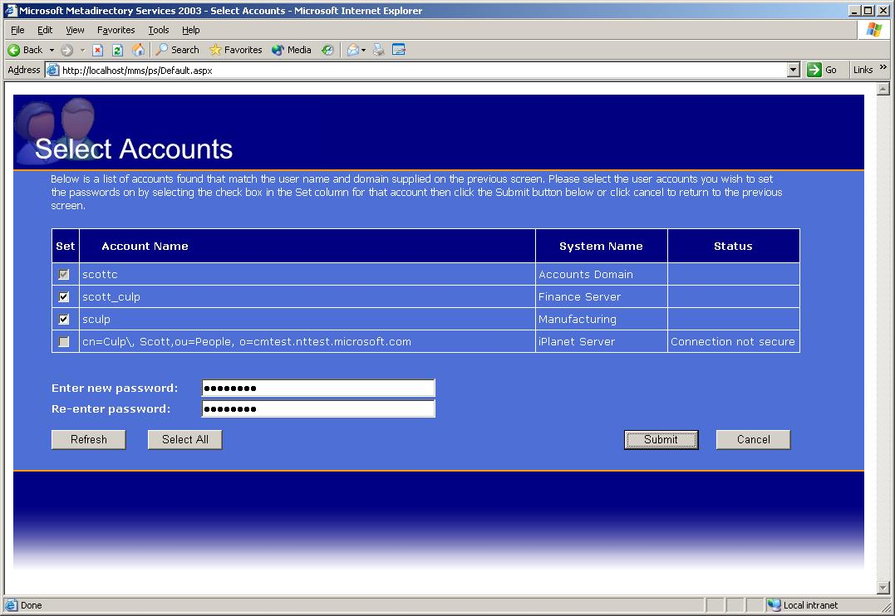
The example above shows the user “Scott Culp” using a Web browser to selectively change his password on a number of systems.

Preview Mode
Any connector space object can be selected and run in preview mode to see what rules are applied and how it is synchronized with other connected directories or sources. This can be done without actually causing any changes to be made to any identity information. Preview mode is simply a simulation of the rules that would apply and how that object would subsequently be synchronized with other systems. Preview mode is invaluable during testing, development, or debugging. Other products leave it up to the administrator to debug complex code or programs in order to determine what is going on in the background.

Provisioning
Provisioning is the process of creating, connecting, and disconnecting objects in the connector space, based upon changes to those objects. Provisioning performs object-level actions, such as:
- Creating a new connector space object and setting initial attribute values, that are not part of export attribute flow, on the object.
- Disconnecting connector space objects from the metaverse.
- Renaming and moving existing connectors--that is, changing the distinguished name attribute (DN).
Provisioning is implemented by creating a custom extension and enabling its use. The custom extension is run whenever a metaverse object is modified. Provisioning can be enabled or disabled using the Configure Rules Extensions dialog on the Tool menu. When the provisioning rules are enabled, they affect all objects in the metaverse. Provisioning rules are called whenever:
- An attribute has been added, modified, or deleted by import attribute flow rules.
- A connector space object has been joined to a metaverse object.
- A connector space object has been projected to the metaverse.
- A connector space object has been disconnected or connected using Joiner.
- A connector space object has been disconnected from a metaverse object and the metaverse object has not been deleted.
- Rules are re-evaluated during the run of a management agent.
The custom extension for provisioning rules can take advantage of the transactional capabilities of MIIS 2003. In the case where a connector space object is provisioned to multiple connected data sources and one fails, the complete synchronization operation will fail by default. The custom extension can be written to catch errors and handle them on a management agent basis by:
- Calling a routine to handle the error and then proceeding with the synchronization. In this case, the synchronization will succeed.
- Reporting the error to MIIS. In this case, the synchronization of this object will fail.
- Ignoring the error. In this case, the synchronization of this object will fail.
If you are synchronizing with a connected data source that uses a hierarchical structure, it is important to note that MIIS 2003 does not export container operations. That is, if you are provisioning a child object, MIIS 2003 will not create the parent automatically. Directory management of containers with hierarchies must be done completely in the connected data source.

Deprovisioning
Deprovisioning rules are defined per management agent, and are called when a connector space object is disconnected from a metaverse object. Deprovisioning rules can be selected using the management agent properties in the Identity Manager, or can be defined using a custom extension.
The options available in the Identity Manager are:
- Make the connector space object a disconnector.
- Make the connector space object an explicit disconnector. This is the default behavior.
- Delete the connector space object.
By using a custom extension, when a connector space object is disconnected from the metaverse, you can specify different actions, such as:
- Specify a disconnector state (in other words, normal or explicit).
- Rename or move the connector space object. (In other words, change the DN attribute.)
- Set attributes on the connector space object for export. (For example, you may want to set the AccountDisabled flag on any user account that has been disconnected.)
Deprovisioning rules are not called when an object is disconnected using Joiner or the Connector filter. They are only called when the provisioning rules disconnect an object.

Windows Management Instrumentation
MIIS 2003 continues to integrate extensively with both the Windows Event Log and Performance Monitor (PerfMon). In addition, in MIIS 2003 we have built in a Windows Management Instrumentation (WMI) interface. This WMI integration allows MIIS 2003 to be interfaced to management consoles like Microsoft Operations Manager (MOM), HP OpenView, Tivoli, and other third-party consoles. Through the scripting interfaces to WMI an administrator can easily develop operational WMI scripts and applications using VBS or other languages that can start, stop, or launch management agents; check for status or errors; or generate statistical reports.

Summary
Microsoft Identity Integration Server 2003 is the third major release of Microsoft’s identity life-cycle management product. This release reflects over five years of deployment experience with hundreds of customers that represent millions of identities managed by MIIS. Building on this experience, Microsoft has elevated identity life-cycle management to new levels with MIIS 2003 by making it:
- Extensible and scalable in order to meet the most demanding requirements.
- Easier to design, deploy, and operate without requiring extensive consulting services.
- Beneficial for use by an organization of any size.
With the integration of MIIS 2003 with Windows Server 2003, Enterprise Edition; SQL Server 2000; and Visual Studio .NET, a company can benefit from the latest advances in operating systems, programming environments, database scalability, and security. Whether integrated with Active Directory or not, MIIS 2003 is a company’s best choice for a scalable, reliable identity life-cycle management system.

Related Links
See the following resources for further information:
- Microsoft Identity Integration Server 2003 Partners at http://www.microsoft.com/windowsserversystem/miis2003/partners/default.mspx.
- Microsoft Identity Integration Server 2003 Password Management at http://www.microsoft.com/windowsserversystem/miis2003/techinfo/planning/miispass.mspx.
- Microsoft Identity Integration Server 2003 High Availability Planning at http://www.microsoft.com/windowsserversystem/miis2003/techinfo/planning/highavail.mspx.
- Microsoft Identity Integration Server 2003 home page at http://www.microsoft.com/miis.
For the latest information about Windows Server 2003, see the Windows Server 2003 Web site at http://www.microsoft.com/windowsserver2003.

This white paper is specific to the functionality of MIIS 2003, Enterprise Edition, with Service Pack 1 (SP1)

