Improving an IT Self-Help Portal User Experience
Published: September 2006
Migrating from Microsoft® Content Management Server (MCMS) 2002 to Microsoft Office SharePoint® Server 2007 has enabled Microsoft Information Technology (Microsoft IT) to improve its self-help support portal, called ITWeb. The ITWeb site now provides more personalized content to users, improved search features, improved content creation, and streamlined workflow. The new solution also requires less support effort.
One of the first places where Microsoft employees look for information—for example, to purchase equipment or find help with a technical problem—is the ITWeb site. ITWeb is Microsoft IT’s face to the company. It is a rich content portal to provide employees worldwide with the tools and knowledge that they need to be productive.
Situation
Microsoft needed to improve the user experience with its internal IT self-help portal. The existing solution made the process of creating, maintaining, and locating content too difficult.
Solution
Microsoft migrated the content from the existing the self-help portal in Content Management Server 2002 to SharePoint Server 2007.
Benefits
Migrating the solution to SharePoint Server 2007 improved the user experience by providing better:
- Content authoring and management.
- Navigation and search.
- Integration and customization.
- Uptime and response time.
Products & Technologies
- Content Management Server 2002
- Office SharePoint Server 2007
- The 2007 Microsoft Office system
The previous version of ITWeb was based on MCMS 2002. Although that solution met the business requirements when Microsoft IT implemented it, the growing need for improvement in the services provided by ITWeb necessitated an update of the site's functionality.
To help address these growing business requirements, Microsoft IT took advantage of the features of Office SharePoint Server 2007. This document discusses the migration of ITWeb from MCMS 2002 to SharePoint Server 2007. It is intended for chief information officers, IT directors, software development executives and managers, solution architects, and technical decision makers who are considering a similar solution.
Situation
Microsoft IT understands that knowledge is a valuable commodity. The ITWeb site uses Microsoft technologies to enable employees to access the tools, services, and information that they need to be successful anywhere, anytime, on any device. The goal of ITWeb is to provide employees with:
- IT information that is easy to locate.
- IT self-help services that are easy to use.
- Engaging content that contains richly formatted content and graphics.
- Relevant articles and topics that help employees perform their job functions.
Providing self-help support desk functions through ITWeb greatly reduces live and in-person support costs. The ability to provide users with help in resolving common technical problems at any time of the day also increases employee efficiency.
Another important function of ITWeb is to provide an easy way for users throughout Microsoft to create a team Web presence. Users share their organizational information with other groups and individuals through team sites for collaboration on projects.
Microsoft has over 65,000 employees worldwide. In a single day, thousands of employees turn to ITWeb for help in solving problems. On the average, ITWeb receives 9,000 page requests per day, making it one of the most highly used internal sites.
For most of the employees at Microsoft, ITWeb is an integral part of their day-to-day activities. Any outages in service directly affect the efficiency of these employees. Also, employees expect to find the most current information about technology services and how to use them, service level delivery, and real-time availability on ITWeb. Therefore, ensuring that IT service managers can easily update the portal's content is key. Service managers are responsible for delivering information such as:
- IT services that Microsoft IT provides.
- Current status of key infrastructure services (such as the status of Microsoft Exchange servers).
- Security updates that are currently active.
- Products that are being tested internally.
- Hardware standards that Microsoft IT supports.
- Software products that are available for download.
- Troubleshooting tips for resolving common issues.
- Productivity tools that are available to help in performing job functions.
Many improvements in products and technologies have occurred since Microsoft IT initially deployed the MCMS 2002 version of ITWeb. Most of the custom-developed features in the MCMS 2002–based solution are now standard features in newer products, like SharePoint Server 2007.
Also, employees are using Web-based technologies to proactively communicate their projects, ideas, and interests. Some of these ways of communication include blogs, newsgroups, discussion boards, and other collaborative tools. SharePoint Server 2007 includes many of these technologies as well.
The MCMS 2002 solution addressed business requirements at the time of its deployment five years ago. However, it presented the following limitations as business requirements evolved:
- Outdated or irrelevant content. The solution did not allow for the easy identification of outdated or irrelevant content.
- Inconsistent content authoring and management. The authoring process did not always produce WYSIWYG results. Published content might not be formatted identically to the format as shown in the authoring tools.
- Inadequate content approval process. The requirements for the content approval workflow process are more complex now than they were when the solution was originally deployed. The existing approval workflow was inadequate to meet the current requirements without further customization.
- Limited collaboration. Employees want to share their ideas and project statuses with other employees. The solution limited the tools, products, and technologies available to employees for collaboration. And, the collaboration tools, products, and technologies that were used were scattered across multiple sites.
- Inability to personalize content. Because of the continuous growth of content, personalizing content helps users find the information they are looking for. However, the solution did not support personalization. Content was the same for all users.
- Insufficiently secured content. The solution did not provide sufficient content protection through the editing, approval, and publishing process. Only authorized users should have access to the content.
- Lack of integration with available business data. The solution did not integrate the business data from the various systems within Microsoft. In many instances, users had to access this data through multiple tools.
- Inadequate site navigation. The navigation methods used on ITWeb were inadequate for locating all the content available on the Microsoft intranet. The existing navigation structure was not easily modified to adapt to the changing structure of internal sites and content.
- Inaccurate search facilities. The search facilities did not include all the data within the Microsoft intranet. In addition, users could see search results that they were not authorized to view, which presented potential security issues.
- Duplication for multiple-language support. Developers provided language support by creating a separate instance of content for each language. The site structure, hierarchy, and features were duplicated for each language supported.
- High level of customization. The solution was heavily customized and required a lot of development effort. Changes to the solution required more customization and development.
Solution
The way organizations conduct business has changed as much on intranets as on the Internet. Social-business is a new trend in which people are proactively posting content relevant to their jobs on their business sites, and they are subscribing to other peoples' content. To support this productivity-positive trend, portals like ITWeb also need to proactively provide customized information based on what services a user consumes.
By migrating ITWeb to a SharePoint Server 2007–based solution, Microsoft IT realized the following benefits. Most of them are standard features of SharePoint Server 2007 and required minimal or no customization.
Content Authoring and Management
The new solution uses the Enterprise Content Management (ECM) feature in SharePoint Server 2007. This feature provides the following benefits in the area of content authoring and management:
- Content creation, editing, and formatting. New client-side tools improve authoring of content. Content authors have a better representation of how the content will appear on the site than in the previous solution.
- Site creation and formatting. The site creation tools enable users to create sites and post content to the sites. Site templates make changes to the style, layout, and user interface of a site (through cascading style sheets). For example, themes can be applied to sites to change the color schemes. Subordinate sites inherit the templates from the parent site, so the appearance of a site can be updated and managed in one location. In addition, creation of a site map is highly automated, so any updates to the site map (such as the addition of a new site) can be automatically reflected on the site.
- Automatic content expiration and archiving. Content authors and administrators can set content expiration dates and set whether the content should be archived when it expires. This ability helps reduce the effort required to manage the content.
- Content creation and approval workflow. The new workflow features of SharePoint Server 2007 enable the creation of complex workflow processes through minimal (or no) end-user development effort. The complexity of customizing the workflow is directly related to the complexity of the process being automated.
- Collaboration. Employees can share their ideas and projects with other employees by using the collaborative features of SharePoint Server 2007. The new solution enables employees to connect with each other more effectively than ever before.
- Content security. SharePoint Server 2007 helps protect access to content. Content owners can establish permissions to help ensure that only authorized users can view or modify the appropriate data. Content owners can apply security to data on an item-by-item basis.
- Content update notification. Users can subscribe to notifications for content updates. If content is added or modified, users can receive e-mail notification of the changes. In addition, users can be notified when content they create is almost expired and soon to be deleted or archived.
- Multiple-language support. SharePoint Server 2007 enables the display of content in the same format, but in different languages. The site hierarchy remains the same, but the content displayed is localized based on the language preferences of the user (when available).
Navigation and Search
The following benefits affect navigation and search features:
- Consolidated view of Microsoft IT. SharePoint Server 2007 gives users a single source for locating any information within the Microsoft corporate network. One of the key features of SharePoint Server 2007 is to act as an organization-wide portal. The IT Service Catalog portal that Microsoft IT created exists within the ITWeb portal and provides a consolidated view of Microsoft IT services with links to additional content about those services.
- Customizable hierarchy. Administrators can dynamically modify the structure of the site without modifying the content or the format of the pages where the content appears.
- Personalized content. SharePoint Server 2007 enables users to view personalized content through targeted content and their own portal sites. The personal portal sites help users find and save locations for pertinent information. Users can customize their sites to their business requirements.
- Content categorization and tagging. Content can be categorized and tagged to be highlighted in the search engine or through site navigation. Users can then find information faster with fewer results that contain unrelated information.
- Content search across multiple content sources. Users can search content stored in a variety of content sources (not only the content stored in SharePoint Server 2007). These content sources are products and technologies that store content that SharePoint Server 2007 will index. The content sources that can be indexed and searched include:
- Other SharePoint Server 2007, Microsoft Office SharePoint Portal Server 2003, and Microsoft Windows® SharePoint Services 2.0 sites.
- Shared folders.
- Web site content.
- Exchange public folders.
- Content security. Search results include only results where the user has at least read access to the content.
- Faster search. SharePoint Server 2007 has improved indexing and search capabilities. In addition, users can restrict the scope of searches to reduce the number of results, which reduces the time taken to search. Multiple search servers can be added to the solution to improve overall search performance. This feature of SharePoint Server 2007 requires no customization after the search servers are deployed.
Integration and Customization
The following benefits affect integration and customization of the solution:
- Web Parts. Integration with other business systems (such as Helpdesk and trouble ticket submission) enables real-time updates to information on the site. Some of the Web Parts used in the solution are parts of products and required no customization for the solution (such as the Exchange Web Parts). Some custom Web Parts are a part of the solution but required less time to develop than traditional Web applets. In general, the level of customization required depends on the complexity of the Web Part being developed.
- Microsoft Office InfoPath® forms. One of the components of the trouble ticket solution is the use of Office InfoPath 2007. InfoPath automatically populates forms by collecting information from the employee's computer. The populated trouble ticket is then submitted to the Helpdesk for resolution.
- Single sign-on. Users authenticated by SharePoint Server 2007 can access other systems (such as SAP) without supplying additional credentials. The single sign-on feature allows the authenticated users to access other systems through ITWeb by using different credentials but signing on only once. The use of the different credentials is transparent to the users.
- Off-the-shelf solution. Because Microsoft Windows Server System™ products (such as Microsoft SQL Server™ and Microsoft Exchange Server) contain integration features, less customization is required.
Uptime and Response Time
The following benefits affect uptime and response time:
- Clustered front-end and back-end architecture. SharePoint Server 2007 runs as a Microsoft ASP.NET application on Internet Information Services (IIS) version 6.0. The content and configuration database is stored in SQL Server. The solution uses a load balancing solution (such as Network Load Balancing in Microsoft Windows Server® 2003) to provide fault tolerance for the front-end portion that runs on IIS 6.0. Server clusters provide fault tolerance for the database's store in SQL Server.
- Scalability. The solution uses the multiprocessor and enhanced memory features of Windows Server 2003 to scale up the solution to support a larger number of users per physical computer. The clustering technologies (Network Load Balancing and server clusters) enable Microsoft IT to scale out the solution.
Migration to Office SharePoint Server 2007
Microsoft IT took the following steps in the migration from MCMS 2002 to SharePoint Server 2007:
- Migrate the MCMS 2002 content to SharePoint Server 2007.
- Migrate applications from MCMS 2002 to SharePoint Server 2007.
- Develop the approval workflow.
- Develop custom Web Parts.
Microsoft IT had to ensure that the migration from the MCMS 2002 solution to SharePoint Server 2007 caused minimal outages of required services. To accomplish this, Microsoft IT co-hosted the services. That is, during the migration process, Microsoft IT ran the MCMS 2002–based and SharePoint Server 2007–based solutions on the same computers in the same Web farm. This approach enabled Microsoft IT to complete the migration at a reasonable pace and helped ensure continuous service.
Migrating Content
SharePoint Server 2007 has a built-in tool for migrating content from MCMS 2002: the Content Management Server Migration tool. This tool migrates the following parts of an MCMS 2002 installation into a SharePoint Server 2007 site collection:
- Channels, postings, and all placeholder content
- Resource galleries and resources
- Template galleries and template gallery items (not the ASP.NET files)
- Rights groups and users
- Custom properties
Upon completion of migrating the content, the tool:
- Creates a functional site that contains all the migrated content.
- Provides an unbranded master page.
- Generates unbranded page layouts for each template that is in the source channel.
Note: After the Content Management Server Migration tool completes the preceding process, the content files can be customized to match the desired branding.
Some of the content on ITWeb required manual migration in addition to the content that was migrated through the Content Management Server Migration tool. However, the amount of the manual migration was minimal.
This process is discussed in more detail in the "Content Migration" section of the article "Planning MCMS 2002 Application Migration to SharePoint Server 2007," available at http://msdn.microsoft.com/office/server/moss/2007/migration/default.aspx?pull=/library/en-us/dnmscms02/html/CMS2002PlanningForMigration.asp.
Migrating Applications
After the content was migrated, Microsoft IT had a functioning SharePoint Server 2007 site that contained the content. In addition, the site contained a set of unbranded page layouts. To migrate the code in the applications, Microsoft IT did the following:
- Edit each unbranded template page layout.
- Upgrade any Microsoft ASP.NET version 2.0 master pages used in the MCMS 2002 site.
- Add or rewrite custom controls by using the templates.
The amount of code required to develop a SharePoint Server 2007 site is significantly less than the code required to create an MCMS 2002 site. In addition, SharePoint Server 2007 provides a lot of default functionality that MCMS 2002 does not contain. This means that no code migration to SharePoint Server 2007 should ever require a 100 percent rewrite. Many of the custom code features of MCMS 2002 are standard features in SharePoint Server 2007, as shown in Table 1.
Table 1. MCMS 2002 Custom Code Features Standard in SharePoint Server 2007
MCMS 2002 feature | SharePoint Server 2007 feature
Navigation | ASP.NET–based navigation provider model.
Search | Integrated indexing and searching of content stored in SharePoint Server 2007 and in other content sources. For more information, see the software development kit (SDK) topic "Searching in Office SharePoint Server 2007" at http://msdn2.microsoft.com/en-us/ms497338(office.12).aspx.
Summary pages | Summary Links control. This control enables users to create summaries that include a link, a description, and an image, and to set a display style for the summary. Users can organize summary links into groups and can sort the links by using a drag-and-drop operation.  Content by Query control. This control enables users to easily define queries that return links to pages that match certain criteria and then style the results.  Table of Contents control. This control enables authors to create and style a hierarchical view of pages.
Deployment scripts | Built-in content deployment user interface.
Form login screens | ASP.NET–based authentication provider model.

This process of migrating applications is discussed in more detail in:
- The "Code Migration" section of the article "Planning MCMS 2002 Application Migration to SharePoint Server 2007," available at http://msdn.microsoft.com/office/server/moss/2007/migration/default.aspx?pull=/library/en-us/dnmscms02/html/CMS2002PlanningForMigration.asp.
- The article "Mapping MCMS 2002 APIs to SharePoint Server 2007," available at http://msdn.microsoft.com/office/server/moss/2007/migration/default.aspx?pull=/library/en-us/dnmscms02/html/CMSVersionAPIDiffs.asp.
- The article "Assessing and Analyzing Your MCMS 2002 Application for Migration," available at http://msdn.microsoft.com/office/server/moss/2007/migration/default.aspx?pull=/library/en-us/dnmscms02/html/CMSAssessAnalyzing2002Application.asp.
Developing Approval Workflow
SharePoint Server 2007 builds on and extends the workflow development framework in Microsoft Windows SharePoint Services 3.0. Workflow developers have access to the entire range of workflow development options in Windows SharePoint Services 3.0. They can also use Office InfoPath 2007 to create forms that can be hosted inside applications such as Microsoft Office Word, Microsoft Office PowerPoint®, and Microsoft Office Excel®, as well as on the server.
The ITWeb team developed the workflows by using the following applications:
- Windows Workflow Foundation Designer for Windows Workflow Foundation in Microsoft Visual Studio® 2005 to develop workflows that include custom code and InfoPath forms.
- Microsoft Office SharePoint Designer 2007 to develop declarative, rules-based workflows that contain no code and are developed for a specific SharePoint site.
Figure 1 illustrates the technologies that can be used to develop workflows for SharePoint Server 2007.
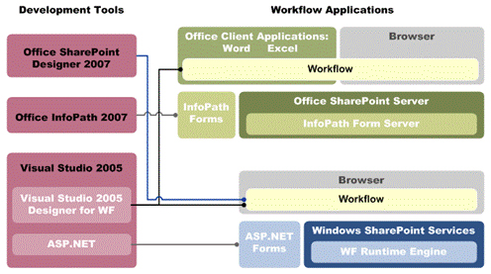
Figure 1. Technologies used to develop workflow for SharePoint Server 2007
This process is discussed in more detail in:
- The SDK topic "Workflows in Office SharePoint Server 2007," available at http://msdn2.microsoft.com/en-us/library/ms549489.aspx.
- The SDK topic "Workflow Development for Windows SharePoint Services," available at http://msdn2.microsoft.com/en-us/library/ms414613.aspx.
Developing Custom Web Parts
As the final step in the migration process, Microsoft IT developed custom Web Parts to integrate other business systems and to provide extended functionality. For example, in the case of ITWeb, Microsoft IT wanted to provide users with a dashboard where they can get status information about critical services (such as Exchange server status) and other features. This Web Part is located at the bottom of the ITWeb home page, as illustrated in Figure 2.
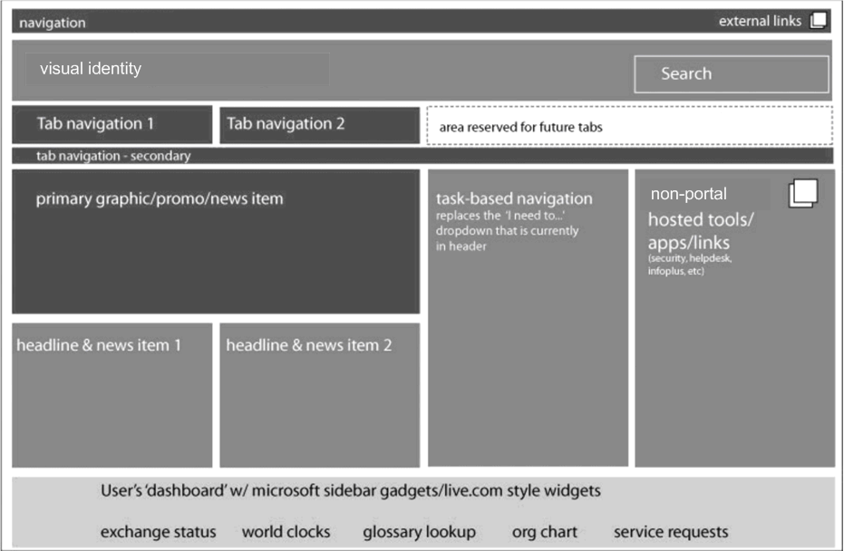
Figure 2. Layout of ITWeb home page
Users can customize the dashboard Web Part. Figure 3 illustrates the user dashboard with the My Information, Exchange Status, World Clocks, Glossary Lookup, Org Chart, and Service Requests features.
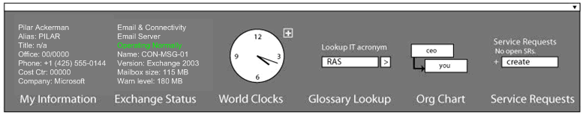
Figure 3. Example of user dashboard Web Part
Figure 4 illustrates the same user dashboard but with multiple world clocks displayed and the My Information, Glossary Lookup, and Org Chart features minimized.
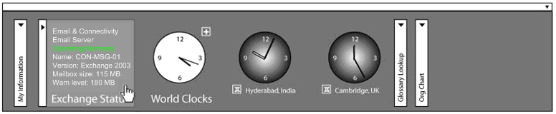
Figure 4. Example of the user dashboard with multiple world clocks
Accommodating Content That Cannot Be Migrated
Despite best efforts, most existing solutions have content that cannot be migrated entirely to the SharePoint Server 2007 environment. The content cannot be migrated typically because of the complexity of the content and the functionality of some Web site components. In the case of ITWeb, custom-developed Web-based tools and other Active Server Pages (ASP) pages existed. These tools and ASP pages performed certain functionality outside the normal content authoring and publishing functions. MCMS did not originally manage these tools and ASP pages in the MCMS 2002 solution.
To maintain consistency and performance within the SharePoint Server 2007 environment, the ITWeb team decided to host these tools and other ASP pages outside the SharePoint Server 2007 environment. This choice enables users to use these tools and other ASP pages without affecting the overall SharePoint Server 2007 environment. Reducing the impact on the SharePoint Server 2007 environment helped reduce the time for troubleshooting and other maintenance tasks.
Microsoft integrated these tools and other ASP pages with the SharePoint 2007 solution by:
- Adding the appropriate links between the SharePoint Server 2007 sites and the other sites so that users can easily locate content between the other sites.
- Including the sites that host the content in the indexing process to ensure that users can search for information on the sites (where appropriate).
Best Practices
During the process of developing and deploying the new ITWeb solution, Microsoft IT gained practical, real-world experience with migrating an MCMS 2002–based solution to SharePoint Server 2007. This experience has resulted in the following best practices:
- Run MCMS 2002 and SharePoint Server 2007 solutions simultaneously. This method enables the migration process to occur in stages without service interruption.
- Migrate all MCMS 2002 content into a test environment. An organization should ensure that migration in a test environment is successful before performing production migrations. Migrating in a test environment first helps reduce the risks in migrating in the production environment.
- Migrate MCMS 2002 to provide equivalent functionality before modifying the site. An organization should focus on migrating the MCMS 2002 content and applications first to reduce the number of changes introduced. After the migration is successful, the organization can modify the site to extend functionality.
- Access databases by using a published application programming interface (API). An organization should avoid directly accessing a database in an attempt to make migration easier. Instead, it should use the published APIs for database access.
- Minimize the number of templates. Reducing the number of templates reduces the amount of effort in porting templates during the migration process.
- Avoid embedding business logic directly in MCMS templates. Embedding business logic directly in templates requires more effort during migration. Instead, an organization should place business logic in a control placed in MCMS 2002 templates that can be easily migrated to SharePoint Server 2007.
- Use ASP.NET master pages in MCMS 2002 templates. The use of ASP.NET master pages encapsulates styles, layout, and other site branding artifacts and reduces the effort in migration.
- Use Visual Studio 2005 provider models for navigation and forms login. Using the navigation and logon controls in existing MCMS 2002 solutions makes the migration easier. During the migration of navigation and forms logon, an organization can simply change from the Visual Studio 2005 providers to the SharePoint Server 2007 providers.
Conclusion
By migrating the ITWeb solution from MCMS 2002 to SharePoint Server 2007, Microsoft improved the user experience, reduced Helpdesk costs, and gained the ability to publish more engaging and timelier information. These benefits, and others, improved the following aspects of the solution:
- Content authoring and management
- Navigation and search
- Integration and customization
- Uptime and response time
Microsoft IT achieved all of these benefits with less development effort by using the features of SharePoint Server 2007, the 2007 Microsoft Office system, and Visual Studio 2005.
For More Information
For more information about Microsoft products or services, call the Microsoft Sales Information Center at (800) 426-9400. In Canada, call the Microsoft Canada information Centre at (800) 563-9048. Outside the 50 United States and Canada, please contact your local Microsoft subsidiary. To access information through the World Wide Web, go to:
http://www.microsoft.com
http://www.microsoft.com/technet/itshowcase
http://msdn.microsoft.com/office/server/moss/2007/migration/default.aspx?pull=/library/en-us/dnmscms02/html/CMSAssessAnalyzing2002Application.asp
http://msdn.microsoft.com/office/server/moss/2007/migration/default.aspx?pull=/library/en-us/dnmscms02/html/CMS2002PlanningForMigration.asp

© 2006 Microsoft Corporation. All rights reserved.
This document is for informational purposes only. MICROSOFT MAKES NO WARRANTIES, EXPRESS OR IMPLIED, IN THIS SUMMARY. Microsoft, Excel, InfoPath, PowerPoint, SharePoint, Visual Studio, Windows, Windows Server, and Windows Server System are either registered trademarks or trademarks of Microsoft Corporation in the United States and/or other countries. The names of actual companies and products mentioned herein may be the trademarks of their respective owners.

