Microsoft® Business Solutions−Axapta® Human Resource Management I
Microsoft Business Solutions−Axapta Human Resource Management (HRM) I helps you gather and structure information to get an optimal overview of your employees and your organization.

Key Benefits:
- Strengthened focus on employee competency
- Centralized and dynamic employee information
- Simple and dynamic restructuring of organizational units

Key Features:
- Core HRM administrative functionality
- Payroll information
- Job application information storage
- Management of line, matrix and project organizations
- Visual, function-oriented organizational charts
Microsoft Business Solutions−Axapta Human Resource Management I helps you manage employees as well as structure knowledge and competence areas. Your business must be able to keep up with the changing business environment, and an agile HRM system will make it possible for you to quickly adapt your organization to meet these new challenges.
Microsoft Axapta Human Resource Management is divided into three modules. This means you can get the functionality you need right now, and implement more modules as your business grows.
HRM I: Core administration for employees and HR professionals
HRM II: Recruitment and absence management
HRM III: Strategic HR

Core functionality
With Microsoft Axapta Resource Management I, you can store employment information and agreements, note the reasons for a resignation and keep track of transfers between departments. The framework is easily adapted to fit the specific needs and requirements of your business so you can pull out exactly the data and information you need.

Modeling organizational units
Keep track of the organizational changes going on in your business. With the visual, function-oriented diagrams you can create organizational charts of the entire organization, a matrix organization or even a project organization. You can easily change the program framework to reflect any changes in your organizational structure and create new cross-units simply by using the drag and drop function.

The employee database
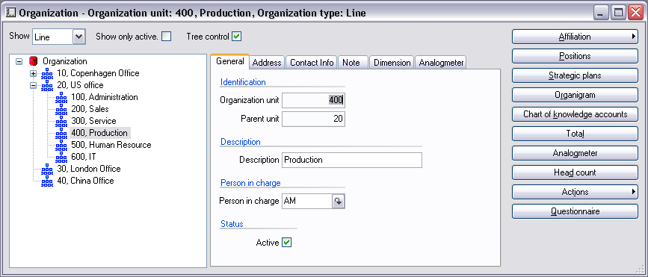
Create organizational charts
Store all the information about your employees in the employee database. Use this central database to store résumés, primary contacts, and contract and payroll information. This is the only place you will have to look for employee-related information and the only place you need to update.
Historical data is available at any time from the system view of employees or organizational units. If you want to see the older versions of an organizational chart or the employment history of a specific employee, it is all there in the database and you can retrieve it just by clicking a button.

Employee profiles
Microsoft Axapta Human Resource Management I provides a framework for maintaining employee profiles. You can use the profiles to maintain basic data, enter key dates, document employee accomplishments or store information regarding education. The database can also be used to record information regarding an employee’s title, responsibility, qualifications, project participation and business experience.
When you need to find the most suitable person for a specific project or for a new position, the employee profiles can immediately show you which of your resources would be best suited for the job.

Supplementary employee information
In addition to the employee profiles, you can maintain payroll information for every single employee. Bank account numbers, tax numbers, pension schemes and accrued vacation can all be stored for each employee. You can also keep track of variables such as bonuses, stock options, health insurance, and other employee-specific supplements.

Manage benefits and loans
Microsoft Axapta Human Resource Management makes it easy to monitor benefits that have been agreed with an employee. It also provides effective tracking of items that are loaned out, such as mobile phones, computers and access cards. All these items can be categorized, with administration of responsibility by defined time periods for the loans. This means that you can optimize the usage of the loan items and also be sure that they will be returned.
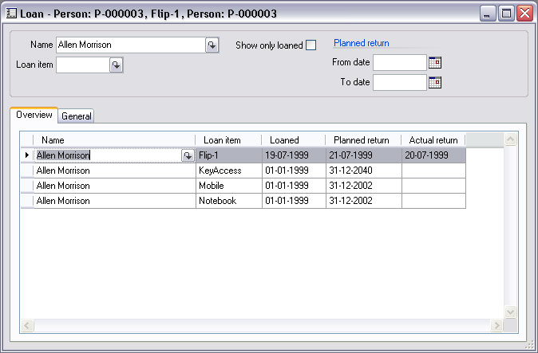
Loan administration

Contact your partner
To learn more about Microsoft Business Solutions−Axapta, contact your local Microsoft Certified Business Solutions Partner. They have the expertise necessary to meet your specific business needs.

About Microsoft Business Solutions
Microsoft Business Solutions, a division of Microsoft, offers a wide range of integrated, end-to-end business applications and services designed to help small, midmarket and corporate businesses become more connected with customers, employees, partners and suppliers. Microsoft Business Solutions' applications optimize strategic business processes across financial management, analytics, human resources management, project management, customer relationship management, field service management, supply chain management, e-commerce, manufacturing and retail management. The applications are designed to provide insight to help customers achieve business success. More information about Microsoft Business Solutions can be found at www.microsoft.com/BusinessSolutions.

Address:
Microsoft Business Solutions
Frydenlunds Allé 6
2950 Vedbaek
Denmark
Tel +45 45 67 80 00
Fax +45 45 67 80 01
www.microsoft.com/BusinessSolutions

Key Features | Description
Easy to Use | - Intuitive layout and structure  - User-adjustable menus, forms and reports  - User-adjustable layout of main tables and journals  - Windows commands incl. ‘copy and paste’ from and to Microsoft Axapta  - Direct access to main tables from journals  - Advanced sorting and filter options  - Built-in user help including an integrated manual  - Option to mail and fax directly from Microsoft Axapta  - Application can be run in different languages
Core HRM | - Core human resource management administrative functionality  - Payroll information  - Historical data storage  - Job application information storage  - Registration of benefits  - Management of loans  - Reports for follow-up, periodic reporting and decision support for management
Organization | - Manage line, matrix and project organizations  - Maintain the organizational structure and create new cross-units  - Visual, function-oriented organizational charts

System Requirements
To obtain all of the features mentioned in this fact sheet,  the following modules and technologies are required: | - Microsoft Business Solutions−Axapta 3.0  - Microsoft Business Solutions−Axapta Human Resource I
14.04.2003
© 2003 Microsoft Business Solutions ApS, Denmark. All rights reserved. Microsoft, Great Plains, Navision, FRx, *list other trademarks mentioned are either registered trademarks or trademarks of Microsoft Corporation, Great Plains Software, Inc., FRx Software Corporation, or Microsoft Business Solutions ApS or their affiliates in the United States and/or other countries. Great Plains Software, Inc., FRx Software Corporation, and Microsoft Business Solutions ApS are subsidiaries of Microsoft Corporation. The names of actual companies and products mentioned herein may be the trademarks of their respective owners. The example companies, organizations, products, domain names, email addresses, logos, people and events depicted herein are fictitious. No association with any real company, organization, product, domain name, e-mail address, logo, person, or event is intended or should be inferred.

