

Using the Wireless Provisioning Services (WPS) Technology Authoring Tool
Microsoft Corporation
Published: February 2005
Author: James McIllece

Abstract
Describes how to configure XML files and create a sign-up wizard with the Wireless Provisioning Services (WPS) technology XML file authoring tool.

Information in this document, including URL and other Internet Web site references, is subject to change without notice. Unless otherwise noted, the example companies, organizations, products, domain names, e-mail addresses, logos, people, places, and events depicted herein are fictitious, and no association with any real company, organization, product, domain name, e-mail address, logo, person, place, or event is intended or should be inferred. Complying with all applicable copyright laws is the responsibility of the user. Without limiting the rights under copyright, no part of this document may be reproduced, stored in or introduced into a retrieval system, or transmitted in any form or by any means (electronic, mechanical, photocopying, recording, or otherwise), or for any purpose, without the express written permission of Microsoft Corporation.

Microsoft may have patents, patent applications, trademarks, copyrights, or other intellectual property rights covering subject matter in this document. Except as expressly provided in any written license agreement from Microsoft, the furnishing of this document does not give you any license to these patents, trademarks, copyrights, or other intellectual property.

© 2005 Microsoft Corporation. All rights reserved.

Microsoft, Active Directory, Windows, Windows logo, and Windows Server are either registered trademarks or trademarks of Microsoft Corporation in the United States and/or other countries.

All other trademarks are property of their respective owners.

Contents
Using the Wireless Provisioning Services (WPS) Technology Authoring Tool 1
Abstract 1
Contents 3
Introduction (Using the Wireless Provisioning Services (WPS) Technology Authoring Tool) 7
The WPS Authoring Tool 8
Requirements 10
Understanding the Graphical User Interface 11
The Master File node 11
The Wizard Panels (All Languages) node 13
Wizard panel descriptions 13
How to create XML master file and subfiles 15
To configure an XML master file 15
To configure an XML SSID subfile 16
To configure an XML branding subfile 17
To configure an XML location subfile 18
To configure an XML help subfile 19
To create a help file or plan description file in MHTML format 19
To configure an XML connection subfile 20
To obtain the SHA-1 hash of a trusted root CA certificate 22
How to create a sign-up wizard 24
Planning your sign-up wizard 24
Configuring file information and connection plans 25
Creating connection plans 26
Configuring individual plans 28
Creating wizard panels for each connection plan 29
Welcome panel 29
Plan Selection panel 31
Promotional Code panel 32
Personal Info panel 34
Contact Info panel 37
Privacy Options panel 39
Credit Card panel 42
Billing Info panel 44
Coupon panel 47
Credentials panel 49
Terms panel 52
Creating account panel 54
Completion panel 54
Completing plan selection configuration 54
Previewing your sign-up wizard 55
How to create XML files for languages other than English 56
To create XML subfiles for additional languages 56
How to create a sign-up wizard for languages other than English 57
Appendix A: Worksheet for WPS Sign-up Wizard Panels 58
Access plan information 58
Plan 1 58
Plan 2 58
Plan 3 59
Welcome panel 59
Plan Selection panel 59
Promotional Code panel 59
Personal Info panel 60
first-name 60
middle-initial 60
last-name 61
suffix 61
company 61
job-title 62
Contact Info panel 62
address1 62
address2 62
city 63
zipcode 63
telephone1 63
telephone2 64
Privacy options panel 64
Credit Card panel 64
card-number 65
card-expdate 65
card-securitycode 65
Billing Info panel 66
first-name 66
middle-initial 66
last-name 66
suffix 67
address1 67
address2 67
city 68
zipcode 68
telephone1 68
telephone2 69
Coupon panel 69
coupon 69
Credentials panel 69
username 70
password 70
Terms panel 70
Creating account panel 70
Completion panel 71
Appendix B: XML files 71
XML master file 71
XML SSID subfile 72
XML branding subfile 73
XML location subfile 76
XML connection subfile 77
XML wizard subfile 78
XML sign-up wizard subfile 78

Introduction (Using the Wireless Provisioning Services (WPS) Technology Authoring Tool)
By using Wireless Provisioning Services (WPS) technology, your organization can offer wireless access in any location where you provide connectivity with Wi-Fi hotspots to new and existing customers that have computers running Windows XP with Service Pack 2 (SP2).
When you deploy WPS technology, you must configure XML master file and subfiles that contain configuration settings for client computers connecting to your network. These XML files are downloaded by client computers during the provisioning process. The settings in the XML files are used by Windows XP with SP2 to automatically configure the client computer network settings.
There are two methods you can use to create and configure your XML master file and subfiles:
• Use the WPS Authoring Tool to create a WPS project and publish your XML master file and subfiles to the provisioning server. The WPS Authoring Tool has a graphical user interface and assists you in accurately producing and managing a collection of XML files for your WPS solution. Using the WPS Authoring Tool to create your XML data files is recommended, because it is based on the XML schema and allows you to validate your XML files against the XML schema before using the XML files in a production environment. Download the WPS Authoring Tool from the Web at http://go.microsoft.com/fwlink/?LinkId=40535.
• Use the XML schema to manually create your XML master file and subfiles. After you have created these files, you can enter information specific to your network and deployment parameters. For example, where the location of the provisioning server is required, you can provide an HTTPS URL. In another example, you might need to enter your domain name in several places; you can examine the schemas and example files to determine where to insert your domain name.
When your XML files are configured with the information for your organization, you can store them on your provisioning server and configure your Web application so that it can find the files when necessary. If you are using Internet Information Services (IIS) to run your Web server, you can install the files at the location %systemroot%\inetpub\wwwroot.
Included in the XML files you need to deploy are files with the default names of wizard.xml and signup.xml. (If necessary for your deployment, you can use names other than wizard.xml and signup.xml.) These are XML subfiles that contain settings for a sign-up wizard called Wireless Network Registration Wizard. Windows XP displays the network registration wizard to users who are interested in your service offerings and who launch the wizard from within the Windows XP wireless user interface.
For more information about how to deploy WPS technology, see Introduction to Deploying Wireless Provisioning Services (WPS) Technology on the Web at http://go.microsoft.com/fwlink/?LinkId=42108.

The WPS Authoring Tool
The WPS Authoring Tool is used to create and publish XML master file and subfiles for your WPS deployment. You can also use the tool to define the contents of the Sign-up, Renewal, and Password Change wizards that run on client computers.
The default language for the WPS Authoring Tool is English; however you can define other languages in the tool and use the tool to create wizards for all languages that you define.
Each set of XML master file and subfiles is defined by first creating a project in the WPS Authoring Tool. The project can be created, saved, and revised over time before you generate, or publish, any XML files by using the tool. Even after you have published a project and created your XML files, you can open the project to modify your data, then publish a new version of the files. This is useful in circumstances where some aspect of your WPS deployment has changed and you want to easily update the XML files provided to client computers connecting to your Wi-Fi hotspots.
For example, if your company logo changes and you have a new graphic you want displayed in the wizard during customer sign up at a Wi-Fi hotspot, you can easily open your WPS project and revise the XML branding subfile so that the new graphic file is downloaded to client computers rather than the old graphic file. When you revise and publish the new branding XML file, the version number of the file is automatically incremented by the WPS Authoring Tool.
In another example, you might want to revise your MHTML Help file to provide your customers with a new contact telephone number. In this circumstance, you can create your new MHTML file, then open your WPS project and import the new MHTML Help file. After you have made this change, you can publish the new XML files to your provisioning server and customers with wireless client computers can access your new Help file at your Wi-Fi hotspots. As in the previous example, your changes to the XML help subfile result in the WPS Authoring Tool incrementing the version number by one. For more information about MHTML, see RFC 2557, “MIME Encapsulation of Aggregate Documents,” on the Web at http://www.ietf.org/rfc/rfc2557.txt?number=2557.
By using the WPS Authoring Tool you can:
• Easily create and manage one or more WPS projects with reduced possibility of XML file misconfiguration. The tool allows you to modify only the values for the XML files, while keeping the XML tags in the background.
• Enter custom data for your XML master file and subfiles, including defining the contents of all WPS Wizard panels that display on client computers.
• Publish your XML master file and subfiles to a location of your choice, such as to a folder on your provisioning server.
• Define multiple languages for each WPS project. You can define as many languages as you need, and create Sign-up, Renewal, and Change Password wizards for each language.
• Easily track XML file versions. File version numbers are auto-incremented each time you make changes to the files.
• Validate your XML files against the underlying XML schema.
• Preview XML files before publishing them.
• Import XML files that were manually created using the same schema as the schema that is supported by the tool.
• Preview the sign-up wizard you have created by using the Sign-up Wizard Simulation Tool.
When you use the WPS Authoring Tool, you create your XML master file and subfiles in the following stages:
1. Determine the languages for which you want to create XML files.
2. Plan your service offerings based on your business model, and author all text required to configure your wizards. Your service offerings include:
a. The types of connection plans available to your customers. For example, you can offer connectivity plans based on time (hourly, daily, monthly, etc.), on locations, or on other factors or combination of factors.
b. Legal requirements and restrictions for each plan (commonly called “Terms of Use” contracts).
c. Privacy statements to your customers that determine how customer information will be used by your organization.
d. Types of payment accepted from your customers (for example, types of credit cards, such as Visa or American Express).
e. Technical support or other end user assistance you plan to provide to your customers.
3. Determine the input you want to receive from your customers to allow them to create or renew an account. For example, determine whether you require the use of promotional codes. In another example, you can provide customers with up to three possible privacy options plans from which they can select.
4. Design and create the graphics that display to users that are running your wizards.
5. Create a project using the WPS Authoring Tool.
6. For each language that you want to deploy:
a. Configure your XML master file and subfiles.
b. Configure wizards.
c. Publish your XML master and subfiles to the provisioning server.
d. Preview and test your wizards.

Requirements
You can install and run the WPS Authoring Tool on any computer running Windows XP with SP2 or Windows Server 2003 with SP1. In order to use the Preview Signup Wizard feature, however, the tool must be installed on a computer running Windows XP with SP2.
When you create a wizard with the WPS Authoring Tool, you can brand your wizard with two custom graphics: a logo image and a wizard banner image. The size requirements for these images are:
• Logo image. Your logo image must be a maximum of 49 pixels by 49 pixels (49 X 49) in size to display properly on client computers.
• Wizard banner image. Your wizard banner image must be a maximum of 272 pixels by 49 pixels (272 X 49) in size to display properly on client computers.

Understanding the Graphical User Interface
The WPS Authoring Tool provides a two-pane user interface with a toolbar and menu system above the panes.
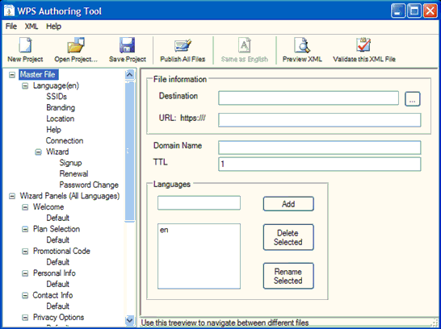

The navigation pane of the user interface (UI) depicts an expanded tree view of XML files and, in some cases, specific sections of XML files. When you click an item in the navigation pane, the right pane (also called the details pane), provides controls that you can use to edit the selected XML file or file section. The two root folders in the tree view are Master File and Wizard Panels (All Languages). These two folders and their subfolders are described in the following sections.

The Master File node
The Master File node contains the following items:
• Master File. Every WPS deployment requires the use of an XML master file to provide client computers with network information and the location of the XML subfiles that are used to provision the client computers. When you click Master File in the WPS Authoring Tool, you can configure your XML master file contents in the details pane. For more information, see “To configure an XML master file” in this paper.
• Language (en). The XML subfiles defined in this folder are created for English language customers. If you have customers that speak other languages, you must create subfiles for each language you want to deploy. For more information, see “How to create XML files for a language other than English” in this paper.
• SSIDs. You can configure your XML SSID subfile when you click SSID in the WPS Authoring Tool. SSID is used to define one or more network names that are broadcast by your wireless access points. For more information, see “To configure an XML SSID subfile” in this paper.
• Branding. You can configure your XML branding subfile when you click Branding in the WPS Authoring Tool. The branding subfile is used to deliver your company name, company logo and other information to client computers. For more information, see “To configure an XML branding subfile” in this paper.
• Location. You can configure your XML location subfile when you click Location in the WPS Authoring Tool. The location subfile describes the locations of your Wi-Fi hotspots so that customers know where they can go to connect to your network. For more information, see “To configure an XML location subfile” in this paper.
• Help. You can configure your XML help subfile when you click Help in the WPS Authoring Tool. The help subfile contains all technical assistance information you want to be available to your customers. The help file itself must be created in MHTML format. For more information, see “To create a help file in MHTML format” and “To configure an XML help subfile” in this paper.
• Connection. You can configure your XML connection subfile when you click Connection in the WPS Authoring Tool. The connection subfile contains network settings that are downloaded to the client by WPS. After the settings are downloaded, WPS configures the client computer according to the settings in the XML connection subfile. For more information, see “To configure an XML connection subfile” in this paper.
• Wizard. You can configure file information for three different wizards when you click Wizard in the WPS Authoring Tool: the Sign-up wizard, the Renewal wizard, and the Change Password wizard. For more information, see “How to create a sign-up wizard” and “How to create XML files for a language other than English” in this paper.
• For more information, see “How to create XML master file and subfiles” and “How to create a sign-up wizard” in this paper.

The Wizard Panels (All Languages) node
You can use the Wizard Panels (All Languages) node to define the contents of your wizards (Sign-up, Renewal, and Password Change) for all languages that you define in the Master File node. A wizard panel is a UI element that resembles a dialog box. Wizard panels can be used to communicate information to your customers, to gather information from your customers, or both. Some wizard panels are optional, providing you with the ability to create custom wizards that collect and display only the information that you want.
Each wizard panel subfolder in Wizard Panels (All Languages) contains a folder named Default. You can use this folder to define the contents of a default wizard panel, or you can name and add your own wizard panels.

Wizard panel descriptions
The Wizard Panels (All Languages) node contains the following subfolders that describe panel types. For example, there is a type of panel named Welcome and there is a type of panel named Promotional Code. Some panel types are required, while others are optional. When designing your wizards, you can decide which optional panels to use based on your business model and other requirements:
• Welcome. Required. You must define Welcome panels for all wizards and all languages. The Welcome panel provides your customers with an introductory message when the wizard starts on a client computer.
• Plan Selection. Required if multiple plans are configured; if only one plan is configured, the wizard automatically skips this wizard panel. This panel allows you to specify and define multiple Internet access plans from which the customers at your Wi-Fi hotspots can select. For example, you can offer hourly, daily, and monthly plans, each with a different pricing structure. You can define Plan Selection panels for all wizards and all languages that provide your customers with plan descriptions and choices. In addition, you can define individual wizard panels for each plan, use the same wizard panels for all plans, or any combination thereof.
• Promotional Code. Optional. You can define Promotional Code panels for all wizards and all languages that provide your customers with the ability to enter promotional codes. In addition, if you are offering multiple connection plans to your customers, Promotional Code panels can be defined on a per-plan basis, or the same panel can be used for each plan.
• Personal Info. Optional. You can define Personal Info panels for all wizards and all languages that provide your customers with the ability to type their name, company, and other information. In addition, if you are offering multiple connection plans to your customers, Personal Info panels can be defined on a per-plan basis, or the same panel can be used for each plan.
• Contact Info. Optional. You can define Contact Info panels for all wizards and all languages that provide your customers with the ability to type their address, telephone, and e-mail address information. In addition, if you are offering multiple connection plans to your customers, Contact Info panels can be defined on a per-plan basis, or the same panel can be used for each plan.
• Privacy Options. Optional. You can define Privacy Options panels for all wizards and all languages that provide your customers with the ability to select privacy options. In addition, if you are offering multiple connection plans to your customers, Privacy Options panels can be defined on a per-plan basis, or the same panel can be used for each plan.
• Credit Card. Optional. You can define Credit Card panels for all wizards and all languages that provide your customers with the ability to type their credit card information. In addition, if you are offering multiple connection plans to your customers, Credit Card panels can be defined on a per-plan basis, or the same panel can be used for each plan.
• Billing Info. Optional. You can define Billing Info panels for all wizards and all languages that provide your customers with the ability to enter the contact information for the credit card account holder. In addition, if you are offering multiple connection plans to your customers, Billing Info panels can be defined on a per-plan basis, or the same panel can be used for each plan.
• Coupon. Optional. You can define Coupon panels for all wizards and all languages that provide your customers with the ability to type coupon information, if you are using prepaid coupons. In addition, if you are offering multiple connection plans to your customers, Coupon panels can be defined on a per-plan basis, or the same panel can be used for each plan.
• Credentials. Optional. You can define Credentials panels for all wizards and all languages that provide your customers with the ability to type the user name and password that they want associated with their account. In addition, if you are offering multiple connection plans to your customers, Credentials panels can be defined on a per-plan basis, or the same panel can be used for each plan.
• Terms. Optional. You can define Terms panels for all wizards and all languages that provide your customers with the terms of use for the account for which they are signing up. In addition, if you are offering multiple connection plans to your customers, Terms panels can be defined on a per-plan basis, or the same panel can be used for each plan.
• Creating Account. Required. You can define Creating Account panels for all wizards and all languages that provide your customers with the informational message you want to display to them during the time that WPS technology is processing their information and creating an account for them on your network. In addition, if you are offering multiple connection plans to your customers, Creating Account panels can be defined on a per-plan basis, or the same panel can be used for each plan.
• Completion. Required. You can define Completion panels for all wizards and all languages that provide your customers with the informational message you want to display to them when the account creation process is successful or when it fails. In addition, if you are offering multiple connection plans to your customers, Completion panels can be defined on a per-plan basis, or the same panel can be used for each plan.
• For detailed information about how to create wizards and configure individual panels, see “How to create a sign-up wizard” in this paper.

How to create XML master file and subfiles
The following procedures provide instructions on how to use the WPS Authoring Tool. For all procedures, the following assumptions exist:
1. You have installed the WPS Authoring Tool on a computer running Windows XP or Windows Server 2003. In order to use the Preview Signup Wizard feature, however, the tool must be installed on a computer running Windows XP with SP2.
2. You have started the WPS Authoring Tool. After installation, to start the WPS Authoring Tool, click Start, click All Programs, click the WPS Authoring Tool folder, and then click WPS Authoring Tool.

To configure an XML master file
1. In the navigation pane, click Master File.
2. In the details pane, in File Information, click Destination, and then type the path to the location where you want to store your XML files. Alternatively, you can browse to the file location using the ellipsis button (…) to the right of the text box. The location can be on the local computer or on a network share. If you browse to the file location with the ellipsis button, you must enter a file name for your XML Master file. For example, master.xml.
3. In the details pane, click Domain Name, and then type the domain name of your Web server in one of two possible formats:
• Web server address. For example, if microsoft is your domain name and com is your top-level domain, type www.microsoft.com. Do not, however, type http:// or https:// before the Web server address.
• Fully qualified domain name (FQDN). Type the FQDN of your Web server. For example, if your Web server is named test and is located in the microsoft.com domain, type test.microsoft.com.
4. In the details pane, in File Information, click URL, and then type the file name for your XML master file. For example, master.xml.
5. In the details pane, click TTL, and then type the time-to-live interval at which client computers contact the provisioning server for a newer version of the XML master file, if one exists. The TTL is expressed as an integer and represents the number of days before the client computer queries the provisioning server for a new master file. For example, if you enter a TTL value of 1, client computers query the provisioning server once every 24 hours to check for a new XML master file. If a new XML master file exists, the client computer downloads the file. In another example, if you enter a TTL value of 5, client computers query the provisioning server once every 120 hours to check for a new XML master file.

To configure an XML SSID subfile
1. In the navigation pane, click SSIDs.
2. In the details pane, in File Information, click Destination, and then type the path to the location where you want to store your XML files. Alternatively, you can browse to the file location using the ellipsis button (…) to the right of the text box. The location can be on the local computer or on a network share. If you browse to the file location with the ellipsis button, you must enter a file name for your XML SSID subfile. For example, ssid.xml.
3. In the details pane, in File Information, click URL, and then type the file name for your XML SSID subfile. For example, ssid.xml.
4. In Version, a version number for the XML SSID subfile is automatically generated and displayed. Each time you revise and then publish the file, the version number is automatically incremented by one (1) by the WPS Authoring Tool. Because the version number is automatically generated by the tool, do not manually enter a value for version.
5. In the details pane, multiple SSIDs can be defined. Enter values for the following SSID properties:
• SSID. Required. Type the network name that you want your customers to see when their wireless computer is within range of your Wi-Fi hotspot.
• Priority. Optional. If you are defining multiple SSIDs, you can set the order in which the SSID is advertised by typing an integer in Priority. SSIDs with a priority of 1 are advertised first.
• Additional fields. Do not enter values for Connection, Authentication, Encryption, IEEE 802.1X, Non-802.1X, or Key Index. These fields are not currently implemented in the XML schema.

To configure an XML branding subfile
1. In the navigation pane, click Branding.
2. In the details pane, in File Information, click Destination, and then type the path to the location where you want to store your XML files. Alternatively, you can browse to the file location using the ellipsis button (…) to the right of the text box. The location can be on the local computer or on a network share. If you browse to the file location with the ellipsis button, you must enter a file name for your XML branding subfile. For example, branding.xml.
3. In the details pane, in File Information, click URL, and then type the file name for your XML branding subfile. For example, branding.xml.
4. In Version, a version number for the XML branding subfile is automatically generated and displayed. Each time you revise and then publish the file, the version number is automatically incremented by one (1) by the WPS Authoring Tool. Because the version number is automatically generated by the tool, do not manually enter a value for version.
5. In Branding Information, in Friendly Name, type the name you want your customers to see in Windows XP when they arrive at your Wi-Fi hotspots.
6. In Branding Information, in Service Description, type marketing and other information that you want your potential customers to see when they arrive at your Wi-Fi hotspots.
7. In Branding Information, in Post Connected Action, type a URL or script location. The URL or script is started after the connection is made.
8. In Images, in File name for Logo Image, type the path to and file name of your logo image file. Alternatively, you can browse to the file location using the ellipsis button (…) to the right of the text box. Your logo image must be a maximum of 49 pixels by 49 pixels in size to display properly on client computers.
9. In Images, in File name for Wizard Banner Image, type the path to and file name of your wizard banner image file. Alternatively, you can browse to the file location using the ellipsis button (…) to the right of the text box. Your wizard banner image must be a maximum of 272 pixels by 49 pixels in size to display properly on client computers.

To configure an XML location subfile
1. In the navigation pane, click Location.
2. In the details pane, in File Information, click Destination, and then type the path to the location where you want to store your XML files. Alternatively, you can browse to the file location using the ellipsis button (…) to the right of the text box. The location can be on the local computer or on a network share. If you browse to the file location with the ellipsis button, you must enter a file name for your XML location subfile. For example, location.xml.
3. In the details pane, in File Information, click URL, and then type the file name for your XML location subfile. For example, location.xml.
4. In Version, a version number for the XML location subfile is automatically generated and displayed. Each time you revise and then publish the file, the version number is automatically incremented by one (1) by the WPS Authoring Tool. Because the version number is automatically generated by the tool, do not manually enter a value for version.
5. In the details pane you can define multiple Wi-Fi hotspot locations. This list of locations is visible to customers and provides them with specific locales where they can connect to your network. Enter values for the following location properties:
• Location. Type the name of the location of your Wi-Fi hotspot. For example, if you have Wi-Fi hotspots deployed throughout the Los Angeles International Airport (LAX), with one hotspot at the Blue Yonder Airlines terminal, you can type LAX - Blue Yonder Airlines terminal.
• Operator. Type your company name.
• Address. Type the address where the Wi-Fi hotspot is located.
• City. Type the city where the Wi-Fi hotspot is located.
• State. Type the state or province where the Wi-Fi hotspot is located.
• Zipcode. Type the zip code or postal code where the Wi-Fi hotspot is located.
• Country. Type the country where the Wi-Fi hotspot is located.

To configure an XML help subfile
1. In the navigation pane, click Help.
2. In the details pane, in File Information, click Destination, and then type the path to the location where you want to store your XML files. Alternatively, you can browse to the file location using the ellipsis button (…) to the right of the text box. The location can be on the local computer or on a network share. If you browse to the file location with the ellipsis button, you must enter a file name for your XML help subfile. For example, help.xml.
3. In the details pane, in File Information, click URL, and then type the file name for your XML help subfile. For example, help.xml.
4. In Version, a version number for the XML help subfile is automatically generated and displayed. Each time you revise and then publish the file, the version number is automatically incremented by one (1) by the WPS Authoring Tool. Because the version number is automatically generated by the tool, do not manually enter a value for version.
5. In MHTML File to Import, type the path and file name of the MHTML Help file you want to display to your customers. Alternatively, you can browse to the file location using the ellipsis button (…) to the right of the text box.

To create a help file or plan description file in MHTML format
If your HTML editor supports the MHTML format, do the following:
1. Open the HTML editor and create your help file or plan description file in HTML format.
2. Save the HTML file in MHTML format (*.mht).
If your HTML editor does not support the MHTML format, do the following:
1. Open the HTML editor and create your help file in HTML format.
2. Save the HTML file in HTML format (*.htm or *.html).
3. Open Internet Explorer. Click File, click Open, and then click Browse. Browse to the HTML file and double-click the file, and then click OK. Internet Explorer opens the file.
4. On the File menu, click Save As. The Save Web page dialog box opens. Browse to the location where you want to save your MHTML file.
5. In the Save Web page dialog box, click Save As Type.
6. In the drop-down list, click Web archive, single file (*.mht), and then click Save.
In addition to creating a help file in MHTML format, full plan descriptions must be created in MHTML format. For more information, see “Planning your sign-up wizard” in this paper.
It is recommended that your MHTML file does not exceed one printed page — approximately 3,500 characters — in length. To provide more information to your customers, you can include a link in your MHTML Help file to additional content on your Web site.

To configure an XML connection subfile
1. In the navigation pane, under the language you want to configure, click Connection.
2. In the details pane, in File Information, click Destination, and then type the path to the location where you want to store your XML files. Alternatively, you can browse to the file location using the ellipsis button (…) to the right of the text box. The location can be on the local computer or on a network share. If you browse to the file location with the ellipsis button, you must enter a file name for your XML connection subfile. For example, connection.xml.
3. In the details pane, in File Information, click URL, and then type the file name for your XML Connection subfile. For example, connection.xml.
4. In Version, a version number for the XML connection subfile is automatically generated and displayed. Each time you revise and then publish the file, the version number is automatically incremented by one (1) by the WPS Authoring Tool. Because the version number is automatically generated by the tool, do not manually enter a value for version.
5. In Server Validation, configure the following settings:
• Enable Server Validation. To verify that the server certificates presented to your users' computers have the correct signature, have not expired, and were issued by a trusted root CA, verify that the Enable Server Validation check box is selected.
Note
This setting is equivalent to the Validate server certificate check box in the Protected EAP Properties dialog box of a wireless network on a wireless computer running Windows XP with SP2.
To access this setting on a wireless computer running Windows XP, obtain the properties of a wireless connection, click the Wireless Networks tab, then obtain the properties of a wireless network in Preferred networks. Click the Authentication tab, and then click Properties.
Important
Do not clear the Enable Server Validation check box or client computers will not verify the identity of your servers during the authentication process. If server authentication does not occur, users are exposed to severe security risks, including the possibility that users might unknowingly connect to a rogue network.
• Enable Server Names. When this checkbox is selected, you can type in a semicolon-separated list of the exact server names of your access points. You can also type regular expressions, containing an asterisk (*), for one or more of the required domains within which your access points must reside. For example, if you want to permit users to connect to all access points in the microsoft.com domain, type ^.*\.microsoft\.com$. It is recommended that you configure server names to prevent users from inadvertently connecting to unknown or rogue networks.
Note
The Enable Server Names setting is equivalent to the Connect to these servers text box in the Protected EAP Properties dialog box of a wireless network on a wireless computer running Windows XP with SP2. To access this setting on a wireless computer running Windows XP, obtain the properties of a wireless connection, click the Wireless Networks tab, then obtain the properties of a wireless network in Preferred networks. Click the Authentication tab, and then click Properties.
• Certificates. By typing the Secure Hash Algorithm (SHA-1) hash of a certificate, you can designate which trusted root certification authority (CA) certificates client computers use to determine whether they trust your servers, such as your IAS server and your provisioning server. The SHA-1 hash of the trusted root CA certificate is a hexadecimal string, such as a4 34 89 15 9a 52 0f 0d 93 d0 32 cc af 37 e7 fe 20 a8 b4 19. When you type or paste a SHA-1 hash in Certificates, you can keep the spaces between the pairs of numbers in the hash. To designate a certificate, copy the SHA-1 hash of the trusted root CA certificate, paste the SHA-1 hash in Certificates, and then click Add. For more information, see “To obtain the SHA-1 hash of a trusted root CA certificate” in this paper.
Important
The trusted root CA certificates that you designate in Certificates must already be installed on client computers. Do not specify a trusted root CA certificate that client computers do not already have in the Trusted Root Certification Authorities stores for the Current User and Local Computer. If you designate a certificate that is not installed on client computers, authentication will fail.
• Disable User Prompt for Server Validation. If this check box is selected, this setting prevents the user from being prompted to trust a server certificate if that certificate is misconfigured, is not already trusted, or both. It is recommended that you select this check box in order to simplify the user experience and to prevent users from inadvertently choosing to trust a server deployed by an attacker. It is also recommended that you configure Enable Server Names and that you use Certificates to specify the trusted root CAs that client computers trust.
6. Select the Enable Fast Reconnect check box if you want customers to have the capability of roaming with their wireless computers between access points without being reauthenticated each time they encounter a new access point. Fast reconnect works only when access points are configured as Remote Authentication Dial-In User Service (RADIUS) clients to the same Internet Authentication Service (IAS) server; if a client computer associates with an access point that is configured as a RADIUS client to a different IAS server, the authentication process occurs in full, including client authentication of the IAS server.

To obtain the SHA-1 hash of a trusted root CA certificate
1. Open the Certificates snap-in for the Local Computer certificate store.
2. In the navigation pane, double-click Certificates (Local Computer), and then double-click the Trusted Root Certification Authorities certificate store.
3. The Certificates folder is a subfolder of the Trusted Root Certification Authorities certificate store. Click the Certificates folder.
4. In the details pane, browse to the certificate for your trusted root CA. Double-click the certificate. The Certificate dialog box opens.
5. In the Certificate dialog box, click the Details tab.
6. In the list of fields, select Thumbprint.
7. In the lower pane, the hexadecimal string that is the SHA-1 hash of your certificate is displayed. Select the SHA-1 hash and press the Windows keyboard shortcut for the Copy command (Ctl+C) to copy the hash to the Windows clipboard.
The following figure depicts an example configuration of an XML connection subfile in the details pane of the WPS Authoring Tool. In this example, the provisioning server is named test and is in the microsoft.com domain, while the XML master file and subfiles are stored on the provisioning server in the folder wpsfiles. In this configuration, the value in Connect to these servers permits users to connect to all access points in the microsoft.com domain. The SHA-1 hash of the Microsoft Root Authority certificate is entered in Certificates, designating that client computers trust the server certificates of the IAS server and provisioning server if they are issued by the Microsoft Root Authority.
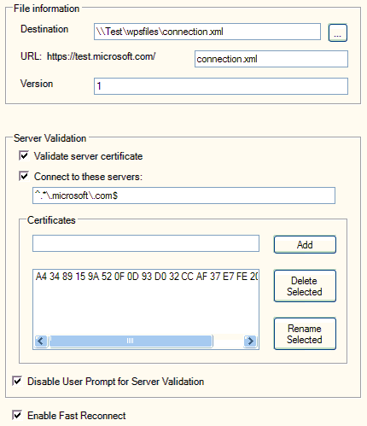

For more information about using the Certificates snap-in, see To manage certificates for a computer in Windows XP Help and Support Center or on the Web at http://go.microsoft.com/fwlink/?LinkId=41042.
For more information about Windows keyboard shortcuts, see Windows keyboard shortcuts overview in Windows XP Help and Support Center or on the Web at http://go.microsoft.com/fwlink/?LinkId=36303.

How to create a sign-up wizard
You can create a sign-up wizard using the WPS Authoring Tool by completing the following steps, which are described in the following sections:
1. Planning your sign-up wizard. This includes determining the connection plans and writing the text displayed to customers in the wizard. You can use the WPS Sign-up Wizard Panels Worksheet in Appendix A to assist you in creating your project.
2. Configuring file information and connection plans.
3. Creating wizard panels for each connection plan. Wizard panels are chosen and configured based on your business model and plan selections.
4. Completing plan selection configuration.
5. Previewing the sign-up wizard.

Planning your sign-up wizard
Before you use the WPS Authoring Tool to create your sign-up wizard, you must do the following:
• Select wizard panels based on your deployment. Define which wizard panels you plan to display to your customers in your sign-up wizard. Some wizard panels are optional, and whether you use them will depend on your decisions about how to deploy WPS technology. For example, if you are using promotional codes with your deployment, you will be using the Promotion Code panel; if you are not using promotional codes, you will not include this panel in your wizard.
• Define connection plans. Define the Internet access plans being offered to customers, and the terms of each plan. For example, you may offer a daily plan, a weekly plan, a monthly plan, an annual plan, or all of these types of plans. For each plan you intend to offer to your customers, you must create a plan description file in MHTML format. For more information about how to create an MHTML file, see “To create a help file or plan description file in MHTML format” in this paper.
• Write all text to be displayed in wizard panels. If you write your text before using the WPS Authoring Tool, you and others can edit and revise the text more easily. When you are running the WPS Authoring Tool, you can copy and paste the final, approved text into the tool.
• Define payment methods. Determine payment methods allowed and what information you need to collect from your customers in order to successfully process their payment.
• Create graphics for the wizard logo and banner. Your sign-up wizard can be customized with two graphics: a wizard logo and a banner logo. Before running the WPS Authoring Tool, create these graphics and make sure they match the wizard graphics size requirements. The size requirements for these images are:
• Logo image. Your logo image must be 49 pixels by 49 pixels (49 X 49) in size to display properly on client computers.
• Wizard banner image. Your wizard banner image must be 272 pixels by 49 pixels (272 X 49) in size to display properly on client computers.
• Create text and graphics for other languages. If you need to create wizards for languages other than English, write all of the applicable text for the panels in each language.
You can use the WPS Sign-up Wizard Panels Worksheet in Appendix A to assist you in creating your project.

Configuring file information and connection plans
To configure file information for your sign-up wizard, do the following:
1. In the navigation pane, on the folder path Master File | Language(en) | Wizard | Signup, click Signup.
2. In the details pane, in File Information, click Destination, and then type the path to the location where you want to store your XML files. Alternatively, you can browse to the file location using the ellipsis button (…) to the right of the text box. The location can be on the local computer or on a network share. If you browse to the file location with the ellipsis button, you must enter a file name for your XML Wizard subfile. For example, wizard.xml.
3. In the details pane, in File Information, click URL, and then type the file name for your XML Wizard subfile. For example, wizard.xml.
4. In Post To, type the name of the folder on your provisioning server where you want to publish the wizard and other XML files.
5. Do not enter a value for Welcome at this time. After the Welcome wizard panel is defined, you will return to this section of the user interface to select the appropriate panel.
6. Follow the instructions in “Creating connection plans” below to configure Plan Selection.

Creating connection plans
In many cases, you can use the same wizard panels for all connection plans that you define, however there may be circumstances where the panels you use differ between connection plans. For example, if you offer an hourly plan, a daily plan, and a monthly plan, the terms of use for each plan might be slightly different. In this circumstance you can create three different Terms wizard panels, one for each plan.
In another example, if you offer multiple time-based plans, you might run a promotional campaign that uses promotion codes and discounts for longer-term plans but not for shorter-term plans, such as hourly or daily plans. In this circumstance you can configure the longer-term plan with a Promotional Code wizard panel, while omitting this panel from the panel list for the plans of shorter duration.
The first step in creating connection plans using the WPS Authoring Tool is to determine whether you want to use the default Plan Selection wizard panel or create a panel with a name other than Default.

To create a wizard panel with a name other than Default
1. In Wizard Panels (All Languages), click the type of panel you want to add. For example, if you want to add a Plan Selection panel, click Plan Selection.
2. In the details pane, type a name for the panel in the text box next to the Add button.
3. Click Add.
After you have named a new wizard panel, the panel appears in the navigation pane below the panel type. In the following figure, two new Plan Selection panels are added named en-Planselect and fr-Planselect.
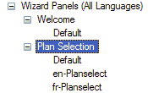

The following instructions describe the information needed to configure each panel type. To configure the panel, select a panel type in the navigation pane and then click Default beneath the panel type.
After you have created a new panel or determined that you are going to use the default Plan Selection panel, do the following to create your connection plans:
1. In the navigation pane, on the folder path Master File | Language(en) | Wizard | Signup, click Signup.
2. In the details pane, in Plan Selection, select a Plan Selection wizard panel to configure. If you created a Plan Selection panel with a name other than Default, select that panel; otherwise, select Default. The following figure depicts a portion of the Master File | Language(en) | Wizard | Signup details pane and the selection of a Plan Selection panel named en-Planselect.
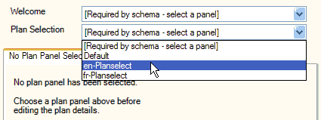

3. If it is not already selected, click the Add a New Plan tab.
4. In Plan Name, type a name for the Internet access plan. For example, type Weekly Access Plan, as shown in the following figure.
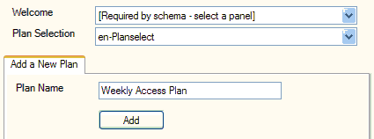

5. Click Add. A tab appears with the name of the new plan, as shown in the following figure.
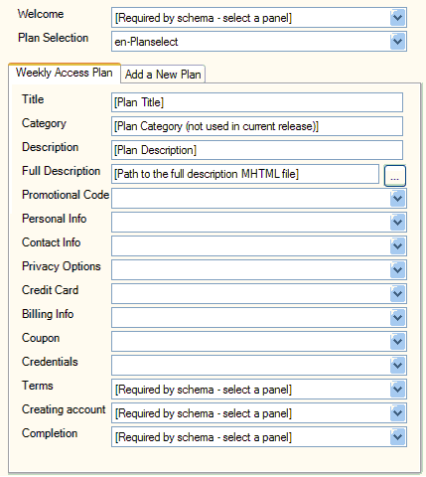

6. Repeat steps 3–5 for each plan that you want to add.

Configuring individual plans
To configure each connection plan that you offer to your customers, you must do the following:
1. In the navigation pane, on the folder path Master File | Language(en) | Wizard | Signup, click Signup.
2. In the details pane, click the tab for the plan you want to configure. For example, if you have a plan named Weekly Access Plan, click the Weekly Access Plan tab.
3. In Title, type the name of the access plan. This name is visible to your customers in the Plan Selection wizard panel when they are running the sign-up wizard.
4. In Category, do not enter any information. This item is not used in the current release of the WPS Authoring Tool.
5. In Description, type a short description for the access plan.
6. In Full Description, type the path to the MHTML file that contains a full description of the access plan. The MHTML file is displayed if your customers selects the plan, and then click View Plan Details.
7. Create wizard panels for each connection plan, following the detailed instructions in “Creating wizard panels for each connection plan” in this paper. You might determine that all connection plans can use the same wizard panels, or you might determine that one or more plans require one or more customized panels.
8. In Master File | Language(en) | Wizard | Signup, in the details pane, click the tab for the plan you want to configure. Starting with Promotional Code, select the wizard panels to display when your customers are running the Wireless Network Registration Wizard. For more information, see “Completing plan selection configuration” in this paper.

Creating wizard panels for each connection plan
Information about how to configure each available wizard panel is detailed in this section. These instructions assume that you are configuring the default panel for each panel type. The default panel for each panel type is named Default. You can, however, create panels with names other than Default.
If you have multiple connection plans and you want to configure a different wizard panel of a specific type (such as Promotional Code) for each plan, you must create individual panels with distinct names for each connection plan. For example, if you have three different access plans and each one has different terms, you can create a Terms panel for each plan, with names such as Daily, Weekly, and Monthly.
The following instructions describe the information needed to configure each panel type. To configure the panel, select a panel type in the navigation pane and then click Default beneath the panel type.

Welcome panel
This panel contains the following controls:
• Title: Title text is not displayed for the Welcome panel; do not enter text in this field.
• Subtitle: Subtitle text is not displayed for the Welcome panel; do not enter text in this field.
• Body: Enter the body text to greet and provide overview information to wireless customers that are using this wizard.
The following figure depicts the Welcome panel configured in the WPS Authoring Tool.
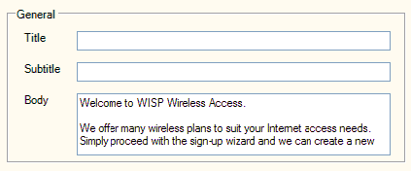

The following figure depicts the same panel displayed in wizard preview.
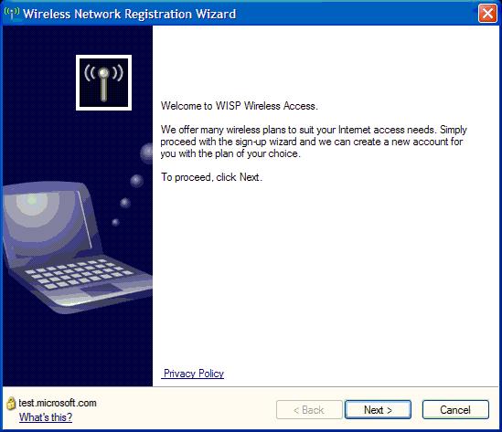

Plan Selection panel
This panel contains the following controls:
• Title: Enter the text that appears as the title of this wizard panel. When applicable, this text appears in the wizard at the top of the panel in bold.
• Subtitle: Enter the text that appears as the subtitle of this wizard panel. When applicable, this text appears just beneath the title text at the top of the panel.
• Body: Enter the body text that explains to your customers how to view each available plan's details, how to select a plan, and how to proceed.
• Hint: This is the text that is displayed when users click the field in the wizard.
• Error: Do not enter a value for this field.
• Plans: Do not enter a value for this field. Instead, define your plans at Master File | Language(abbr) | Wizard | Signup, where abbr is the abbreviation of the language name for which you want to configure plans, such as en for English or fr for French.
The following figure depicts a portion of the Plan Selection panel configured in the WPS Authoring Tool.
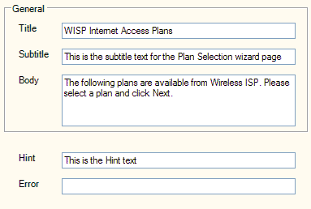

The following figure depicts the same panel displayed in wizard preview after plans are configured in Master File | Language(abbr) | Wizard | Signup.
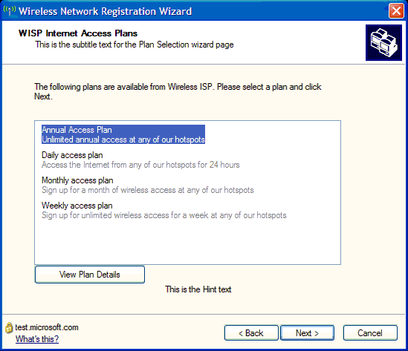

Promotional Code panel
This panel contains the following controls:
• Title: Enter the text that appears as the title of this wizard panel. When applicable, this text appears in the wizard at the top of the panel in bold.
• Subtitle: Enter the text that appears as the subtitle of this wizard panel. When applicable, this text appears just beneath the title text at the top of the panel.
• Body: Enter the body text that explains to your customers where to locate their promotional code, and how to proceed whether they do or do not have a promotional code.
• Value: If you want to provide your customers with a default promotional code, enter the code in this field.
• Hint: This is the text that is displayed when users click the field in the wizard.
• Error: Do not enter a value for this field.
• Displayed: If this check box is selected, the Promotional Code field is displayed in the wizard. If this check box is not selected, the field is not displayed.
• Required: If this check box is selected, a value for promotional code is required, whether the value is supplied by your customers or as a default value. If this check box is not selected, your customers can proceed with account sign-up without entering a value.
• Read Only: If this check box is selected, your customers cannot enter a value for promotional code. If this check box is not selected, your customers can enter a value.
• Maximum length: The value selected is the maximum number of characters that your customers are allowed to enter. If you set the maximum length to zero (0), the number of characters your customers can enter is unlimited.
The following figure depicts a portion of the details pane for a Promotional Code panel configured in the WPS Authoring Tool.
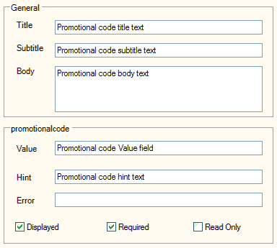

The following figure depicts the same panel displayed in wizard preview.
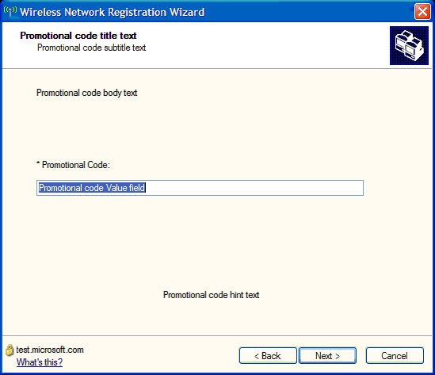

Personal Info panel
This panel contains the following controls:
• Title: Enter the text that appears as the title of this wizard panel. When applicable, this text appears in the wizard at the top of the panel in bold.
• Subtitle: Enter the text that appears as the subtitle of this wizard panel. When applicable, this text appears just beneath the title text at the top of the panel.
• Body: Enter the body text that contains the instructions you want to provide to your customers.
• Salutation: To create a list of courtesy titles from which your customers can choose (such as Mr., Mrs., and Ms.), type the courtesy title in the text box and click Add.
• Language-preference: To create a list of language preferences from which your customers can choose, type a language name (such as French, Dutch, or Spanish) in the text box and click Add.
There are six additional items that you can configure for the Personal Information wizard panel: first-name, middle-initial, last-name, suffix, company, and job-title. For each item you can configure:
• Value: If you want to display a default value in the wizard, you can type one here.
• Hint: This is the text that is displayed when users click the field in the wizard.
• Error: Do not enter a value for this field.
• Displayed: If this check box is selected, the field is displayed in the wizard. If this check box is not selected, the field is not displayed.
• Required: If this check box is selected, a value is required, whether the value is supplied by your customers or as a default value. If this check box is not selected, your customers can proceed with account sign-up without entering a value.
• Read Only: If this check box is selected, your customers cannot enter a value. If this check box is not selected, your customers can enter a value.
• Maximum Length: The value selected is the maximum number of characters that your customers are allowed to enter. If you set the maximum length to zero (0), the number of characters your customers can enter is unlimited.
The following figure depicts a portion of the Personal Info panel configured in the WPS Authoring Tool.
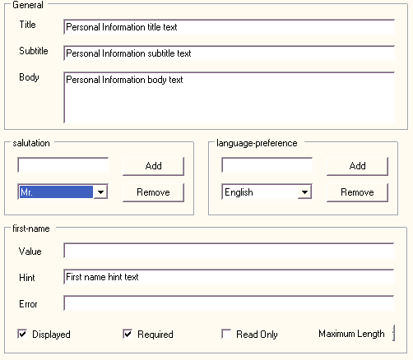

The following figure depicts the same panel displayed in wizard preview.
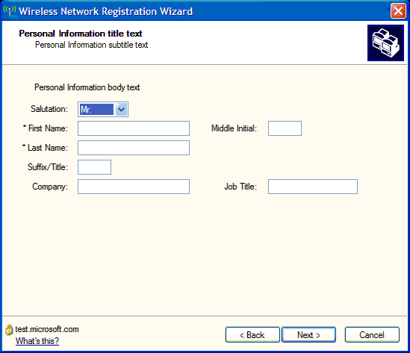

Contact Info panel
This panel contains the following controls:
• Title: Enter the text that appears as the title of this wizard panel. When applicable, this text appears in the wizard at the top of the panel in bold.
• Subtitle: Enter the text that appears as the subtitle of this wizard panel. When applicable, this text appears just beneath the title text at the top of the panel.
• Body: Enter the body text that contains the instructions you want to provide to your customers.
For each additional item (such as address1), you can configure the following controls:
• Value: If you want to display a default value in the wizard, you can type one here.
• Hint: This is the text that is displayed when users click the field in the wizard.
• Error: Do not enter a value for this field.
• Displayed: If this check box is selected, the field is displayed in the wizard. If this check box is not selected, the field is not displayed.
• Required: If this check box is selected, a value is required, whether the value is supplied by your customers or as a default value. If this check box is not selected, your customers can proceed with account sign-up without entering a value.
• Read Only: If this check box is selected, your customers cannot enter a value. If this check box is not selected, your customers can enter a value.
• Maximum Length: The value selected is the maximum number of characters that your customers are allowed to enter. If you set the maximum length to zero (0), the number of characters your customers can enter is unlimited.
• State: To create a list of states from which your customers can choose, type the state abbreviation in the text box, and then click Add.
• Country: To create a list of countries from which your customers can choose, type the country name in the text box, and then click Add.
The following figure depicts a portion of the Contact Info panel configured in the WPS Authoring Tool.
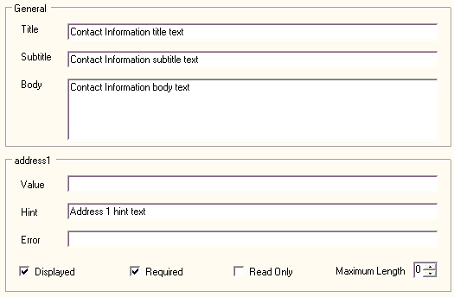

The following figure depicts the same panel displayed in wizard preview:
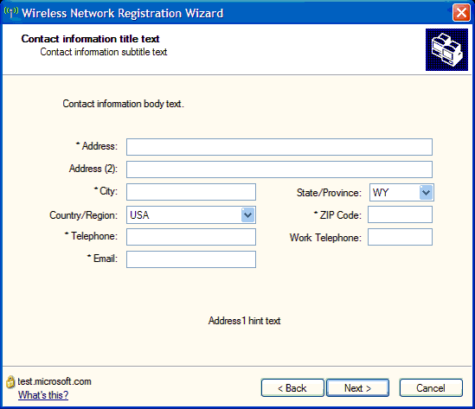

Privacy Options panel
This panel contains the following controls:
• Title: Enter the text that appears as the title of this wizard panel. When applicable, this text appears in the wizard at the top of the panel in bold.
• Subtitle: Enter the text that appears as the subtitle of this wizard panel. When applicable, this text appears just beneath the title text at the top of the panel.
• Body: Enter the body text that contains the instructions you want to provide to your customers.
Only one of the following three check boxes should be selected; the one that is selected will be the default selection when your customers run the sign-up wizard. Typically, the first check box is the default. If you enter text in the text boxes next to the check boxes, and you have chosen to display the Privacy Options panel, the privacy option is displayed in the sign-up wizard. If you do not enter text in the text box, the privacy option is not displayed.
• check1: If you want this check box to be selected by default, select the check box in the WPS Authoring Tool; otherwise, do not select the check box. Type the privacy option text in the text box to the right of the check box.
• check2: If you want this check box to be selected by default, select the check box in the WPS Authoring Tool; otherwise, do not select the check box. Type the privacy option text in the text box to the right of the check box.
• check3: If you want this check box to be selected by default, select the check box in the WPS Authoring Tool; otherwise, do not select the check box. Type the privacy option text in the text box to the right of the check box.
The following figure depicts the Privacy Options panel configured in the WPS Authoring Tool.
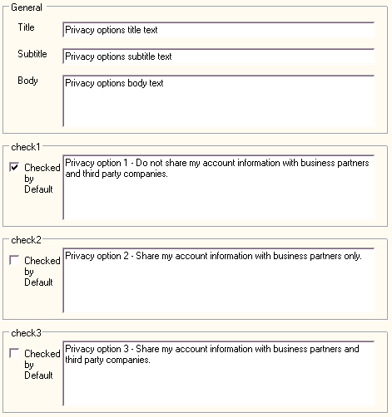

The following figure depicts the same panel displayed in wizard preview.
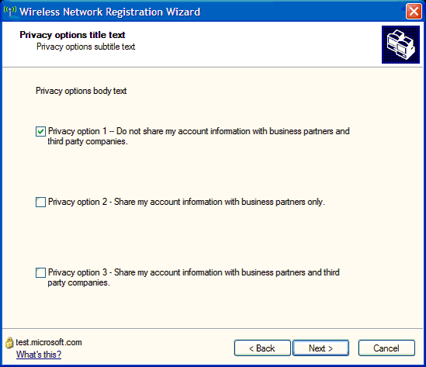

Credit Card panel
This panel contains the following controls:
• Title: Enter the text that appears as the title of this wizard panel. When applicable, this text appears in the wizard at the top of the panel in bold.
• Subtitle: Enter the text that appears as the subtitle of this wizard panel. When applicable, this text appears just beneath the title text at the top of the panel.
• Body: Enter the body text that contains the instructions you want to provide to your customers.
• Card name: Enter the types of credit cards you accept, such as Visa, Mastercard, and Discover.
For each item (such as card number) you can configure:
• Value: If you want to display a default value in the wizard, you can type one here.
• Hint: This is the text that is displayed when users click the field in the wizard.
• Error: Do not enter a value for this field.
• Displayed: If this check box is selected, the field is displayed in the wizard. If this check box is not selected, the field is not displayed.
• Required: If this check box is selected, a value is required, whether the value is supplied by your customers or as a default value. If this check box is not selected, your customers can proceed with account sign-up without entering a value.
• Maximum Length: The value selected is the maximum number of characters that your customers are allowed to enter. If you set the maximum length to zero (0), the number of characters your customers can enter is unlimited.
The following figure depicts a portion of the Credit Card panel configured in the WPS Authoring Tool.
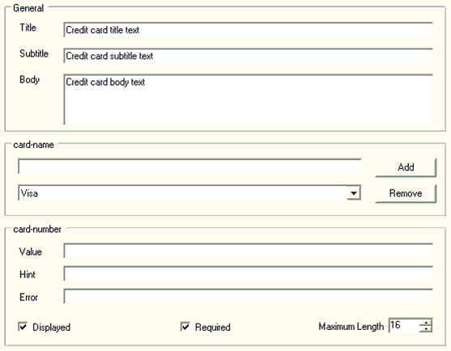

The following figure depicts the same panel displayed in wizard preview.
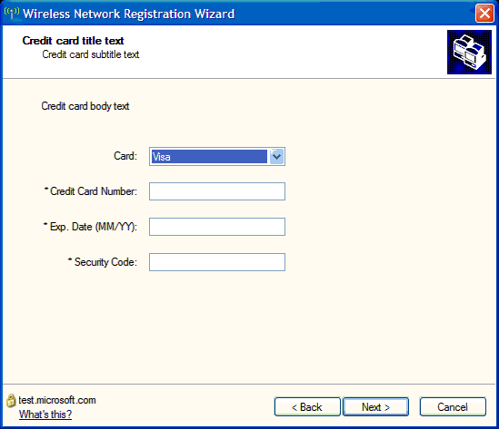

Billing Info panel
This panel contains the following controls:
• Title: Enter the text that appears as the title of this wizard panel. When applicable, this text appears in the wizard at the top of the panel in bold.
• Subtitle: Enter the text that appears as the subtitle of this wizard panel. When applicable, this text appears just beneath the title text at the top of the panel.
• Body: Enter the body text that contains the instructions you want to provide to your customers.
For each item (such as address1) you can configure:
• Value: If you want to display a default value in the wizard, you can type one here.
• Hint: This is the text that is displayed when users click the field in the wizard.
• Error: Do not enter a value for this field.
• Displayed: If this check box is selected, the field is displayed in the wizard. If this check box is not selected, the field is not displayed.
• Required: If this check box is selected, a value is required, whether the value is supplied by your customers or as a default value. If this check box is not selected, your customers can proceed with account sign-up without entering a value.
• Read Only: If this check box is selected, your customers cannot enter a value. If this check box is not selected, your customers can enter a value.
• Maximum Length: The value selected is the maximum number of characters that your customers are allowed to enter. If you set the maximum length to zero (0), the number of characters your customers can enter is unlimited.
The following figure depicts a portion of the Billing Info panel configured in the WPS Authoring Tool.
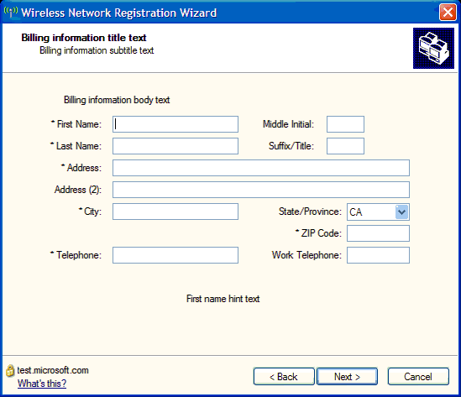

The following figure depicts the same panel displayed in wizard preview.
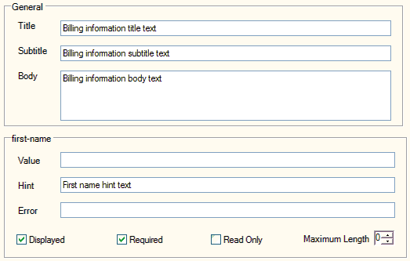

Coupon panel
This panel contains the following controls:
• Title: Enter the text that appears as the title of this wizard panel. When applicable, this text appears in the wizard at the top of the panel in bold.
• Subtitle: Enter the text that appears as the subtitle of this wizard panel. When applicable, this text appears just beneath the title text at the top of the panel.
• Body: Enter the body text that contains the instructions you want to provide to your customers.
For coupon you can configure:
• Value: If you want to display a default value in the wizard, you can type one here.
• Hint: This is the text that is displayed when users click the field in the wizard.
• Error: Do not enter a value for this field.
• Displayed: If this check box is selected, the field is displayed in the wizard. If this check box is not selected, the field is not displayed.
• Required: If this check box is selected, a value is required, whether the value is supplied by your customers or as a default value. If this check box is not selected, your customers can proceed with account sign-up without entering a value.
• Read Only: If this check box is selected, your customers cannot enter a value. If this check box is not selected, your customers can enter a value.
• Maximum Length: The value selected is the maximum number of characters that your customers are allowed to enter. If you set the maximum length to zero (0), the number of characters your customers can enter is unlimited.
The following figure depicts the Coupon panel configured in the WPS Authoring Tool.
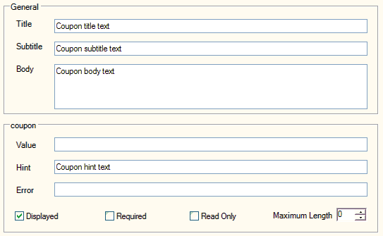

The following figure depicts the same panel displayed in wizard preview.
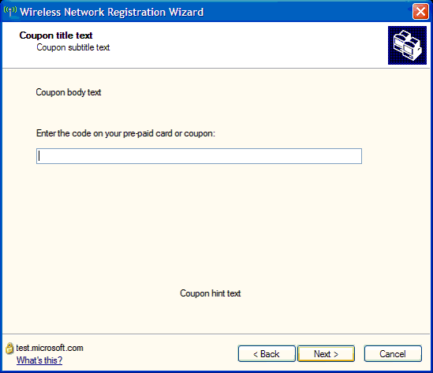

Credentials panel
This panel contains the following controls:
• Title: Enter the text that appears as the title of this wizard panel. When applicable, this text appears in the wizard at the top of the panel in bold.
• Subtitle: Enter the text that appears as the subtitle of this wizard panel. When applicable, this text appears just beneath the title text at the top of the panel.
• Body: Enter the body text that contains the instructions you want to provide to your customers.
For each item you can configure:
• Value: If you want to display a default value in the wizard, you can type one here.
• Hint: This is the text that is displayed when users click the field in the wizard.
• Error: Do not enter a value for this field.
• Displayed: If this check box is selected, the field is displayed in the wizard. If this check box is not selected, the field is not displayed.
• Required: If this check box is selected, a value is required, whether the value is supplied by your customers or as a default value. If this check box is not selected, your customers can proceed with account sign-up without entering a value.
• Read Only: If this check box is selected, your customers cannot enter a value. If this check box is not selected, your customers can enter a value.
• Maximum Length: The value selected is the maximum number of characters that your customers are allowed to enter. If you set the maximum length to zero (0), the number of characters your customers can enter is unlimited.
The following figure depicts the Credentials panel configured in the WPS Authoring Tool.
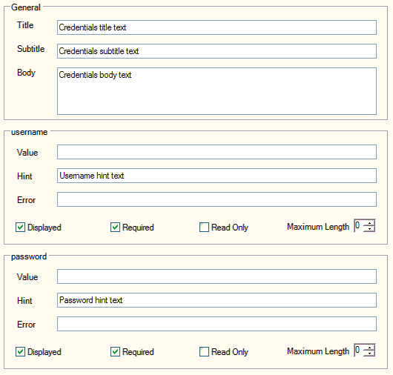

The following figure depicts the same panel displayed in wizard preview.
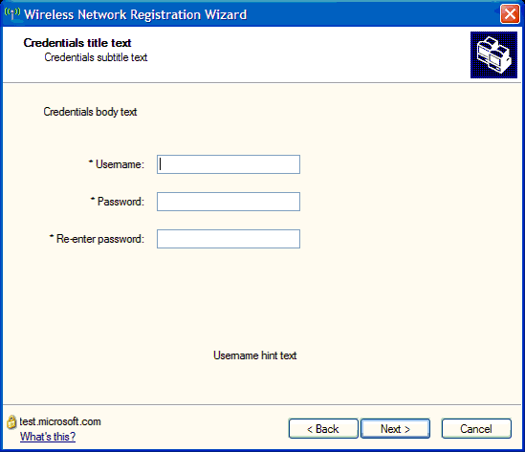

Terms panel
This panel contains the following controls:
• Title: Enter the text that appears as the title of this wizard panel. When applicable, this text appears in the wizard at the top of the panel in bold.
• Subtitle: Enter the text that appears as the subtitle of this wizard panel. When applicable, this text appears just beneath the title text at the top of the panel.
• Body: Enter the body text that contains the instructions you want to provide to your customers.
• Terms: Enter the terms of the user agreement here.
The following figure depicts a portion of the Terms panel configured in the WPS Authoring Tool.
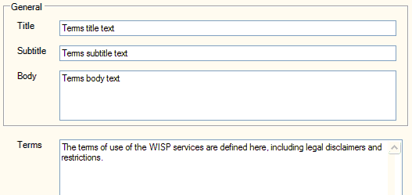

The following figure depicts the same panel displayed in wizard preview.
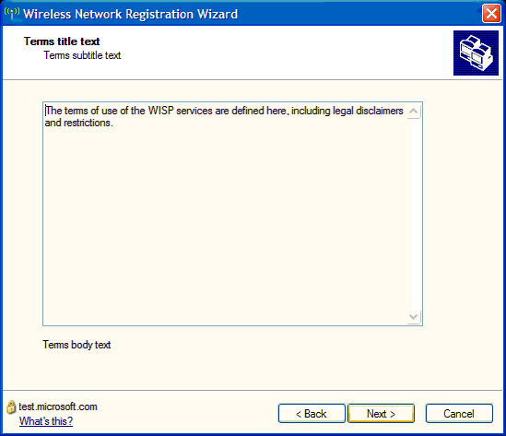

Creating account panel
This panel contains the following controls:
• Title: Enter the text that appears as the title of this wizard panel. When applicable, this text appears in the wizard at the top of the panel in bold.
• Subtitle: Enter the text that appears as the subtitle of this wizard panel. When applicable, this text appears just beneath the title text at the top of the panel.
• Body: Enter the body text that contains the instructions you want to provide to your customers.

Completion panel
This panel contains the following controls:
• Title: Enter the text that appears as the title of this wizard panel. When applicable, this text appears in the wizard at the top of the panel in bold.
• Subtitle: Enter the text that appears as the subtitle of this wizard panel. When applicable, this text appears just beneath the title text at the top of the panel.
• Body: Enter the body text that contains the instructions you want to provide to your customers.
• Info: Enter the additional information you want to provide to your customers after they have set up their account.

Completing plan selection configuration
To select the panels you’ve created for each plan, do the following:
1. In the navigation pane, click Master File | Language(en) | Wizard | Signup, and then click Signup.
2. In the details pane, click the tab for the plan you want to configure.
3. For each panel type that you want to appear in the wizard, select a panel from the list.
The following figure depicts a portion of the Signup details pane with the tab for the Weekly Access Plan selected. In this example, all wizard panel types are used except Coupon, for which a wizard panel is not selected. All other wizard panel types use the default panel.
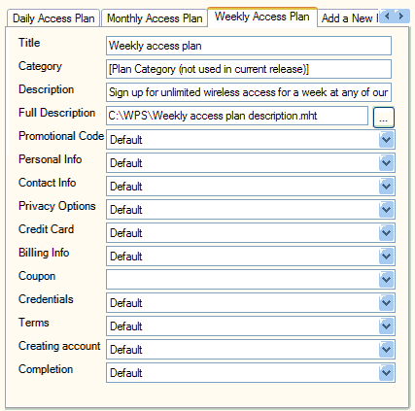

Previewing your sign-up wizard
If you are running the WPS Authoring Tool on a computer running Windows XP with SP2, you can use the Preview Signup Wizard feature to see how your signup wizard looks. To preview your wizard, do the following:
1. In the navigation pane, click the language and wizard you want to preview. For example, if you want to preview the English sign-up wizard, under Master File, Language(en), Wizard, click Signup.
2. Click the menu XML, and then click Preview Signup Wizard.
3. The Wireless Network Registration Wizard opens, and you can preview your wizard.

How to create XML files for languages other than English
To create XML files for languages other than English, you must first define the language in the WPS Authoring Tool. After the language is defined, a new Language(abbr) section is inserted beneath Master File, allowing you to configure XML subfiles for the language.
The following figure depicts the Master File node with the French language added using the abbreviation fr.
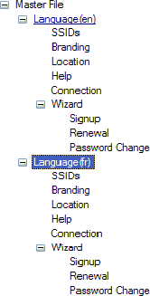

For more information, see “To create XML subfiles for additional languages.”
To configure wizards for languages other than English, you can create new wizard panels of each wizard panel type that you require. For more information, see “How to create a sign-up wizard for languages other than English.”

To create XML subfiles for additional languages
1. In the navigation pane, click Master File.
2. In the details pane, click Languages, and then type an abbreviation for the language you want to add. For example, if you want to create XML files for customers who speak French, type fr.
3. Click Add. In the navigation pane, under Master File, a new node appears named Language(abbr), where abbr is the abbreviation for the language you want to add. For example, if you have added French and have abbreviated it fr, the new node is named Language(fr).
4. Under the new Language(abbr) node, enter values for the XML subfiles that will service customers who speak the language.

How to create a sign-up wizard for languages other than English
You can use the Wizard Panels (All Languages) node to define the contents of your wizards (Sign-up, Renewal, and Password Change) for all languages that you define in the Master File node. Each wizard panel subfolder in Wizard Panels (All Languages) contains a folder named Default. You can use this folder to define the contents of a default wizard panel, or you can name and add your own wizard panels.
For example, if you are creating all three wizards (Sign-up, Renewal, and Password Change) for both French-speaking customers and English-speaking customers, you can create panels that allow you to easily identify the panels by name in the user interface of the tool.
To create wizards for additional languages, complete the following steps:
1. Add the language using the Master File node. For more information, see “To create XML subfiles for additional languages” in this paper.
2. For each wizard panel type (such as Welcome and Plan Selection), add a new panel with a name that clearly identifies the language for which the panel is used. For example, if you are creating the Welcome panel for the French sign-up wizard, you can click Welcome, and then in the details pane of the tool type fr-Welcome, where fr is an abbreviation for “French” and Welcome indicates the panel type. When you click Add, the new panel is available for configuration. For more information, see “To add a new wizard panel” in this paper.
3. Create connection plans, and then configure wizard panels for each connection plan as needed. For more information, see “How to create a sign-up wizard” in this paper.
4. Configure the wizards for each language using the panels you configured in step 3. In the Master File node, click each individual wizard for each language and configure the wizard with your panels. For example, if you defined the Master File with the French language using the abbreviation fr, navigate to the location Master File, Language(fr), Wizard, and then select the wizard you want to configure. To configure the sign-up wizard, click Signup, and then in the details pane, in Welcome, select the Welcome panel for the French language sign-up wizard. If you used the naming convention described earlier in this process, the panel is available in the drop-down list as fr-Welcome.

Appendix A: Worksheet for WPS Sign-up Wizard Panels
The worksheet for sign-up wizard panels is provided so that you can:
• Record all settings for your sign-up wizard as decisions are made.
• Circulate the worksheet between departments and co-workers for corrections and ideas.
• Maintain documentation of your wizard settings for easy review and revision.
Each wizard panel is represented in the following worksheet, so you can plan the contents of each wizard panel.

Access plan information
You can use the access plan information section to write and revise the text that displays in the wizard for each connection plan you offer your customers. For each plan, the full description must be saved as an MHTML file. You can create new connection plans in the WPS Authoring Tool at Master File | Language(en) | Wizard | Signup.

Plan 1
Title:
Category: Do not enter a value for this field.
Description:
Full description: Create an MHTML file and, in the WPS Authoring Tool, enter the path to the file and the file name.

Plan 2
Title:
Category: Do not enter a value for this field.
Description:
Full description: Create an MHTML file and, in the WPS Authoring Tool, enter the path to the file and the file name.

Plan 3
Title:
Category: Do not enter a value for this field.
Description:
Full description: Create an MHTML file and, in the WPS Authoring Tool, enter the path to the file and the file name.

Welcome panel
Title:
Subtitle:
Body:

Plan Selection panel
Title:
Subtitle:
Body:
Hint:
Error: Do not enter a value for this field.
Plans: Do not enter a value for this field. Instead, define your plans at Master File | Language(abbr) | Wizard | Signup, where abbr is the abbreviation of the language name for which you want to configure plans, such as en for English or fr for French.

Promotional Code panel
Title:
Subtitle:
Body:
Value:
Hint:
Error: Do not enter a value for this field.
Displayed
Required
Read Only
Maximum Length:

Personal Info panel
Title:
Subtitle:
Body:
Salutation: Create a list in the tool.
Language-preference: Create a list in the tool.

first-name
Value:
Hint:
Error: Do not enter a value for this field.
Displayed
Required
Read Only
Maximum Length:

middle-initial
Value:
Hint:
Error: Do not enter a value for this field.
Displayed
Required
Read Only
Maximum Length:

last-name
Value:
Hint:
Error: Do not enter a value for this field.
Displayed
Required
Read Only
Maximum Length:

suffix
Value:
Hint:
Error: Do not enter a value for this field.
Displayed
Required
Read Only
Maximum Length:

company
Value:
Hint:
Error: Do not enter a value for this field.
Displayed
Required
Read Only
Maximum Length:

job-title
Value:
Hint:
Error: Do not enter a value for this field.
Displayed
Required
Read Only
Maximum Length:

Contact Info panel
Title:
Subtitle:
Body:

address1
Value:
Hint:
Error: Do not enter a value for this field.
Displayed
Required
Read Only
Maximum Length:

address2
Value:
Hint:
Error: Do not enter a value for this field.
Displayed
Required
Read Only
Maximum Length:

city
Value:
Hint:
Error: Do not enter a value for this field.
Displayed
Required
Read Only
Maximum Length:
State: Create a list in the tool.
Country: Create a list in the tool.

zipcode
Value:
Hint:
Error: Do not enter a value for this field.
Displayed
Required
Read Only
Maximum Length:

telephone1
Value:
Hint:
Error: Do not enter a value for this field.
Displayed
Required
Read Only
Maximum Length:

telephone2
Value:
Hint:
Error: Do not enter a value for this field.
Displayed
Required
Read Only
Maximum Length:

Privacy options panel
Title:
Subtitle:
Body:
check1:
check2:
check3:

Credit Card panel
Title:
Subtitle:
Body:
card-name: Create a list in the tool of the types of credit cards you accept, such as Visa, Mastercard, and Discover.

card-number
Value:
Hint:
Error: Do not enter a value for this field.
Displayed
Required
Read Only
Maximum Length:

card-expdate
Value:
Hint:
Error: Do not enter a value for this field.
Displayed
Required
Read Only
Maximum Length:

card-securitycode
Value:
Hint:
Error: Do not enter a value for this field.
Displayed
Required
Read Only
Maximum Length:

Billing Info panel
Title:
Subtitle:
Body:

first-name
Value:
Hint:
Error: Do not enter a value for this field.
Displayed
Required
Read Only
Maximum Length:

middle-initial
Value:
Hint:
Error: Do not enter a value for this field.
Displayed
Required
Read Only
Maximum Length:

last-name
Value:
Hint:
Error: Do not enter a value for this field.
Displayed
Required
Read Only
Maximum Length:

suffix
Value:
Hint:
Error: Do not enter a value for this field.
Displayed
Required
Read Only
Maximum Length:

address1
Value:
Hint:
Error: Do not enter a value for this field.
Displayed
Required
Read Only
Maximum Length:

address2
Value:
Hint:
Error: Do not enter a value for this field.
Displayed
Required
Read Only
Maximum Length:

city
Value:
Hint:
Error: Do not enter a value for this field.
Displayed
Required
Read Only
Maximum Length:
State: Create a list in the tool.
Country: Create a list in the tool.

zipcode
Value:
Hint:
Error: Do not enter a value for this field.
Displayed
Required
Read Only
Maximum Length:

telephone1
Value:
Hint:
Error: Do not enter a value for this field.
Displayed
Required
Read Only
Maximum Length:

telephone2
Value:
Hint:
Error: Do not enter a value for this field.
Displayed
Required
Read Only
Maximum Length:

Coupon panel
Title:
Subtitle:
Body:

coupon
Value:
Hint:
Error: Do not enter a value for this field.
Displayed
Required
Read Only
Maximum Length:

Credentials panel
Title:
Subtitle:
Body:

username
Value:
Hint:
Error: Do not enter a value for this field.
Displayed
Required
Read Only
Maximum Length:

password
Value:
Hint:
Error: Do not enter a value for this field.
Displayed
Required
Read Only
Maximum Length:

Terms panel
Title:
Subtitle:
Body:
Terms:

Creating account panel
Title:
Subtitle:
Body:

Completion panel
Title:
Subtitle:
Body:
Info:

Appendix B: XML files
Following are an example XML master file and subfiles that contain settings used in this paper. If you want to manually configure your XML files rather than using the WPS Authoring Tool, you can copy the code, save it to a text file with an *.xml extension, and replace the example values with the values for your WPS technology deployment.

XML master file
The following code depicts an example XML master file:
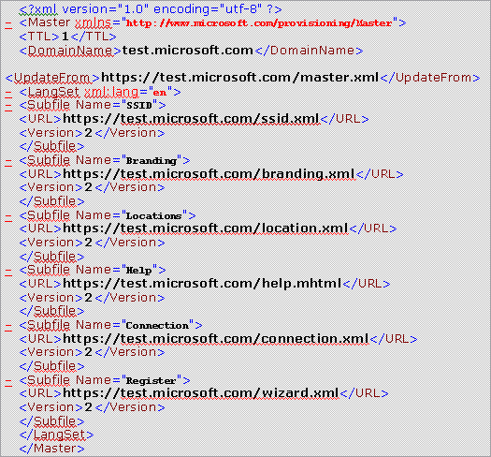

XML SSID subfile
The following code depicts an example XML SSID subfile:
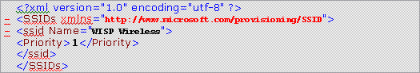

XML branding subfile
The following code depicts an example XML branding subfile:
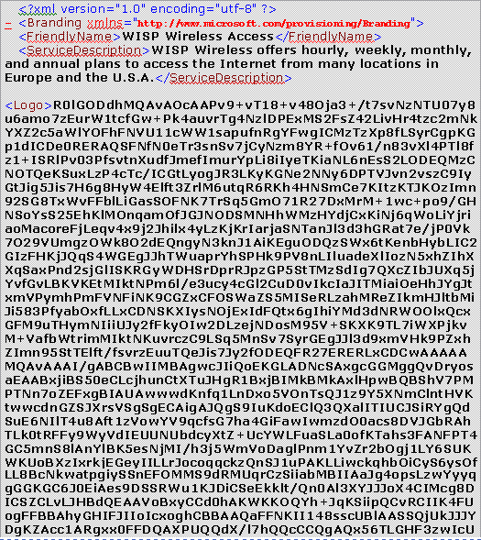

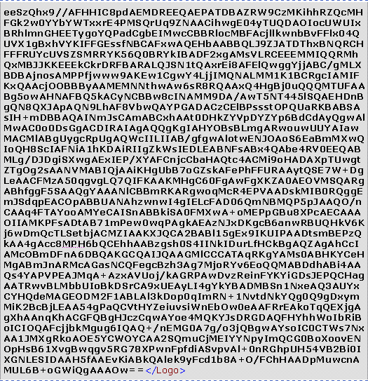



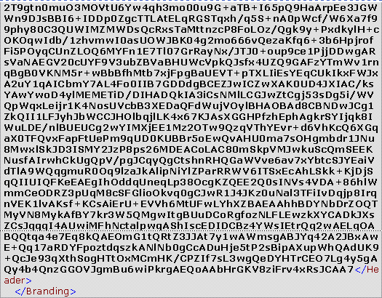

XML location subfile
The following code depicts an example XML location subfile:
<?xml version="1.0" encoding="utf-8" ?>
- <hotspotfinder xmlns="http://www.microsoft.com/provisioning/Locations">
- <entry>
<city>Los Angeles</city>
<state>CA</state>
<country>USA</country>
<zipcode>90045</zipcode>
<operator>WISP</operator>
<location>LAX - Blue Yonder Airlines terminal</location>
<address>1 World Way</address>
</entry>
- <entry>
<city>Chicago</city>
<state>IL</state>
<country>USA</country>
<zipcode>60607</zipcode>
<operator>WISP</operator>
<location>O'Hare International Airport</location>
</entry>
- <entry>
<city>New York</city>
<state>NY</state>
<country>USA</country>
<zipcode>10001</zipcode>
<operator>WISP</operator>
<location>JFK International Airport</location>
<address>Jamaica</address>
</entry>
<entry />
</hotspotfinder>

XML connection subfile
The following code depicts an example XML connection subfile:
<?xml version="1.0" encoding="utf-8" ?>
- <Connections xmlns="http://www.microsoft.com/provisioning/EapConnectionPropertiesV1">
- <Connection>
<Name />
- <baseEap:Eap xmlns:baseEap="http://www.microsoft.com/provisioning/BaseEapConnectionPropertiesV1">
<baseEap:Type>25</baseEap:Type>
- <msPeap:EapType xmlns:msPeap="http://www.microsoft.com/provisioning/MsPeapConnectionPropertiesV1">
- <msPeap:ServerValidation>
<msPeap:DisableUserPromptForServerValidation>true</msPeap:DisableUserPromptForServerValidation>
<msPeap:ServerNames>^.*\.microsoft\.com$</msPeap:ServerNames>
<msPeap:TrustedRootCA>A4 34 89 15 9A 52 0F 0D 93 D0 32 CC AF 37 E7 FE 20 A8 B4 19</msPeap:TrustedRootCA>
</msPeap:ServerValidation>
<msPeap:FastReconnect>true</msPeap:FastReconnect>
<msPeap:InnerEapOptional>1</msPeap:InnerEapOptional>
- <baseEap:Eap>
<baseEap:Type>26</baseEap:Type>
<EapType xmlns="http://www.microsoft.com/provisioning/MsChapV2ConnectionPropertiesV1" />
</baseEap:Eap>
</msPeap:EapType>
</baseEap:Eap>
</Connection>
</Connections>

XML wizard subfile
The following code depicts an example XML wizard subfile:
<?xml version="1.0" encoding="utf-8" ?>
- <register xmlns="http://www.microsoft.com/provisioning/Register">
<signup>https://test.microsoft.com/signup.xml</signup>
</register>

XML sign-up wizard subfile
The following code depicts an example XML sign-up wizard subfile:
