Microsoft business solutions–Axapta Telemarketing
Microsoft® Business Solutions−Axapta® Telemarketing helps you execute and manage telephone-assisted sales and marketing activities from one connected solution.

Key Benefits:
- Improved lead generation and qualification

- Execute guided calls efficiently with call center functionality

- Use data from telemarketing activities directly in the sales process
Designed for sales teams or telemarketing groups, the Microsoft Business Solutions−Axapta Telemarketing module can be used for a variety of activities including sales-lead generation, customer surveys, direct marketing campaigns and customer support.
Microsoft Axapta Telemarketing lets your entire business work with the same user-friendly application—from accounting, production and logistics to sales and marketing. And most features can be set up to match your business processes, so the software conforms to your company practices, not the other way around.
Microsoft Axapta Telemarketing is part of our Sales and Marketing solution, which includes Sales Force Automation, Sales Management, and Marketing Automation.

Improved lead generation and qualification
The effectiveness of telemarketing depends, to a large extent, on the quality of the leads selected for each campaign. Microsoft Axapta Telemarketing lets you draw up targeted call lists based on key customer information stored in your Microsoft Axapta system. You can select customers and prospects using background and relationship-oriented information such as sales district, revenue, relation types, segment and past sales behavior. Telemarketing staff can also use this background information to more effectively identify customer needs.
Once a call list has been created, the Microsoft Axapta Telemarketing module makes it easy to distribute the list to colleagues based on criteria you choose. For instance, calls can be distributed to sales people who have previously been in contact with the target or who speak their native language.
Follow up on failed calls is made easy because the caller is automatically reminded to repeat the call after a specified period of time.

Execute calls efficiently with call center functionality
Plan and execute any number of Telemarketing Campaigns to selected groups of companies, and identify the employees to perform the calls
Access your customer directly through Computer Telephone Integration (CTI) System

To simplify actual calls, Microsoft Axapta Telemarketing provides a single window for managing phone calls. To give you a quick and complete overview, the Telemarketing window combines information on the business relation and contact person in one simple view. Salespeople can also see information about business relations activities, open orders, projects, products purchased, and so on.
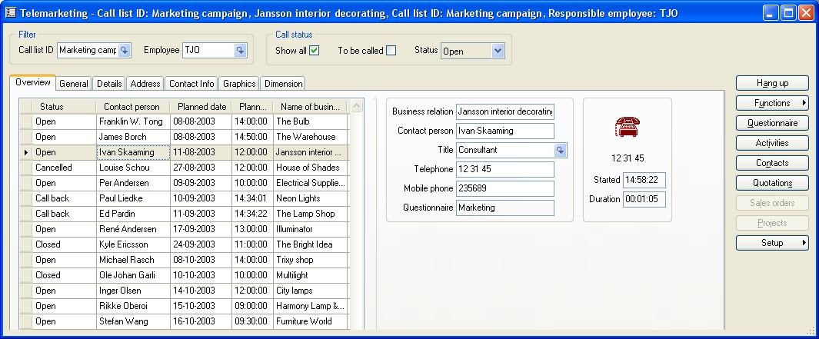

To navigate directly to other windows of interest, the salesperson just has to click the menu buttons in the Telemarketing window. For example, if a customer would like to place an order during a call, it is easy for the salesperson to create a sales order or sales quote.
By integrating an external Computer Telephone Integration system, calls can be made directly from the Microsoft Axapta Telemarketing window by simply clicking the Call button. When the call is finished, the system automatically prepares for the next call in the list. All the caller has to do is click the call button again.

Use telemarketing data in the sales process
Every call made via Microsoft Axapta Telemarketing can be logged for use in the sales process. Using the call log, reports can be generated that summarize the result of telemarketing campaigns. They can also be used to generate new call lists for following up on specific call types such as Call Back.
Use questionnaires for guided sales flows

Access in-depth information on your targets

If you prefer to use telemarketing for electronic survey purposes or in a guided sales process, you can easily connect a Questionnaire to your call list. Responses to your Questionnaire are recorded in your database, and can be used to identify and understand your prospects or customer needs. By accessing and analyzing the information, it can be utilized in marketing campaigns, follow up sales calls, quotations or the like.

Microsoft Business Solutions–Axapta
Microsoft Axapta Telemarketing is part of Microsoft Business Solutions–Axapta, a customizable, scalable and global Enterprise Resource Planning (ERP) solution that supports connectivity with your business community and provides you with a fast and powerful way to gain competitive advantage.

For more information about Microsoft Axapta
To learn more about Microsoft Axapta, contact your local Microsoft Business Solutions office or Microsoft Certified Business Solutions Partner, using the following Web address. They have the expertise to meet your specific business needs.

About Microsoft Business Solutions
Microsoft Business Solutions, a division of Microsoft, offers a wide range of integrated, end-to-end business applications and services designed to help small, midmarket and corporate businesses become more connected with customers, employees, partners and suppliers. Microsoft Business Solutions' applications optimize strategic business processes across financial management, analytics, human resources management, project management, customer relationship management, field service management, supply chain management, e-commerce, manufacturing and retail management. The applications are designed to provide insight to help customers achieve business success. More information about Microsoft Business Solutions can be found at www.microsoft.com/BusinessSolutions.

Address:
Microsoft Business Solutions
Frydenlunds Allé 6
2950 Vedbaek
Denmark
Tel +45 45 67 80 00
Fax +45 45 67 80 01
www.microsoft.com/BusinessSolutions

Key Features | Description
Easy to Use | - Intuitive layout and structure  - User-adjustable menus, forms and reports  - User-adjustable layout of main tables and journals  - Windows commands including ‘copy and paste’ to and from Axapta  - Direct access to main tables from journals  - Advanced sorting and filter options  - Built-in user Help including an integrated manual  - Option to e-mail and fax directly from Axapta  - Application can be run in different languages
Telemarketing overview | - Manage and execute telemarketing activities  - Telemarketing window with all relevant information at your fingertips  - Computer Telephone Integration (CTI) via TAPI  - Full call logging that includes time, date, duration, caller etc.  - Range of telemarketing reports
Call list overview | - Create call lists based on contacts in business relation and contacts table  - Distribute and administrate calls lists among callers  - Integration between call list and questionnaire module  - Integration between campaigns and call list  - Range of telemarketing reports  - Integrate survey data in the sales process

System Requirements
To obtain all of the features mentioned in this fact sheet,  the following modules and technologies are required: | - Microsoft Business Solutions−Axapta 3.0  - Microsoft Business Solutions−Axapta Trade Series  - Microsoft Business Solutions−Axapta Sales Force Automation  - Microsoft Business Solutions−Axapta Telemarketing  - Microsoft Business Solutions−Axapta Questionnaire I  - CTI system
1 October, 2003
The information contained in this document represents the current view of Microsoft Corporation on the issues discussed as of the date of publication. Because Microsoft must respond to changing market conditions, it should not be interpreted to be a commitment on the part of Microsoft, and Microsoft cannot guarantee the accuracy of any information presented after the date of publication.
This document is for informational purposes only. MICROSOFT MAKES NO WARRANTIES, EXPRESS, IMPLIED OR STATUTORY, AS TO THE INFORMATION IN THIS DOCUMENT.
Complying with all applicable copyright laws is the responsibility of the user. Without limiting the rights under copyright, no part of this document may be reproduced, stored in or introduced into a retrieval system, or transmitted in any form or by any means (electronic, mechanical, photocopying, recording, or otherwise), or for any purpose, without the express written permission of Microsoft Corporation.
Microsoft may have patents, patent applications, trademarks, copyrights, or other intellectual property rights covering subject matter in this document. Except as expressly provided in any written license agreement from Microsoft, the furnishing of this document does not give you any license to these patents, trademarks, copyrights, or other intellectual property.
© 2003 Microsoft Business Solutions ApS, Denmark. All rights reserved. Microsoft and Axapta are either registered trademarks or trademarks of Microsoft Corporation, Great Plains Software, Inc., FRx Software Corporation, or Microsoft Business Solutions ApS or their affiliates in the United States and/or other countries. Great Plains Software, Inc., FRx Software Corporation, and Microsoft Business Solutions ApS are subsidiaries of Microsoft Corporation. The names of actual companies and products mentioned herein may be the trademarks of their respective owners. The example companies, organizations, products, domain names, email addresses, logos, people and events depicted herein are fictitious. No association with any real company, organization, product, domain name, e-mail address, logo, person, or event is intended or should be inferred.

