Microsoft Business Solutions−Axapta
Business Analysis
Microsoft® Business Solutions−Axapta® Business Analysis helps provide the power needed to quickly transform business data into knowledge and strategic action.

Key Benefits
- Helps provide the insight needed to better control your business

- No need for external reporting tools or data replication

Turn raw data into useful business knowledge
As a business leader in today’s market, you base your strategic decisions on the answers to tough questions—and you need these answers fast. Who are your best customers? Which supplier should you choose? How do your numbers stack up quarter-to-date? Do you deliver products consistently on time? Do you have the right mix of people? Getting the right answers can depend on having solid analytical tools to extract usable information from all the data. Microsoft Axapta Business Analysis can help give you the accurate and fast analysis you need to make the right choices.
Microsoft Axapta is an all-in-one solution that gives you real-time connectivity across your business. Microsoft Axapta Business Analysis exchanges information with many other functional areas in the solution including Sales and Marketing, Production, Master Planning, Trade, and Finance to deliver in-depth analyses of key areas of your business.

Turn raw data into useful business knowledge
Microsoft Axapta Business Analysis helps you analyze the factors that affect your bottom line. You can compare vendor data, analyze warehouse operations, develop strategies to retain preferred customers and attract new customers, create customer profiles and segmentation analyses, and more. You can share up-to-the-minute information such as customer purchasing and supplier inventory, and identify weak spots in your supply chain so that you can make the necessary changes. Analysis tools help you answer questions like “How will switching my suppliers affect my profits?” or “What is my delivery lead time?” You can also analyze costs associated with employee retention and productivity.
Microsoft Axapta Business Analysis uses predefined views to transform raw data into valuable business insight. The analytical tools are based on On-Line Analytical Processing technology (OLAP), letting you perform multidimensional analysis using Microsoft Analysis Services.
You can think of a multidimensional analysis as a multi-sided cube. Each side of the cube represents a “dimension” that is analyzed by the OLAP server. Dimensions are distinct categories of business data such as time, products, geographical regions or sales channels. Within every dimension, a hierarchy of data exists. For example, the hierarchy of the category of “time” could include year, quarter, month and weekday.
With Microsoft Axapta Business Analysis, you can reduce the time and costs associated with transferring data, while also reducing the potential for errors, simply by centralizing the data from multiple sources into a single source of business information and analysis. Just select the data sources you want when creating a query in Microsoft Axapta, and run the analysis. The tool also supports many languages and currencies. After the analysis is ready, you can save it in the language and currency you prefer.
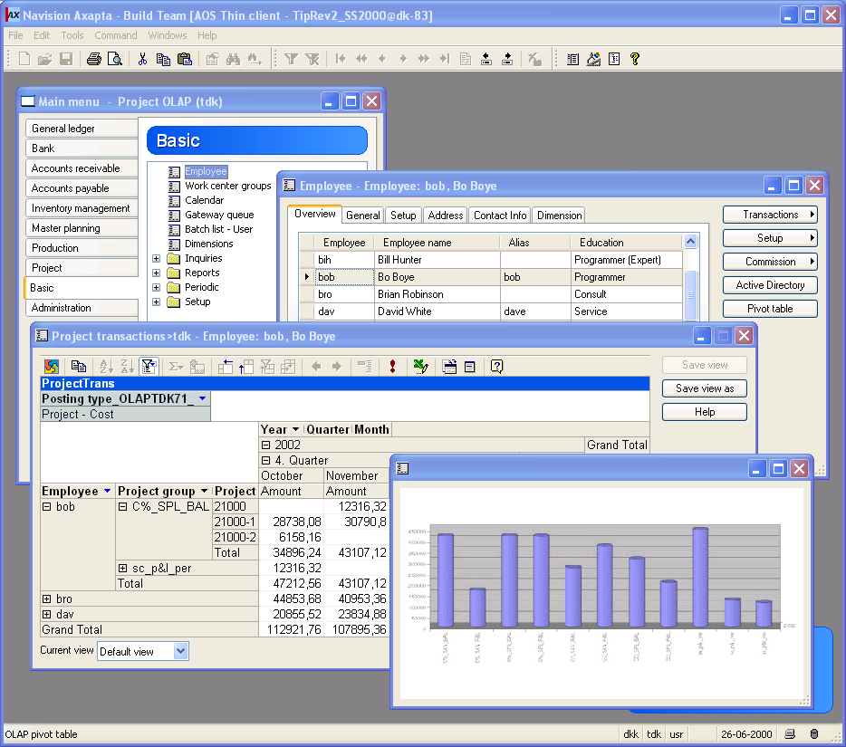
You can use Microsoft Pivot Tables from Microsoft Excel® to view data

Get the answers you need in realtime
Microsoft Axapta Business Analysis can give you business insight when you need it. You won’t need to wait for the IT department or a system administrator to create special reports for you. Analyze and drill down into your business information instead of following static reports. Transform data into multi-dimensional analyses that support enterprise-scale data volumes and hierarchies. Manipulate and derive actionable business information by applying ratios, cumulative totals, trends and allocations across dimensions and across hierarchical levels of your data.
For optimum performance, Microsoft Axapta Business Analysis saves cubes using the MOLAP model (multidimensional OLAP), which stores aggregations and a copy of the cube’s source data in a multidimensional structure. Reports can be published without intervention by your IT department.

Precision
Microsoft Axapta Business Analysis helps you get reliable results of your analyses, regardless of how complex the query is. The business data used during analysis is constantly updated because it includes changes as they occur in Microsoft Axapta or other data sources. You can set the update to run every day, every week or every month. There is no duplication or doubling of information sources.
You can also look at the results of your analyses at any scale, from a high-level overview down to microscopic detail. When analyzing buying patterns, for example, you can view information by customer group, by specific customer, specific invoice or by any other level of your choice. By measuring performance continuously, you can measure accurately whether your business goals are being met and whether your strategies are working effectively. Microsoft Axapta Business Analysis also gives you transparency when looking for the relationship between activities in different departments, locations or subsidiaries.
One of the barriers to traditional OLAP analysis is the time and expertise needed to build and maintain the applications and data. Microsoft Axapta Business Analysis can have a lower total cost of ownership than other analytical applications, by using a built-in Cube Definition Manager to simplify the processes of creating and maintaining cubes.

Get deep analyses directly from Microsoft Axapta
With traditional OLAP products, the process of mapping information between the enterprise resource planning (ERP) business data and the OLAP cube can often be difficult and time-consuming, because information needs to be mapped between two separate systems. But with Microsoft Axapta Business Analysis, the OLAP functionality and the ERP data are part of the same system. You don’t need to spend a lot of resources integrating a third-party business intelligence system that you need to reintegrate every time you upgrade your ERP solution. Microsoft Axapta Business Analysis requires Microsoft Axapta and Microsoft Analysis Services, but not third party analytical tools. All mappings occur directly in Microsoft Axapta, helping you get the most advantage out of your business information and making the most of relationships between tables and extended data types.

Security
The security is managed centrally, reducing the effect on users and strain on your IT department. You have full control over which users have access to which models. The users must be registered on the server they select to gain access.

For more information
To learn more about Microsoft Business Solutions–Axapta Business Analysis, contact your local Microsoft Business Solutions office, a Microsoft Certified Business Solutions reselling partner, and/or visit www.microsoft.com/BusinessSolutions.

About Microsoft Business Solutions
Microsoft Business Solutions offers a wide range of integrated, end-to-end business applications and services designed to help small, mid-market segment and corporate businesses become more connected with customers, employees, partners and suppliers. Microsoft Business Solutions applications optimize strategic business processes across financial management, supply chain management, customer relationship management and analytics. The applications are designed to provide insight to help customers achieve business success. More information can be found at www.microsoft.com/BusinessSolutions.

Address
Microsoft
Frydenlunds Allé 6
2950 Vedbaek
Denmark
Tel +45 45 67 80 00
Fax +45 45 67 80 01
www.microsoft.com/BusinessSolutions
Microsoft
One Lone Tree Road
Fargo ND 58104-3911
USA
Tel +1 888 477 7989; +1 701 281 6500
Fax +1 425 936 7329
www.microsoft.com/BusinessSolutions

Key Features | Description
Easy to use | - Intuitive layout and structure  - Direct access to main tables from journals  - Advanced sorting and filter options  - Application can be run in different languages
General | - Multidimensional analysis  - Embedded and context adaptable viewing of cubes  - Easy access to manipulation of views in Microsoft Excel  - Full control within Microsoft Axapta
Microsoft Analysis Server | - Create, maintain and control OLAP databases and cubes  - Cubes stored as MOLAP cubes with no querying drag on legacy database after update (should perhaps be rephrased to be more bullet-like)
Embedded Pivot Table | - Fully integrated with Microsoft Excel 2000 (Microsoft Query)  - Viewing of cube data  - Easy access to manipulation of view in Excel
Cube Definition Manager | - Full use of Microsoft Axapta data model  - Microsoft Axapta forms for easy set-up
Generation of Cubes | - Create cubes in multiple currencies and languages  - Periodic batch update possible for all cubes
Viewing of Cubes | - General overview of available views  - Automatic filtering from Microsoft Axapta base data on Pivot Table
Security and Configuration | - Configuration key control of which cubes to generate  - Security key control of access to cubes and views
Third Party Products | - Any third party product add-on which supports Microsoft Analysis Services can be used for viewing cubes but is not necessary

System Requirements
To obtain all of the features mentioned in this fact sheet,  the following modules and technologies are required: | To obtain all of the features mentioned in this fact sheet, the following modules and technologies are required:  - Microsoft Business Solutions–Axapta 3.0  - Microsoft Business Solutions–Axapta Business Analysis  - Microsoft Analysis Server 2000
15 December 2003
The information contained in this document represents the current view of Microsoft Corporation on the issues discussed as of the date of publication. Because Microsoft must respond to changing market conditions, it should not be interpreted to be a commitment on the part of Microsoft, and Microsoft cannot guarantee the accuracy of any information presented after the date of publication. This document is for informational purposes only. MICROSOFT MAKES NO WARRANTIES, EXPRESS, IMPLIED OR STATUTORY, AS TO THE INFORMATION IN THIS DOCUMENT. Complying with all applicable copyright laws is the responsibility of the user. Without limiting the rights under copyright, no part of this document may be reproduced, stored in or introduced into a retrieval system, or transmitted in any form or by any means (electronic, mechanical, photocopying, recording, or otherwise), or for any purpose, without the express written permission of Microsoft Corporation. Microsoft may have patents, patent applications, trademarks, copyrights, or other intellectual property rights covering subject matter in this document. Except as expressly provided in any written license agreement from Microsoft, the furnishing of this document does not give you any license to these patents, trademarks, copyrights, or other intellectual property. © 2003 Microsoft Business Solutions ApS, Denmark. All rights reserved. Microsoft, Great Plains, Navision, FRx, and Axapta are either registered trademarks or trademarks of Microsoft Corporation, Great Plains Software, Inc., FRx Software Corporation, or Microsoft Business Solutions ApS or their affiliates in the United States and/or other countries. Great Plains Software, Inc., FRx Software Corporation, and Microsoft Business Solutions ApS are subsidiaries of Microsoft Corporation. The names of actual companies and products mentioned herein may be the trademarks of their respective owners. The example companies, organizations, products, domain names, email addresses, logos, people and events depicted herein are fictitious. No association with any real company, organization, product, domain name, e-mail address, logo, person, or event is intended or should be inferred.

