
Windows Azure
Customer Solution Case Study
 |  |  | 3M Launches Web-Based Visual Attention Service to Heighten Design Impact

Overview  Country or Region: United States  Industry: Manufacturing—High tech and electronics  Customer Profile  With 75,000 employees and operations in more than 60 countries, 3M develops an extensive range of consumer and industrial products. Well-known 3M brands include Scotch, Post-it, Thinsulate, and Scotch-Brite.  Business Situation  3M wanted to make its Visual Attention Service (VAS) available to customers as a Web-based application, with high performance, scalability, and low infrastructure and management costs.  Solution  3M used the Windows Azure™ platform to deliver the VAS solution to customers, taking advantage of Microsoft® data center infrastructure and service management to keep performance high and costs low.  Benefits  - Easy, efficient deployment  - Lower costs, high scalability  - Excellent customer solution |  |  | “Windows Azure helps 3M customers take advantage of complex algorithms that encapsulate 30 years of research and get simple, powerful results from their browser, almost instantly.”  Terry Collier, Marketing Manager, 3M
 |  |  | A recognized world leader in technology research and development, 3M wanted to make its decades of expertise in the workings of the human visual system available as a service to customers. Using the Windows Azure™ platform, 3M created a Web-based application that gives designers the ability to invoke complex algorithms to analyze the effectiveness of a design, based on how the human eye will respond. By hosting its application in Microsoft® data centers, 3M has made an innovative service available to a global audience, while minimizing its investment in hardware infrastructure and ongoing administration. The solution, which permitted developers to evaluate frequent iterations of the application, helped the company speed time-to-market for its service and achieve higher quality results, faster than in a traditional development environment.
 |  |  | 

Situation
From well-known brands such as Post-it products, Thinsulate insulation, and Nexcare first aid, to high-strength bonding tapes, industrial abrasives, and traffic safety systems, 3M products are ubiquitous around the world. Founded in 1902, 3M is a science-based company and has developed thousands of innovative products for a broad range of markets. The company now operates in 60 countries and its worldwide sales in 2008 were more than U.S.$25 billion.

3M supports more than 40 different technology platforms and has invested years of scientific research in developing them. In fact, 7,000 of the company’s employees are dedicated solely to research. One area of research that is used in many 3M products—such as reflective materials used in roadway signage, emergency exit markings, and display and graphics technologies—is the understanding of how the human visual system works. The company’s vision scientists, working in its corporate research labs, study how the human brain processes visual information and have developed complex algorithms for predicting what a person will notice in a visual scene.

Bill Smyth, Business Manager at 3M, says, “Our job, on the business and marketing side, is to make the most of these capabilities.” To this end, Smyth and his colleagues identified a use for these predictive algorithms. “We knew there was a need to make the process for designing things that people interact with visually more science-based and iterative to bring about more effective results.”
“We knew there was a need to make the process for designing things that people interact with visually more science-based and iterative to bring about more effective results.”
Bill Smyth, Business Manager, 3M

Terry Collier, Marketing Manager at 3M, adds, “In our market research, we found that designers spend a lot of time creating, honing, and optimizing their images but they can be challenged by the fact that they don’t ever truly know how people are seeing a design before it’s completed.” 3M’s goal was to provide designers with predictive measurements about how their creations—from a logo design, to a Web site layout, to the placement of an electronic screen in a hotel lobby—would be perceived by their audience. Also, it was critical that this information be immediately available. “We needed to be able to provide designers with access to this information directly from their computer desktop, multiple times throughout the design process, so they could alter their designs in direct response to the analyses, rather than engaging in lengthy focus group sessions that happen after a design reaches a near-final state of completion,” says Collier.

The company developed a prototype of a Web-based application, called the 3M Visual Attention Service (VAS). The service makes it possible for designers to test the effectiveness of their content using visual attention models, which are based on algorithms that predict the elements of a scene that a viewer is likely to see and to remember. The prototype, a Web-based application that was hosted on 3M data center servers, enabled users to upload photographs of a physical environment or a graphic design to the VAS. The application’s processing engine then evaluated the image for its “visual saliency” and returned a map of the image that indicated, using markings such as those seen on a heat map, which areas of the image were most likely to attract a viewer’s attention. (Figure 1.)

But 3M wanted the application to work efficiently as part of its customers’ existing design processes. To become a viable offering, the VAS application had to be available to customers in real time, be capable of processing images and returning near-immediate results, of scaling rapidly during peak design times, such as just prior to holiday advertising deadlines, and it had to carry a low up-front investment risk for 3M. “Especially in the current economic environment, we have to be very careful about how we invest our capital,” says Smyth. “We didn’t want to invest in costly data center infrastructure and capacity that, much of the time, would sit idle and unused.”
“The similarities between Windows Azure and our current development environment gave us a huge advantage and made the decision easy.”
Jim Graham, Technical Manager, 3M

Jim Graham, Technical Manager at 3M, adds, “We needed to be able to provide a high-performance application to customers everywhere, without deploying data centers around the world.”

Solution
3M believed that the most effective approach would be to operate the VAS application from a “cloud computing” environment, in which the solution would be hosted and managed on the Internet and reside in an external partner’s data centers. The company evaluated hosted infrastructure offerings from Microsoft and others, but, says Graham, “3M has for a long time relied on Microsoft® tools and technologies to support the development of our technology.” For this reason, 3M chose the Windows Azure™ platform from Microsoft. Windows Azure is a cloud services operating system that serves as the development, service hosting, and service management environment for the Windows Azure platform. Windows Azure provides developers with on-demand compute and storage to host, scale, and manage Web applications on the internet through Microsoft data centers.


From its experience with the Community Technology Preview (CTP) of Windows Azure, a Microsoft program for early adopters to experiment with prerelease technology, Graham’s team thought that the solution was a good fit for 3M. “The similarities between Windows Azure and our current development environment gave us a huge advantage and made the decision easy,” says Graham. 3M relied on the Microsoft Visual Studio® 2008 development system to produce the VAS application, including Microsoft Visual Studio Team System 2008 Team Suite and Microsoft Visual Studio Team System 2008 Team Foundation Server. It also used Microsoft Expression Blend™ 3 design software and Microsoft SQL Server® 2008 data management software. “We saw that Windows Azure would work well with our Visual Studio development environment. We also saw the opportunity to take advantage of a new technology platform that would allow us to deploy in different countries, with rapid scaling capabilities and no up-front capital investment,” says Graham.
Figure 1. 3M VAS image map indicating areas most likely to attract viewers’ attention

To prepare the VAS application for commercial release, 3M built a new user interface. The timing coincided with the CTP of Windows Azure, so Graham’s team developed the interface to Windows Azure specifications. “We developed the whole user experience, from the ground up, on Windows Azure,” says Graham. His team also used the Windows Azure development fabric, which it used to simulate the Windows Azure environment on local computers, making it easy to run and test the VAS application before deploying it.
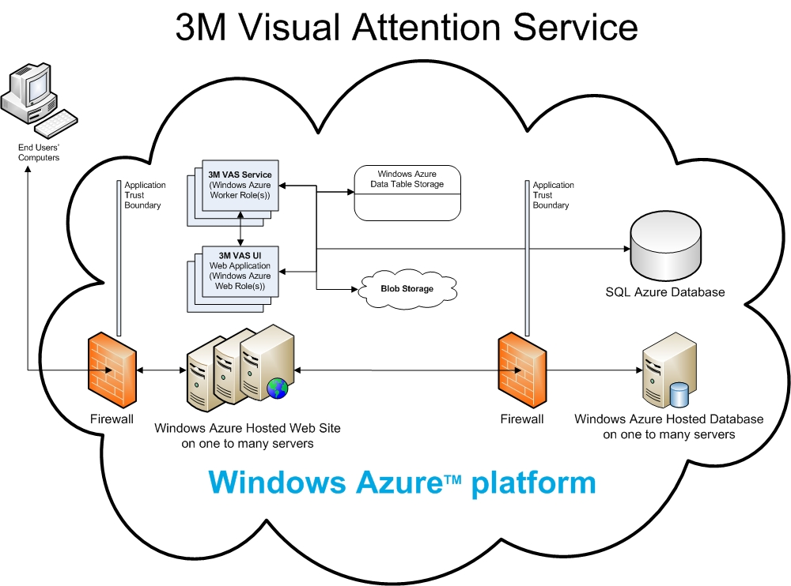
“SQL Azure is of great value to 3M because it takes the database management piece off our plate.”
Jim Graham, Technical Manager, 3M

VAS incorporates a number of unmanaged, high-performance image-processing software libraries developed by 3M. “The Windows Azure development fabric helped us perform quick iterations of code, allowing us to overcome many of the hurdles we might not have seen until we had deployed to a more formal staging or production environment,” explains Graham.
The VAS interface, and the Web site where users go to access it, was developed using Microsoft ASP.NET 2.0, part of the Microsoft .NET Framework. Graham’s team used the Microsoft Silverlight™ browser plug-in to build controls into the application that enable users to edit and modify images they submit to the VAS processing engine. The Silverlight-enabled controls are embedded into the ASP.NET application framework, creating a seamless experience for users. “Users don’t have to switch between different interfaces to perform certain functions,” explains Graham.
Figure 2. Diagram of 3M VAS deployed on Windows Azure

The VAS application relies on the Access Control Service feature of Windows Azure to authenticate users to the system, providing access to various components of the service based on a user’s credentials. 3M used Microsoft SQL Azure, a cloud-based relational database platform that is built on SQL Server technologies, to manage the images that users upload. SQL Azure also is used to deliver analytical results from the image processing engine. SQL Azure, as part of the Windows Azure platform, provides automated management capabilities, including built-in data protection, self-healing, and disaster recovery—crucial for protecting customers’ data. “SQL Azure is of great value to 3M because it takes the database management piece off our plate,” says Graham.

3M uses Windows Azure data storage services to store image files and analysis generated by the engine, and it uses the Queue service feature to provide users with high-performance and near-immediate response times even when the application is inundated with high traffic during peak load times.

“In short,” explains Graham, “With Access Control, we can create a pipeline from the ASP.NET-based interface, to the Queue service, to the VAS engine where the analysis is performed using the algorithms our scientists have developed.” (Figure 2.)

Currently, VAS helps customers evaluate any number of graphical or photographic images that they choose to upload to the application. In future versions, 3M plans to provide customers with the ability to create entire databases of test images, enabling users to experiment with, for example, the content of an advertisement in a variety of design scenes—or, conversely, a number of different types of advertising content in one particular scene. 3M plans to release a final version of the VAS application running on Windows Azure to customers by mid-November 2009.

Benefits
Using the Windows Azure platform, 3M developed a highly innovative Web-based service that can dramatically alter and improve the process for designing images and environments that rely on how the human visual system responds. By using a cloud service, 3M experienced an efficient deployment and lowered its infrastructure costs. The highly scalable Web-based service will make it possible for 3M customers to optimize designs in response to scientific analysis, thereby helping to make the most of their marketing dollars.

Easy, Efficient Deployment
The close connection between Windows Azure and the 3M Visual Studio development environment helped the company achieve a rapid deployment of the VAS application. “We were able to wrap our core technology into Windows Azure in less than eight weeks. It was very fast,” says Graham. “The tools and technologies we were already using, for instance forms authentication, are fully supported in Windows Azure. And, the Windows Azure development fabric provided a great simulation environment in which we could see our work in progress and incorporate feedback—early and often. We rapidly deployed interim releases to stakeholders within the company. The Windows Azure development fabric has been a significant time savings.”

In addition, once the VAS application development is complete and the service is made publicly available on Windows Azure, 3M will be able to quickly release product updates and enhancements. “We will be able to deploy much faster on the Microsoft technology platform through Windows Azure than with any other cloud solution we evaluated,” says Graham.
“We will be able to deploy much faster on the Microsoft technology platform through Windows Azure than with any other cloud solution we evaluated.”
Jim Graham, Technical Manager, 3M

Lower Costs, High Scalability
With Windows Azure, 3M capitalizes on a pay-as-you-use pricing model to minimize hosting costs and maximize profits. “With Windows Azure, we get a highly scalable environment, pay only for the resources we need, and relieve our IT staff of the systems management and administration responsibilities of supporting a dynamic infrastructure,” says Graham.

3M found SQL Azure to be especially beneficial because it can use it to offer the VAS application to a global audience, without the expense of establishing and maintaining regional data centers. Graham explains, “With SQL Azure, we can deploy internationally without having to migrate customer data from one region to another, without having to replicate databases, and without all of the service management we would otherwise have to engage in.” Graham compares the time and cost savings that result from the use of Windows Azure as a cloud services platform to other endeavors at 3M. “We have full-time staff members who are solely dedicated to managing our hosted solutions. Were we to host the VAS application ourselves, we would have to increase our support staff.”

Excellent Customer Solution
“3M VAS and Windows Azure will help our customers spend their marketing dollars more wisely.”
Bill Smyth, Business Manager, 3M

Most importantly, 3M used Windows Azure to deliver a new technology that could change the design process paradigm, especially in areas where success hinges on a viewer’s response to a scene. “Windows Azure helps 3M customers take advantage of complex algorithms that encapsulate 30 years of research and get simple, powerful results from their browser, almost instantly,” says Collier.

Graham says, “We wanted to make it so simple for our users that they didn’t even have to step outside of the workflow they are used to. With the VAS application running on Windows Azure, users can open a Web browser and analyze any number of files, straight from their computer.” As VAS becomes an integral, natural element of the design process for 3M customers, the company expects to “significantly reduce the time and cost of design iterations—while improving the overall impact of the designs,” says Graham.

“3M VAS and Windows Azure will help our customers spend their marketing dollars more wisely,” explains Smyth. “In our research, we found that customers value having an analytical, science-based assessment of their designs. It takes it out of the ego space of subjective evaluations from colleagues or from their own clients. We believe that with the Windows Azure–based solution, we can have a significant impact on the financial aspects of marketing-based design.”

Windows Azure Platform
The Windows Azure platform provides an excellent foundation for expanding online product and service offerings. The main components include:
- Windows Azure. Windows Azure is the development, service hosting, and service management environment for the Windows Azure platform. Windows Azure provides developers with on-demand compute and storage to host, scale, and manage Web applications on the Internet through Microsoft data centers. In addition, Windows Azure serves developers’ connectivity needs through the following services.
- The Service Bus connects services and applications across network boundaries to help developers build distributed applications.
- The Access Control Service provides federated, claims-based access control for REST Web services.
- Microsoft SQL Azure. Microsoft SQL Azure offers the first cloud-based relational and self-managed database service built on Microsoft SQL Server 2008 technologies.

To learn more about the Windows Azure platform, visit:
www.windowsazure.com

For More Information
For more information about Microsoft products and services, call the Microsoft Sales Information Center at (800) 426-9400. In Canada, call the Microsoft Canada Information Centre at (877) 568-2495. Customers in the United States and Canada who are deaf or hard-of-hearing can reach Microsoft text telephone (TTY/TDD) services at (800) 892-5234. Outside the 50 United States and Canada, please contact your local Microsoft subsidiary. To access information using the World Wide Web, go to:
www.microsoft.com

For more information about the 3M Visual Attention Service, visit the VAS Web site at:
www.3m.com/vas

Additional Resources:
Download: Windows Azure Platform Training Kit
View: Architecting and Developing for Windows Azure

This case study is for informational purposes only. MICROSOFT MAKES NO WARRANTIES, EXPRESS OR IMPLIED, IN THIS SUMMARY.

Document published November 2009

Software and Services  - Windows Azure Platform  - Windows Azure  - Access Control Service  - Microsoft SQL Azure  - Microsoft Server Product Portfolio  - Microsoft SQL Server 2008  - Microsoft Visual Studio  - Microsoft Visual Studio Team System 2008 Team Foundation Server | - Microsoft Visual Team System 2008 Team Suite  - Microsoft Expression  - Microsoft Expression Blend 3  - Technologies  - Microsoft ASP.NET 2.0  - Microsoft .NET Framework  - Microsoft Silverlight

