**­**

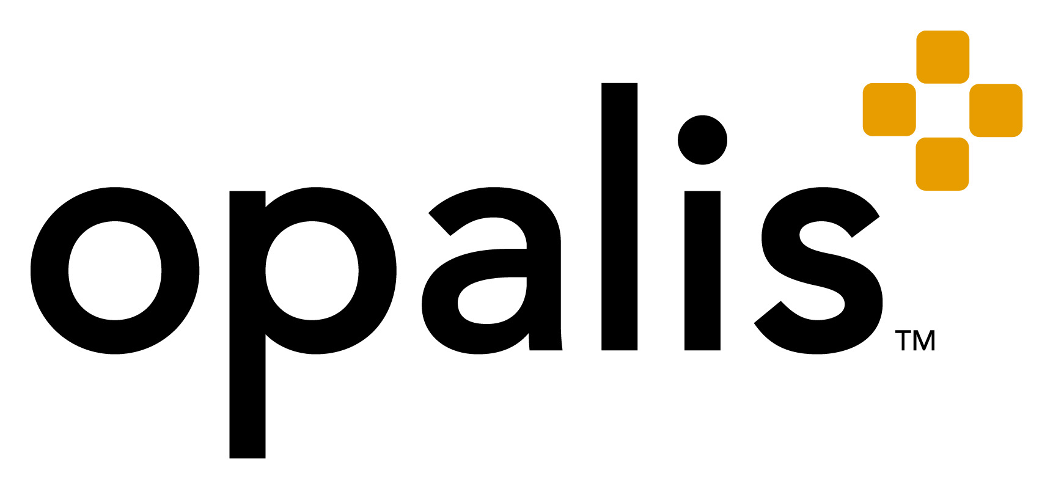

**An Overview of   
IT Process Automation**

***Disclaimer and Copyright Notice***

*The information contained in this document represents the current view of Microsoft Corporation on the issues discussed as of the date of publication. Because Microsoft must respond to changing market conditions, it should not be interpreted to be a commitment on the part of Microsoft, and Microsoft cannot guarantee the accuracy of any information presented after the date of publication.*

*This White Paper is for informational purposes only. MICROSOFT MAKES NO WARRANTIES, EXPRESS, IMPLIED, OR STATUTORY, AS TO THE INFORMATION IN THIS DOCUMENT.*

*Complying with all applicable copyright laws is the responsibility of the user. Without limiting the rights under copyright, no part of this document may be reproduced, stored in, or introduced into a retrieval system, or transmitted in any form or by any means (electronic, mechanical, photocopying, recording, or otherwise), or for any purpose, without the express written permission of Microsoft Corporation.*

*Microsoft may have patents, patent applications, trademarks, copyrights, or other intellectual property rights covering subject matter in this document. Except as expressly provided in any written license agreement from Microsoft, the furnishing of this document does not give you any license to these patents, trademarks, copyrights, or other intellectual property.*

*© 2010 Microsoft Corporation. All rights reserved.*

*Microsoft and the Microsoft logo are trademarks of the Microsoft group of companies.*

*All other trademarks are property of their respective owners.*

# 

Table of Contents

Introduction 4

Traditional Automation Methods 4

Beyond Job Scheduling 5

System Center and Opalis IT PRocess Automation 5

Integrating System Center with Non Microsoft Tools 5

Orchestrating System Center tools with 3rd party systems 6

Automating Processes through Workflow 6

Where to Start 7

# Introduction

IT organizations are under increasing pressure to ensure high service levels and infrastructure efficiency, while lowering operating costs and adhering to best practices. As such, efforts to integrate systems and automate processes have become two key goals for IT organization professionals. Achieving these objectives means improving the level of automation within both production and operations environments.

By increasing the levels of automation and eliminating common, repetitive tasks, companies can reduce operational costs, as well as reduce the amount of specialized staff needed to manage its systems. What’s more, highly skilled IT professionals can be freed up to manage more strategic company projects and initiatives. Although the benefits of automation meets the business objectives of reducing costs, increasing productivity, and maximizing efficiency, the number one concern of IT managers today is integration. Automation itself can be a best practice in many organizations as they struggle to manage—and integrate across—increasingly complex infrastructures, but let’s talk specifically about how automation enables best practices.

Implementing best practices is achieved primarily by defining and automating IT operations management processes. Although most data center tools (monitoring, provisioning, virtualization, service desk, etc.) provide deep task automation within their solutions, they do not automate processes between applications, departments, or data silos. This leaves a substantial amount of manual work for IT staff. Done right, IT Process Automation (ITPA), also commonly known as Run Book Automation (RBA), can greatly expedite service management if they provide the means to integrate and orchestrate IT processes.

# Traditional Automation Methods

Traditional automation methods, namely custom coding and scripts, are useful for running simple tasks, however, they typically lack best practices, change management, documentation, and the flexibility required in an operations environment, where business rules and configuration settings change frequently.

Traditional automation methods, namely job schedulers, run and monitor batch jobs. Although job scheduling comprises an important function in a production-computing environment, it is not well suited to automate operational processes or run book procedures, as they provide little to no integration with surrounding systems.

Due to the recent recognition of this market by both IT organizations and leading industry analyst firms alike, some companies have attempted to accomplish the equivalent of what is now known as ITPA, by running lengthy scripts with a job scheduler. This technique is costly, unreliable, and error-prone.

While scripts and schedulers work well for small tasks, they can rarely scale to handle complex environments. They also lack sophisticated dependencies and reporting that allow users to keep audit trails of processes. As process requirements grow, and more functionality is added, the result is a complex mix of scripts, programs, and utilities that only a few people actually understand. More concerning is that home-grown scripts can quickly turn into a fulltime programming commitment as well as a time-consuming and costly management burden.

# Beyond Job Scheduling

ITPA solutions include many of the features and capabilities users require in a job scheduler, while also providing more advanced functions. IT process automation software can automate any administrative, maintenance, or business processes, such as restarting services, rotating logs, backing up data, deleting temporary files, and e-mailing files. It can also run several jobs on multiple machines, modify accounts, query databases, up load data and filter/read/send e-mail. In addition to standard enterprise requirements like load balancing, failover, failure routines, error handling, and logging, ITPA should also provide integration, orchestration, and process workflow.

# System Center and Opalis IT PRocess Automation

System Center lowers the cost of delivering datacenter services through integrated, end-to-end management of physical and virtual environments. Through adopting System Center, customers are able to standardize their datacenter management environment for significantly lower costs than competitive solutions while implementing best practices that can deliver thousands of dollars of operational savings each year. This is delivered through simplified management of the datacenter via an integrated set of tools that automate server management and optimize the use of server and datacenter resources.

As a part of the System Center portfolio, Opalis IT Process Automation extends automation, optimization and simplification by orchestrating and integrating System Center with non-Microsoft systems to enable interoperability across the entire datacenter. The combined offering reduces the cost of delivering and managing datacenter services by:

## Integrating System Center with Non Microsoft Tools

Integration is a key component to IT process automation solutions, as it provides the ability to query, modify, collect, parse, and pass data between systems and products. Opalis uses data to make decisions, to dynamically configure task parameters with relevant run-time data, and to update systems such as Configuration Manager and Service Manager with process information. This gives IT organizations the ability to update one or all systems with detailed information on a process. It also ensures help desk staff, and level 1-2-3 support staff has access to problem status.

## Orchestrating System Center tools with 3rd party systems

ITPA also requires intelligent orchestration capabilities so it can initiate actions within third party systems. The Opalis orchestration engine works in conjunction with integration capabilities to read results of these actions to determine next steps and to log/report on each step within the process. This is paramount for tracking change requests and maintenance procedures that interact with multiple systems and impact service availability.

## Automating Processes through Workflow

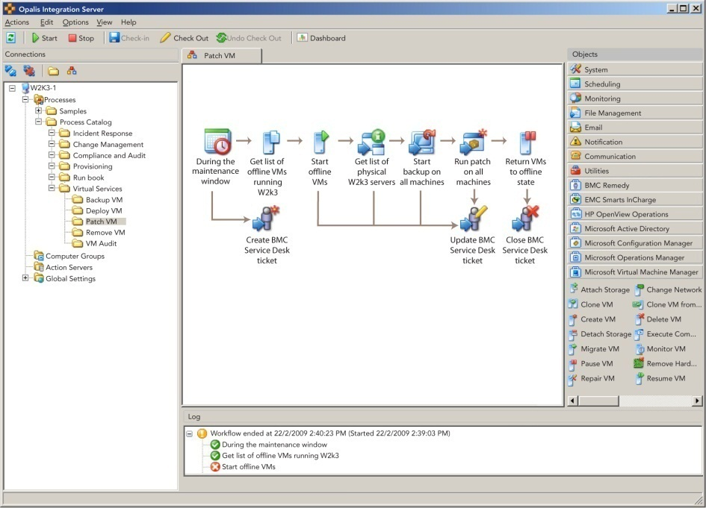Opalis workflow not only provides visual insight as to the nature of a process, it also delivers decision making logic and dependency support needed to automate complex processes. Opalis workflow also enables branching capabilities, useful for creating incident response routines that handle a range of errors and conditions. The main workflow can define the expected process, while branches are used for exception cases, error handling and escalation routines.

**3**

**4**

**4**

Opalis Workflow Designer

# Where to Start

To summarize, Opalis IT Process Automation helps to automate, integrate, and orchestrate operational processes across multiple data, departmental, and application silos. System Center and Opalis automation can enable and enforce best practices in an IT organization and help align IT services with business objectives through repeatable, reliable, and standardized best practices.

Initiatives such as ITIL and MOF outline best practices for all IT activities. The service support areas of ITIL; incident, problem, configuration, change, and release management make up the daily operational tasks within IT. With many companies embracing ITIL best practices, it’s a good place to start with automation since these are the most critical areas of IT operations today. And, how else can you ensure best practices and processes are truly followed, unless with automation?