

Microsoft Assessment and Planning Toolkit
Getting Started Guide

Version 4.0

Published: June 12th, 2009
For the latest information, please see
http://go.microsoft.com/fwlink/?LinkId=106437

Copyright © 2009 Microsoft Corporation. All rights reserved. Complying with the applicable copyright laws is your responsibility. By using or providing feedback on this documentation, you agree to the license agreement below.

If you are using this documentation solely for non-commercial purposes internally within YOUR company or organization, then this documentation is licensed to you under the Creative Commons Attribution-NonCommercial License. To view a copy of this license, visit http://creativecommons.org/licenses/by-nc/2.5/ or send a letter to Creative Commons, 543 Howard Street, 5th Floor, San Francisco, California, 94105, USA.

This documentation is provided to you for informational purposes only, and is provided to you entirely "AS IS". Your use of the documentation cannot be understood as substituting for customized service and information that might be developed by Microsoft Corporation for a particular user based upon that user’s particular environment. To the extent permitted by law, MICROSOFT MAKES NO WARRANTY OF ANY KIND, DISCLAIMS ALL EXPRESS, IMPLIED AND STATUTORY WARRANTIES, AND ASSUMES NO LIABILITY TO YOU FOR ANY DAMAGES OF ANY TYPE IN CONNECTION WITH THESE MATERIALS OR ANY INTELLECTUAL PROPERTY IN THEM.

Microsoft may have patents, patent applications, trademarks, or other intellectual property rights covering subject matter within this documentation. Except as provided in a separate agreement from Microsoft, your use of this document does not give you any license to these patents, trademarks or other intellectual property.

Information in this document, including URL and other Internet Web site references, is subject to change without notice. Unless otherwise noted, the example companies, organizations, products, domain names, e-mail addresses, logos, people, places and events depicted herein are fictitious.

Microsoft, Active Directory, SQL Server, Windows, Windows NT, and Windows Vista are either registered trademarks or trademarks of Microsoft Corporation in the United States and/or other countries.

The names of actual companies and products mentioned herein may be the trademarks of their respective owners.

You have no obligation to give Microsoft any suggestions, comments or other feedback ("Feedback") relating to the documentation. However, if you do provide any Feedback to Microsoft then you provide to Microsoft, without charge, the right to use, share and commercialize your Feedback in any way and for any purpose. You also give to third parties, without charge, any patent rights needed for their products, technologies and services to use or interface with any specific parts of a Microsoft software or service that includes the Feedback. You will not give Feedback that is subject to a license that requires Microsoft to license its software or documentation to third parties because we include your Feedback in them.

Contents
Overview 1
Computer Discovery Methods 1
Active Directory Domain Services (AD DS) 1
Windows Networking Protocols 1
Import Computer Names from a File 2
Scan an IP Address Range 2
Manually Enter Computer Names 2
Inventory Methods 2
Documentation Roadmap 3
In This Guide 3
Installing the MAP Tool 3
Uninstalling the Toolkit 3
Preparing Your Environment 4
Remote Computer Configurations 4
Windows Management Instrumentation 4
Remote Registry Service 7
Using the MAP Toolkit 7
Inventory and Assessment 7
Discovery and Readiness 7
Server Consolidation 9
Surveys 11
Reference Material 12
Using the MAP Tool Wizards 12
Analyzing the Results 13
For More Information 13
Installation Questions 13
Obtain Product Support 13
Feedback 13

Overview
The Microsoft® Assessment and Planning (MAP) Toolkit helps you understand your current IT infrastructure and determine the right Microsoft technologies for your IT needs. It is a powerful inventory, assessment, and reporting tool that can securely inventory small or large IT environments without requiring the installation of any agent software in your environment. The data and analysis that this tool provides can significantly simplify the planning process for a wide range of migration projects.

Computer Discovery Methods
MAP can discover computers in your environment or you can specify which computers to inventory using one of the following methods:
- Active Directory® Domain Services (AD DS).
- Windows® networking protocols.
- Import computer names from a file.
- Scan an IP address range.
- Manually enter computer names.

Active Directory Domain Services (AD DS)
This method allows you to query a domain controller via the Lightweight Directory Access Protocol (LDAP) and select computers in all or specific domains, containers, or organizational units (OUs). Use this method if all computers and devices are in Active Directory.
It is recommended that you not use the AD DS method together with the standard Windows networking protocols inventory method. Using only the AD DS method can significantly improve the time required to complete the inventory. Computers that have not been logged onto the AD domain for more than 90 days will not be inventoried.
This inventory method has the following characteristics:
- Scope. This inventory method identifies all computers running Microsoft operating systems that are managed by Active Directory.
- Process. Active Directory queries return a list of computer objects defined in Active Directory, which Windows Management Instrumentation (WMI) then uses to perform a detailed inventory.
- Limitations. This method supports up to 120,000 computer objects per domain per run of the AD DS inventory method. If there are more than 120,000 computers, the additional objects will not be reported in the inventory results.
- Credentials required. The wizard requires a domain account that is to be used to query Active Directory. At a minimum, this account should be a member of the Domain Users group in the domain. For each computer to be included in the WMI inventory process, the wizard also requires an account that is a member of the local Administrators group on that computer.

Windows Networking Protocols
This method uses the WIN32 LAN Manager APIs to query the Computer Browser service for computers in workgroups and Windows NT® 4.0-based domains. If the computers on the network are not joined to an Active Directory domain, use only the Windows Networking Protocols option to find computers.
If you are inventorying computers in workgroups or Windows NT 4.0 domains and there are also computers joined to an Active Directory domain, use this inventory method and also select the option to find computers using AD DS.
If the Windows Networking Protocols page of the wizard does not provide a list of workgroups, Windows NT 4.0 domains, or Active Directory domain NetBIOS names, ensure that the Computer Browser and Server services are running on the computer performing inventory. For help, see Troubleshooting the Microsoft Computer Browser Service at http://go.microsoft.com/fwlink/?LinkId=155696.
This inventory method has the following characteristics:
- Scope. This inventory method identifies the computers on a network that are running Microsoft operating systems. If your organization has multiple LAN segments, you must run the wizard on each LAN segment only to find all workgroups.
- Process. The computer browser broadcasts a message on the network to which most Windows-based computers will respond, which identifies the computers running on the network. For each computer on the network that supports WMI, the WMI collector gathers detailed hardware and software inventory from each identified computer.
- Limitations. There are no limits to the number of WMI clients that can be scanned. However, WMI inventory collects a lot of information on each client and inventory of a large number of WMI clients takes additional time.

Import Computer Names from a File
Using this method, you can create a text file with a list of computer names that will be inventoried. Each computer name should be on a new line and the file should not use delimiters, such as comma, period, or tab.
Use this method if you have a list of up to 120,000 computer names that you want to inventory. The imported file can contain computer names, NetBIOS names, or Fully Qualified Domain Names (FQDN). Only one file can be imported each time you run the wizard.

Scan an IP Address Range
This method allows you to specify the starting address and ending address of an IP address range. The wizard will then scan all IP addresses in the range and inventory only those computers. The IP address range computer discovery method is limited to scanning only 100,000 IP addresses at one time. If you have more addresses than the limit, run the wizard multiple times, specifying different IP address ranges each time you run the wizard.
The following recommendations are provided for the IP address range computer discovery method:
- Use this method to specifically target a set of computers in a branch office or specific subnets when you only want inventory performed on those computers.
- Use it to find devices and computers that cannot be found using the Computer Browser service or AD DS.
- Limit the size of the IP address range provided. This will reduce the time required to perform inventory.

Manually Enter Computer Names
This method enables you to test and inventory a few computers at a time. Use this method if you want to inventory a small number of specific computers. You can manually enter computer names, NetBIOS names, or FQDNs. For each computer, you will need to provide credentials that have local Administrator access.

Inventory Methods
The MAP Toolkit uses multiple inventory methods. For each computer in a network that is to be included in the inventory and assessment process, you must specify an account that is a member of the local Administrators group on that computer. To inventory domain controllers in your network, you need to specify domain administrator credentials. The inventory methods used include:
- Windows Management Instrumentation (WMI). This inventory method is used to collect hardware, device, and software information from the remote computer.
- Remote Registry service. The Remote Registry service is used to find the roles installed on a server. The “Remote Computer Configurations” section of this document describes in detail how to enable configurations on remote computers.
- VMware Webservice. This method is used to inventory hosts running VMware ESX, VMware ESXi and VMware Server in your environment.

Documentation Roadmap
The MAP Toolkit includes the following documents and resources:
- Release Notes. Provides information you should read before installing the MAP tool, including installation prerequisites, and known issues.
- Getting Started Guide (this document). Provides information about installing the tool, describes supported assessment scenarios, and shows how to use the results.
- Toolkit Help. Provides detailed information about the tool, including wizard options. To access Help, click the Help button, or click Start, point to All Programs, click Microsoft Assessment and Planning Toolkit, and then click Toolkit Help.

In This Guide
This guide discusses the following:
- Installing the MAP tool
- Preparing your environment
- Using the MAP tool
- Analyzing the results

Installing the MAP Tool
For more information about the hardware and software prerequisites for installing the MAP Toolkit, see the Release Notes at http://go.microsoft.com/fwlink/?LinkId=155697.
Install the MAP Toolkit on a single computer that has access to the network on which you want to conduct an inventory and assessment. The Microsoft Assessment and Planning Toolkit Setup Wizard guides you through the installation of application files and SQL Server® 2008 Express Edition.
The MAP Toolkit requires a non-default instance of SQL Server 2008 Express Edition. If the computer is already running another instance of SQL Server 2008 Express Edition, the setup wizard must still install a new instance. This instance is customized for exclusive use by the MAP Toolkit wizards and should not be modified. By default, access to this instance is blocked from remote computers. Access to the instance on the local computer is only enabled for users who have local administrator credentials.
If you encounter a problem during installation, refer to the installation log files. The log files are located in the path specified in the %TEMP% environment variable on the local computer. You can find additional troubleshooting information by examining the application and system event logs.

Uninstalling the Toolkit
You can use the Microsoft Assessment and Planning Toolkit Setup Wizard to uninstall the MAP Toolkit. The setup wizard provides the option to remove the SQL Server 2008 Express Edition instance and delete files created by the application. The SQL Server 2008 common installation files will not be removed during uninstall. To uninstall them manually, in Control Panel, click Add/Remove Programs or the Programs and Features in Windows Vista®.

Preparing Your Environment
To prepare to use the MAP Toolkit in your environment, you first need to make certain configurations to remote computers.

Remote Computer Configurations
In order to run the MAP Toolkit wizards, the only required configuration is to configure the Windows Firewall (where appropriate) to enable remote access to WMI. This section describes this and other potential configurations that need to be completed before using the MAP Toolkit.

Windows Management Instrumentation
WMI is used to collect hardware, device, and software information from the remote computers. This inventory method is required for all assessment scenarios and must be enabled on all remote computers. The Inventory and Assessment Wizard will not provide an option to enable WMI. It must be enabled via Group Policy settings, logon scripts, or manually on each computer.
To connect remotely and perform the WMI inventory, you will need to provide accounts that are members of the local Administrators group on the computer being inventoried. For most networks, the network administrator will have a domain or local account that is a member of the local Administrators group on all of the computers in the environment. These are the accounts you should enter on the Inventory Accounts page in the Inventory and Assessment Wizard to perform the WMI inventory. By default in Windows domain environments, the Domain Admins security group is added to the local Administrators group on a computer when it is joined to a domain.
The following table describes all of the common WMI considerations for the Inventory and Assessment Wizard.
Table 1. WMI Considerations
Required Configuration | Description
Set password for local accounts | If a computer is in a workgroup and the local account used for inventory does not have a password configured, by default, logon is limited to the console only. For a WMI inventory of the computer to be successful, the local account needs to be a member of the local Administrators group and must have a password defined.
Configure network access policy | If the computer is in a workgroup, you need to manually change the Network access: Sharing and security model for local accounts policy setting from Guest only to Classic on the local computer. For more information, see http://go.microsoft.com/fwlink/?LinkId=155699.
Enable Remote Administration exception | The Remote Administration exception needs to be enabled for computers when the Windows Firewall is enabled. This exception opens TCP port 135. If you have another host firewall installed, you will need to allow network traffic through this port.  To allow for remote administration  - Click Start, click Run, type gpedit.msc, and then click OK.  - Under Console Root, expand Computer Configuration, expand Administrative Templates, expand Network, expand Network Connections, expand Windows Firewall, and then click Domain Profile.  - Right-click Windows Firewall: Allow remote administration exception, and then click Properties.  - Click Enabled, and then click OK.
Enable File and Printer Sharing exception | The File and Printer Sharing exception must be enabled for computers when the Windows Firewall is enabled. This exception opens TCP ports 139 and 445, as well as UDP ports 137 and 138. If you have another host firewall installed, you will need to allow network traffic through these ports.
Other WMI connectivity information | Many host-based and software-based firewall products will block DCOM traffic across the network adapters on the computer. For example, remote WMI connections will likely fail when attempting to connect to a computer running the Microsoft Internet Security and Acceleration (ISA) firewall service. To enable remote WMI access, you need to make sure that the TCP/UDP ports mentioned previously for the Remote Administration and File and Printer Sharing exceptions are open on the computer running the software firewall.

Computers that are running Windows Firewall introduce some challenges to the inventory process. By default, Windows Firewall is configured to block remote requests to authenticate and connect to the computer via WMI. The following sections describe how to enable the required exceptions using Group Policy and scriptable commands.
Note For computers running Windows XP, the number of physical hyperthreading-enabled processors or the number of physical multicore processors is incorrectly reported. For additional information see KB article 936235 Knowledge Base article 936235 at http://go.microsoft.com/fwlink/?LinkId=155700.

Windows Installer Provider
The Windows Installer Provider (MSI Provider) is available by default on 32-bit operating systems. On 64-bit operating systems, the provider is an optional component. By default, it is not installed on Windows Server 2003.
This prevents the MAP toolkit from completing the application inventory and may result in incorrect role reporting. The following procedure enables the inventory of installed applications.
To enable the WMI Windows Installer Provider
- In Add/Remove Programs, click Add/Remove Windows Components.
- In the Windows Components Wizard, click Management and Monitoring Tools, and then click Details.
- In the Management and Monitoring Tools dialog box, select WMI Windows Installer Provider, and then click OK.
- Click Next.
Note For Windows NT 4.0–based environments, you can download WMI Core from http://go.microsoft.com/fwlink/?LinkId=131306.

Active Directory Environments
Use the Group Policy Editor to edit Group Policy for the organizational units that contain the computers on which you will perform the assessment. For instructions on how to use the Group Policy Editor, see the following resources.
- For Windows XP, see How To Use the Group Policy Editor to Manage Local Computer Policy in Windows XP at http://go.microsoft.com/fwlink/?LinkId=155701.
- For Windows Vista, see Deploying Group Policy Using Windows Vista http://go.microsoft.com/fwlink/?LinkId=155702.
- For Windows 7, see What's New in Group Policy at http://go.microsoft.com/fwlink/?LinkId=155703.
To enable Windows Firewall exceptions using Group Policy
- Using the Group Policy Editor, click Computer Configuration, click Windows Settings, click Security Settings, click Local Policies, and then click Security Options.
- In the Network access: Sharing and security model for local accounts section, click Classic – local users authenticate as themselves.
- Using the Group Policy Editor, click Computer Configuration, click Administrative Templates, click Network, click Network Connections, click Windows Firewall, and then click Domain Profile.
- In the Windows Firewall: Allow remote administration exception section, click Enabled.
- In the Allow unsolicited incoming messages from text box, type the IP address or subnet of the computer that will be performing the inventory.
- In the Windows Firewall: Allow file and print sharing exception section, click Enabled.
- In the Allow unsolicited incoming messages from text box, type the IP address or subnet of the computer performing the inventory.
After saving the policy changes, you will need to wait up to two hours for the Group Policy settings to be applied to the client computers.

Workgroups and Windows NT 4.0-based Domains
For computers in a workgroup, you will need to manually configure each computer. For computers in a Windows NT 4.0–based domain, use logon scripts to configure the Windows Firewall exceptions.
To configure Windows Firewall exceptions for workgroups and Windows NT 4.0–based domains
- Using the Local Security Policy tool available from the Administrative Tools menu of the computer to be inventoried, click Security Settings, click Local Policies, and then click Security Options.
- In the Network access: Sharing and security model for local accounts section, click Classic – local users authenticate as themselves.
- Manually run the following command, or run it from a logon script on each computer to enable the remote administration exception:
netsh firewall add portopening protocol=tcp port=135 name=DCOM_TCP135
- Manually run the following command, or run it from a logon script on each computer to enable the file and printer sharing exception:
netsh firewall set service type=fileandprint mode=enable profile=all

Remote Registry Service
The Remote Registry service is used to find the roles installed on a server. It is also required for running the Gather Performance Metrics Wizard. This service is installed on Windows-based clients and servers, but the following conditions must exist for this inventory method to be successful:
- The Remote Registry service must be started. By default, it is configured to start automatically.
- The Windows Firewall Remote Administration exception must be enabled.
- You must authenticate using local Administrator equivalent privileges.
If the Remote Registry service is disabled on a server, you need to enable it before performing the inventory. You can either manually enable the service or configure it to start via Group Policy and wait until the servers are rebooted (and the service starts) before starting the Windows Server 2008 Hardware Assessment or Performance Metrics Wizard.
To manually enable the Remote Registry service
- On the computer on which you want to access Reliability Monitor data, click Start, right-click Computer, and then click Manage.
Microsoft Management Console (MMC) starts.
- In the navigation pane, expand Services and Applications, and then click Services.
- In the console pane, right-click Remote Registry, and then click Start.

Using the MAP Toolkit
When you start the MAP Toolkit, a dialog box asks you to create or select a database to use. The MAP tool gathers detailed data about the networked devices discovered during inventory and stores the data in a SQL Server 2008 Express Edition database.
Use a single inventory database for each organization. When you run the wizards to update a database (for example, to include separate network subnets), data is added and modified in the database, as appropriate, but data is not deleted from the database.
The MAP tool has three sections to which you can navigate using wunderbars in the lower left corner of the tool. These are:
- Inventory and Assessment
- Surveys
- Reference Material

Inventory and Assessment
The Inventory and Assessment section displays two nodes in the upper left corner: Discovery and Readiness and Server Consolidation.

Discovery and Readiness
When you select the Discovery and Readiness node, the results pane displays the Client, Server, and Virtualization assessments you can complete using the Inventory and Assessment Wizard, as shown in the following figure.
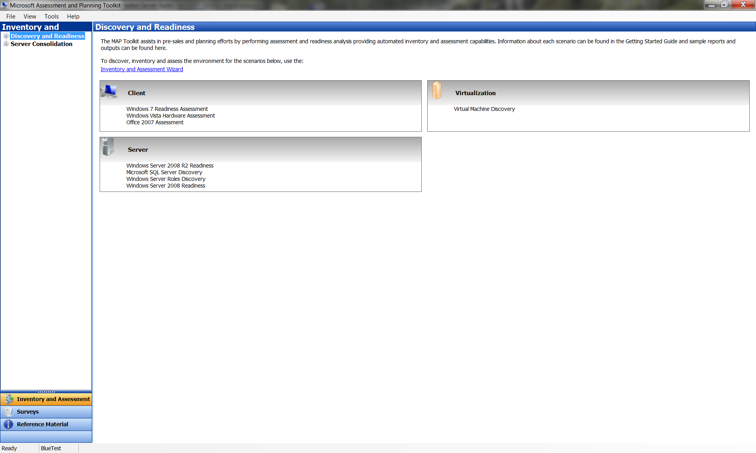
Figure 1. Discovery and Readiness node of the Inventory and Assessment section
These assessments include:
- Windows 7 Readiness Assessment. This assessment indicates which computers in your environment can support Windows 7 and makes suggestions about the types of hardware upgrades that would be necessary to make all computers ready for Windows 7. This assessment generates a written proposal (Windows7Proposal-date-time.docx) and a detailed report (Windows7HardwareAssessment-date-time.xlsx).
- Windows Vista Hardware Assessment. This assessment provides detailed information about the client computers in your environment. It indicates which computers can support Windows Vista and makes suggestions about the types of hardware upgrades that would be necessary to make all computers ready for Windows Vista. This assessment generates a written proposal (VistaProposal-date-time.docx) and a detailed report (VistaHardwareAssessment-date-time.xlsx).
- 2007 Office Assessment. This assessment reports on the versions of Microsoft Office discovered during inventory and provides a summary of the client computers that can be upgraded to the 2007 Microsoft Office release.
- Windows Server 2008 R2 Readiness. This assessment provides detailed information about which servers in your environment can support Windows Server 2008 R2 and makes suggestions about the types of hardware upgrades that would be necessary to make all servers ready for Windows Server 2008 R2. This assessment generates a written proposal (WS2008R2Proposal-date-time.docx) and a detailed report (WS2008R2HardwareAssessment-date-time.xlsx).
- Microsoft SQL Server Discovery. This assessment identifies computers that have SQL Server or SQL Server components installed. It indicates their ability to migrate to SQL Server 2008.
- Windows Server Role Discovery. This assessment provides detailed information about all discovered physical computers and virtual machines running a Windows Server operating system in your environment. These systems are inventoried and analyzed to determine which server roles are installed on the server and to recommend an upgrade path for that server.
- Windows Server 2008 Readiness. This assessment provides detailed information about which servers in your environment can support Windows Server 2008 and makes suggestions about the types of hardware upgrades that would be necessary to make all servers ready for Windows Server 2008. This assessment generates a detailed report (WS2008RoleAssessment- date-time.xlsx).
- Virtual Machine Inventory. This assessment reports on all discovered computers running Microsoft and VMware virtualization technologies in your environment.
- Power Savings Assessment This assessment describes the power savings that you can realize by migrating your client computers to Windows Vista or Windows 7, and upgrading your servers to Windows Server 2008 or Windows Server 2008 R2.
- Security Assessment. This assessment identifies computers on which antispyware, antivirus, and firewall products are not found or are out of date as reported through Windows Security Center.
- Application Virtualization Assessment. This assessment identifies the applications and computers within your environment that are capable of supporting a Microsoft Application Virtualization (App-V) environment and makes recommendations about how you could approach a move to virtualization. The report also provides additional information about the virtualization and management technologies that complement the assessment recommendations.

Server Consolidation
When you expand the Server Consolidation node, the results pane describes how the MAP tool can help you prepare for server consolidation efforts, as shown in the following figure.
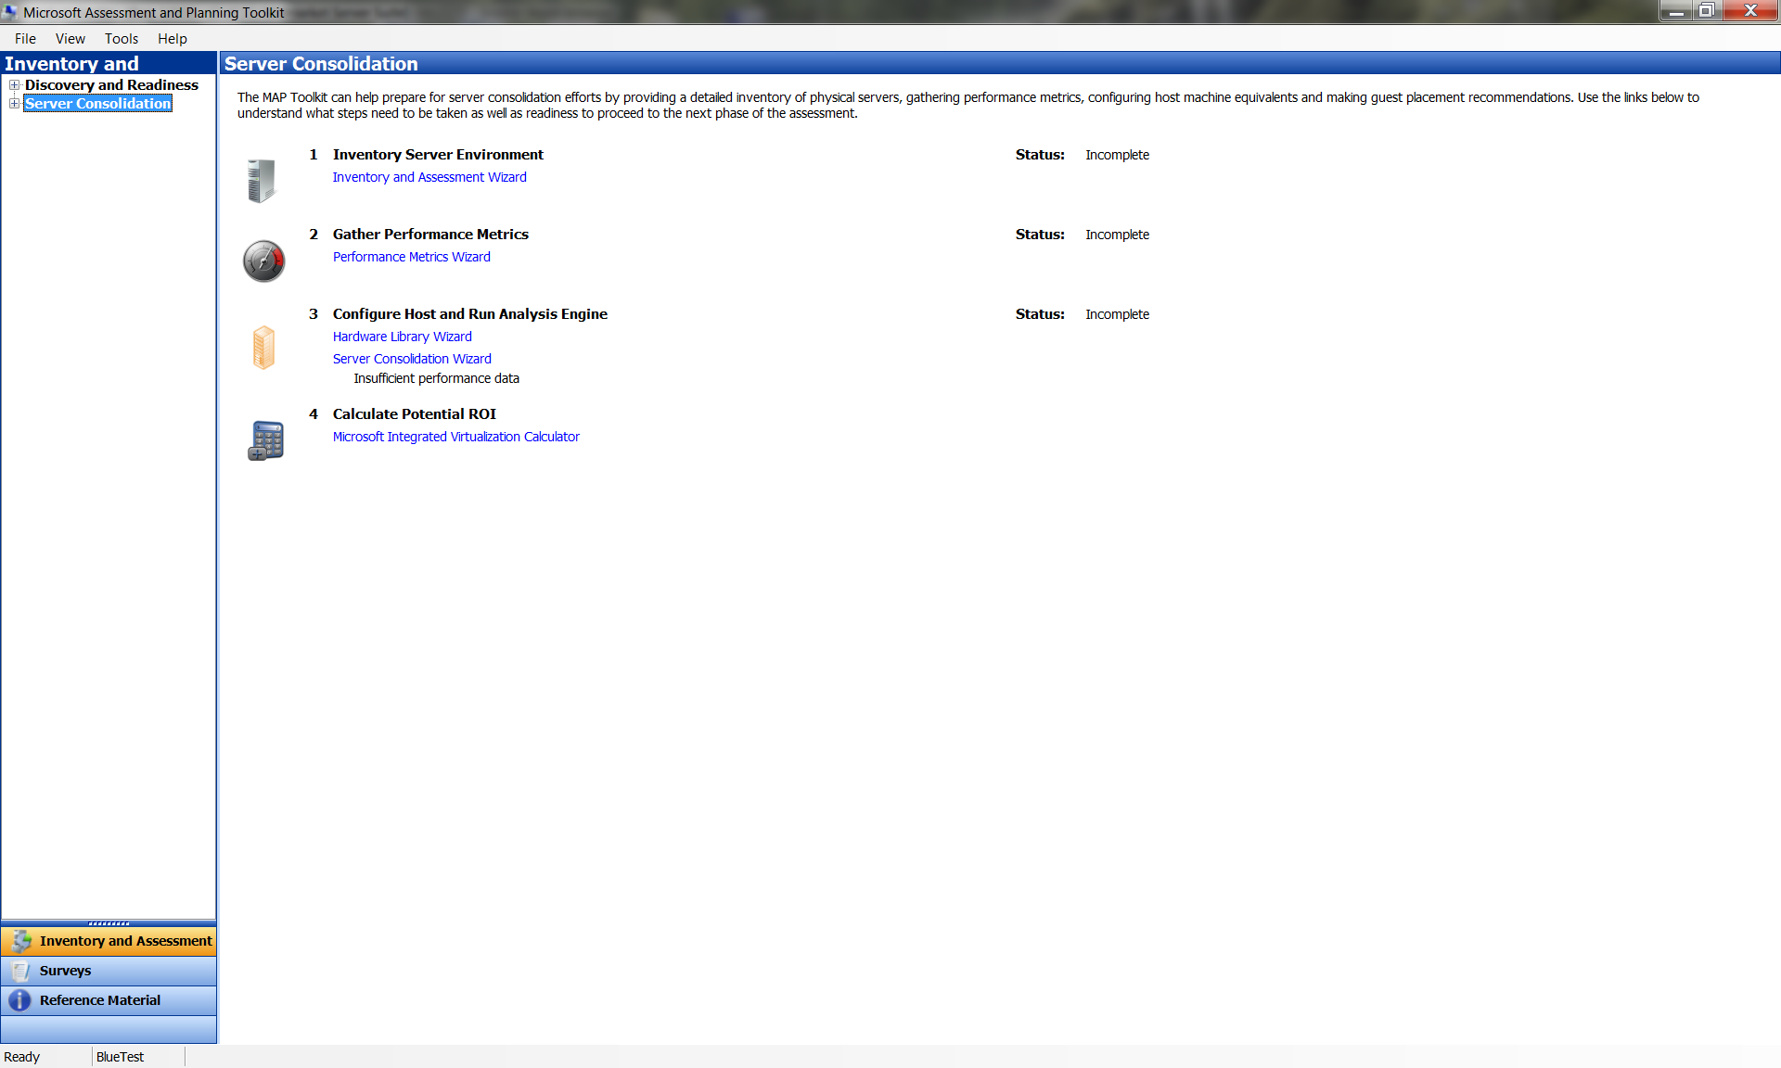
Figure 2. Server Consolidation node of the Inventory and Assessment section
The MAP tool helps you to gather information about your environment and analyze the results of your assessments to determine how to proceed with server consolidation efforts. These steps include wizards and a calculator to help you:
- Inventory your server environment. You can use the Inventory and Assessment Wizard to gather information about your server environment, including hardware configurations, roles, applications and services running on those computers.
- Gather performance metrics. You can use the Performance Metrics Wizard to gather information about the CPU, memory, disk and network utilization of computers for a duration you specify. The MAP tool can provide better consolidation recommendations if peak utilization data is gathered. If you know when peak utilization will occur, start capturing data with a leading hour before the peak and set the duration to include an hour after the peak utilization is expected to end. If peak utilization periods are unknown, it is recommended to collect performance data for longer periods of time. If you are attempting to capture utilization information for machines with different peak utilization periods, it is recommended to gather this information over a longer period of time to capture all peak periods or to gather utilization information for each set of computers in different performance metric gathering runs.
Performance counters are collected from each machine in five minute intervals. The number of machines from which the MAP tool can collect performance counter data successfully depends upon factors such as network latency and the responsiveness of servers. If you want to collect performance data for a large number of machines, it is recommended to split the target machines into batches of up to 150 machines.
Note If you have previously gathered performance data, you will be prompted on subsequent performance counter gathering runs to either delete existing data or to append the newly gathered data to what has been collected previously. If you splitting up your target machines, to improve performance, make sure to select ‘No’ on the Performance Data Exists dialog.
- Configure host and run analysis engine. You can use the Server Virtualization Planning Wizard to help in planning your server virtualization effort. In this wizard, you can select a virtualization technology platform, set a virtual host machine’s hardware configuration, manage assessment properties and identify which computers you would like to virtualize. Use the Hardware Library wizard to create and manage often used hardware configurations for quick what-if analysis.
- Calculate potential ROI. You can evaluate potential ROI associated with the consolidation recommendations made by the MAP toolkit using Alinean’s Integrated Virtualization ROI calculator. MAP generates an XML (provide name of file) file at the end of every server consolidation assessment. Import the XML file into the Alinean Virtualization Integration ROI calculator to analyze potential ROI. To learn more, go to http://go.microsoft.com/fwlink/?LinkID=149142.

Note MAP toolkit internally uses a capacity modeling engine to model resource utilization of servers. In some cases, an exact match for servers in your environment cannot be made by the modeling engine. MAP will attempt to match your selection to the model resource utilization, which may result in resource utilization estimates that vary from the actual utilization. You should use the consolidation recommendations made by the MAP toolkit for initial planning purposes. Use Microsoft System Center products to actively monitor and fine-tune production environments.

Surveys
The Surveys section provides links to surveys, as shown in the following figure.
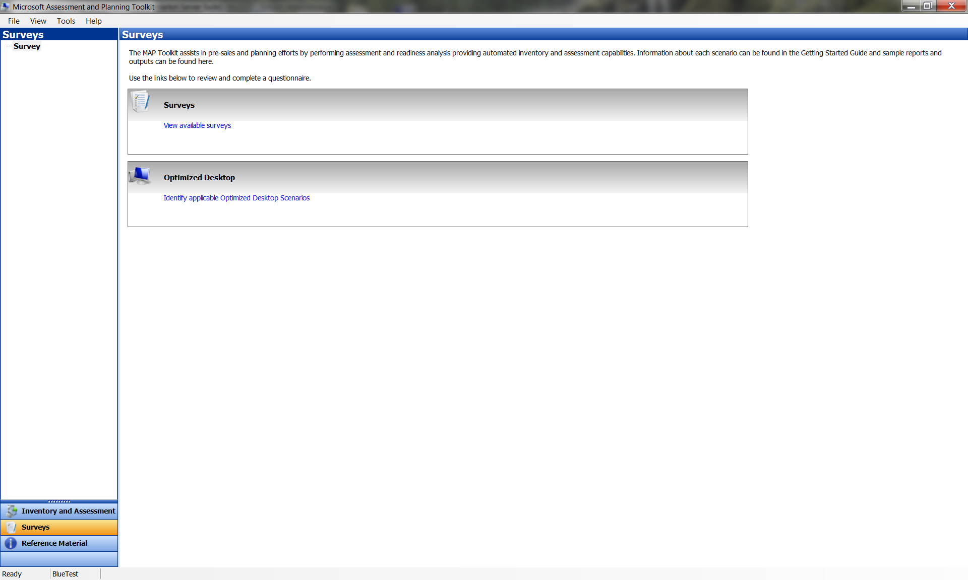
Figure 3. Surveys section of the MAP tool
The Survey section provides links to questionnaires that you can complete to learn more about:
- View Available Surveys. This link will show the list of available surveys available in the toolkit.
- Windows Optimized Desktop. This link takes you to the landing page for the Windows Optimized Desktop Scenarios Assessment guide and Windows Optimized Desktop Scenario Selection Tool on Microsoft TechNet.
The Windows Optimized Desktop Scenarios relate business requirements for a flexible, efficient, and managed desktop environment to sets of complementary Microsoft technologies by defining and using five standard user scenarios that map business requirements to technology solutions. These core scenarios are: Office Worker, Mobile Worker, Task Worker, Contract Worker, and workers who need to Access from Home.

Reference Material
The Reference Material section provides links to a wide variety of resources, as shown in the following figure.
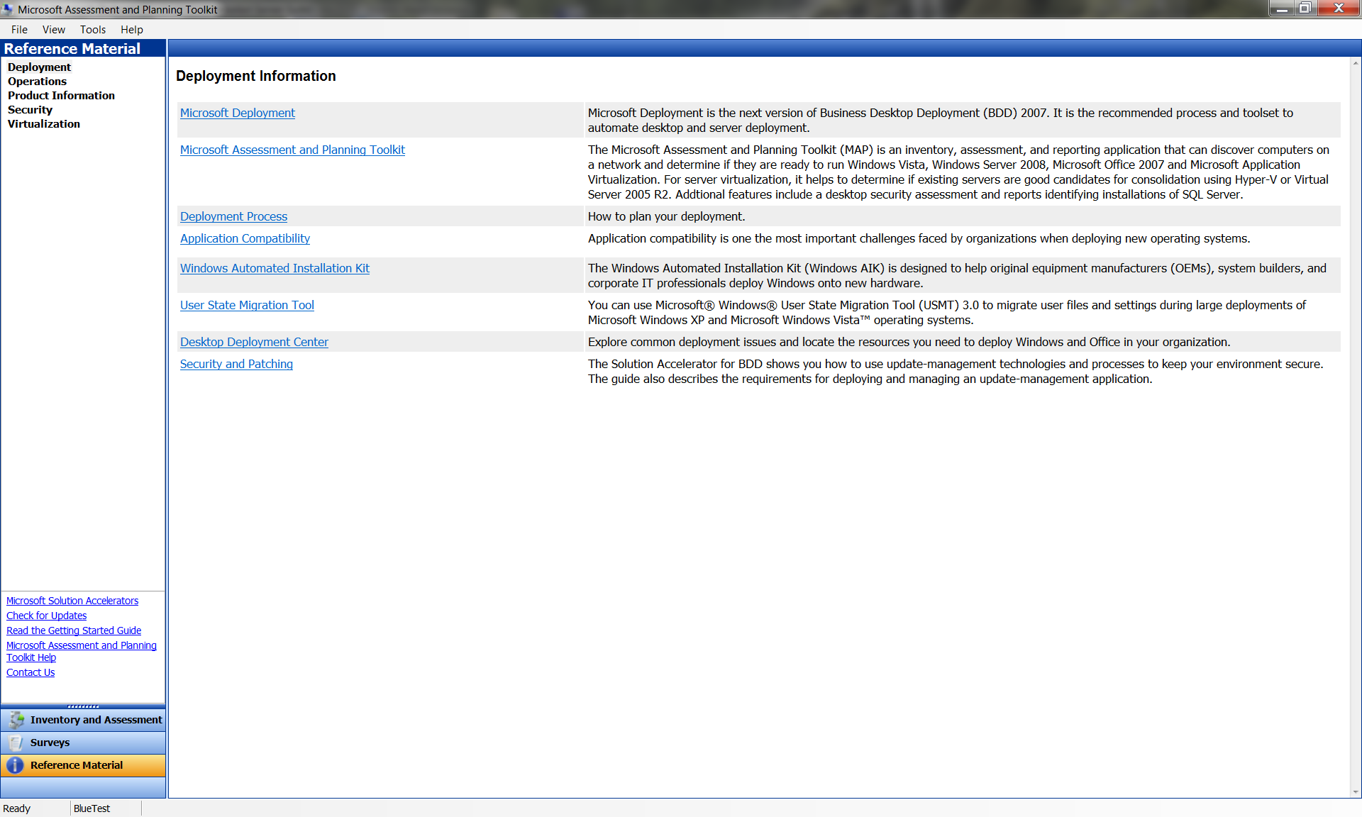
Figure 4. Reference Material section of the MAP tool
The Reference Material section includes links to additional information about:
- Deployment. Includes links to information related to deployment, application compatibility, automated installation kits, user state migration, and so on.
- Operations. Includes links to information related to infrastructure planning, configuration management, change review, management, and so on.
- Product information. Includes links to Microsoft Web sites for operating systems, management tools, developer tools, and so on.
- Security. Includes links to security guidance, trustworthy computing sites, Microsoft and TechNet security centers, and so on.
- Virtualization. Includes links to a wide variety of resources on the topic of virtualization.

Using the MAP Tool Wizards
The MAP tool uses different wizards to help you configure MAP, perform different assessments and create reports and proposals. These include:
- Inventory and Assessment Wizard. You can use this wizard to gather information about the client computers and servers in your environment. Depending upon your network environment, you can choose among several computer discovery methods.
- Gather Performance Metrics Wizard. You can use this wizard to gather CPU, memory, storage and network utilization information about servers in your environment.
- Server Virtualization Planning Wizard. You can use this wizard to select a virtualization technology platform, select a potential host’s hardware configuration, set guest and host thresholds and identify candidate machines for virtualization.
- Hardware Library Configuration Wizard. You can use this wizard to pre-configure potential virtual server host machines for use in the Server Consolidation Wizard.
- Prepare New Reports and Proposals Wizard. This wizard is only available after an initial inventory has been completed. This wizard lets you prepare new reports and proposals using the data about your environment that you gathered when you ran the Inventory and Assessment Wizard, Gather Performance Metrics Wizard or Server Virtualization Planning Wizard previously.

Analyzing the Results
The MAP Toolkit generates a series of reports and proposals that you can use to significantly simplify the planning process for operating system migration and server virtualization. Each report provided allows you to quickly filter results to find detailed information about each computer discovered during the inventory process. The summary proposal document gives you presentation ready information for your use. Use the Hardware Inventory report to help in validating inventory results.

For More Information
Refer to the following sources for more information about the MAP Toolkit.

Installation Questions
For questions about how to install the MAP Toolkit, including details about hardware and software prerequisites, see the Release Notes at http://go.microsoft.com/fwlink/?LinkId=155697.

Obtain Product Support
Support for the MAP Toolkit is provided through Microsoft Product Support Services (PSS). Premier customers should contact Premier Support for assistance. Support offerings and regional contact information for support can be found at http://go.microsoft.com/fwlink/?LinkId=155704.

Feedback
To send feedback or suggestions for improving the Microsoft Assessment and Planning Toolkit, see http://go.microsoft.com/fwlink/?LinkID=110990.

