

IBM Interoperability with Arabic Support
Microsoft Host Integration Server 2004 Technical Article

Published: August 2005

Copyright
The information contained in this document represents the current view of Microsoft Corporation on the issues discussed as of the date of publication. Because Microsoft must respond to changing market conditions, it should not be interpreted to be a commitment on the part of Microsoft, and Microsoft cannot guarantee the accuracy of any information presented after the date of publication.
This White Paper is for informational purposes only. MICROSOFT MAKES NO WARRANTIES, EXPRESS OR IMPLIED, AS TO THE INFORMATION IN THIS DOCUMENT.
Complying with all applicable copyright laws is the responsibility of the user. Without limiting the rights under copyright, no part of this document may be reproduced, stored in or introduced into a retrieval system, or transmitted in any form or by any means (electronic, mechanical, photocopying, recording, or otherwise), or for any purpose, without the express written permission of Microsoft Corporation.
Microsoft may have patents, patent applications, trademarks, copyrights, or other intellectual property rights covering subject matter in this document. Except as expressly provided in any written license agreement from Microsoft, the furnishing of this document does not give you any license to these patents, trademarks, copyrights, or other intellectual property.
Unless otherwise noted, the example companies, organizations, products, domain names, e-mail addresses, logos, people, places and events depicted herein are fictitious, and no association with any real company, organization, product, domain name, email address, logo, person, place or event is intended or should be inferred.

© 2005 Microsoft Corporation. All rights reserved.
Microsoft, ActiveX, BizTalk, Excel, Visual Studio, Windows, Windows Server, and Windows Server System are either registered trademarks or trademarks of Microsoft Corporation in the United States and/or other countries.
The names of actual companies and products mentioned herein may be the trademarks of their respective owners.

Table of Contents
IBM Interoperability with Arabic Support 1
What is Arabic Language Support? 1
Characters Encoding 1
SNANLS Library 2
Host Integration Server 2004 and Arabic Support 2
Host Integration Server 2004 Components and NLS Support 2
Required Settings for Arabic Support 4
Setting the User Locale to Arabic and Installing Arabic EBCDIC Fonts 4
To set the user locale in Windows XP and Windows Server 2003 4
To set the user locale in Windows 2002 6
Installing Host Integration Server 8
Hardware and Software Prerequisites 8
Installing the Server 8
To install Host Integration Server 2004 8
To uninstall Host Integration Server 2004 using Add/Remove Programs 8
Arabic Updates and Hot Fixes 8
Configuring Host Integration Server for Arabic Support 9
Configuring Host Print Service for Arabic Support 9
To configure Host Print Service for an AS/400 connection 10
To configure Host Print Service for a 3270 connection 13
Configuring OLE DB and ODBC Provider for Arabic Support 15
To create new data source 15
Configuring Transaction Integrator for Arabic support 16
To configure HIP Remote Host Environments for Arabic support 16
To configure WIP Remote Environments for Arabic support 17
Arabic Support Limitations 18
Questions and Answers 19
Appendix A - Microsoft Partner Product for the Arabic Support 20
HostFront Web-to-Host with Arabic Support 20
HostFront Components and Arabic Support 21
HostFront 3270 and 5250 ActiveX Display Clients 21
HostFront 3270 and 5250 ActiveX Printer Clients 22
HostFront 3270, 5250 FTP, APPC and IND$FILE ActiveX File Transfer Clients 23
HostFront Screen Logic Integration with 3270 and 5250 Arabic Applications 24
HostFront Legacy Integrator with Arabic Support 26

Abstract
This paper presents an overview of the Arabic language support features in Microsoft® Host Integration Server 2004. It documents the necessary steps to enable Host Integration Server 2004 to work with Arabic characters. This document presents key considerations and should not be considered to be a substitution for the Host Integration Server 2004 documentation.
For more information about Microsoft Host Integration Server 2004, visit: http://www.microsoft.com/his

Introduction
Microsoft® Host Integration Server 2004 helps customers integrate IBM host applications, data sources, messaging and security systems with new solutions developed using the Microsoft Windows Server System™ platform.
Host Integration Server 2004 features and technologies, including network integration, host access with enhanced security, and application integration, enable Microsoft Windows® developers to publish business processes in IBM mainframe and AS/400 applications as XML Web Services, which brings their host applications and processes into a services oriented environment.
In the Arabic-speaking regions, the most frequently asked question is likely to be “How can I enable the Arabic language and use Host Integration Server to integrate Arabic data in my organization?” The goal of this white paper is to help you understand Host Integration Server and its Arabic support capability.
Important This white paper contains information about changing system configuration and some system files. Before you edit them, you should first make a backup copy of your system.

What is Arabic Language Support?
When saying Arabic language support, we mean the extent of Arabic characters support in Data Integration, Application Integration, and Host Printing features of Microsoft© Host Integration Server. In this document, we will discuss the following topics:
- Difference between IBM host system and Microsoft in handling Arabic data
- What is new in Microsoft Host Integration Server 2004
- Installation in an Arabic-enabled environment
- Enabling Arabic EBCDIC 420 bi-directional layout data conversion
- Enabling support for Arabic bi-directional layout conversion in Host Print Service
- Enabling support for Arabic bi-directional layout conversion in Transaction Integrator
- Limitations of Arabic support and its patches for Microsoft Host Integration Server 2004

Characters Encoding
IBM DB2 of z/OS, and IBM DB2 for OS/400 are frequently configured to use EBCDIC code pages, for example EBCDIC 420 (Arabic). Microsoft® Host Integration Server 2004 includes support for most EBCDIC code pages for purposes of EBCDIC-to-UNICODE-to-ANSI, ANSI-to-UNICODE-to-EBCDIC, and EBCDIC-to-UNICODE-to-EBCDIC conversions.

SNANLS Library
IBM mainframe zSeries and midrange iSeries programs store data in visual or physical order, with the shapes laid out and reversed into Arabic blocks, that is, Englishcibara.
Microsoft® Windows® 32-bit applications store data in logical or spoken order, that is, EnglishArabic.
With Host Integration Server 2000, Microsoft SNANLS library converts strings (UNICODE< EBCDIC, ISO, OEMPC, ASCII, ANSI), typically performing a MultiByteToWideChar conversions, using system-provided National Language Support (NLS) tables. SNANLS does not perform any visual to logical re-ordering. Also, SNANLS did not map to UNICODE using presentation forms B (FExx range) using the 600 range, which represents the Arabic code points. This left the Arabic blocks unreadable, unless the Windows consumer application re-arranges the characters.

Host Integration Server 2004 and Arabic Support
The Microsoft® Host Integration Server team is committed to enabling Microsoft enterprise customers to integrate their line-of-business data stored on IBM mainframe zSeries and midrange iSeries computers with new solutions based on Microsoft Windows® desktop and server operating systems. Therefore, in Microsoft Host Integration Server 2004, a bi-directional layout conversion for Arabic strings was added. This new TrnsBiDi library is called from the SNANLS library, when the features listed below are configured for host EBCDIC 420 Arabic coded character set identifier (CCSID). At runtime, the feature sends Arabic strings to SNANLS, then in turn to TrnsBiDi for processing. TrnsBiDi parses the strings, determining the storage order, based on direction of data movement, then transforms any visual segments to logical segments. The ability to parse and determine the storage order is estimated to be 95% accurate. This conversion is supported within the features listed below. This is also offered as a separate Win32 feature of the SNA Server Software Development Kit (SDK) by way of the TrnsBiDi.dll as part of the SNANLS API.
- SNA Print Service
- Transaction Integrator
- Managed Provider for DB2
- OLE DB Provider for DB2
- OLE DB Provider for AS/400 and VSAM

Host Integration Server 2004 Components and NLS Support
The following table lists the conversion methods and types used by the various components in Microsoft® Host Integration Server 2004.

Table 1 Conversion methods and types
Component | SNANLS | TrnsDT (DBCS) | Bidirectional layout (Arabic) | Notes
3270 Applet | No | No | No | Refer to Appendix A
5250 Applet | No | No | No | Refer to Appendix A
SNA Print Service | Yes | Yes | Yes | Printer needs Arabic fonts, and 864 code page enabled
ODBC Driver for DB2 | Yes | Yes | Yes
OLE DB Provider for DB2 | Yes | Yes | Yes
OLE DB Provider for AS/400 and VSAM | Yes | Yes | Yes
Managed Provider for DB2 | Yes | Yes | Yes
Transaction Integrator | Yes | Yes | Yes
SNANLS API | Yes | Yes | Yes | Standalone API in SNA SDK.
Data Queues ActiveX® Control | Yes | Yes | No | Send only. No conversion on receive. Not fully DBCS-enabled.
Host File Transfer ActiveX Control | Yes | Yes | No | Not fully DBCS-enabled. Refer to the Appendix A
Enterprise SSO | No | No | No | Only Latin I code pages supported.
NetView Alert Service | No | No | No
NetView RunCmd Service | No | No | No
CSV Convert Verb | No | No | No

Required Settings for Arabic Support

Setting the User Locale to Arabic and Installing Arabic EBCDIC Fonts
The steps needed to change the User Locale settings will differ from one operating system to another.
In Microsoft® Windows® XP and Windows Server™ 2003, follow these steps in order to set the user locale.

To set the user locale in Windows XP and Windows Server 2003
- From the Control Panel, double-click Regional and Language Options to open the dialog box.
- On the Regional Options tab, change the selected language to any Arabic country (Figure 1).
- On the Advanced tab, change the Language for non-Unicode programs to any Arabic country (Figure2).
- Choose 204020 (IBM EBCDIC – Arabic) from the Code page conversion tables list (Figure2).
- Check the Apply all settings to the current user account and to the default user profile option and then click OK (Figure 2).
Figure 1 Setting User Locale in Windows XP and Windows Server 2003
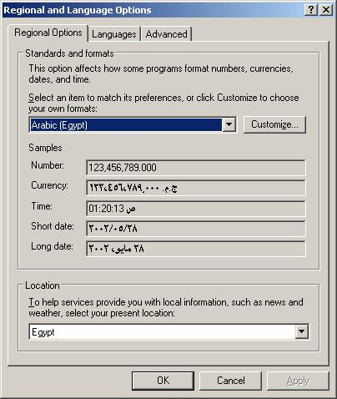
Figure 2 Setting language for non-Unicode programs and installing EBCDIC fonts
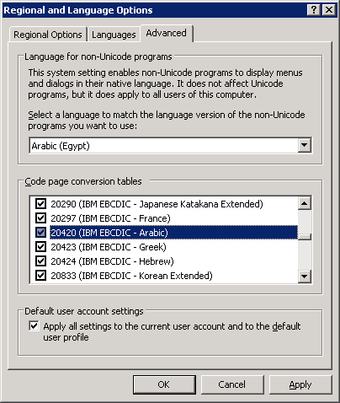
In Windows 2000, follow these steps in order to set the user locale.

To set the user locale in Windows 2002
- From the Control Panel, double-click Regional Options to open the dialog box.
- On the General tab, change the selected language to any Arabic country (Figure 3).
- Click Advanced and make sure 204020 (IBM EBCDIC – Arabic) is selected from the code page conversion tables list (Figure 4).
- Click OK, and then click OK again. Close the Regional and Language Options dialog box.
Figure 3 Setting User Locale in Windows 2000
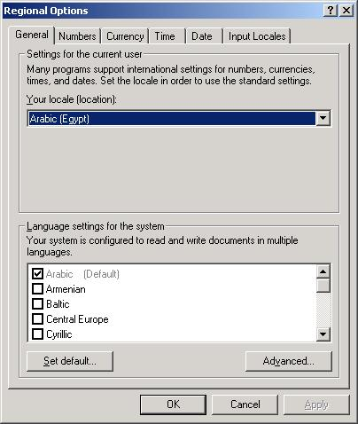

Figure 4 Installing EBCDIC Arabic font
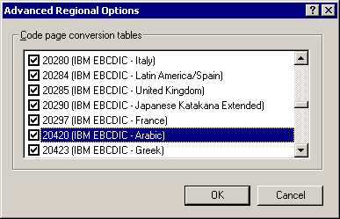

Installing Host Integration Server
In order to install Microsoft® Host Integration Server 2004 you must be running one of the following operating systems:
- Microsoft Windows® 2000 Service Pack 4 or later along with Update for Microsoft Windows 2000 KB821887 hot fix, which you can download from the following location: http://go.microsoft.com/fwlink/?linkid=29480
- Windows XP Professional with Service Pack 1 or later (for development only)
- Windows Server™ 2003

Hardware and Software Prerequisites
For a complete list of hardware and software requirements for installing Microsoft® Host Integration Server 2004 components refer to the installation file INSTALLATION GUIDE.HTM on Host Integration Server 2004 Compact Disk

Installing the Server

To install Host Integration Server 2004
- In Microsoft® Windows® Explorer, navigate to the installation folder in which you have the setup files.
- Click setup.exe. The Host Integration Server 2004 Auto Run panel will appear.
- Click Install Microsoft Host Integration Server 2004 Server to begin the installation. The Host Integration Server 2004 Installation Wizard appears and guides you through the rest of the installation process.
- Click Finish.
- The Configuration wizard will start and guide you through the configuration of Host Integration Server 2004.

To uninstall Host Integration Server 2004 using Add/Remove Programs
- Click Start, point to Settings, and then click Control Panel.
- In Control Panel, open Add/Remove Programs, select Microsoft Host Integration Server 2004, and then click Change/Remove. The Microsoft Host Integration Server 2004 Add/Remove Application dialog box appears.
- Click Remove, and then click Next. The Uninstall Wizard appears and automatically begins the uninstall process.
- When the wizard has completed the process, click Finish.

Arabic Updates and Hot Fixes
Currently there are two hot fixes that must be installed in order to get Arabic character conversion on Microsoft® Host Integration Server 2004.
- Microsoft Host Integration Server Hot Fix [KB article 886681]
- Fix Arabic character conversion on OLE DB and ODBC providers
- Fix Arabic character conversion on Transaction Integrator
- Microsoft Host Integration Server Hot Fix [KB article 886715]
- Fix Arabic character conversion on Host Print Service
Make sure to stop all Host Integration Server applications and services before you start installing any of these two hot fixes.
Here are the fixes related to TransBidi
- KB 886681 - Some Arabic characters are not recognized when sent to DB2 using OLE DB Provider for DB2. http://support.microsoft.com/default.aspx?scid=KB;EN-US;886681
- KB 886715– Update to 3270 printing to support Arabic printing http://support.microsoft.com/default.aspx?scid=KB;EN-US;886715
- KB 890353 – Update to TransBiDi to support Left to Right Physical Storage http://support.microsoft.com/default.aspx?scid=KB;EN-US;890353
- KB 903652 – Fixed memory leak in the TransBiDi http://support.microsoft.com/default.aspx?scid=KB;EN-US;890353
- KB 904424 – Update to 5250 printing to support Arabic printing (Still an active DCR, no schedule release date) http://support.microsoft.com/default.aspx?scid=KB;EN-US;904424

Configuring Host Integration Server for Arabic Support
Configuring Microsoft® Host Integration Server 2004 to enable Arabic bidirectional conversion is a straightforward operation. What you need in your hand is the host Code Character Set Identifier (CCSID) to map the exact host code page in the Host Integration Server. Below we will discuss enabling Arabic character conversion in the supported Host Integration Server Services in details.

Configuring Host Print Service for Arabic Support
Host Print Service provides server-based 3270 and 5250 print emulation, allowing mainframe and AS/400 applications to print to a LAN printer supported by Microsoft® Windows Server™ 2003 and Windows® 2000. The printer must support the 864 code page “Arabic Enabled Printer”. Microsoft Host Integration Server 2004 Host Print Service enables centralized control of LU print resources. You can administer all Host Print Service functions using SNA Manager, including margin control, fonts, character conversion, and characters per line. Host Print Service also supports print-to-file with auto-incrementing file names. You can configure the file naming scheme for each printer LU.

To configure Host Print Service for an AS/400 connection
- In SNA Manager, expand the server on which you want to add print services.
- Right-click Print Service, point to New, and then click APPC Session. The Properties page for this session appears.
- On the General tab, type a session name.
- On the Host Code page choose your host CCSID. By default it will be (EBCDIC – Arabic [20420]) on most host systems as seen in Figure 5.
- Click Printer, and then configure a printer. The printer must support Arabic Code Page 864.
- On the APPC tab, provide an AS/400 Device Name, a Local LU Alias, a Mode Name, and a Remote LU. Define a device name for the printer which will be created automatically on the AS/400 to use for this print session.
Note The Local LU Alias and Remote LU should be created and configured before choosing them.
- On the Security tab, define a username and a password of a user who has the right to create devices on the AS/400.
- On the Job Format tab, set the job format option to Do not format print job.
- Configure other parameters as desired.
- Click OK to add this print session.
- In the console tree, right-click Print Service, and then click Save Configuration.
- Right-click Print Service again, and then click Start.
- The device will be created automatically on the AS/400 with the parameters seen in Figures 6, 7, and 8. The AS/400 defaults should be set to auto-create new devices. Figure 9 shows a sample Arabic printout.
Note Any changes in the configuration to the Host Print Service requires the administrator to stop the SNA Service and Printer Service, and then start them again in order for the changes to take effect.
Figure 5 Setting the host CCSID to EBCDIC Arabic [20420]
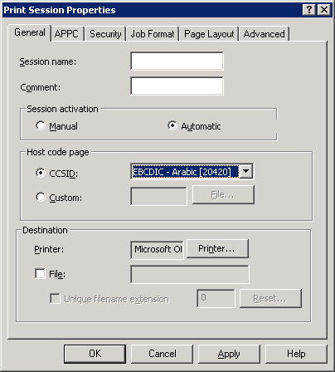

Figure 6 AS400 device configuration
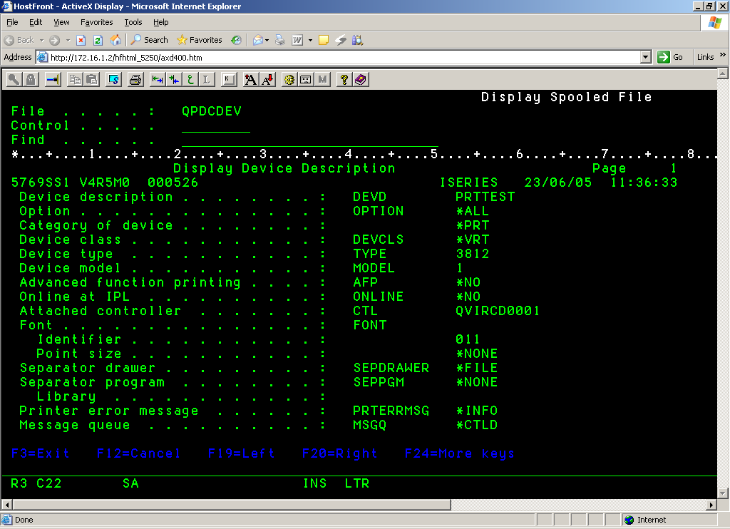

Figure 7 AS400 device configuration
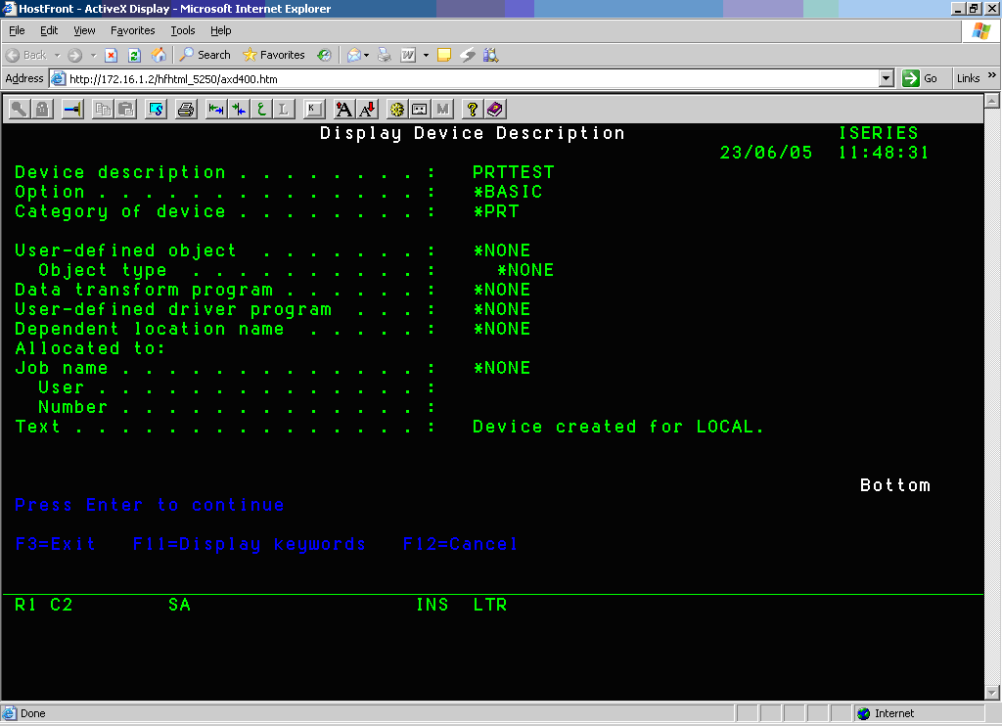

Figure 8 AS400 device configuration

Print out sample: Figure 9 shows a sample for a print out in AS400, which presents all the combination characters in Arabic language.

Figure 9 AS400 sample printout
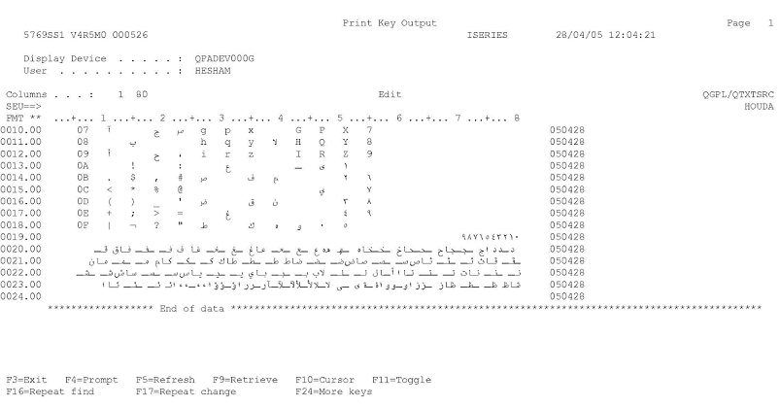

To configure Host Print Service for a 3270 connection
- In SNA Manager, expand the server on which you want to add print services.
- Right-click Print Service, point to New, and then click 3270. The Properties page for this session appears.
- On the General tab, type a session name.
- On the Host Code page choose your host CCSID. By default it will be (EBCDIC – Arabic [20420]) on most host systems as shown in Figure 10.
- Click Printer, and then configure a printer.
- Click the 3270 tab; choose an LU name to use for this print session. If there are no LU names in the drop-down list, you must insert a printer LU on the 3270 connection to be used for this print session.
- Note To create a print LU, refer to the Host Integration Server Help.
- Configure other parameters as desired.
- Click OK to add this print session.
- In the console tree, right-click Print Service, and then click Save Configuration.
- Right-click Print Service again, and then click Start.
Figure 10 Host Print session for mainframe
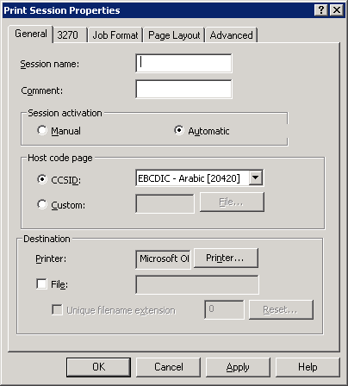

Configuring OLE DB and ODBC Provider for Arabic Support
Microsoft® Host Integration Server 2004 provides efficient data integration support for IBM DB2 databases, mainframe, and AS/400 file systems. Host Integration Server 2004 offers a new DB2 network protocol client (DRDA AR) over which the ODBC, OLE DB, and managed data providers communicate with the remote DB2 database server. A new Data Access Tool is also provided to create and manage connection definitions to DB2 and host file systems.
ODBC, OLE DB, and Managed Data providers support Arabic through the use of the SNANLS library for character set conversion and TransBiDi.dll for character reordering. You need to apply the Arabic Hot Fixes mentioned before in order for Arabic to work properly.

To create new data source
- In the Data Access Tool right-click Data Sources, and then click New Data Source.
- On the Welcome to the Data Source Wizard page, click Next.
- Select the data source platform from the dropdown menu, select a network type then click Next.
- Configure your network parameters as desired.
- Configure your data source parameters as desired.
- On the Locale screen select your host CCSID and PC Code Page. Normally it should be EBCDIC - Arabic [20420] for host CCSID and ANSI - Arabic [1256] for PC Code Page as shown in Figure 11.
- Click Next.
- Configure Security and Advanced Options parameters as desired.
- Validate your connection, create the required packages, and then click Next.
- Type a Data Source name and choose a Data Source type then click Next.
- Click Finish.
Figure 11 Setting the host CCSID and PC code page
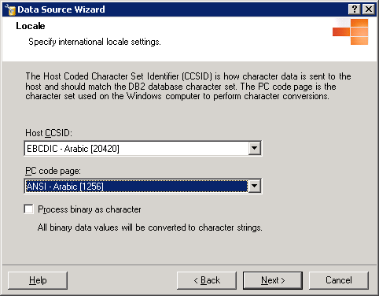

Configuring Transaction Integrator for Arabic support
Transaction Integrator (TI) enables you to integrate mainframe-based transaction programs (TPs) with component-based Microsoft® Windows® applications and enables the Microsoft Windows Server™ to function as a peer to IBM mainframe and AS/400 computers. These capabilities enable you to leverage existing COBOL and RPG applications for client/server or Web-service applications.
Running on Windows 2000 Server or Windows Server™ 2003, TI components appear as simple automation or .NET servers that developers can easily add to their application. Behind the scenes, TI functions as a proxy that communicates with an application program running on IBM z/OS or OS/400 operating systems. This means that you can invoke a legacy application on the host and return values to a Web-based client without rewriting the host application. You do not need any knowledge of COBOL or RPG programming to use Transaction Integrator
When deploying TI projects within global environments, the TI runtime can convert character strings based on a new Arabic Bi-Directional Layout Conversion, common for both TI Windows-initiated Processing (WIP) and Host-initiated Processing (HIP) scenarios.

To configure HIP Remote Host Environments for Arabic support
- In TI Manager, expand Transaction Integrator and then Host Initiated Processing.
- Right-click Host Environments, point to New, and then click Host Environment.
- In the Welcome to the New Host Environment Wizard, click Next.
- In the Host Environment dialog box, type a host environment name.
- Select the data conversion routine from the Data Conversion dropdown list.
- Select a host code page from the Host Code Page dropdown menu. Normally it should be EBCDIC - Arabic [20420] as shown in Figure 12.
- Select a network type from the Network Type dropdown menu.
- Type the IP address of the host or the host name registered in the DNS (for a TCP/IP network), or the LU name associated with the host system (for an SNA network) in the Remote Endpoint Manager text box.
- Configure other parameters as desired.

Figure 12 Setting the host code page on TI HIP host environment

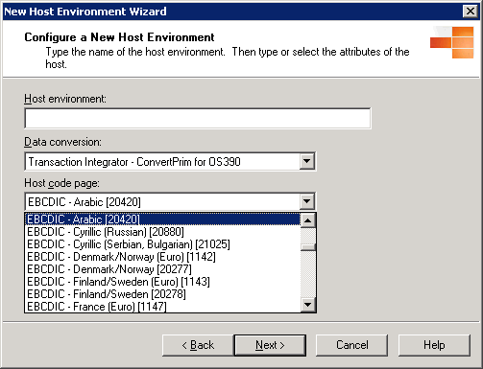

To configure WIP Remote Environments for Arabic support
- In TI Manager, expand Transaction Integrator and then Windows Initiated Processing.
- Expand Remote Environments, right-click your remote host environment, and then click Properties. The Properties page for this Remote Environment appears.
- On the Locale tab choose Arabic (your country) as shown in Figure 13.
- Clear Use default code page for the selected locale and choose a code page from the Code Page dropdown menu if different code pages are used on your host environment.
- Click OK to close the Properties page.

Figure 13 Setting the locale and code page on TI WIP remote environment

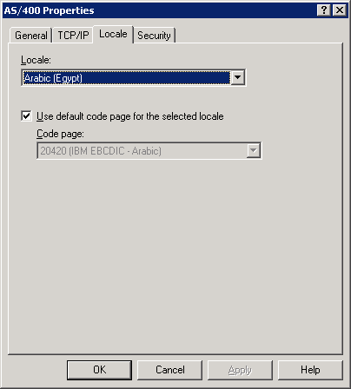

Arabic Support Limitations
Microsoft® Host Integration Server 2004 supports bidirectional Arabic conversion on both IBM mainframes and AS/400 systems with some limitations
- Host Print Service: Not fully supported on AS/400 Systems.
(The Printer must support Arabic Code Page 864. For more information contact your printer manufacture).
- Data Queues ActiveX® Control: Send only. No characters conversion on receive. Not fully DBCS-enabled.
- Host File Transfer ActiveX Control: Not fully DBCS-enabled.
- Enterprise Single Sign On (SSO): User identifiers and passwords are converted from computer to host. Only Latin I code pages supported.

Questions and Answers

Q1: When setting the locale on TI WIP Remote Environment to Arabic, no Arabic Code Page appears in the Dropdown menu?
A1: Make sure you have installed the Arabic EBCDIC fonts as described in Page 7 "Setting the User Local to Arabic and installing Arabic EBCDIC Fonts" in this document.

Q2: My AS/400 Print Device prints Arabic characters in a reversed order?
A2: To print Arabic data the printer device should support Arabic code page 864. For more information, consult your printer manufacture.

Q3: Why can I not read Arabic Characters with 3270 and 5250 Terminal Clients?
A3: The Host Integration Server 3270 and 5250 clients do not support Arabic Code Pages. For more detail on 3270 and 5250 Arabic ActiveX® Client support, refer to the Appendix [A]

Q4: What do you mean by the printer support for 864 code page?
A4: Host Integration Server 2004 does One-to-One mapping between the EDCDIC 420 Arabic code page and the printer 864 Arabic code page, which depends on the printer that supports a built-in 864 code page in order to achieve the Host Print Service output with the proper Arabic support.

Q5: My LAN printer prints any Microsoft® Word document in Arabic; can it be used as Host Printer Server Printer?
A5: Not all printers could load the 864 code page. You will require a specific LAN printer that could support 864 code pages in order to have the Host Integration Server 2004 Host Print Service configuration to the specified printer.

Q6: Can I configure the Host Integration Server 2004 Host Print Service with Arabic support to print a PDF electronic file?
A6: Microsoft Office 2003 provides the Office Document Image Writer which can generate MDI electronic output with Arabic support for any general printing; however the Host Print Service would require the 864 code page to be a resident on the target printer. Currently Host Integration Server 2004 does not support electronic output printing. You may refer to the Appendix [A] for the Partner product with Arabic support.

Q7: Can I have control to format the host print output before we print?
A7: Yes you could do so by the Host Integration Server 2004 Host Print Service which helps you customize the font size, margin, and character conversion.

Q8: Which version/edition of Host Integration Server 2004 contains the Host Print Service?
A8: Host Print Service with Arabic support is available in any edition of the Host Integration Server 2004 Standard, Enterprise, or Developer edition.

Q9: Which edition of the Host Integration Server2004 supports the Arabic Application Integration?
A9: Application Integration in form of Transaction Integrator is available only in the Microsoft Host Integration Server 2004 Enterprise edition.

Appendix A - Microsoft Partner Product for the Arabic Support

HostFront Web-to-Host with Arabic Support
Farabi Technology Corp. introduced its first Arabic-enabled IBM terminal emulator in 1987. Since then, Farabi host access products have evolved to meet industry demands and its expertise in integrating Arabic data in IBM host environments has become well known throughout the Middle East.

HostFront Enterprise Server is Farabi’s flagship product. It is an enterprise-class solution for complete host access and legacy integration based on the Microsoft® Windows Server System™ platform. HostFront Enterprise Server helps customers integrate Arabic host data with Web or Windows applications in real time and capitalize on a Service-Oriented Architecture (SOA) by using advanced tools that automatically generate reusable Web Services.

HostFront Enterprise Server provides full Arabic EBCDIC code page 420 (XBASIC) support to IBM mainframe zSeries and midrange iSeries host environments making it the perfect companion to Microsoft Host Integration Server 2004 and BizTalk® Server 2004.

This section describes the Arabic language support provided in Farabi HostFront Enterprise Server.

HostFront Components and Arabic Support
Arabic Bi-directional support is a built-in feature of HostFront Display, Printer and File Transfer ActiveX® clients as well as all its Integration components:
- 3270, 5250, and VT100 ActiveX Display clients
- 3270, 5250, and VT100 ActiveX Printer clients
- 3270, 5250 FTP, APPC and IND$FILE ActiveX File Transfer clients
- Screen Logic Integration (SLI)
- Legacy Integrator (Visual Studio.NET integration tool)

HostFront 3270 and 5250 ActiveX Display Clients
HostFront ActiveX® display sessions provide full Bi-directional Arabic support. A true type display font named “Farabi Multi” is automatically downloaded together with the ActiveX Display client by the Microsoft® Internet Explorer browser. The font is designed to match the characters from XBASIC 420 table (one–to-one). A significant advantage of using the Farabi true type font is Arabic support is provided on the host application even if the client Windows Operating System is not Arabic enabled. The data conversion occurs on the fly and users can view and type Arabic characters that are fully compliant with the XBASIC 420 code table.
HostFront ActiveX Display clients support all Arabic-specific data handling such as change screen direction (screen flipping), auto-shaping, Auto-push, reverse push, left-to-right orientation, right-to-left orientation, numeric distinction, etc.

Figure 14 HostFront display session with Arabic support
In addition, when users types Arabic characters from an Arabic keyboard, HostFront automatically recognizes the keyboard scan codes and sends the correct XBASIC character to the IBM host. Similarly, the ActiveX display client displays the correct Arabic character on the screen.

The HostFront ActiveX display client also provides Arabic copy-and-paste to other Microsoft Windows® application such as Word or Excel®, and the ability to perform a host print screen with Arabic support to locally-attached or networked printers.

HostFront 3270 and 5250 ActiveX Printer Clients
HostFront ActiveX® Printer clients provide full Arabic support. HostFront Administrators can configure users for display and/or printer sessions with Arabic support. Once a user connects to the HostFront server, the ActiveX Printer client is automatically downloaded together with a true type printer font named “Farabi Print”. This font enables Arabic character printing on any locally attached or networked Microsoft® Windows® printer. Printers can be laser or dot-matrix printers and they do not require code page 864 support.
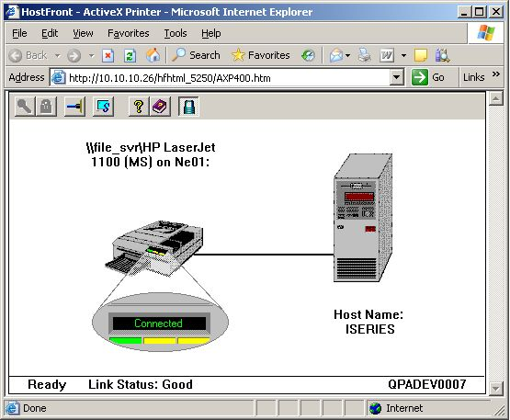
The printer engine of HostFront handles the conversion of the incoming XBASIC print data stream from the IBM host to the resident “Farabi Print” font of the ActiveX Printer client. In turn, the ActiveX Printer client sends the font to the printer driver for Arabic printing (in graphics mode).
Users who want to print in draft mode (faster) will need native Arabic support (namely Arabic NLS code page 864) on the target printer. The HostFront printer session will also need to be configured to use the “default printer font” option. Once this option is selected, the HostFront printer session performs a one-to-one character mapping from XBASIC 420 table to NLS 864 code page. In draft mode, no format printing is supported and the converted data is sent directly to the printer.
Figure 15 Arabic printing support extended to pdf or mdi formats
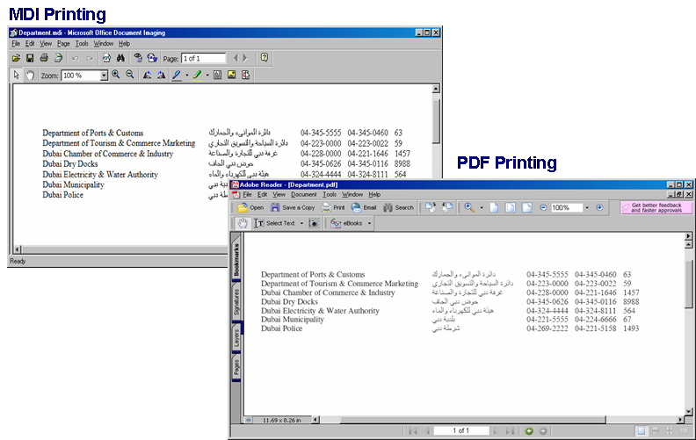

HostFront 3270, 5250 FTP, APPC and IND$FILE ActiveX File Transfer Clients
Transferring data from the IBM host to a PC is very common. Several different methods can be used to transfer file to and from IBM hosts depending on their type.
- File transfers in IBM iSeries (midrange) environments can be done using APPC and FTP
- File transfers in IBM zSeries (mainframe) environments can be done using IND$FILE and FTP
In the case of the IBM iSeries, HostFront supports two types of file transfer methods (APPC and FTP) with Arabic support. The APPC File Transfer method can be used when the host connection is done via Microsoft® Host Integration Server 2004. The FTP File Transfer method can be used only if the connection with the host is done over TCP/IP using TN5250. HostFront File Transfer ActiveX® clients feature drag-and-drop capabilities.
Figure 16 HostFront File Transfer session with Arabic support
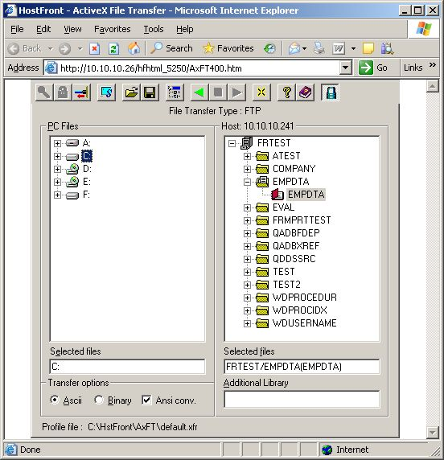

In the case of the IBM zSeries, HostFront supports two types of file transfer methods (IND$FILE and FTP) with Arabic support. IND$FILE is a mainframe utility that relies on a display session to transfer data in the form of data blocks. IND$FILE can be used if the host connection is done via Microsoft Host Integration Server 2004, or directly over TCP/IP with TN3270. The FTP file transfer method can be used only if the connection with the IBM host is over TCP/IP.
It is important to mention that a comprehensive logic is built-in into HostFront’s conversion engine so that the highest level of accuracy in Arabic conversion is achieved.

HostFront Screen Logic Integration with 3270 and 5250 Arabic Applications
Farabi’s HostFront integration components provide real time Screen Logic Integration (SLI) with legacy host systems. SLI facilitates the integration of 3270 and 5250 host applications/screens in real-time and with full Arabic support. SLI is based on non-intrusive integration principles, offering impressive development speed and quick time-to-market. SLI complements the Business Logic Integration (BLI) of Microsoft’s Host Integration Server 2004 (e.g. Transaction Integrator, OLEDB Provider and MQSeries Bridge). With SLI and BLI, the legacy integration spectrum is entirely covered for both transactional and non-transactional host applications.
Having previously set the language to Arabic, developers can use the HostFront .NET toolkit, or COM object to integrate host applications and retrieve Arabic data. Below is the syntax used to set the language to Arabic in Microsoft Visual Studio® .NET using HostFront .NET toolkit:
Figure 17 Setting the user language option in Visual Studio .NET using HostFront .NET toolkit
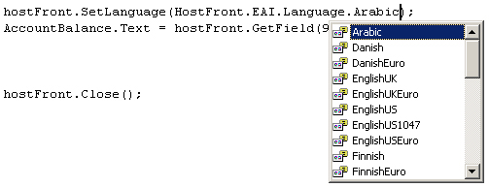
The HostFront Integration APIs allow developers to publish Arabic, Arabic English, Arabic numeric data or any combination of from host application screens. The Bi-directional Arabic support is not limited to viewing Arabic, it also includes posting Arabic data to those screens.
The figure below illustrates data such as it is displayed on a typical legacy “green screen” and the published equivalent after retrieving it with the HostFront Integration API.
Figure 18 Arabic host data with numbers and HostFront published data.
Legacy Screen Data
HostFront Published Data

The following figure illustrates Arabic host data published as an XML Web service.
Figure 19 Arabic host application published as a XML Web service

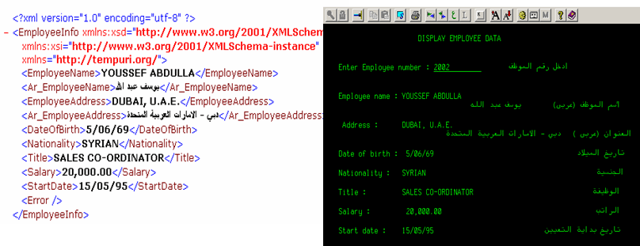

HostFront Legacy Integrator with Arabic Support
Farabi’s HostFront Legacy Integrator (HFLI) is an IDE-integrated development tool that further simplifies the development by automatically generating code or Web Services out of screen navigations on the legacy application. Based on managed code, the HFLI natively integrates with Microsoft’s Visual Studio.NET offering developers an advanced extension to the development environment they are familiar with. It is designed to generate C# or Visual Basic.NET code through a totally visual interface and without requiring the developer to write any code.

Support for Arabic language by the HFLI includes navigation recording, editing and step-debugging. Developers must use displays sessions that were previously set to the Arabic language in HostFront prior to recording display sessions.
Figure 20 HFLI Design Tool within Visual Studio .NET
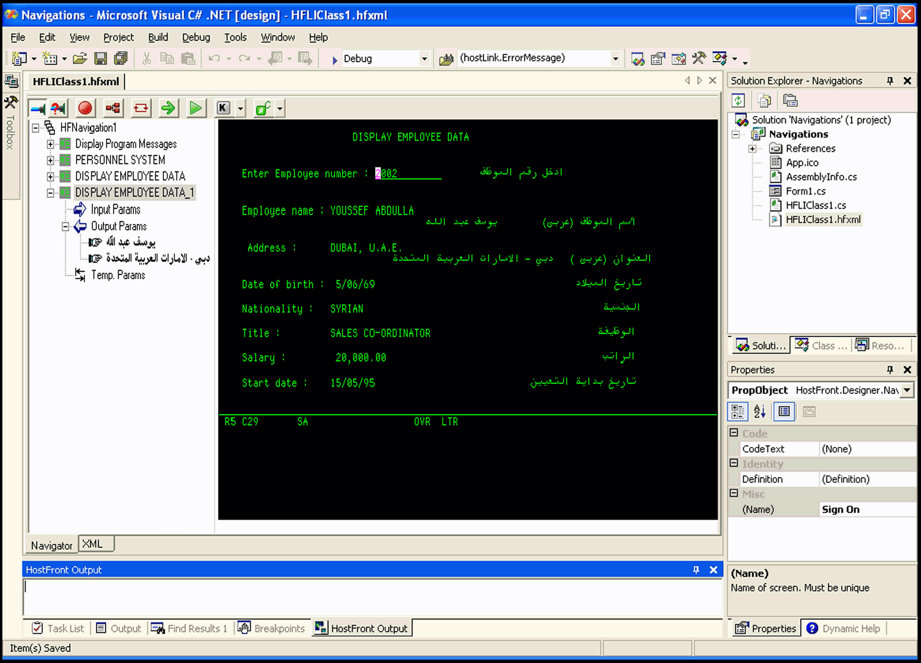

Farabi Technology Corp.  Head Office  www.farabi.com  Tel: 1-514-332-3455  sales@farabi.com  support@farabi.com | Farabi Technology Middle East  Middle East Regional Office  www.farabi.ae  Tel: 971-4-262-7300  support@farabi.ae  Sales@farabi.ae

