Microsoft® Office PerformancePointTM Server 2007  
Comprehensive Performance Management Delivered Through Microsoft Office

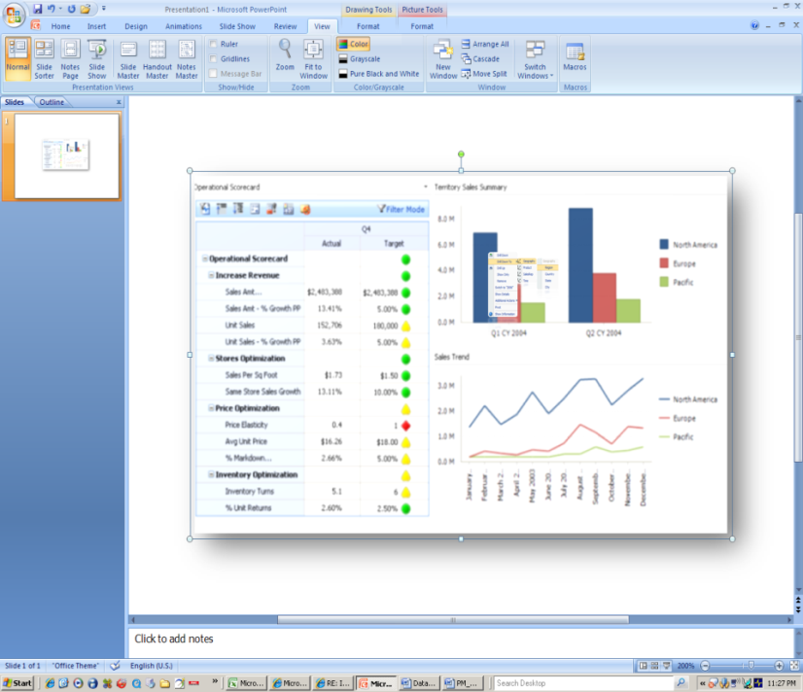**Microsoft® Office PerformancePoint™   
Server 2007 is a comprehensive performance management solution that allows organizations to formulate strategy, drive execution and more effectively monitor performance though integrated monitoring, analytics, and planning capabilities.**

Monitor: What is happening?

Greater visibility into critical business information allows individuals across the organization to better manage and measure performance. With Office PerformancePoint Server 2007, employees can rely on Web-based and personalized scorecards to work with information that is relevant, actionable and aligned to their organization’s objectives.

**Business Scorecards and Strategy Maps**

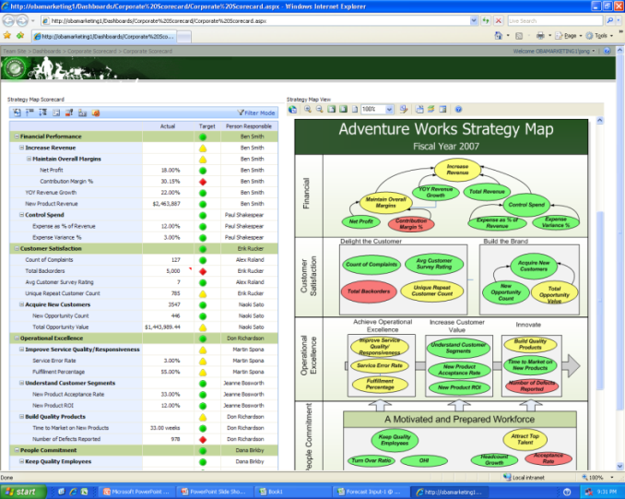Web-based and personalized performance dashboards let more employees work with information that is relevant, actionable and aligned to their organization’s objectives.

Analyze: Why is it happening?

Information workers need to spend less time working for the data and more time working with information. PerformancePoint Server 2007 dashboards and analytics allow employees to easily work across the various organization’s datasources. Intuitive analytical functionality such as cross-drilling and intelligent filters let users understand complex information faster, allowing them to spot trends and opportunities.

**Performance dashboards and analytics**

PerformancePoint dashboards and analytics provide better insight, allowing users to work with and understand complex information faster.

Plan: What would we like to see happen?

Better business performance is about consistency and agility across planning, budgeting, forecasting and reporting activities. With PerformancePoint Server, organizations can rely on built-in financial intelligence, robust business modeling capabilities and strong connectivity with Microsoft Office system to bring systems, processes and people together, while enforcing secured information access across multiple divisions and geographies.

***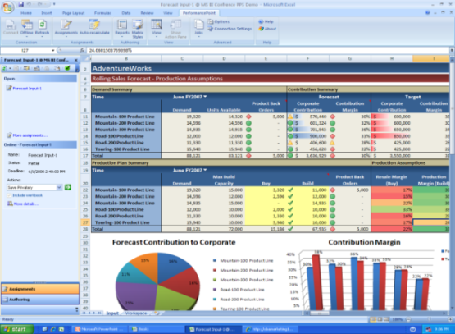*Planning, Forecasting and Budgeting in Office**

Connectivity with Office allows more employees to participate in *the processes of planning, budgeting and forecasting, while relying on centrally-managed business definitions and security.*

Key Features

|  |
| --- |
| Monitor   * Analysis capabilities span from personal performance dashboards to formal methodology-based and cascading scorecards. * Access to a wide range of structured and unstructured data-sources enables a more comprehensive dashboarding and scorecarding experience (OLAP, Relational, and Office). * Contextual KPIs and reports reflect changes of planning, budgeting and forecasting data. * Rich capabilities can be deployed quickly and cost-effectively (Strategy Maps, MOSS connectivity). * Built-in templates and wizards allow users to quickly build and share dashboards and scorecards.   Analyze   * Users can build, share and manage their analysis without the need for coding. * Web-based analytics provides access to information to the right people at the right time. * Guided and contextual analysis can be gained through the tight integration between KPIs and analytics within the same performance dashboards. * Analytics span from multidimensional slice and dice to rich functionality like drill-across, drill-to-detail, pivoting, root-cause analysis, and prediction.   Plan   * Business users can design models the way they think about their business, incorporating standard financial functionality. Capabilities range from single model deployments to enterprise scenarios. * Top-down and bottom-up planning functionality connects people and drives accountability. Dynamic and standard reports include financial and business performance reports. * Process management features enable business users to manage forms, workflows, submissions, approvals, reports and annotations. * Management and GAAP consolidation processes are supported with multiple currency conversions, inter-company eliminations and reconciliations, and multi-tier allocations. * Reports can be published from Microsoft Office Excel to Reporting Services and Microsoft Office Server, providing consistency of experience for report consumers. * Users work within a secure and auditable environment |

Benefits

**Enhances partnership with IT**  
PerformancePoint Server 2007 accommodates advanced business rules, logic, calculations and workflows, making it easy for users to define, customize, modify, and maintain their performance plans, dashboards, scorecards and analytics. Business users can perform analysis in a self-serve mode and work with information in the way they think about their business. This frees up IT to focus on critical infrastructure, security and compliance needs.

**Spans across the organization**   
The model-driven approach in PerformancePoint Server 2007 makes it easy to create corporate-wide models across multiple business operations. By providing synchronized models up, down and across the organization, all users can easily get a consistent view of organizational performance.

**Built on the Microsoft BI platform and tools**  
Unlike many competing performance management solutions that use disparate technologies and require costly integration, PerformancePoint Server takes advantage of the reliability, security, high performance, and scalability of Microsoft SQL Server™. In addition, PerformancePoint Server works well with the widely used and supported Microsoft Office system environment, making broad adoption possible, and enabling performance management to become cost-effective organization-wide.

System Requirements

|  |
| --- |
| **Office PerformancePoint Server 2007 is based on the following Microsoft programs and technologies:**  ●   Windows Server® 2003 SP1, Standard Edition, or later  ●   Microsoft Windows SharePoint® Services 3.0/ Microsoft Office SharePoint® Server 2007  ●   Microsoft Windows® XP Professional SP2, or later  ●   Microsoft Office 2003 SP2, or later  ●   Microsoft SQL Server™ 2005 SP2, Enterprise Edition, or later  ●   Windows Installer 3.1, or later  ●   Microsoft .NET Framework 2.0  ●   Microsoft Internet Information Services 6.0, or later  ●   ASP.NET 2.0  ●   ASP.NET 2.0 AJAX Extensions 1.0 |

© 2007 Microsoft Corporation. All rights reserved. Microsoft, Excel, the Office logo, PerformancePoint, SharePoint, SQL Server, Windows, and Windows Server are either registered trademarks or trademarks of Microsoft Corporation or the Microsoft group of companies. All other trademarks are property of their respective owners.

10/04/07