


Microsoft Office Outlook 2003 with Business Contact Manager
Product Guide
September 2003
Introducing Microsoft Office Outlook with Business Contact Manager 3
Work More Efficiently 3
Close More Sales 3
Connect Effectively with Customers 3
Work with the Application You Already Know 4
The Small Business Advantage 4
Improved Efficiency 4
Consolidated Business Contact Data 4
Rapid Response to Customers 5
Increased Insight into Your Business 5
Outlook with Business Contact Manager in Action 6
Small Business Owner—Frank Pellow 6
Sales Person—Tamara Johnston 7
Manage Opportunities and Follow-Up More Effectively 8
Track Your Business Contacts Easily 8
Manage Opportunities to Maximize Sales Potential 9
Gain Insight into Your Customers and Sales Pipeline 10
Connect with Customers More Effectively 11
Stay “Top of Mind” with Customers 11
Work with Other Microsoft Office Applications and Services 11
Share Contact Information with Other Applications 12
Spend More Time with Your Customers 13
Work within Microsoft Outlook 13
Find Important Documents Instantly 14
Outlook with Business Contact Manager Action Tours 15
Glossary 19
System Requirements 20
©2003 Microsoft Corporation. All rights reserved.
The information contained in this document represents the current view of Microsoft Corporation on the issues discussed as of the date of publication. Because Microsoft must respond to changing market conditions, it should not be interpreted to be a commitment on the part of Microsoft, and Microsoft cannot guarantee the accuracy of any information presented after the date of publication. This document is for informational purposes only. MICROSOFT MAKES NO WARRANTIES, EXPRESS OR IMPLIED, IN THIS DOCUMENT.
The example companies, organizations, products, domain names, e-mail addresses, logos, people, places, and events depicted herein are fictitious. No association with any real company, organization, product, domain name, e-mail address, logo, person, places, or events is intended or should be inferred.
Microsoft, bCentral, IntelliMouse, the Office logo, Outlook, and Windows are either registered trademarks or trademarks of Microsoft Corporation in the United States and/or other countries. The names of actual companies and products mentioned herein may be the trademarks of their respective owners.

Introducing Microsoft Office Outlook 2003 with Business Content Manager
Microsoft® Office Outlook® 2003 with Business Contact Manager helps you manage your business contacts and sales opportunities so your company can grow its business and deliver improved customer service. Designed to meet the needs of small businesses with fewer than 25 employees, Outlook with Business Contact Manager is a single-user desktop application that equips you to organize your business contacts, track sales activities, and analyze sales performance. With Outlook with Business Contact Manager, you can be more productive, close a higher percentage of sales, and market more effectively to new and existing customers—all within the familiar Outlook environment.
Work More Efficiently
With Outlook with Business Contact Manager, account information is at your fingertips and instantly accessible anytime you need it. E-mail messages, notes, appointments, and task items link to your business contacts and sales opportunities, keeping you completely informed about account activity. Preformatted reports track the status of sales efforts, helping you prioritize sales tasks and offering insight into your sales pipeline. You can work more efficiently, respond faster to customers, and make better-informed decisions.
Close More Sales
Your company’s success depends on closing sales. Outlook with Business Contact Manager helps you effectively manage the complete sales cycle—from new opportunities and sales prospects through closure. By tracking information such as revenue potential, probability of closing, and expected close date, you can make sure no detail is overlooked. The bottom line? Increased sales and higher revenues for your business.
Connect Effectively with Customers
Customers are the heart of your business. Business Contact Manger can help you build stronger relationships with existing customers and grow your prospect base. Export your business contacts to Microsoft bCentral™ List Builder to send personalized, professional-looking e-mail newsletters or special offers that keep your customers connected and up-to-date on your products and services. Develop new relationships by attracting new business prospects and target your marketing campaigns using Microsoft bCentral Sales Leads. With access to comprehensive, updated and up-to-date
databases of millions of businesses and consumers, you can identify qualified leads matching specific criteria quickly and import them into Outlook with Business Contact Manager.
Work with the Application You Already Know
Because you work within Outlook, the familiar contact and e-mail management tool you already know and use, Outlook with Business Contact Manager is easy to learn. You can get up-to-speed quickly, without disrupting your busy schedule.
Outlook with Business Contact Manager also helps you position your business to grow. When the time is right, expand your customer information management capabilities by upgrading to Microsoft Business Solutions CRM, a multi-user customer relationship management solution.

The Small Business Advantage
Whether you run a retail operation, manage your company’s sales and marketing efforts, or handle sales in addition to your other responsibilities, Outlook with Business Contact Manager provides significant advantages over paper-based systems or basic contact management software.
Improved Efficiency
Outlook with Business Contact Manager helps you stop wasting valuable time searching for information, sifting through mounds of paper or switching between multiple applications to find the data you need. The Account History consolidates documents, e-mail messages, tasks, appointments, and more in one location for instant access. With the Opportunity feature, you can track leads and sales prospects throughout the sales cycle, helping ensure that your company optimizes every situation.
Consolidated Business Contact Data
Sticky notes and individual pieces of paper may be an easy method for jotting down changes to sales orders or new contact names, but they are just as easy to lose, throw out, or become smudged and illegible. With Outlook with Business Contact Manager, all your contact data remain in a centralized location on your desktop, making it easy to reference and re-use information for each subsequent customer contact. Consolidating contact, account, and opportunity data also makes it very easy to create reports for insight into your sales activities, as well as print contact lists and calendars.
Rapid Response to Customers
Every time a customer contacts your business you have an opportunity to increase customer loyalty. With Outlook with Business Contact Manager, you can respond quickly to time-sensitive situations by instantly accessing account information—such as number of sales, open contracts, last contact date, and other associated items and documents—in a single, unified view. The ability to respond quickly helps you provide the best service possible to your customer.
Increased Insight into Your Business
Twenty preformatted reports consolidate information about your business contacts, accounts, and opportunities, helping you understand your business better and make more informed decisions. Outlook with Business Contact Manager can help you forecast sales, monitor sales performance, prioritize tasks, and offer insight into your sales pipeline. You can sort and filter report information quickly to view the data most relevant to your sales activities and then export results to Microsoft Office Word 2003 or Microsoft Office Excel 2003 for further analysis and formatting.

Outlook with Business Contact Manager equips you with powerful sales tools for organizing your business contacts and optimizing sales potential. Here are just two examples of how Outlook with Business Contact Manager can be used successfully in the workplace

Small Business Owner—Frank Pellow
Frank Pellow is the owner of Wingtip Toys, an education games distributor with 10 employees. Recently his company expanded its distribution line to keep pace in a competitive market and inquiries and sales have increased significantly. With no additional resources to hire more employees, Frank and his team must manage their sales-related processes even more efficiently to provide consistent, quality service and maximize every opportunity to increase sales revenue.
Because Frank and his employees already use Outlook to manage e-mail messages and addresses, they can get up-to-speed quickly with Business Contact Manger to create and manage business contacts, opportunities, and accounts within the familiar Outlook environment. Frank consolidates all his customer information—including contacts, accounts, address lists, tasks, and documents—in one place. He uses the Accounts and Business Contacts feature to establish explicit associations between the companies he’s doing business with and the individual contacts who work there—eliminating confusion when he receives a phone call from someone at a large company with multiple contact points.
Frank’s employees no longer sift through an ocean of sticky notes, document folders, and scraps of paper to retrieve account and opportunity information. They can link e-mail messages, notes, and other Microsoft Office documents to Account and Opportunity records automatically, as well as attach faxes and scanned documents. His employees also can respond more quickly and accurately to customers, improving service and spending more time making sales.
Frank uses the reporting capabilities in Outlook with Business Contact Manager to measure and predict sales activity accurately from existing as well as new customers. He periodically runs customizable reports that show sales status, order information, and the probability of closing for all opportunities and accounts or for a specific subset that he can define. He also makes sure that his sales team uses reports to help ensure that they follow-up on tasks and manage sales opportunities more effectively. Choosing from 20 customizable reports, they can sort and filter information quickly to pinpoint the status of accounts they are working on or have not contacted recently. They can use this information to set priorities for sales efforts, organize daily tasks, and make sure that customer requests and follow-up opportunities don’t fall through the cracks.
Frank now uses Outlook with Business Contact Manager as a powerful sales tool that supports his efforts to accommodate the increase in sales volume. With immediate access to up-to-date information and the ability to generate reports that provide insight into the sales pipeline, Frank can make better business decisions and respond more proactively to changes in the market place.

Salesperson —Tamara Johnston
Tamara Johnston is a salesperson for Contoso, a small company that offers a specialized line of products and services. Responsible for managing all the sales accounts and marketing efforts for the company, Tamara uses Outlook with Business Contact Manager to help her retain existing customers and identify new prospects based on specific customer preferences.
Without leaving the familiar Outlook environment, she manages her sales efforts by using efficient methods for tracking leads and opportunities throughout the sales cycle. By running an Opportunity Forecast, one of 20 preformatted reports, Tamara is fully informed about the status of her sales activities and expectations, including anticipated close dates and detailed product and pricing information.
Tamara imports contact information from other applications to Outlook with Business Contact Manager, using her expanded customer lists to create a variety of different marketing communications, including targeted e-mail campaigns with bCentral List Builder. Because Outlook with Business Contact Manager integrates with Microsoft Office Publisher 2003 and Word 2003, Tamara’s personalizes e-mail campaigns to her customer contacts and automatically captures the messages in the activity history for each account.
Working with List Builder, Tamara can evaluate the success of her campaign enabling her to make smarter decisions about how to target the customer demographics for future efforts. By taking full advantage of these integration capabilities, Tamara no longer worries about keeping the company “top of mind” with the market segments she wants to reach.
Tamara can expand her list of potential, new customers using bCentral Sales Leads by purchasing leads based on demographic and geographic criteria from up-to-date databases of more than 14 million businesses and 250 million consumers.
Just like Contoso’s Tamara Johnston and Wingtip’s Frank Pellow, you, can take full advantage of the features built into Outlook with Business Contact Manager to help you manage your business contacts and sales opportunities efficiently, connect effectively with customers, and grow your business.
Manage Opportunities and Follow-Up More Efficiently
Small businesses experience many of the same pressures as larger companies, including growing the business and staying ahead of the competition. Business Contact Manger offers you powerful tools in the familiar Outlook environment to help organize your customer accounts and business contacts, track every sales opportunity, and generate informative reports to gain insight into customers and sales potential.
Track Your Business Contacts Easily
Outlook with Business Contact Manager automatically links business contacts, incoming and outgoing e-mail messages, notes, appointments, and tasks to the appropriate Account, Business Contact, or Opportunity record, organizing your important customer information in one place and making it easy to track activity. Also, you can link other items such as phone call logs, Microsoft Office files, and scanned documents to records, accessing them directly from within Outlook with Business Contact Manager.
Figure 1. The Account record provides a complete view of customer information and history. |  | 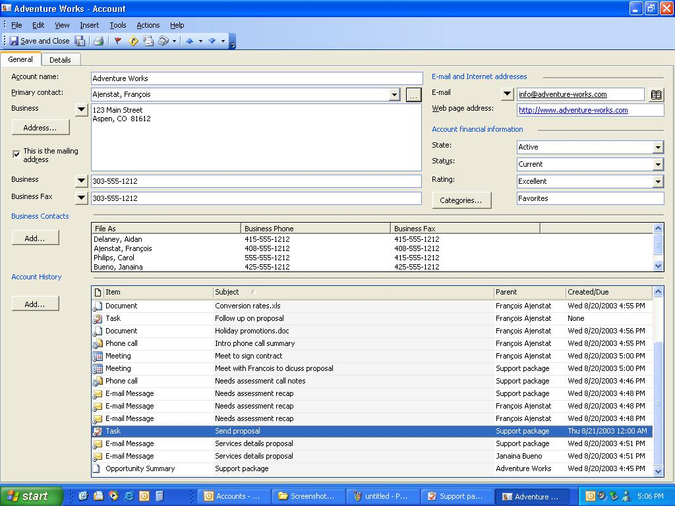

For example, the Account record provides quick access to the company address and other contact information, billing and shipping information, and the financial status and rating of the account. Listed also are individual business contacts and their information, as well as the Account History, a list of linked items and documents.
If your customer calls with a last-minute order change, you can document the phone conversation quickly to note the quantity change and new delivery information. Several days later, when you receive an e-mail message confirming delivery, you can scan the list of associated notes, e-mail messages, and other items to locate the relevant phone log. With a single click, you can access the information you stored earlier in the week directly from the Account record, helping you to respond instantly to your customer.
Manage Opportunities to Maximize Sales Potential
Outlook with Business Contact Manager helps you manage your opportunities and sales prospects effectively throughout the sales cycle by tracking important information—such as revenue potential, probability of closing, and expected close date—so that no opportunity falls through the cracks. An Opportunity that is linked to the appropriate account contains all the information you need to increase sales and capture new customers, including up-to-date pricing information with unit and extended prices for your products and services.
Figure 2. Capturing the details for every opportunity helps you make the most of each potential sale. |  | 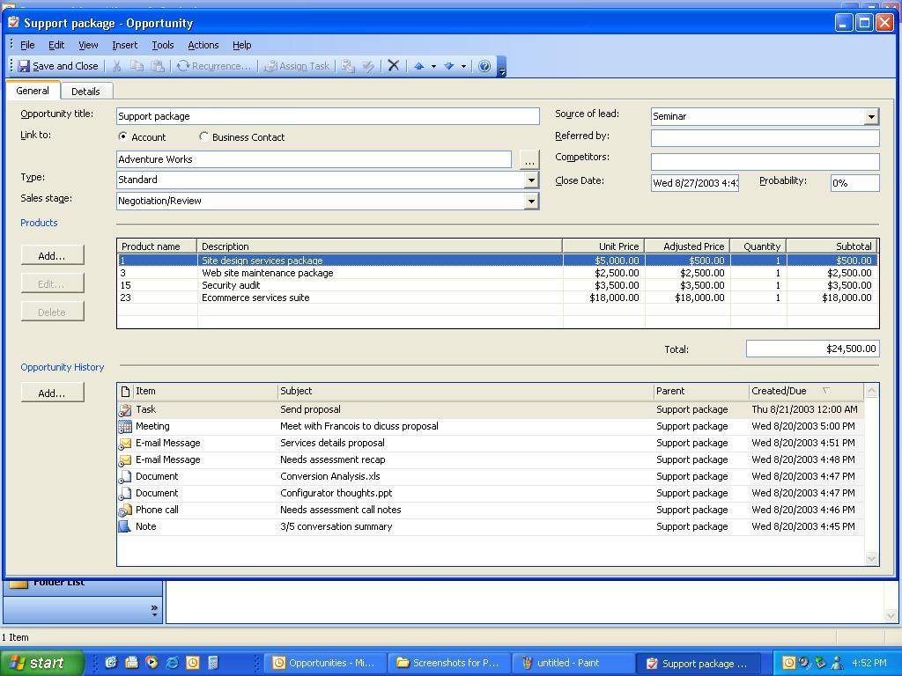

For example, during a conversation with a buyer from an existing account, you learn that the company will be opening a new retail branch. Current orders will double, and the additional location may offer opportunities to sell new items.
With Outlook with Business Contact Manager, you can document and track this and other opportunities, and then forecast your sales with confidence from consolidated information in the Opportunity Forecast report.
Gain Insight into Your Customers and Sales Pipeline
Run reports in Outlook with Business Contact Manager to forecast your sales pipeline accurately and prioritize your work effectively. Choose from a set of 20 reports to gain a better understanding of your sales performance, forecast sales accurately, and prioritize tasks to follow up on the most beneficial opportunities. Customize reports quickly and easily by sorting and filtering information to locate the specific data you need. For example, an unexpectedly large delivery of products to your warehouse may give you the opportunity to offer potential customers a price reduction on a first order. By generating an Opportunities by Product report and sorting by probability or sales stage, you can see which customers might be interested in placing an order for the product. The Opportunity Forecast report then can project your expected revenue.
Figure 3. Creating informative reports tailored to the specific information you need is easy and provides you with the support you need to gain insight into your business and make better decisions. |  | 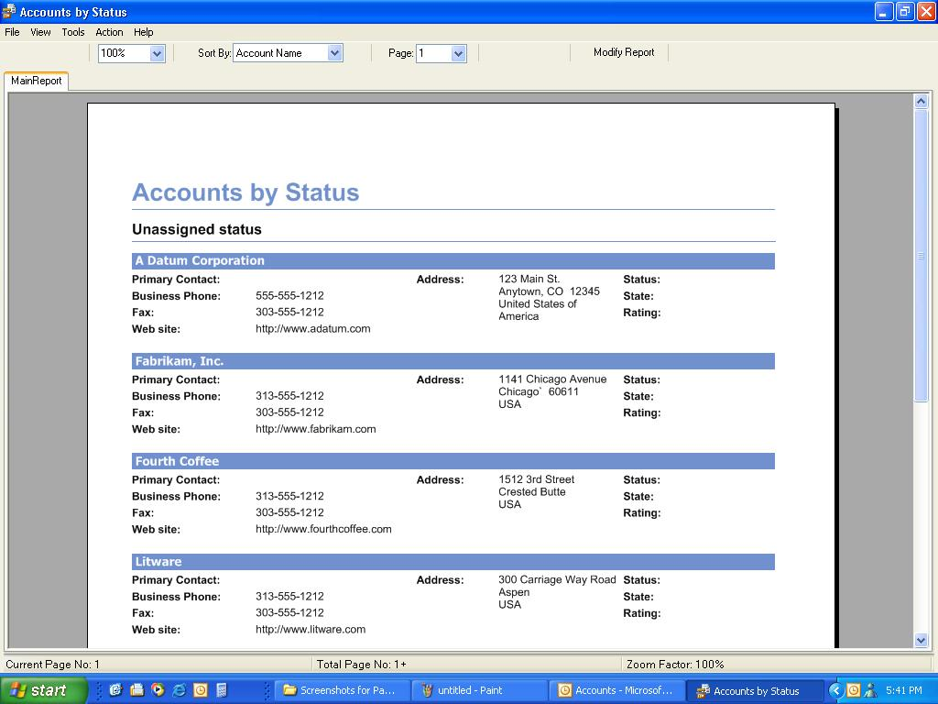
Connect with Customers More Effectively
Connecting with customers effectively is critical for any business that wants to retain existing customers and attract new business. By integrating Outlook with Business Contact Manager with Microsoft Office System programs and Microsoft bCentral Services you have the tools you need to build strong customer relationships.
Stay “Top of Mind” with Customers
Direct e-mail is one of the most effective methods for connecting with customers, helping you to maintain customer awareness of your business, make special offers, or announce a new product or service. Export your business contacts to bCentral List Builder and easily send your customers personalized, professional-looking e-mail messages. For example, if your business sells gourmet products, you can send your contacts a monthly newsletter with recipes and cooking tips that feature your products, including a short article about types of chili peppers or the use of garlic in Italian cuisine. Links to your Web site and order information can help facilitate an immediate sale. Afterwards, evaluate the effectiveness of your marketing efforts by tracking who opened your e-mail messages and which links they clicked.
Expand your prospect base and acquire new customers by purchasing and importing targeted, qualified leads automatically from bCentral Sales Leads. Specify the demographic characteristics you want—for example, age, income, education level, geographical location, and so on—to help you zero in on customers who will be most interested in your business. You can build mailing lists quickly and cost-effectively to extend your marketing efforts and grow your business.
Work with Other Microsoft Office Applications and Services
Outlook with Business Contact Manager works easily and flexibly with other Microsoft Office System programs and services. For example, you can create your own personalized newsletters from a variety of professionally designed Publisher 2003 templates that give your newsletters a polished and appealing look. Because Outlook with Business Contact Manager integrates with Publisher and Word, you can personalize your newsletters and e-mail campaigns to your customer contacts, helping communicate your messages more effectively.

Figure 4. Create sales quotes and proposals quickly with up-to-date product lists imported into Outlook with Business Contact Manager and linked to a business opportunity.

The Account History automatically captures the e-mail messages you send and receive for future reference. You can easily link other Microsoft Office documents to your accounts, business contacts, and sales opportunities, storing your important related documents together. You also can add product information manually or import up-to-date price lists from Excel 2003 into your Opportunity records, giving you the exact information you need at your fingertips and helping you to create quotes quickly and accurately.
Share Contact Information with Other Applications
Outlook with Business Contact Manager gives you incredible flexibility for sharing customer information with other applications. Customer data can be transferred quickly and easily from Word, Excel, and Microsoft Office Access 2003, as well as ACT! and other sources. Auto-association of e-mail messages in Outlook with Business Contact Manager eliminates the need to add them manually to the appropriate account or business contact. Also, if you prefer to carry hard copies of your calendar and contact list, you can print both to fit the paper-based formats you already use, including Franklin Planner, Day-Timer, and more.
Spend More Time with Your Customers
Most small businesses want to focus their greatest efforts on connecting with customers and closing sales—not learning new software. Outlook with Business Contact Manager is intuitive and easy to use right from the start. Your computer quickly becomes a powerful sales and productivity tool, helping you organize your business information, access important documents instantly, and manage mailing lists easily and effectively. The payoff is more time with your customers, not your computer.
Work within Microsoft Outlook
Because you are working within the familiar Outlook environment, your learning curve is virtually eliminated. You start and end your day in the same application you already know and use, working with features that are easy-to-learn and that integrate fully with Outlook, Excel, and Word. The windows and forms are simple and intuitive, with built-in help available if you need it. Generating up-to-date, customizable reports takes only a few clicks, and you can sort and filter the data depending on your specific needs for viewing, printing, or exporting to Excel or Word.
Figure 5. Additional menu items, folders, and toolbar buttons can be accessed from within the familiar Outlook environment. |  | 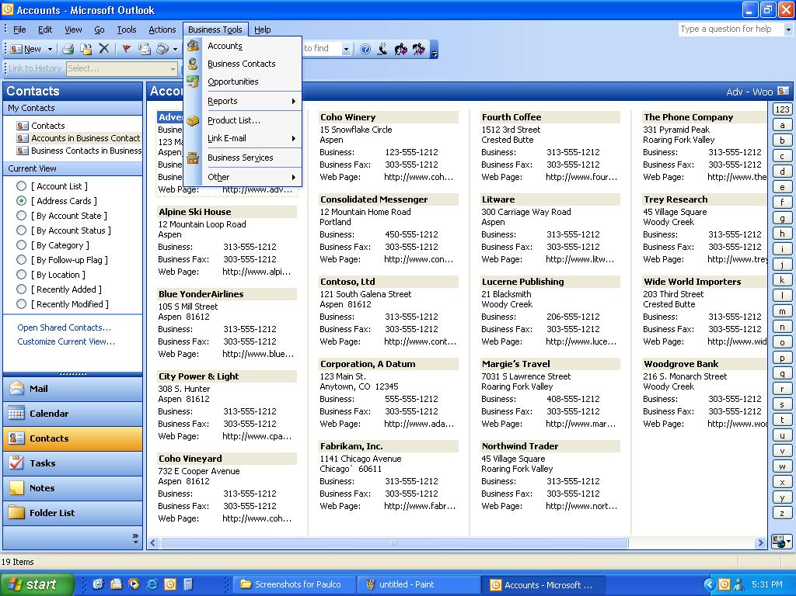
The Business Tools menu, a few additional icons in the Outlook Bar, and an extra set of folders provide access to most of the features you use for Outlook with Business Contact Manager. Easy-to-learn features and the ability to integrate with software and other services you already use keep you focused on your customers, not on your computer.
Find Important Documents Instantly
Respond to customers quickly by locating the information you need instantly. The minute you pick up the phone, you can click on an account or opportunity to view customer information and an up-to-date history that includes all associated documents and items. Whether you need to recall an order change from a recent phone call, confirm a price, review a contract specification, or verify an appointment time, Outlook with Business Contact Manager helps you locate the exact information you need.
Figure 6. Documents and Outlook items, such as phone logs, e-mail messages, and appointments are listed in one place to show an up-to-date activity history.

See for yourself how quickly you can get up to speed with Outlook with Business Contact Manager. Working within Outlook, an application you use every day, your learning curve is dramatically reduced. Try these tasks and you’ll be well on your way to tracking your business contacts and managing sales opportunities so that you can grow your revenue and deliver improved customer service.
Create an Account
- On the Outlook Bar, click the Business Contact Manager folder.  - Under the Business Contact Manager folder, click Accounts.  - On the Actions menu, click New Account.  - On the Account form, enter information about the account.  - Click Save and Close. | Store important customer data in one place. Capture information about your accounts in the Business Contact Manager default form with predefined fields. Once created, you can link Opportunity and Business Contact records to the account and add items and documents to the history.
Create a Business Contact
- On the Standard toolbar, click the down-arrow next to New.  - On the New menu, click New Business Contact.  - In the Check Full Name dialog box, enter the name details, and then click OK.  - Click the icon to the right of the Account field.  - In the Account dialog box, enter the account you want to link to, and then click OK.  - On the Business Contact form, complete the information for the business contact.  - To enter another contact for the same account, click Save and New, or to save the record, click Save and Close. | Individual business contact information helps provide a complete picture of a customer account. Capture contact detail and link the record to a specific customer. Multiple contacts can be linked to the same account, helping you to understand every customer interaction with a specific company.

Create an Opportunity
- On the Standard toolbar, click the down-arrow next to New.  - On the New menu, click New Opportunity.  - Complete the Business Opportunity form. | Capture and track opportunities so you can follow-up effectively. Enter the details of an opportunity to sell your company’s products or services in the Opportunity form and then link it to a business contact or account record.
Export Data Files
- On the File menu, point to Import and Export, and then click Business Contact Manager.  - Click Export a file, and then click Next.  - Select the file type you want to export to, and then click Next.  - Follow the instructions in the Business Data Import/Export Wizard. | Re-use existing business data efficiently to launch a marketing campaign, print paper-based calendars and appointment lists, or for analysis and reporting purposes. Export the data to another copy of Outlook with Business Contact Manager, bCentral List Builder, or a Comma Separated Value file (.csv) such as Excel.
Import Business Data
- On the File menu, point to Import and Export, and then click Business Contact Manager.  - Click Import a file, and then click Next.  - Select the type of file that you want to import, and then click Next.  - Follow the instructions in the Business Data Import/Export Wizard. | Take advantage of existing customer information by importing it directly into Outlook with Business Contact Manager and eliminating the need to re-key data. If you've stored your business data in another application, such as ACT!, Excel, bCentral List Builder, QuickBooks, or any application that can export to a Comma Separated Value file (.csv), you can quickly import the data into Outlook with Business Contact Manager.

Link History Items to an Account, Business Contact or Opportunity
- On the Outlook Bar, click Contacts.  - Under the My Contacts folder, click Accounts in Business Contact Manager.  - In the Accounts list, click the account you want to open.  - On the Account form, under Account History, click Add, and then select an item.  - In the dialog box for the item, enter the appropriate information.  - On the Business Contact Manager toolbar, click the arrow next to the Link to History list, and then select Account, Business Contact, or Opportunity.  - Click the arrow next to the Name list and select a name.  - Click Save and Close. | Outlook with Business Contact Manager automatically links your e-mail messages, assigned tasks, appointments, and meetings to the appropriate Account, Business Contact, or Opportunity record. You can also manually link appointments, phone logs, tasks, business notes, and documents to records.
Generate Reports
- On the Business Tools menu, point to Reports, point to Accounts, Business Contacts, Opportunities, or Other.  - Click the specific report you want to generate.  - Use the Report toolbar to sort report data, modify the information displayed, or print the report. | View your customer information from all sides to gain insight into your sales performance and forecast potential revenues.

Import a Product List
- On the Business Tools menu, click Opportunities.  - Double-click the opportunity that you want to import a product list into.  - On the Opportunity form, under Products, click Add.  - In the Add/Edit Product Entry dialog box, click Product List.  - In the Edit Master Product List dialog box, click Import.  - Follow the instructions in the Products Import wizard. | To sell more effectively and help you determine the potential value of an opportunity, you can import a product list into an Opportunity record. With information at your fingertips, it’s easier to create up-to-date quotes and proposals quickly and accurately.

Account
An organization with which you do business.
Business Contact
The person with whom you do business at a company or organization.
Business Tools menu
The menu on the Outlook menu bar that provides access to Business Contact Manager. Menu items include Account records, Reports, and Product List.
Customer Relationship Management (CRM)
The combination of methods and software that help a business organize and manage relationships with customers.
Form
A way to distribute and collect information electronically. For example, a form can be available for anyone to order supplies or to post information in a public folder. All Business Contact Manager items, such as phone logs and Account records, are based on forms.
History
Tasks, appointments, meetings, e-mail messages, business notes, phone logs, files, scanned documents, or Opportunity records that have been added to the history section in the Account or Business Contact record.
Item
An item is the basic element that holds information in Outlook (similar to a file in other programs) and includes e-mail messages, appointments, contacts, tasks, journal entries, notes, posted items, and documents.
Opportunity
A potential buyer for your products or services. An Opportunity record can be linked to a Business Contact or an Account record to track all your sales information in one place.
Record
A completed Account, Opportunity, or Business Contact form. The record contains Account, Opportunity, or Business Contact information, plus the other records and History items that are linked to it.
Report toolbar
The toolbar located at the top of the Reports dialog box. You can use the Report toolbar to alter the display, sort information, or modify the report.
Sales Cycle
The steps involved in closing a sale, including prospecting, qualification, needs analysis, proposal or price quote, negotiation, and closure.
System requirements for Outlook 2003 with Business Contact Manager are:
- Outlook with Business Contact Manager must be used in combination with a POP3, IMAP and HTML email Server. Outlook with Business Contact Manager is not enabled when used in combination with Microsoft Exchange Server or Microsoft Small Business Server configured for MAPI based email.
- Computer with Pentium III 450 megahertz (MHz) or higher processor recommended
- 256 megabytes (MB) of random access memory (RAM) or above
- Microsoft Windows® 2000 operating system with Service Pack 3, Windows XP, or later.
- 190 MB of available hard-disk space (hard-disk usage will vary depending on configuration; custom installation choices may require more or less hard-disk space)
- CD-ROM drive
- Super VGA (800 x 600) or higher-resolution monitor with 256 colors
- Microsoft mouse, Microsoft IntelliMouse®, or compatible pointing device

