Hyper-Greening your Infrastructure

Sevens Steps to Performance per Watt and Cost Savings

By Adam Bogobowicz and Dave Ohara

## Introduction

Server virtualization enables multiple operating systems to run on a single physical machine as virtual machines (VMs), consolidating workloads across multiple underutilized servers and offers substantial green and cost benefits.

There is an opportunity to be greener in virtualization scenarios by pushing the limits, questioning whether you have overlooked an opportunity to conserve resources or use required systems more effectively. A well executed Hyper-Greening effort can reduce environmental impact of your virtual infrastructure by another 50% and bring corresponding cost savings to your organization.

Building a Hyper-Green virtualization infrastructure is focused on taking the steps necessary to reduce energy consumption and improving performance per watt of your virtualized system. This approach can start small; it can be comparable to switching from incandescent light bulbs to compact fluorescent light bulbs at home. Your next step could be analogous to turning off lights, automatically setting thermostats, and using devices such as Kill-A-Watt to identify practices that waste energy. The specific technologies are not as important as an awareness of the situation and a dedication to make things better. A zealous focus on efficiency and reducing waste has lasting effects.

Not long ago, buying a Toyota Prius would have placed you on the cutting edge of green. Now, hybrids are the most popular car category. Being a green fanatic—and looking at all of details in a virtualized solution—may seem extreme now, but it will be the standard approach in the near future.

This article will give you seven steps to follow in building a Hyper-Green server virtualization system that is better than most. In addition, this article estimates the savings percentage that four steps can achieve in creating a Hyper-Green virtualization system; the remaining three are strategic steps that can have a wide range of energy savings.

1. Save Power
2. Eliminate Waste
3. Manage for High Utilization
4. Power Size Hardware
5. Power Size Software
6. Plan and Deploy for Green
7. See the Forest for the Trees

## Step 1: Save Power

Power management is essential for laptop computers and is now standard on server processors; however, Hyper-V virtual machines have power management disabled. Given that there are multiple VMs on one machine, you can easily understand how different VMs need to be in different power states. Therefore, VMs have processor power management disabled. Any VM power policy settings have no effect. This is a side-effect of a virtualized environment in which VMs do not interact with physical hardware. Does this mean that processor power management is irrelevant? No. Hyper-V still saves power by allowing the root partition to control the power management policies for the entire system.

Microsoft Windows Server® 2008 R2 will have new features to save more power. R2 provides other improvement such as; rewritten processor power management engine and new settings; Intelligent Timer Tick Distribution, to help keep cores and processors in sleep states longer – timer interrupts are handled by a single processor; and Core Parking allows R2 to consolidate processing onto the fewest number of possible processor cores, and suspends inactive processor cores

#### Tip: Use performance tuning

Performance tuning can improve system responsiveness as well as power savings. Minimizing background work, such as employing synthetic I/O and timer ticks for VMs, reduces interrupt traffic and ensures that Processor Power management PPM effects are maximized. You should follow the performance tuning steps for virtualized systems in *Performance Tuning Guidelines for Windows Server 2008* on the WHDC Web site, at <http://download.microsoft.com/download/9/c/5/9c5b2167-8017-4bae-9fde-d599bac8184a/Perf-tun-srv.docx>

Every hardware component has a power footprint, and RAM power consumption is second only to processors, especially when you consider the amount of DIMMS and memory required for VM solutions. Until R2 arrives with new hardware power budgeting capabilities, to measure power consumption, create a spreadsheet that tracks the power consumption of components. Better yet, ask your vendor for a spreadsheet that lists the power consumption of components in your server. This gives you a good idea about whether a vendor can help you achieve a higher performance per watt by using low-power processors, fewer DIMMS (less power), hard drives, and power supplies.

### Savings

Microsoft has estimated that you can achieve up to a 10% improvement in power efficiency by using power management. You can also explore disabling the BIOS-based power management and use the operating system power management to determine which configuration has the highest energy efficiency. This savings applies to physical and virtual servers.

## Step 2: Eliminate waste

Windows Server 2008 features a Server Core installation option. Server Core offers a minimal environment for hosting a select set of server roles, including Hyper-V. It features a smaller disk, memory profile, and attack surface. Therefore, we highly recommend that Hyper-V servers use the Server Core installation option. Using Server Core in the root partition leaves additional memory for the VMs to use (approximately 80 MB for commit charge on 64-bit Windows).

Additional server roles can adversely affect the performance of the virtualization server, especially if they consume significant CPU, memory, or I/O bandwidth. Minimizing the server roles in the root partition has additional benefits, such as reducing the attack surface and the frequency of updates. For these reasons, Microsoft does not support nor recommended additional roles in the root when Hyper-V is running.

#### Tip: Eliminate background activities to minimize waste

Minimizing the background activity in idle VMs releases CPU cycles that can be used elsewhere by other VMs or saved to reduce power consumption. Windows guests typically use less than 1% of one CPU when they are idle. The following are several best practices for minimizing the background CPU usage of a VM:

* Install the latest version of VM integration services.
* Remove the emulated network adapter through the VM settings dialog box (use a synthetic adapter).
* Remove unused devices such as the CD-ROM and COM port, or disconnect their media.
* Use Windows Server 2008 for the guest operating system as enlightenments are added for Hyper-V. Enlightenments decrease the CPU overhead of Windows that runs in a VM.
* Disable, throttle, or stagger periodic activity, such as backup and defragmentation if appropriate.
* Review scheduled tasks and services enabled by default.

#### Tip: Tune your memory

Are you looking for that last ounce of performance? In his All Topics Performance blog, Anthony Voellm recommends that you configure your VM to a Non-Uniform Access (NUMA) node. (For the full article, go to <http://blogs.msdn.com/tvoellm/archive/2008/09/28/Looking-for-that-last-once-of-performance_3F00_-Then-try-affinitizing-your-VM-to-a-NUMA-node-.aspx>.) In his article, Voellm states:

There are not many performance knobs in Hyper-V, which is by design. We really seek out-of-the-box performance. However, if you are looking for that last bit of performance from your Virtual Machines (VMs) and have already made a good selection for networking and storage, you might consider setting the Non-Uniform Access (NUMA) node.

### Savings

The savings in this area are smaller: you can expect about 5% savings in this area. Eliminating waste can apply to physical and virtual servers.

## Step 3: Manage for High utilization

One good thing about over-provisioning hardware is that you rarely run into resource constraints because you have plenty of processing power, RAM, storage, and network capacity. With virtualization server consolidation, component constraints can become an issue. You must evaluate whether you have enough RAM to run a VM without thrashing the disk, and you must question whether you have enough storage to accommodate your VMs and required backups. With high utilization, you will run into weaknesses in your hardware choices more often. There was a reason why IT departments chose to deploy more hardware than necessary: it was the safest thing to do to keep an application running. But now, with the focus on energy savings, there are too many applications deployed on dedicated servers that remain idle because the application (and therefore the server) is not in use.

To meet maintenance and performance requirements, you should considering creating dedicated server *categories*. For example, you could create a Virtualized SharePoint Servers category, which would simplify maintenance and security, and would allow you to fine-tune performance on the platform without having to consider any other application types. If you do run into performance problems, you know that it is not due to one server role affecting the performance of another. You might not be able to pack everything as densely as you could with mixed VM roles, but keep in mind that in the future, you need to move VMs for more performance or storage. This is much easier to do and is more secure if you use dedicated server roles.

#### Tip: Use a System Center Virtual Machine manager to monitor Hyper-V performance

Performance and Resource Optimization (PRO) is a feature of Virtual Machine Manager. It helps you ensure that your virtual machine infrastructure is operating in an ideal and efficient manner. PRO uses rules and policies set by an administrator to dynamically respond to poor performance or failures of virtualized hardware, operating systems, or applications.

#### Tip: Understand how power consumption varies as machine utilization changes.

The graph below was generated by measuring system power consumption as a scalable workload (the TPC-E benchmark workload) was ramped up.

Power and power efficiency versus throughput (in transactions per second)

The top line on the graph represents power consumption as a percentage of maximum power. As shown here, idle power consumption is approximately 65 percent of maximum, even though no work was being done. This is not anomalous behavior. It is common for server idle power to be approximately two-thirds of fully utilized system power consumption.

### Savings

You might not be ready to operate your system at a high utilization level, and for this reason, you might choose to, run fewer VMs on each computer. However, if you push harder in this area and accept a bit more utilization, you can save approximately 20 percent of your energy consumption by pushing for a higher performance per watt. There are monitoring tools available that can help you to increase utilization without incurring much risk.

## Step 4: Power Size Hardware

What are your VM hardware SKUs? What configurations are best for you? How much of your existing hardware can you repurpose as virtual machine servers, and how does this compare to new equipment purchases? The hardware considerations for Hyper-V servers generally resemble that of other Windows Server-based servers, but Hyper-V servers can exhibit increased CPU usage, consume more memory, and need larger I/O bandwidth because of server consolidation. Performance per watt should be your new focus as you consolidate servers, not just CPU metrics.

Are you focused on choosing 2 socket or 4 socket servers? Instead, think about RAM before processors. You are consolidating because of low processor utilization, so why focus on the processor now?. To get your VMs running well, you need RAM. Therefore, evaluate components in the following order: first, consider the amount of RAM, then cost per GB, and then power per GB. Consider that different memory configurations have different costs as well as different power footprints.

### Correct Memory Sizing

You should size VM memory as you typically do for server applications on a physical machine. You must have sufficient memory to handle the expected load at ordinary and peak times because insufficient memory can significantly increase response times and CPU or I/O usage. In addition, the root partition must have sufficient memory (leave at least 512 MB available) to provide services such as I/O virtualization, snapshot, and management to support the child partitions.

A good standard for the memory overhead of each VM is 32 MB for the first 1 GB of virtual RAM plus another 8 MB for each additional GB of virtual RAM. This should be factored in your calculation of how many VMs to host on a physical server. The memory overhead varies depending on the actual load and amount of memory that is assigned to each VM.

### CPU Performance and Statistics

For best CPU performance, plan on one virtual processor per logical processor core. If you need more than 4 virtual processors, then a physical machine is appropriate for that load. Hyper-V publishes performance counters to help characterize the behavior of the virtualization server and break out the resource usage. The standard set of tools for viewing performance counters in Windows includes Performance Monitor (perfmon.exe) and Performance Logger (logman.exe), which can display and log the Hyper-V performance counters. The names of the relevant counter objects are prefixed with “Hyper-V.”

### Storage I/O Performance

Hyper-V supports synthetic and emulated storage devices in VMs, but the synthetic devices generally offer significantly better throughput and response times and reduced CPU overhead. The exception is if a filter driver can be loaded and can reroute I/Os to the synthetic storage device. Virtual hard disks (VHDs) can be backed by three types of VHD files or raw disks.

The storage hardware should have sufficient I/O bandwidth and capacity to meet current and future needs of the VMs that the physical server hosts. Consider these requirements when you select storage controllers and disks, and choose the RAID configuration. Placing VMs with highly disk-intensive workloads on different physical disks will likely improve overall performance.

Networking

If the expected loads are network intensive, the virtualization server can benefit from having multiple network adapters or multiport network adapters. VMs can be distributed among the adapters for better overall performance. To reduce the CPU usage of network I/Os from VMs, Hyper-V can use hardware offloads such as Large Send Offload (LSOv1) and TCPv4 checksum offload. For details about network hardware considerations, see “Performance Tuning for Networking Subsystem” in this document <http://download.microsoft.com/download/9/c/5/9c5b2167-8017-4bae-9fde-d599bac8184a/Perf-tun-srv.docx> .

#### Tip: Use Virtual Machine Manager 2008 Configuration Analyzer

Virtual Machine Manager 2008 Configuration Analyzer (VMMCA) Update 1 is a diagnostic tool that you can use to evaluate important configuration settings for computers that are serving or might serve in Virtual Machine Manager (VMM) roles or are performing other VMM functions. You can download VMMCA Update 1 from the Microsoft Web site. Go to

<http://www.microsoft.com/downloads/details.aspx?FamilyID=ae7c6a09-e8df-4adc-8686-f4d140a3a3f4&displaylang=en>

You should always measure the CPU usage of the physical system through the Hyper-V Hypervisor Logical Processor performance counters. The statistics that Task Manager and Performance Monitor report in the root and child partitions do not fully capture the CPU usage. Be aware, however, that Hyper-V clocks can give inaccurate results if you don’t use them in the root. As Anthony Voellm notes in his blog:

“If you are doing performance analysis and using performance counters, be aware that the counters in the Guest Virtual Machine “lie” so to speak. What you need to use are the Hyper-V Hypervisor Performance Counters in the Root to get Physical Processor usage.”

For the full text of the blog entry, go to <http://blogs.msdn.com/tvoellm/archive/2008/03/20/hyper-v-clocks-lie.aspx> ).

#### Tip: Generating a “load line” for a system configuration

You can do this by measuring the power consumption of a system while throughput varies across the utilization range of a system, from idle up to 100-percent utilization. The below graph is an example of the load line concept.

Typical Server Utilization Range

(Lower is better)

Above is a graph of the power consumption of three system configurations across their load lines. Configuration 3 is the most power-efficient configuration at all points except at 10-percent utilization, where configuration 2 is more power efficient. Configuration 1 has the highest power consumption across the load line, which makes it the least power efficient. All configurations can achieve the same level of peak throughput. By using the load line approach, you can evaluate and compare the performance and energy consumption of different configurations.

### Savings

Getting your virtualization SKUs matched to your server load is one of your most important decisions. Microsoft IT[1] recently presented their strategy of using high end 4-processor machines in development and test labs and using 2-processor machines in production. The reasoning behind this strategy was that they were more power constrained in the development and test environments and achieving higher performance per watt was part of their deployment plan. Matching SKUs to server load has a broad effect on many different areas, and presents 10% of your savings opportunity.

## Step 5: Power Size Software

What is the ideal server for virtualization? A 2 or 4 socket processor? 2 GB DIMMs or 4GB Dimms? Local drives or network storage?. So many choices make it difficult to make the right decisions, and tests can confuse you even more. To give you an idea about how you can use tests to evaluate server loads, consider this excerpt from the BBC’s Top Gear TV show, where they evaluated the fuel economy of a BMW M3 and compared it to a Toyota Prius:[2]

“… miles per gallon test between the BMW M3 and Toyota Prius might have been a little, er, biased. But should your commute be, er, speedy, and you're looking for an excuse to buy the RWD, V8-powered M3 instead of a FWD 4-cyl hybrid... Simple rules drive the Prius as fast as possible, and have the BMW keep up. The Prius did 17.2 MPG, M3 did 19.4 MPG.”

In this article, the load was chosen to show that the M3 had better gas mileage than the Prius. However, most commuters would not drive under the same conditions and the article’s conclusions would not apply. The message in the story is not to buy a BMW M3 for fuel economy. Rather, it is to make you aware that how you drive and the conditions of your environment will affect fuel economy.

Do you think that virtualization test labs choose server loads that maximize the vendor’s product savings? Even if they attempt to be neutral by using different loads and hardware, a test lab cannot replicate your server environment: the energy consumption in your enterprise will not match the consumption that a lab might have or that may occur in another enterprise with similar equipment and a different load. Therefore, to get a realistic picture of your energy consumption and savings, you need to determine your own loads and evaluate your strategy based on your conditions.

### What are you trying to achieve – efficiency or speed?

Most people focus on the efficiency of virtualization technologies, but there are situations where the speed of virtualization technology has savings as well. Testing and development are frequently the first business functions to take advantage of virtualization technology. Using virtual machines, development staff can create and test a wide variety of scenarios in a safe, self-contained environment that accurately approximates the operation of physical servers and clients. One of the main benefits of using virtualization in this scenario is the speed at which environments can be setup and then wiped clean for a fresh start, or how easy it is to go to an early checkpoint and then repeat a series of tests. As one Microsoft test team states:

“With Hyper-V we can build out one copy of each topology, clone it, and distribute it as many times as we need. Then we save initial state (via a snapshot), test, revert to the initial state (in less than 1 minute in most cases), test, revert, test, revert, and so on. This means that we cut our test time in half and every test runs on a perfect clean state. We also reduce a pile of dev/test time building, testing and maintaining cleanup task scripts because we don’t care about clean up anymore.”[3]

#### Tip: Save time by using the Microsoft Assessment and Planning Toolkit

The Microsoft® Assessment and Planning Toolkit (MAP) makes it easy for you to assess your current IT infrastructure and determine the right Microsoft technologies for your IT needs. MAP is a powerful inventory, assessment, and reporting tool that can run securely in small or large IT environments, without requiring the installation of agent software on any computers or devices. <http://technet.microsoft.com/en-us/library/bb977556.aspx>

### Savings

Consider the following scenarios where you migrate to a virtual machine topology: In the first scenario, the migration results in randomly arranged and densely packed virtual machines (VMs). In the second scenario, the migration is planned carefully and results in an organized deployment with room for growth and changes. If you outsource your VM migration, which are you going to get? It is cheaper to use the first scenario because it requires fewer machines and uses all hardware to full capacity, but over time you could be in a worse state than you were in with physical machines. Over the long run you could make sizeable change in your performance per watt by understanding your server loads up front, measuring how your SLAs are met, and planning your migration based on this knowledge. The exact savings is this area is customer specific.

## Step 6: Plan and Deploy For Green

A whole book could easily be written on this topic (and has been), but here are a few resources that can actually help you to plan and deploy for a greener virtual infrastructure. Microsoft Visio has released planning tools for configuring racks for virtualization, and then monitoring your cooling system in your server area. Note that the amount of power required for cooling servers can be 100 to 200% of the energy to run the servers. Monitoring is more important than ever because when servers are used to capacity, they generate more heat and put more stress on the cooling system.

The following image shows the Visio planning tool.

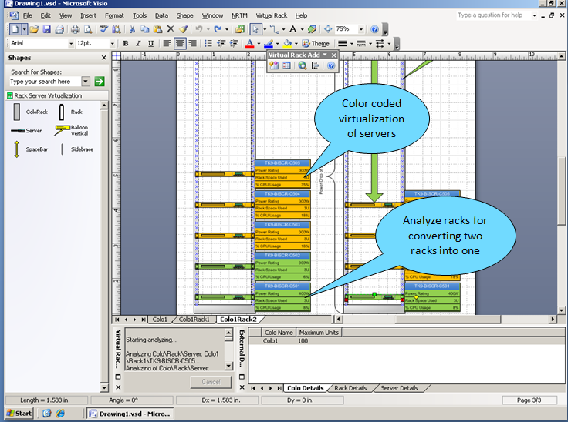

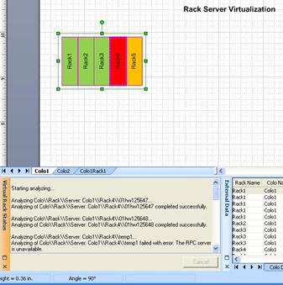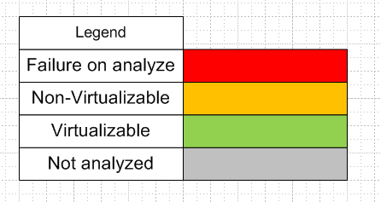

For more information about the Visio tool, go to <http://visiotoolbox.com/en-US/gogreen.aspx> .

In addition to the Visio tool, Microsoft has set up the [www.hyper-green.com](http://www.hyper-green.com) site to help you quantify and report your virtualization project. The site provides a tool that reports your energy savings for servers and cooling and provides additional reporting on carbon emissions. The next image shows the tool available on the hyper-green Web site..

[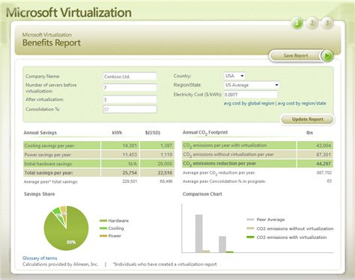](http://www.hyper-green.com/report.aspx?a)

When you use the tools in combination with your previous calculations (the server load data, the SKUs that you need, where VMs should be allocated), you can evaluate your energy consumption and opportunities for increased savings.

Another feature coming in Windows Server 2008 R2 allows power metering and budgeting in conjunction with hardware support, which will help provide you with the tools you need to set energy consumption goals, measure your progress against these goals, and save power throughout your environment.

#### Tip: Refer to published case studies

Microsoft has published case studies based on work done by the Microsoft Enterprise Engineering Center (EEC) and their 9 Hyper-V labs in 2008.The results of the studies were shared with the Microsoft product teams, and best practices based on these EEC engagements have been created and published. The Enterprise Engineering Center is currently upgrading their procedures to incorporate power monitoring throughout the lab. The new power monitoring solution will allow the EEC to monitor the consumption at the outlet level, enabling monitoring the exact amount of power a server or device is using.  Additionally it will allow us to monitor the power consumed by each power supply in a multi-power supply system.

This new capability will allow Microsoft and Microsoft customers to continue investigating the most energy efficient hardware and software to run IT services.

The following three examples of the Enterprise Engineering Center’s Hyper-V work have been published:

* This paper describes tests that were conducted to compare the performance of Microsoft Office SharePoint® Server 2007 servers deployed as guests on a Hyper-V host against SharePoint servers deployed on physical computers, and provides recommendations for deploying Office SharePoint on Hyper-V: <http://technet.microsoft.com/en-us/library/dd277865.aspx>
* This paper introduces and describes the benefits of PeopleSoft virtualization using the new Windows Server 2008 Hyper-V technology, and how to effectively implement this new technology into a PeopleSoft environment: <http://download.microsoft.com/download/1/2/8/12848718-065E-4482-AD4C-1931794786EE/Virtualizing%20PeopleSoft%20Enterprise%20Applications%20with%20Hyper-v.doc>
* This paper explains that with the release of Microsoft Windows Server 2008 with Hyper-V and Microsoft Hyper-V Server 2008, a virtualized Exchange 2007 SP1 server is no longer restricted to the lab; it can be deployed in a production environment and receive full support from Microsoft. <http://msexchangeteam.com/archive/2009/01/19/450463.aspx>

### Savings

While researching this article, we discovered that there were many horror stories of virtualization projects that had gone bad during planning and rollout. Planning and deployment are customer specific scenario with wide range of possible savings.

## Step 7: See the forest for the trees

How do you know that you are achieving Hyper Green performance per watt? If you use a synthetic driver rather than an emulated driver, you will be more efficient because you will use fewer processor cycles and get higher performance. However, if you demonstrate your virtualization success based on CPU utilization, you should use the inefficient emulated drivers to decrease your performance and increase CPU utilization. This action will make the hardware and processor vendors smile, but it is the wrong thing to do.

Measure your performance per watt. Power summarizes the energy used by all components in a server, and gives you an overall indicator of how hard the server is working.

In this dynamic environment, the speed with which you take action can make the difference. If you postpone making decisions because you don’t have all of the data that you think you need, you will be avoiding criticism, but you will be wasting money. Instead, you should be willing to take a risk, be an early adopter, and set the trend. Let your competition follow your lead. Demonstrate to others how much energy they can save by being Hyper-Green.

### Savings

It is hard to gain perspective about when to act and when to wait for information, but being willing to take action is just as important as using power management. The savings for being an early adopter are difficult to measure as you are the leader.

## Conclusion

You may not be able to complete all of the tasks in the following list, but even if you complete a few of them, you will be on a better path. Below is a summary of the seven steps adding up to 50% energy savings.

|  |  |
| --- | --- |
|  | Performance per watt |
| 1. Save Power | 10% |
| 1. Eliminate Waste | 5% |
| 1. Manage for High Utilization | 20% |
| 1. Power Size Hardware | 15% |
| 1. Power Size Software | Advanced Technique |
| 1. Save Power | Advanced Technique |
| 1. Eliminate Waste | Advanced Technique |
|  | 50% |

If you take the time to look at these seven steps, you will be ahead of others who are distracted by irrelevant details. Every step should fit in your overall plan.

Just like the comparison of the Toyota Prius and BMW M3 MPG, you can see how results can be modified to support a scenario. Your scenario differs from everyone else’s, and the only way that you can be a Hyper-Green performer is by developing a plan for your own needs.

## Additional References

<http://www.microsoft.com/whdc/system/pnppwr/powermgmt/Svr_Pwr_ITAdmin.mspx>

<http://download.microsoft.com/download/9/c/5/9c5b2167-8017-4bae-9fde-d599bac8184a/Perf-tun-srv.docx>

Microsoft IT use of Hyper-V <https://msevents.microsoft.com/cui/r.aspx?r=1300508070&c=en-US&t=4>

## Authors

Adam Bogobowicz is a Microsoft product manager.

Dave Ohara is a green IT consultant with over 25 years experience at HP, Apple, and Microsoft, and blogs on the green data center topic at [www.greenm3.com](http://www.greenm3.com) .

1. Microsoft IT use of Hyper-V <https://msevents.microsoft.com/cui/r.aspx?r=1300508070&c=en-US&t=4>
2. The full text of the article is available at <http://www.topgear.com/us/blog/more/bmw-m319.4-mpg-toyota-prius-17.2-mpg/>
3. Quote based on interview with Exchange Server test team.