Getting Your Bearings
What you will do:
- Start
FrontPage 2000.
- Explore the FrontPage 2000 main window.
- Start a Web site by creating a new page.
- Become familiar with the different ways to view your work in FrontPage 2000.


FrontPage 2000 makes it easy for you and your students to create a Web site. With FrontPage 2000, you can create the structure or layout of your Web site, apply graphical themes to its pages, and organize its files and folders. You can import and export files, test and repair hyperlinks, track tasks, and design and edit the contents of your Web pages. When your Web is completed, use FrontPage 2000 to publish it on your computer, your organization's intranet, or the World Wide Web.
As you add components such as text, images, tables, and form elements, FrontPage 2000 displays them as they would appear in a Web browser. Although it is a powerful tool, FrontPage 2000 is easy to use because it looks much like a word-processor. You do not need to learn Hypertext Markup Language (HTML) to use FrontPage 2000 because it creates all the HTML code for you. You can click the HTML tab at the bottom of the page to view and directly edit the code, and then click Normal for “What you see is what you get” (WYSIWYG) format. Also, the Preview tab lets you see what your Web site looks like in the browser.
Before you begin
To get an idea of how you want your Web site to look, it is a good idea to look at outstanding Web sites that other people have created. Look at these sites for good examples of Web design and organization.
- The United States Department of Education at http://www.ed.gov/
- The University of Washington at http://www.washington.edu/
- The United States Information Association at http://www.usia.gov/
Several organizations give awards for outstanding Web sites. The following two Web sites are examples of this type of Web site. Visit them for examples of what Web users like to see:
- Best of the Web at http://www.botw.org/
- Internet Professional Publishers Organization at http://www.ippa.org
Starting FrontPage 2000
This lesson walks you through opening FrontPage 2000, viewing the screens and toolbars, and creating your first Web page using FrontPage 2000. When you have finished this lesson, you will have a simple Web site with a template attached.

To start FrontPage 2000
- Turn on your computer.
- On the Windows Taskbar, click Start, point to Programs, and then click Microsoft FrontPage. FrontPage 2000 opens in Page view.
Exploring the FrontPage 2000 window
Finding your way around FrontPage 2000 is easy once you know the location of folders and files and the navigational techniques. To give you greater control over how your Web pages turn out, FrontPage 2000 offers six different views of the current FrontPage 2000 Web. When you open FrontPage 2000 the first time, you see the Page view window. The toolbars and scroll bar you see are available for all six views.
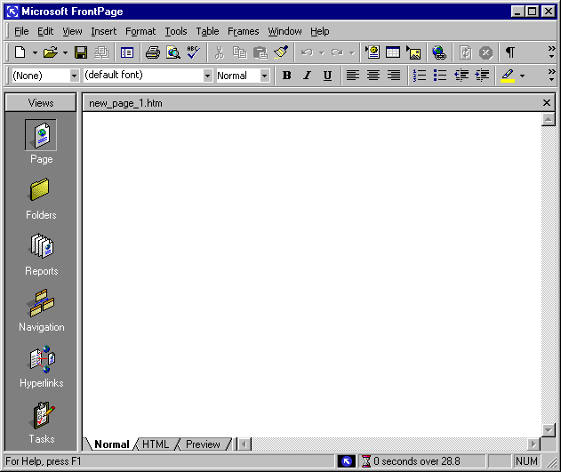
Views toolbar
Click to see your Web site in the different available views.

Tabs
Click to see your Web page in Normal (WYSISYG) format, HTML coding, or a preview of what the page looks like in the browser.

Scroll bars
Use these to move up and down or across your Web page.

Standard toolbar
Formatting toolbar

Working with the FrontPage 2000 toolbars
Three toolbars are available in Page view when you open FrontPage 2000 for the first time.
Menu toolbar
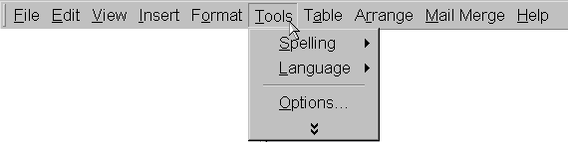
The Menu bar contains a list of menus that help you create, edit, and format Web pages in FrontPage 2000. As you click each menu, additional options appear. Each option shows you more choices, depending on what you are doing. If a menu option looks faded (is grayed out), the option is not currently available to you, but are available for other activities. If you see a chevron at the bottom of the menu, click it and the rest of the menu options appear. The options you use most are promoted to the top of the menu.
Explore the Menu toolbar by clicking on each of the
menus. For example, click Tools to see the options
in the Tools menu.

Arrows indicate that there are additional options for this menu item.

The chevron means more options are available.

Standard toolbar
The Standard toolbar contains buttons that give you quick access to FrontPage 2000's most commonly used functions, such as opening, saving, and printing.
Click to create, open, save, or send a document as e-mail. | Print a document, preview printing, or check spelling. |  | Undo or redo any action. |  | Insert a hyperlink. | Show or hide markers.
View the list of folders used in your Web site. |  | Cut, copy, and paste objects, text, or styles. |  | Add components, create tables, or add graphics. | Refresh the page or stop a jump. | Ask the Answer Wizard for help.

Formatting toolbar
The Formatting toolbar contains buttons that allow you to format text and paragraphs on your Web pages.
Format paragraph styles on your Web page. |  | Change the font size. |  | Right justify, center, or left justify text. |  | Highlight text or change the font color.
Change fonts on your Web page. |  | Format fonts as bold, italic, or underlined. |  | Format text as a numbered or bulleted list, and move the indentation in or out.

Creating a Web
A Web is any document or set of documents you can view on the World Wide Web. A Web can be a single page or an entire Web site. Web pages are individual HTML files that stand-alone and have their own address (URL) on the Web. Web sites are related collection of pages, including a beginning file called a home page. From the home page, you can navigate to all other pages on the site.

Microsoft also provides templates for several types of Web sites. Try experimenting with the templates to find one that suites you.

Begin creating your Web site by building a home page in FrontPage 2000. This is the “front door” to your Web site and should include a greeting, a short explanation of what the Web site is for, and links to the rest of the Web site. For this exercise, you will create a school Web site, so your home page is an introduction to the school and related Web pages. You can then use the same skills to create a homepage for a class you are teaching, whether you teach online or in person.

To start building a Web
- Start FrontPage 2000 if it is not already open. When you open FrontPage 2000, you see the Page view.
- On the Standard toolbar, click the arrow next to the New button and then click Web. The New dialog box appears.
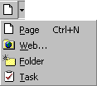
Click the arrow next to the New button.

Then, click the New Web button

- On the Web Sites tab, click Empty Web, and then click OK. The Folder list appears between the Views menu and the page.
- On the Views menu, click 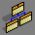. Because you have not yet added any pages, the Navigation view is blank. Click to add a home page.
- Right-click the home page icon and click Rename, then type Central High School Home Page. This is the text that appears at the top of the page.
- To add connecting pages to your home page, click the home page and then click five time to add five pages. The pages appear under the home page.
- Right-click New Page 2, and click Rename. Type Calendar of Events.
- Repeat step 7 with the other new pages and name them Departments and Faculty, Academic Requirements, Alumni Activities, and Educational Links.
Adding tools to get around a Web
To make it easier for people to find information on your Web, add navigational tools. The easiest way to do this is by adding shared borders. Shared borders are regions that are common to one or more pages in a web. A shared border may be a region at the top of the page (similar to a page header), at the bottom (similar to a page footer), at the left, or at the right. With shared borders, you can easily add a logo or navigation buttons at the top of each page because you must only add the information once and it appears on all pages sharing the same border.

To add shared borders
- From the Navigation view, double-click the Calendar of Events page.
- On the Format menu, click Shared Borders.
- Select the All Pages option, then select the Top, Left, and Bottom checkboxes.
- Select the Include navigation buttons checkbox below the Left option to add links to all the pages in your Web, and then click OK. Dotted lines appear on the Web page to indicate where shared borders are located.
- Click in the top shared border area. The text is highlighted.
- On the Insert menu, click Page Banner.
- Select the Picture option, verify that Calendar of Events is in the Page banner text box, and then click OK. The title Calendar of Events can now be seen in the top shared border.
- Click in the left shared border area. The text is highlighted.
- On the Insert menu, click Navigation Bar.
- Select the Same level option, then select the Vertical, and Text options and click OK. Hyperlinks to each of the Web pages below the home page are now located in the left shared border.
- Click on the bottom shared border area. The text is highlighted.
- On the Insert menu, click Navigation Bar.
- Select the Top level option, then select the Horizontal and Text options and click OK. The title Central High School Home Page can now be seen in the shared border at the bottom of the page.
You now have a very simple Web site with navigational links between pages. With a Web site under construction, you can now get to know each of the FrontPage 2000 views.
Become familiar with the FrontPage 2000 views
Once you have a Web site under construction, you can view the site in any of the six available views.


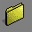

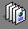

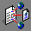

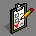

Page View. Create and edit individual pages. Page view also allows you to see your content in Normal (WYSIWYG), Reveal Tags in Normal, HTML, or Preview in browser views.
Folders View. View the organization of all the Web pages, graphics, and files in your Web.
Reports View. See pages, graphics, and files in your Web, and run reports listing slow pages, unlinked, errors, status, recently added or changed files, broken hyperlinks, or categories for any of the files.
Navigation View. Create navigation bars, view the navigational layout of the site, preserve settings across editing sessions, and zoom in to work on specific parts of the site.
Hyperlinks View. See all of the items that link to or from a specific page or Microsoft Office document, and visually see if any links are broken.
Tasks View. Track what tasks need to be done and to whom the tasks are assigned, and quickly see the status, description, and the priority of the tasks.
In the following sections you’ll get a more in-depth look at each of the views and see how they help you work better as you build a Web site.

Working with content in Page view
The actual writing of the Web pages occurs in Page view. You can add content, add graphics, effects, and motion clips to pages, as well as apply a theme and check spelling and grammar.
Dotted lines indicate shared borders.
Text you add in the active page with font and size changed.

The hyperlink to the home page that you added.

This is Page view with the Normal tab selected.

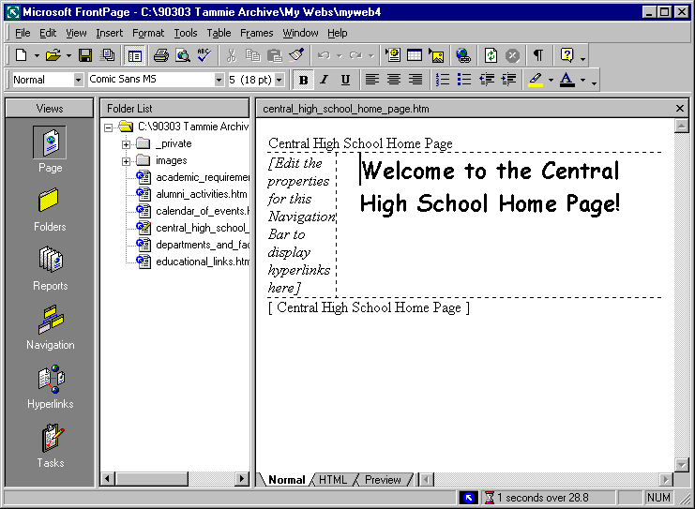

To explore the Page view
- On the Views toolbar, click the Page button. You see the current page you have been working on with the Normal tab selected. You can edit a Web page in Page view much like you would edit a document in Microsoft Word.
- In the Folder List, double-click central_high_school_home_page, click in the area to the right of the left shared border, and then type Welcome to the Central High School Home Page!. Select the text by dragging over it with the pointer, and then click . If you do not see the Folder list, click .
- With the text still selected, change the font by selecting Comic Sans MS from the Font drop-down list and change the font size by selecting 4 (14 pt) from the Font Size drop-down list
- Click the HTML tab. This tab shows you the HTML code that determines what the page looks like in the browser. If you know HTML code, you can edit your Web page directly in the HTML code.
- Click the Preview tab. Here you see the Web page as it looks in the browser. Use the scroll bar on the right to see the bottom of the page.

Organizing a Web with the Folders view
Folders contain the organization of the contents of files and folders in the Web. You can create, delete, copy, and move them in the Folders view.
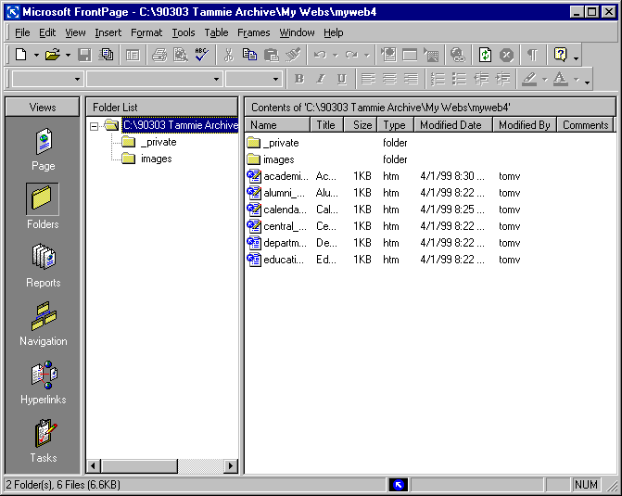
Folder List
Shows the file structure of the Web folder.

Contents
Shows the selected Web folder's contents.

To explore the Folders view
- On the Views toolbar, click the Folders button. You see the folders for your School Web site. Because you have not created all the pages, you do not yet have many folders.
- In the Folders List pane, click images.htm.
- In the right pane, view the contents of the images folder. Because you have not yet added any graphics to your Web, this folder is empty.
As your Web site becomes larger and more complex, you will see more folders in the Folder list and they will contain more information. Examples of files that FrontPage 2000 adds to the folder list include the following:
- Global.asa contains information about the Web’s data connection for use with database functions.
- Animate.js contains Dynamic HTML animation effects.
- Fphover.class contains hover buttons added to Web pages.

Retrieving information about your Web with Reports view
All Webs contain a list of files in the project's folders. The list provides information such as file names, sizes, types, number of links, types of links, and modification dates.
The name of the report.

The number of effected files.
The size of the files.

A description of the report type.

The Reports toolbar helps you move between different reports.

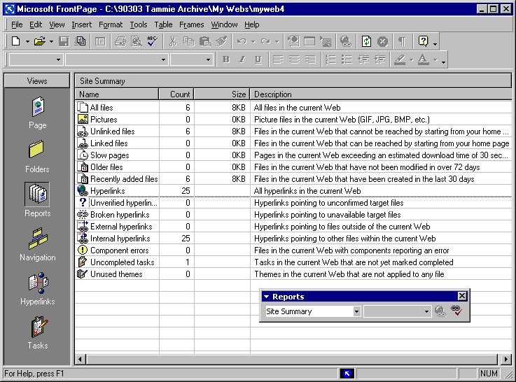

To explore the Reports view
- On the Views toolbar, click the Reports button. A list of report topics appears in the left column.
- Double-click Recently added files. The list of files you just created appears.
- Click Title to sort the hyperlinks by page title.
- On the Views menu, click Reports, and then click Site Summary to return to the summary page in the Reports view.
-Or-
On the Reports toolbar, select Site Summary from the Report drop-down list.
Reports view alerts you to possible problems in your Web site. As you continue to work on your Web site, the reports become more useful. You are able to see broken hyperlinks in your Web site, which pages take too long to download, and which tasks are incomplete.

Maintaining site navigation with Navigation view
The Navigation view shows you a display of the structure of your Web. You can create, display, and print this Web structure. If there is more than one page box, you can click the + (plus sign) in the Home page box to open it; if there is a – (minus sign), click it to close the Home box.
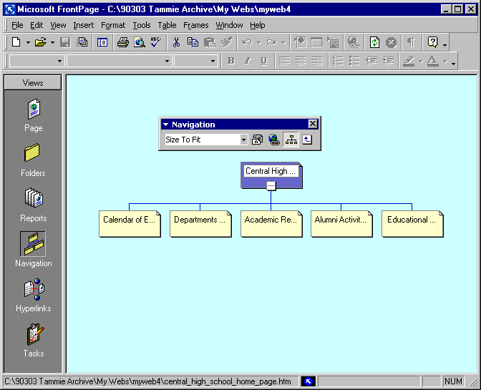
The Navigation toolbar allows you to view the navigation structure at different percentages. Also, the external link button on the Navigation toolbar allows you to add links to pages outside your Web to your navigation structure.

The minus sign shows you there are pages below this page and that all the pages are visible.
The navigational structure of your Web is represented with a tree structure.

To explore the Navigation view
- On the Views toolbar, click Navigation.
- Click the Central High School Home Page page. Notice that the selected page is blue, while the others are yellow.
- In the Central High School Home Page page, click - to collapse the Web, then click + to expand the Web again.
- Click and hold the Alumni Activities page, and then drag it under the Calendar of Events page. Any changes you make in this view effect the pages in Page view, so click and drag the Alumni Activities page back to its original place.
- On the Navigation toolbar, select 150% from the Zoom drop-down list. Notice that you can view a select portion of the Web and use the scroll bar to view the rest of the Web. You can also select Size To Fit to view the entire Web, regardless of how big it is.
- From the Navigation view, you can also double-click a page to see it in Page view.

Managing hyperlinks with Hyperlinks view
In the Hyperlinks view, you can view the Web pages in the left pane and the hyperlinks in the right pane. The page graphically displays hyperlinks between pages, between files in your FrontPage 2000 Web, and from your Web to other sites on the World Wide Web.
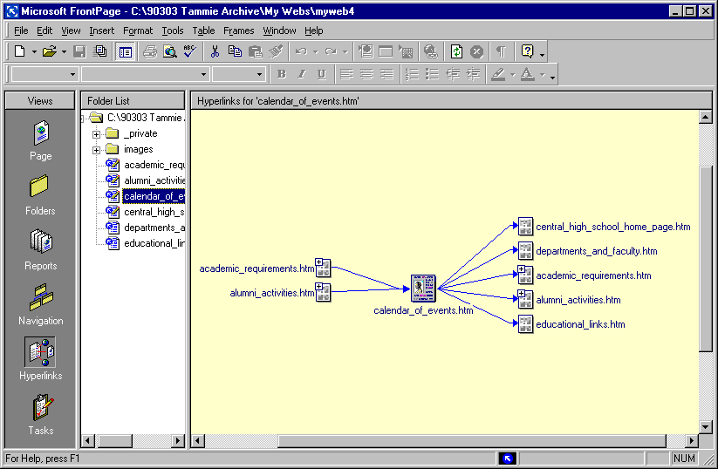
Pages that link to the selected page.
The selected page.

Pages to which the selected page links. A + (plus sign) indicates that the page has additional links.

To explore the Hyperlinks view
- On the Views toolbar, click Hyperlinks.
- In the Folder list, click central_high_school_home_page.htm. This shows you all the links to and from the Web page.
- In the left pane, click the + in front of calendar_of_events.htm. This expands the view of hyperlinks to that Web page. A page without a + or a - does not have any additional hyperlinks.
- Click the - in front of calendar_of_events.htm to close.
- Right-click calendar_of_events.htm, and then click Move to Center. This makes calendar_of_events.htm the center of the Hyperlinks view.

Monitoring tasks in Tasks view
With the Tasks view, you can generate and keep track of a list of tasks to complete your FrontPage 2000 Web. You can create new tasks, assign them to specific pages, and track their progress. Use this view to display the status of Web tasks before you publish your Web. Prior to your creating and assigning tasks, Tasks view is empty.
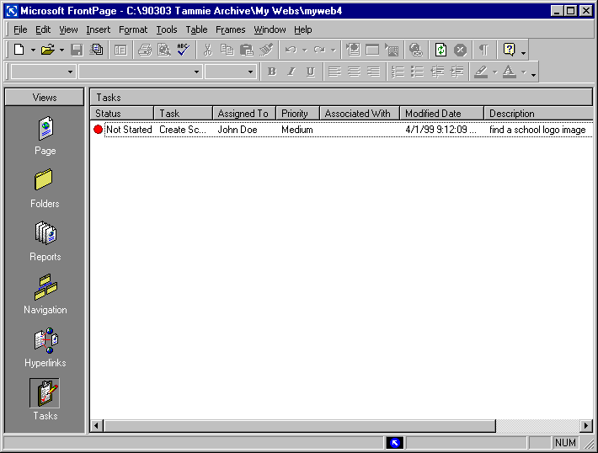
Click these buttons to sort the tasks.
Each task appears in the Task view with a dot indicating whether the task has or has not been completed.

To explore the Task view
- On the Views toolbar, click Tasks.
- On the Standard toolbar, click the arrow next to the New button and then click Task. The New Task dialog box appears.
Click the arrow next to the New button.

Then, click the New Task button

- In the New Task dialog box, type Create School Logo.
- Type John Doe in the Assigned To box.
- Under Priority, select the Medium option.
- In the Description box, type find a school logo image, and then click OK. The task appears in the Task view with a red dot next to it to indicate that it is not yet complete. Green dots appear next to completed tasks.
Extending your knowledge
Many features of FrontPage 2000 are described in this book, and there are many more that you can explore on your own. To learn more about any feature in FrontPage 2000 use the Answer Wizard.

Exploring FrontPage 2000 Help
Use the FrontPage 2000 Help command to get online help. To answer your questions quickly and efficiently, the FrontPage 2000 help system has three parts: Contents, Index, and the Answer Wizard. Contents is like a table of contents where help is organized by chapters and subtopics. In Index, you type a keyword that you want to find more information about. The Answer Wizard allows you to ask a question using natural language, then generates a list of topics that relate to your question.

To ask the Answer Wizard a question
- Click to open the Answer Wizard.
- Type your question in the box that appears. For example, type How do I publish my Web site?
- Click Search.
- Select the topic that most accurately answers your question. The text appears in the Help window.
- To close the Answer Wizard, click the X in the upper-right corner of the Answer Wizard's box.

Viewing ScreenTips
In addition to the Answer Wizard, ScreenTips can be a helpful tool in learning to use FrontPage 2000. When you position the pointer next to any button on the toolbars, a small box appears with the name of each button. The box is called a ScreenTip.
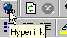
Point to any toolbar button.

The Screen Tip appears.

Closing FrontPage 2000
To make sure that you do not lose any work you have done with FrontPage 2000, always follow the proper procedures to close your file. If you plan to continue to the next activity in this book, you do not need to close FrontPage 2000.

To close FrontPage 2000
- Save your work by clicking Save .
- On the File menu, click Exit.
- If you did not save your work, click Yes to save.

