Microsoft® Communication and Collaboration: Working Together in the New World of Work
White Paper

Published: September 2006
For the latest information, please see http://www.microsoft.com/office

The information in this document and any document referenced herein is provided for informational purposes only, is provided AS IS AND WITH ALL FAULTS and cannot be understood as substituting for customized service and information that might be developed by Microsoft Corporation for a particular user based upon that user’s particular environment. RELIANCE UPON THIS DOCUMENT AND ANY DOCUMENT REFERENCED HEREIN IS AT THE USER’S OWN RISK.
© 2006 Microsoft Corporation. All rights reserved.
If the user of this work is using the work solely for non-commercial purposes internally within a company or organization, then this work is licensed under the Creative Commons Attribution-NonCommercial License. To view a copy of this license, visit http://creativecommons.org/licenses/by-nc/2.5/ or send a letter to Creative Commons, 543 Howard Street, 5th Floor, San Francisco, California, 94105, USA.
MICROSOFT CORPORATION PROVIDES NO WARRANTIES, EXPRESS, IMPLIED OR STATUTORY, AS TO THE INFORMATION CONTAINED IN THIS DOCUMENT AND ANY DOCUMENT REFERENCED HEREIN. Microsoft Corporation provides no warranty and makes no representation that the information provided in this document or any document referenced herein is suitable or appropriate for any situation, and Microsoft Corporation cannot be held liable for any claim or damage of any kind that users of this document or any document referenced herein may suffer. Your retention of and/or use of this document and/or any document referenced herein constitutes your acceptance of these terms and conditions. If you do not accept these terms and conditions, Microsoft Corporation does not provide you with any right to use any part of this document or any document referenced herein.
Complying with the applicable copyright laws is the responsibility of the user. Without limiting the rights under copyright, no part of this document may be reproduced, stored in or introduced into a retrieval system, or transmitted in any form or by any means (electronic, mechanical, photocopying, recording or otherwise), or for any purpose, without the express written permission of Microsoft Corporation.
Microsoft may have patents, patent applications, trademarks, copyrights or other intellectual property rights covering subject matter within this document. Except as provided in any separate written license agreement from Microsoft, the furnishing of this document does not give you, the user, any license to these patents, trademarks, copyrights or other intellectual property.
Information in this document, including URL and other Internet Web site references, is subject to change without notice. Unless otherwise noted, the example companies, organizations, products, domain names, e-mail addresses, logos, people, places and events depicted herein are fictitious, and no association with any real company, organization, product, domain name, e-mail address, logo, person, place or event is intended or should be inferred.
Microsoft, Active Directory, Excel, FrontPage, Groove, InfoPath, Internet Explorer, OneNote, Outlook, PowerPoint, SharePoint, SQL Server, Windows, Windows Mobile, Windows Server, and Windows Server System are either registered trademarks or trademarks of Microsoft Corporation in the United States and/or other countries.
The names of actual companies and products mentioned herein may be the trademarks of their respective owners.

Contents
Working Together in the New World of Work 1
One World of Business 1
Always On, Always Connected 1
Transparent Organizations 1
Communication and Collaboration at Work 2
The Foundation for Competitive Advantage 2
Business Culture and Working Together 3
Added Value 4
Where Do We Go from Here? 4
Organization’s Vision 4
Technology Assets 4
The Microsoft Communication and Collaboration Platform 5
Collaborative Workspaces 5
Platform Basics—Windows SharePoint Services 3.0 5
Solution Extender—Microsoft Office Groove® 2007 9
Unified Communications 10
Platform Basics—Office Outlook 2007 and Microsoft Exchange Server 2007 11
Solution Extenders—Office Communicator 2007 and Microsoft Office Live Meeting 13
Connected People, Processes, and Information 14
Platform Basics—Office SharePoint Server 2007 14
A Complete Solution 16
Benefits of the Microsoft Communication and Collaboration Platform 17
Enable Dispersed Teams to Work Across Organizations 17
Keep Teams Informed, Accessible, and Accountable 18
Create Content, Prepare and Share Information, and Capture Community Knowledge 19
Empower Users While Protecting Information and Controlling Data Integrity 19
Integrate Collaboration in Vertical and Horizontal Processes and Applications 20
Impact on Technology Fundamentals 21
Improved Management and Infrastructure 21
Simplified Setups 21
Enhanced Mobile Access 22
Better Protection 22
Increased Customization 22
Conclusion 23
For More Information 23

Working Together in the New World of Work
Living in a connected world, many of the economic and intellectual barriers that once separated the world’s businesses no longer exist.
Free trade, growing labor markets, increased capital, and business and technology standards contribute to a worldwide information-based economy. People and businesses work together in ways never before possible.
As local economies adapt to this new world of work, certain worldwide trends emerge. These trends define how your company conducts business and how you work with information and other people.

One World of Business
- Geographical and organizational boundaries are more open. People, products, and intellectual property move more freely between organizations and across national borders.
- Open boundaries provide new opportunities for growth.
- Taking advantage of these opportunities often requires the dispersement of workers to multiple cities, states, and countries. The number of workers who work away from the office or from a home office is increasing.
- Dispersed colleagues, partners, and customers need an easy and effective way to share ideas and information.

Always On, Always Connected
- The Internet and other worldwide networks, along with advancements in broadband technology, connect you to the people and information you need.
- Constant connectivity comes with a constant flow of information, which increases demands on your time.
- You must be able to prioritize and act on information to be successful.
- Communication and collaboration technology must adapt to the number of people working together and the network connection they use.

Transparent Organizations
- Making an organization more transparent can put proprietary information at risk.
- The opening of organizational information can build deeper relationships with partners and customers.
- The opening of organizational processes can help identify processes that need to be improved.
- Organizations must find the right balance between transparency and confidentiality.
Microsoft® believes that successful businesses are a direct result of successful people. Businesses that empower you to overcome challenges are more likely to flourish in the new worldwide economy.
By continuing to invest in people and the technology they need, businesses around the world can transform obstacles into advantages. The new world of work becomes a new world of opportunity.

Communication and Collaboration at Work
Start with a simple computer power supply. The power supply’s design was created by an inventor in Hong Kong. The internal parts for the power supply come from places all over the world. The finished product is assembled in factories in Shenzhen, China. The parent company is based in Shanghai, China.
Sales representatives travel to visit customers in Brazil, Europe, and other countries. Some customers place orders for a slightly modified version of the original design, so sales must work with the original inventor and engineers to come up with a final design specification that meets the customers’ needs.
Operations must make sure that sufficient parts and supplies are in place to fill the orders in a specific amount of time. And all of these functions integrate seamlessly across a shared, standard technology infrastructure, allowing the computer power supply company to sell the units at a lower price than the competition, improving sales growth and profitability.
To this company, operating and doing business in growth markets around the world means constantly trying to find new ways to streamline operations and improve productivity. To this end it must provide its employees with tools that enable them to sort through the ever-growing volumes of information that can help them make well-informed decisions quickly.
Specific business needs include
- Tracking projects — including the status of tasks, key dates, and costs — from a central location.
- Collaborating more efficiently to create high-quality sales proposals.
- Coordinating schedules between suppliers, sales, and operations.
- Organizing meetings when attendees are in different geographical locations.
- Communicating by means of a simple messaging solution that supports real-time communication.
- Sharing design specifications and versioning in an online collaborative workspace.

The Foundation for Competitive Advantage
This company and other companies in growth markets have taken advantage of the advances in communications and collaboration technologies using familiar products such as Microsoft Office and Microsoft Windows® SharePoint™ Services to gain a competitive advantage. Collaboration is a key driver behind this success. A leading global research firm, Frost & Sullivan, provides strategic analysis of the effects of collaboration at work. According to a 2006 study by Frost & Sullivan, collaboration can have significant positive impacts on
- Profitability, profit growth, and sales growth.
- Customer satisfaction.
- Employee satisfaction, productivity, and performance.
- Product quality, product development, and innovation.
In simple terms, companies that communicate and collaborate well perform better in every aspect. Those that don’t collaborate will not do nearly as well.

Business Culture and Working Together
Collaboration through technology can empower individuals and organizations if it can be readily adopted within the existing cultural and social framework on which end users rely. In some cases, hierarchically structured businesses might not encourage communication and collaboration. Even though that might be the case, companies that do foster a collaborative environment cultivate it from the top to the bottom of the organization, gaining an individual and organizational competitive advantage.
Some other important considerations when talking about business culture and working together:
Presence and being able to find and communicate with people in the organization when and where you want is a crucial part of being always on and always connected.
Privacy is a strong consideration in many companies. Using the right tools and technology to share such things as calendars and schedules is especially important.
Workflow and how information is going to be shared between managers and staff during the development process can have an impact on the success or failure of a project. What are the people, processes, and technology going across, up, and down the organization that will lead to the greatest probability of success for projects, sales proposals, presentations, and documents?
Education is the tool that empowers information workers within an organization so that they can take advantage of technologies already in place. Many information workers know one application in an application suite very well, and the others not so well. According to a 2006 study conducted by global research and analysis firm IDC, the average information worker understands and uses 10 to 30 percent of the capabilities of the typical desktop application suite such as Microsoft Office. A lack of internal training can lead to
- A loss in personal efficiency and a time loss for day-to-day work on an individual basis.
- An increase in support center calls.
- Unhappy workers, which can affect the overall employee retention rate.
Personal productivity is an important value to the information worker. Enabling employees to improve productivity by using familiar programs means that they can spend more time doing what they do best: creating value for the company.
Working together in a team environment is important to 70 percent of information workers and business executives, according to Frost & Sullivan. Collaboration tools can add to this experience and help push information across the organization, leading to greater overall productivity.
Collaboration is critical to the success of organizations across the globe. The key is achieving the proper mix of collaborative technologies, a culture of openness, and a decentralized structure in the organization. It is this delicate blend of resources and investments in technology and people that provides companies a source of sustainable competitive advantage.

Added Value
Using technology for collaboration can extend what people can do in business: It can help organizations leverage existing strengths. Many small to midsized growth-market organizations already have the tools in place to collaborate by using technology. (According to IDC, a large percentage of small to midsized growth-market companies are using some sort of client/server architecture with Windows and Microsoft Office on the desktop.) So, what would be the business impact of exposing those tools and taking advantage of existing infrastructure?
Collaboration that uses technology as an aid or an enhancement can lead to an increase in personal efficiency and can simplify how people work together. Ultimately, collaboration can have a positive effect for individuals’ and team members’ sense of satisfaction in the work that they do, and thus can increase the possibility of greater revenues, profitability, and growth.

Where Do We Go from Here?
For small to midsized organizations operating and doing business in growth markets, using technology as a tool for collaboration requires a strategic approach. Before implementing a solution, it is important to understand the organization’s vision, strategy, and how technology is currently being used.

Organization’s Vision
- What are the organization’s goals, direction, and mission?
- What are the short and long term business goals?
- What are the top three items that the organization wants to see accomplished using information technology (IT)?
Also as part of the assessment process, management should work with IT to inventory the available technology assets and how they are being used.

Technology Assets
- Does the organization have a server in place allowing for sharing of files, data, print, and fax resources?
- Does the current e-mail infrastructure provide tools and support for anti-virus, anti-spyware, and anti-phishing compliance?
- Do workers use a shared calendar to set up meetings?
- Does the organization use shared online workspaces to collaborate internally or with external customers and suppliers?
- Do traveling workers use Personal Digital Assistants (PDAs), cell phones, and other mobile devices to stay connected to the main office?
- Do workers have access to company resources, whether working from a branch office, from home, or out in the field visiting customers, anyplace, anytime?
Gathering this information will help lay the groundwork for long-term planning and solutions that will help meet the organization’s goals and needs.
Collaboration through technology empowers individuals and organizations to reach greater heights. This is especially important in rapidly growing markets. Microsoft has a strong vision for providing the infrastructure that can enable people to work together more effectively, allowing businesses to do what they do best.

The Microsoft Communication and Collaboration Platform
Microsoft believes an effective communication and collaboration platform must empower the individual to creatively communicate their ideas and control when and how to share work with others.
You should be able to work seamlessly with colleagues, customers, and partners in your city, across your state or province, around your country, or even around the world. Communication and collaboration features should be pervasive throughout the applications that you already know and use.
The foundation of the Microsoft communication and collaboration platform is the 2007 Microsoft Office system, an integrated set of programs, servers, services, and solutions.
The cornerstones of the 2007 Office system, the 2007 Office suites, provide you with familiar, easy-to-use applications for electronic communications, content creation, and data analysis.
The same applications you use to create document content can also be used to prepare documents for sharing, create a collaborative workspace, and manage document content and lifecycle.
By integrating communication and collaboration features into the 2007 Office system and then extending these features beyond the desktop, Microsoft helps you overcome the challenges of the new world of work through the creation of collaborative workspaces, the unifying of communication methods, and the connection of people, processes, and information.

Collaborative Workspaces
Whether in a cubicle, an office, or a home office, you need a place to work. Some workers create their own place to work in an airplane, hotel room, or coffee shop.
Where do you go when you need to work with others? A conference room? An online meeting?
While working with others can be as simple as sharing ideas or information, more complex scenarios involve the collective creation, editing, and distribution of documents.
In addition, you cannot assume that your project is as important to someone else. Getting all required participants together for a working session at a particular time can be difficult. Consider the increasing geographical dispersement of teams and workgroups and such meetings become unrealistic.
Whether working with others in your local area or abroad, you must be able to transcend the physical boundaries of the traditional work environment into the online environment of the collaborative workspace.
Workspaces are a collaboration-ready alternative to standard shared network locations. Basic team communications and document storage and management capabilities are available to you out of the box. Most importantly, workspaces are designed to connect to and work with the Microsoft Office applications you already know and use.

Platform Basics—Windows SharePoint Services 3.0
Windows SharePoint Services, an integrated feature of Microsoft Windows Server® 2003, empowers you to create collaborative workspaces for sharing ideas and information. Windows SharePoint Services workspaces store and manage shared calendars, contacts, tasks, documents, and more.
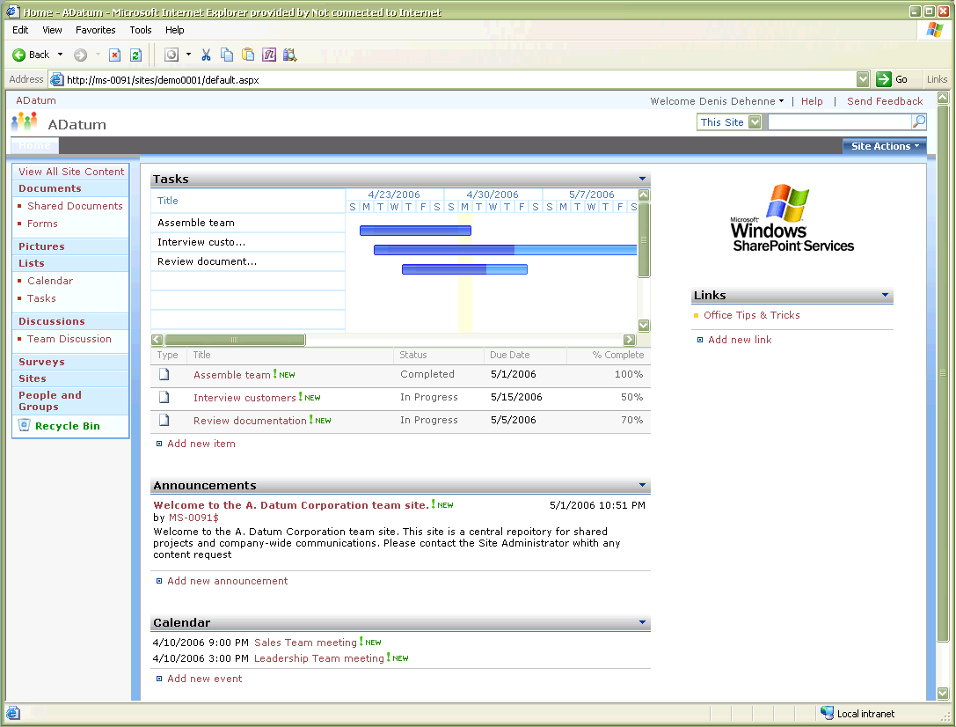
Figure 1. Windows SharePoint Services 3.0 Team Site with Gantt Chart
Windows SharePoint Services workspaces address many common scenarios out of the box:
- Meeting Workspaces facilitate the storing and sharing of meeting documents and information. A basic Meeting Workspace template manages lists of meeting objectives and agenda items. Relevant documents can be uploaded to the default document library. Meeting attendees can view all invited participants, their response to the meeting invitation, and their online or offline presence information and related communication options from the workspace home page.
- Document Workspaces provide a central location for storing, editing, and communicating about project-specific documents. A Document Workspace template manages lists of announcements, relevant links, tasks, and calendar items. Members can manage these shared tasks and calendar items alongside their personal items in Microsoft Office Outlook® 2007. Document Workspaces include libraries for storing and editing documents and pictures. Each workspace features a default discussion forum and survey engine for team communications. Workspace members in organizations running Microsoft Office Communications Server 2007 can view each others’ online or offline presence information and related communication options from the workspace home page.
- Team Sites provide a centralized gathering place for team members to communicate and collaborate on documents and other information. The Team Site template includes a document library for storing and working with team documents. The Team Site home page allows team members to view and manage team announcements, contacts, events, and links.
- Blogs (short for Weblogs) provide a forum for communicating ideas or information. The Blog template allows the blog owner (or blogger) to post items to the site. Visitors to the blog can comment on the individual posts and subscribe to a Really Simple Syndication (RSS) feed to automatically receive regular blog updates in their Office Outlook 2007 Inbox or other RSS reader.
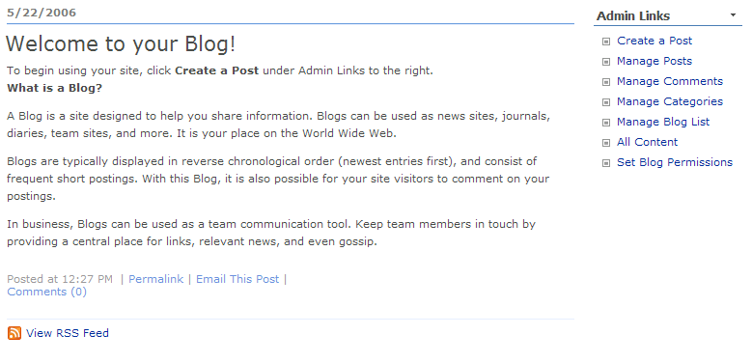
Figure 2. Windows SharePoint Services 3.0 Blog template
- Wiki sites promote the regular gathering or brainstorming of information from a group of people. Wikis can be used to collaborate on team ideas or to build a community knowledge base. Participants contribute to the site directly from their browser.
Windows SharePoint Services workspaces are easy to create:
- You can use the browser-based interface to create Team Sites, Document Workspaces, Meeting Workspaces, Blogs, Wikis, and other types of online gathering places.
- Select the shared attachment option when attaching a file to an Office Outlook 2003 or Office Outlook 2007 e-mail message to configure a Document Workspace for the attached document. Sending the e-mail initiates the workspace creation process, linking the workspace and e-mail versions of the file for consistent versioning. You can also create a Document Workspace by using the Document Management Task Pane in other Office 2003 and 2007 Office system applications.
- Select the meeting workspace option in a new Office Outlook 2007 meeting request to configure a collaborative workspace for storing and sharing meeting information. Sending the meeting request initiates the workspace creation process and adds meeting attendees to the workspace permissions.
Windows SharePoint Services workspaces help preserve document integrity:
- You can check out a workspace document before editing, temporarily reserving the editing rights. Checking out documents eliminates duplicate or conflicting changes made by multiple contributors.
- When editing workspace documents, you can view workspace content and membership from within the 2007 Office system application you are working in. This helps you focus on work instead of on switching windows.
- You can enable the workspace to track major and minor document versions, any of which can be compared with or restored over the current version. This allows you to maintain control over the workspace documents and provides an opportunity to undo unwanted changes.
- The two-tier Recycle Bin helps members and administrators control how information is deleted from workspace lists and libraries. You can restore deleted items from the Web-level Recycle Bin on the workspace. When this Recycle Bin is emptied, items move to a second bin controlled by the administrator. The administrator can manually restore items from the second bin or set a timer to automatically delete items after a specific time period.
- As an administrator, you can define site or workspace permissions down to the individual document or item level.
Windows SharePoint Services workspaces encourage better communications with colleagues:
- Workspaces in environments running Office Communications Server 2007 can display the online or offline presence of workspace members. This allows you to see who is available at any given time and then communicate with that person through instant message, e-mail, telephone, or audio/video conferencing.
- Workspaces can include a team or shared calendar allowing you to post project-related meetings and appointments for everyone to see. You can view and manage the workspace calendar alongside your personal calendar in Office Outlook 2007.
- Workspaces can include a list of team or shared contacts allowing you quick access to relevant people or organizations. You can view and manage the workspace contacts alongside your personal contacts in Office Outlook 2007.
- Workspaces can provide online discussion forums as an alternate method of team communication. You can create and reply to blog postings on your own time, participate in Wiki brainstorm sessions, and contribute to other informal discussions outside of the time-sensitive confines of e-mail and instant messaging.
- Workspaces offer an easy solution for polling team members or gathering answers to project-related questions. You can create and respond to custom surveys and generate online or spreadsheet-based reports of the survey responses.
- Workspaces automatically inform members of changes to workspace content or the assignment of workspace tasks. Members can set alerts for specific items or subscribe to an RSS feed. All alerts, notifications, and RSS feeds can be delivered to an Office Outlook 2007 Inbox.
Windows SharePoint Services workspaces scale to meet the needs of almost any project, process, or scenario:
- You can customize the default workspace layout and components to meet the specific needs of the meeting or project. For example, a non-default list such as a task list can be created for a meeting workspace and placed on the workspace home page.
- You can also personalize your workspaces by applying workspace themes and adding team photos or other relevant images to the workspace home page. Web designers can use Microsoft Office SharePoint® Designer 2007 (the next generation of Microsoft Office FrontPage®) to further enhance the look and feel of the workspace. A personalized workspace can reflect the individual, team, or company it represents.
- A number of pre-built Application Templates are available for Windows SharePoint Services 3.0. These Application Templates address a number of common processes and activities (including Human Resources Recruiting, Expense Reimbursement, and Legal Document Review) and provide a baseline for more complex vertical and horizontal solutions. Application Templates can be downloaded from http://www.microsoft.com/technet/windowsserver/sharepoint/wssapps/default.mspx.
- Microsoft partners are available to help you develop and deploy custom workspace solutions for most vertical and horizontal processes. Information on many of these partners can be found at http://office.microsoft.com/marketplace.

Solution Extender—Microsoft Office Groove® 2007
While Windows SharePoint Services provides the core infrastructure requirements for creating and using collaborative workspaces, additional components of the Microsoft communication and collaboration platform, such as Office Groove 2007, can extend these capabilities in new directions.
Office Groove 2007 decentralized workspaces make it possible to collaborate across network boundaries. A decentralized workspace allows people from different organizations to securely share files and information, without requiring each workspace member to have permission to the same internal networks. This flexibility enables you to work more effectively with external customers and partners.
With Office Groove 2007 installed on your local computer, you can join, create, and contribute to Groove workspaces. Because Office Groove 2007 operates outside the network firewall, you can invite anyone also running Office Groove 2007 on his or her computer to join a workspace, even people on other networks.
- Office Groove 2007’s built-in presence information indicates when workspace members are online, providing an opportunity to initiate a Microsoft Office Communicator 2007 conversation from within the workspace.
- You can easily add files, forms, discussions, and other tools to the workspace and synchronize them between workspace members.
- Office Groove 2007 is tightly integrated with Windows SharePoint Services and Microsoft Office SharePoint Server 2007, allowing you to collaborate on and synchronize files stored in SharePoint document libraries.
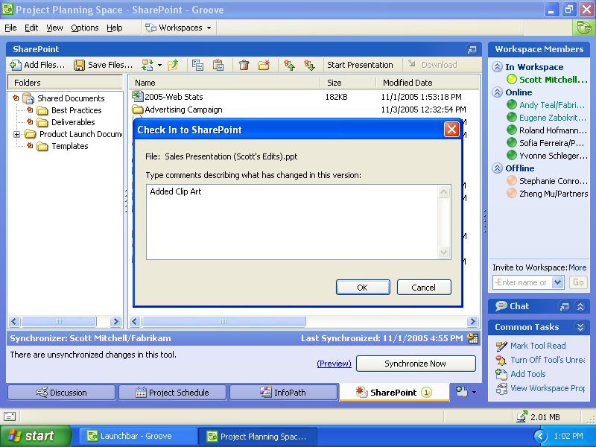
Figure 3. Synchronizing Windows SharePoint Services files to Office Groove 2007
- Office Groove 2007’s decentralized architecture means that only document and workspace changes are pushed to other workspace members’ computers.
- Office Groove 2007’s encryption capabilities protect locally stored data as well as data transfers between workspace members.
- Only invited workspace members can access the workspace data. There is no centrally stored server copy at risk.
With Windows SharePoint Services and Office Groove 2007, Microsoft empowers you to create the type of workspace that is best for your needs, and then connects you to the people, processes, and information you need to be successful.

Unified Communications
Ironically, with all the available communications technology, finding and communicating with the people you need is more difficult than ever before:
- You want to schedule a meeting with your colleague but do not have permission to view his or her calendar.
- You place a call to your colleague to ask about an available meeting time and end up in voicemail.
- You leave a message and then call the person’s mobile phone.
- You leave another message and then send an e-mail message repeating the request of the two voice messages.
- You go to a customer meeting and put your mobile phone in silent mode moments before your colleague returns your call.
- After the meeting, you check your voicemail and learn that your colleague has e-mailed you a list of available meeting times. Unfortunately, your computer is at the office and you won’t be back there until later in the afternoon.
The organization, language, and location might be different, but the scenario is the same. How do you find and communicate with the people you need in the right way at the right time? Consider the number of available communication methods and devices:
- Desktop telephones
- E-mail applications
- Fax machines
- Mobile telephones
- Multi-function devices such as Pocket PCs and Smartphones
- Instant-messaging applications
- Audio- and video-conferencing utilities
- Online meeting services
How many of these applications, services, and devices do you use in any one business conversation or business issue? How many have access to the same contact information? How many share a similar user interface?
Microsoft’s communication and collaboration platform unifies the communication methods and devices that you use on a daily basis.

Platform Basics—Office Outlook 2007 and Microsoft Exchange Server 2007
Office Outlook 2007(available in Microsoft Office Basic 2007, Office Enterprise 2007, Office Standard 2007, and Office Professional Plus 2007) is a key communication and collaboration enabler.
As an e-mail application, Office Outlook 2007 helps you find, organize, and take action on increasing amounts of e-mail. Through integration with Exchange Server 2007’s built-in anti-spam and anti-phishing capabilities, Office Outlook 2007 provides a safer and more controlled e-mail environment, protecting you from unsolicited and malicious e-mail.
As a collaboration application, Office Outlook 2007, with Exchange Server 2007(a member of the Microsoft Windows Server System™), unifies communications in several ways.
Office Outlook 2007 and Exchange Server 2007 deliver unified messaging:
- Exchange Server 2007 Unified Messaging delivers e-mails, voicemails, and faxes directly to your Office Outlook 2007 Inbox.
- You spend less time switching between your computer and desktop telephone and walking back and forth to the fax machine.
- Unified Messaging eliminates the need for a standalone voicemail system.
- Unified Messaging builds on existing Microsoft Active Directory® directory service investments.
- Exchange Server 2007 Outlook Voice Access enables you to listen to your e-mail, calendar items, tasks, and contacts using text-to-speech technology from any telephone. You can reply or forward items, call a contact, or search the Global Address Book for someone to call.
Office Outlook 2007 and Exchange Server 2007 provide enhanced calendaring:
- Office Outlook 2007 and Exchange Server 2007 enable you to connect with other people faster and more efficiently.
- Exchange Server 2007 Scheduling Assistant analyzes attendee information in your Office Outlook 2007 meeting request and proposes the best time and location for the meeting.
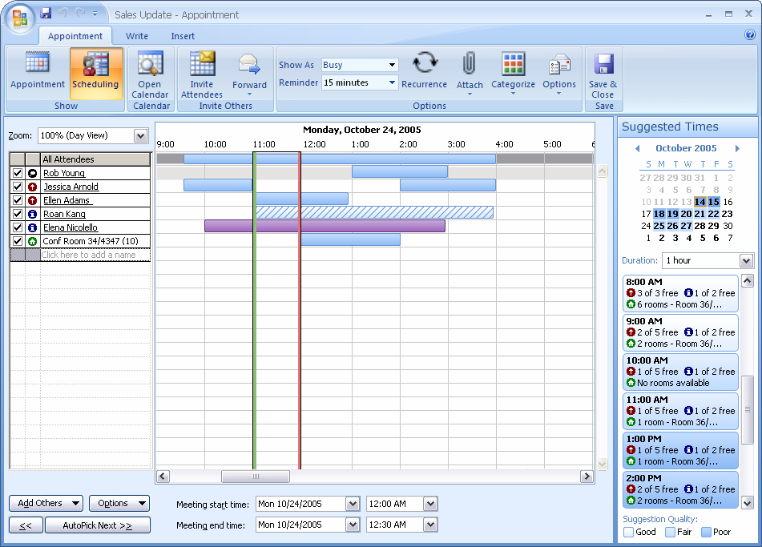
Figure 4. Scheduling meetings in Office Outlook 2007 is easier with Exchange Server 2007 Scheduling Assistant
- You can use Exchange Server 2007 Resource Booking Attendant to browse and reserve rooms and equipment separately from individuals. Resource owners can define policies to automatically accept or decline resource requests and can create custom responses for each resource.
- With Exchange Server 2007, you can use the Out of Office Assistant to schedule when your out-of-office period begins and ends. You can also turn your Out of Office message on or off from your Microsoft Windows Mobile® device or by using Outlook Voice Access. If enabled by IT, you can send a separate Out of Office message to recipients outside your organization.
- Improved management of free/busy information gives you more control over who can view personal calendar information.
- Office Outlook 2007-generated sharing requests encourage and facilitate the sharing of calendars and other non-mail Outlook folders.
- Calendar snapshots deliver an HTML snapshot of your schedule to a colleague’s Inbox.
- Microsoft Office Online Internet calendars allow you to securely share your Office Outlook 2007 calendar with colleagues outside the organization.
Office Outlook 2007 and Exchange Server 2007 improve mobile access:
- You can connect Windows SharePoint Services lists and libraries to Office Outlook 2007 for centralized access and management of shared calendars, contacts, tasks, and documents. You can edit documents contained in connected libraries offline and synchronize them back to the workspace when a connection is available.
- Exchange Server 2007 Cached Exchange Mode enables you to read and respond to e-mail when disconnected from the network.
- Exchange Server 2007 Outlook Anywhere allows you to synchronize your Office Outlook 2007 mailbox over the Internet without a virtual private network (VPN) connection. Similarly, Exchange Server 2007 LinkAccess allows you to open links to files stored in Windows SharePoint Services document libraries without a VPN connection.
- You can use Exchange Server 2007 and Microsoft Office Outlook Web Access (OWA) to access your e-mail, calendar, contacts, and tasks from the Web browser of any Internet-connected computer. OWA features a rich interface similar to that of Office Outlook 2007. You can create and send new e-mails and meeting requests, use categories and flags, search your Inbox and the Global Address Book, access SharePoint documents without a VPN connection, receive faxes and listen to voicemail, and more. Users running older versions of Microsoft Internet Explorer® or other browsers, such as Safari and Firefox, can use the OWA Light version to read and send e-mail and other items.
- Exchange Server 2007 Exchange ActiveSync (Direct Push) Technology securely delivers e-mail, calendar items, contacts, and tasks to a Windows Mobile device as soon as the server receives them. You also receive incoming faxes and voicemails on your device. Exchange Server 2007 also supports over-the-air search of server-based information from your device, as well as the mobile delivery of Information Rights Management–protected e-mail.

Solution Extenders—Office Communicator 2007 and Microsoft Office Live Meeting
Whereas Office Outlook 2007 and Exchange Server 2007 provide the basic infrastructure requirements for unifying communications, additional components of the Microsoft communication and collaboration platform, such as Office Communicator 2007 and Office Live Meeting, can extend these capabilities in new directions.
As the client for Office Communications Server 2007, Office Communicator 2007 unifies instant messaging, voice, and video communications into a single application.
Office Communicator 2007 is tightly integrated with other components of the 2007 Office system, (including Office Outlook 2007, Microsoft Office OneNote® 2007, and Office Groove 2007, Windows SharePoint Services, and Office SharePoint Server 2007).
- Office Communicator 2007 displays the real-time presence information of online contacts. You can see when a colleague is online and then contact that person through instant messaging, voice, or video conversation using Voice over Internet Protocol (VOIP), a call over a desktop telephone, e-mail, an Office Live Meeting 2007 session, and more.
- Office Communicator 2007 displays presence information for contacts on public instant messaging services such as MSN, AOL, or Yahoo!, as well as other organizations running Office Communications Server 2007.
- You can elevate existing conversations into application-sharing sessions, allowing real-time document viewing and editing between disparate locations.
- Remote access to presence information and instant messaging capabilities is available through Microsoft Office Communicator Web Access and Microsoft Office Communicator Mobile.
As a Web-conferencing service, Office Live Meeting 2007 allows colleagues, partners, and customers with a computer and an Internet connection to meet and collaborate online.
Office Live Meeting 2007 is tightly integrated with Office Outlook 2007 and the other 2007 Office system applications.
- You can turn any Office Outlook 2007 meeting request into an Office Live Meeting 2007 request.
- You can start spontaneous Office Live Meeting 2007 sessions directly from Office Outlook 2007 or Microsoft Office Word 2007, Office Excel® 2007, or Office PowerPoint® 2007.
- Office Live Meeting 2007 enables real-time application sharing between meeting participants.
By unifying communications with Office Outlook 2007, Exchange Server 2007, Office Communicator 2007, and Office Live Meeting, Microsoft is enabling faster, more productive connections between workers. These connections accelerate the exchange of ideas and knowledge, facilitate issue resolution, and make it easier to work together.

Connected People, Processes, and Information
A recent study by Accenture (a global management consulting and technology services company) estimates that the amount of content created over the next two years will surpass all the content created since man first appeared on the earth. Ninety-three percent of this new content will be created electronically.
If Accenture’s prediction turns out to be only half true, there will still be centuries upon centuries’ worth of content for workers to sift through.
How will you find the information you need to be productive? What processes will be in place for routing and archiving these vast amounts of data?
What about people? As companies grow and disperse employees around their local geographies and beyond, how can you stay connected to the people that affect your job? How will you discover new colleagues who can offer different perspectives or help resolve future problems?
A corporate portal combines organizational information, document storage, and collaborative workspaces into a single resource, accessible through a centralized portal interface.
- You can use a corporate portal to search for documents and information relevant to your job.
- You can create a personal site on the portal for managing content and developing a social network of colleagues with related roles, interests, or documents.
- You can improve business processes through the integration of electronic forms and easy-to-use document workflows.

Platform Basics—Office SharePoint Server 2007
Office SharePoint Server 2007 extends the capabilities of Windows SharePoint Services into an enterprise-scale solution for document and process management, improved business insight, and portal-centric collaboration.
Office SharePoint Server 2007 centralizes document storage, access, and management under a unified portal interface:
- Enterprise Search allows you to find the people, documents, data, and Web pages you need, no matter where they are in the portal structure.
- Knowledge-management tools help you develop internal and external social networks for faster connections and more efficient sharing of information.
Office SharePoint Server 2007 delivers business insight to each user:
- You can use the integrated Excel Services in Office SharePoint Server 2007 to publish Office Excel 2007 spreadsheets to Windows SharePoint Services sites and workspaces. You decide how much to share and the level of interactivity available to other users. Visitors with permission can view and manipulate the spreadsheet data within their Web browser.
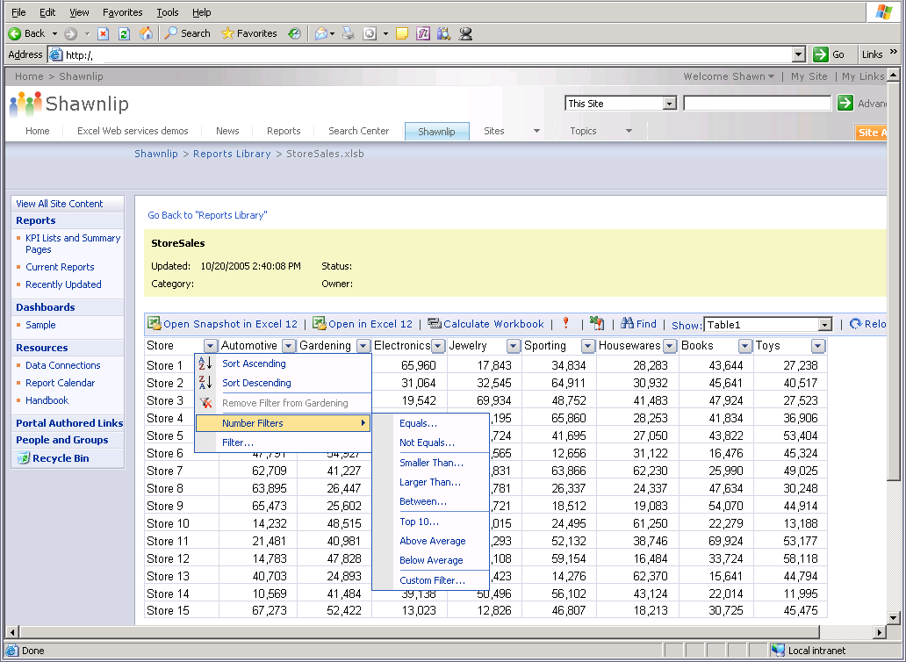
Figure 5. Interactive Office Excel 2007 spreadsheet rendered by Excel Services
- You can use Data Connection Libraries to store connection files others can use to easily connect to necessary data sources.
- You can create customizable online dashboards that display Key Performance Indicators (KPIs), Office Excel 2007 spreadsheets, and Microsoft SQL Server™ Reporting Services reports on one page.
Office SharePoint Server 2007 streamlines forms-driven business processes:
- You can use the integrated Microsoft Office Forms Server 2007 to deploy Microsoft Office InfoPath® 2007 forms to the browser. These browser-based forms do not require a local installation of Office InfoPath 2007 to complete and can be deployed beyond the corporate firewall for information gathering outside of the organization.
- You can integrate Office InfoPath 2007 forms with the Windows SharePoint Services workflow framework to automate routing, notification, and archiving.
- You can store and manage Office InfoPath 2007 forms in a SharePoint forms library, ensuring information submitted from Office InfoPath 2007 client forms and browser-based forms resides in the same place.
Office SharePoint Server 2007 combines document storage with document management capabilities:
- You can initiate an out-of-the-box workflow to automatically route documents for approval or review. Workflows reduce the amount of time you would otherwise spend sending the document to a colleague and then following up to see if the assigned task was completed. Workflow participants receive workflow notifications in their e-mail Inbox with the option to approve, reject, reassign, or request changes to the workflow document. Workflow progress is viewable from the workspace, so you always know the status of the document. You can customize these out-of-the-box workflows for a specific scenario. Developers can use the built-in workflow infrastructure to create custom workflows that address other document management processes.
- Integrated document lifecycle features ensure that document content meets internal policy and external regulation guidelines. You can define specific information management policies that govern how a document is archived, what document activities should be audited or tracked, and how long that document should exist on the workspace.
Office SharePoint Server 2007 empowers each person to create his or her personal Web site:
- You can use the portal to quickly create and configure a My Site personal Web site.
- You can use your My Site for personal document storage and management, as well as make shared documents available to others.
- My Sites build social networks by presenting information about related colleagues and managers, group and distribution list (DL) memberships, and documents in progress.
By connecting people, processes, and information, Office SharePoint Server 2007 helps you quickly find the colleagues and documents you need to get your job done.

A Complete Solution
Through collaborative workspaces, unified communications, and connected people, processes, and information, Microsoft empowers you to succeed in the new world of work.
This empowerment should not be interpreted as a decrease in information control. What happens before and after a document is shared is equally important.
The Microsoft technology set includes features you can use to prepare a document for sharing with colleagues or customers.
- You can apply editing and formatting restrictions to your document.
- You can inspect documents for hidden text, revisions, comments, and other personal information, and then remove this information from the document.
- You can apply Information Rights Management protections to prevent the unauthorized printing, copying, or distribution of sensitive content.
Microsoft has made similar investments in document lifecycle and records management.
- E-mail and document content can be archived, audited, and deleted, based on information-management policies you define.
- You can create document centers and records repositories to store and manage enterprise-wide documents and records.
Microsoft is committed to delivering on this comprehensive vision.
Many of these communication and collaboration features are included in the 2007 Office system. Others are made possible by Microsoft server infrastructure products such as Windows Server 2003 and Exchange Server 2007.
Regardless of where individual functionality resides, you can be confident in the integrated capabilities of the Microsoft communication and collaboration platform and the solutions it delivers.

Benefits of the Microsoft Communication and Collaboration Platform
The Microsoft communication and collaboration platform offers integrated, familiar, and easy-to-use applications that simplify how you work with others. These applications are designed to be people-ready.
By empowering you with the tools you need to control when, where, and how to collaborate, an investment in the Microsoft communication and collaboration platform is a direct investment in the people an organization depends on.
Once deployed, the Microsoft communication and collaboration platform delivers a number of immediate benefits.

Enable Dispersed Teams to Work Across Organizations
The Microsoft communication and collaboration platform transcends geographical and organizational boundaries.
- You can collaborate without worrying about physical location or network connectivity.
- You can initiate spontaneous collaboration scenarios or take advantage of enhanced calendaring for more structured engagements.
- You can host and participate in interactive online meetings across town, around your region, or even around the world.
- Integrated task functionality offers centralized access to Office Outlook 2007, Office OneNote 2007, Microsoft Office Project 2007, and Windows SharePoint Services tasks, simplifying basic project management.
- The ability to share general or detailed calendar information broadly or with specific people encourages confident collaboration within existing hierarchical boundaries.
- Collaborative workspaces can scale to meet the unique needs of the situation or people involved.
- A built-in compatibility checker, free file converters, and support for legacy file formats help transcend technological boundaries and effectively share documents and information with people running earlier versions of Microsoft Office.
- The native Office Open XML Formats are as much as 75 percent smaller than previous binary-based file formats, delivering improved damage recovery and inherently safer documents. As an XML-based format, Office Open XML Formats documents can communicate and exchange data with other Microsoft Office applications and XML-capable enterprise business systems.

Keep Teams Informed, Accessible, and Accountable
The Microsoft communication and collaboration platform ensures that you have access to the information, people, and processes you need to be successful.
- Finding related people and documents on a corporate portal is easy using enterprise search functionality.
- Integrated presence information in e-mail, applications, and workspaces informs you of colleagues’ availability and provides options for quick connections through instant messaging, e-mail, or telephone.
- You can use alerts and RSS subscriptions to keep track of changes to collaborative workspaces and workspace documents.
- You can connect Windows SharePoint Services document libraries to Office Outlook 2007, edit the shared documents offline, and then synchronize them back to the workspace.
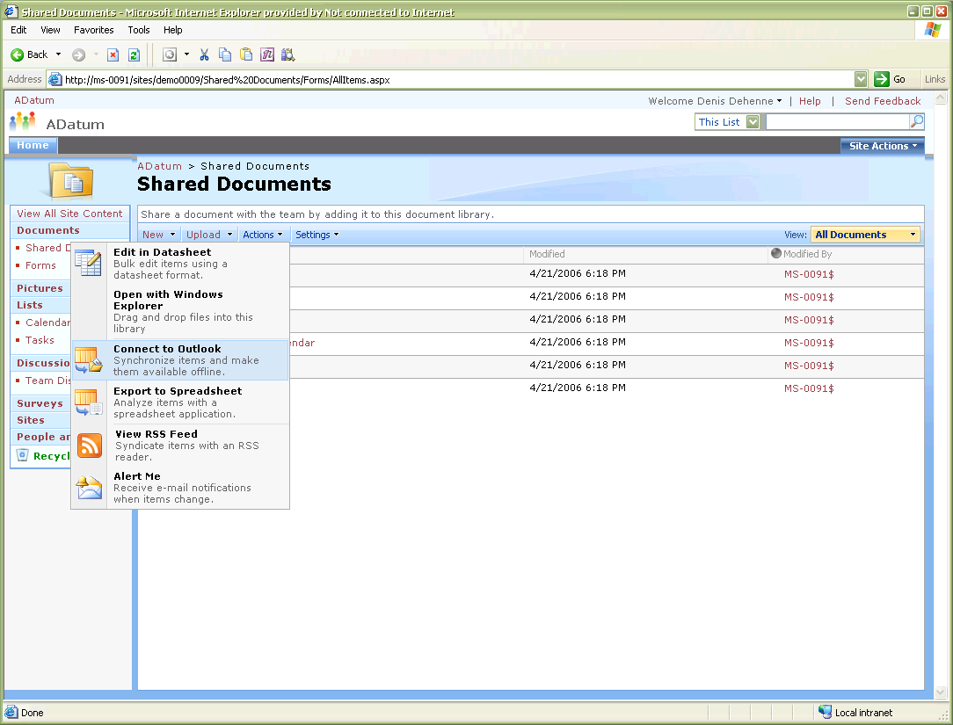
Figure 6. Connect a Windows SharePoint Services document library to Office Outlook 2007
- You can use Exchange Server 2007 LinkAccess to open files stored in Windows SharePoint Services document libraries without establishing a VPN connection.
- You can use Exchange Server 2007 WebReady Document Viewing to view Microsoft Office Word, Excel, and PowerPoint and Adobe PDF OWA attachments, even when the necessary application is not installed on the local machine.
- You can count on a consistent e-mail experience whether you are using your computer, an Internet kiosk, or a mobile device.
- Unified communications reduce the number of devices you use to connect with others.

Create Content, Prepare and Share Information, and Capture Community Knowledge
Because the Microsoft communication and collaboration platform is built on the 2007 Office system, you have access to the familiar, easy-to-use productivity applications you use every day.
- The redesigned user interface facilitates easier discovery of the full range of available functionality, allowing workers of all skill levels to create more professional-looking documents in less time.
- Visual, results-oriented commands help new and general users adapt quickly to the new structure, while power users take advantage of advanced dialog boxes and continued support for keyboard shortcuts.
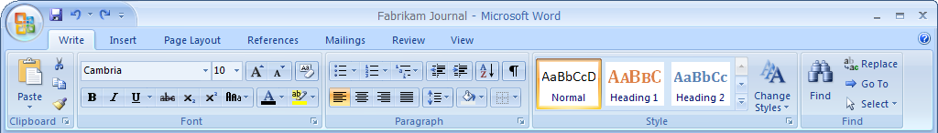
Figure 7. The Ribbon in Office Word 2007
- You can use the same application for content creation, to prepare documents for sharing, and to create a workspace for document collaboration. You decide how to share your information and who to share it with.
- In addition to document storage and editing capabilities, workspaces facilitate workgroup communications and knowledge sharing through discussion forums, team surveys, blogs, Wikis, and more.
- Office SharePoint Server 2007 personal My Sites provide you with your own location for storing documents, sharing information, and building a social network of relevant business contacts.
- Multiple communication options and offline editing capabilities provide you with the flexibility to collaborate at a time that is convenient for you.

Empower Users While Protecting Information and Controlling Data Integrity
The Microsoft communication and collaboration platform includes tools and features designed to protect and preserve the integrity of shared files.
- You can inspect documents for hidden or personally identifiable information and permanently remove these components before sharing.
- Digital signatures and Information Rights Management protections help ensure files are not compromised when they leave your direct control.
- The self-service nature of Windows SharePoint Services 3.0 workspaces provides a flexible collaboration solution to end users, while keeping IT in control of the infrastructure and policy management.
- The check-out and check-in capability of Windows SharePoint Services document libraries prevents many of the conflicts associated with the simultaneous editing of shared documents.
- You can track each version of a particular document; and even restore older versions over current versions.
- Information and records management policies in Office SharePoint Server 2007 ensure that document archiving, auditing, and retention adhere to internal or regulation guidelines.
- Exchange Server 2007 supports compliance and legal discovery needs through content filtering, archiving and encryption (on premise or hosted), allowing for more granular policy application. Exchange Server 2007 supports Information Rights Management protections based on subject, content, or sender/recipient.

Integrate Collaboration in Vertical and Horizontal Processes and Applications
Deeper integration of application features help you work seamlessly across applications.
- Creating a chart or graph in one application and copying it to another application is easier with the 2007 Office system’s shared charting engine.
- Tasks created in Office Outlook 2007, Office OneNote 2007, or Windows SharePoint Services 3.0 can be tracked and managed from one place in Office Outlook 2007.
- Windows SharePoint Services 3.0 Project Tasks can be viewed as a Gantt chart, providing team members a visual way to track team dates and tasks.
You can extend communication and collaboration through the automation of forms-driven business processes with Office InfoPath 2007. Unifying forms-driven processes with a dynamic XML-based forms application such as Office InfoPath 2007 makes form completion easier and the data collected usable by other XML-capable systems.
Existing paper-based forms created in Office Word 2007 or Office Excel 2007 can easily be
- Converted to Office InfoPath 2007.
- Checked for errors.
- Deployed in an Office Outlook 2007 e-mail message, Web browser, or Windows SharePoint Services forms library.
The Microsoft communication and collaboration platform also provides a powerful foundation for building custom collaboration-ready processes and applications.
- Pre-built, customizable Application Templates for Windows SharePoint Services address a wide variety of vertical and horizontal business scenarios. These scenarios include Human Resources Recruiting, Expense Reimbursement, Legal Document Review, and more.
- Office SharePoint Server 2007 extends Windows SharePoint Services’ workflow structure into easy-to-use document review and approval workflow processes.
- Workflows can also be designed and integrated into custom Windows SharePoint Services applications.
- Applications built in Microsoft Office Access 2007 can be moved to a Windows SharePoint Services 3.0 workspace with one click. Workspace members with appropriate permissions can view, add, or delete the application information directly on the workspace. Office Access 2007 takes advantage of the Windows SharePoint Services 3.0 workflow support for building collaboration-ready applications. SharePoint lists can be opened and edited with Office Access 2007 and integrated into Office Access 2007 tracking applications.
- Developers and site owners can use Office SharePoint Designer 2007 to customize sites, create reporting, and build application templates without coding. Office SharePoint Designer 2007 can also be used to create and configure workflows using the built-in workflow framework in Windows SharePoint Services 3.0.

Impact on Technology Fundamentals
Microsoft believes an integrated communication and collaboration platform should be easy for you to use and easy for your IT counterparts to set up, manage, and secure.
The Microsoft communication and collaboration platform offers a number of direct IT benefits.

Improved Management and Infrastructure
The Microsoft communication and collaboration platform scales to meet the needs of any organization.
- The Exchange Management Console simplifies server administration through an enhanced graphical interface. The Exchange Management Shell offers command line access for automating common tasks.
- Exchange Server 2007’s 64-bit architecture lowers per-mailbox storage costs and increases the number of mailboxes that each server can handle.
- By combining e-mail and voicemail into a single infrastructure, Exchange Server 2007 Unified Messaging eliminates the need for a costly and complex standalone voicemail system.
- Windows SharePoint Services uses the operating system and database services of Windows Server 2003 and SQL Server 2005 to scale the collaborative workspace experience from small businesses to worldwide enterprises.
- Windows SharePoint Services includes a Microsoft Operations Manager (MOM) package to help administrators manage and monitor single-server and server-farm configurations.
- Redesigned site-administration Web pages facilitate easier management of individual sites, workspaces, and applications.

Simplified Setups
Initial setup and deployment, as well as migration and upgrade processes, are also made easier by the Microsoft communication and collaboration platform.
- Exchange Server 2007 can be deployed as one of five modular server roles, allowing administrators to choose the best Exchange Server configuration for their situation and allowing for easier scaling out of systems.
- Exchange Server 2007 automatically configures Office Outlook 2007 clients on the network, reducing laborer confusion and resulting support center involvement.
- Windows SharePoint Services supports side-by-side upgrades, allowing administrators to perform gradual upgrades of large, complex environments.
- Multiple migration modes ease the transition between development, test, and production.

Enhanced Mobile Access
The Microsoft communication and collaboration platform helps IT support and secure pervasive connectivity for mobile workers.
- Exchange Server 2007 provides secure connections to Office Outlook 2007 and Windows SharePoint Services information without a costly VPN connection.
- Exchange Server 2007 OWA provides secure access to e-mail, calendar items, contacts, and tasks from any computer with a Web browser and Internet connection.
- Exchange ActiveSync ensures that information stored on mobile devices is updated as items arrive on the server.
- E-mail and documents protected with Information Rights Management policies can be viewed on mobile devices without separate server validation.
- Exchange Server 2007’s mobile device support enables administrators to define and enforce device policies. Administrators can allow/disallow the receipt of attachments on mobile devices, require PIN identification, and perform a device wipe if a particular device is lost or stolen.

Better Protection
The Microsoft communication and collaboration platform helps IT protect you and the organization you work for from outside attack or compromise.
- Exchange Server 2007’s integrated anti-spam and anti-phishing features help insulate you from malicious e-mail content.
- Exchange Hosted Filtering and Forefront Security for Exchange Server offer a tiered approach to stopping viruses and malware.
- Administrators can use a Windows SharePoint Services virtual server to configure multiple secure authentication zones (for example, intranet and extranet).
- Access controls in Windows SharePoint Services sites and workspaces extend down to the file, folder, and list levels.

Increased Customization
The Microsoft communication and collaboration platform offers extensible and easily-customized solutions.
- Exchange Web Services in Exchange Server 2007 provide developers with a powerful new application programming interface (API) for integrating Exchange Server information into line-of-business processes and applications.
- OWA Web Parts can easily be added to Windows SharePoint Services sites, workspaces, and applications.
- Pre-built Application Templates provide a customizable baseline solution for many vertical and horizontal scenarios.
- Site administrators can use Office SharePoint Designer 2007 to create and deploy custom Windows SharePoint Services applications and extend the functionality of existing Application Templates.

Conclusion
The new world of work is here. Businesses around the world already feel the impact of a dispersed workforce, pervasive connectivity with a persistent flow of information, and the watchful eyes of shareholders and government regulators.
In such an environment, business agility is intrinsically linked to people agility—ensuring that you have the tools you need to effectively communicate and collaborate when, how, and where you need to do.
Communication and collaboration through technology adds value to a work force by enabling people to work together more effectively. A more collaborative business is key to greater success. Technology does not replace people, but rather adds value to what people are already achieving and helps extend their capabilities at work.
Microsoft provides the education, tools, and ecosystem to help small-to-midsized businesses throughout the world achieve this reality. Because of the integration and incremental value-add delivered by each component of the Microsoft communication and collaboration platform, businesses can adopt all or part of the platform depending on cost and available resources. In this way, the Microsoft communication and collaboration platform offers a flexible solution set to businesses of all types.
Microsoft believes in the people-ready business. By empowering you to create and manage your own collaborative workspaces, unifying communications, and connecting you to the people, processes, and information you need to be successful, the Microsoft communication and collaboration platform helps you turn the new world of work into a new world of opportunity.

For More Information
Please refer to the following resources for more information on the topics covered in this document:
- The 2007 Microsoft Office System Preview Site at www.microsoft.com/office/preview
- The 2007 Microsoft Office System Frequently Asked Questions Page at www.microsoft.com/office/preview/faq.mspx
- The 2007 Microsoft Office Release System Requirements Page at www.microsoft.com/office/preview/beta/sysreq.mspx
- The Microsoft Office Open XML Formats Page at www.microsoft.com/office/preview/itpro/fileoverview.mspx
- The Microsoft Office Outlook 2007 Preview Site at www.microsoft.com/office/preview/programs/outlook/highlights.mspx
- The Microsoft Exchange Server 2007 Preview Site at www.microsoft.com/exchange/preview
- The Microsoft Windows SharePoint Services 3.0 Preview Site at www.microsoft.com/office/preview/technologies/sharepointtechnology/highlights.mspx
- The Microsoft Office SharePoint Server 2007 Preview Site at www.microsoft.com/office/preview/servers/sharepointserver/highlights.mspx
- The Microsoft Office SharePoint Designer 2007 Preview Site at www.microsoft.com/office/preview/programs/designer/highlights.mspx
- The Microsoft Office Communicator 2007 Preview Site at www.microsoft.com/office/preview/programs/communicator/highlights.mspx
- The Microsoft Office Groove 2007 Preview Site at www.microsoft.com/office/preview/programs/groove/highlights.mspx
- The Microsoft Office Live Meeting Site at www.microsoft.com/office/livemeeting/
- The 2007 Microsoft Office System for Developers Site at www.microsoft.com/office/preview/developer/highlights.mspx
- The 2007 Microsoft Office System for IT Professionals at www.microsoft.com/office/preview/itpro/highlights.mspx
- The Microsoft Office Beta Community at www.microsoft.com/office/preview/community/overview.mspx
- The 2007 Microsoft Office System Worldwide Page at www.microsoft.com/office/preview/worldwide.mspx
- The Microsoft Collaboration Site at www.microsoft.com/collaboration
- The Microsoft Office Marketplace at office.microsoft.com/marketplace
- Download Application Templates for Windows SharePoint Services at www.microsoft.com/technet/windowsserver/sharepoint/wssapps/default.mspx

