Microsoft® Business Solutions−Axapta®
Security System
Microsoft Business Solutions−Axapta configuration and security keys are used to configure Microsoft Axapta and control user access to different features.

Key Benefits:
- View only accessible features for an as-simple-as-possible experience
- Grant different rights to each company’s accounts in the same database
- Grant access on a data level using Record Level security

There are many issues to consider when investing in extensive software for your business. Will the software be able to grow with my business? If we do not need all the features right from the start, will we be able to activate them later on? How easy is it to define which users have access to which parts of the system?
Microsoft Business Solutions–Axapta models to the needs of your business. The configuration and security keys enable you to turn on new functionality as your business needs expand and to determine user access for high security and protection of your data.

Configuration keys
The configuration keys in Microsoft Axapta are your tools to control the functionalities and features in the system. There are close to 100 configuration keys with each one thoroughly documented to make it clear which functionality is affected when you de-activate it.
For example, a company that buys the Trade module license code gets the standard Trade functionality. If or when they do business with other countries, it’s quick and straightforward to enable the Foreign trade configuration key.
Configuration keys ensure that your Microsoft Axapta solution is not cluttered with functionality you don’t use. So you get a user interface that is easy to use, quicker data communication and less strain on your network. The de-activated functionality is hidden but not deleted or removed from the system.
When you install Microsoft Axapta, you’ll get the simplest possible start-up, whether you use one module or several. If and when you need extra features, these can safely be enabled later. A specific setup can still be exported and imported, or, if necessary, reset to standard, which is the minimized system.

Security keys
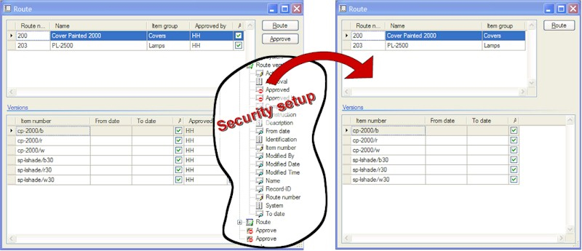
Security setup
With security keys, you can determine the functionalities that different users have access to. As with the configuration keys, the restrictions you set up for a specific user will be reflected throughout the entire application. You can deny or grant users access to entire modules or even to specific forms and fields.
You can give one user rights to set up a sales order and view stock in trade but no access to edit or view stock postings, whereas another user can have full access to stock postings but can only view sales orders.
The security key structure resembles the Main menu structure. To make it easier to set up the details under each security keys, it’s possible to drill down in the functionality. The drill-down will display the tables, fields, form controls and other menu items that are accessible from the menu item giving you the complete picture of the functionality you grant access too.
The functionality that a user does not have access to will visually disappear from the interface and all related fields will be hidden from the users. If and when you choose to re-activate certain functionality, all the related fields will become visible again.
When you determine user access to menu items and tables, there are five different categories to facilitate different levels of user access:
- No access – the user cannot see these items
- View - the user can only view items
- Edit – the user has access to edit items
- Create – the user can create new items
- Full control – the user has full access rights to create and delete items

The different categories let you accommodate different users’ needs for access to your business’ data and at the same time you can keep modification rights to a minimum.

Record Level Security
Record Level Security is security at a more detailed and specified level. It can be used in addition to the other permission setups in Microsoft Axapta. You can set up a query for each combination of company and user group, limiting data access for the specific combination. You can specify, for example, that a certain user group only have access to see and work with customer account numbers from 1000 to 2000.

Contact your partner
To learn more about Microsoft Axapta, contact your local Microsoft Certified Business Solutions Partner. They have the expertise necessary to meet your specific business needs.

About Microsoft Business Solutions
Microsoft Business Solutions, a division of Microsoft, offers a wide range of integrated, end-to-end business applications and services designed to help small, midmarket and corporate businesses become more connected with customers, employees, partners and suppliers. Microsoft Business Solutions' applications optimize strategic business processes across financial management, analytics, human resources management, project management, customer relationship management, field service management, supply chain management, e-commerce, manufacturing and retail management. The applications are designed to provide insight to help customers achieve business success. More information about Microsoft Business Solutions can be found at www.microsoft.com/BusinessSolutions.

Address:
Microsoft Business Solutions
Frydenlunds Allé 6
2950 Vedbaek
Denmark
Tel +45 45 67 80 00
Fax +45 45 67 80 01
www.microsoft.com/BusinessSolutions

16.04.2003
© 2003 Microsoft Business Solutions ApS, Denmark. All rights reserved. Microsoft, Great Plains, Navision, FRx, *list other trademarks mentioned are either registered trademarks or trademarks of Microsoft Corporation, Great Plains Software, Inc., FRx Software Corporation, or Microsoft Business Solutions ApS or their affiliates in the United States and/or other countries. Great Plains Software, Inc., FRx Software Corporation, and Microsoft Business Solutions ApS are subsidiaries of Microsoft Corporation. The names of actual companies and products mentioned herein may be the trademarks of their respective owners. The example companies, organizations, products, domain names, email addresses, logos, people and events depicted herein are fictitious. No association with any real company, organization, product, domain name, e-mail address, logo, person, or event is intended or should be inferred.

