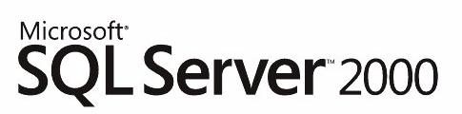

Microsoft SQL Server Migration Assistant™ for Oracle
Facilitating Database Migration
Published: March 2005
For the latest information, please see http://www.microsoft.com/sql/migration.

Contents
Introduction 1
Assessment Phase 1
Schema Conversion 3
Data Migration 5
Business Logic Conversion 5
Validation, Integration, and Performance Analysis 12
Conclusion 14

Introduction
SQL Server is the premier relational database management system on the market today. According to recent reports by IDC (see http://news.com.com/Database+sales+show+some+life/2100-1012_3-5602603.html), SQL Server is the fastest growing database on the market. Customers are adopting SQL Server in large numbers because of its low total cost of ownership, ease of management, robust security and enterprise class scalability, availability and reliability. However, many customers are still running their applications on other database such as Oracle and DB2. This is primarily because of the cost and complexity of migrating these databases to SQL Server.
To address this situation, Microsoft is offering a new product to make migration to SQL Server easier. Microsoft SQL Server Migration Assistant (SSMA) automates the process of migrating from other databases to SQL Server. This paper will explain each step of the database migration process and discuss how SSMA significantly speeds up, and reduces the cost of, every one of the steps. The initial release of SSMA addresses Oracle to Microsoft SQL Server 2000 migration.
SQL Server Migration Assistant consists of the following major components:
- Migration Analyzer — evaluates the complexity of the migration project.
- Schema & Data Migrator and SQL Converter — performs database conversion and provides a powerful IDE for cross-platform database developers.
- Migration Tester — provides automated validation of the migration process.
Migrating your application from other database systems to SQL Server includes the following phases.
- Assessment phase
- Schema conversion
- Data migration
- Business logic conversion
- Validation, integration, and performance analysis
The following sections cover each of these steps using the SQL Server Migration Assistant to show how the migration is accomplished.

Assessment Phase
When IT has determined that it would be beneficial to migrate a number of databases from Oracle to SQL Server; the first step in the migration is to assess the difficulty, time and cost of the migration. Factors that contribute directly to this are the “complexity” of the databases and of the applications that use them. While there is no formal measure of database complexity, a database will be increasingly complex and costly to migrate the more business logic objects (stored procedures, functions, triggers, packages, and so forth) it contains. Adding to the migration complexity are system function differences between the two platforms. Functions provided on one platform may not be provided on the other, or there may be syntactic or semantic differences in the implementation of common functions.
The complexity of migrating the applications to the new database also need to be assessed. Contributing to the complexity is the number of SQL requests made by the application, because all of them must be converted. More importantly, the degree to which dynamic SQL is used adds significantly to the conversion complexity, because a major code rewrite may be necessary to convert dynamic SQL queries.
The result of the migration assessment is an estimate of the amount of effort that is required to accomplish each step in the migration process, and the overall expense of the project. It should be noted that conducting a migration assessment can itself be a time consuming and costly effort. It’s not unusual for an assessment to take several months for a large migration project, and to cost tens of thousands of dollars.
Fortunately, there’s a new migration assessment tool, SSMA Migration Analyzer, which performs a deep analysis to obtain estimates of the time and effort required to migrate a database. Typically, an assessment will take less than a day to complete. The tool provides an estimate of the labor required to migrate the database manually, as well as the percentage of the database that can be converted automatically. The Migration Analyzer computes approximately 100 specific statistics that comprehensively characterizes the database. The SQL Converter typically converts more than 90 percent of the SQL code, automatically, and it has accomplished up to 99 percent automatic code conversion. In addition to the comprehensive profile of the Oracle database, the assessment report indicates the database objects that the SQL Converter can’t convert together with the specific constructs in the code that cause the problem.
The following are some of the statistics computed by the Migration Analyzer over all database objects in the source Oracle database. The statistics include:
- Total number of database objects such as procedures, functions, triggers, tables, indexes, packages, sequences, and views.
- Total number of code lines, including per-object statistics.
- Total number of SELECT, INSERT, DELETE, and UPDATE statements.
- Total number of CURSORs, RECORDs, and EXCEPTIONs.
- Total number and percentage of automatically convertible components.
- Estimated complexity of conversion.
- Estimated migration of the project length in terms of manual work hours (assuming the SSMA is NOT used).
The statistics provided by the Migration Analyzer can be saved into an external file in Excel-compliant format to enable the user to work with this data offline if they choose.
The following screen shot shows how the Migration Analyzer presents these statistics to the user:
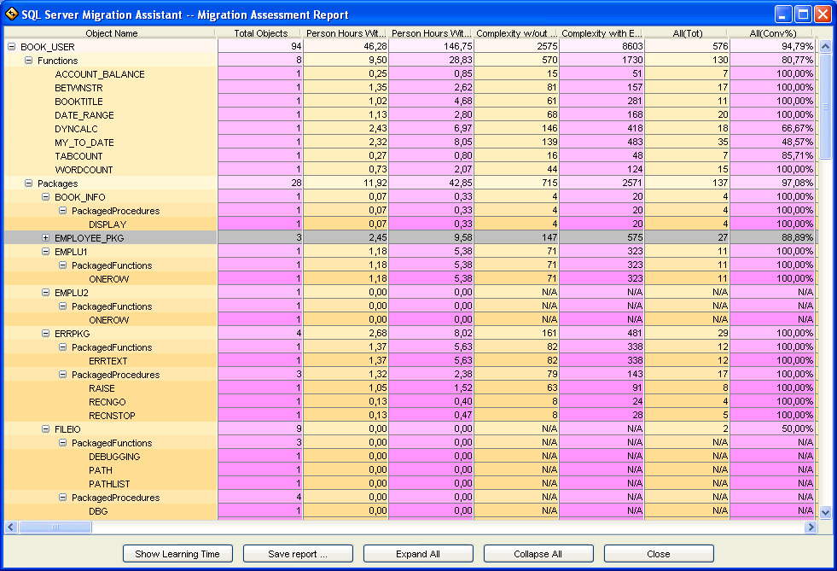

Schema Conversion

Schema and object mapping
The schema is the basis for defining the target database. In migrating from Oracle to SQL Server, the new schema can be derived in a fairly straightforward manner from the original schema. Because of feature differences between the two platforms, the mapping between the schemas may not be one to one. An example of where this arises is in dealing with long-valued attributes such as BLOBs.
Oracle supports multiple BLOB-valued attributes per table while SQL Server supports only one per table. In this case, a single table in Oracle may map to multiple tables in SQL Server. Because of such differences, migrating the data between databases may not be a simple table copy, because the new table structures may be somewhat different from the old ones. Tools to help in the manual definition of database schemas have been available for many years. Another set of tools exist to transform and physically move large databases between platforms. The Schema & Data Migrator (SSMA) automatically converts an Oracle database schema (tables, constraints, indexes) to a Microsoft SQL Server schema and physically migrates the data to populate the new database.
When the SSMA starts the user connects to:
- The source Oracle database specifying the following parameters:
Hosname, port, SID, username, password.
- The target Microsoft SQL Server (SQL SERVER) database specifying the following parameters
Hostname, port, instance name, database name, schema, username, password.
The user will be presented with the following GUI:
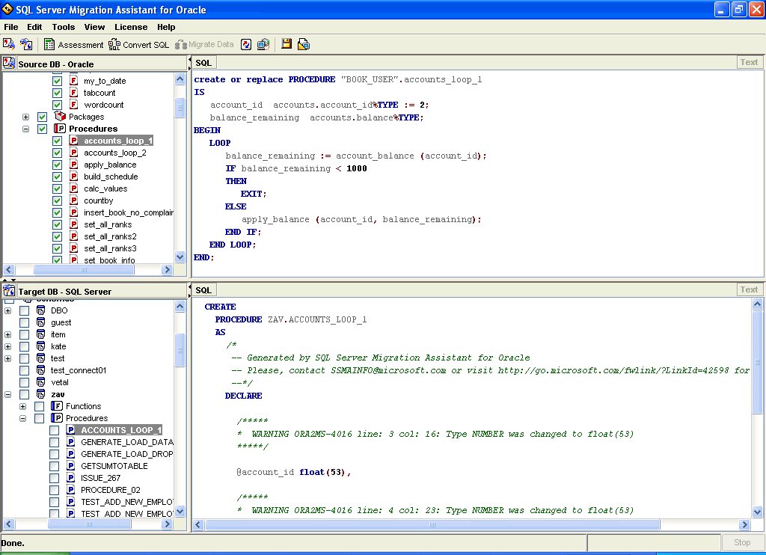
The upper half represents the source database objects, accessible through the navigation controls on the left. Similarly, the lower half presents translated objects ready for insertion into the source database. The user can select source objects, in this case from the Oracle database (default or any other schema), that are to be converted to the SQL Server schema. The converted objects can then be browsed in the lower half of the display. In addition, when the user has reviewed the generated objects and possibly made some revisions to the schema, they can generate a script for loading the generated schema into SQL Server.
For Oracle system functions and procedures that don’t have direct counterparts in SQL Server there is a database SYSDB with schema SYS, and the installation scripts will load UDFs, stored procedures, and extended stored procedures that emulate the behavior of Oracle objects. When a table is saved as a script, two files are produced: one with table and index definitions, and another one with constraints and triggers. A new column ROWID of uniqueidentifier data type with NEWID() default value will be added to each converted table to assist with trigger conversions.

Data type mapping
When converting tables, Oracle scalar data types will be converted to SQL Server data types based on the following rules:
varchar2 → varchar
char → char
number → numeric
date → datetime
long → text
nvarchar2 → nvarchar
boolean → smallint

Constraint mapping and conversion
Defaults on Oracle will be converted to defaults on SQL Server, primary keys to primary keys, unique keys to unique keys, foreign keys to foreign keys, NOT NULL constraints to NOT NULL, check constraints to check constraints. Defaults, primary keys, unique keys, and foreign keys will preserve their names.

View conversion
Views on Oracle will be converted to views on SQL Server.

Index conversion
Indexes on Oracle will be converted to indexes on SQL Server.

Sequence conversion
- Sequences on Oracle will be emulated on SQL SERVER using a table and two functions. Each sequence will be represented as a row in the SequenceEmulator table.
- SeqName.CURRVAL will be converted into a db_get_curr_sequence_value function call.
- SeqName.NEXTVAL will be converted into a db_get_next_sequence_value function call.

Data Migration
Another set of tools exist to transform and physically move large databases between platforms. The Schema & Data Migrator (SSMA) automatically converts an Oracle database schema (tables, constraints, indexes) to a Microsoft SQL Server schema and physically migrates the data to populate the new database.
After the schema is converted, the data can be migrated. It will be migrated on a per table basis one by one or all selected tables at once. Because the data migration process inserts records into the target table, it is the user’s responsibility to see that no constraints or triggers will prevent records from being inserted into the table.

Business Logic Conversion
As noted previously, the complexity of a database from a migration perspective is a function of the number of business logic objects it contains, the size of those objects, and the particular language features used to implement them. Additional complexity derives from differences in the system function libraries provided in the two platforms.
For example, Oracle’s stored procedure language, PL/SQL, has many features not supported in Transact-SQL (T-SQL), the stored procedure language of SQL Server, and even where similar features exist, the languages contain many syntactic and semantic differences. To migrate a PL/SQL object that uses a feature that has no T-SQL counterpart requires that that capability be emulated in T-SQL using the available features. Developing a good emulation can be quite subtle and time consuming. In fact many subtleties need to be addressed in the migration whether developing emulations for missing features or accounting for semantic differences in corresponding features.

SQL conversion
- Outer joins of (+) form on Oracle will be converted to ANSI-standard outer joins on SQL Server.
- Hints on Oracle will be converted to hints on SQL Server. Currently supported hints include FIRST_ROWS, INDEX (tablename indexname), APPEND, MERGE_AJ, MERGE_SJ, MERGE(tablename). Some of the Oracle hints don’t have equivalent SQL Server hints, and they will be ignored.
Example:
Oracle | Microsoft SQL Server
select /*+ first_rows index (rank_table ix_rank_table_1) */ r_id  from rank_table; | select r_id  from rank_table with (index (ix_rank_table_1))  option (fast 1)

- Boolean data type on Oracle is converted to smallint on SQL Server, using various rules.
Example:
Oracle | Microsoft SQL Server
declare  v1 boolean := true;  v2 boolean := false;  …  begin  …  v1 := (x>3) and v2;  end;; | Declare  @v1 smallint,  @v2 smallint  set @v1 = /* TRUE */ 1  set @v2 = /* FALSE */ 0  begin  set @a = case when ((@x>3) and (@v2 <> /* FALSE */ 0)) THEN /*TRUE*/ 1 ELSE /*FALSE*/ 0 end  end

Stored procedure and function conversion
Stored procedures on Oracle will be converted to stored procedures on SQL Server.
- String parameters with unspecified length will be converted to varchar(8000) and a warning will be reported.
- Numeric parameters with unspecified length and precision will be converted to numeric(38, 10) and a warning will be reported.
Functions on Oracle will be converted to user-defined functions on SQL Server.
- A function containing UPDATE/INSERT/DELETE statements will be replaced with a function and a stored procedure containing the body of the source Oracle function.
- A function containing an output parameter will be replaced with a stored procedure. There is a limited number of cases where such replacement may not be fully equivalent, and those cases should be handled manually.

Trigger conversion
Triggers will be converted to triggers based on the following rules:
- BEFORE triggers will be converted to INSTEAD OF triggers.
- AFTER triggers will be converted to AFTER triggers.
- Row-level triggers will be emulated using cursor processing.
- Multiple triggers defined on the same operation will be combined into one trigger.
Example:
Oracle | Microsoft SQL Server
create trigger tr_bi_rank_table  before insert on rank_table for each row  begin  select seq_rank_id.nextval  into :new.r_id from sys.dual;  end; | create trigger instead_of_insert_on_rank_table  on rank_table instead of insert  as  /* begin of trigger implementation */  set nocount on  /* column variables declaration */  declare  @column_new_value____1 numeric,  @column_new_value____2 varchar(50),  @column_new_value____3 numeric,  @column_new_value____4 char(1)  /* iterate for each row from inserted/deleted tables*/  declare ForEachInsertedRowTriggerCursor cursor local forward_only read_only  for select “RANK”, “RANK_NAME”, “R_ID”, “R_SN”  from inserted  open ForEachInsertedRowTriggerCursor  fetch next from ForEachInsertedRowTriggerCursor  into @column_new_value____1,@column_new_value____2, @column_new_value____3,@column_new_value____4  while @@fetch_status = 0  begin  /* Oracle trigger tr_bi_rank_table implementation: begin*/  begin  select @ column_new_value____3 = SYSDB.SYS.DB_GET_NEXT_SEQUENCE_VALUE (‘SCHEMA_NAME’, ‘SEQ_RANK_ID’)  end  /* Oracle trigger tr_bi_rank_table implementation: end*/  /* DML-operation emulation */  insert into rank_table (“RANK”, “RANK_NAME”, “R_ID”, “R_SN)” values (@column_new_value____1,@column_new_value____2, @column_new_value____3,@column_new_value____4)  fetch next from ForEachInsertedRowTriggerCursor  into @column_new_value____1,@column_new_value____2, @column_new_value____3,@column_new_value____4  end  close ForEachInsertedRowTriggerCursor  deallocate ForEachInsertedRowTriggerCursor  /* end of trigger implementation */

Package conversion
- Package functions will be converted to user-defined functions using PackageName_FunctionName naming convention.
- Package procedures will be converted to stored procedures using PackageName_ProcedureName naming convention.
- Package variables are emulated using a table and a set of functions.

System functions
System functions will be converted to either Microsoft SQL Server system functions or user-defined functions from the provided system function library.

Control statements
- IF statement will be converted to IF statement.
- IF-ELSIF… ELSIF-ELSE-END IF statements will be converted to nested IF statements.
- NULL statement will be converted to a call to SYSDB.SYS.DB_NULL_STATEMENT procedure.
Example:
Oracle | Microsoft SQL Server
declare v1 numeric;  begin  v1 := 1;  if v1 > 1 then  dbms_output.put_line (‘1>1’);  v1 := 100;  elseif v1 > 2 then  dbms_output.put_line (‘1 > 2’);  v1 := 200;  else  dbms_output.put_line (‘None’);  null;  end if;  end; | declare @v1 numeric  begin  set @v1 = 1  if (@v1 > 1)  begin  print ‘1>1’  set @v1 = 100  end  else  if (@v1 > 2)  begin  print ‘1>2’  set @v1 = 200  end  else  begin  print ‘None’  exec SYSDB.SYS.DB_NULL_STATEMENT  end  end
- CASE statement will be converted to CASE statement.
- GOTO statement will be converted to GOTO statement.

Loop statements
- LOOP statement (with EXIT or EXIT WHEN) will be converted to WHILE (1=1) statement with BREAK statement.
Example:
Oracle | Microsoft SQL Server
loop  exit when rank > max_rank;  do something;  rank := rank + 1;  end loop; | while (1 =1)  begin  if @rank > @max_rank  break  do something  set @rank = @rank + 1  end

- WHILE statement will be converted to WHILE statement.
Example:
Oracle | Microsoft SQL Server
while rank <= max_rank  loop  do something;  rank := rank + 1;  end loop; | while (@rank <= @max_rank)  begin  do something  set @rank = @rank + 1  end
- Numeric FOR loop (including optional REVERSE keyword) will be converted to WHILE statement.
Example:
Oracle | Microsoft SQL Server
for rank in 1..max_rank  loop  do something;  end loop; | declare @rank int  set @rank = 1  while (@rank <= max_rank)  begin  do something  set @rank = @rank + 1  end

Cursor conversion
- Cursors will be converted to cursors.
- Cursor attributes will be converted as follows:
  - cursor_name%NOTFOUND → (@@FETCH_STATUS = -1)
  - cursor_name%FOUND → (@@FETCH_STATUS = 0)
  - cursor_name%ISOPEN → (cursor_status (‘local’, ‘cursor_name’) = 1)
  - cursor_name%ROWCOUNT → @v_cursor_name_rowcount declared and incremented after each fetch operation
Example:
Oracle | Microsoft SQL Server
Declare  cursor rank_cur is  select rank, rank_name  from rank_table;  rank_rec rank_cur%ROWTYPE;  begin  open rank_cur;  loop  fetch rank_cur into rank_rec;  exit when rank_cur%NOTFOUND;  do something;  end loop;  close rank_cur;  end; | Declare  @v_rank_cur_rowcount int,  @rank numeric,  @rank_name varchar(50)  declare  rank_cur cursor for  select rank, rank_name  from rank_table;  begin  open rank_cur  set @v_rank_cur_rowcount = 0  while (1=1)  begin  fetch next from rank_cur  into @rank, @rank_name  set @v_rank_cur_rowcount  = @v_rank_cur_rowcount + 1  if (@@fetch_status = -1)  break  do something  end  close rank_cur  deallocate rank_cur  end
- Cursors with parameters will be converted to multiple cursors.
Example:
Oracle | Microsoft SQL Server
declare  cursor rank_cur (id number, sn char(1))  is select rank, rank_name  from rank_table  where r_id = id and r_sn = sn;  begin  open rank_cur (1, ‘c’);  open rank_cur (2, ‘d’);  end; | declare  @id numeric,  @sn char(1)  begin  set @id = 1  set @sn = ‘c’  declare  rank_cur_1 cursor for  select rank, rank_name  from rank_table  where r_id = @id and r_sn = @sn  open rank_cur_1  set @id = 2  set @sn = ‘d’  declare  rank_cur_2 cursor for  select rank, rank_name  from rank_table  where r_id = @id and r_sn = @sn  open rank_cur_2  end
- Cursor FOR loop will be converted to a cursor with local variables.
- CLOSE cursor_name will be converted to CLOSE cursor_name and DEALLOCATE cursor_name.

RETURN conversion
- RETURN statement will be converted to RETURN statement.

Comments conversion
- Comments will be converted to comments.

Variable declaration conversion
- Static variable declarations will be converted to variable declarations.
- Variable declarations including %TYPE have the column data type resolved at conversion time. For example, if a variable is declared in the following way:
var1 table1.col1%TYPE;
and the col1 in table1 has varchar2(50) data type, then it will be converted to:
var1 varchar(50)

- Variable declarations including %ROWTYPE on Oracle will be converted to a group of local variables on SQL Server.
- RECORDs on Oracle will be converted to a group of local variables on SQL Server.
Example:
Oracle | Microsoft SQL Server
create or replace procedure test_proc  (  arg_rec1 table1%ROWTYPE;  arg_rec2 table2%ROWTYPE;  )  as  type rec is record  (  col1 int;  col2 table1.c1%TYPE;  col3 varchar2(32)  );  rec1 rec;  begin  rec1 := NULL;  rec1 := arg_rec1;  rec1.col2 := arg_rec2.col1_table1;  end; | create procedure test_proc  @arg_rec1_col1_table1 numeric (38),  @arg_rec1_col2_table1 numeric (38),  @arg_rec1_col3_table1 varchar (32),  @arg_rec2_col1_table1 numeric (38),  @arg_rec2_col2_table1 numeric (38),  @arg_rec2_col3_table1 varchar (32)  as  declare  @rec1_col1 int,  @rec1_col2 numeric,  @rec1_col3 varchar (32)  begin  set @rec1_col1 = null  set @rec1_col2 = null  set @rec1_col3 = null  set @rec1_col1 = @arg_rec1_col1_table1  set @rec1_col2 = @arg_rec1_col2_table1  set @rec1_col3 = @arg_rec1_col3_table1  set @rec1_col2 = @arg_rec2_col1_table1  end

Exception conversion
Exceptions will be emulated in Transact-SQL. The emulation can be turned on or off. If it’s off, then no exception handling will happen in SQL Server. If the emulation is on, then user-defined and system exceptions are converted using IF, GOTO statements, and user-defined functions. Currently supported system exceptions include NO_DATA_FOUND and TOO_MANY_ROWS. All user exceptions are supported.

Procedure and function call conversion
- Procedure calls will be converted to procedure calls.
- Function calls will be converted to function calls.

Transaction management conversion
- BEGIN TRAN, COMMIT, and ROLLBACK statements on Oracle will be converted to the corresponding BEGIN TRAN, COMMIT, and ROLLBACK statements on SQL Server.
- Because in Oracle transactions are started automatically when a DML operation is performed, in SQL Server we will allow implicit transactions by using SET IMPLICIT_TRANSACTIONS ON statement or will use BEGIN TRAN and COMMIT TRAN.
- SAVEPOINT will be converted to SAVE TRANSACTION.

Validation, Integration, and Performance Analysis
The Zebra Visualization Tool extends the GUI to address the need for testing as well as to enable the user to follow the automated migration process. After the PL/SQL code has been converted, this tool allows the user to easily browse through the code and to find the corresponding code structures. One simply clicks the colored component in one window and they will see the corresponding converted component in the second window. The following screen shot shows how this correspondence is presented by using color-coded stripes.
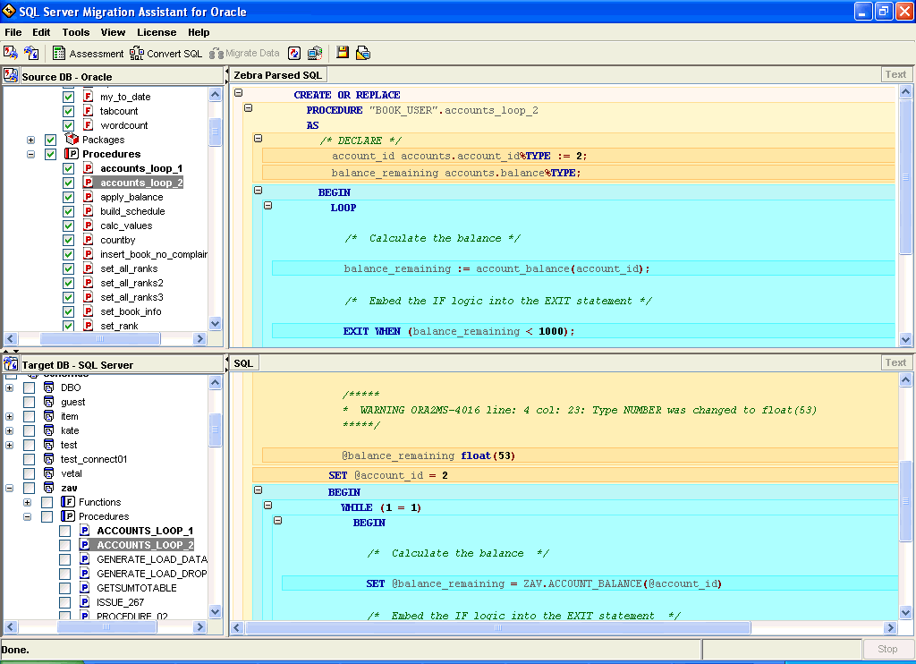

After some objects are converted, the workspace can be synchronized with both the source and the target databases. The synchronization can be configured with the following options:
- Always overwrite database objects with local workspace objects.
- Always overwrite local workspace objects with database objects.
- Automatically merge objects based on the last change date.

Conclusion
SQL Server Migration Assistant enables customers to migrate their applications from other database to SQL Server easily and in a predictable manner. Microsoft SQL Server Migration Assistant automates almost every aspect of database migration. As a result, the time, cost, and risks associated with migrating to SQL Server are greatly reduced. With SQL Server Migration Assistant customers do not have to be locked into an expensive database on an expensive anymore.

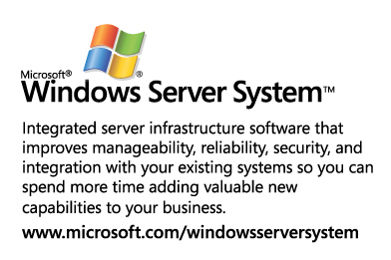

This is a preliminary document and may be changed substantially prior to final commercial release of the software described herein.
The information contained in this document represents the current view of Microsoft Corporation on the issues discussed as of the date of publication. Because Microsoft must respond to changing market conditions, it should not be interpreted to be a commitment on the part of Microsoft, and Microsoft cannot guarantee the accuracy of any information presented after the date of publication.
This white paper is for informational purposes only. MICROSOFT MAKES NO WARRANTIES, EXPRESS OR IMPLIED, IN THIS
DOCUMENT.
Complying with all applicable copyright laws is the responsibility of the user. Without limiting the rights under copyright, no part of this document may be reproduced, stored in, or introduced into a retrieval system, or transmitted in any form or by any means (electronic, mechanical, photocopying, recording, or otherwise), or for any purpose, without the express written permission of Microsoft Corporation.
Microsoft may have patents, patent applications, trademarks, copyrights, or other intellectual property rights covering subject matter in this document. Except as expressly provided in any written license agreement from Microsoft, the furnishing of this document does not give you any license to these patents, trademarks, copyrights, or other intellectual property.
© 2001 Microsoft Corporation. All rights reserved.
Microsoft, Windows, the Windows logo, Windows Server System, Visual Studio, SQL Server, and SQL Server Migration Assistant, are either registered trademarks or trademarks of Microsoft Corporation in the United States and/or other countries.
The names of actual companies and products mentioned herein may be the trademarks of their respective owners.

