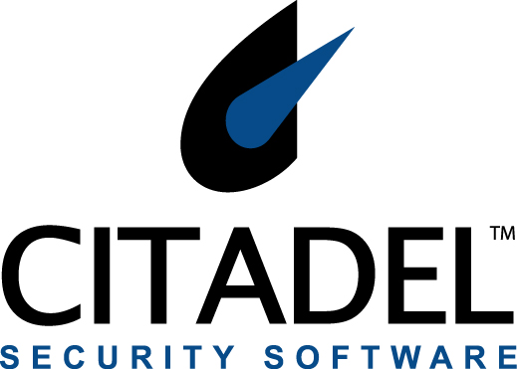

PRESS RELEASE

Contact: Laura Sellers Kim Dion
Citadel Security Software Inc. BRODEUR
(214) 234-2504 (415) 593-2262
lsellers@citadel.com kdion@brodeur.com

Citadel Security Software Announces Support for Microsoft Baseline Security Analyzer 2.0

Dallas, TX – June 7, 2005– Citadel Security Software Inc. (NASDAQ: CDSS), a leader in enterprise vulnerability management and policy enforcement solutions announced today that it will provide support for Microsoft Baseline Security Analyzer (MBSA) 2.0 as part of the Company’s ongoing commitment to provide integration with industry leading vulnerability assessment scanners. MBSA 2.0 will utilize the Windows Update Agent (WUA) infrastructure for security update scanning and offers customers an improved user experience.

Citadel is one of four security software vendors to participate in Microsoft Corp.’s beta of Microsoft Baseline Security Analyzer 2.0 and is a key supporter of Microsoft’s initiatives to deliver vulnerability assessment and remediation solutions. The MBSA 2.0 beta program is expected to be completed July, 2005. Citadel will provide support for MBSA 2.0 shortly after Microsoft announces its shipping date.

“Citadel’s Hercules is one of the premier vendor solutions that consume MBSA data,” said Mike Chan, technical product manager for Microsoft. “Microsoft is pleased to be working with Citadel to deliver vulnerability management solutions which will help customers improve their security update management process on the Windows platform.”

Citadel’s Hercules technology automates the resolution of all classes of vulnerabilities. With one of the largest library of tested vulnerability remedies across Windows and UNIX platforms and interoperability with industry leading network scanners and vulnerability assessment tools, Hercules allows users to import and aggregate data from multiple sources, review, approve and customize resolutions and systematically deploy vulnerability fixes.

“Citadel has been a Microsoft Gold Certified Partner since December, 2003 and has historically supported Microsoft’s effort to streamline the complex security update process,” said Carl Banzhof, CTO of Citadel Security Software. “We look forward to continuing to provide our current and future Microsoft customer base with an integrated solution that automates the remediation of vulnerabilities discovered by MBSA quickly and easily.”

About MBSA
The Microsoft Baseline Security Analyzer (MBSA) is a tool that allows users to scan one or more Windows-based computers for common security misconfigurations. MBSA will scan a Windows-based computer and check the operating system and other installed components, such as Microsoft Internet Information Services (IIS) and SQL Server™, for security misconfigurations and whether or not they are up-to-date with respect to recommended security updates.

About Citadel
Citadel Security Software (NASDAQ:CDSS) delivers security solutions that enable organizations to manage risk, reduce threats and enforce compliance with security policies and regulations. Citadel’s proven architecture provides a business process to manage the increasing volume, frequency and complexity of cyber security attacks. Citadel combines the world’s largest active library of remediations spanning all classes of vulnerabilities with a proven delivery methodology to dramatically streamline vulnerability management and security compliance and provide ROI from the first use. For more information, visit www.citadel.com or contact the company at (214) 520-9292.

Safe Harbor/Forward-looking Statements:
This press release may contain forward-looking statements that are intended to be subject to the safe harbor protection provided by Section 27A of the Securities Act of 1933 and Section 21E of the Securities Exchange Act of 1934. These statements relate to future events or future financial performance and involve known and unknown risks and uncertainties that may cause actual results or performance to be materially different from those indicated by any forward-looking statements. In some cases, you can identify forward-looking statements by terminology such as "forecast," "may," "will," "could," "should," "anticipate," "expect," "plan," "believe," "potential" or other similar words indicating future events or contingencies. Some of the things that could cause actual results to differ from expectations are: the economic and geopolitical environment; changes in the information technology spending trends; the uncertainty of funding of government and corporate information technology security projects; the variability of the product sales cycle, including longer sales cycles for government and large commercial contracts; changes to the company’s sales model in connection with the rollout of its new products and services and channel sales may result in decreased revenues or earnings; the uncertainty that the company's prospective deals will result in final contracts; the potential changes in the buying decision makers during a customer purchasing cycle; the complexities in scope and timing for finalization of contracts; the fluctuations in product delivery schedules; a lack of Citadel operating history; uncertainty of product development and acceptance; uncertainty of ability to compete effectively in a new market; the uncertainty of profitability and cash flow of Citadel; intellectual property rights and dependence on key personnel; economic conditions; the continued impact of terrorist attacks, global instability and potential U.S. military involvement; the competitive environment and other trends in the company's industry; the effects of inflation; changes in laws and regulations; changes in the company's business plans, including shifts to new pricing models and sales model (including channel sales) that may cause delays in licenses; interest rates and the availability of financing; liability, legal and other claims asserted against the company; labor disputes; the company's ability to attract and retain qualified personnel; and adjustments to the amounts presented in the unaudited financial tables as a result of the completion of the audit process. For a discussion of these and other risk factors, see the company's Annual Report on Form 10-KSB for the year ended December 31, 2004, and the company’s Quarterly Report on Form 10-Q for the quarter ended March 31, 2005. All of the forward-looking statements are qualified in their entirety by reference to the risk factors discussed therein. These risk factors may not be exhaustive. The company operates in a continually changing business environment, and new risk factors emerge from time to time. Management cannot predict such new risk factors, nor can it assess the impact, if any, of such new risk factors on the company's business or events described in any forward-looking statements. The company disclaims any obligation to publicly update or revise any forward-looking statements after the date of this report to conform them to actual results.
Editors Note: Citadel is a trademark and Hercules® is a registered trademark of Citadel Security Software. All other companies’ names or products mentioned in this document, if any, may be either registered trademarks or trademarks of their respective owners.

# # #

