The Windows Malicious Software Removal Tool: Progress Made, Trends Observed

June 2006

For more information, press only:
Rapid Response Team
Waggener Edstrom Worldwide
(503) 443-7070
rrt@waggeneredstrom.com

The information contained in this document represents the current view of Microsoft Corp. on the issues discussed as of the date of publication. Because Microsoft must respond to changing market conditions, it should not be interpreted to be a commitment on the part of Microsoft, and Microsoft cannot guarantee the accuracy of any information presented after the date of publication.
This document is for informational purposes only. MICROSOFT MAKES NO WARRANTIES, EXPRESS OR IMPLIED, IN THIS DOCUMENT.
© 2006 Microsoft Corp. All rights reserved.

Microsoft, Windows, Windows Live, OneCare, Windows Server, ActiveX, Excel, Windows Vista and MSN are either registered trademarks or trademarks of Microsoft Corp. in the United States and/or other countries.
The names of actual companies and products mentioned herein may be the trademarks of their respective owners.
Contents

Executive Summary 1
MSRT Overview 2
Report Background 3
Release Statistics 4
Targeted Malware Details 5
Malware Removed by the MSRT 7
Conclusions 17
Appendix 18
MSRT Background 18
Data Collection Details 19

Executive Summary
Microsoft Corp. has made significant investments over the past few years in research into malicious software (or “malware”) and in developing technology to help customers mitigate the security risk that it creates. As part of this investment, Microsoft has built a dedicated anti-malware team that is responsible for researching malicious software, spyware and other potentially unwanted software, as well as the release and maintenance of the Windows® Malicious Software Removal Tool (MSRT) and Windows Defender. The team also supplies the core anti-malware technology (including the scanning engine and malware definition updates) to Windows Live™ OneCare™, Windows Live Safety Center Beta, Microsoft® Antigen, and the upcoming release of Microsoft Forefront Client Security.

Microsoft delivered the first version of the MSRT on Jan. 13, 2005, in 24 languages to users of Windows 2000-, Windows XP- and Windows Server™ 2003-based computers. The tool is designed to help identify and remove prevalent malware from customer computers and is available at no charge to licensed Windows users. As of the writing of this report, Microsoft has shipped 15 additional enhanced versions of the tool and continues to ship a new version on the second Tuesday of each month, each adding new prevalent malware to detect and remove. Since the initial release of the MSRT, the tool has been executed approximately 2.7 billion times by at least 270 million unique computers.

This report provides an in-depth perspective on the malware landscape based on the data collected by the MSRT, and highlights the impact that the MSRT has had in reducing the impact of malware on Windows users. Key insights from the data are summarized below and are covered in greater detail in the body of the paper.

- The MSRT has removed 16 million instances of malicious software from 5.7 million unique Windows-based computers over the past 15 months. On average, the tool removes at least one instance of malware from every 311 computers it runs on.
- Forty-one of the 61 malware families targeted by the MSRT from January 2005 to February 2006 have been detected less frequently since being added to the tool, with 21 of the families experiencing decreases greater than 75 percent.
- Backdoor Trojans, which can enable an attacker to control an infected computer and steal confidential information, are a significant and tangible threat to Windows users. The MSRT has removed at least one backdoor Trojan each from approximately 3.5 million unique computers. Thus, of the 5.7 million unique computers from which the tool has removed malware, a backdoor Trojan was present in 62 percent of computers. Bots, a subcategory of backdoor Trojans that communicate through the Internet Relay Chat (IRC) network, represent a majority of the removals.
- Rootkits, which make system changes for the purpose of hiding or protecting some other, possibly malicious, components, are an emerging potential threat but have not yet reached widespread prevalence. Of the 5.7 million unique computers from which the tool has removed malware, a rootkit was present in 14 percent of the cases; this figure drops to 9 percent if WinNT/F4IRootkit, the rootkit distributed on some Sony music CDs, is excluded. In 20 percent of the cases when a rootkit was found on a computer, at least one backdoor Trojan was found as well.
- Social engineering attacks represent a significant source of malware infections. Worms that spread through e-mail, peer-to-peer networks and instant messaging clients account for 35 percent of the computers cleaned by the tool.
- The malware problem appears to be migratory in nature. Most of the computers cleaned with each release of the MSRT are computers from which the tool has never removed malware. In the March 2006 version of the MSRT, the tool removed malware from approximately 150,000 computers (20 percent of all computers cleaned) from which some malware had previously been removed by the tool in an earlier release.

MSRT Overview
The Windows Malicious Software Removal Tool (MSRT) is designed to help identify and remove prevalent malware from customers’ computers and is available at no charge to licensed Windows users. The main release mechanism of the MSRT is through Windows Update (WU), Microsoft Update (MU) and Automatic Updates (AU). Versions of the tool are also made available for download from the Microsoft Download Center and as an ActiveX® control at http://www.microsoft.com/malwareremove. The current release of the tool is capable of detecting and removing 61 distinct malware families.

In releasing and maintaining the MSRT, Microsoft has two main objectives:

- To reduce the impact of prevalent malicious software on Windows-based computers.
- To use the data collected by the MSRT to assemble a reliable set of trends on the malicious software actually affecting Windows customers today. This data has been used by the Microsoft Antimalware Team to focus development efforts and to minimize the time required to respond to malware submissions. Also, through reports such as this, other security researchers can use this data to enhance their understanding of the malware landscape and focus on the shared goal of reducing the impact of malware to the Windows user base.

The tool does not target spyware and potentially unwanted software. Windows users should download and install an up-to-date anti-spyware application to detect and remove spyware and potentially unwanted software from their computers. Windows Defender, Microsoft’s anti-spyware solution, in beta at the time of this report, is offered to genuinely licensed Windows users at no charge at http://www.microsoft.com/windowsdefender.

Also, the MSRT is not a replacement for an up-to-date anti-virus solution due to its lack of real-time protection and use of only the portion of Microsoft’s anti-virus signature database that enables it to target prevalent malicious software. However, Microsoft recommends that users who have up-to-date anti-virus software installed also run the tool as an in-depth defense measure. Such users also indirectly benefit from the MSRT, because infected users can detrimentally affect shared resources such as the Internet or a local area network.

It is highly recommended that Windows users install and maintain an up-to-date anti-virus solution offering real-time protection and a complete anti-virus signature database. Microsoft Windows Live OneCare fulfills these requirements, as do other products offered by Microsoft’s anti-virus partners, listed at http://www.microsoft.com/security/partners/antivirus.asp.

Report Background
This report provides data and insight describing ways that Microsoft, through the release of the MSRT, has been able to make progress on its release objectives over the past 15 months: reducing the amount of prevalent malicious software affecting users and obtaining valuable telemetry that functions as an essential road map for the current state of Windows malware. Additional reports that detail Microsoft’s understanding of the malware landscape will be released in the future, with greater frequency, and with data from sources in addition to the MSRT.

This report includes data up to and including the March 2006 release of the MSRT. While newer versions of the MSRT have been made available since the release of this report, it was necessary to freeze the data at an earlier point to allow for processing, verification and analysis. For a description of the data collected by the MSRT, please see the Appendix.

The data used in this report was derived by measuring infections on customer computers, as reported by the MSRT. There are many other techniques used today to measure malware prevalence. Some measure requests to a network; others track the number of e-mail messages sent as threats. However, techniques such as these monitor only the number of copies of threats being distributed by infected computers, not the number of infected computers, as one infection can generate many copies of itself. Therefore, tracking specific infections is the most accurate method of determining the prevalence of malware infection. In the case of the MSRT, the relevance of the data becomes especially significant when the scale of the number of executions is considered.

The profiles of the users of the MSRT are varied, but home users or small businesses are the most likely group of users to use the tool because of the way its mechanisms are accessed. Therefore most of the data in this report reflects this audience. However, the trends and the guidance supplied throughout are applicable to all Windows users.

This paper will refer to several malware-related terms:

- Family. A grouping of similar variants of malicious software. For example, Win32/Rbot is a malware family containing thousands of similar, yet distinct, variants.
- Variant. A specific piece of malicious software. For example, Win32/Rbot.A is a variant within the Win32/Rbot family.
- Instance, or infection. The identification of a specific malware variant on a computer. Note that one instance includes all of the components (files, registry keys, etc.) of a single variant, and that each time a malware variant is removed from a computer, it is counted as a separate instance. For example, if the tool removes Win32/Rbot.A and Win32/Rbot.B from a computer at the same time, this is counted as two infections, or instances. If, three months later, the tool removes Win32/Rbot.A again from that same computer, that is counted as an additional infection.

Release Statistics
The main delivery vehicle for the Windows MSRT is through WU/MU/AU. Through this mechanism, the MSRT is executed on hundreds of millions of computers per month worldwide, providing a strong source of threat data for analysis.

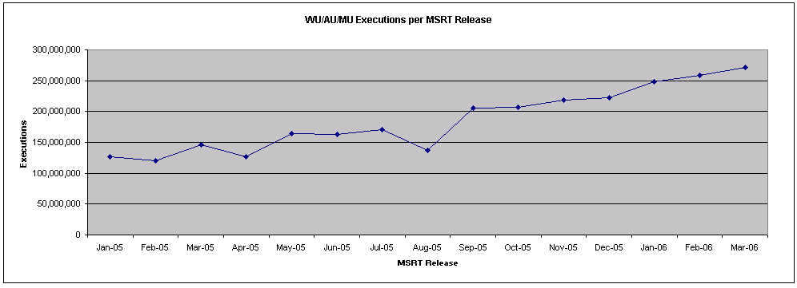
Figure 1. Executions of the MSRT through WU/AU/MU

Figure 1 illustrates the number of executions of the MSRT by unique computers for each of the 15 monthly releases from January 2005 through March 2006. Note that, in this graph, the values listed as the categories for the X-axis refer to releases of the MSRT, not calendar months. For example, the February 2006 release of the MSRT was released on Feb. 14, 2006, and was then superseded by the March 2006 release on March 14, 2006. Also note that the August out-of-band release in response to the Zotob worm is not listed in this figure because it was released only to the Microsoft Download Center and as an ActiveX control on the site http://www.microsoft.com/malwareremove, not released through WU/MU/AU.

As shown in Figure 1, with few exceptions, the executions of the MSRT have increased with each release. Particularly striking is the difference in the number of executions between the first release of the tool and the most recent release. Between those releases, the executions per release have more than doubled, from approximately 125 million to 270 million executions by unique computers. The difference is due to increased use of WU and AU by Windows users, which in turn is likely a result of Microsoft initiatives such as Windows XP Service Pack 2 (SP2), which recommended enabling AU; and the Protect Your PC initiative; and partnerships with original equipment manufacturers (OEMs) to ship new computers preinstalled with Windows XP SP2. Summing the executions for each release produces the total number of executions of the MSRT through WU/AU/MU: approximately 2.7 billion since release.

The number of executions is also encouraging with respect to the increasing trend and current high number of computers accessing WU/AU on a regular basis. Increased and timely use of these Microsoft update mechanisms can help decrease the impact of threats on customers.

Targeted Malware Details
Each month, members of the Microsoft Antimalware Team research new prevalent malware threats to add to the next version of the MSRT. The criteria for how the team chooses new threats to be added to the MSRT are based on three factors:

- The threat must appear to be prevalent.
- The threat must be malicious or capable of inciting a malicious scenario.
- The threat should be likely to be actively running when the MSRT executes.

To find new threats and determine their prevalence, the team uses a set of internal and external metrics. Key internal metrics include data gathered by the Windows Live Safety Center beta (http://safety.live.com) and Windows Live OneCare, both of which scan computers for the full set of malware threats known to Microsoft. The key external metric used is the WildList (http://www.wildlist.org), the de facto anti-virus industry standard listing of prevalent malicious software and the basis for most anti-virus product certifications such as the ICSA Labs Antivirus Certification and West Coast Labs Checkmark, both of which were recently bestowed upon Windows Live OneCare.

The second requirement for items added to the tool is that they be malicious software (viruses, worms, Trojans, bots, rootkits, etc.). In most cases, this designation refers to the replication of code, code that causes explicit damage, or code that can expose an affected system to compromise, or other security risks. The tool does not target spyware or potentially unwanted software.

The third requirement is that the malware is likely to be actively running on a computer. This criterion is a byproduct of how the tool runs via WU/MU/AU. Because, in most cases, the tool runs once a month, looks for malware actively running and in auto-start locations, and then exits without any resident components, the tool will be effective only if the malware is running at that time or linked to from an auto-start location. Thus, the tool does not target such threats as data-file-infecting threats, including Microsoft Office Word or Microsoft Office Excel® macro viruses.

Once a new family of malicious software is chosen to be added to the tool, all variants of that family are included in that release as well. With each future release, any new variants of that family are added to the tool.

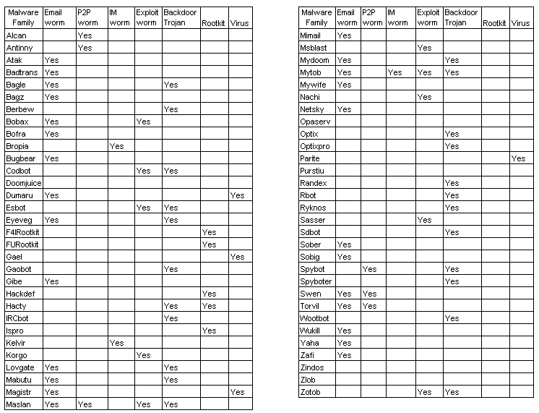
Figure 2. Malware families detected and removed by the MSRT

Figure 2 lists the 61 malware families, in alphabetical order, that the MSRT is capable of detecting as of the March 2006 release. They are classified into seven categories and are not mutually exclusive. While there are many ways to classify malware (based on capabilities, replication vector, etc.), the seven categories shown in the figure — e-mail worm, peer-to-peer (P2P) worm, instant messaging (IM) worm, exploit worm, backdoor Trojan, rootkit and virus — provide a useful high-level classification system that will be used in the remainder of this document. Because new malware variants in some of these families are appearing daily, these classifications may change following the publication of this paper. Note that in this figure an exploit worm is defined as a threat that exploits at least one software vulnerability that permits execution of code without action from the user. Malware that exploits a vulnerability that does require user action (e.g., viewing an e-mail message or navigating to a Web site) is not included in this category.

For a malware family to be associated with a category, all known variants must, by default, exhibit the behavior associated with that category. For example, only one variant of the Bagle family (Bagle.O) can be categorized as a virus because it infects executable files. Thus, the Bagle family is not characterized as a virus. As another example, many variants of the Rbot family are capable of exploiting software vulnerabilities. However, because in most of these cases manual intervention by the bot owner is required to trigger this form of replication, Rbot is not classified as an exploit worm. As shown previously, a small number of the families in Figure 2 do not fit into any of the seven categories.

Note that the MSRT is capable of detecting a small number of specific malware variants beyond the families listed above. These variants are dropped by the families listed and are detected by the tool to provide an end-to-end disinfection experience.

Malware Removed by the MSRT
The remainder of this document will discuss details about the malicious software that the MSRT has removed over the past 15 months, including high-level characteristics (e.g., operating system versions, locales) of the computers from which the malicious software has been removed.

Overview
This section will illustrate the magnitude of the removals performed by the MSRT.

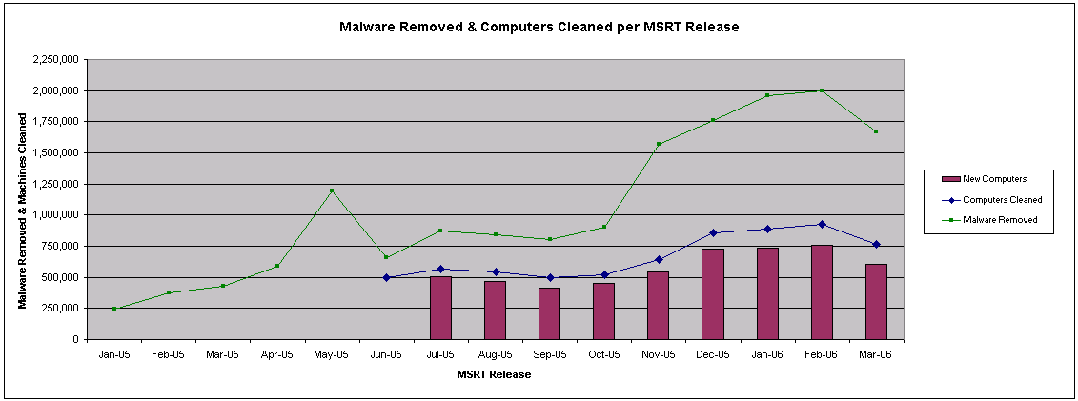
Figure 3. Malware removed and computers cleaned per MSRT release

Figure 3 provides the following information through the three data series in the graph:

- Malware removed. The number of instances of malware removed by the MSRT for each release from January 2005 to March 2006. Across all releases, the tool has removed 16 million instances of malicious software.
Computers cleaned. The number of unique computers cleaned by the MSRT, per release, from June 2005 to March 2006. The number of unique computers cleaned per release will always be fewer than the number of instances of malware removed for that same release (multiple infections can be removed from a single computer). In addition, this data series begins in June 2005, when the first release of the tool began measuring this metric. From June 2005 to March 2006, the tool has removed at least one instance of malicious software from 5.7 million unique computers. The total number since the tool’s initial release is larger than this figure but is unknown because data on this measurement is not available for the period before June 2005.
- New computers. From the number of total computers cleaned per release, the number of new, unique computers that the tool removed malware from with each release. Here, “new” refers to a computer from which the tool, including all previous releases of the MSRT, has never removed malware. For each release, this value will never be greater than the number of total computers cleaned. Because this figure is associated with the number of computers cleaned, the first release that can be measured is July 2005. Note that if a user reinstalls the operating system on his or her computer, this system will appear to be “new” to this telemetry. For this report, the bias introduced by this scenario is assumed to be small and is thus not taken into account.

Several observations can be made from the data shown in Figure 3:

- The increases in malware removed and in computers cleaned are due to both an increase in executions of the MSRT (as shown in Figure 1) and an increase in the number of prevalent malicious software families and variants targeted by the tool. In particular, releases since November 2005 have seen a significant increase in the number of disinfections. Each of these increases is attributable to the inclusion of one or a set of specific prevalent malicious software families in the tool. Because some of these families were discovered in the past and it is impossible to determine when a user was first infected, it would not be accurate to interpret this data as a rise in the amount of malicious software.

  - November 2005: A combination of Win32/Mabutu, Win32/Codbot, and Win32/Bugbear
  - December 2005: WinNT/F4IRootkit
  - January 2006: Win32/Parite
  - February 2006: Win32/Alcan
- Combining the data shown in Figure 1 with that shown in Figure 3 allows us to determine that, in the most recent release of the MSRT (March 2006), the rate of infected computers per executions of the tool was 0.28 percent. In other words, the tool removed malware from approximately one in every 355 computers on which it ran. The average rate across all releases from June 2005 to March 2006 is similar, at 0.32 percent, or approximately one in every 311 computers. This infection rate has remained relatively constant across the measurable releases, with the high being 0.4 percent in August 2005 and the low being 0.24 percent in September 2005.
- For each release, the majority of computers from which the tool removes malware are those from which it is removing malware for the first time. Conversely, with each release, the tool removes malware from a comparatively small number of computers from which it has previously removed some malware. For example, in the March 2006 release of the tool, approximately 600,000 out of 750,000 computers cleaned with the tool (80 percent) were new systems. In 20 percent of the cases, the tool had removed some malware from the same computers in a previous release. These removals represent the same computer being infected with a different malware variant or family as well as reinfections from the same malware variant (likely due to a nonpatched computer or effective social engineering).

Malware Removed per Computer
Another interesting metric to examine is the number of unique malware variants removed from each computer. In most cases the tool has removed only a single malware variant from a computer. However, in some cases the tool has removed dozens or even hundreds of malware variants from computers.

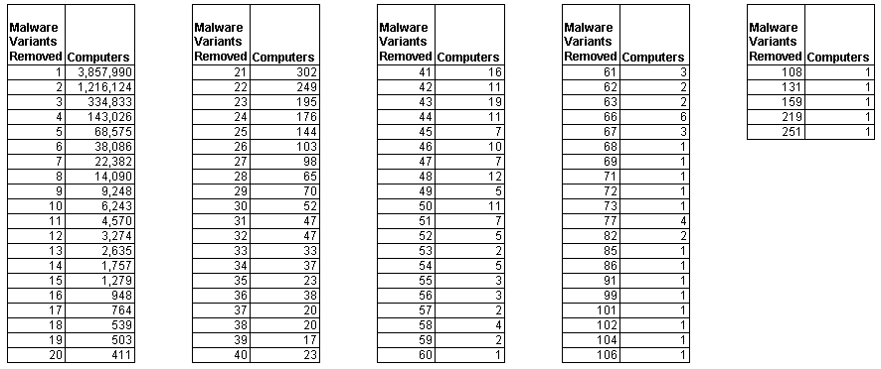
Figure 4. Unique malware variants removed per computer

Figure 4 shows the number of computers for which a certain number of unique, individual malware variants were removed across all executions of the tool on a computer. For example, if the tool removed the same malware variant twice from a computer, it is counted in Figure 4 only once. Using the data in Figure 4, we can determine that the average number of unique malware variants removed per machine is 1.59. In other words, the tool is slightly more likely to remove more than one malware variant per computer than just one variant.

In cases with a significant number of removals, computers are usually infected with a variety of bot variants, likely because a user becomes infected with a single bot and then the bot owner uses that first backdoor to install other bots on that computer.

Win32/Antinny, a peer-to-peer worm that affects Japanese computers almost exclusively, is also a threat known to have a high number of infections per computer. This is because Antinny uses a variety of social engineering tricks to entice users to download and run the worm. Thus, a user who is likely to execute the worm once and infect his or her computer is likely to do so repeatedly.

Malware Removed Details
This section provides more detail on the relationship between the data provided in the previous sections and the 61 malware families that the MSRT is capable of detecting and removing.

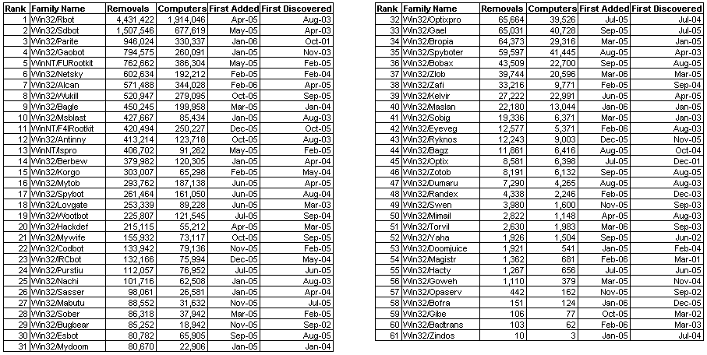
Figure 5. Computers cleaned by malware family

Figure 5 lists the 61 malware families that the MSRT is capable of detecting as of the March 2006 release, along with the following information:

- The number of times that the malware family has been removed from a computer from January 2005 to March 2006. The list is sorted in decreasing order by this value.
- The number of unique computers from which the malware family has been removed from June 2005 to March 2006
- The release of the MSRT for which detection of the malware family was first present in the tool
- The month and year in which the first variant of the family was discovered

The data in Figure 5 includes some interesting points to highlight:

- Removals of Win32/Parite, Win32/Alcan and WinNT/F4IRootkit rank among the highest despite the fact that detection for the families was added to the tool only within the last five releases. Parite, a file-infecting virus, is especially interesting because it first appeared in 2001 and continues to be prevalent. This is likely due to the difficulty associated with completely cleaning Parite from a computer and its aggressive file infection routine. In fact, there are no significant correlations between number of removals and when the family was first discovered or when detection for it was first added to the tool.
- Bots (Rbot, Sdbot, and Gaobot) constitute three of the top five slots in terms of total number of removals. The prevalence of these three malware families reinforces the point made in the executive summary regarding the pervasiveness of backdoor Trojans.
- Win32/Antinny, at No. 12, spreads via a Japanese file-sharing network. The fact that the worm is almost exclusively found on Japanese-language systems but is still ranked so high after only six releases means it was fairly prevalent within Japan and illustrates the thread of region- and language-specific threats.
- Win32/Alcan, a little-known worm that replicates over peer-to-peer networks, already has one of the highest removal figures after just being added to the tool in February 2006. The worm’s prevalence is likely due to its leveraging a number of fairly effective social engineering techniques, including masquerading as an application that encounters an error during installation after being run.
- Win32/Zotob, which exploited a vulnerability addressed by Microsoft Security Bulletin MS05-039, was removed from only 6,132 computers, making it the least prevalent of all exploit worms listed. This makes sense given that the vulnerability affected only Windows 2000-based computers. Ironically, Win32/Esbot, at No. 30, which exploits the same vulnerability, was removed from 10 times as many computers compared with Win32/Zotob but received much less attention. Win32/Msblast, at No. 10, remains the exploit worm with the highest number of removals.
- Similarly, while the Hacker Defender rootkit family usually receives most of the attention given to “notable” rootkit families, it is actually one of the least prevalent rootkits targeted by the tool. WinNT/FURootkit is the top rootkit removed by the tool and is often used to hide the presence of a backdoor Trojan installed on a computer.

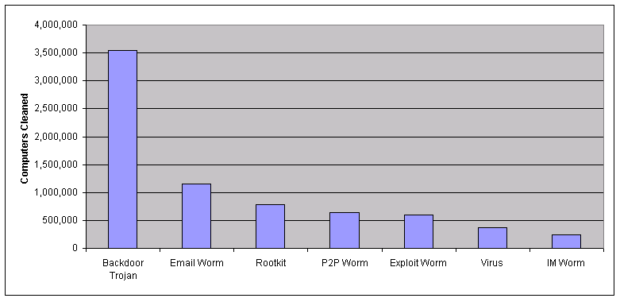
Figure 6. Computers cleaned by malware type

Figure 6 combines the data shown in Figure 5 with the malware classifications established in Figure 2. Out of the 5.7 million computers cleaned, the MSRT has removed a backdoor Trojan from over 3.5 million (62 percent) of them. As documented by several recent high-profile cases, attackers frequently use these backdoor Trojans for financial gain by establishing networks of infected computers and selling them as relays and distribution points for spam, spyware and denial of service attacks. In addition to using an up-to-date antivirus solution, customers should leverage bidirectional firewalls to help prevent information disclosure and the remote monitoring and controlling aspects of these threats.

Compared to backdoor Trojans, rootkits were found on far fewer computers: approximately 780,000. This figure drops to around 530,000, however, if detections of WinNT/F4IRootkit are ignored. This case is highlighted specifically because, while malicious software has subsequently appeared that leverages the rootkit to conceal itself on a computer, Sony did not release it as a malicious software package, but rather as anti-piracy functionality, and consequently the rootkit had retail distribution characteristics rather than viral distribution characteristics. Naturally, as with the other malware categories discussed in this report, the data provided here is relevant only to the malware families that the tool is capable of detecting. While there are known rootkits that are not detected by the tool due to low prevalence and, likely, unknown rootkits not detected by the tool, customer feedback and telemetry from such other Microsoft offerings as Windows Live OneCare and the Windows Live Safety Center beta indicate that the five rootkit families already targeted by the MSRT represent a significant portion of the rootkits actively affecting a large group of users today.

The most effective technique against rootkits is prevention. Customers are advised to keep their anti-virus signatures up to date so the software’s real-time protection mechanism is capable of detecting and blocking the rootkit before it can install itself on the computer and, where possible, to run their systems as a nonadministrator. Users who run their systems as standard users will not have the ability to install most rootkits on their computers. Microsoft’s next-generation operating system, Windows Vista™, includes several features to help block rootkits from tampering with the operating system’s key internal structures. If prevention is not possible and a machine is already affected by a rootkit, customers should use an antivirus product or tool capable of detecting and removing the rootkit. In this case, users, especially corporate users, should weigh the tradeoffs of taking additional steps to resolve the situation.

In terms of social engineering threats, e-mail is the most common form of the techniques shown above, with about 20 percent of the computers cleaned being infected with at least one threat capable of spreading through e-mail. While the MSRT is capable of detecting and removing three of the top instant messaging worms (Win32/Bropia, Win32/Kelvir and Win32/Mytob), these threats have been found on comparatively small number of computers: fewer than 250,000. Compare this to the 450,000 or so computers cleaned of Win32/Alcan and Win32/Antinny alone, which spread through P2P networks. Malware that spreads through a P2P network has the capability to detect threats if popular P2P applications are installed on a computer. If so, the malicious applications will create copies of themselves, usually using enticing names, in the directories that the P2P applications use to share files on the network. When this happens, the worm is then shared on the P2P network. In addition to maintaining up-to-date anti-virus solutions, users can best protect themselves from such social engineering threats by educating themselves about the forms malware can take and by running their systems as a nonadministrator to limit the impact of executing a threat.

One reason that recent IM threats have been less successful in spreading to a widespread audience than P2P threats is that IM programs are beginning to build in features that help prevent users from infecting their computers with malware. For example, MSN® Messenger version 7 prevents users from sending files with certain executable file types, and clicking on links within instant messages requires additional user consent. Such protections have not yet been integrated into P2P client programs. Another reason for this difference is that P2P applications, as mechanisms for exchanging files, are much more suited to the spread of malicious files than IM programs, which focus more on messaging.

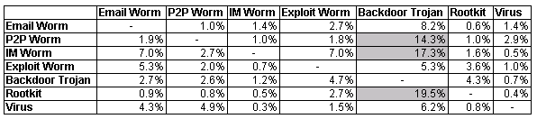
Figure 7. Correlation of malware infections by type

Figure 7 shows the overlap between the detections of the above malware types on a computer. Of all the computers on which MSRT detected an e-mail worm, it also detected a P2P worm in 1.0 percent of them. Conversely, in 1.9 percent of the cases where the tool detected a P2P worm, an e-mail worm was also detected.

The largest correlation shown above is between rootkits and backdoor Trojans. In approximately 20 percent of the cases in which a rootkit was found on a computer, at least one backdoor Trojan was found as well. This emphasizes the trend of many rootkits being distributed or leveraged by backdoor Trojans. The correlations are also high between P2P worms and backdoor Trojans, and IM worms and backdoor Trojans. The high values here are also expected, given that many P2P worms and IM worms will often drop bots on the computer once they run.

Changes in Malware Removals
Tracking changes in malware family removals by the tool is useful for two reasons. First, it allows Microsoft to monitor the activity and prevalence of specific malware families. Those families that experience increases in removals since first being added to the release usually indicate that variants are being actively released and are replicating. Tracking changes in removals is also useful because it allows Microsoft to monitor the success of the MSRT by ensuring that variants of the malware families detected by the tool are decreasing in prevalence. While other factors may account for the decrease, the fact that the MSRT has removed a significant number of instances of these malware families from computers means that the tool’s release is at least partially responsible for decreases in prevalence.

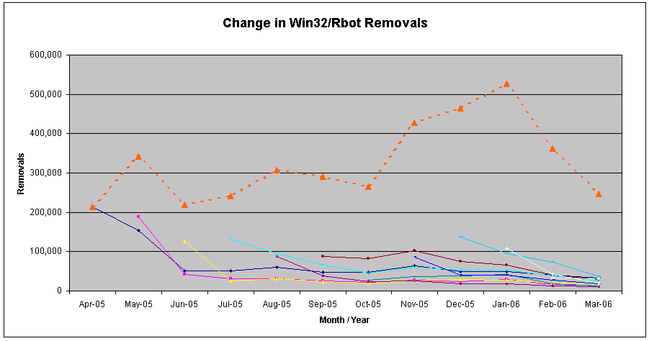
Figure 8. Change in Win32/Rbot removals

Microsoft tracks the change in malware removals by the MSRT with two metrics that are mapped to the reasons described above. Figure 8 illustrates these metrics using the Win32/Rbot family. Note that the X-axis corresponds to calendar months and years. Using the date in this model is important to show progression over time. Because users are able to run older versions of the MSRT (although a warning screen is shown 60 days after release), using the MSRT release month would skew this measurement.

- Family change (red-dotted line). The change in removals for a family between the time detection for it was first added to the tool and the latest release. While this provides an excellent view into ways that removals of a family have changed over time, it is skewed by families that are active and that, when first added to the tool, accounted for a small number of removals. The graph shows the total number of removals of the Win32/Rbot family from April 2005 to March 2006. Using this data, we can calculate that the number of removals of this family has increased by approximately 16 percent over the past 11 months. Given this information and the data from Figure 5, we can conclude that Rbot is a very active and prevalent family. Note that, graphically, this data series represents the sum of the solid lines below it.
- Average per-release change (solid lines). The change in the number of removals for a specific set of variants added to a single release from the time the set was first added to the tool to the latest version of the tool, averaged across all releases. This metric is resistant to the large number of removals produced by active malware families and is thus a better measure for determining how well the tool has accomplished reducing the instances of a family “in the wild.” In the graph, the solid lines represent the number of removals from a set of Win32/Rbot variants added to a specific release, over time. The longer the line, the longer the detections have been in the tool. The general observation here is that when detection for a set of Rbot variants is added to the tool, the number of removals of those variants has eventually decreased. If we calculate the change in removals for each of those sets of variants over time and then take the average of those changes, we find that removals of Rbot variants have decreased by approximately 79 percent since first being added to the MSRT.

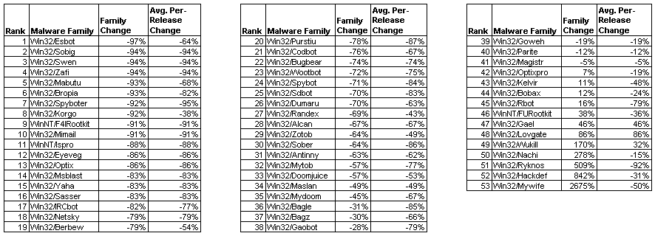
Figure 9. Changes in malware removals

Figure 9 shows most of the malware families detected by the tool along with the two measures for removal changes discussed above, arranged by percentage of family change in increasing order. Note that the three families added in the March 2006 release of the tool (Win32/Atak, Win32/Torvil and Win32/Zlob) are not included in this listing because there has not yet been an opportunity to determine a change in the number of removals. Also, Win32/Bofra, Win32/Gibe, Win32/Opaserv, Win32/Badtrans and Win32/Zotob are excluded because there are not enough removals (likely fewer than 1,000 of each worm) to generate a reliable change metric.

It is encouraging to see that the majority of the families (41 of 53) have decreased in prevalence since first being added to the tool, with 33 of the 41 families exhibiting more than a 50 percent decrease, and 21 of the 41 more than a 75 percent decrease. Of the 12 families that have increased in prevalence overall, only three (Win32/Gael, Win32/Lovgate and Win32/Wukill) have seen, on average, a consistent increase in each set of variants added to the tool. The remaining nine families (including, as shown in Figure 8, Win32/Rbot) have experienced a net decrease in removals per release.

Other highlights of this data include these:

- Removals of WinNT/F4IRootkit, the First4Internet rootkit distributed with certain Sony music CDs, have rapidly decreased since detection was first added to the release in December 2005. This likely indicates that few users installed or reinstalled the software from affected CDs after the media attention garnered by the issue.
- The rapid growth in Mywife removals is due to the inclusion of Win32/Mywife.E in the tool. Mywife.E appeared in late January 2006 and was also referred to as CME-24 and the Kama Sutra worm by the news media. The worm spread predominantly over e-mail and was capable of damaging key data files on the third day of every calendar month. In this case, the removals shot up from about 700 removals in January 2006 to about 92,000 in February 2006.
- The increase in Win32/Rbot removals is due to a large number of variants of that malware family being added to the MSRT with each release. On average, approximately 2,000 new variants of Win32/Rbot have been added to the tool each month.
- Increases in removals of such families as Win32/Hackdef and Win32/Ryknos are due to the low number of initial removals, which is in turn due to the low number of variants initially detected by the tool. For example, the April 2005 release of the MSRT was capable of detecting 78 variants of the Win32/Hackdef family. The number of variants dramatically increased to 439 in March 2006, representing more than a 400 percent increase. Similarly, the number of removals increased from about 3,000 to 30,000 during that time. Thus, while the number of Hackdef removals is still low compared with other malware families, they have increased significantly since detection of the family was first added to the tool. These trends are evident from the change metrics for this family, shown in Figure 9. While there has been a large increase in removals (842 percent), this figure is exacerbated by the fact that removals of the family began with a low figure. Removals of the family, per release, have decreased by an average of 31 percent.

Operating System Information
Using the telemetry information collected by the MSRT, Microsoft is able to determine the prevalence of the threats detected on the supported versions of Microsoft Windows. Figure 10 shows various views of the malware prevalence across these operating systems for the March 2006 release.

The first two pie charts reflect all malware detected by the tool during the March 2006 release. In the chart labeled “Total,” we see that most of the removals are from Windows XP SP2, with Windows XP constituting 89 percent of all removals by the tool. This high number is expected since most of the executions of the tool are on Windows XP SP2-based computers. Therefore, to get a more realistic view of which malware is more common on certain operating systems, the data in the first figure can be “normalized.”

In this case, normalization means adjusting the disinfection percentage across operating systems to take into account the number of executions of the tool on that operating system. In other words, to reduce the bias in the disinfection percentage introduced by a high number of executions from an operating system, we divide the number of disinfections from a specific operating system by the relative percentage of executions from that operating system. Thus, those operating systems with a large percentage of executions will have the number of disinfections increased by a smaller amount than an operating system with a low percentage of executions.

The specific mathematical formula used in this case is the following:

Normalized disinfections_{OS} = Disinfections_{OS}/Execution percentage_{OS}
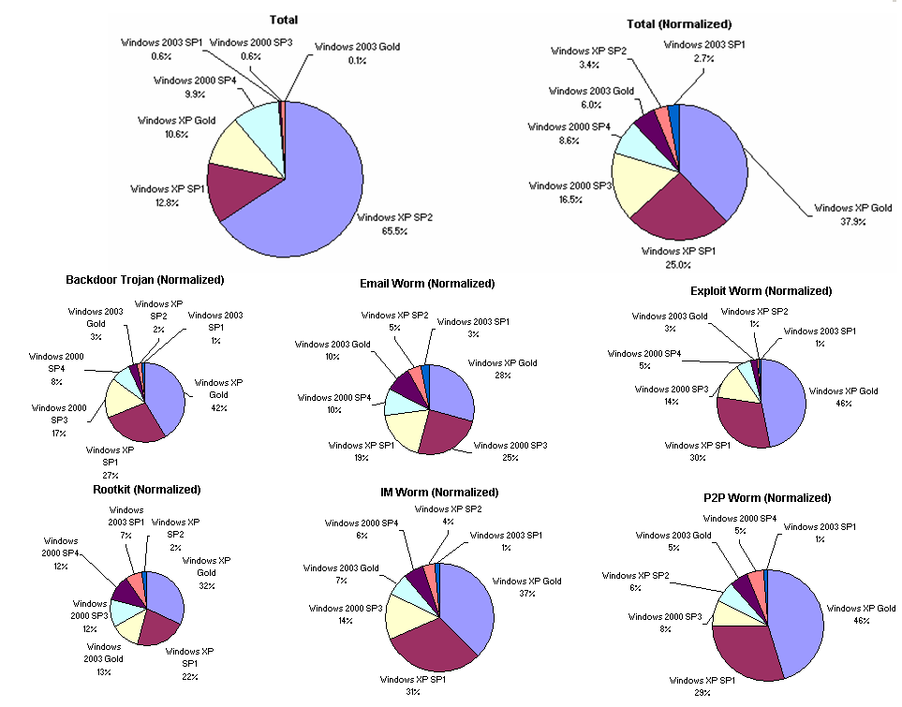Figure 10. Computers cleaned by the March 2006 release, by operating system

Applying this formula to the disinfection and execution percentages for the March 2006 release yields the graph in the upper-right corner of Figure 10. The graph shows a dramatic change in the percentages, with Windows XP SP2 dropping to only 3 percent of the normalized disinfections and Windows XP Gold and SP1 accounting for 63 percent of the disinfections. This arrangement makes sense for technical and social reasons. Windows XP SP2 includes a number of security enhancements and patches for vulnerabilities not found in earlier versions of Windows XP, making it more difficult to be infected by malware in some cases. And it is likely that a user who has not yet upgraded to the latest service pack would be more susceptible to social-engineering-based attacks. In fact, this seems to hold true for Windows 2000 and Windows Server 2003 as well, where the latest versions of the service packs for those operating systems have the lowest number of normalized disinfections compared with the older versions of the operating systems.

The six graphs following the two main charts show the normalized disinfections broken down by the same categories shown in Figure 2. In general, the results from these graphs are similar to the normalized results when all disinfections are taken into account. In fact, the ordering of the operating systems is identical in all cases. When looking at Windows XP SP2 specifically, it is interesting to see that the highest percentages for disinfections of this operating system are from threats that spread over e-mail, instant messaging and peer-to-peer networks. This arrangement is expected because these threats (in contrast to exploit worms, for example) use social engineering attacks to infect a machine, a method to which all operating systems are susceptible.

Locale Information

Figure 11. Computers cleaned by the March 2006 release, by locale

Figure 11 shows the breakdown of computers cleaned by operating system locale for the March 2006 release of the MSRT. Note that the locale is not necessarily indicative of geographical location. For example, English (U.S.) is used widely around the world.

The chart on the left side of Figure 11 shows that a large number of the computers cleaned have an English-language operating system. However, as with Windows XP SP2 above, this metric is slightly deceptive considering that many of the computers on which the tool is executed have an English language operating system installed. Therefore, as with operating system versions, the computers cleaned can be normalized by the execution percentage of a locale. The calculation is similar to the one performed for operating system version, with Execution Percentage_{Locale} used in place of Execution Percentage_{OS}.

The result of this calculation is displayed in the right side of Figure 11 and yields interesting results. Here, the normalization process has divided the disinfections quite fairly among the majority of locales. In other words, when all malware removed by the tool is taken into account and the values are normalized, the removals of that malware are spread across all Windows locales, including English. As evident in the graph, the exception to this statement is the Turkish locale, which accounts for 20.2 percent of the computers cleaned post-normalization. A deeper examination of the data shows that this pattern is similar across all malware families. While the Microsoft Antimalware Team is continuing to research this data, the specific reason that a high percentage of normalized detections come from Turkish-language computers is unknown.

Conclusions
The past 15 months have been exciting for the Microsoft Antimalware Team and its intra-company partners, with the release of the Windows Malicious Software Removal Tool, the Windows Defender Beta, Windows Live OneCare Beta, and the Windows Live Safety Center Beta. The next 15 months promise to be just as exciting, with full releases of these offerings expected in addition to the launch of Microsoft Forefront Client Security, a unified malware protection solution for desktops, laptops and server operating systems that is easier to manage and control, and the continued delivery of the MSRT.

The introduction of these offerings will provide Microsoft with additional sources of data on the prevalence of malicious software, similar to the data collected by the MSRT. The collection of this information is key to Microsoft’s understanding of the threat landscape and efforts to combat these threats and improve the overall computing experience for Microsoft customers. For example, the identification of bots as a significant majority of the detections by the MSRT resulted in the development of several automated analysis and signature-generation techniques for these threats by the Microsoft Antimalware Team. This has dramatically increased the output of signatures and the team’s ability to respond to the appearance of new bots.

Microsoft believes that there is significant value in sharing this information with partners and customers, not only to demonstrate the impact of our tools and products on the threat landscape, but also to share our knowledge. This report is the first significant example of sharing such information; more will follow and with increased frequency. Our hope is that others in the security industry can use this data to enhance our common understanding of the malware landscape and focus on the shared goal of reducing the impact of malware to the Windows user base.

Appendix

MSRT Background
In late 2003, Microsoft acquired assets from GeCAD Software, a provider of anti-virus technology, allowing the Microsoft Security Technology Unit (STU) to begin investigating tools and technologies related to anti-virus capabilities. The first release to benefit from this acquisition was the Blaster Worm Removal Tool, which the STU’s Antimalware Team shipped in January 2004 in response to information from Microsoft’s Internet service provider (ISP) partners that Blaster was still a threat at that point. The tool was capable of removing all known variants of Msblast and Nachi at the time and was deployed to infected computers via Windows Update. Users whose computers were likely to be infected were offered the tool through Windows Update (WU)/Automatic Updates (AU), allowing Microsoft to obtain key telemetry about the prevalence of Msblast and Nachi in 2004 and resulting in the removal of these malware from more than 10 million customer computers. Subsequent and independent cleaner tools were released in March and May 2004 to detect and remove Mydoom and Berbew, respectively.

While Microsoft received positive feedback from customers that these single-use cleaner tools were valuable, many asked for a more consistent, predictable system. This feedback led to the creation of the Windows Malicious Software Removal Tool (MSRT).

Key features of the release are as follows:

- The tool is released once a month, on the second Tuesday of the month, with any security updates for that month. If necessary, the tool is released out-of-band of this schedule for high-priority threats. So far, Microsoft has shipped only one out-of-band update of the tool, in August 2005 to counteract the Zotob worm. Since the spread of the Zotob worm was anticipated to be limited to specific organizations running Windows 2000, the update was distributed only through the Microsoft Download Center and the Web site.
- All monthly releases of the tool are distributed simultaneously to Microsoft Update (MU), WU, AU, the Microsoft Download Center and the MSRT Web site (http://www.microsoft.com/security/malwareremove/default.mspx).
- Each release of the tool is cumulative, including all threats added from previous releases of the tool.
- When delivered through WU/MU/AU, each release of the tool runs only once and then exits. If any malicious software is found and removed, the tool provides a message to the user after the next reboot. If no malicious software is found, no messages or user interface are shown to the user. Users who want to run the tool more than once a month, on demand, can download a copy from the Microsoft Download Center or execute it from the Web site at http://www.microsoft.com/malwareremove.
- By default, the tool looks only for malware that is currently running or linked to through an auto-start point, such as in the registry. The tool was intentionally designed this way to minimize the execution time, especially through WU/AU.
- The tool is instrumented so that it can easily be deployed and managed by corporate customers. Specific target scenarios include distribution through Microsoft System Management Server (SMS) or a similar application management system as well as execution of the tool at each system logon or startup. Administrators who implement the tool in one of these scenarios can use the status codes returned by the tool (listed in KB891716) to monitor its rollout and status. The tool is also available for deployment through Windows Server Update Services.

The tool’s size is kept as small as possible to accommodate customers with limited bandwidth. In June 2005, the tool began to utilize delta updates through WU/MU/AU. In this scenario, users who have run a recent version of the tool are offered a smaller update (essentially the difference between what the user already had on his or her system and the most recent version). Currently, approximately 80 percent of WU/MU/AU users leverage these smaller updates, resulting in an average savings of 1 megabyte (MB) per user and approximately 80 terabytes (TB) of saved data per release.

Data Collection Details
To enable the Microsoft Antimalware Team to obtain accurate data about the state of malware within the Windows ecosystem, the MSRT collects select infection-related information from customer computers, none of which can be used to personally identify a specific user. This information is sent to Microsoft only in the event that the tool detects malicious software on a computer. Users also have an option to prevent the software from reporting back to Microsoft by modifying the registry. The tool does not transmit any information back to Microsoft on computers that are updated by a Windows Server Update Services server.

The following information is sent back to Microsoft:

- The name of the malicious software detected on the computer
- The result of the attempt to remove the malicious software
- The operating system version, including the service pack number
- The locale of the operating system
- The processor architecture
- The version number of the tool
- An indicator that denotes whether the tool is being run from WU/AU, from the Download Center or from the MSRT Web site
- An anonymous GUID that is used to track the number of unique computers that have removed malware. It is generated explicitly for this scenario.
- A cryptographic one-way hash (MD5) of the path and file name of each malicious software file that is removed from the computer. Because they could be considered personal information, neither the actual path nor the file name is sent.

In cases where the tool detects software on a computer that may be potentially malicious, users are prompted to send the file(s) to Microsoft along with the cryptographic one-way hash (MD5). The Microsoft Antimalware Team analyzes the submissions and adds them to the threat database if necessary.

The tool does not collect any personally identifiable information and thus can not be used to tie a specific user to an infection report. For information on data collected by the tool, please refer to the Appendix. For Microsoft’s definition of personally identifiable information, please refer to the Microsoft Security Glossary at http://www.microsoft.com/security/glossary.mspx.
The tool does not collect any personally identifiable information and thus cannot be used to tie a specific user to an infection report. For information on data collected by the tool, please refer to the Appendix. For Microsoft’s definition of personally identifiable information, please refer to the Microsoft Security Glossary at http://www.microsoft.com/security/glossary.mspx.

