Microsoft Business Solutions CRM 1.2 Hardware and Software Requirements

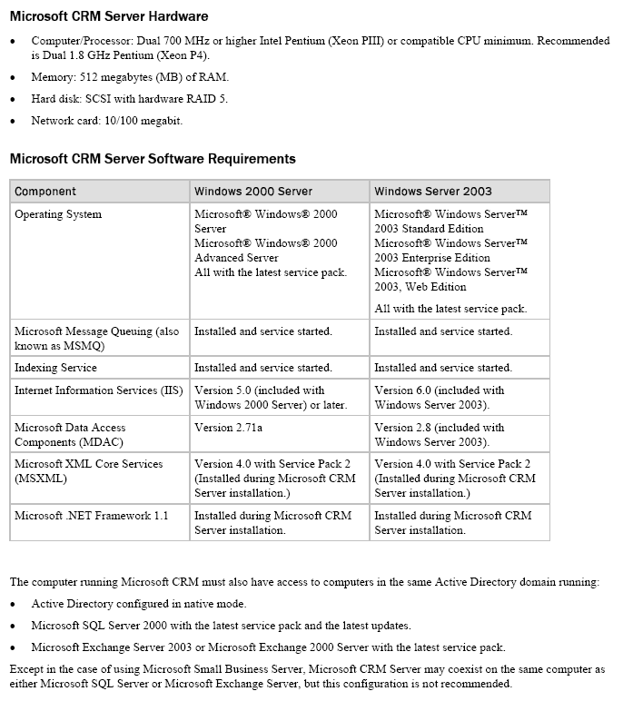
Microsoft Business Solutions CRM 1.2 Hardware and Software Requirements

