

**Technical Brief**

**Media Sharing**

Microsoft® Corporation

Published: August 2008

Version: 1.1

**Abstract**

This technical brief provides an in-depth look at the features and functionality of Windows® Home Server Media Sharing. This brief has been updated to include additional information from Power Pack 1.

To learn more about other aspects of WindowsHome Server, see the [Microsoft Web site](http://go.microsoft.com/fwlink/?LinkId=100260) (http://go.microsoft.com/fwlink/?LinkId=100260).



*The information contained in this document represents the current view of Microsoft Corporation on the issues discussed as of the date of publication. Because Microsoft must respond to changing market conditions, it should not be interpreted to be a commitment on the part of Microsoft, and Microsoft cannot guarantee the accuracy of any information presented after the date of publication.*

*This Technical Brief is for informational purposes only. MICROSOFT MAKES NO WARRANTIES, EXPRESS, IMPLIED OR STATUTORY, AS TO THE INFORMATION IN THIS DOCUMENT.*

*Complying with all applicable copyright laws is the responsibility of the user. Without limiting the rights under copyright, no part of this document may be reproduced, stored in or introduced into a retrieval system, or transmitted in any form or by any means (electronic, mechanical, photocopying, recording, or otherwise), or for any purpose, without the express written permission of Microsoft Corporation.*

*Microsoft may have patents, patent applications, trademarks, copyrights, or other intellectual property rights covering subject matter in this document. Except as expressly provided in any written license agreement from Microsoft, the furnishing of this document does not give you any license to these patents, trademarks, copyrights, or other intellectual property.*

*Unless otherwise noted, the companies, organizations, products, domain names, e-mail addresses, logos, people, places, and events depicted in examples herein are fictitious. No association with any real company, organization, product, domain name, e-mail address, logo, person, place, or event is intended or should be inferred.*

*© 2008 Microsoft Corporation. All rights reserved.*

*Microsoft, ActiveX, Windows, Windows Server, Zune, Xbox 360, Windows Media, and Windows Vista are trademarks of the Microsoft group of companies.*

*UPnP is a certification mark of the UPnP Implementers Corporation.*

*All other trademarks are property of their respective owners.*

**Contents**

[Media Streaming Overview 4](#_Toc204754485)

[Features and Functionality 4](#_Toc204754486)

[Benefits 5](#_Toc204754487)

[Media Sharing In Depth 6](#_Toc204754488)

[Enabling Media Sharing 6](#_Toc204754489)

[Supported Media File Formats 8](#_Toc204754490)

[Viewing Photo Slide Shows 10](#_Toc204754491)

[Windows Vista Screensaver 10](#_Toc204754492)

[Using an Xbox 360 10](#_Toc204754493)

[Using a Digital Picture Frame 11](#_Toc204754494)

[Streaming Music 12](#_Toc204754495)

[Windows Media Player 12](#_Toc204754496)

[Xbox 360 14](#_Toc204754497)

[Windows Media Center Edition 15](#_Toc204754498)

[Microsoft Zune 16](#_Toc204754499)

[Connecting an Old Stereo 17](#_Toc204754500)

[Watching Videos 17](#_Toc204754501)

[Xbox 360 17](#_Toc204754502)

[Windows Media Player 19](#_Toc204754503)

[Additional Tips 21](#_Toc204754504)

[Playlists 21](#_Toc204754505)

[More Information 22](#_Toc204754506)

# 

# Media Streaming Overview

Windows® Home Server Media Sharing enables you to view, listen, and watch your favorite media stored on your home server by using digital media receivers and playback devices, such as the Microsoft® Xbox 360™.

## Features and Functionality

After you turn on Media Sharing in Windows Home Server, you can simultaneously share photos, music, and videos with your home computers and other devices that support Windows Media Connect.

* **Presenting Photo Slide Shows**

You can store your digital photos in the **Photos** shared folder on your home server and then access them from any home computer or from an Xbox 360 that is connected to a TV in your home. You can watch photo slide shows, turning your TV into a large picture frame.

* **Streaming Music**

When you turn on Media Sharing for the **Music** shared folder, you can access your music from devices that support Windows Media Connect. You do not need to enable or configure any user accounts to stream from the **Music** shared folder after sharing is turned on.

* **Watching Videos**

Your home server can be used to store and stream large collections of videos and recorded TV shows to your home computers or other playback devices on your home network. You can stream videos to an Xbox 360 or to a home computer by using Windows Media® Player.

## Benefits

Windows Home Server Media Sharing is unique compared to other media sharing solutions. Some of the benefits are:

* **Ease-of-use**

When you install Windows Home Server Connector software on your home computers, the software adds a shortcut to the shared folders on your home server. You can copy your photos, music, and videos from your existing home computers into the **Photos**, **Music**, and **Video** shared folders on your home server. To turn on media sharing on your home network, open the Windows Home Server Console, click **Settings,** and then click **Media Sharing**.

* **Access your media from any home computer**

Windows Home Server can become a hub for your media files so that they are accessible from any home computers that are connected to your home network. Additionally, you can access your media files from digital media receivers connected to your home network.

* **Listen while you work and play**

With Windows Home Server, you can play music while you are viewing a photo slide show, playing an Xbox 360 game, or working in Microsoft Word on one of your home computers. Your music, photos, and videos can be stored centrally and accessed from multiple home computers or from an Xbox 360 all at the same time.

# Media Sharing In Depth

This section explains how Windows Home Server Media Sharing works.

## Turn On Media Sharing

By default, Media Sharing is turned off.

** To turn on Media Sharing:**

1. Open the Windows Home Server Console.
2. Click **Settings**.
3. Click **Media Sharing**.
4. Click **On** for each of the shared folders (**Music**, **Photos**, and **Video**) that you want to stream.
5. Click **OK**.

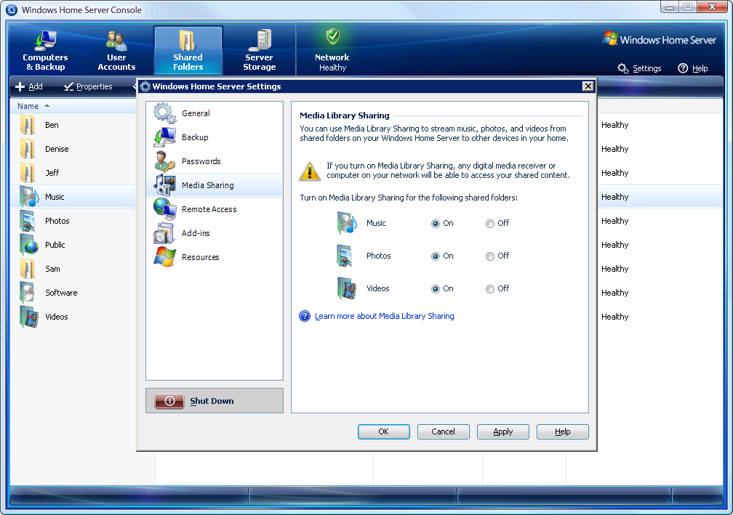**Figure 1:**Windows Home Server Media Sharing settings

Windows Home Server automatically tries to open the correct ports in Windows Firewall on your home server. Any media in the Music, Photos**,** and Videos shared folders will be accessible by devices on your home network that support Windows Media Connect (the media must be stored in a supported file format).

note_dd**Note**

If you have a lot of media files, it may take Windows Home Server some time to catalog all of the media files before they can be accessed by using Windows Media Connect over your home network.

caution_dd**Caution**

Windows Media Connect 2.0 is designed to be controlled through the Windows Home Server Console. Altering the Windows Media Connect tool outside of the Windows Home Server Console will likely damage the media streaming functionality.

Before you turn on Media Sharing for a shared folder, you should know that Media Library Sharing bypasses any type of user-account access that you set for the shared folder. For example, if you set **No Access** to the Photos shared folder for a user account called Bobby, and then you turn on Media Library Sharing for the Photos shared folder, Bobby can still stream any digital media from the Photos shared folder to any supported digital media player or digital media receiver. If you have digital media that you do not want to share, store the files in a folder that does not have Media Library Sharing turned on.

Before you turn on Media Library Sharing, make sure that you secure your wireless network. If you turn on Media Library Sharing for a shared folder, any supported digital media player or digital media receiver that can access your home network can also access your digital media in that shared folder. For example, if you have not secured your wireless network, anybody within range of your wireless network can potentially access your digital media in that folder. For more information, see the documentation for your wireless access point.

## Supported Media File Formats

Windows Home Server includes Windows Media Connect 2.0 functionality. The following file formats are supported in this version of Windows Media Connect:

**Photos**

* Bitmap (.bmp)
* Graphics Interchange Format (.gif)
* Joint Photographic Experts Group (.jpeg, .jpg)
* Portable Network Graphics (.png)
* Tagged Image File Format (.tif, .tiff)

**Audio**

* Windows Media Audio (.wma)
* Advanced Systems Format (.asf)
* MP3 (.mp3)
* WAV (.wav)
* Windows Media Playlist (.wpl)
* MP3 Playlist (.m3u)

**Video**

* Windows Media Video (.wmv)
* Microsoft Recorded TV Show (.dvr-ms)
* Audio Video Interleaved (.avi)
* MPEG-1 (.mpeg, .mpg)
* MPEG-2 (.mp2, .mpeg, .mpg)

note_dd**Note**

Although Windows Media Connect can stream a variety of file formats to your media playback devices, a given device may not be capable of playing every file format that Windows Media Connect supports. For information about which file formats your media playback device supports, see the documentation that came with the device.

Some media files are protected to prevent unauthorized distribution and playback. For example, files downloaded from online music stores are often protected with digital rights management (DRM) technology. Media files that are DRM protected may not be accessible from your home computers or other playback devices on your home network when they are stored on your home server.

Most broadband routers today only support 10/100 megabit per second (Mbps) wired Ethernet connections. To improve your network performance, you should consider adding a 1 Gigabit (1000 Mbps) network switch to your network. Connect your home computers and home server to the faster switch, and then connect the switch to your broadband router. High-definition video can require a lot of network throughput and may require a Gigabit network.

important_ddImportant

By default, Windows Home Server allows connections to the home server only from home computers and devices that are on the same subnet. Please ensure that your Windows Home Server is on the same subnet as your home computers and media playback devices.

## Viewing Photo Slide Shows

Photos stored on your home server can be accessed from a variety of devices on your home network.

### Windows Vista Screensaver

You can easily set the screensavers on your home computers running Windows Vista® to show slide shows of your favorite photos stored on your home server.

** To setup Windows Vista screen saver to show photos from your home server:**

1. Click **Start,** and then click **Control Panel.**
2. Click **Appearance and Personalization**.
3. Under **Personalization**, click **Change screen saver**.
4. In the drop down list, select **Photos**, and then click **Settings**.
5. Under **Use pictures and videos from:** click **Browse** and then type [**\\Server\Photos**](file:///\\Server\Photos).   
     
   By default, Windows Home Server is installed with the name Server. If you have chosen a different name for your home server, substitute that name for Server.
6. Click **Save**.

### Using an Xbox 360

An Xbox 360 is capable of accessing photos that are stored on your Windows Home Server. After your Xbox 360 is configured to stream from your Windows Home Server, all you have to do is browse for the photos that you want to view, or select a folder that you want to play as a slide show.

** To configure your Xbox 360 to stream media from your Windows Home Server**

1. On your Xbox 360, scroll up to **My Xbox**.
2. Scroll right to **Picture Library**.
3. Select **Server:1**. By Default, Windows Home Server is installed under the name **Server**. If you have chosen a different name for your home server, substitute that name for **Server**.
4. After you select your Windows Home Server, the Xbox 360 will display the photos available on your Windows Home Server.

After your Xbox 360 is set up, you can access and stream your photos, music, and videos if you have already enabled Media Sharing for the Photos, Music, and Videos shared folders on your home server.

### Using a Digital Picture Frame

Before purchasing a digital picture frame, you should verify that it can access and stream photos from your Windows Home Server. Some digital picture frames are not designed to work with Windows Media Connect 2.0. Ensure that your digital picture frame is compatible with Windows Media Connect 2.0 or Windows Home Server.

The digital picture frame setup instructions may include steps for how to use a home computer. If your Photos shared folder is already enabled for media sharing on your home server, you may be able to skip the steps for setting up your home computer.

Depending on the device, you will want to point the device to access the photos stored in [\\Server\Photos](file://Server/Photos). This may include enabling the guest account or entering a user name and password. By default, Windows Home Server is installed using the name **Server**. If you have chosen a different name for your home server, substitute that name for **Server**. This document assumes that the Windows Home Server name is **Server**.

You can turn your TV into a large picture frame in a few different ways. Some companies are producing TVs with Windows Media Connect capabilities built in, so you do not need extra devices to display photos and videos or play music that is stored on your home server.

To enable Windows Home Server to share photos with these TVs, turn on the Media Sharing library for photos in the Windows Home Server console, then configure the TV to stream from your Windows Home Server. Review the instructions from the manufacturer of the TV for complete step-by-step instructions. There are media playback devices other than Xbox 360 that offer media streaming to TVs. For a list of compatible devices, see the [Microsoft Web site](http://go.microsoft.com/fwlink/?LinkID=103942) (http://go.microsoft.com/fwlink/?LinkID=103942).

## Streaming Music

After you turn on media sharing for your Music shared folder, you can stream your music to your home computers or other media playback devices on your home network. There are a variety of devices and ways that you can access the music stored on your home server. Highlighted below are some of the more common ways for listening to your music.

### Windows Media Player

You can view the songs listed on your Windows Home Server in two ways. Using Media Connect is the simplest way to access and share music with your home computers. You can also add your Music folder from your home server to the Windows Media Player library on a home computer. This requires a few extra steps and proper user permissions, and it can clutter your library on that computer.

If you listen to music on a computer that might leave your home network, it is recommended that you use Windows Media Connect for listening to the music that is stored on your home server while at home. This capability is available in home computers running Windows Vista. Using Windows Media Connect on your home computers prevents music that is stored on your Windows Home Server from falsely displaying on your computer when you are away from home. However, using this function instead of adding Monitored Folders will not allow you to access album art, change star ratings, or modify playlists from within Windows Media Player 11. If you want to use the Windows Media Player 11 functions, see “Adding the Music Shared Folder to the list of Monitored Folders” later in this document.

* **Configuring Windows Media Player to use Windows Media Connect**

1. Open **Windows Media Player**.
2. Right-click **Now Playing**, and then select **More Options**.
3. Click the **Library** tab.
4. Click **Configure Sharing…**
5. Select the **Find media that others are sharing** check box.
6. Click **OK** twice.

Windows Media Player displays **User 1 on Server**.

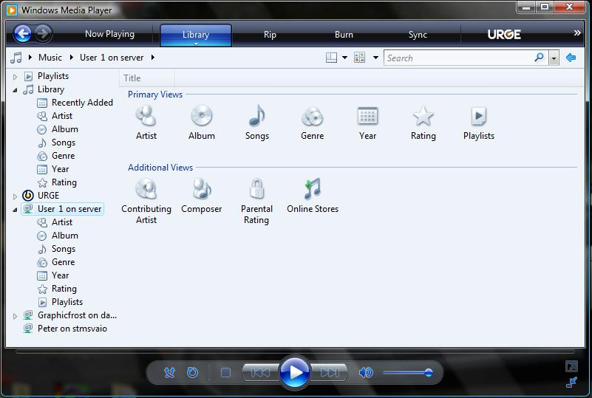

**Figure 2:**Windows Media Player Library dialog box

note_ddNote

The user account used to access the Music shared folder on the home server must have at least Read permissions to add the music to Windows Media Player monitored folders list.

** Adding the Music shared folder to the list of monitored folders**

1. Open **Windows Media Player**.
2. Right-click **Now Playing**, and then select **More Options**.
3. Click the **Library** tab.
4. Click **Monitor Folders…**
5. Click **Add…**
6. Type [\\Server\Music](file://Server/Music).
7. Click **OK**.

Windows Media Player monitors the Music shared folder on your home server and indexes the existing music and music that is added to the shared folder.

### Xbox 360

Your Xbox 360 needs to be properly configured and connected to your home network. Make sure that Media Sharing is enabled for Music on your home server before you proceed.

After you configure your Xbox 360 to stream from your Windows Home Server, you can listen to music that is stored on your home server while you watch photo slide shows (if enabled), play Xbox 360 video games, and view the Xbox 360 Dashboard.

** Configuring your Xbox 360 to stream music from Windows Home Server**

1. Scroll up to **My Xbox** in the Xbox 360 Dashboard.
2. Scroll right to **Music Library**.
3. Select **Server:1**. By default, Windows Home Server is installed with the name **Server**. If you have chosen a different name for your home server, substitute that name for **Server**.
4. After selecting your Windows Home Server, the Xbox 360 displays the music that is available on your Windows Home Server.

### Windows Media Center Edition

In Windows Vista Home Premium, Windows Vista Ultimate, and Windows XP Media Center Edition 2005 operating systems, you can view the music that is stored on your home server through the Windows Media Center user interface. On your Windows Home Server, you must enable the Guest user account and give the Guest account Read rights to each shared folder that you would like Windows Media Center to view and play. Media Center Edition creates and uses a random user name, which requires the Guest account to be enabled.

If Windows Media Player has already added the shared folders to its Watched Folder list, you will not have to add those folders in Media Center. Media Center views the Watched Folders list in Windows Media Player and adds them to your Media Center Watched Folder list.

**To enable the Guest user account in Windows Home Server**

1. Open the **Windows Home Server Console**.
2. Click the **User Accounts** tab.
3. Right-click **Guest**, and then select **Enable Guest Account…**
4. Click **Next.**
5. Select **No Guest Password**, and then click **Next**.
6. Click **Read** for any shared folder that you would like to have accessed and viewed using Windows Media Center.
7. Click **Finish**.

caution_dd**Caution**

Enabling the Guest account gives access to anyone on your home network to view the shared folders: Music, Photos, Videos, Public, and Software, without entering a password.

After enabling the Guest user account and giving the Guest account access to your folders, you can enable Windows Media Center Edition to watch the shared media from your home server.

** To enable Windows Media Center so that you can watch shared media**

1. Open **Windows Media Center**.
2. Click **Settings**.
3. Click **Library setup**.
4. Select **Add folder to watch**, and then click **Next**.
5. Select **Add shared folders from another computer**, and then click **Next**.
6. Select the [\\Server\Music](file:///\\Server\Music) folder.
7. Click **Finish**.

note_ddNote

You can similarly add the Photos and Videos shared folders (or any shared folders that you create). The media stored in these folders on your home server is then accessible through the Windows Media Center user interface on your home computers.

After Windows Media Center searches the Watched Folders that you have added, you will be able to view and play the music, videos, and photos with compatible formats.

### Microsoft Zune

To synch your Microsoft Zune™ with your Windows Home Server, you need to add the Music, Videos, and/or Photos shared folders to the monitored folders on your Zune software.

** To add shared folders to the monitored folder list in the Zune Library**

1. Open your **Zune** software.
2. Click **Settings**, then click **Collection**
3. Click **Add Folder ….**
4. Type the following into the **Folder:** box and click **OK**
   * [\\Server\Music](file:///\\Server\Music)
   * [\\Server\Videos](file://Server/Videos)
   * [\\Server\Photos](file://Server/Photos)

### Connecting an Old Stereo

There are a variety of media playback devices that you can connect to an older stereo system to access and stream the music from your home server. For example, ROKU and D-Link support Windows Media Connect 2.0. They provide access across your home network to the music that you store on your home server from your stereo system.

For more information about these options, see the [Microsoft Web site](http://go.microsoft.com/fwlink/?LinkID=103942) (http://go.microsoft.com/fwlink/?LinkID=103942).

## Watching Videos

The setup for sharing videos will differ from device to device. In most cases, with media sharing enabled for the Videos shared folder on your home server, you can attach the device that supports Windows Media Connect to your home network, and then access the content on your home server.

### Xbox 360

An Xbox 360 is capable of streaming videos from your Windows Home Server. If your Xbox 360 is already configured to stream from your Windows Home Server, browse for the video that you want to watch and press **Play**.

** To set up your Xbox 360**

1. Scroll up to **My Xbox** on your Xbox 360.
2. Scroll right to **Video Library**.
3. Select **Server:1**. By default, Windows Home Server is installed with the name **Server**. If you have chosen a different name for your home server, substitute that name for **Server**.
4. After you select your Windows Home Server (**Server:1**), the Xbox 360 displays the videos that are available from your Windows Home Server.

After your Xbox 360 is set up, you can access and stream the videos that are stored on your home server. You will not be able to stream media from a shared folder that is not enabled for Media Sharing.

important_ddImportant

Windows Home Server can stream media file types that other devices cannot play. Review the documentation for your digital media playback devices to find out what file types they can access through streaming capabilities.

### Windows Media Player

You can watch the videos stored on your Windows Home Server in two ways. You can watch your videos through Windows Media Connect or by adding your Media Share folder from your home server to the Windows Media Player library on a home computer. Using Media Connect is the simplest way to access and watch videos from your home computers. If you are interested in learning how to add videos to the Windows Media Player library on a home computer, refer to the “Streaming Music” section earlier in this document.

note_dd**Note**

If you are watching videos on a computer that might leave your home network, it is recommended that you use the Windows Media Connect feature for accessing the videos that are stored on your home server. This capability is available in home computers that are running Windows Vista. This prevents videos that are stored on your Windows Home Server from falsely displaying when you are away from home.

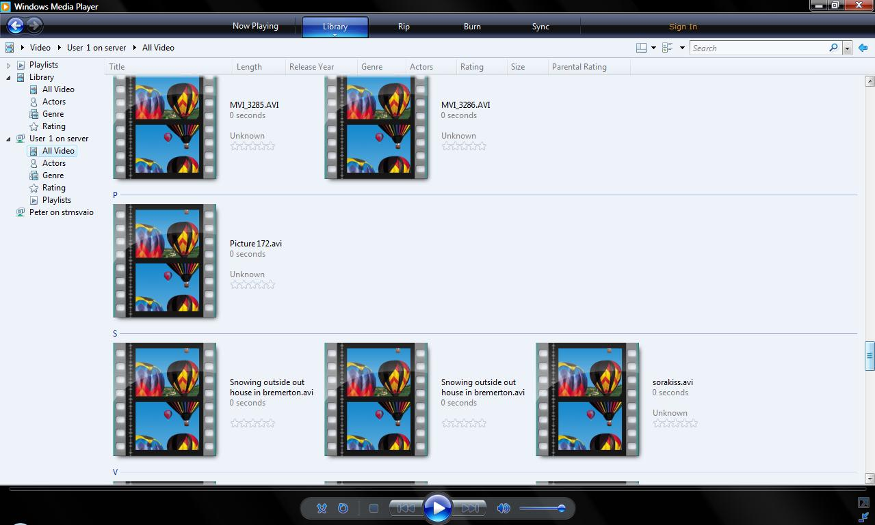

**Figure 3:**   Windows Media Player Library selections

 **Configuring Windows Media Player to use Windows Media Connect**

1. Open **Windows Media Player**.
2. Right-click **Now Playing**, and then select **More Options**.
3. Select the **Library** tab.
4. Click **Configure Sharing…**
5. Select the **Find media that others are sharing** check box.
6. Click **OK** twice.

## Additional Tips

### Playlists

Playlists stored on Windows Home Server can also be set up and shared. Playlists that were created before you move the music to the Windows Home Server should play as long as the hierarchy of the folder structure is maintained after transferring your music from your home computer to the Windows Home Server.

note_ddNote

You must have full permissions to a folder before you can create folders or files, even if Windows Media Sharing is enabled.

** To create Playlists**

1. Open [\\Server\Music](file://Server/Music).
2. Create a folder called **Playlists**.
3. Open **Windows Media Player 11** on your home computer running Windows Vista or Windows XP.
4. Click the **Now Playing** tab. Remove music that is in the **Now Playing** list.
5. Select music from [\\Server\Music](file:///\\Server\Music) that you want to use to create a playlist. You can drag single songs, multiple songs, and even folders to the **Now Playing** section.
6. Click the **Now Playing** drop-down menu above the songs that you dragged.
7. Click **Save Playlist As**.
8. Save the playlist to [\\Server\Music\Playlists](file:///\\Server\Music\Playlists).

# More Information

For more information about WindowsHome Server, see the [Microsoft Web site](http://go.microsoft.com/fwlink/?LinkId=100260) (http://go.microsoft.com/fwlink/?LinkId=100260).

For more information about Windows Home Server Media Sharing, see the Community Forums at the [Microsoft Web site](http://go.microsoft.com/fwlink/?LinkId=100263) (<http://go.microsoft.com/fwlink/?LinkId=100263>).