Microsoft Office Small Business 2007

**Microsoft® Office Small Business 2007 provides you with a complete set of productivity and contact management tools to accomplish routine tasks quickly, manage customer and contact information in one place, and produce professional-quality marketing materials and campaigns in-house. Use Office Small Business 2007 to save time, stay organized, and spend more time with your customers.**

Quickly Accomplish Your Routine Tasks

Office Small Business 2007 includes new and improved tools and the Microsoft Office Fluent™ user interface to help you work faster and create more professional documents, spreadsheets, and presentations.

Introducing a new look and feel.

New task-based menus and toolbars automatically display the commands and options you can use, making it faster and easier to find the software features you need. And the Live Preview feature makes it easy to sample your changes before you apply them.

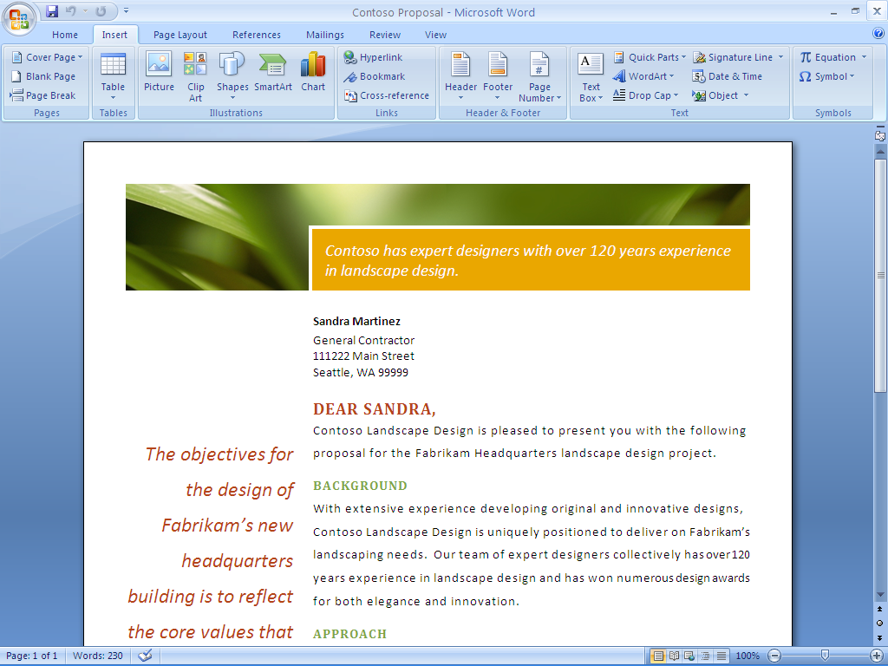

The Office Fluent user interface of the 2007 Microsoft Office system recognizes your current task, and automatically displays the menus and toolbars for that task.

Create professional-quality documents quickly.

New Quick Styles in Microsoft Office Word 2007 help you easily apply a new look and feel to all of your business documents by providing a library of predefined styles. You can now easily reuse content in your documents by using Building Blocks, and you can quickly preview changes with Live Preview.

Manage an increasing volume of e-mail.

New features in Microsoft Office Outlook® 2007 help you find, filter, and prioritize e-mail messages. Easily find critical information with the new Instant Search feature. Color Categories help you more easily sort and manage your e-mail. An improved junk mail filter and anti-phishing technologies help prevent undesirable messages from reaching your inbox.

Manage time and tasks more easily.

New capabilities in Office Outlook 2007 help you stay organized and work more efficiently. The new To-Do Bar provides a consolidated view of tasks, e-mail messages flagged as tasks, and upcoming appointments. Improved task and calendar integration enables you to allocate time for tasks by dragging them onto your calendar.

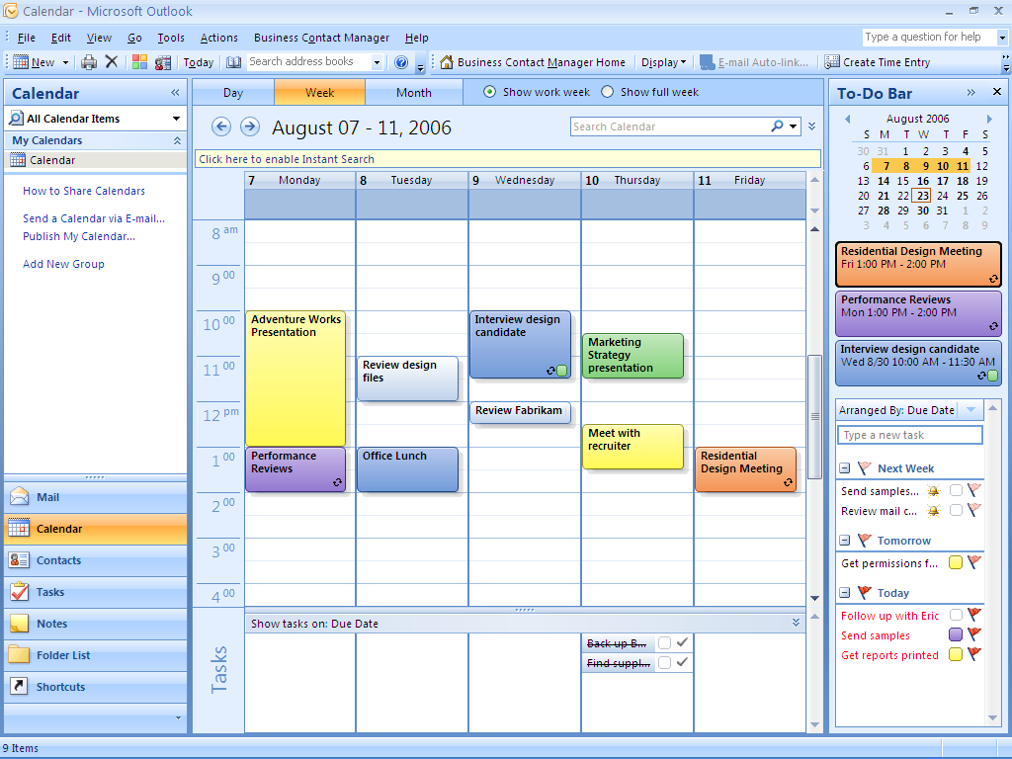

Tasks are easy to follow up on because they’re included on the   
To-Do Bar and within Outlook reminders.

Analyze business information more effectively.

Filter, sort, and visualize data more effectively with improved table, charting, and graphing tools in Microsoft Office Excel**®** 2007.

Manage Contact and Customer Information   
in One Place

Simplify prospect and customer management with new, user-friendly Outlook capabilities.

Centralize all of your contact information.

Using Microsoft Office Outlook 2007 with Business Contact Manager helps you centralize all of your contact information within Office Outlook 2007, including contact history, e-mail messages, phone calls, appointments, notes, and more.

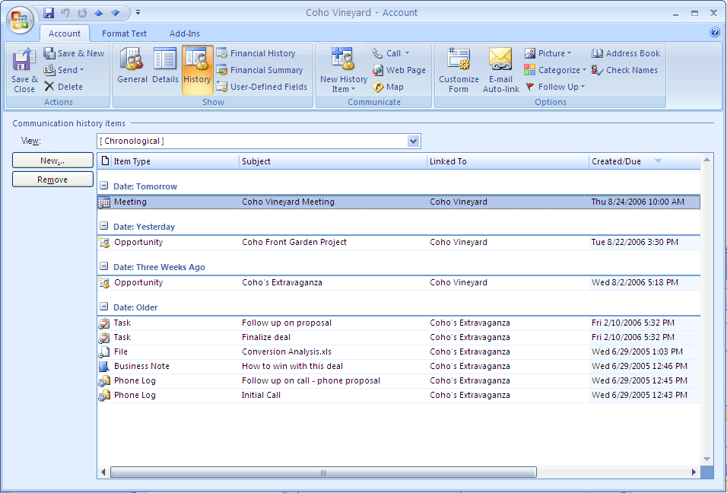

Office Outlook 2007 with Business Contact Manager combines contact, customer, and prospect information in one place.

Customize contact information for your unique business needs.

Office Outlook 2007 with Business Contact Manager can be customized, so you can create fields to capture the information that is most useful to your sales process.

Track and manage sales leads and opportunities.

Manage contact information, communications history, and the potential amount and status of each sales opportunity so you can easily track progress, follow up on, and close your sales.

Forecast sales and prioritize tasks.

Get a consolidated view of your sales pipeline across the company by using a variety of flexible reports. A customizable information dashboard gives you a snapshot view of your sales pipeline to help you make decisions and prioritize tasks.

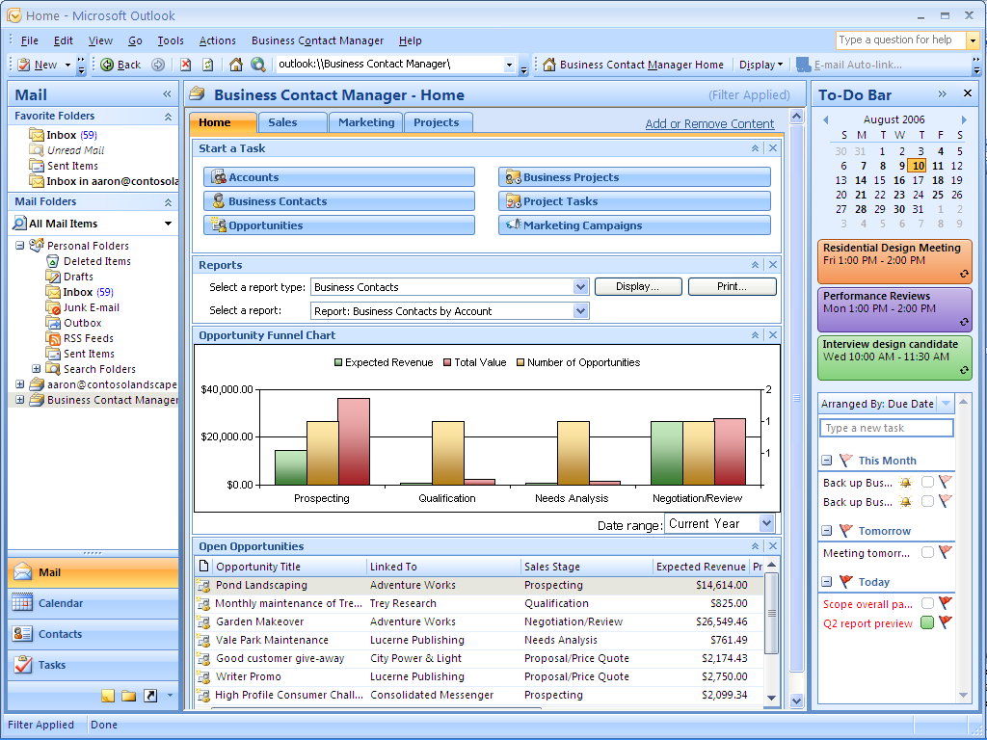

You can customize the new information dashboard in Office Outlook 2007 with Business Contact Manager and display your sales pipeline information.

Track and manage projects and tasks   
in one place.

You can manage all of your project-related information, such as e-mail messages, meetings, notes, and documents, in Office Outlook 2007 with Business Contact Manager. Manage your own work or assign tasks to coworkers. The To-Do Bar and reminders make follow-up easy.

Produce Professional Marketing Communications and Campaigns In-House

Create professional-quality communications and manage marketing campaigns in-house with powerful, easy-to-use tools.

Choose from a library of designer-created templates.

Microsoft Office Publisher 2007 provides templates in many categories for print, e-mail, and Web formats that you can customize to meet your needs.

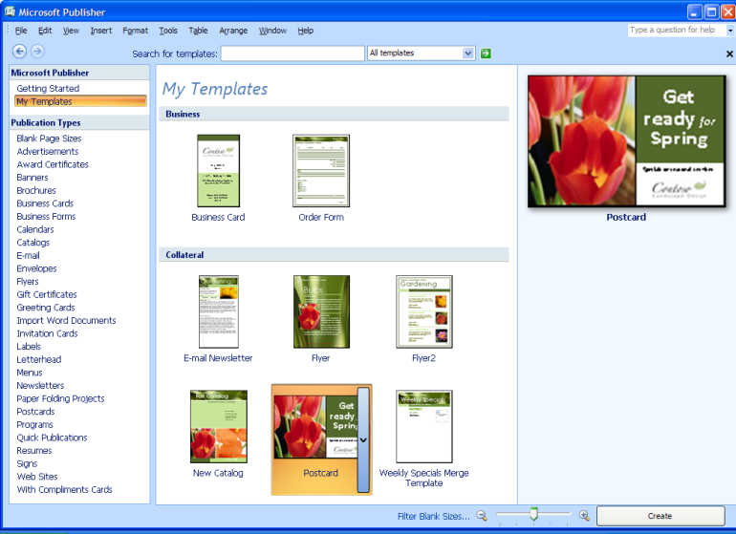

Office Publisher 2007 provides a large library of professionally designed templates.

Get started fast.

Office Publisher 2007 includes step-by-step guides that lead you through the process of creating and publishing marketing materials so you can quickly and cost-effectively create campaigns in-house.

Create high-quality marketing materials that enhance your brand identity.

Office Publisher 2007 includes new and improved tools to help you efficiently create, customize, and reuse a wide variety of marketing communications materials that are tailored to your company’s specific needs.

Choose your colors and fonts.

Customize your publications with 70 color schemes and 30 font schemes, or create your own custom schemes that reflect your brand identity and apply them to all of your marketing materials for print, e-mail, and the Web.

Save time by reusing content.

You can reuse entire publications by quickly changing from one publication type to another, such as changing a newsletter to a flyer. With the new Content Library, you can easily store text and graphics for use in other publications.

Market more effectively by using personalized communications.

Improved integration among Office Outlook 2007 with Business Contact Manager, Office Publisher 2007, and Word makes it easier to personalize print and e-mail marketing materials and monitor response to your campaigns.

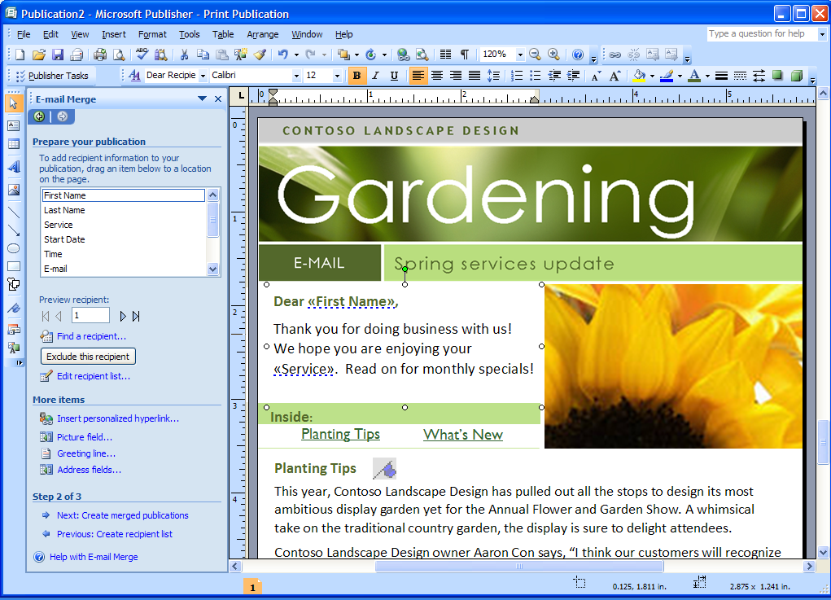

Create, preview, and send personalized e-mail publications with Office Publisher 2007 by using new E-Mail Merge.

Create more dynamic business presentations.

Microsoft Office PowerPoint**®** 2007 helps you easily get started with a more extensive library of professional slide layouts and new tools to create powerful charts, diagrams, and tables, and to preview changes quickly.

Distribute marketing materials and documents as PDF files.

Convert your Excel, Word, PowerPoint, Publisher, and Microsoft Office Access 2007 files to PDF files so you can distribute documents easily for online viewing or high-quality printing.[[1]](#footnote-2) In addition, Office Publisher 2007 supports creating press-ready PDF documents for commercial printing.

|  |
| --- |
| Microsoft Office Small Business 2007 includes: |
| * Microsoft Office Excel 2007 |
| * Microsoft Office Outlook 2007 with  Business Contact Manager |
| * Microsoft Office PowerPoint 2007 |
| * Microsoft Office Publisher 2007 |
| * Microsoft Office Word 2007 |
| * Microsoft Office Accounting Express 2007 |

For More Information

Learn more about Office Small Business 2007 and the entire Microsoft Office system at <www.microsoft.com/office/suites/smallbusiness>.

For complete system requirements, please visit [www.microsoft.com/office/suites/smallbusiness](http://www.microsoft.com/office/suites/smallbusiness).

This document is for informational purposes only. MICROSOFT MAKES NO WARRANTIES, EXPRESS OR IMPLIED, IN THIS SUMMARY.

The example companies, organizations, products, domain names, e-mail addresses, logos, people, places, and events depicted herein are fictitious. No association with any real company, organization, product, domain name, e-mail address, logo, person, place, or event is intended or should be inferred.

Microsoft_logo_jpg© 2006 Microsoft Corporation. All rights reserved. Microsoft, Excel, Fluent, the Office logo, Outlook, and PowerPoint are either registered trademarks or trademarks of Microsoft Corporation in the United States and/or other countries. All other trademarks are property of their respective owners.

1. You can save as a PDF or XPS file from a 2007 Microsoft Office system program only after you have installed an add-in. For more information, see [Install and use a PDF or XPS add-in](http://r.office.microsoft.com/r/rlidOOPDFXPSAddin?clid=1033). [↑](#footnote-ref-2)