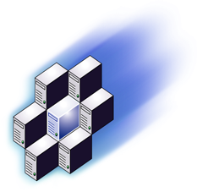


Evaluation Guide
January 2001

© 2000 Microsoft Corporation. All rights reserved.
The information contained in this document represents the current view of Microsoft Corp. on the issues discussed as of the date of publication. Because Microsoft must respond to changing market conditions, it should not be interpreted to be a commitment on the part of Microsoft, and Microsoft cannot guarantee the accuracy of any information presented after the date of publication.
This reviewers guide is for informational purposes only. MICROSOFT MAKES NO WARRANTIES, EXPRESS OR IMPLIED, IN THIS DOCUMENT.
Microsoft, Windows, MSDN, Windows NT, BizTalk, Win32, Visual Studio, Active Directory, Visual C++ and Visual Basic are either trademarks or registered trademarks of Microsoft Corp. in the United States and/or other countries.

The names of actual companies and products mentioned herein may be the trademarks of their respective owners.
Microsoft Corporation • One Microsoft Way • Redmond, WA 98052-6399 • USA

Contents
INTRODUCTION TO THE REVIEWERS GUIDE 1
Overview 1
Audience 1
Additional Information 2
Contact Information 2
ABOUT APPLICATION CENTER 2000 3
.NET ENTERPRISE SERVERS and APPLICATION CENTER 2000 4
.NET Enterprise Servers 5
APPLICATION CENTER 2000 DESIGN THEMES 7
Make Software Scaling Easy 7
Simplify Application Management 7
Increase Application Availability 8
APPLICATION CENTER 2000 USER INTERFACES 9
Integrated Management Console 9
Browser-Based Administration 11
Scriptable Interfaces 12
MAKE SOFTWARE SCALING EASY 13
Simplified Cluster Operations 13
Application Load Balancing 17
On-Demand Scalability 22
SIMPLIFY APPLICATION MANAGEMENT 23
Reduce Application Management Complexity 23
Manage Many Servers as One 24
Streamlined Application Deployment 26
INCREASE APPLICATION AVAILABILITY 28
Fault Tolerance 28
Performance and Health Monitoring 28
CONCLUSION 33
FEATURES OVERVIEW 34
FREQUENTLY ASKED QUESTIONS 36

Overview

INTRODUCTION TO THE REVIEWERS GUIDE
Welcome to the Microsoft® Application Center 2000 Evaluation Guide. This guide is designed to help you understand the product design goals for Microsoft Application Center 2000, as well as Microsoft’s strategy for helping customers deploy and manage high-availability Web applications built on the Microsoft Windows® 2000 platform.
The following sections are included in this guide to assist you in your evaluation:
- Application Center 2000 User Interface
- Application Center 2000 Design Themes
- Application Center 2000 Features Overview
- Application Center 2000 Frequently Asked Questions
In addition to this guide, there is also an Application Center 2000 Guided Tour, also called the Pre-Flight Checklist, to help with your evaluation. This tour is a self-paced, self-guided demonstration of the product and its capabilities.
While reading this document and taking the tour, use the following questions as a guide:
- Ease of cluster creation
How easy is it to create a cluster?
How much time does it take?
How much data needs to be gathered beforehand?
- Ease of application management
How easy is it to deploy an application?
How much application knowledge is required?
How does application synchronization compare with current methods?
- Increased availability
How will software scaling help your site’s availability?
How much downtime could be avoided through elimination of single points of failure?
How much information is available through the monitors?
How many resources can be saved through the automation of responses to system events?

Audience
This guide is designed for users, decision makers and influencers in the area of system infrastructure software. Although experience with Web hosting, application hosting and monitoring tools is desirable, it is not required for understanding of the product or this document.

Additional Information
There are several sources of additional information on Application Center 2000:
- The Microsoft Application Center 2000 Web site provides product information, pricing and licensing, white papers, research reports and studies, links to third-party vendors, and other resources.
- Microsoft TechNet provides detailed information about deploying, maintaining and supporting Application Center 2000 and other Microsoft products and technologies.
- The Microsoft Application Center Resource Kit will be available close to the product launch. This book contains technical details about the product and its use.

Application Center 2000 began as a project by the Internet Information Server (IIS) team in early 1998 during an extensive series of customer visits. Microsoft discovered that customers running IIS as a critical piece of their platform for high-availability Web-based applications were achieving high availability by deploying applications simultaneously on multiple servers and using a load-balancing mechanism to distribute incoming requests. This approach is called software scaling.

ABOUT APPLICATION CENTER 2000
MSN® is one example of a site that uses software scaling. When a user points a browser to http://home.msn.com, the request is routed to one of more than 50 servers that process the request and return an HTML file for display. Each server is capable of handling more than 1,000 concurrent users, which means the maximum system capacity is roughly equal to 50x1,000 users, or 50,000 concurrent user requests. Using software scaling, MSN has been able to keep up with growing traffic simply by adding new machines to handle increased load. If one server is taken offline, there are still 49 servers online to process user requests so that users would never be aware of the problem.
Software scaling provides two important benefits:
- Scalability — Companies can increase capacity simply by replicating the application onto a new box and adding it to the cluster.
- High availability — Because each server in the cluster is running identical applications, individual servers can fail without interrupting service to the users of that application. In the event of a server failure, workload would simply shift to the remaining servers in the cluster.
By using Windows 2000 running on off-the-shelf hardware, customers running their Web applications using the software scaling approach are satisfying the requirements of even the largest sites on the Web today with considerable benefits over the “big iron” approach.
But these same customers also told us of the difficulties they had in moving their systems to a software-scaled architecture. These common problems included the following:
- Moving applications was labor intensive.
- Scaling applications was too complex.
- Managing and monitoring clusters was hard.

Although the benefits of software scaling are very apparent in its linear scalability, those benefits are offset by the high operational costs that accompany them.
Application Center 2000 is designed to enable Web applications to achieve on-demand scalability and mission-critical availability through software scaling, while reducing operational complexity and costs.

The Microsoft .NET Enterprise Servers deliver maximum agility for today's E-Business enterprise. Along with Microsoft Windows® 2000, the .NET Enterprise Servers supply the core e-business solutions infrastructure for developing and managing enterprise applications today while building the foundation for the next-generation of Internet based e-business solutions and services

.NET ENTERPRISE SERVERS and APPLICATION CENTER 2000
Designed with mission-critical performance in mind, .NET Enterprise Servers are built from the ground up for interoperability, using open Web standards such as Extensible Markup Language (XML).
Specifically, the .NET Enterprise Servers offer:

- Enterprise Agility — Windows 2000 and the .NET Enterprise Servers provide the flexible infrastructure that will enable your company to realign business strategy and partnerships to keep pace with market changes. The .NET Enterprise Servers provide a comprehensive set of ‘building blocks’ for adapting to a constantly changing business environment, help your company execute quickly and empower employees to quickly respond to emerging business opportunities.
- Fast Time to Market — Through deep integration of all of the products and services making up the .NET Enterprise Servers and with world-class development tools and support, developers need only focus on implementing business logic when building an application. The overhead associated with creating custom system services and infrastructure has been alleviated by including all of these technologies as standard components of the platform. This, along with a fundamental commitment to ease of use, allows developers to develop and deploy solutions more quickly than on any other platform.
- Full exploitation of Windows 2000 Server — Windows 2000 Server includes an integrated, enterprise-class application server and provides an infrastructure that leverages state-of-the art hardware technologies such as Storage Area Networks (SANs), large memory and SMP architectures with up to 32 processors. The .NET Enterprise Servers build on this platform and leverage these services and capabilities for specific functions such as data management and XML support.
- Availability — Downtime is inherently reduced with a software scaling approach because most, if not all, single points of failure are removed. Should a server go down, other servers pick up the load dynamically, enabling the application to continue servicing clients. Furthermore, integrated tools simplify management of all components and services across the platform, reducing management downtime and maximizing availability.
- Software Scaling — Server “farms” or clusters divide the load of an application or system across multiple, inexpensive off-the-shelf PC servers rather than addressing scalability with ever-more powerful and expensive hardware.
- Ease of Deployment, Administration and Management — In the past, building multi-tier applications and deploying and managing those applications in clustered environments has been exceedingly complex and unapproachable. A fundamental design philosophy at Microsoft is to deliver state-of-the-art technology in such a way that it is easier for developers and IT managers to use. The .NET Enterprise Servers are designed to make it easy for developers to build reliable applications that scale out on the Web tier, application tier and data tier — and are inherently more manageable than applications on any previous platform.
- Interoperability — Integrating heterogeneous systems and applications to connect customers, partners and suppliers is a core feature of the .NET Enterprise Servers, allowing developers to build solutions easily and quickly that integrate with all heterogeneous environments.
- Internet Standards Support — The .NET Enterprise Servers use standards such as XML, HTML, HTTP, FTP and XPath to exchange data effectively across the Internet and intranets providing a flexible infrastructure for integrating applications, systems and solutions today as well as tomorrow.

.NET Enterprise Servers
In addition to Windows 2000 Server and Application Center 2000, the .NET Enterprise Servers include:

- Microsoft BizTalk™ Server 2000 —Enables the development and management of application integration within and between organizations using the universal standard of XML. BizTalk Server 2000 provides comprehensive process management and is designed for reliable business document interchange and business processes integration.
- Microsoft Commerce Server 2000 — Provides the fastest way to get a business online. Commerce Server 2000 delivers the personalization, closed loop analysis and electronic store infrastructure necessary for business-to-business and business-to-consumer e-commerce, and is designed for quickly building tailored, scalable e-commerce solutions that optimize the user experience and provide business managers with real-time analysis and control of their online business.
- Microsoft Exchange 2000 Server — Provides the foundation for building scaleable, reliable, and easy-to-manage messaging and collaboration applications. Exchange 2000 Server provides the messaging and collaboration infrastructure for connecting people with knowledge enabling organizations to communicate anytime, anywhere, collaborate beyond e-mail.
- Microsoft Host Integration Server 2000 — Enables companies to respond quickly to rapidly evolving business and technology demands while preserving their investments in existing host technology. Host Integration Server 2000 includes a comprehensive set of integration components for connecting host-based data and transactions with new applications, enabling companies to design flexible solutions that meet their integration needs.
- Microsoft Internet Security and Acceleration Server 2000 — Provides scalable enterprise firewall and Web caching server designed to meet the performance, management and scalability needs of high-volume Internet traffic environments. Using centralized server management, multiple levels of access policy, and fault tolerant capabilities, ISA Server Enterprise Edition provides secure, scalable, and fast Internet connectivity for mission-critical environments.
- Microsoft Mobile Information 2001 Server — Extends the reach of Microsoft .NET Enterprise applications, enterprise data, and intranet content into the realm of the mobile user. Mobile Information 2001 Server will bring the power of the corporate intranet to the latest generation of mobile devices, so that users can securely access their e-mail, contacts, calendar, tasks, or any intranet line-of-business application in real time, wherever they happen to be.
- Microsoft SQL Server™ 2000 — Offers a complete database and analysis solution for next-generation e-commerce, line-of-business, and data warehousing applications. SQL Server 2000 dramatically reduces the time required to bring applications to market while offering advanced scalability and reliability for the most demanding enterprise environments.

Microsoft has a strong history of providing industry-leading development tools that allow users to build applications quickly. These tools have evolved alongside the Windows platform, which now provides a comprehensive set of integrated Application Services in the operating system to allow developers to extend their knowledge into building new Web-based applications. Application Center 2000 is designed to provide an equivalent set of tools for the operation of these applications.

APPLICATION CENTER 2000 DESIGN THEMES
After conducting extensive research, including customer site visits, focus groups and consumer surveys, Microsoft designed Application Center 2000 with three themes in mind:
- Make software scaling easy
- Simplify Web and component application management
- Increase Web and component application availability

Make Software Scaling Easy
In the past, software scaling was a time-consuming and resource-intensive operation. With Application Center 2000, creating and running a groups of servers is designed to be as simple as operating a single server.
- Simplify cluster setup — Traditionally, software scaling has carried a “high barrier to entry,” including a high cost in complexity and resources in getting applications to run on multiple servers as a unified resource. Application Center eliminates the barriers that make the move to a software-scaled architecture difficult.
- Scale on demand — Application Center 2000 makes scaling easy enough that applications can achieve on-demand scalability. Using Application Center, applications can handle increases and decreases in their capacity requirements by easily adding or removing servers.
- Require no new APIs — Application Center 2000 offers the benefits of software scaling to existing applications without requiring modifications or rewrites.

Simplify Application Management
Application Center 2000 empowers both developers and administrators to deploy and operate applications while minimizing the in-depth application knowledge requirements. This in turn reduces the complexity and cost of operating a scalable, highly available application.
- Reduce application management complexity. Today’s applications consist of many bits and pieces. Using Application Center 2000, administrators can construct logical groupings including the contents, components and configuration of applications. This grouping can then be managed throughout the cluster, reducing application complexity.
- Manage many servers as one. When changes are made to a server, Application Center applies those changes to the other servers in the cluster. Possible changes include changes to application content or configuration settings.
- Streamline application deployment. Application Center simplifies the task of migrating applications through the development cycle (from development to testing and to production). It helps ensure consistency between the developed application, the tested application and the production application. By automating deployment of applications from one server to another, Application Center speeds up the transfer time, eliminates manual errors and improves the quality of releases.

Increase Application Availability
Application Center 2000 is designed so that any server may be brought down without affecting the availability of the application. There is no single point of failure. This means applications can have the necessary mission-critical availability, all using off-the-shelf hardware.

- Actively monitor performance and health — Application Center 2000 provides tools that monitor the cluster and its servers. Application Center also includes powerful features that enable viewing of performance and event log data for one server or the entire cluster. Administrators can even monitor applications remotely using a browser-based console.
- Automate event responses — Application Center 2000 can monitor server and application health and can even take action in response to particular events and conditions. With automated responses, operational costs will be reduced through the elimination of manual tasks. Automated responses can also provide higher application availability.
- Rolling upgrades — Production applications change. Application Center 2000 eases the process of applying those changes, without decreasing the availability of the application.

Application Center 2000 includes an easy-to-use interface. It also includes a range of features for accessing information and performing cluster and server operations. Administrators have their choice of ways to manage Application Center 2000:

APPLICATION CENTER 2000 USER INTERFACES
- Integrated management console
- Browser-based administration
- Scriptable interfaces

Integrated Management Console
Application Center offers a main console for managing server and member functions. From the Microsoft Management Console (MMC) snap-in, administrators can manage the full functionality of the server cluster. This easy-to-use snap-in tool organizes and manages deployment, synchronization, load balancing, and monitoring of Web and COM+ applications. The MMC snap-in offers individual or aggregated views of performance, health and event data across the entire cluster. From the MMC, wizards designed to simplify cluster management and operations can also be launched. Figure 1 shows the Microsoft Management Console snap-in for Application Center 2000.

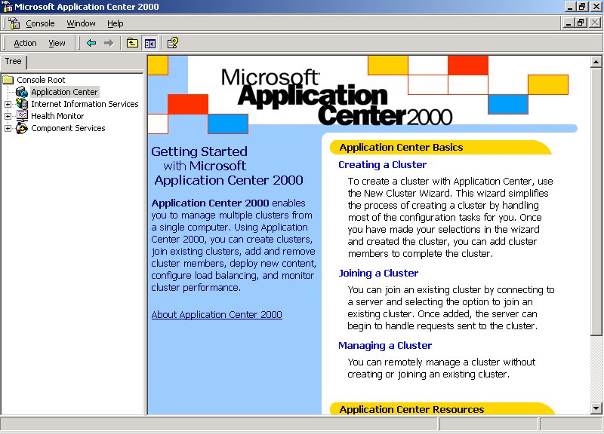
Figure 1: The Microsoft Management Console (MMC) snap-in

Application Center resides on each server in the cluster. The MMC snap-in may be run on any of the cluster servers, or from any computer running on Windows 2000, by using the client installation of Application Center. In addition to providing the MMC snap-in, Application Center also provides the following services on each server:

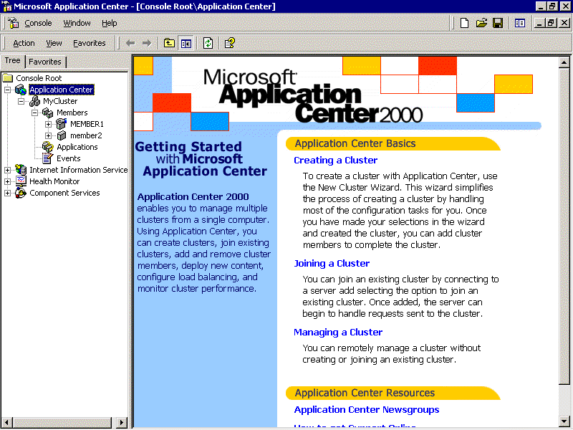
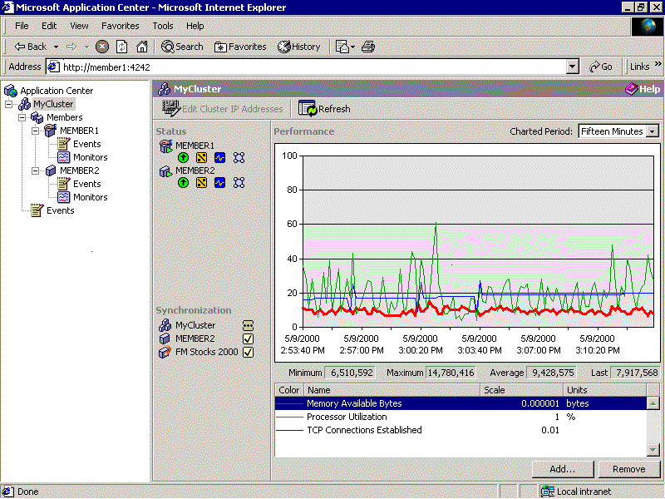
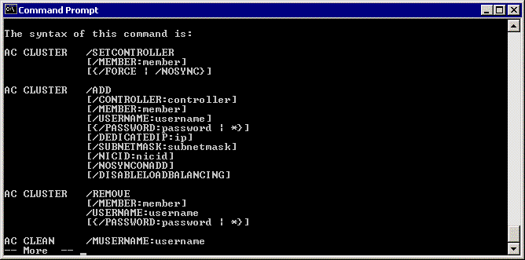
Figure 2: Application Center provides multiple interfaces for each server in the cluster.
MMC, Web & Command Line Interfaces GUIs
Sample Application
NLB
Cluster
CLB
Cluster

- Administrative Services are invoked through the various management interfaces.
- Logging and Query Services give visibility to performance, health and event information for any server
- Name Resolution Services resolve match names to IP addresses, eliminating a requirement for Domains or Active Directory.
- Synchronization Services coordinate the replication of content, components and configuration settings.

Using the management console, administrators can manage a range of cluster functions, including the following:
- Connect to servers or clusters
- Create the cluster
- Add or remove servers from a cluster
- Restart a server
- Manage the applications running on the cluster
- Change the cluster controller
- Synchronize the cluster
- Disband the cluster
- Clear Monitoring alerts on the cluster
The MMC also lets administrators view cluster status, performance and events, and it integrates with other tools including IIS, COM+ and Health Monitor.
Application Center 2000 also allows for the remote administration of cluster and member activities using the MMC Console. This gives administrators a high degree of flexibility in managing their cluster activity. Whether at work or at home, administrators can perform cluster operations and monitor the health of the cluster.
Remote administration is also possible using Windows 2000 Terminal Services. A system administrator can log on to any server in the cluster that has Terminal Services installed, including the controller server, and manage the cluster as if they were on the local server.

Browser-Based Administration
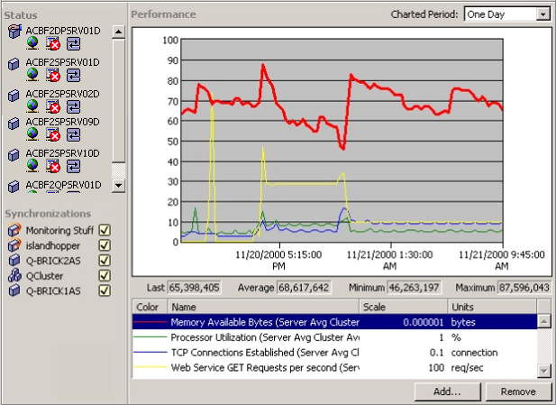
Administrators have also expressed a desire to be able to monitor the cluster from any client with a browser. Toward this end, the browser console was developed. The Browser Console is a more streamlined version of the MMC snap-in from which performance, health and event information for a single server or for the entire cluster may be viewed. Limited administrative tasks also may be performed using the Browser Console. Figure 3 shows the Browser Console.
Figure 3: Application Center 2000 Browser Console

Scriptable Interfaces
Application Center 2000 provides a standard command line interface for those who prefer command-line administration. The command line utility also allows for the scripting of many Application Center features and settings. Figure 4 shows a view of the command line screen.
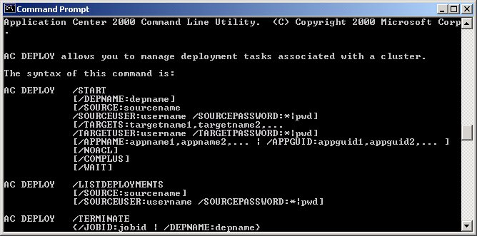
Figure 4: Command line screen
The command-line interface functionality includes:
- Adding and removing servers.
- Changing the cluster controller.
- Taking servers online/offline.
- Draining connections on servers.
- Specifying NLB load balancing address.
- Changing NLB load balancing weight.
- Changing component services routing.
- Synchronizing the cluster.
- Disabling synchronization.
- Viewing applications on the controller.
- Deploying applications.

Application Center 2000 is designed to make managing groups of servers as simple as managing a single machine. To ease the complex task of managing the software scaling process, Application Center 2000 offers:

MAKE SOFTWARE SCALING EASY
- Simplified cluster operations, including easy-to-use wizards and menus.
- Load balancing options, including compatibility with third-party load balancing solutions, and a request forwarding mechanism designed to help maintain session state across a cluster.
- On-demand scalability.

Simplified Cluster Operations
Application Center provides a number of tools and wizards that simplify and automate the complex processes of creating and managing Web and component clusters. Using clusters with Application Center should be no more difficult than operating a single server. All cluster operations can be initiated from within the Application Center user interface.

New Cluster Wizard
The New Cluster Wizard simplifies the cluster creation process. The New Cluster Wizard can set up a fully functional, load balanced, synchronized cluster in a few minutes with minimal information required directly from the administrator. Application Center will automatically detect resources and configuration of servers and use that information to configure an optimal configuration. Any of these settings can be changed after the wizard has completed.
The wizard configures load balancing and network settings, and sets up the server as the cluster controller. Figure 5 shows the New Cluster Wizard.

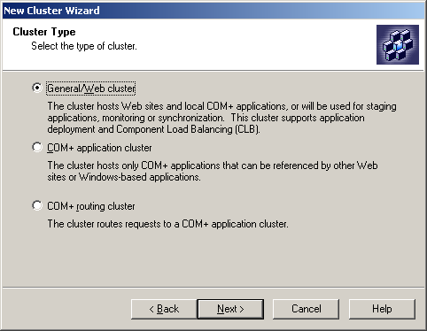
Figure 5: The New Cluster Wizard
Through the New Cluster Wizard, three types of clusters may be created. The most common type of cluster is the Web cluster, which is used to host Web sites and locally run COM+ applications. Another option is a COM+ application cluster, which uses Component Load Balancing to distribute component activations to the servers in the cluster. Finally, a COM+ routing cluster may be created. This cluster is used in situations where the COM+ requests do not originate in an Application Center cluster (e.g., from a Visual Basic®-based application). Each of these clusters uses the New Cluster Wizard to provide a common user interface for all cluster creation, regardless of the type.

Add Server Wizard
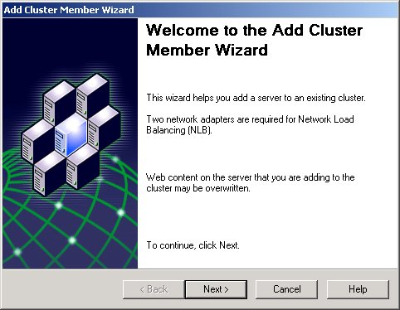
Once a cluster has been created, additional servers may be added quickly and easily using the Add Server Wizard. Only minimal information (such as which server to add) needs to be specified, as the wizard handles the rest. The new server is configured, brought into the load-balancing schema, with all applications deployed. When the wizard is completed, the new server is ready to actively receive requests as a member of the cluster. Figure 6 shows the Add Server Wizard.
Figure 6: Application Center allows easy on-demand scalability through the use of the Add Server Wizard.

Cluster Controller
Every cluster has one server designated as the cluster controller. In a new cluster, the first server is automatically the controller. This server, which can optionally serve requests in addition to its controller duties, is the source for all cluster synchronization, which includes content, components and configuration. If the cluster controller is not available, the member servers will continue serving requests, but the synchronization and cluster management features (adding and removing servers) will be disabled. These features may be re-enabled by making the controller available again, or by designating another server as the cluster controller. Since all cluster members contain identical copies of content and configuration, assigning a cluster member to be a new cluster controller is a quick and easy process from the MMC snap-in or command-line.

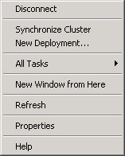
Manage and configure the settings for the entire cluster though these menu options.
MMC standard menu options
Figure 7: The cluster context menu

Context Menus
Cluster operations are located on context menus in the console tree on the left portion of the user interface. To create a new cluster, simply connect to the server that will act as the cluster controller. The New Cluster Wizard will launch and guide the process, as shown in Figure 5. Context menus also allow access to the other cluster operations. Figure 7 shows a Context Menu.

Task | Description
Disconnect | Stop the MMC connection to this server or cluster.
Synchronize Cluster | Force the content and configuration of the applications on the member servers to mirror that of the cluster controller.
New Deployment… | Copy entire applications from this server to one or more servers. The target servers do not have to be in the cluster.
Add Cluster Member | Add a new server to the cluster. This will bring up the Add Server Wizard.
Properties | Manage the cluster’s properties, including settings for synchronization, NLB, and drain time. The CLB routing list is also located here.
Table 1: Tasks available through the cluster context menu
In addition to the cluster tasks, each server has dedicated tasks available on server context menus. The cluster controller uses a simplified version of the member server menu. Figure 8 shows the member server context menu.

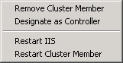
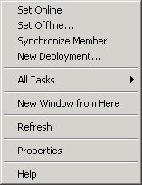
Figure 8: The member server context menu
Manage and configure each server in the cluster from the same interface

Task | Description
Set Online | Enable the server to serve requests. When using a supported load balancer, load balancing will be updated to distribute load to this server.
Set Offline… | Stop sending requests to this server. This command includes the ability to “drain” a server. This allows the server to complete the sessions it is currently serving without starting new ones.
Synchronize Member | Force the content and configuration of the applications on this server to mirror that of the cluster controller.
New Deployment… | Copy entire applications from this server to one or more servers. The target servers do not have to be in the cluster.
Remove Cluster Member | Take this server out of the cluster.
Designate as Controller | Give this server the responsibilities of the cluster controller. Cluster configuration and application content will now be synchronized to this match this server.
Restart IIS | Stopping the IIS service on the server and restarting it.
Restart Cluster Member | Force a reboot of the server.
Properties | Manage the server level properties including synchronization and load balancing weight.
Table 2: Tasks available through the member server context menu

Application Load Balancing
To ease the complex task of managing the software scaling process, Application Center 2000 offers a range of load balancing options to ensure that load is adequately distributed across the cluster. Application Center 2000 makes it easy to adjust applications to differing levels of activity and demand. Software scaling requires some form of load balancing to distribute the load among servers. Application Center 2000 provides several load balancing options. The type of requests being made to the cluster (IP or COM+) determine which of the following load balancing options is best for each application. The load balancing options include:
- Network Load Balancing
- Application Center Component Load Balancing
- Third-Party Load Balancing

Network Load Balancing
NLB accepts IP requests and distributes the load across multiple cluster hosts. It runs within cluster hosts as part of the Windows 2000 operating system and requires no dedicated hardware support. Application Center enables the use of NLB on Windows 2000 Server, but NLB also comes as a part of Windows 2000 Advanced Server and Datacenter Server. Application Center does not make changes to the NLB code but instead provides the technology with a centralized management interface. For more information on Network Load Balancing, see the NLB section of the Microsoft Web site.
The Add Server Wizard, the New Cluster Wizard and the Application Center user interface simplify the NLB configuration process. Like all wizards in Application Center, the interface requires administrators to make fewer decisions to choose the load balancing option that’s right for their application. In addition, the wizards perform hardware and software diagnostic testing to ensure that the minimal platform requirements are available to support load balancing. Administrators can adjust NLB affinity settings and individual server weights using the MMC snap-in.
Application Center simplifies the use of NLB by handling the setup and configuration duties. The cluster is configured with optimal settings for most applications. From the Application Center console, adjustments can be made to the cluster IP addresses, affinity and server weight. Settings can also be adjusted through the standard NLB property pages.
Application Center also makes NLB easier to use by centralizing its settings into a single console that may be accessed locally or remotely. Figure 9 shows how incoming request load can be adjusted using this console.

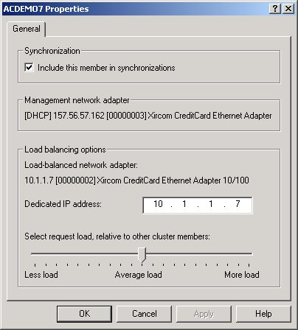
Figure 9: The Application Center 2000 Server Properties dialog box
Change the NLB relative server load without leaving Application Center.
The MMC Client allows administrators to maintain server settings from one or more central locations.

Component Load Balancing
Component Load Balancing (CLB) is an Application Center service. CLB provides a simple scaling mechanism for applications built using COM+ components. It allows a COM+ layer to be scaled independently of the application’s other tiers. It moves component workload from Web servers to a dedicated COM+ tier, which is particularly helpful if the COM+ components are relatively “heavy” — that is, if they use a lot of memory and/or processing capacity — and require an optimum-performance server.

CLB was originally introduced in early beta versions of Windows 2000. Feedback from customers evaluating CLB as part of the Windows 2000 beta program was positive, but it indicated there was a need for additional functionality around CLB in the areas of management, monitoring and deployment. Application Center fulfills these needs and simplifies the management of the routing lists. In addition, the CLB service has been updated to remove the single point of failure inherent in the earlier design.
In the same way that NLB distributes IP requests, CLB distributes COM+ activations. CLB uses a list of potential servers in conjunction with a response time/round-robin hybrid distribution scheme to determine where to route the request. The distribution mechanism has been optimized to provide the best performance, while eliminating the “hotspots” that can occur with some schemes. Figure 10 shows the Component Properties Dialog Box that is a part of the standard COM+ Component Services snap-in.
CLB also provides several benefits that simplify the load balancing process. They include:
- Add load balancing to existing applications without code modification
- No modifications required to the programming model
- Transparent to users
- Balances activations only
- Allows dynamic creation or updates using the command line
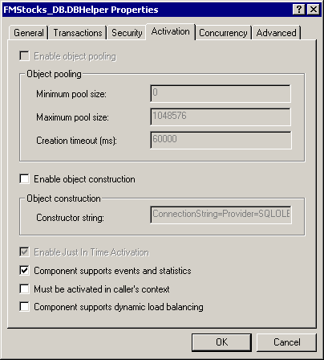
Figure 10: The COM+ Component Properties Dialog Box in the Component Services snap-in
To enable Component Load Balancing, check here in the component’s properties
Note that CLB is not appropriate for all applications. While it can bring performance benefits to some applications, performance may decrease in others. In applications with short-lived, low resource components, the cost of activating the component across the network will free up resources on the Web servers.

Request Forwarding
One of the biggest challenges faced by application developers is maintaining session state or coherency, or ensuring that client session information is not lost. Session state is a temporary store for user session information such as user preferences, shopping baskets and other user-specific information.
In a load-balanced, multi-server environment (such as one using NLB), managing and resolving session state for individual clients is more complex. In certain scenarios a client request can be re-mapped to the “wrong” server in a cluster. This happens when a client requires state information that was created on a different server during an earlier part of the session. This typically happens when a client connection originates from an environment that contains multiple proxy servers, such as the ones used by large ISPs.
The Application Center 2000 Request Forwarder (RF) is a mechanism designed to resolve these session state issues when handling HTTP client requests. Request forwarding allows applications to be clustered and preserve session state without major modifications. The RF design is based on these principles:
- Transparent to clients — Clients are not aware of request forwarding and beyond the requirement of accepting cookies do not have to participate in request forwarding programmatically.
- Transparent to server applications — IIS applications such as ISAPI and ASP on either the “wrong” server or the original server that handled a client requests are unaware of any request handling problems caused by NLB load mapping.
- Format generic — Rather than hard-coding DAV (Distributed Authoring and Versioning) verbs and FrontPage®-based URL formats into IIS, generic policies are applied to specific HTTP verbs and parts of the URL namespace so applications that require session coherency or single-server execution can use request forwarding.
- Easy to configure — No configuration is required to use request forwarding.
- Distributed — Processing on the forwarding server is minimized and the bulk of the processing takes place on the original server that handles the client request.
The RF sits between the HTTP client and server applications (for example, ISAPI and ASP). It stores information that identifies the “sticky” server — the first server that handled the client request — in an HTTP cookie.
This cookie is returned to the client on its first trip. On subsequent client requests the cookie is checked to see which server first handled the client during a given session. If NLB sends the request to a different server than the original, the RF sends the request to the “sticky” server. The RF behaves like a proxy server without caching — if a request needs to be forwarded, the server holding the request opens up a connection to the “sticky” server and forwards the HTTP request. The original server responds to the HTTP request, and the RF pipes the response back out to the client. Figure 11 shows the request forwarding process.

Figure 11: The request forwarding process

Step | Description
1 | Client requests myplace.com. This request goes through proxy 2.
2 | NLB routes client request to server A based on the IP address of proxy 2.
3 | Server A attaches a cookie to its return message.
4 | Client makes a second request. This request goes through proxy 1
5 | NLB routes client request to server B based on the IP address of proxy 1.
6 | Server B sees the cookie, determines that A has already handled this client and sends the response there.
7 | Server A responds to the client request. Its functionality is not affected by the forwarding of the request by server B.
Application Center 2000 also extends the “draining” capabilities of NLB. A draining server is completing its current requests without taking new ones. This feature is used when bringing a server offline so that no customer connection is disrupted. Using RF, Application Center allows a draining server to receive requests of existing sessions without starting new ones. In this way, customer sessions do not get lost when a server is taken offline.

Third-Party Load Balancing Compatibility
Application Center 2000 provides a framework that can accommodate third-party load balancing solutions. Third-party load balancing allows companies to leverage their existing investments in load balancing technology while benefiting from the cluster management capability of Application Center 2000. While Application Center does not integrate with the management functions of the devices, compatibility is being tested with load-balancing solutions from Cisco, F5, and Alteon. Integration scripts will be available as a part of the Application Center Resource Kit. For more information, see the Application Center Web site.

On-Demand Scalability
Increasing the capacity of an individual server is a reliable model of scalability for microprocessors. But that model of scalability began to erode with the growing demands of the Web, where systems needed to be able to scale on demand and scale cost effectively. Software scaling allows an organization to expand or reduce its server capacity as its needs change.
On-demand scalability offers incredible flexibility. Companies can grow and shrink their sites according to current capacity needs. For example, a site that offers online tax returns for consumers will have increased demand starting in January that will peak in April. By May, demand will drop dramatically. On-demand scalability allows capacity to expand quickly simply by adding more machines to the cluster and replicating applications to them. The additional machines can be removed just as easily from the cluster when demand drops off.
Application Center gives the flexibility of easily expanding or reducing application capacity. When there is a spike in demand, add servers to the cluster to handle the new load using the Add Server Wizard. If demand for an application is low, servers can be moved to another application that has greater need. The result is better resource management and improved use of resources.

In the past, customers have been slow to adopt software scaling because of the complexity of managing such a system. Maintaining these applications required advanced manual operational skills. Updating an application meant updating it on every machine in the cluster, which is tedious when an application runs on hundreds of servers. Setting up several servers to run as one required an intimate knowledge of the application design and architecture, as well as advanced networking skills.

SIMPLIFY APPLICATION MANAGEMENT
Application Center 2000 provides the tools and features to manage a multi-tier, distributed application as a single entity. It allows system administrators and developers to:
- Reduce application management complexity.
- Manage many servers as one server.
- Streamline application deployment.

Reduce Application Management Complexity
Most substantial Web applications are comprised of bits and pieces scattered throughout the operating system. These multiple elements can include HTML files, Active Server Pages, graphics files, IIS Web sites and settings, certificates, registry and server settings, business logic contained in COM+ components, Data Source Names, and load balancing software configuration. To ease the management of these bits and pieces, Application Center 2000 allows administrators to collect them into a logical entity, the Single Application Image.

Single Application Image
To Application Center, an application is defined as a collection of software resources. Such an application can consist of Web site content, components and configuration settings. A system administrator defines which resources constitute an application. This approach allows administrators to think of applications as logical groupings.
Application Center 2000 provides a central console to manage the collection of these resources for each application, allowing a system administrator to view the application as a single image. This Single Application Image extends across multiple servers, allowing a one-to-many management of server clusters. A system administrator can make updates and changes on the cluster controller and those changes will be automatically synchronized across the cluster. Figure 12 shows a Single Application Image.

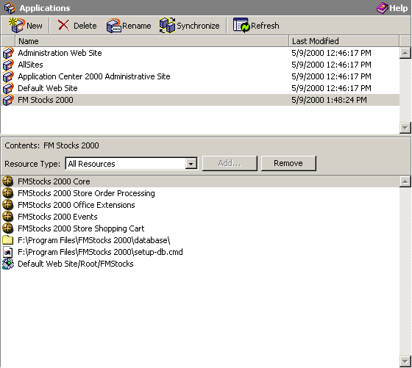
Figure 12: Application resources managed as a Single Application Image

Manage Many Servers as One
Even more difficult than defining what is part of an application is the task of keeping applications consistent across multiple servers. Not only must the content of the application be uniform, but all of the components and the application and server configurations must be uniform as well. Application Center is designed to automate the task of synchronizing the servers in the cluster so that administrators need only worry about a single server, truly managing many servers as one.
Application Center Synchronization is the coordination of entire applications on the member servers with the version residing on the cluster controller. The entire Single Application Image is synchronized including the content and configuration settings. In addition to the applications, cluster configuration and data are also synchronized, ensuring that each member server is consistent with the cluster controller. This capability allows any member server to assume the role of controller easily and quickly. In all cases, efficiency is a primary consideration. Consequently, only changed items are sent across the network in order to minimize network traffic and synchronization times.
Application Center automatically synchronizes the following items across the cluster:
- Date/Time
- Network Load Balancing settings
- Cluster name
- Cluster IP address
- Cluster network mask
- Port rules/affinity
- Multicast/Unicast configuration
- Network settings
- IP address settings
- DNS settings
- WINS settings
- Content and applications
- Files
- Directories
- Web roots
- Metabase settings
- CryptoAPI (CAPI) server certificates
- Registry keys
- System data source names (DSNs)
- Health Monitor configuration and settings
- Application Center configuration
Application Center allows an administrator to choose either automatic or manual synchronization. Automatic synchronization is invoked whenever a change is made to its applications or cluster settings on the cluster controller. Changes may be detected in the file system, the registry, IIS, and multiple properties and settings. No administrator input is required. For example, in order to change the connection timeout for IIS, an administrator would change that setting in the normal IIS administration Web site on the cluster controller. Application Center detects the change and makes the same change on all of the member servers. Administrators also have the option of removing one or more servers from real-time synchronization. Real-time synchronization saves the time and resources of manually synchronizing applications to all members of the cluster and tracking down problems caused by server inconsistency.
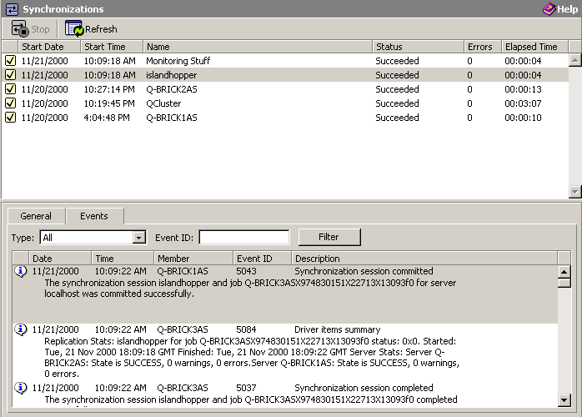
In order to monitor the deployment and synchronization jobs in the cluster, a dedicated pane is included in the MMC snap-in to provide administrators with status, event, time, and size information in a single consolidated source.
Figure 13: The Synchronization Pane provides details for jobs running in the cluster
In addition to the automatic mode, synchronization may also be scheduled to run on a periodic basis and run on-demand from the MMC snap-in. These options give more flexibility on the size and frequency of changes to the servers.

Streamlined Application Deployment
There are many instances in the normal operation and maintenance of a high availability application where content, components, and configuration need to be deployed from one server to another. These include changing content and configuration across clusters, migrating new versions of an application from development and testing, and applying changes made on a staging server to a cluster controller.
In the same way that Application Center 2000 simplifies the synchronization of a cluster, it also simplifies the process of deploying applications from one server to another. Unlike synchronization, however, deployment will operate outside and between clusters. These deployments are carried out using the Deployment Wizard.

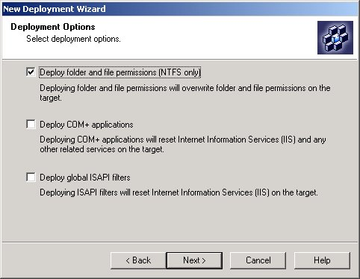
Figure 14: Deploying applications using the Deployment Wizard
The Application Center 2000 Deployment Wizard is designed to ease the process of staging and deploying applications. One of its primary functions is to coordinate the deployment of one or more Single Application Images to a server or servers. Because the application has already been defined, the wizard simply lets administrators choose which application(s) to deploy to which server(s).
Another key function of the Deployment Wizard is in the deployment of COM+ applications and ISAPI filters. Because these items require restarting IIS when they are deployed, customers have expressed their desire to have more control over their deployment. Application Center 2000 gives this control by placing the deployment of these objects into the Deployment Wizard. It simplifies the process of deploying to sections of a cluster, so that the application remains available. This process is known as a rolling upgrade.
The deployment capabilities also enable the use of staging servers. A staging server is a computer running Application Center 2000 that is not a member of the cluster. The benefit of using a staging server comes from its use as a central content store, which can then be deployed to different clusters. The staging servers can be used as a backup mechanism, or as a method of grouping multiple clusters.
In addition to using the Deployment Wizard, applications can also be deployed using command-line scripting.

FrontPage Integration
Managing content is perhaps one of the most labor-intensive and error-prone activities for development and support staff. Application Center 2000 allows authors to seamlessly publish content updates from the FrontPage Web site creation and management tool to a production cluster. Application Center automatically routes FrontPage publishing requests to the cluster controller so that the changes can be synchronized accurately to the member servers. The publisher is not affected in any way and may not even be aware that they are publishing to a cluster. Users of FrontPage can now easily take advantage of software scaling with no changes to their processes or procedures.


Microsoft FrontPage Publishing

A highly available system provides continuous service without interruptions caused by software or hardware failures. It provides a robust monitoring environment to handle and prevent service failures. A highly available system also offers event detection and response tools to allow administrators to respond quickly and effectively to service-altering changes in the system. Application Center 2000 is designed to meet these goals.

INCREASE APPLICATION AVAILABILITY

Fault Tolerance
A software scaled system is, by nature, fault tolerant. As the system is scaled, more “backup” servers are put in place. Should a server go down, another server will pick up the load dynamically, enabling the application to continue working without any disruption in service. Each server in a cluster contains the same content, components and configuration settings, so any server may assume the place of another if necessary.
It is worth mentioning that a potential fault tolerance issue may lie in how an application handles session state. Even using the Application Center 2000 Request Forwarding capabilities, some implementations of session state are not fault tolerant. If the original server is no longer available, it cannot receive the forwarded request, and state information is potentially lost. Although Application Center 2000 cannot make these applications completely fault tolerant, it can improve their fault tolerance. In order to make them completely fault tolerant, a persistent method of maintaining state must be implemented (For more information on fault tolerance, go to http://www.msdn.microsoft.com).
Application Center 2000 also enables high availability because there is no single point of failure. Every aspect of the Application Center solution has been designed so that the application will continue serving requests in case of hardware or software failure. If the cluster controller (or any other member) is not available, the cluster is still available. This allows the application to gracefully handle failures without affecting the customer experience.

Performance and Health Monitoring
In order to maintain a highly available environment, an administrator has to be able to monitor the performance and health of the system’s key components: its network, machines, and applications. A robust monitoring environment — one that provides real time and historical data — enables an administrator to keep an eye on the overall performance and health of the system.
The first step of this process is gathering all of the necessary data to understand the current workings of the applications. Microsoft consulted with many groups of users to find out what information they most commonly used, and as a result these data collectors have been included in Application Center 2000:
- CPU
- Memory
- File System
- System Events
- Application Events
- TCP/IP Ports
- HTTP Requests
- COM+ Applications
- IIS
- Health Monitor Alerts
Supported data collectors are by no means limited to those included with the product. Application Center supports standard PerfMon monitors, which can easily be added to the system.
In order to alert administrators to potential issues, Application Center 2000 also provides a comprehensive monitoring system. Default monitors handle such items as Web services, Application Center services and system events. Monitors may also be created by adding thresholds to performance counters.
Thresholds are monitoring rules that evaluate a single property of a data collector. When these rules are met, the state of the data collector changes, such as from Normal to Critical. For example, a CPU threshold can be defined to enter a critical state if the processor utilization collector is greater than 75 percent for 30 seconds, measuring every 10 seconds. Using thresholds, administrators may define not only which areas of the system they wish to monitor, but also when these areas become a cause for concern.
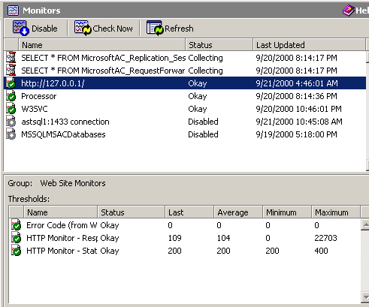
The monitors for a cluster are synchronized configuration settings, so the administrator is assured that the proper monitors are running on each server in the cluster.
Figure 15: Monitoring in Application Center
In order to manage the data from all these disparate sources, Application Center is using Windows Management Instrumentation (WMI). WMI is the Microsoft implementation of Web-Based Enterprise Management (WBEM), an industry initiative to develop a standard technology for accessing management information in an enterprise environment. The purpose of this initiative is to help companies lower their total cost of ownership by enabling powerful enterprise-class management of systems, applications and devices. Numerous companies are participating in the WBEM initiative, including BMC Software Inc., Cisco Systems Inc., Compaq Computer Corp., Intel Corp. and Microsoft.
Because WMI is being used, applications that have been instrumented with WMI will automatically be supported by Application Center. Working as a WMI consumer, Application Center captures data from each data collector and consolidates it into a local data store. Each server in the cluster is responsible for its own data, eliminating bottlenecks and single points of failure.

Data Analysis Tools
In order to help administrators understand the data, Application Center 2000 also provides tools to view and analyze each type of data. Performance data may be viewed in graph form, with multiple counters on a single graph. For assistance in spotting trends, each graph can represent the counters for a single server, or an aggregate of the counters across the entire cluster. Monitors may also be viewed centrally, so that alerts may be spotted quickly. The performance viewer is shown in Figure 16.
Although this example shows aggregated cluster information, individual server performance may be viewed as well.
Change the period of charting to spot long and short-term trends.
Counter values are scaled so that many can be viewed easily on the same graph.
Figure 16: The Performance Monitor
As the number of servers increases, it can become increasingly difficult to determine what is happening on any one server. Application Center 2000 provides several features to help manage event monitoring, including an intelligent event log. The event viewer, shown in figure 16, allows administrators to view event data from any server or from the entire cluster. Using queries, extraneous events may be filtered out, making problem detection easier. The streamlined user interface is designed for beginning to intermediate administrators. Keeping this level of user in mind, Microsoft has also provided links directly to online support from the application monitor.
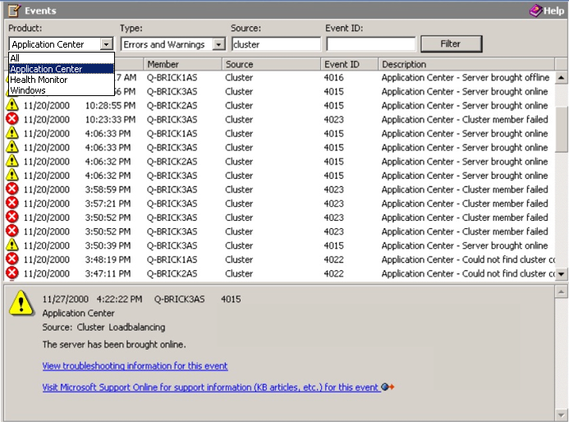
Each server stores its performance and health data in a local Microsoft Data Engine (MSDE) database, which minimizes its impact on the server with its small footprint. Since MSDE uses the Microsoft SQL Server™ engine, all SQL Server tools and practices may be used to copy or transfer the data from each server. The schema is documented for archiving and potential export to an external database for further trend analysis. The data tools in Microsoft Office may also be used.
Figure 17: Application Center Event Viewer

Automated Event Responses
When a monitor is alerted or a threshold is exceeded, sometimes an alert isn’t enough. Application Center 2000 provides the ability to automate responses to each monitor. For example, if the IIS service is not running, a restart action would be more desirable than a page or an e-mail. Both would be even better. There are many types of actions that may be attached including Application Center actions (adding a server, bringing a server on- or offline), running a script, or executing a program. By automating responses to system events and monitors, Application Center 2000 reduces support costs and increases the availability of the application.

Integration With Third-party Management Tools
To facilitate integration with Application Center, Microsoft is taking advantage of the WMI standard. Using standard SQL syntax, WMI allows developers to use a simple, consistent mechanism to query for information or configure settings on computers across an enterprise. Through the WMI interface, administrators can access hardware settings, performance information, driver configuration, BIOS information, application settings, event log information and more. Application Center 2000 was built around WMI and its core services fire events using WMI.
For example, Application Center fires an event during cluster synchronization. A WMI consumer may be implemented to create audit log entries for the beginning and ending times of each synchronization session. Using the WMI infrastructure, third-party vendors can extend the capabilities of Application Center 2000 and leverage the information that it contains.

CONCLUSION
Microsoft Application Center 2000 is the deployment and management tool for high-availability Web applications built on Windows 2000. It enables these applications to achieve on-demand scalability and mission-critical availability through software scaling, while reducing operational complexity and costs. Application Center 2000 makes managing groups of servers as simple as managing a single machine.

FEATURES OVERVIEW
Simplify Application Management
Feature | Description and Benefits
Single application Image | Manage an application as a single high-level definition that encompasses all of its content, components and configuration settings.
Integrated management console | Make configuration changes and view performance and event log data for one or all machines, all from a single console.
Local or browser-based administration | Perform all administrative tasks locally, using a standard application, or remotely using an HTML interface.
Automatic application synchronization | Keep application content and configuration settings consistent across all the machines in one cluster.
Application staging and deployment | Automates application deployment, including content, components, and configuration data, from one server to another. For example, deploy from development to test, staging and production environments.
Microsoft FrontPage® and Web DAV integration | Seamlessly publish content updates using FrontPage or Web Distributed Authoring and Versioning to a cluster of servers.
Integration w/ Microsoft Web platform | Scale and manage Windows 2000 applications built with Visual Studio, Commerce Server 2000, BizTalk Server 2000, Host Integration Server 2000, SQL Server 2000, and Internet Security and Acceleration Server 2000.

Make Software Scaling Easy
Feature | Description and Benefits
Network Load Balancing | Automatic configuration and control over Windows 2000 Network Load Balancing. Also, enable the use of Network Load Balancing on Windows 2000 Server.
Component Load Balancing | Distribute COM+ component execution load across multiple servers.
Third-party load balancing compatibility | Manage applications running in clusters that use third-party hardware load balancing solutions.
Cluster Wizard | Automates the process of creating, configuring, and managing Web and COM+ clusters.
Simplified routine cluster operations | Simplify and automate the complex processes of creating and managing Web and component clusters with easy-to-use wizards.
Request forwarding | Augments client affinity load balancing solutions to allow ASP session objects to be used, even behind rotating client-side proxies.

Increase Application Availability
Feature | Description and Benefits
No single point of failure | Achieve advanced fault tolerance. Application Center creates a system that can withstand software and hardware failures at any point in the system without disrupting application service.
Rolling upgrades | Upgrade production applications without service interruptions.
Aggregated Performance Data | Analyze performance data for any server in the cluster, or for the entire cluster as a single aggregated source.
Automated event detection and response | Automatically respond to pre-configured system events to pre-empt application failure, reducing administrative menial tasks and freeing up time for more important tasks.
Intelligent event log | Query event data from one or more machines to quickly diagnose problems with applications or servers, thanks to smart, distributed event logging facilities.
Integration with third-party management tools | Integrate Application Center 2000 with existing third-party server and enterprise management tools.
Windows Management Instrument (WMI) support | Consumes and emits WMI events, allowing easier integration with other applications and system management tools that support WMI.
Health Monitor | Set pre-configured thresholds to monitor system performance.

What is Application Center 2000?

FREQUENTLY ASKED QUESTIONS
Application Center is a high-availability deployment and management tool for Web applications built on Windows 2000. Application Center allows users to easily deploy and manage Web applications across clusters of PC servers (also called "web clusters" or "web farms"). It provides the following benefits:
- Simplified application management
- Software scaling made easy
- Mission-critical availability
Who cares about Application Center? What is the target market?
Application Center is designed for customers building and managing Web applications that demand mainframe caliber scalability and availability. This includes corporations building mission-critical business applications and commerce sites, dot-com companies, and ISPs hosting sites on Windows 2000 Server.
How does this stack up to the competition?
There's not one clear competitor that offers all the functionality that we provide in a single integrated product. The combination of Windows 2000 and Application Center 2000 provides an integrated, scalable, high-availability application server runtime environment with best of breed deployment, management, and monitoring tools at a fraction of the cost of competitive products.
How do Application Center Clusters differ from Microsoft Cluster Service (MSCS)?
MSCS is a fail-over clustering solution available in Windows 2000 Advanced Server and Datacenter Server that provides high-availability for the data and storage tier of an application. Application Center 2000 focuses on providing both scalability and availability through load-balanced, shared-nothing clustering for the Web (IIS) and component (COM+) tiers of an application. With Application Center 2000, the addition of incremental machines to the cluster provides increases in both the availability and the capacity of the Web or component tier. In a complete multi-tier application involving Web, component, and database/storage tiers, both types of clustering are used together to provide a total solution for end-to-end availability.
Is this product compatible with existing system and network management tools?
Yes. Application Center is intended to complement and integrate with existing enterprise system and network management tools.
What is the maximum cluster size supported by Application Center 2000?
The maximum cluster size is influenced by many factors including the capacity of the controller, the frequency and sizes of updates, and the network being used to connect the servers. As a general recommendation, the maximum number is 12 servers. Using staging servers and multiple clusters, however, there is no practical limit to the number of servers that can serve an application. For example, Microsoft.com uses 7 clusters of 6-8 servers per cluster. Around 50 servers are being used to host the application, with no limits being hit.
Does Application Center 2000 require Active Directory?
No. Application Center 2000 can be used to manage servers that are deployed outside of a Windows 2000 Active Directory domain. However, Application Center 2000 can be used with Active Directory and will utilize manageability features of Active Directory for end-to-end management of both the operating system and the application.
What are the system requirements for Application Center 2000?
- Pentium-compatible 400 MHz or higher processor.
- Microsoft Windows 2000 Server, Windows 2000 Advanced Server, or Windows 2000 Datacenter operating system with Service Pack 1.
- 256 MB of RAM minimum recommended.
- 100 MB of available hard-disk space to install services; additional space required for site content and databases.
- CD-ROM drive.
- One Network Interface Card (2 recommended); if using Windows 2000 Network Load Balancing, two NICs are required.
- Windows 2000-compatible video graphics adapter with 800x600 minimum resolution.
- Microsoft Mouse or compatible pointing device.
- Microsoft Internet Information Services 5.0 must be installed as part of Windows 2000 installation.

