
INVENTORY

Microsoft Dynamics™ SL

Benefits
- Control inventory flexibly
From the initial setup of inventory items to the multiple methods of valuation supported, Microsoft Dynamics SL Inventory meets the diverse daily requirements of a wide variety of industries.

- Tailor to your needs
Control inventory challenges, exceed
customer expectations, and maximize
your company’s net profits based on
the way you do business. Define default
inventory account numbers, COGS,
variances, sites, product classes,
valuation methods and more.

- Identify items efficiently
Include up to 30 characters in your
inventory IDs. Each item can be identified by class to help group items for pricing, promotional, or analytical purposes and by type, such as finished good, raw material, component, and more.

- Value and organize items effectively
Valuation capabilities are equally flexible, with support for: LIFO, FIFO, average cost, specific identification, standard cost, and user-specified cost methods.

- Access information instantly
Quickly and easily find just what you need using extensive inventory cross-reference features. Identify quantity on hand, quantity available, quantity on back order, costs, and list prices. Or,
drill down to transaction source documentation for even more detail.

Help to ensure that your customers get what they want, when they
want it — and maximize return on your inventory investment. Microsoft Dynamics SL Inventory helps you deal with the full range of inventory issues, including outgoing orders, incoming stock, returns, backorders, surplus inventory, and dead stock.

Flexible
inventory management supports quantity on hand, selling price, cost, sticking units, general ledger posting rules, and more.

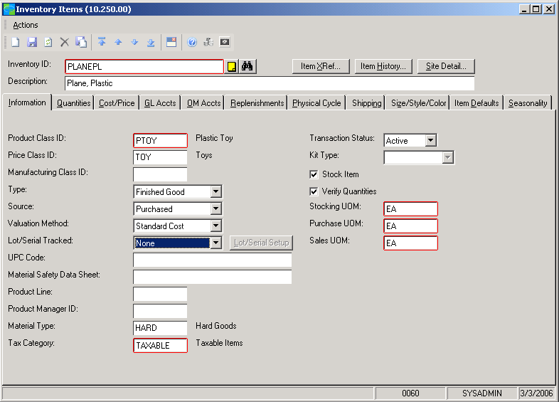

Quickly access
detailed information about each inventory item, including item history, from a single screen.

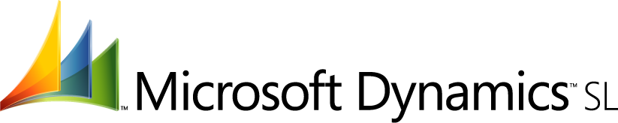

features

BENEFITS

Flexible Setup | Specify various general ledger accounts for posting — in detail or  summary. Indicate whether to use multiple warehouses, negative  quantities, and lot/serial numbers — even specify when these should  be assigned: as received or when used.
Instant Information Access | Use in conjunction with Microsoft Dynamics SL Order Management to allow managers, salespeople, and customer service representatives to access inventory availability information via the Sales Orders screen.
Comprehensive Reporting | Get the information you need to purchase the right products at the right  time and maximize your inventory investments. Report options let you  sort and select on any report field and view only the information you  want.
Reporting Variety | Choose from a wide variety of standard reports, including inventory trial  balance, inventory valuation, inventory transactions, sales analysis by  inventory ID and product class, and physical inventory reports.
Lot/Serial Tracking | Handle lot and serial numbers efficiently. Lot/serial tracking streamlines  entry during inventory transactions. When a lot or serial number is  needed, a window opens with suitable information, based on your  business rules.
Physical Inventory Support | Simplify entry and reconciliation of physical inventory counts with a  variety of options, including the ability to freeze inventory quantities  so they are not updated by transactions while you are counting.
Cycle Counting Support | For companies that perform frequent physical counts, Microsoft  Dynamics SL Inventory fully supports cycle counting. Enter physical  counts into the system, print count worksheets, and preview and  automatically compute adjustments.
Inventory Item Status Codes | Limit how items are used to control your most valuable assets. Status  codes allow you to control which transactions are allowed for particular  inventory items.
Kitting Support | Gain flexibility in maintaining kits and kit components. Microsoft  Dynamics SL Inventory also supports unlimited kit items.
For more information about Microsoft Dynamics™ SL, visit: http://www.microsoft.com/dynamics/sl

This document is for information purposes only.
MICROSOFT MAKES NO WARRANTIES, EXPRESS, IMPLIED, OR STATUTORY, AS TO THE INFORMATION IN THIS DOCUMENT.

© 2005 Microsoft Corporation. All rights reserved.
Microsoft, The Microsoft Dynamics Logo, are either registered trademarks or trademarks of Microsoft Corporation or Microsoft Business Solutions ApS in the United States and/or other countries. Microsoft Business Solutions ApS is a subsidiary of Microsoft Corporation.

